Mike Bruenger

June 8, 2021

Introduction to Python

Assignment09

<https://github.com/Bruengerjr/IntroToProg-Python-Mod09.git>

Programming and Modules

# Introduction

The purpose of this document is to describe the steps taken to complete Assignment09, which consists of researching Classes and applying the learned knowledge. It will consist of 4 steps, copying the scripts, performing the testing, creating the main script, and preparing them for submission.

# Copying the Scripts

I began by copying the DataClasses, ProcessingClasses, TestHarness, and IOClasses scripts. I also added the code necessary for each script

# Performing the Testing

For testing I added the appropriate code to the TestHarness script to validate each of the Processing, IO, and Data classes. The testing was successful and I received the expected results from the test cases.

# Creating the Main Script

I created the main script, which contains the code and logic for the menu and choice system. I called the already existing menu function from the IO class and used the user choice function within the class as well. I also included the necessary logic to interpret the user’s choice to perform different tasks. I had some trouble with the saving component. It does save the file, but it doesn’t contain the data, it saves the objects memory location. Unfortunately I ran out of time for the week and was not able to debug this issue.

# Preparing for Submission

In preparation for submission I created the desired folder hierarchy, named the files appropriately, and took the required screenshots of the code in action (Figure 1), the created txt file (Figure 2).

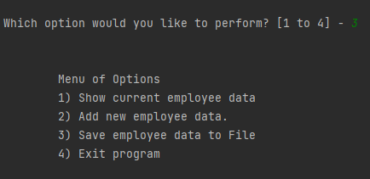

Figure 1: My script executing.

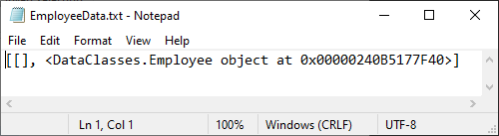

Figure 2: The EmployeeData.txt File

# Summary

I have described the process of completing Assignment09 and the steps I took copying the scripts, performing the testing, creating the main script, and preparing them for submission.