Mike Bruenger

May 11, 2021

Introduction to Python

Assignment05

<https://github.com/Bruengerjr/IntroToProg-Python.git>

To Do List

# Introduction

The purpose of this document is to describe the steps taken to complete Assignment05, which consists of using a starter script, intended to represent taking over someone else’s code, to create a to do list that can be manipulated within the context of a menu. It will consist of 3 steps, opening the Assignment05 Starter script, adding additional capabilities to the script, and preparing them for submission.

# Opening the Assignment05 Starter Script

As directed, I began by opening the starter script and examining the existing code. After fixing a few minor spelling errors I observed that I needed to add code chunks for each of 5 areas of a menu system. To ensure simplicity and to avoid trying to pull data from both memory and a saved file, I opted to pull the contents of the file into memory upon startup. This allows me to manipulate only the contents in memory until the user chooses option 4 to commit the data to file. Once this code was implemented the steps for Option 1 came with ease.

# Adding Additional Capabilities to the Script

Option 2 proved to be a modest challenge, but I was able to get new tasks added to the list as dictionary objects. Expecting difficulty with Option 3 I held out until last and had no issues with the writing to file components of Option 4. Focusing on Option 3, and with some assistance from some colleagues at work, I was able to get the remove to work as expected and provided some neatly formatted feedback for the user. This prompted me to reflect that most of the options provided little feedback which prompted me to add some user feedback prompts for options 2, 4, and 5.

# Preparing for Submission

In preparation for submission I created the desired folder hierarchy, named the files appropriately, and took the required screenshots of the code in action (Figure 1) as well as the created txt file (Figure 2).

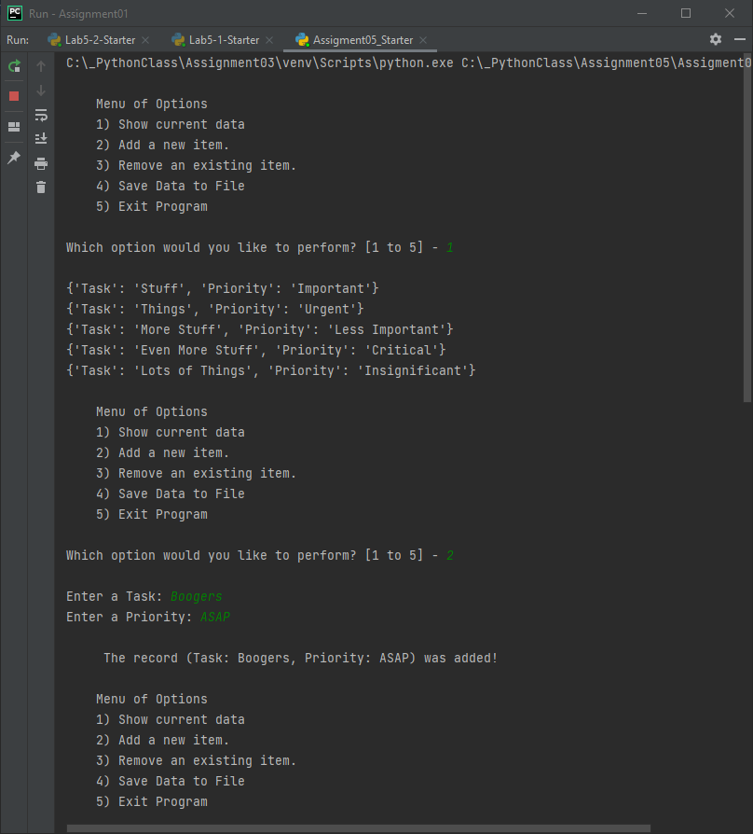 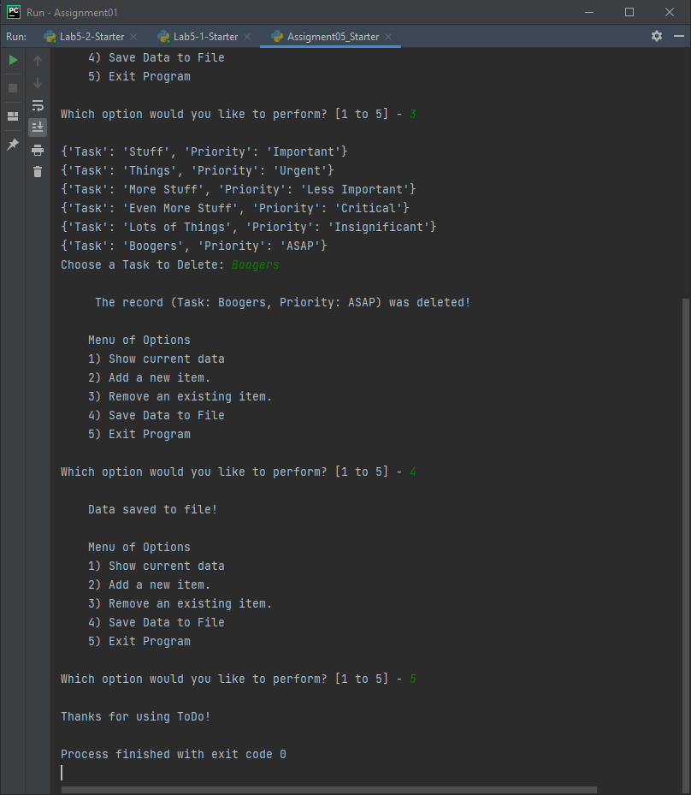

Figure 1a: My script executing. Figure 1b: My script executing

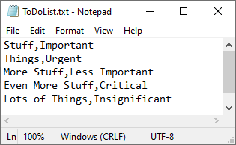

Figure 2: The ToDoList.txt File

# Summary

I have described the process of completing Assignment05 and the steps I opening the Assignment05 Starter script, adding additional capabilities to the script, and preparing them for submission.