Payscale

# Analysis

## State

There are 50 graduates of each state in the sample.

## Salaries

The mba slaries are between 59000 and 113000, with a mean of about $80000.

The most frequent value is around 70000.

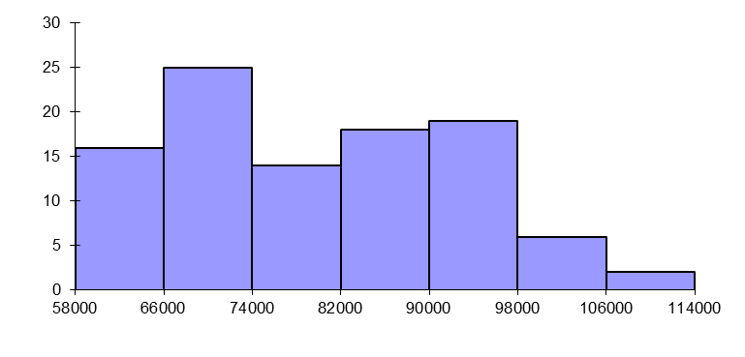

The salary is strongly linked to the state: in California, the mean salary is 91 000, vs 69 000 in Florida

The variation is roughly the same in the two states (coefficient of variation = 8.5% in California, vs 7.9% in Florida

