STUDENT GRADE PREDICTION MODEL
Anshul Chamoli, Bhavya Sharma, Sejal Anand, Shivam Rathi
School of Computer Science
University of Petroleum and Energy Studies
Dehradun-248007, India

Abstract—In this paper, we attempt to apply decision trees algorithm for educational data modelling. Using the classified data for decision-making is a necessary task and computers are trained to take this data as inputs, automatically manage data using machine learning algorithms and make decisions as an output. Various data mining algorithms are available. However, decision trees are frequently used for classification because they have a simple hierarchical structure that facilitates user decision-making. The decision tree classification learning process simplifies the process of classifying data. Decision tree algorithms are widely used in marketing, surveillance, fraud detection, recommendation system, and many other fields. This can be used to boost the quality of education for students by using classification techniques for measuring and predicting the student performance.
Keywords: Student Grade Prediction Model, Decision Trees, Education Data Modelling

INTRODUCTION
Educational data modelling (EDM) is an emerging field in data mining that employs classification algorithms to find the specific types of data that come from the education system to understand the students and system better. Within the previous six years, there has been a rise in their application and decision tree classification learning process simplifies the process of classifying data. Here, the purpose is to imply decision trees algorithm for prediction and evaluation of scores of individual students for each academic term. The model’s goal is to offer a method that spares both institutes and the students’ time and effort and to improve the quality of education. Many previous works prove the efficacy of data mining the issues in the educational arena and student performance prediction is one of the most important issues.
For higher educational institutions, the prediction of students’ performance in the academic sector is essential for it will benefit both students and professors and thus enabling the latter to do proactive measures and find ways in helping students learn, ultimately improving their academic performance.[1] The evaluated performance can be used to identify at-risk students and identify the priority learning needs for different groups of students to create interventions.
Decision tree is one of most effective and admired classification and prediction techniques in the field of data mining. Basically, decision tree is executed in decision theory and statistics and decision tree algorithm can work on a variety of nominal, numeric and textual type of response documents and various datasets with a large number of errors and missing values. Also, the building a decision tree does not require any domain-specific knowledge or parameter setting. Decision trees clearly provide intimation of which factors or attributes are most important for prediction or classification and generate understandable rules.
The model targets academic institutions to implement better teaching processes by allowing the educators to use the data stored to improvise teaching and learning processes. This will help the educators and students themselves to know their progress and increase their performance in schools.

LITERATURE SURVEY
In this section, various works on student grade model using decision trees are reviewed.
Dr. Tripti Mishra et. al. employs various classification methods to build a performance prediction model based on students' performance, social and academic integration, as well as a number of emotional competencies that been thought about thus far. J48 (implementation of C4.5) and random forest are two algorithms. The records of MCA students from colleges connected with Guru Gobind Singh Indraprastha University have been updated with decision tree.
In the study by Kolo David et al., various factors like gender, previous grades, finance level, motivation level can affect the student performance. A more automated system can be used to achieve prediction of students’ performance through data mining. This research also suggests public and private institutions for efficient prediction analysis in education.
Following are some studies with the same goal of implementing student grade prediction models to help the students improvise and achieve better performance.
Using Decision Tree Algorithm to Predict Student Performance
Author: Micheline Apolinar -Gotardo
Summary: The author created a model that was based on a decision tree. The marks were calculated in Data Structures and algorithms subject with pass, fail and conditional remarks. The model was also able to identify 85.31% accuracy for the attribute Pass, 79.41% accuracy for the attribute Conditional and 91.67% accuracy for the attribute Failed.

A Review Paper on Student Performance using Decision Tree Algorithms
Author: Pratibha V.Jadhav, Dr.Vaishali V. Patil, Dr.S.D.Gore

Summary: Decision tree algorithms like ID3, C4.5, CART help many institutions for prediction of Student Grade. Attributes like attendance, internal marks and final marks are taken for prediction. Techniques like regression, classification, association and clustering are known as Knowledge Discovery Database when used in educational fields.

Performance Evaluation Among ID3, C4.5, and CART Decision Tree Algorithm
Author: F.M. Javed Mehedi Shamrat, Rumesh Ranjan, Khan Md. Hasib, Amit Yadav, and Abdul Hasib Siddique
Summary: From this paper, the Authors have analyzed that Decision tree Algorithms like ID3, C4.5 and CART hold a very high accuracy rate. All these algorithms are based on Hut's algorithm. ID3 Algorithm provides a satisfactory result on a common dataset whereas C4.5 will work if pruning of tree is required. CART has the highest accuracy among these algorithms as the dataset contained some impurities.

Students Performance Prediction Using Decision Tree Technique
Author: Dr. Anjali B Raut, Ms. Ankita A Nichat
Summary: The paper is mainly focused on using classification methods like decision trees for Prediction of Student Grade. An early analysis of Student’s Performance can help the institution take early actions and plan for the upcoming examination. The authors used C4.5 and the splitting criterion is Normalized Information Gain. They further used Generalized Sequential Pattern mining algorithm for predicting student’s performance as pass or fail.

Data Mining: A Prediction for Performance Improvement of Engineering Students using Classification
Author: Surjeet Kumar Yadav and Saurabh Pal
Summary: Educational Data mining is utilized to concentrate on the information accessible in the instructive field and draw out the concealed information from it. Classification strategies like Decision trees, Bayesian Network and so forth can be applied on the instructive information for anticipating the understudy's presentation in assessment. This expectation will assist with recognizing the frail understudies and assist them with scoring better stamps. The C4.5, ID3 and Truck decision tree calculations are applied on designing understudies' information to anticipate their presentation in the last test of the year. The result of the choice tree anticipated the number of understudies who are probably going to pass, fail or be promoted to the following year. The outcomes give moves toward work on the presentation of the understudies who were anticipated to come up short or advanced. After the statement of the outcomes in the last assessment the imprints acquired by the understudies are taken care of into the framework and the outcomes were broken down for the following meeting. The near examination of the outcomes states that the forecast has assisted the more fragile understudies with improving and got out improvement the outcome.

Predicting Students’ Performance using ID3 and C4.5 Classification Algorithms
Author: Kalpesh Adhatrao, Aditya Gaykar, Amiraj Dhawan, Rohit Jha and Vipul Honrao
Summary: In this paper, the authors have predicted the results of the students that are currently in their first year of engineering. They have predicted the marks of 182 students present in the university with an accuracy of 75.275 percent. They have used HTML, CSS for frontend development. They have also used MySQL for storing and retrieving student data. Rapid Miner is further used for Data processing. They have divided the entire implementation into five stages. In the first stage, information about students who have been admitted to the second year was collected. This included the details submitted to the college at the time of enrolment. In the second stage, extraneous information was removed from the collected data and the relevant information was fed into a database. The third stage involved applying the ID3 and C4.5 algorithms on the training data to obtain decision trees of both the algorithms. In the next stage, the test data, i.e. information about students currently enrolled in the first year, was applied to the decision trees. The final stage consisted of developing the front end in the form of a web application.

EXISTING SYSTEM
Before the concept of Educational Data Modelling, the traditional system of recording and assessing student performance relied completely on the manual record and the efforts put by individual teachers. The authentic method of institutes includes keeping the record of students’ grade and there is no prediction of the future performance of the individual students. Some higher educational institutes might follow the strategy of student grade prediction to improve the quality of education and use various factors in the database to analyse the scope of improvement for each student. Using machine learning technology, student grade prediction model can be developed. There are studies that have verified that data mining techniques can be used in prediction of students’ academic performance in higher educational institutions. All of the studies provide valid results and can be used to predict graduation CGPA in higher educational institutes and final grades in each academic term.

PROPOSED SYSTEM
We have come up with a student grade prediction system where the student final grade is predicted based on the marks scored during the previous academic terms and in order to make such prediction, we need some data to analyse and predict the grade with various factors that could affect the decision-making process. The basic student information like age, sex and address and the previous academic term grades along with factors like past class failures, school support, internet access, free-time, etc. are taken as input to predict the student grade and identify the performance as well as if the student is at-risk and analyse the immediate learning needs to help the student. The model uses various decision tree algorithms of ID3, C4.5 and CART as reference to build a decision tree and predict the grade. The administration, faculty and the user (student) can use this system to get the predicted grade and work on their academics. To build the decision tree and select the splitting attributes, the concepts of entropy and information gain are used. The remarks are generated by the system which can be used an intervention for the analysis of the predicted grade.

Reference Algorithm
Decision tree is a supervised learning technique that can be used for both classification and regression problems. Mainly used for classification, it is tree-structured classifier, where internal nodes represent the features of the data, branches represent decision rules and the leaf nodes represent the outcome. A decision tree can contain categorical as well as numerical data. Such representation of decision is given by:
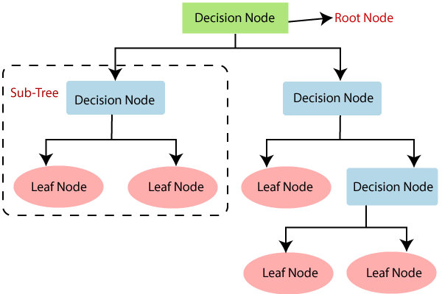Figure 1 Basic structure of a decision tree

In order to build a tree, CART, Classification and Regression Tree, algorithm is used. The decision tree algorithms used as a reference for building of the model are ID3, C4.5 and CART and these are the most prominent of the many algorithms. Each of these was built to be more efficient than the last and have an overall high efficiency rate and low execution time [2].

ID3

ID3 (Iterative Dichotomiser 3) was built as a decision tree algorithm by Ross Quinlan in 1986. It is carried out sequentially and is based on an interpretation by Hunt’s analysis [2]. ID3 can work only categorical dataset and cannot take continuous values [3]. In this algorithm, entropy function and information gain is used as metrics for the splitting the attributes.

Entropy: Entropy is the level of irregulairty of information that portrays the virtue of the information. It is the measure of uncertainty. If the entropy of a dataset is zero, it is considered to be homogeneous and dubious [4].
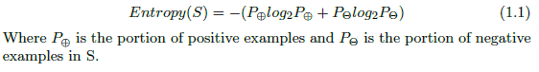
Information Gain: The expected reduction in entropy caused by portioning the dataset according to the splitting attribute. The attribute with the most elevated information gain is chosen as the most acceptable splitting standard trait. The information gain of an attribute A relative to a collection of dataset S is defined as:
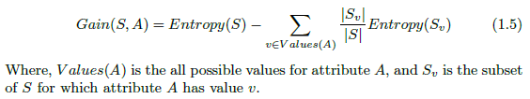

C4.5

C4.5 (Classification 4.5) was created in 1993 as improved version of ID3. In 4.5, pruning happens by displacing the inner hub through a leaf node, thus lessening the mistake ratio [5]. This algorithm deals with both discrete as well as continuous datasets. Also, it can handle incomplete datasets. It utilizes gain ratio based on the idea of information gain. Gain ratio can be defined as the ratio of information gain to the intrinsic information.
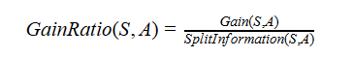

CART
CART (Classification and Regression Trees) is dependent of Hunt’s algorithm and can be applied successively. By applying numeric splitting, we can construct the tree based on CART [6]. This algorithm uses Gini Index as a metric. Gini Index measures the probability of a random instance being misclassified when chosen randomly. The lower the Gini Index, the better and the lower the likelihood of misclassification.


Working of Decision Trees
A tree can be “learned” by splitting the source set into subsets based on an attribute value test. This process is repeated on each derived subset in a recursive manner called recursive partitioning. The recursion is completed when the subset at a node all has the same value of the target variable, or when splitting no longer adds value to the predictions.
Step-1: Begin the tree with the root node, says S, which contains the complete dataset.
Step-2: Find the best attribute in the dataset using Attribute Selection Measure (ASM).
By this measurement, we can easily select the best attribute for the nodes of the tree. Information Gain and Gini Index are two popular techniques for ASM.
Step-3: Divide the S into subsets that contains possible values for the best attributes.
Step-4: Generate the decision tree node, which contains the best attribute.
Step-5: Recursively make new decision trees using the subsets of the dataset created in step -3. Continue this process until a stage is reached where you cannot further classify the nodes and called the final node as a leaf node.

Requirements

System Requirements:
User Interface: The user interface of our project is a limited scope design where the user works on a Command Line Interface (CLI) to input the data and perform the grade predictions. The constraints of this are that the user has to manually enter the data file and has to remember the command.
Software Interface: Implementation is in C++ programming language that will execute in any system for which will require SDE's compilers like MinGW or Cygwin and an IDE for executing the code.
Database Interface: Data used to train the model is txt file format.
Protocols: HTTP/HTTPS request and response objects to send requests and download data from the web.

Non-Functional Requirements
Performance Requirements: The performance of the model is very much efficient and reliable. Even if there is a sudden spike in the number of students, the performance of the model wouldn’t be affected at all.
Security Requirements: The dataset isn’t stored in any database management system. Hence, it is not secured. The model’s security can’t be commented upon as in order to use the model’s features the user will have to set up their own environment on their systems of choice. The project files are hosted on GitHub and are publicly accessible.
Software Quality Attributes:
Usability: The usability of our model is very high allowing the end users to use our model easily.
Reliability: The reliability of our model is quite high as it is able to predict grade on basis of different attributes provided.
Availability: It is easily available for every end user for the better analysis of the grades of their subjects.
Robustness: Our model is highly robust and effective as the code used for its development is really optimized.
Adaptability: The model developed is highly adaptive in nature. This means that the model can adapt to any changes if required in the future. For instance, if any new attribute is required for prediction, then we can easily train our model and it can take that into consideration next time we use the model.
Portability: Our whole project is developed completely using C++. The requirements of our model are present in a standard system running C++ which allows us to group together with the libraries and our personal settings into one unit. C++ makes it easier to write portable and universal programs that can run on a variety of operating systems like Windows, Mac, Linux etc. Using Make file for executing our code also makes it easy for executing code compiling commands easily.
Testability: Whenever any changes are made in our code, it is tested to check whether the changes done are compatible or not. Testability prevents any errors during the time when the user is using our model.

Assumptions and Dependencies
We make the following assumptions while developing the model:
1. The user has a system which satisfies the requirements for running the C++ code.
2. The user has enough knowledge to decide the best attributes for dataset.
3. The user has an IDE installed in the system.

DESIGN
The design modeling represents the application components and help to develop the model effectively.

Data Flow Diagram
A data flow diagram is a graphical representation of the information flow within a system using standardized set of symbols and notations. The objective is to show the scope and boundaries of a system as a whole. It shows how the data enters and leaves the system, what changes the information and where data is stored. It is considered as an important tool for software engineering.
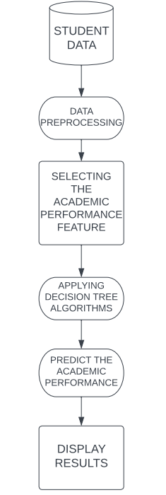

Use Case Diagram
Use case diagrams are the most common type of system/software requirements for newly produced software programs. Use cases describe the desired behavior (what), not the precise means of achieving it (how). Once defined, use cases can be used to indicate both textual and graphic representation (i.e., Use Case Diagram). Use case modelling ability to assist in system design from the standpoint of the end user is a fundamental idea. By describing all externally observable system behavior, it is a useful tool for explaining system behavior to users. Use case diagram does not only give details of the use cases:
• Only a few of the connections between use cases, actors, and systems are summarized.
• It does not display the progression of actions taken to fulfil each use case's objectives.
Purpose of Use Case Diagram:
• Takes the requirements of the system.
• It does drive implementation and make the test cases.
• It also confirms the architecture of the system.
• It also specifies the context of a system.
Use cases merely depict a system's functional requirements. It is necessary to individually describe other needs, such as business rules, requirements for the quality of services, and implementation limitations, using additional UML diagrams.
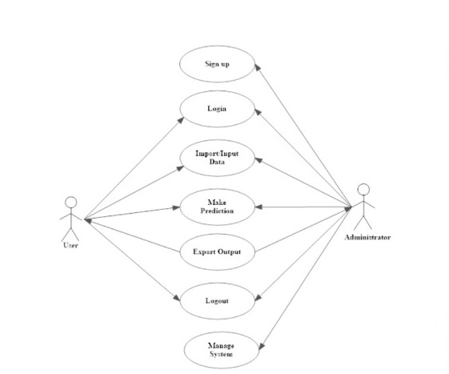

Activity Diagram
Activity diagram is another important behavioral diagram in UML diagram to describe dynamic aspects of the system. Activity diagram is essentially an advanced version of flow chart that modeling the flow from one activity to another activity. Activity Diagrams describe how activities are coordinated to provide a service which can be at different levels of abstraction. Typically, an event needs to be achieved by some operations, particularly where the operation is intended to achieve a number of different things that require coordination, or how the events in a single use case relate to one another, in particular, use cases where activities may overlap and require coordination. It is also suitable for modeling how a collection of use cases coordinates to represent business workflows.

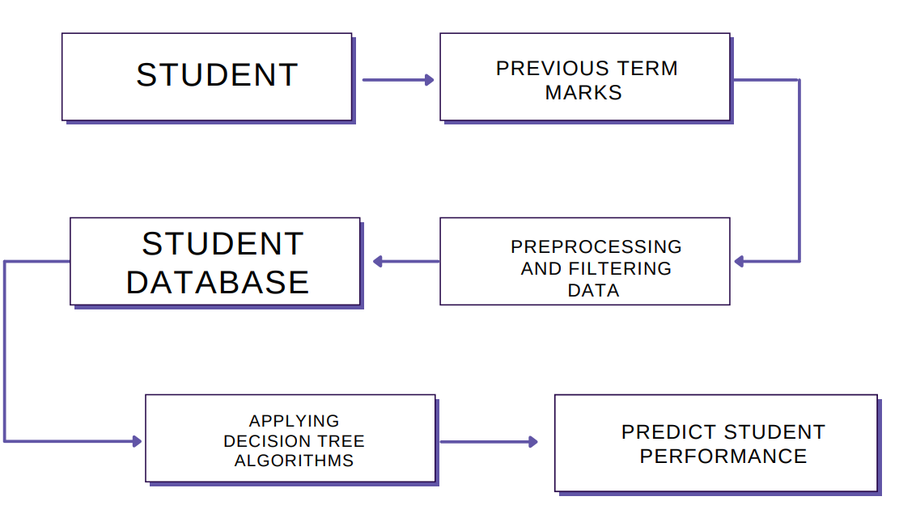

Sequence Diagram
A sequence diagram illustrates the interactions between a group of items and the order in which they take place, a sequence diagram is a sort of interaction diagram. Software engineers and business experts use these diagrams to comprehend the specifications for a new system or to describe an existing procedure. Event diagrams and event scenarios are other names for sequence diagrams.
Purpose of sequence diagram:
• To see how to interaction takes place between the components and objects.
• To understand the functionality of the current and future things and understand them.
• Model the logic of a complex process, function, or method.
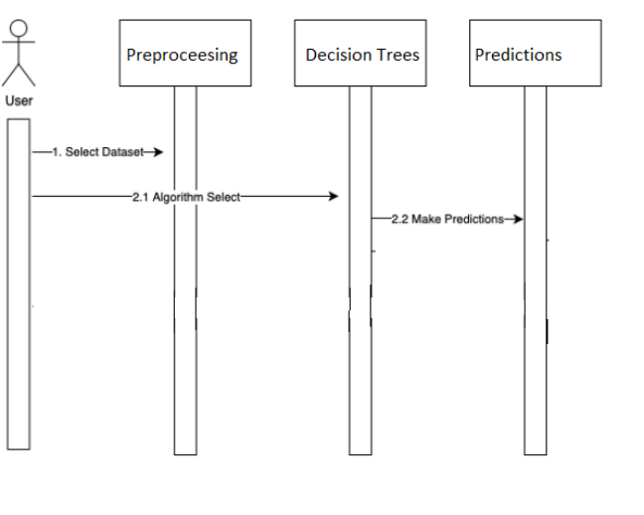

METHODOLOGY
Since there is no dedicated support offered to students who need special attention in the registered courses, many students in higher educational
institutions struggle to complete various courses. However, with the right machine learning techniques, it is possible to relate to previous records, train the computer to learn from it and make predictions for students' grades in various courses. Such techniques would enable an instructor to recognize those students who might require assistance in the courses and would assist students in improving their performance based on predicted grades.
The algorithm, as the name implies, assists in decision making, and its structure is similar to that of a tree. A Decision tree is a flowchart-like tree structure in which each internal node represents a test on an attribute, each branch represents a test outcome, and each leaf node or terminal node retains a class label. All internal nodes have two or more child nodes. All internal nodes contain splits, which test the value of an expression of the attributes. Arcs from an internal node to its children are labeled with distinct outcomes of the test. Each leaf node has a class label associated with it. Decision trees are extremely useful for data analytics and machine learning because they break down complex data into more manageable parts. They're often used in these fields for prediction analysis, data classification, and regression.

ID3 stands for Iterative Dichotomiser 3 and is so named because the algorithm divides feature into two or more groups iteratively at each stage. ID3 constructs a decision tree using a top-down greedy approach. In simple terms, the top-down approach means that we begin building the tree from the top, whereas the greedy approach means that we choose the best feature at the time to create a node at each iteration. ID3 is generally only used for classification problems with nominal features.

C4.5 algorithm is an improvement over ID3 algorithm. C4.5's splitting criterion is the normalized information gain or difference in the entropy. To make the decision, the attribute with the highest normalized information gain is chosen. The partitioned sub lists are then recursively traversed by the C4.5 algorithm.

The CART algorithm divides a node into sub-nodes using the Gini Index criterion. It starts with the training set as a root node, and after successfully splitting it in two, it splits the subsets using the same logic, and then splits the sub-subsets again, recursively, until it finds that further splitting will not give any pure sub-nodes or the maximum number of leaves in a growing tree, which is referred to as tree pruning.

First, we will input the student dataset and then the student information price will be processed. After the data is processed, we fit the data in the model which create a tree accordingly using Gini Impurity as its criteria.
To receive the grade prediction, the models traverse the tree using the yes or no inputs of the most correlated attributes, to reach the final decision.
To achieve this result, we are going to make the use of Visual Studio Code and we'll be using C++ as the primary language for writing the code. The operating system we are using is Windows.

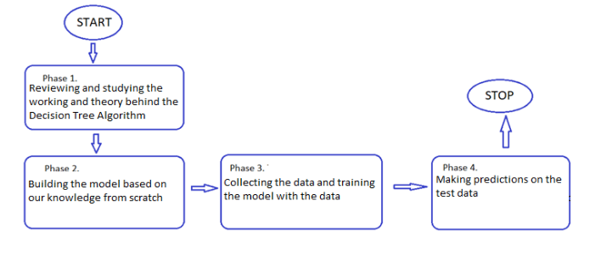

RESULTS
The model predicts the final grade of the student on the basis of various factors provided as an input.
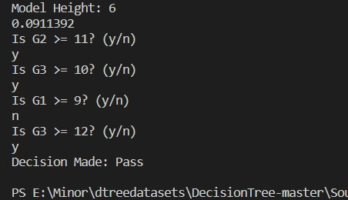

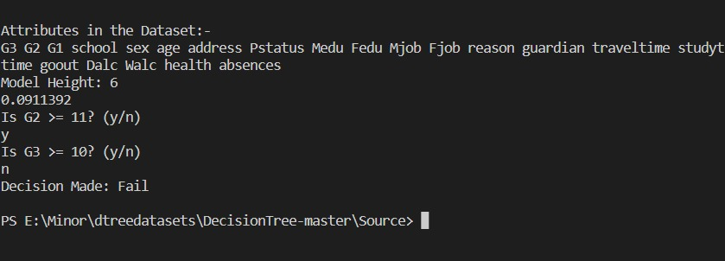

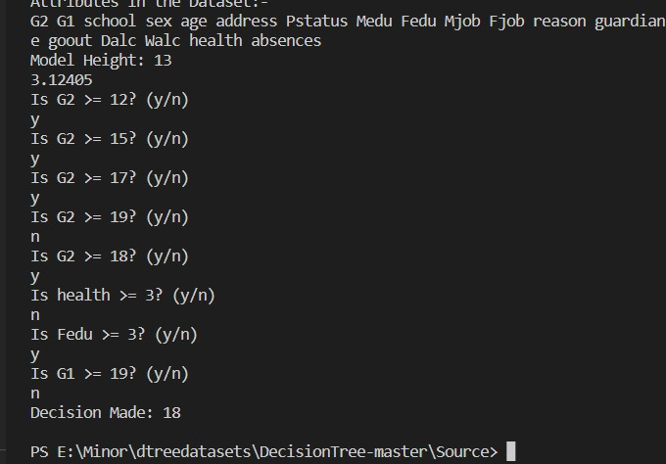

CONCLUSION AND FUTURE WORK
Predicting the grade of a student can give institutions an upper hand and overall improve the performance of a student. With the help of classification
algorithm like decision tree and educational data mining, high accuracy in this model can be achieved. Many institutions and teachers can use this model to take early decision for their students.

REFERENECES
- Micheline Apolinar -Gotardo, “Using Decision Tree Algorithm to Predict Student Performance” (2019). 10.17485/ijst/2019/v12i5/140987
- Shamrat, F.M. & Ranjan, Rumesh & Hasib, Khan & Yadav, Amit & Siddique, Abdul. (2022). Performance Evaluation Among ID3, C4.5, and CART Decision Tree Algorithm. 10.1007/978-981-16-5640-8_11.
- Patel, Harsh & Prajapati, Purvi. (2018). Study and Analysis of Decision Tree Based Classification Algorithms. International Journal of Computer Sciences and Engineering. 6. 74-78. 10.26438/ijcse/v6i10.7478.
- F. M. Javed Mehedi Shamrat, Imran Mahmud, A.K.M Sazzadur Rahman, Anup Majumder, Zarrin Tasnim, Naimul Islam Nobel,“A Smart Automated System Model For Vehicles Detection To Maintain Traffic By Image Processing” International Journal of Scientific & Technology Research, Volume 9, Issue 02, February 2020, ISSN: 2277-8616, pp: 2921-2928.
- Bittencourt, Helio Radke and R. T. Clarke. "Feature Selectıon By Usıng Classıfıcatıon And Regressıon Trees (CART)." (2004).

