# **Finding the Safest Route**

# M. Bruggeling

# September 28, 2020

# Introduction

## Background

Seventy-seven percent of smartphone owners use navigation apps like Google Maps or Waze regularly to reach their destination. Navigation apps are so popular because they make navigating more convenient and help save time and resources by actively guiding the user along the quickest route. However, despite their benefits, navigation apps may also have negative impacts.

## Problem

Experts have indicated that users can end up not only following the quickest route but potentially also a more dangerous route when blindly relying on their navigation apps. Consequently, accidents and serious injury may occur.

## Interest

To provide a solution for this issue and attract new users, an undisclosed navigation app is interested in offering the safest route option. When this option is selected, a prediction is made about where injury causing accident are more likely to occur given the junction type, road, weather, and light conditions. Subsequently, these areas can be circumvented.

# Data

## Data source

The used data source is the “Example Dataset” which can be downloaded in Week 1.

## Feature selection

The selected features are factors that could have influenced an injury causing accident and can be determined before choosing a certain route. Driver-related factors such as speeding or being under the influence of alcohol or drugs are not taken into account, because it is assumed that users who are interested in following a safe route do not exhibit such behavior. The remaining factors (i.e. independent variables) are:

* 'JUNCTIONTYPE': shows the type of junction where a collision happened (e.g. ‘at intersection’).
* 'ROADCOND': indicates the condition of the road at the time of collision (e.g. wet).
* 'LIGHTCOND': represents the light conditions when a collision occurred (e.g. ‘dark - street lights on’).
* 'WEATHER': describes the weather conditions at the time of collision (e.g. overcast).

Furthermore, the dependent variable is:

* 'SEVERITYCODE': indicates whether an accident is injury causing (category 2) or an accident with property damage only (without injury) (category 1).

## Pre-processing Three pre-processing steps were taken:

## Remove rows with missing values

## Change dependent variable categories 1 and 2 to values 0 and 1

## Convert categories in independent variables to separate indicator variables (i.e. dummy variables)

# Methodology

## Exploratory data analysis

To gain an overview of the data and their main characteristics, the different values (0 and 1) for each variable were counted (Table 1) and a correlation matrix was created (see notebook).

Table 1: Value counts per variable

|  |  |  |
| --- | --- | --- |
| **Variable** | **0** | **1** |
| SEVERITYCODE | 126527 | 56669 |
| JUNCTIONTYPE\_At Intersection (but not related to intersection) | 181139 | 2057 |
| JUNCTIONTYPE\_At Intersection (intersection related) | 121955 | 61241 |
| JUNCTIONTYPE\_Driveway Junction | 172676 | 10520 |
| JUNCTIONTYPE\_Mid-Block (but intersection related) | 160843 | 22353 |
| JUNCTIONTYPE\_Mid-Block (not related to intersection) | 96340 | 86856 |
| JUNCTIONTYPE\_Ramp Junction | 183034 | 162 |
| JUNCTIONTYPE\_Unknown | 183189 | 7 |
| ROADCOND\_Dry | 60930 | 122266 |
| ROADCOND\_Ice | 182017 | 1179 |
| ROADCOND\_Oil | 183136 | 60 |
| ROADCOND\_Other | 183073 | 123 |
| ROADCOND\_Sand/Mud/Dirt | 183129 | 67 |
| ROADCOND\_Snow/Slush | 182216 | 980 |
| ROADCOND\_Standing Water | 183087 | 109 |
| ROADCOND\_Unknown | 171542 | 11654 |
| ROADCOND\_Wet | 136438 | 46758 |
| LIGHTCOND\_Dark - No Street Lights | 181733 | 1463 |
| LIGHTCOND\_Dark - Street Lights Off | 182038 | 1158 |
| LIGHTCOND\_Dark - Street Lights On | 135603 | 47593 |
| LIGHTCOND\_Dark - Unknown Lighting | 183185 | 11 |
| LIGHTCOND\_Dawn | 180742 | 2454 |
| LIGHTCOND\_Daylight | 69224 | 113972 |
| LIGHTCOND\_Dusk | 177415 | 5781 |
| LIGHTCOND\_Other | 182985 | 211 |
| LIGHTCOND\_Unknown | 172643 | 10553 |
| WEATHER\_Blowing Sand/Dirt | 183147 | 49 |
| WEATHER\_Clear | 74033 | 109163 |
| WEATHER\_Fog/Smog/Smoke | 182638 | 558 |
| WEATHER\_Other | 182447 | 749 |
| WEATHER\_Overcast | 155988 | 27208 |
| WEATHER\_Partly Cloudy | 183191 | 5 |
| WEATHER\_Raining | 150518 | 32678 |
| WEATHER\_Severe Crosswind | 183171 | 25 |
| WEATHER\_Sleet/Hail/Freezing Rain | 183084 | 112 |
| WEATHER\_Snowing | 182314 | 882 |
| WEATHER\_Unknown | 171429 | 11767 |

## Machine learning algorithms

Because the aim is to classify locations as potentially injury causing or not (property damage only) a classification algorithm is used. Multiple classification algorithms were applied: K-Nearest Neighbors (KNN), Support Vector Machine (SVM), Logistic Regression, (LR) and Decision Tree (DT).

## Evaluation

First, the dataset was split in a train (80%) and test set (20%). Next, each algorithm was trained, tested, and evaluated using the Jaccard, LogLoss, and F1-scores.

## Application

The best performing model was applied to predict and map injury causing accident locations using the test data.

# Results

The best performing model is the K-Nearest Neighbors model using a number of neighbors of 2 (Figure 1). The evaluated accuracies of the model are 66.85% (Jaccard) and 58.77% (F1-score). Furthermore, other models perform quite similar (Table 2). Finally, a map was created that shows the predicted injury causing accident locations (Figure 3).

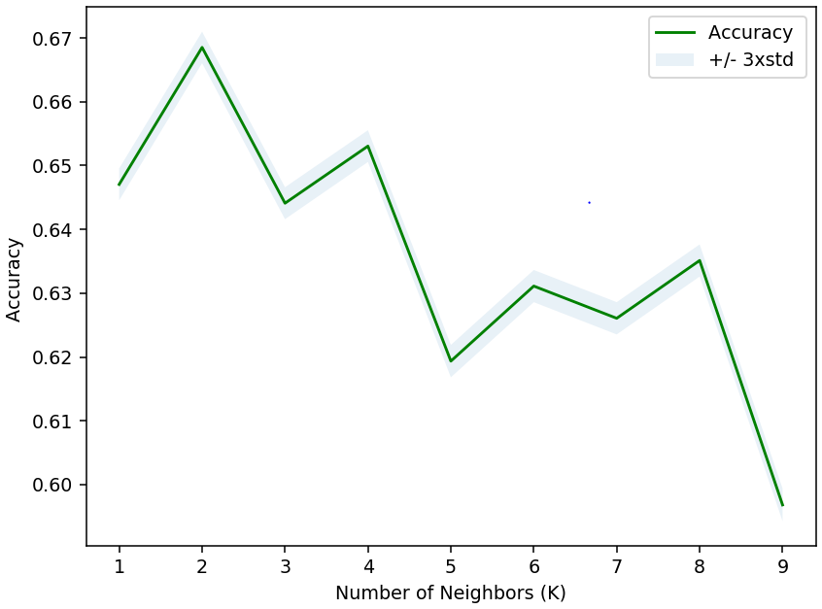

Figure 1: Accuracy of K Nearest-Neighbor model for different numbers of neighbors

Table 2: Model performance evaluation

|  |  |  |  |
| --- | --- | --- | --- |
| **Algorithm** | **Jaccard** | **F1-score** | **LogLoss** |
| KNN | 0.66853 | 0.58771 | NA |
| DT | 0.68835 | 0.56128 | NA |
| SVM | 0.68835 | 0.56133 | NA |
| LR | 0.68835 | 0.56128 | 0.58822 |

# C:\Users\mbru\PycharmProjects\GitProjects\Coursera_Capstone\Map_seattle.PNG

Figure 2: Predicted injury causing accident locations in a part of Seattle

# Conclusion

Using a KNN model, a navigation app can determine where injury causing accidents may occur with a success rate of 58.77-66.85%. These locations can be predicted in advance of a user’s drive by collecting and preparing infrastructural information (road conditions and and junction types) and combining it with the expected light and weather conditions (forecast) along potential routes. It follows that, by offering a route that circumvents these location, the safest route option can be found.