Coursework1: Knowledge Representation and Planning
(Artificial Intelligence and Intelligent Agents F29AI)

By Mark Schmieg
(H00238262)

BSc Computer Science at Heriot Watt University in Edinburgh
Specifications
The goal of this coursework is to create a submarine system, that would successfully carry out its given missions. Such a mission could involve taking pictures of underwater targets, and making reports of recovered artefacts, and send all those back to the Sea Port.

Solution
The submarine would always start at the surface and at the sea port. To move, my submarine needs to dive, the navigator needs to receive movement orders from the captain and both are required to be on the bridge, so that it can perform that action.
When reaching a location containing an artefact or a target, the submarine will first check if there are any Giant Squids swimming around in the same location, before launching the AUV needed for the action. In a case where an AUV happens to be in the same location as a Giant Squid, the Squid will destroy the AUV.
For an artefact a manipulation AUV is launched from the submarine by an engineer in the launch bay, it will pick up the artefact with a hand. Once the artefact is picked up, the AUV is then retracted back into the submarine. The artefact is then unloaded from the AUV and brought into a lab by a scientist and a report is made, which is then sent to the submarine’s database.
For targets an inspection AUV is launched by an engineer, it will then take a picture of the target before being retracted into the submarine. When the inspection AUV is back in the launch bay, its picture is uploaded to the submarine’s database.
When the submarine is in the same location as a Giant Squid, the Giant Squid will attack and immobilize the submarine, the submarine will detect the attack and engage its defence system, by electrocuting the squid. An engineer and a mechanic need to then go to engineering to fix the submarine and reloading the charge.
The submarine database only ever holds one picture or a report, so every time after picking up an artefact or taking a picture of a target, the submarine will resurface to send the data from its database to the sea port database, and then it will dive again to get the rest of the assignments done. When all assignments are done the mission is complete.

Design Choices
While making the coursework, I have encountered some where my actions used the wrong people or objects as variables (e.g. The sub launching the captain instead of an AUV). To fix this issue I have introduced 8 different types (e.g. Personnel, Room, ...), which characterise different parts within the submarine or in its aquatic environment.
For most of the actions, I have fixed some variables (e.g. (InRoom Bridge Captain), which forces the captain to be on the bridge), so that the planner does not choose the wrong variable, when performing the action.

In some cases, I was able to generalize the action, for example moving personnel into a specific room, but I couldn’t make a general action, that would transfer both the pictures and the artefacts reports to the submarine database, because transferring the pictures requires the inspection AUV to be in the launch bay.
Furthermore, when implementing the movement of the personnel within the sub, I would have them all start in the bedroom, except for the captain who starts in his room. All rooms are connected to the corridor. To move from one room to another they would always need to go through the corridor.

Interesting Features
I added an action in which the squid destroys an AUV, which is in the same location. This action never gets triggered in a normal scenario, because before every AUV launch I check whether a squid is in that location or not. If there is a squid in the location, where I want to launch an AUV, the submarine will fight the squid first before any AUVs get deployed.
Additionally, to recharge the defence mechanism of the submarine, I have required an engineer and a mechanic to go to the engineering room, to recharge the electric charge and to fix the submarine so that it can move again.

Solution Examples
The following solution is for the problem1, where the goal state is to have transferred the Artefact 1 and 2 reports and the picture of target 1 to the Sea Port Database.
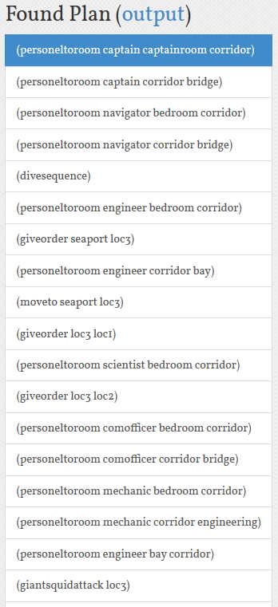

The left side is the first.
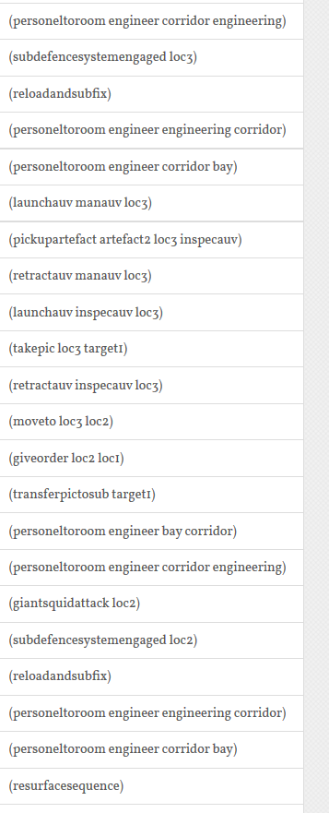

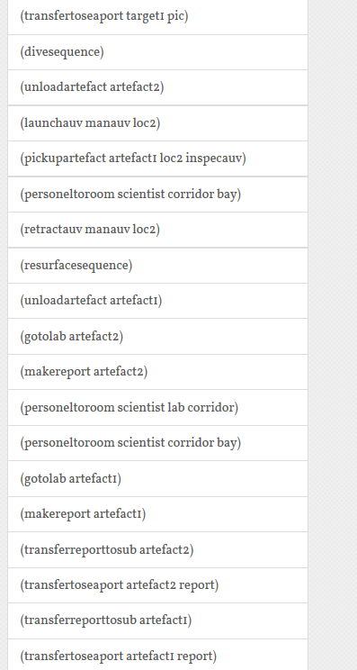

The following solution is for the problem2, where the goal is for the Giant Squid to destroy the inspection AUV.
