Progetto ISPW: gestione ristorante/bar
Davide Brugnoli

[Scuola]
[Titolo del corso]

Contents
INTRODUCTION 1
AIM OF DOCUMENT 1
OVERVIEW 1
HARDWARE AND SOFTWARE REQUIREMENTS 1
USER STORY: 2
FUNTIONAL REQUIREMENTS: 2
USE CASES 3
OVERVIEW DIAGRAM: 3
INTERNAL STEP: 3
STORYBOARD: 5

INTRODUCTION

AIM OF DOCUMENT
the scope of this document is to show objectively the fundamental requirements and specific
ones of the system ___________. So, we will be doing a review of all the important internal and external aspects of the system with the help of some illustration

OVERVIEW
this product provides the instruments to manage a small activity, that work in the restaurant world.
It offer some tool to synchronize in real time the order between the "the hall", the kitchen and the cash desk, but also the management, in fact the system also keep track of cash flow and

HARDWARE AND SOFTWARE REQUIREMENTS

USER STORY:
- As a restaurant manager, I want to keep track of all customer orders, so that I can improve service and accuracy.
- As a waiter, I want to be able to send orders to the kitchen quickly, so that customers receive their food faster.
- As a cashier, I want to see everything a table has ordered, so that I can prepare the bill efficiently.
- As a cashier, I want to see the total bill, so that I can charge the customer correctly.
- As a waiter, I want to be able to custom an order, so that the customer can have a customized item.
- As a waiter, I want to be able to delete, so that I can easily handle situations when the customer changes their mind.

FUNTIONAL REQUIREMENTS:
- The system must keep track of all orders that are placed (and their status).
- The system must offer the possibility of communication between different users.
- The system must offer the possibility to see the orders placed from a particular table.
- The system must offer the possibility to calculate and display the total bill.
- The system must offer the possibility add some customization at the order and add some notes.
- The system must offer the possibility to delete some order.

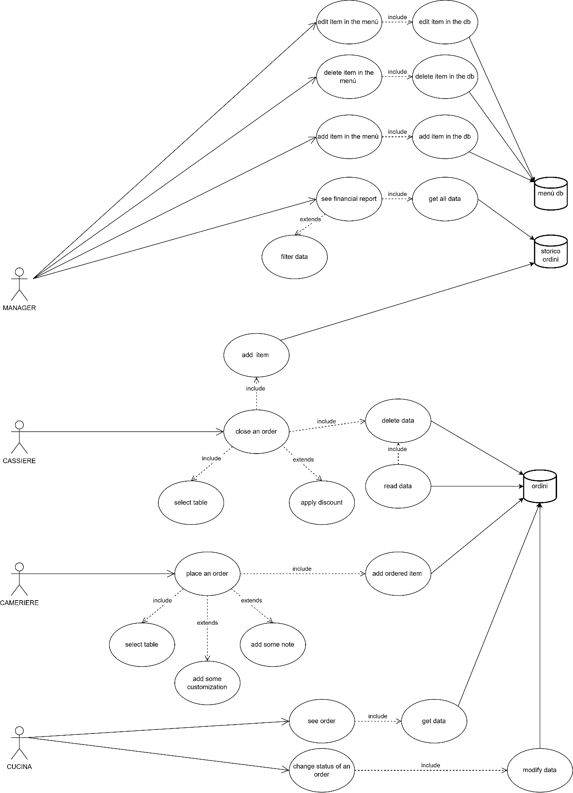
USE CASES

OVERVIEW DIAGRAM:

INTERNAL STEP:
- Name: “insert item in the menu”
- The manager requires insertion of an item in the menu
- The system gives at the manager a form to compile
- The system inserts the item in the menu

- Name: “create an order”:
- The waiter wants to place an order
- The system offers him a form to compile, where him insert the table and what item the guest wants
- The system records the order and sends it at another device: kitchen and cashier
- The kitchen now knows what it has to cook, so it prepares that
- The system now offers the possibility to change the status of order at the kitchen
- The kitchen when start to prepare the order change the status of order
- The cashier now knows what the guest has to pay, so the guest can pay
Extension:
1a: the waiter can add some customization (that are just defined)
1b: the waiter can add some note at the order
7a: the cashier can apply some discount at the order

- Name: “deletion of an item in the menu”
- The manager open ad specific item in the menu
- The system gives at the manager a dashboard
- The manager selects the option: “delete”
- The system deletes the item in the menu

- Name: “edit of an item in the menu”
      - The manager open ad specific item in the menu
      - The system gives at the manager a dashboard
      - The manager selects the option: “edit”
      - The system gives a form to compile at the manager
      - The manager inserts the new value of the item, and send it
      - The system now updates the new value at the item

5. Name: “view a financial report ”
      - The manager requires to view the financial data
      - The system give at the manager a specific view of the historical order and some synthetic data
Extension:
2a: the manager can filter the data whit some parameters

STORYBOARD:

