ISPW PROJECT 2025 / 2026
RESTAURANT MANAGER
Project Documentation

Davide Brugnoli
ISPW — 2025/2026

INDEX
Contents
1. SOFTWARE REQUIREMENT SPECIFICATION 2
1.1 INTRODUCTION 2
1.1.1 AIM OF THE DOCUMENT 2
1.1.2 OVERVIEW OF THE SYSTEM 2
1.1.3 HW & SW REQUIREMENTS 3
1.1.4 RELATED SYSTEMS, PROS AND CONS 4
1.2 USER STORIES 5
1.3 FUNCTIONAL REQUIREMENTS 6
1.4 USE CASES 7
1.4.1 OVERVIEW DIAGRAM 7
1.4.2 INTERNAL STEPS 7
2. STORYBOARDS 9
3. DESIGN 10
3.1 CLASS DIAGRAM 10
3.1.1 Design Patterns Implementation 11
3.2 ACTIVITY DIAGRAM 13
3.3 SEQUENCE DIAGRAM 13
3.4 STATE DIAGRAM 13
4. TESTING 14
5. EXCEPTIONS 15
6. PERSISTENCY 16
7. CODE 17
8. VIDEO 17
9. SONAR CLOUD 17

1. SOFTWARE REQUIREMENT SPECIFICATION

1.1 INTRODUCTION

1.1.1 AIM OF THE DOCUMENT
The purpose of this document is to provide a comprehensive and formal description of the software requirements, architectural design, and implementation choices adopted in the development of Restaurant Manager, an application for the management of restaurant operations developed as part of the Software Engineering and Web Design course (A.Y. 2025/2026).
The document covers the functional specification, use case analysis, design patterns adopted, testing strategy, exception-handling model and persistence architecture of the system, serving as the primary technical reference for evaluation and future maintenance.

1.1.2 OVERVIEW OF THE SYSTEM
Restaurant Manager is a multi-role desktop application designed to coordinate and synchronize the operational workflow of a restaurant environment, supporting four distinct user roles: Manager, Waiter, Kitchen Staff and Cashier. Each role accesses a dedicated, role-specific dashboard once authenticated.
The system provides two complementary entry points:
- Graphical User Interface (GUI): implemented in JavaFX, accessible to all roles, with an additional E-Ink optimized presentation mode (einkscreen) suitable for low-power devices used in kitchen environments.
- Command-Line Interface (CLI): reserved exclusively to the Manager role, allowing menu management and financial reporting operations to be performed without launching the graphical environment.
From a technical standpoint, the application is engineered in Java 21 following a layered architectural model that enforces a strict separation of concerns across the Presentation, Business, Data Access and Domain layers, supported by an application bootstrap layer. The project is built and managed through Apache Maven, and the persistence layer is decoupled from the business logic through the Data Access Object (DAO) abstraction.
The system supports the following core functionalities:
- User Management: role-based authentication (Manager, Waiter, Kitchen Staff, Cashier) with secure password storage and password-change support.
- Order Management: creation, customization, real-time state tracking and cancellation of orders, with automatic dispatch to the appropriate workstation (kitchen / cash desk).
- Menu Management: addition, modification and deletion of menu items, with category-based organization and cost tracking.
- Financial Reporting: historical order consultation with filtering by status and time range, including aggregated revenue data.
- Persistence Flexibility: switchable persistence layer supporting both a relational database (PostgreSQL) and a file system-based implementation, selectable transparently through the DAO abstraction.

1.1.3 SW & HW REQUIREMENTS
To ensure the proper functioning of Restaurant Manager for both development and end-user execution, the following environments are defined.
Software Requirements
Component | Specification
Operating System | Cross-platform (Windows 10/11, macOS 12+, Linux Ubuntu 20.04+)
Runtime Environment | Java Development Kit (JDK) 21 LTS or higher
User Interface | JavaFX SDK 21
Build Automation | Apache Maven 3.8+
Primary Database | PostgreSQL 15+
Containerization | Docker (for the local PostgreSQL instance)
IDE (optional) | IntelliJ IDEA or Eclipse IDE
Version Control | Git

Hardware Requirements
Component | Minimum | Recommended
Processor | Dual-core 1.8 GHz | Quad-core 2.5 GHz or higher
RAM | 4 GB | 8 GB
Storage | 300 MB free disk space | 1 GB (including Docker image)
Display | 1280×720 | 1920×1080
Network | Required for DB connectivity | Stable LAN connection

Note: local storage requirements are minimal, since persistent data resides entirely in the database. The file system-based DAO implementation (OrderDAOFile) generates CSV files of negligible size.

1.1.4 RELATED SYSTEMS, PROS AND CONS
Lightspeed Restaurant
Lightspeed Restaurant is a commercial, cloud-based restaurant management platform covering order management, table coordination, staff role assignment, inventory tracking and billing operations.
Pros:
- Comprehensive feature set covering inventory management, analytics and cloud-based multi-device access.
- Suitable for medium and large restaurant operations with complex workflows.
- Continuous updates and professional vendor support.
Cons:
- Closed and proprietary architecture: no customization of internal workflows.
- Strong dependency on a stable internet connection; unsuitable for offline scenarios.
- Excessive complexity and cost for small operations; non-trivial learning curve.
Square for Restaurants
Square for Restaurants is a point-of-sale system oriented toward order management, basic staff coordination and billing.
Pros:
- Simple, modern interface with fast onboarding.
- Native integration with payment processing systems.
- Free tier available for basic usage.
Cons:
- Primarily focused on billing; limited support for role-based internal workflow customization.
- Advanced features (detailed reporting, multi-location management) require paid subscription plans.
- No native support for kitchen-side order state tracking.
Positioning of Restaurant Manager
Compared to the systems above, Restaurant Manager prioritizes a clear architectural separation of roles (Manager, Waiter, Kitchen Staff, Cashier) and a modular, layered internal structure, favouring maintainability, extensibility and testability over commercial completeness. The system is specifically designed to operate in a local network environment without mandatory dependency on external cloud services, and its dual persistence strategy (PostgreSQL and file system) further enhances deployment flexibility.

1.2 USER STORIES
The following user stories define the functional scope of the system from the perspective of each identified actor. They are grouped by role to ensure traceability with the Use Case Overview Diagram.
Manager
- US-1: As a restaurant manager, I want to view all historical orders with their associated financial data, filtered by time range and status, so that I can monitor operational performance and revenue trends.
- US-2: As a restaurant manager, I want to add, edit and delete items in the menu, so that I can keep the product catalogue accurate and up to date.
- US-3: As a restaurant manager, I want to manage the staff accounts registered in the system, so that I can control access permissions and maintain an accurate list of active personnel.
Waiter
- US-4: As a waiter, I want to compose and send an order for a specific table by selecting items from the menu, so that the kitchen and the cash desk are immediately notified of what the customer has requested.
- US-5: As a waiter, I want to add a free-text note to the entire order, so that the kitchen receives accurate preparation instructions reflecting the customer's preferences.
- US-6: As a waiter, I want to remove an order item from the cart before confirming the order, so that I can correct mistakes or accommodate last-minute changes from the customer.
Kitchen Staff
- US-7: As a kitchen staff member, I want to view all incoming orders filtered by the product categories assigned to my station, so that I can focus exclusively on the preparations relevant to my role without being distracted by unrelated orders.
- US-8: As a kitchen staff member, I want to mark an order as ready, so that the waiter is automatically notified and can proceed with delivery to the correct table.
Cashier
- US-9: As a cashier, I want to view the complete list of order items associated with a specific table, including their individual prices at the time of ordering, so that I can verify the bill before presenting it to the customer.
- US-10: As a cashier, I want to calculate the total bill for a table, apply an optional discount and close the order, so that the payment process is completed accurately and the order is removed from the active views of all other roles.

1.3 FUNCTIONAL REQUIREMENTS
- FR-1: The system shall persist all placed orders and their associated status throughout their lifecycle.
- FR-2: The system shall notify all subscribed client components of order creation and status updates.
- FR-3: The system shall allow authorized users to retrieve active and historical orders associated with a specific table, with optional filtering by status and time range.
- FR-4: The system shall compute and display the total bill for a table based on the prices of the associated order items at the time of ordering.
- FR-5: The system shall allow authorized users to add free-text notes to individual order items.
- FR-6: The system shall allow authorized users to delete an order or order item before billing confirmation.
- FR-7: The system shall enforce role-based access control, ensuring that each authenticated user can only access the functionalities authorized for the corresponding role.

1.4 USE CASES

1.4.1 OVERVIEW DIAGRAM

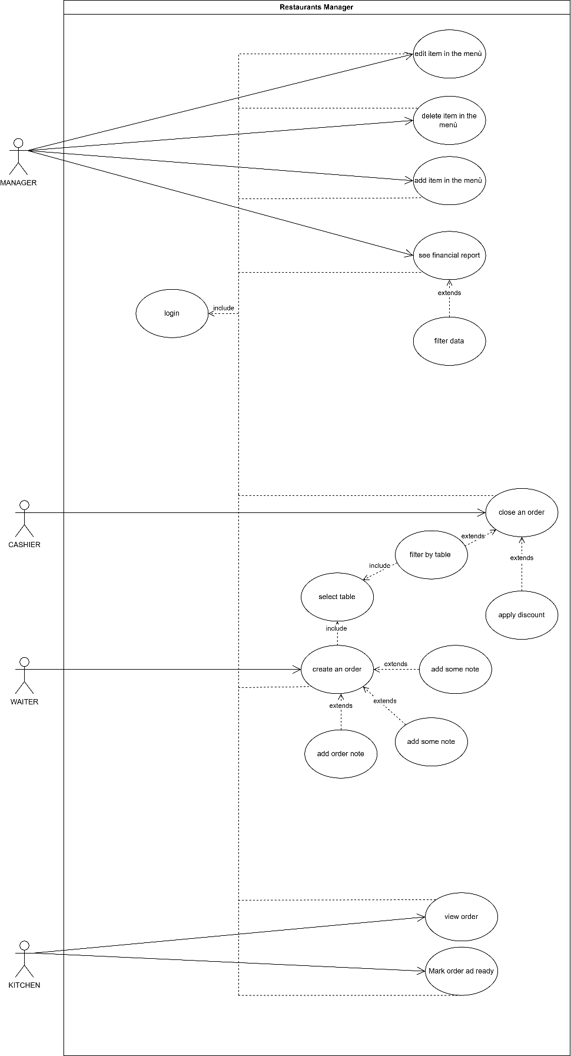

1.4.2 INTERNAL STEPS
UC-1: Create Order
Main Flow:
- The waiter logs into the system and selects the target table from the fillable field.
- The system displays the menu organized by product category.
- The waiter selects one or more menu items,
- The waiter confirms the order.
- The system persists the order, dispatches it to the kitchen workstation filtered by category, and notifies the cash desk.
Extensions:
- 3a. The waiter removes a previously added item from the cart: the system updates the order draft accordingly.
- 4a. The waiter optionally attaches a free-text note to the order.
- 4b. Persistence failure: the system displays an error message and preserves the draft so the waiter can retry.
UC-2: Insert Item in the Menu
Main Flow:
- The manager logs into the system and opens the menu management view.
- The system presents an empty form requesting name, category, price and description.
- The manager fills in the form and confirms.
- The system validates the data and persists the new menu item.
Extensions:
- 3a. The form contains invalid data (e.g. empty name, non-positive price): the system highlights the offending fields and refuses submission.
UC-3: Edit / Delete Menu Item
Main Flow:
- The manager logs into the system, opens the menu management view and selects an existing item from the menu list.
- The system displays the item details and offers the actions Edit and Delete.
- If Edit is selected, the system loads a pre-filled form; the manager modifies the values and confirms; the system persists the update.
- If Delete is selected, the system asks for confirmation and, upon acceptance, removes the item from the menu.
UC-4: Update Order Status (Kitchen)
Main Flow:
- The kitchen staff member logs into the system, opens the kitchen dashboard, restricted to the categories selected in the kitchen preferences.
- The system displays the queue of active orders for those categories.
- The kitchen staff member selects an order and marks it as ready.
- The system updates the order status and notifies the waiter dashboard.
UC-5: View Financial Report
Main Flow:
- The manager , logs into the system and opens the financial view.
- The system retrieves the historical orders together with aggregated synthetic data (total revenue, number of orders).
- The manager optionally applies filters (time range, status).
- The system updates the displayed data accordingly.
UC-6: Close Order at Cash Desk
Main Flow:
- The cashier logs into the system and selects a table from the active tables view.
- The system displays the complete list of order items with their prices at the time of ordering and the computed total.
- The cashier optionally applies a discount.
- The cashier confirms the closure of the order.
- The system marks the order as closed and removes it from the active dashboards of the other roles.

2. STORYBOARDS
The visual representation of the user interaction flows has been designed for each of the four roles supported by the system. After a unified login screen, the user is redirected to a role-specific dashboard.
- Login screen — common to every role; on successful authentication the system reads the role from the user record and routes to the appropriate dashboard.
- Waiter dashboard — table selection, order composition, customization and free-text note attachment, order confirmation.
- Manager dashboard — staff management, menu management (with add / edit / delete actions), financial reporting view, database configuration screen.
- Kitchen dashboard — incoming orders filtered by the categories selected in the kitchen preferences; status update controls.
- Cash desk dashboard — table selection, order summary with itemized prices, optional discount application and order closure.
- Common controls — change-password and logout actions, available in every dashboard through a dedicated control in the navigation area.
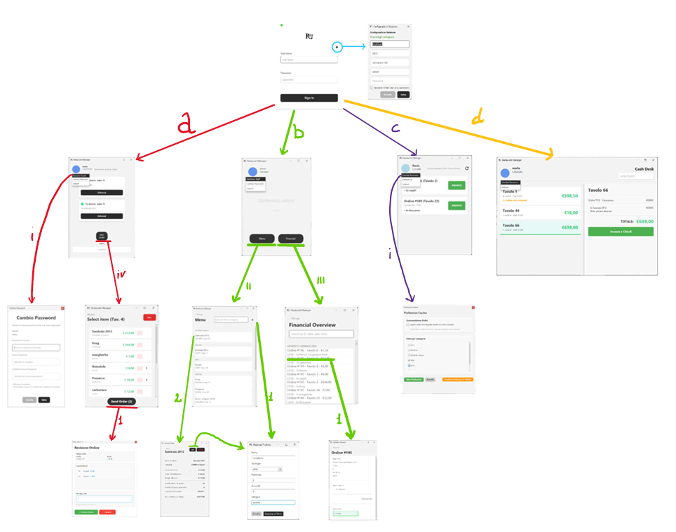
After a simple login screen, depending on type of user the user will show a different dashboard:
  - Waiter dashboard
    - Is possible to change password (this option is available for every user in the left circle handle, so I won’t come repeated) whit a dedicated window
    - Is possible to do a logout whit specific handle (this option is available for every user il the left circle handle, so I won’t come repeated)
    - Is possible to chose what table manage, so only the order (to deliver) related to a selected table will be showed
    - Is possible to go in a view that allows you to choose the products that will make up the order
      - Is showed a confirm page, where is possible to write a note
  - Manager dashboard
    - Is possible to open a dashboard to manage the worker in the activity (insert new user, delete users, see what users exist and what role they have)
    - Is possible to go in a screen dedicated to the menu, that show what product there are in that
      - Add new product (pressing: “+”)
      - See detail (“clicking” on a row)
    - Il possible to go in a screen dedicated to see the order history: “financial”
      - See detail (“clicking” on a row)
  - Kitchen dashboard
    - Is possible to navigate to a preference screen that allows the user to choose what category of order show (if there are more user “kitchen” they can divide work by category, and each one can see their own)
  - cash desk: can see detail and close order
  - there in furthermore a screen dedicated to configure DB

3. DESIGN

3.1 CLASS DIAGRAM
The architectural design of Restaurant Manager adheres to standard software engineering principles to ensure scalability, maintainability and a clear separation of concerns. The codebase is organized into well-defined Java packages, each one corresponding to a specific architectural layer.
Package | Responsibility
com.example.rm.app | Application bootstrap, scene management, user session, factories.
com.example.rm.bean | Data Transfer Objects exchanged between view and controller layers.
com.example.rm.controller | Application services and use case interfaces (business orchestration).
com.example.rm.dao | Data Access Object interfaces and concrete implementations (PostgreSQL, file system).
com.example.rm.exception | Custom exception hierarchy.
com.example.rm.model | Domain entities (User, Order, OrderItem, MenuProduct and role-specific user subclasses).
com.example.rm.preference | User preferences (kitchen filters, graphics mode).
com.example.rm.service | Cross-cutting services (security, connection management, logging).
com.example.rm.view | JavaFX controllers and view models, including the einkscreen variants.

[ Diagram placeholder ]
Figure 8 — VOPC (View of Participating Classes) — to be inserted

[ Diagram placeholder ]
Figure 9 — Design-Level Class Diagram — to be inserted

3.1.1 Design Patterns Implementation
Singleton Pattern.
The Singleton pattern is used to guarantee a single shared instance of components that maintain a global application state and that must remain consistent across the entire user navigation. The UserSession class implements this pattern to represent the currently authenticated user and the related runtime information; in the same way, AppStatus centralizes the global database-connection flag (declared volatile in order to guarantee inter-thread visibility without explicit synchronization).
Factory Method Pattern.
The Factory Method pattern is applied to encapsulate object creation logic and to decouple client code from concrete implementations. The UsersFactory class centralizes the creation of User subclasses (ManagerUser, WaiterUser, KitchenUser) based on the role retrieved from the persistence layer. The same pattern is applied to view-side components: KitchenOrderCardFactory and WaiterNotificationCardFactory expose dedicated implementations for the classic GUI and the E-Ink presentation, allowing the user-interface family to be selected transparently at runtime.
DAO (Data Access Object) Pattern.
The DAO pattern is widely adopted to separate persistence logic from business logic. Interfaces such as OrderDAO, ProductDAO, CategoryDAO and KitchenPreferencesDAO define a stable abstraction for data access, while concrete implementations (OrderDAOPostgres, OrderDAOFile, DatabaseProductDAO, DatabaseCategoryDAO, DatabaseKitchenPreferencesDAO, DatabaseUserDAO) handle the actual persistence mechanism. This design lets the system switch between different storage strategies — relational database or local file system — without affecting higher-level components.
Dependency Injection by Constructor.
Closely related to the DAO pattern, the system applies Dependency Injection by Constructor in service and controller classes such as MenuService, OrderService and KitchenPreferencesController. By receiving DAO interfaces rather than concrete implementations, these classes remain loosely coupled to the persistence layer and can be exercised in isolation by injecting mock or alternative implementations during testing.
Use Case Interfaces (Application Boundary).
The introduction of dedicated Use Case Interfaces (e.g. OrderUseCase, MenuUseCase, KitchenUseCase, FinancialUseCase, ManagerUseCase, UserAccountUseCase) establishes a well-defined boundary between the application logic and the presentation layer. Controllers and services implement these interfaces to expose a stable contract, improving readability, enforcing responsibility separation and simplifying future refactoring.
Layered Architecture.
Overall, the combination of these patterns supports a clean layered architecture composed of the Presentation layer (JavaFX view controllers and FXML resources, including the einkscreen variants), the Business layer (controllers and services exposing use case interfaces), the Data Access layer (DAO interfaces and pluggable implementations) and the Domain layer (entities and value objects).

3.2 ACTIVITY DIAGRAM
The following activity diagram describes the main behavioural flow of the system: the creation of a new order by the waiter, including order composition, optional customizations and confirmation.
[ Diagram placeholder ]
Figure 10 — Activity Diagram: Create Order

[ Diagram placeholder ]
Figure 11 — Activity Diagram: Login

3.3 SEQUENCE DIAGRAM
The following sequence diagram illustrates, at design level, the same use case described above (Create Order), highlighting the message exchange between the View, the Application Service, the DAO layer and the persistence backend.
[ Diagram placeholder ]
Figure 12 — Sequence Diagram: Create Order

3.4 STATE DIAGRAM
The following state diagram represents the lifecycle of the Order entity, from its creation by the waiter to its closure at the cash desk, including the intermediate states managed by the kitchen workstation.
[ Diagram placeholder ]
Figure 13 — State Diagram: Order lifecycle

4. TESTING
The testing strategy adopted for Restaurant Manager combines unit tests on individual classes and use case oriented tests on the most critical end-to-end flows. The tests mainly cover controller classes, DAO classes and configuration services, ensuring correct interaction between layers and proper handling of edge cases.
DBConfigControllerTest.
This suite verifies the behaviour of DBConfigController, in particular the correct loading of the current database configuration through loadConfig() and the behaviour of saveConfig() under different conditions, including invalid input, valid configuration saving and reuse of an existing password when a new one is not provided.
UserAccountControllerTest.
This suite focuses on UserAccountController. It tests the changePassword() method, checking that invalid passwords are rejected, that valid password changes are correctly delegated to SecurityService, and that failures from the underlying service are properly propagated.
KitchenPreferencesControllerTest.
This suite validates KitchenPreferencesController. The tests ensure that the methods load(), save() and reset() correctly delegate their operations to the corresponding KitchenPreferencesDAO, without introducing additional side effects.
DatabaseKitchenPreferencesDAOTest.
This suite verifies the correct interaction with the database service for loading, saving and deleting kitchen preferences, and confirms that the return values correctly reflect the outcome of the underlying database operations.
DatabaseProductDAOTest.
This suite covers the save() method for both new and existing products, ensuring that the correct database operation (addProduct vs updateProduct) is invoked. The delete() method is exercised to confirm correct handling of null, invalid and valid product identifiers.
DBConfigStoreTest.
This suite provides extensive coverage of the DBConfigStore service, with particular attention to password management. It covers password encryption and decryption, handling of empty and null passwords, persistence across instances, configuration clearing, validation of partial configurations, correct behaviour with special characters, Unicode strings and very long passwords. Security-related aspects are also tested by ensuring that stored passwords are never persisted in plaintext.
End-to-End Use Case Coverage.
As required by the assignment, a complete use case is also exercised end-to-end: the creation of an order. This is achieved through TakeOrderControllerTest — which validates that new orders are generated only when input data is valid, that order items are correctly associated with the parent order and that invalid scenarios (missing items, invalid table numbers) are handled appropriately — together with KitchenControllerTest, which verifies the loading of kitchen preferences and active orders, the decomposition of mixed-category orders into separate kitchen views and the correct propagation of status updates (e.g. marking an order as ready).
Summary.
Overall, the test suite provides comprehensive coverage of the most critical components of the application, validating both functional correctness and robustness, especially in areas related to configuration management, data access, security and the end-to-end order workflow.

5. EXCEPTIONS
The system adopts a structured exception-handling strategy based on custom runtime exceptions combined with defensive programming techniques, in order to clearly represent abnormal application states while preserving overall system stability.
Custom Exception Classes
Application-specific exception classes, all extending RuntimeException, are used to signal well-defined logical error conditions:
- AuthenticationException — raised when the user authentication process fails. The exception encapsulates a user-oriented message, designed to be safely displayed in the user interface, and may also wrap an underlying cause when the failure originates from lower-level services.
- DatabaseNotConfiguredException — thrown when the application attempts to access the database without a valid configuration. The exception represents a critical initialization error and provides a dedicated user message prompting the user to verify the database settings before continuing.
- InvalidUserSessionException — thrown when session-dependent operations are invoked without a properly initialized session, enforcing correct session lifecycle management and preventing unauthorized access to protected functionalities.
- ViewNotFoundException — raised when a requested view does not exist or cannot be loaded, ensuring that unsupported or incorrectly referenced views are detected and reported in a controlled manner.
Defensive Coding and Graceful Fallback
In addition to explicit exception throwing, the system applies defensive coding and graceful fallback strategies. In several controllers, services and data access components, input parameters and application state are validated before performing critical operations. When an invalid condition or a recoverable failure is detected, methods return safe values (for example false, null or empty collections) rather than propagating exceptions. This approach is particularly used in data retrieval and persistence logic, where failures should not necessarily interrupt the entire application flow.
Overall, the exception-handling design combines clear semantic signaling through custom exceptions with robust fallback mechanisms, improving both the reliability of the application and the clarity of error management across architectural layers.

6. PERSISTENCY
Data persistence in Restaurant Manager is managed through the Data Access Object (DAO) abstraction, which supports two interchangeable backends: a relational database (PostgreSQL) and a file system implementation based on CSV files. The persistence backend is selected at deployment time without any modification to the higher application layers.

6.1 RELATIONAL DATABASE (POSTGRESQL)
The system uses a PostgreSQL relational database as the primary persistence layer. The schema is designed to represent the entity relationships explicitly (for example between orders and order items) and to ensure data consistency through primary and foreign keys. The principal entities are users, orders, order items, menu products, categories and kitchen preferences.
All database access is performed using JDBC, with explicit SQL queries defined inside the DAO implementations (OrderDAOPostgres, DatabaseProductDAO, DatabaseCategoryDAO, DatabaseUserDAO, DatabaseKitchenPreferencesDAO). No direct database access is allowed outside the DAO layer.
Connection parameters (URL, username and password) are provided at runtime through the database configuration screen and injected into DAO implementations, allowing flexible configuration and easy adaptation to different environments (development, testing, production).
Complex operations involving multiple tables — for example the creation of an order together with its items, or the decomposition of a mixed-category order into separate kitchen views — are executed within explicit database transactions, guaranteeing atomicity and consistency. Transaction management is handled through the standard JDBC mechanisms (manual autoCommit control, explicit commit and rollback on failure).
All SQL exceptions are caught within the DAO layer and logged appropriately. Instead of propagating low-level database exceptions, DAO methods return controlled values (boolean flags, empty collections or default values), allowing higher layers of the application to handle failures gracefully.

6.2 DOCKER-BASED DEVELOPMENT ENVIRONMENT
During development, the PostgreSQL database is executed inside a Docker container, providing environment isolation, reproducibility of the database setup and simplified configuration for testing and deployment. This approach ensures that the application behaves consistently across different machines and reduces dependency-related issues during development.

6.3 FILE SYSTEM PERSISTENCE
Although the primary persistence strategy is based on a relational database, an alternative file system based implementation of the data access layer has also been provided, represented by the class OrderDAOFile, which implements the same OrderDAO interface used by the PostgreSQL based DAO. The purpose of this implementation is to demonstrate the flexibility of the DAO pattern and to allow data persistence without relying on a DBMS, for example in simplified scenarios, in testing contexts or in environments where a database server is not available.
Orders are stored on the file system through CSV-formatted files, organized as follows:
- a main file (orders.csv) containing the core information of each order (identifier, date and time, table number, user, notes, status);
- a dedicated directory (order_items/) containing one CSV file per order, each storing the associated order items.
Each file-based operation mirrors the behaviour of the database-backed DAO, including order creation, status updates, retrieval with total calculation and filtering by status. Unique order identifiers are generated by scanning existing files to determine the next available ID. All file operations are performed using the Java NIO API, and potential I/O errors are handled internally through logging and controlled return values.
The coexistence of the database based and file system based DAO implementations highlights the effectiveness of the DAO abstraction, allowing the persistence mechanism to be replaced transparently without affecting the rest of the application.

7. CODE
The complete source code, including the test suite, is available at the following GitHub repository:
https://github.com/BrugnoliDavide/Restaurant-Managaer.git

8. VIDEO
A video demonstration of the system behaviour is available at the following link:
https://youtu.be/bJbB3tiGvWw

9. SONAR CLOUD
Code quality and static analysis have been continuously monitored through SonarCloud. The analysis report validates that the codebase is free of bugs, code smells and vulnerabilities (every parameter reaches the green status, with the exception of Coverage).
- Project Key: BrugnoliDavide_Restaurant-Managaer
Dashboard URL: Click here to view the SonarCloud Dashboard

