Restaurant Manager
Davide Brugnoli

ISPW PROJECT 2026

Contents
INTRODUCTION 2
AIM OF DOCUMENT 2
OVERVIEW OF THE DEFINED SYSTEM 2
HARDWARE AND SOFTWARE REQUIREMENTS 2
RELATED SYSTEMS, PROS AND CONS 2
USER STORY: 3
FUNCTIONAL REQUIREMENTS: 3
USE CASES 5
OVERVIEW DIAGRAM: 5
INTERNAL STEP: 6
STORYBOARD AND PROTOTYPE: 8
Design: 10
Class diagram: 10
Design patterns: 19
Activity diagram: 21
Sequence diagram: 24
State diagram: 25
TESTING: 26
EXCEPTIONS: 27
DATA BASES: 28
RELATIONAL DATABASE (POSTGRESQL) 28
DATA ACCESS OBJECT (DAO) LAYER 29
DOCKER-BASED DEVELOPMENT ENVIRONMENT 29
FILE SYSTEM–BASED DAO IMPLEMENTATION 29
SONAR CLOUD 31
DEMOSTRATION 31
DOWNLOAD SOURCE CODE 31

INTRODUCTION

AIM OF DOCUMENT
The purpose of this document is to provide a comprehensive and formal description of the software requirements, architectural design, and implementation choices adopted in the development of Restaurant Manager, an application for restaurant operations management;
The document covers the functional specification, use case analysis, design diagrams, testing strategy, exception handling model, and database architecture of the system, serving as the primary technical reference for evaluation and future maintenance.

OVERVIEW OF THE DEFINED SYSTEM
Restaurant Manager is a multi-role desktop application designed to coordinate and synchronize the operational workflow of a restaurant environment, supporting the following user roles: Manager, Waiter, Kitchen Staff, and Cashier.
The system provides two distinct entry points:
- A Graphical User Interface (GUI), implemented in JavaFX, accessible to all roles and presenting role-specific dashboards upon authentication.
- A Command-Line Interface (CLI) (CliApp), reserved exclusively for the Manager role, enabling menu management and financial reporting operations without launching the graphical environment.
From a technical standpoint, the application is engineered in Java 21 following a layered architectural model that enforces a strict separation of concerns across five distinct layers: Presentation, Business, Data Access, Domain.
The system supports the following core functionalities:
- User Management: role-based authentication with support for password change.
- Order Management: creation, customization, real-time state tracking, and cancellation of orders.
- Menu Management: addition, modification, and deletion of menu items with cost tracking.
- Financial Reporting: historical order consultation with filtering and aggregated data display.
- Persistence Flexibility: switchable persistence layer supporting both a relational database (PostgreSQL) and a file system–based implementation, selectable transparently via the DAO abstraction.

HARDWARE AND SOFTWARE REQUIREMENTS
Software Requirements
Component | Specification
Operating System | Cross-platform (Windows 10/11, macOS 12+, Linux Ubuntu 20.04+)
Runtime Environment | Java Development Kit (JDK) 21 LTS or higher
User Interface Framework | JavaFX SDK 21
Build Automation | Apache Maven 3.8+
Primary Database | PostgreSQL 15+
Development Environment | Docker (for containerized PostgreSQL instance)
Version Control | Git
IDE (optional) | IntelliJ IDEA or Eclipse IDE

Hardware Requirements
Component | Minimum | Recommended
Processor | Dual-core 1.8 GHz | Quad-core 2.5 GHz or higher
RAM | 4 GB | 8 GB
Storage | 300 MB free disk space | 1 GB (including Docker image)
Display | 1280×720 | 1920×1080
Network | Required for DB connectivity | Stable LAN connection

Note: Local storage requirements are minimal, as persistent data resides exclusively in the database. The file system–based DAO implementation (OrderDAOFile) generates CSV files of negligible size.

RELATED SYSTEMS, PROS AND CONS
1.1.4 RELATED SYSTEMS, PROS AND CONS
Lightspeed Restaurant
Lightspeed Restaurant is a commercial, cloud-based restaurant management platform designed for order management, table coordination, staff role assignment, inventory tracking, and billing operations.
Pros:
- Comprehensive feature set covering inventory management, analytics, and cloud-based multi-device access.
- Suitable for medium and large restaurant operations with complex workflows.
- Continuous updates and professional vendor support.
Cons:
- Closed and proprietary architecture, offering no customization of internal workflows.
- Strong dependency on a stable internet connection; unsuitable for offline scenarios.
- Excessive complexity and cost for small operations; requires a significant learning curve.
Square for Restaurants
Square for Restaurants is a point-of-sale system oriented toward order management, basic staff coordination, and billing.
Pros:
- Simple and modern interface with fast onboarding.
- Native integration with payment processing systems.
- Free tier available for basic usage.
Cons:
- Primarily focused on billing; offers limited support for role-based internal workflow customization.
- Advanced features (e.g., detailed reporting, multi-location management) require paid subscription plans.
- No native support for kitchen-side order state tracking.
Positioning of Restaurant Manager
Compared to the systems above, Restaurant Manager prioritizes a clear architectural separation of roles (Manager, Waiter, Kitchen Staff, Cashier) and a modular, layered internal structure, favoring maintainability, extensibility, and testability over commercial completeness. The system is specifically designed to operate in a local network environment without mandatory dependency on external cloud services, and its dual persistence strategy (PostgreSQL and file system) further enhances deployment flexibility.

USER STORIES:
(The following user stories define the functional scope of the system from the perspective of each identified actor. Stories are grouped by role for clarity and traceability with the Use Case Overview Diagram)
(Manager)
US-1: As a restaurant manager, I want to view all historical orders with their associated financial data, filtered by time range and status, so that I can monitor operational performance and revenue trends.
US-2: As a restaurant manager, I want to add, edit, and delete items in the menu, so that I can keep the product catalogue accurate and up to date.
US-3 As a restaurant manager, I want to manage the staff accounts registered in the system, so that I can control access permissions and maintain an accurate list of active personnel.
(Waiter)
US-4: As a waiter, I want to compose and send an order for a specific table by selecting items from the menu, so that the kitchen and the cash desk are immediately notified of what the customer has requested.
US-5: As a waiter, I want to apply predefined customization options to an order item and add a free-text note to the entire order, so that the kitchen receives accurate preparation instructions reflecting the customer's preferences.
US-6: As a waiter, I want to remove an order item from the cart before confirming the order, so that I can correct mistakes or accommodate last-minute changes from the customer.
(Kitchen Staff)
US-7: As a kitchen staff member, I want to view all incoming orders filtered by the product categories assigned to my station, so that I can focus exclusively on the preparations relevant to my role without being distracted by unrelated orders.
US-8: As a kitchen staff member, I want to mark an order as ready, so that the waiter is automatically notified and can proceed with delivery to the correct table.
(Cashier)
US-9: As a cashier, I want to view the complete list of order items associated with a specific table, including their individual prices at the time of ordering, so that I can verify the bill before presenting it to the customer.
US-10: As a cashier, I want to calculate the total bill for a table, apply an optional discount, and close the order, so that the payment process is completed accurately and the order is removed from the active views of all other roles.

FUNCTIONAL REQUIREMENTS:
The following functional requirements are derived directly from the implemented codebase and are fully traceable to the User Stories defined in Section 1.2. Requirements are organized by functional domain.

F_R1: The system shall authenticate users by verifying their username against a stored hashed password, granting access exclusively to the role-specific dashboard corresponding to the authenticated account.
F_R2: The system shall enforce role-based access control, ensuring that each user can access only the functionalities and views permitted for their assigned role (Manager, Waiter, Kitchen Staff, Cashier).
F_R3: The system shall allow any authenticated user to change their account password, provided that the current password is correctly supplied and the new password satisfies the minimum length constraint.
F_R4: The system shall allow a Waiter to compose an order for a specified table by selecting one or more items from the current menu catalogue and optionally attaching a free-text note to the entire order.
F_R5: The system shall allow a Waiter to remove individual items from the local cart at any point during order composition, prior to submission.
F_R6: The system shall persist a confirmed order as a transactional unit, recording for each order item a price snapshot and a cost snapshot capturing the selling price and production cost at the exact moment of order creation, independently of any subsequent modifications to the menu catalogue.
F_R7: The system shall propagate order state changes (creation, status update, cancellation) to all connected client instances of the Kitchen and Cash Desk roles within the polling interval, by means of periodic database queries executed on a fixed-interval timeline.
F_R8: The system shall allow Kitchen Staff to mark an order as ready, triggering a status transition that renders the order visible in the Waiter's notification view for delivery.
F_R9: The system shall automatically decompose an order containing items belonging to multiple product categories into distinct sub-orders, one per category, when the Kitchen Staff's split preference is enabled.
F_R10: The system shall allow a Cashier to apply an optional percentage-based or fixed discount to the total bill of a table before closing the order.
F_R11: The system shall allow a Manager to add a new product to the menu catalogue, specifying its name, category, selling price, production cost, and allergen information.
F_R12: The system shall allow a Manager to modify the attributes of an existing menu product.
F_R13: The system shall allow a Manager to permanently delete a product from the menu catalogue. Deletion shall not affect the historical integrity of past orders, which retain their recorded price snapshots independently.

USE CASES

OVERVIEW DIAGRAM:
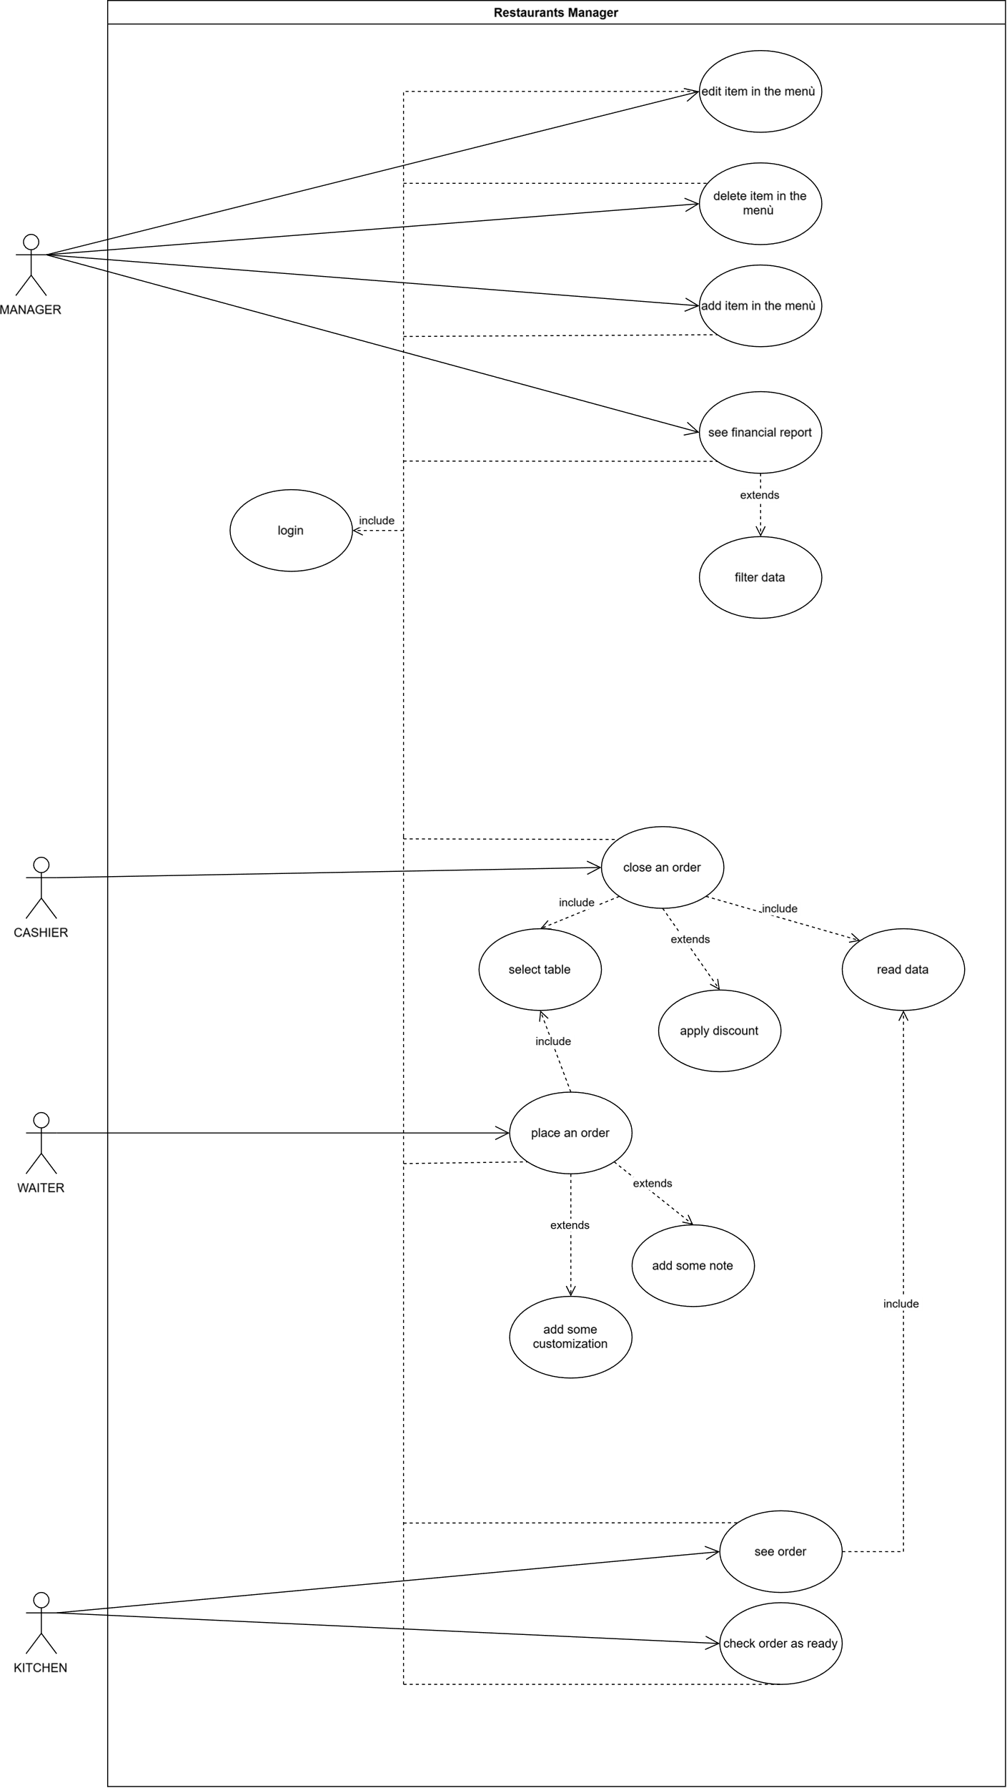

INTERNAL STEP:
- Name: “insert item in the menu”
- The manager requires insertion of an item in the menu.
- The system gives at the manager a form to compile.
- The system inserts the item in the menu.

- Name: “create an order”:
- The waiter wants to place an order.
- The system offers him a form to compile, where him insert the table and what item the guest wants.
- The system records the order and sends it at another device: kitchen and cashier.
- The kitchen now knows what it has to cook, so it prepares that.
- The system now offers the possibility to change the status of order at the kitchen.
- The kitchen when start to prepare the order change the status of order.
- The cashier now knows what the guest has to pay, so the guest can pay.
Extension:
1a: the waiter can add some customization (that are just defined)
1b: the waiter can add some note at the order.
7a: the cashier can apply some discount at the order.

- Name: “deletion of an item in the menu”
- The manager open ad specific item in the menu.
- The system gives at the manager a dashboard.
- The manager selects the option: “delete”.
- The system deletes the item in the menu.

- Name: “edit of an item in the menu”.
      - The manager open ad specific item in the menu.
      - The system gives at the manager a dashboard.
      - The manager selects the option: “edit”.
      - The system gives a form to compile at the manager.
      - The manager inserts the new value of the item and send it.
      - The system now updates the new value at the item.

5. Name: “view a financial report”.
      - The manager requires to view the financial data.
      - The system gives at the manager a specific view of the historical order and some synthetic data.
Extension:
2a: the manager can filter the data whit some parameters.

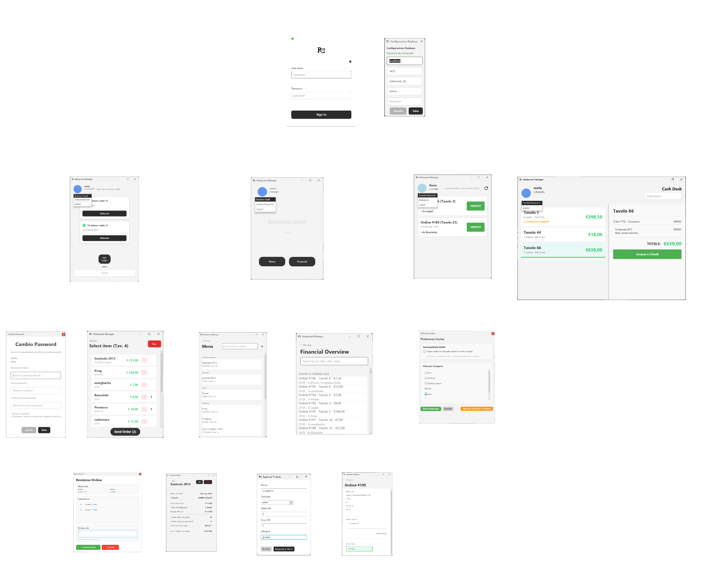
STORYBOARD AND PROTOTYPE:
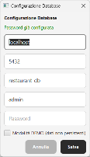
After a simple login screen, depending on type of user the user will show a different dashboard:
  - Waiter dashboard
    - Is possible to change password (this option is available for every user in the left circle handle, so I won’t come repeated) whit a dedicated window
    - Is possible to do a logout whit specific handle (this option is available for every user il the left circle handle, so I won’t come repeated)
    - Is possible to chose what table manage, so only the order (to deliver) related to a selected table will be showed
    - Is possible to go in a view that allows you to choose the products that will make up the order
      - Is showed a confirm page, where is possible to write a note
  - Manager dashboard
    - Is possible to open a dashboard to manage the worker in the activity (insert new user, delete users, see what users exist and what role they have)
    - Is possible to go in a screen dedicated to the menu, that show what product there are in that
      - Add new product (pressing: “+”)
      - See detail (“clicking” on a row)
    - Il possible to go in a screen dedicated to see the order history: “financial”
      - See detail (“clicking” on a row)
  - Kitchen dashboard
    - Is possible to navigate to a preference screen that allows the user to choose what category of order show (if there are more user “kitchen” they can divide work by category, and each one can see their own)
  - cash desk: can see detail and close order
  - there in furthermore a screen dedicated to configure DB

Design:
In this part the principal internal characteristics of the system will be exposed, with some diagrams to express it.

Class diagram:
In this part the principal internal characteristics of the system will be exposed, with some diagrams to express it.

VOPC:
This diagram is attached near to this document to be able to have a closer look to it.

Overview:
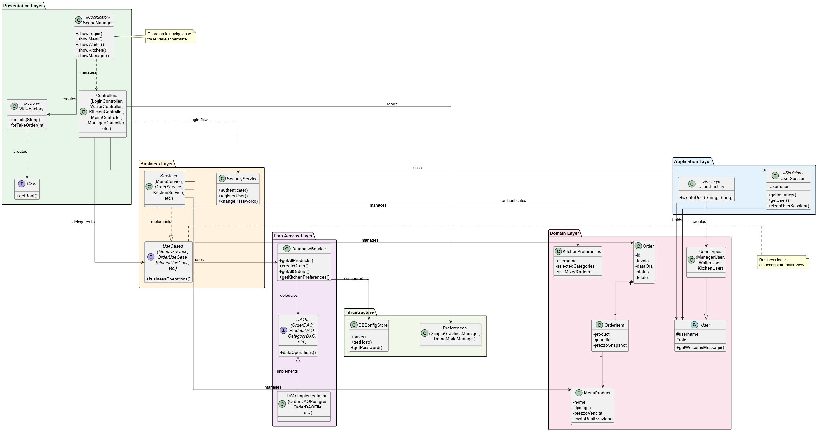

Presentation Layer:
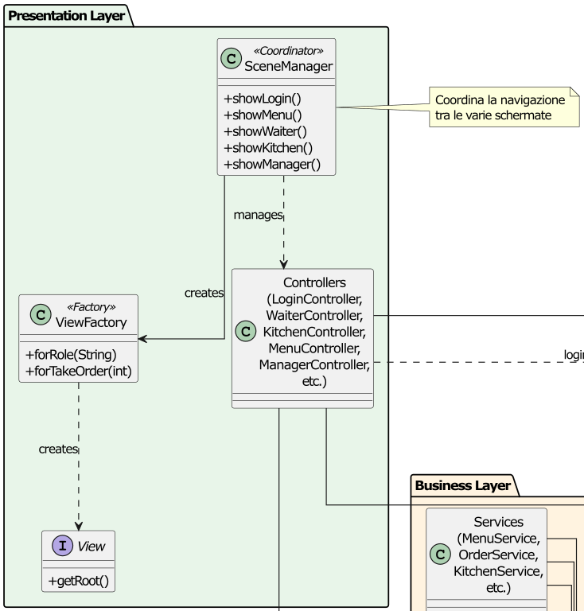

Business layer:
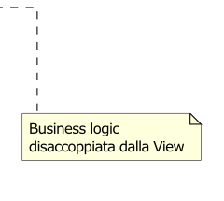
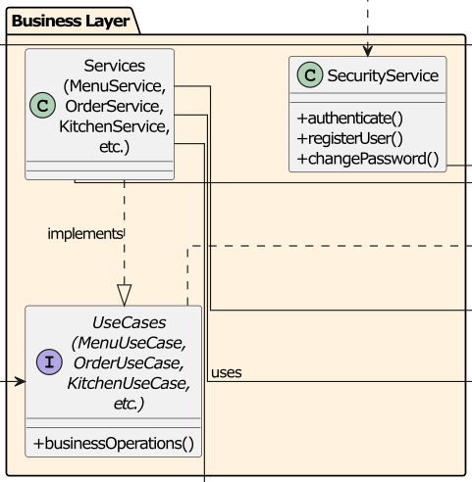

Data access Layer and Infrastructure:
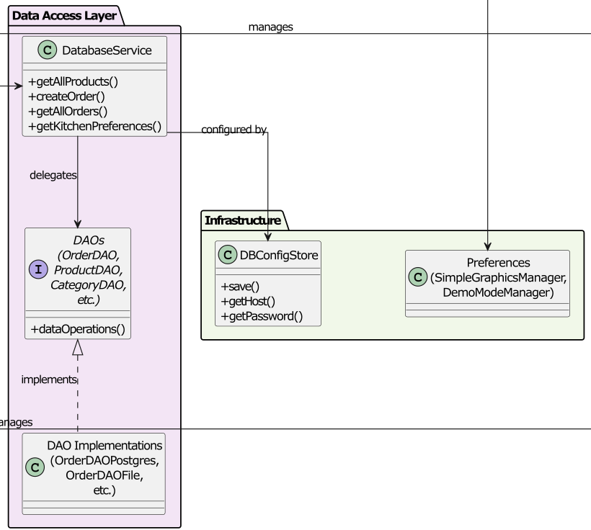

Domain level:
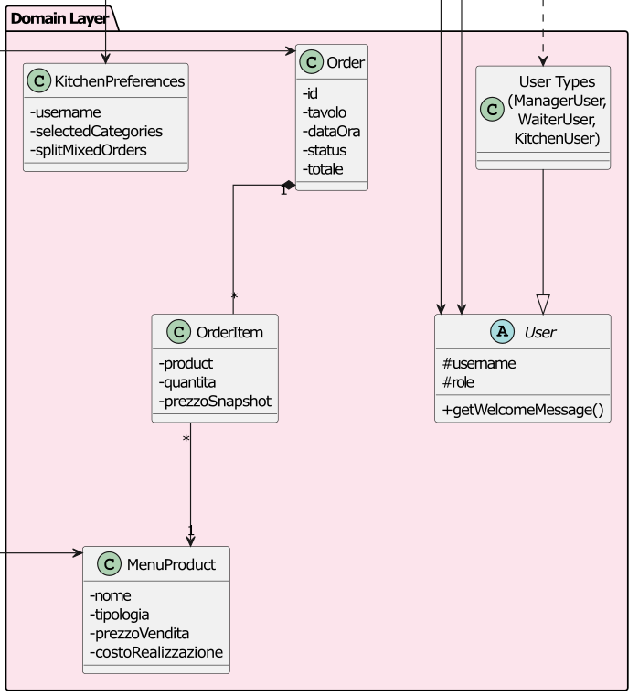

Application layer:
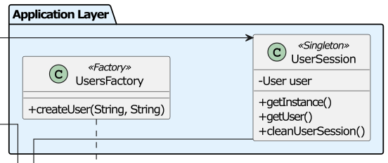

DESIGN-LEVEL DIAGRAM:
This diagram is attached near to this document to be able to have a closer look to it.

Overview:
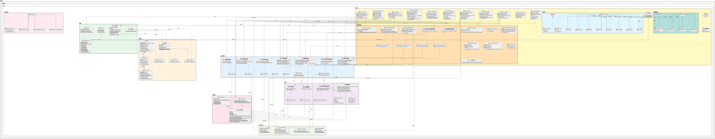

App:
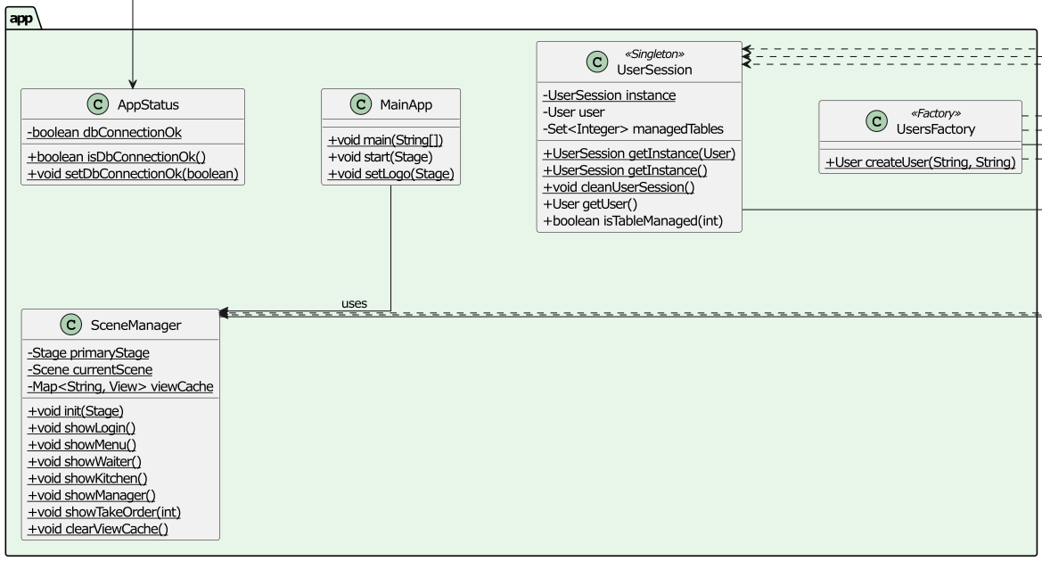

Model:
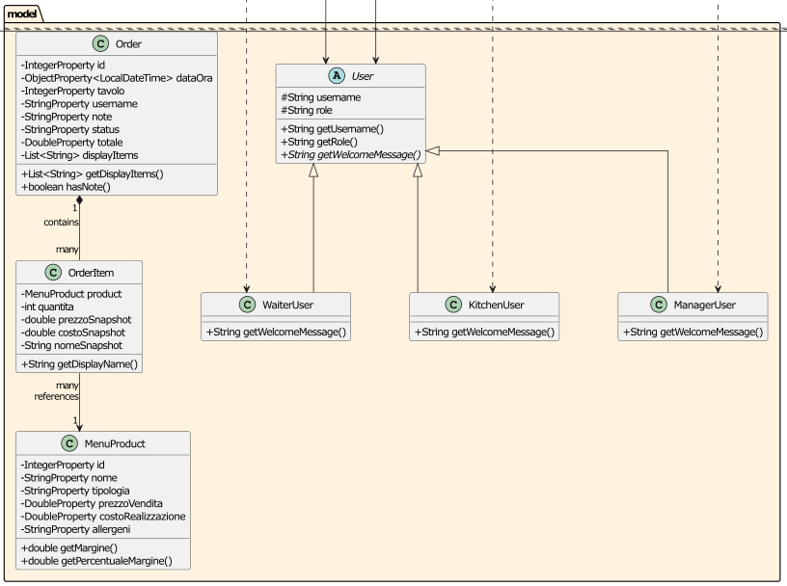

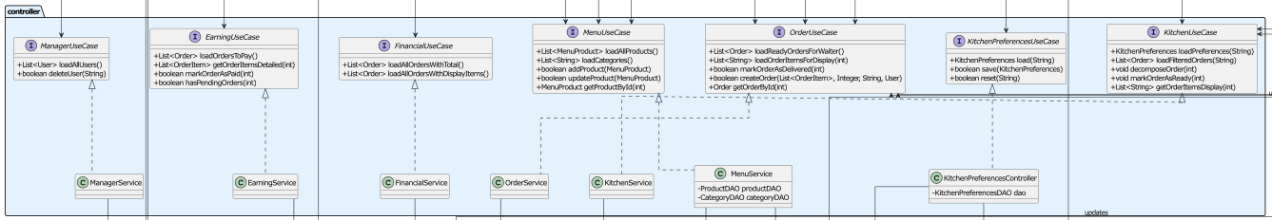
Controller:

Dao:
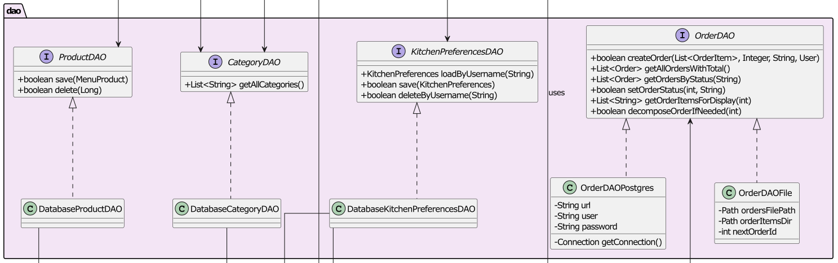

Service:
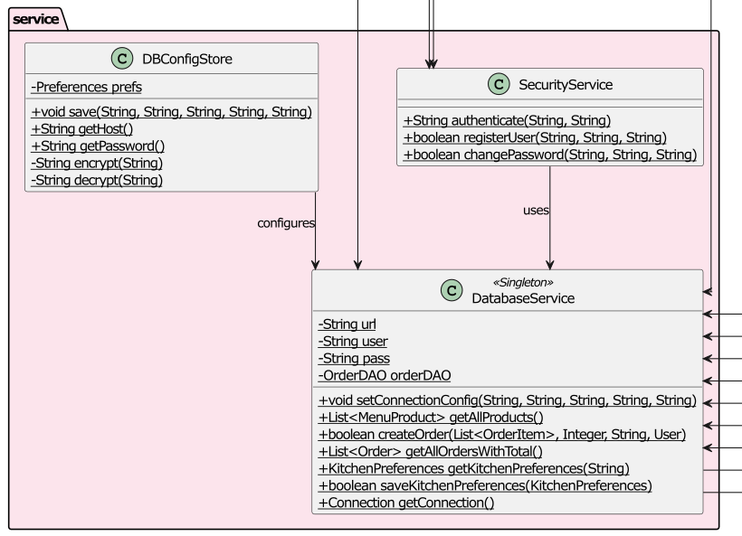

Preference:
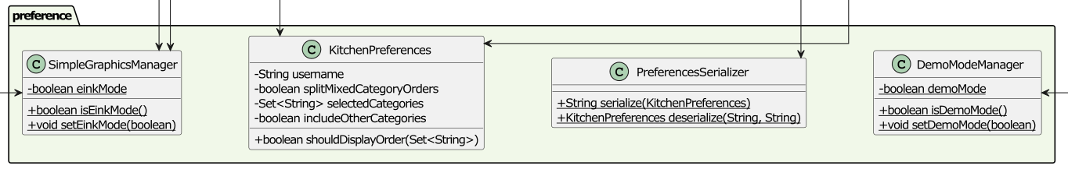

View (overview):
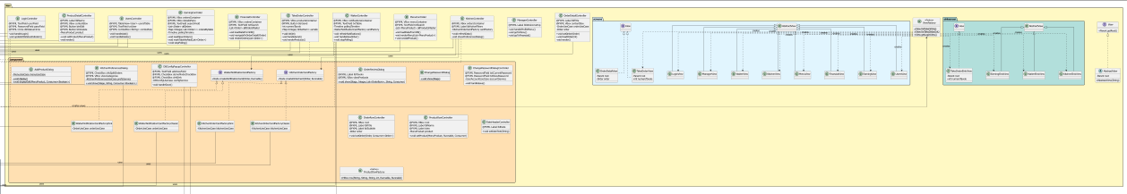

Root of view package:
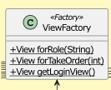
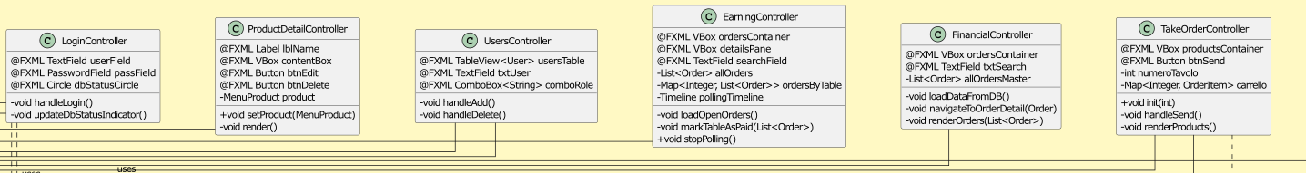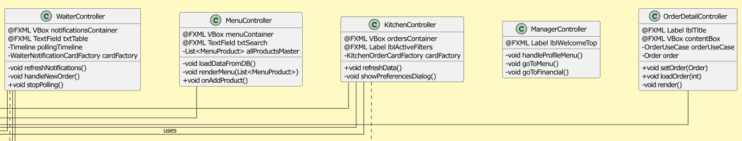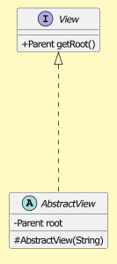

View.component:
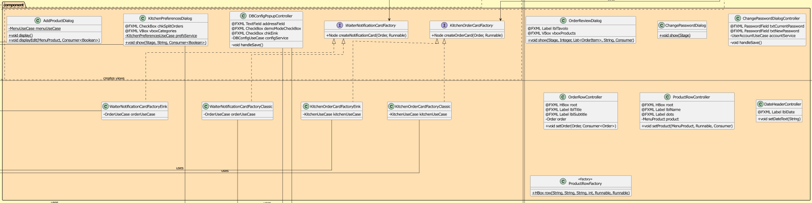

View.screens:
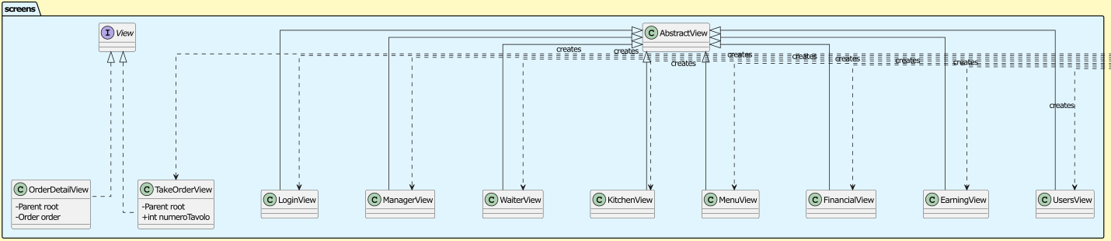

View.einkscreens:
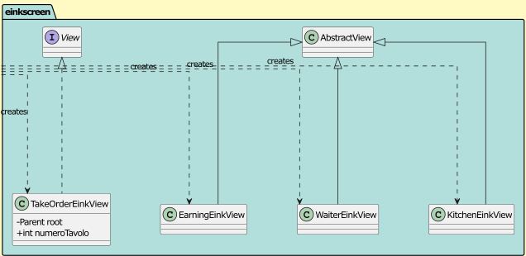

Design patterns:
In the context of the system, several design patterns have been adopted in order to improve modularity, maintainability, and separation of concerns.
A first relevant pattern is the Singleton pattern, whose main purpose is to guarantee the existence of a single shared instance of a specific object throughout the entire application lifecycle. This approach is used to maintain a consistent global state and to avoid incoherent behaviours caused by multiple instances managing the same responsibility.
In particular, the UserSession class implements the Singleton pattern to represent the currently authenticated user and its related runtime information. By doing so, all components that need access to the user context can retrieve it without explicitly passing it through constructors or method parameters. This design choice simplifies the interaction between layers and ensures that session-related data remains consistent during navigation across different application views.
Another relevant pattern employed in the system is the Factory Method pattern. This pattern is used to encapsulate object creation logic and to decouple client code from concrete implementations.
The UsersFactory class applies this pattern to centralize the creation of different User subclasses (ManagerUser, WaiterUser, KitchenUser) based on the role associated with a username. This solution improves extensibility, since introducing a new user role would require modifications only within the factory itself, without affecting the rest of the system.
The DAO (Data Access Object) pattern is widely used to separate persistence logic from business logic. Interfaces such as OrderDAO, ProductDAO, CategoryDAO, and KitchenPreferencesDAO define a stable abstraction for data access, while concrete implementations (OrderDAOPostgres, OrderDAOFile, DatabaseProductDAO, DatabaseCategoryDAO, etc.) handle the actual persistence mechanism.
This design allows the system to switch between different storage strategies (e.g., database or file system) without impacting higher-level components, thus improving flexibility and testability.
Closely related to this, the system makes use of Dependency Injection by constructor, particularly in service and controller classes such as MenuService and KitchenPreferencesController. By receiving DAO interfaces rather than concrete implementations, these classes remain loosely coupled to the persistence layer and can be easily tested by injecting mock or alternative implementations.
Finally, the use of Use Case Interfaces (for example OrderUseCase, KitchenUseCase, FinancialUseCase) introduces a clear boundary between the application logic and the presentation layer. Controllers and services implement these interfaces to expose well-defined operations, improving readability, enforcing responsibility separation, and facilitating future refactoring or extension of the system.
Overall, the combination of these patterns contributes to a clean architectural structure, reduces coupling between components, and supports both scalability and maintainability of the application.

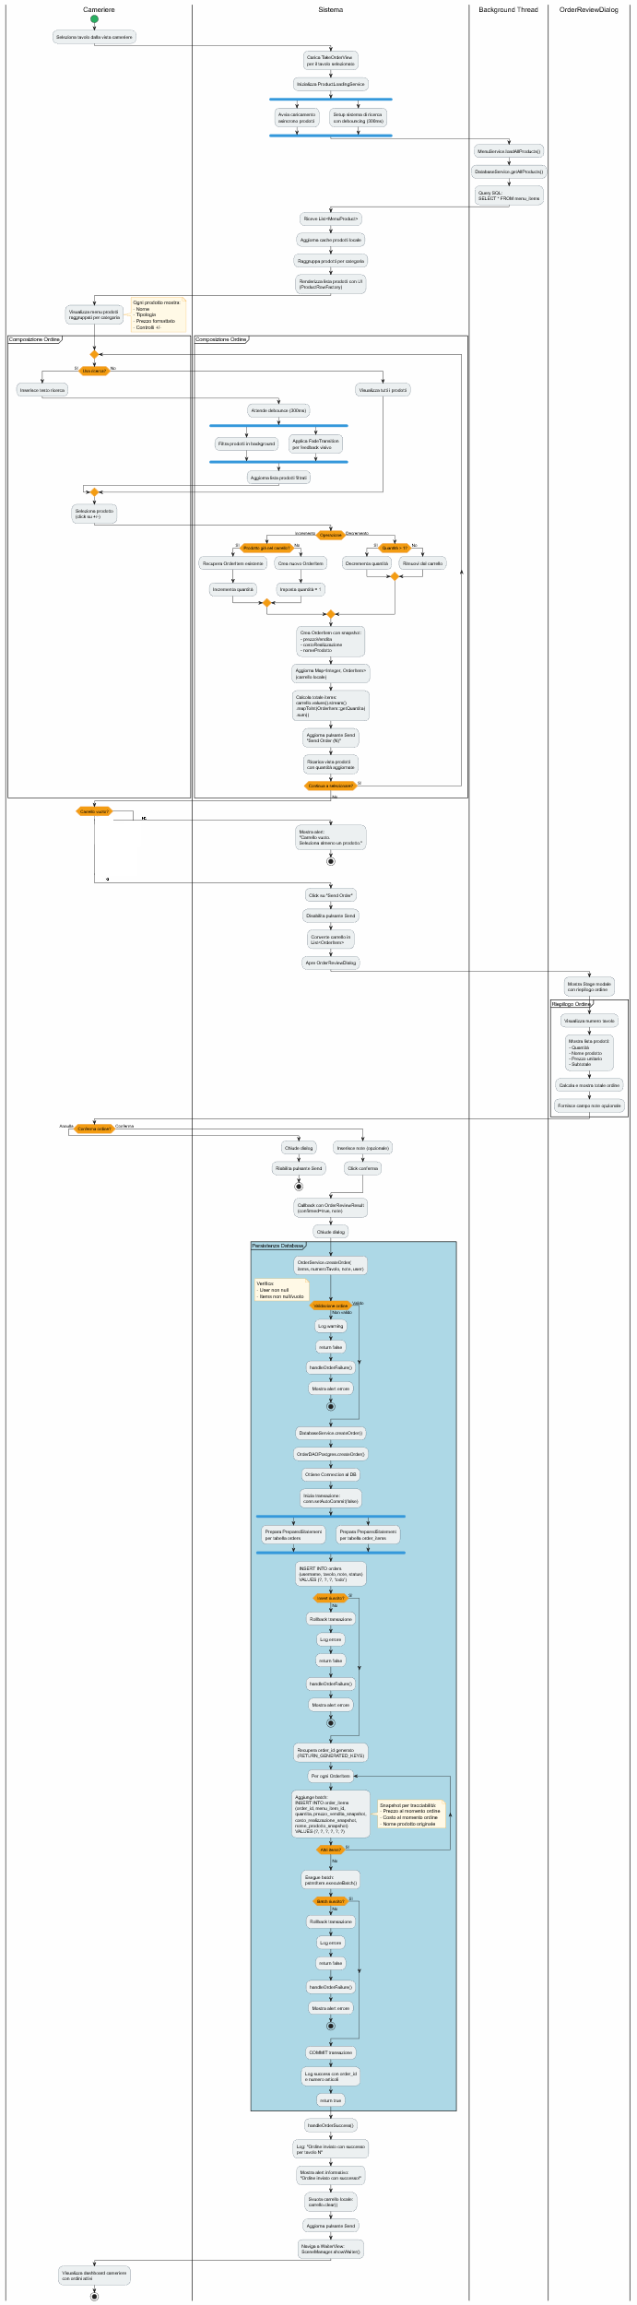
Activity diagram:
the diagram is attached near to this document to be able to have a closer look to it.
The following activity diagram describes one of the main functionalities of the system:
The creation of an order:

(in the following pages there are a closer view)
(furthermore, in the GitHub repo there ‘are all diagrams)
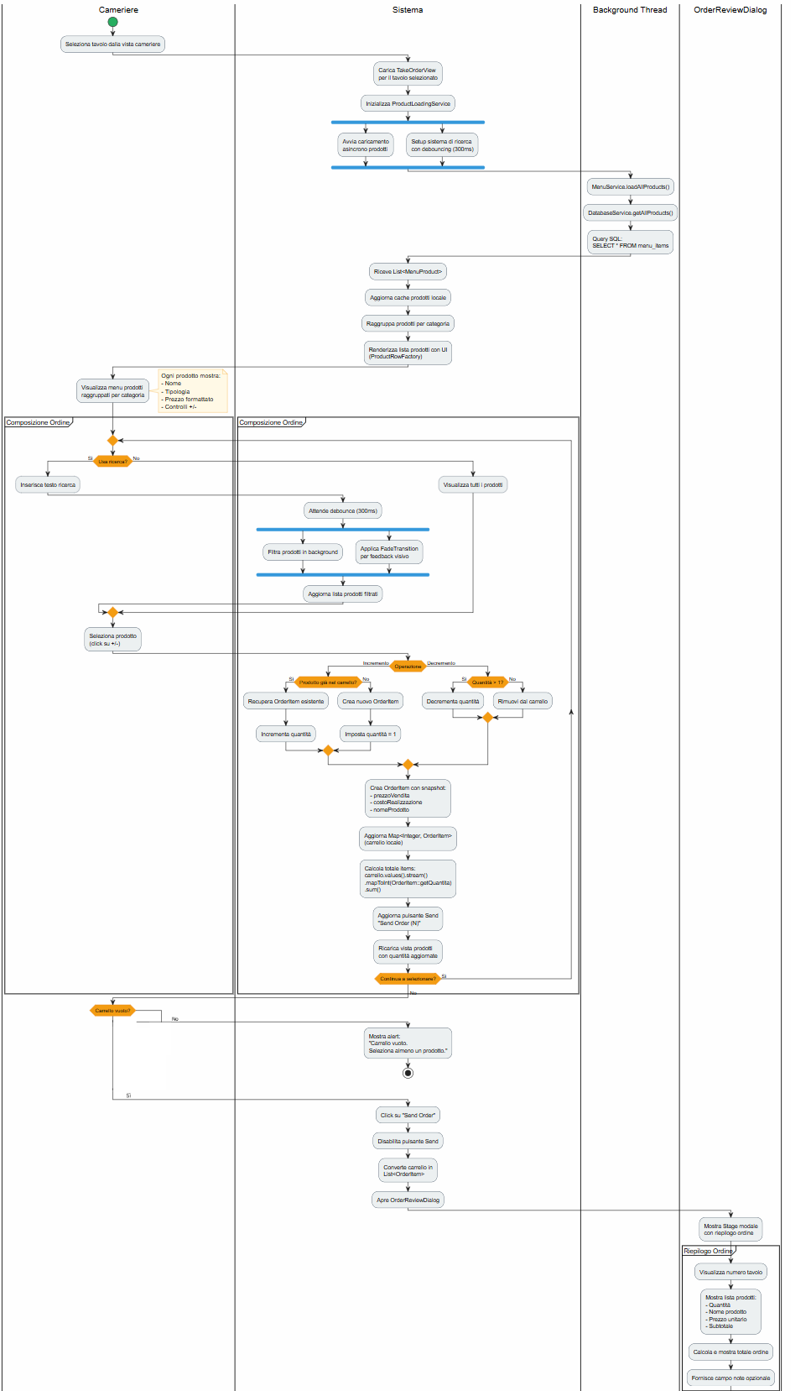
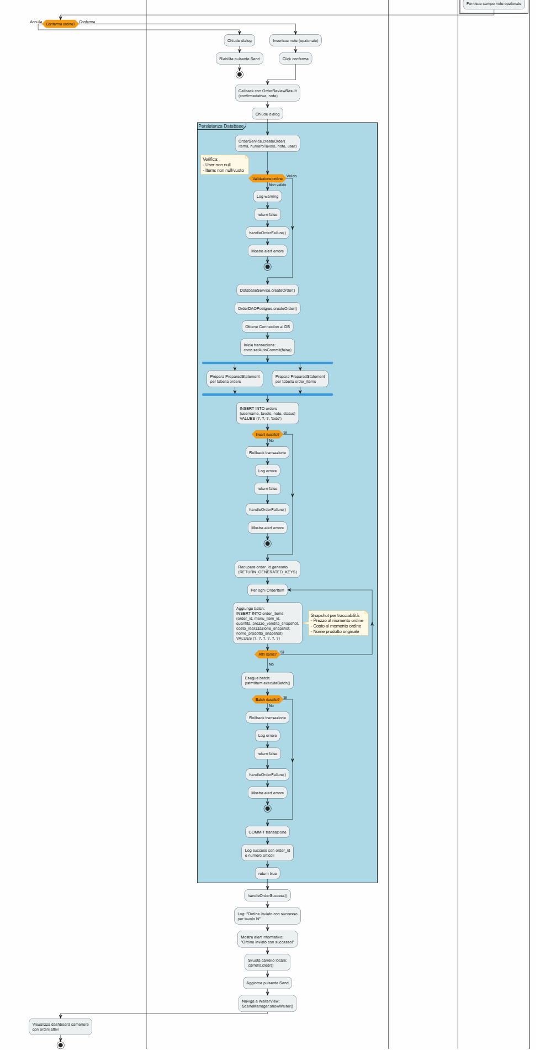

Sequence diagram:
This diagram is attached near to this document to be able to have a closer look to it. The main branch of the system is described in the following sequence diagram, in which is shown the same use case: The creation of an order.
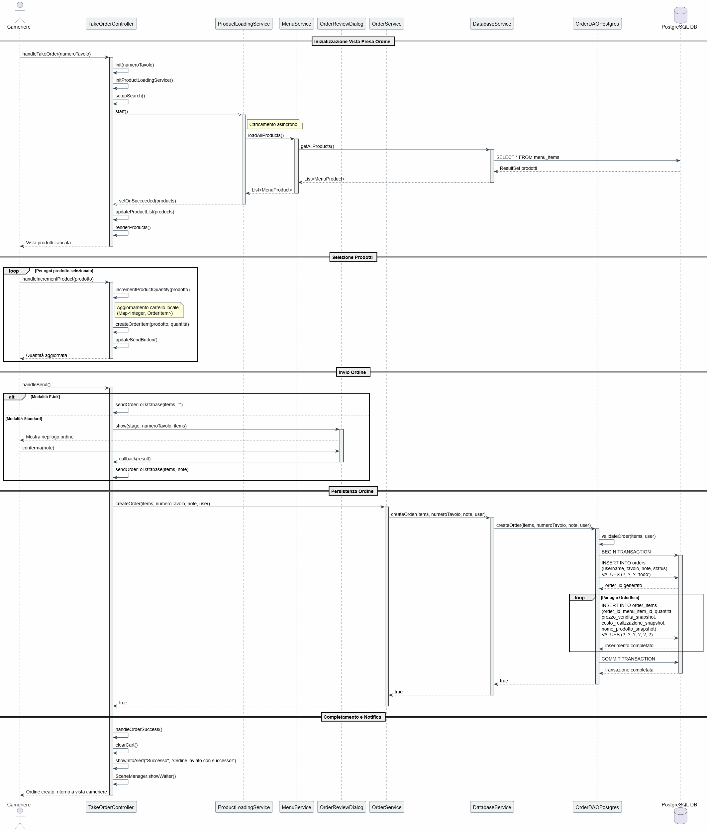

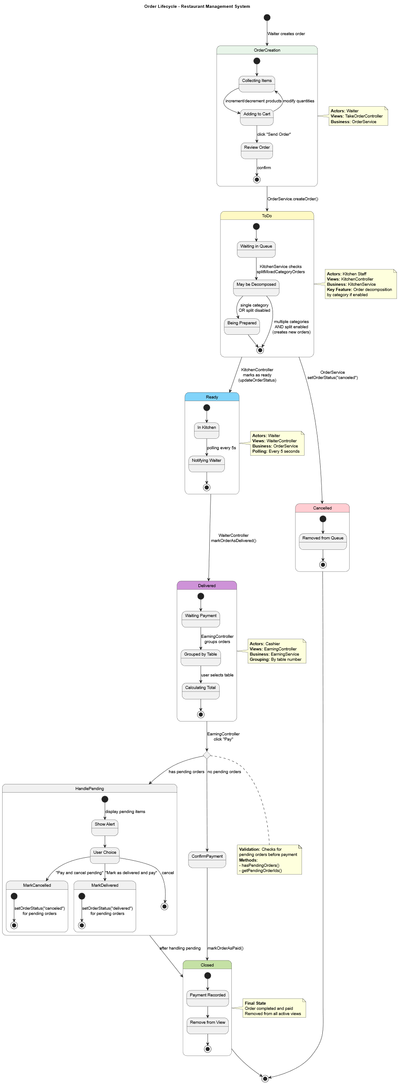
State diagram:
This diagram is attached near to this document to be able to have a closer look to it.
The following state diagram represents the lifecycle of the object order.

TESTING:
In the testing phase, several test classes are defined, each focused on validating the behavior of specific components of the application. The tests mainly cover controller classes, DAO classes, and configuration services, ensuring correct interaction between layers and proper handling of edge cases.
First, the DBConfigControllerTest is responsible for testing the DBConfigController class. In particular, it verifies the correct loading of the current database configuration through loadConfig() and the behavior of saveConfig() under different conditions, such as invalid input, valid configuration saving, and reuse of an existing password when a new one is not provided.
Second, the UserAccountControllerTest focuses on the UserAccountController class. It tests the changePassword() method, checking that invalid passwords are rejected, that valid password changes are correctly delegated to the SecurityService, and that failures from the underlying service are properly propagated.
Third, the KitchenPreferencesControllerTest validates the KitchenPreferencesController. These tests ensure that the methods load(), save(), and reset() correctly delegate their operations to the corresponding KitchenPreferencesDAO, without introducing additional side effects.
Regarding the data access layer, the DatabaseKitchenPreferencesDAOTest tests the DatabaseKitchenPreferencesDAO class. It verifies the correct interaction with DatabaseService for loading, saving, and deleting kitchen preferences, and checks that the return values correctly reflect the outcome of the database operations.
Similarly, the DatabaseProductDAOTest is dedicated to the DatabaseProductDAO class. The tests cover the save() method for both new and existing products, ensuring that the correct database operation (addProduct or updateProduct) is invoked. Additionally, the delete() method is tested to confirm correct handling of null, invalid, and valid product identifiers.
Finally, the DBConfigStoreTest provides an extensive test suite for the DBConfigStore service. These tests verify the correct persistence of database configuration data, with particular attention to password management. They cover password encryption and decryption, handling of empty and null passwords, persistence across instances, configuration clearing, validation of partial configurations, and correct behavior with special characters, Unicode strings, and very long passwords. Security-related aspects are also tested by ensuring that stored passwords are not saved in plaintext.
But as required it’s also a tests for a complete use case, in particular it’s choised as for the diagram the creation of an order, so it was created a function to test TakeOrderController: TakeOrderControllerTest and also KitchenController: KitchenControllerTest so the “entire flow” is tested, in particular the first is focused on validating the order creation and order item handling logic. These tests verify that new orders are created only when valid input data is provided, that order items are correctly associated with the corresponding order, and that invalid scenarios (such as missing items or invalid table numbers) are properly handled. This ensures that the order-taking process is robust and that only consistent and complete orders are persisted and forwarded to the subsequent stages of the application workflow.
And the second verify the correct behavior of the methods responsible for loading kitchen preferences and active orders, as well as updating the status of orders. In particular, these tests ensure that the controller correctly delegates operations to the underlying services, such as retrieving filtered or active kitchen orders, decomposing mixed-category orders when required, and updating order states (e.g., marking orders as ready). The goal of these tests is to guarantee that the kitchen workflow is managed consistently and that all operations affecting order preparation are correctly propagated to the data layer.
Overall, this test suite provides comprehensive coverage of the most critical components of the application, validating both functional correctness and robustness, especially in areas related to configuration management, data access, and security.

EXCEPTIONS:
In the exception handling part, the system adopts a structured approach based on custom runtime exceptions combined with defensive programming techniques, in order to clearly represent abnormal application states while preserving overall system stability.
The first category includes application-specific exception classes, all extending RuntimeException, which are used to signal well-defined logical error conditions.
The AuthenticationException is used to handle errors occurring during the user authentication process. This exception encapsulates a user-oriented message, designed to be safely displayed in the user interface, allowing authentication failures to be communicated clearly without exposing technical details. It may also wrap an underlying cause when the failure originates from lower-level services.
The DatabaseNotConfiguredException is thrown when the application attempts to access the database without a valid configuration. This exception represents a critical initialization error and provides a dedicated user message prompting the user to verify the database settings before continuing.
The InvalidUserSessionException is used to indicate an invalid, expired, or non-existent user session. It is thrown when session-dependent operations are invoked without a properly initialized session, enforcing correct session lifecycle management and preventing unauthorized access to protected functionalities.
The ViewNotFoundException is raised when a requested view does not exist or cannot be loaded. This exception is used to handle navigation errors within the application, ensuring that unsupported or incorrectly referenced views are detected and reported in a controlled manner.
In addition to explicit exception throwing, the system also applies defensive coding and graceful fallback strategies. In several controllers, services, and data access components, input parameters and application state are validated before performing critical operations. When an invalid condition or recoverable failure is detected, methods return safe values such as false, null or in some case empty collections, instead of propagating exceptions. This approach is particularly used in data retrieval and persistence logic, where failures should not necessarily interrupt the entire application flow.
Overall, the exception-handling design combines clear semantic signaling through custom exceptions with robust fallback mechanisms, improving both the reliability of the application and the clarity of error management across different architectural layers.

DATA BASES:
In the described system, data persistence is entirely managed through a relational database management system (RDBMS). During the development phase, the database is executed inside a Docker container, allowing a reproducible and isolated environment independent from the host operating system.
The application interacts with the database exclusively through the Data Access Object (DAO) pattern, ensuring a clear separation between business logic and data persistence logic.

RELATIONAL DATABASE (POSTGRESQL)
The system uses a PostgreSQL relational database to store and manage all persistent data, including users, orders, order items, and menu products.
The database schema is designed to represent entity relationships explicitly (for example, orders and their associated items) and to ensure data consistency through primary and foreign keys.
All database access is performed using JDBC, with explicit SQL queries defined inside DAO implementations. No direct database access is allowed outside the DAO layer.
Connection parameters (URL, username, and password) are provided at runtime and injected into DAO implementations, allowing flexible configuration and easy adaptation to different environments (development, testing, production).

DATA ACCESS OBJECT (DAO) LAYER
Each persistent entity is managed by a dedicated DAO interface and a concrete implementation for PostgreSQL.
For example, the class OrderDAOPostgres is responsible for handling all database operations related to orders and order items.
The DAO layer provides methods for:
- creating new orders and their associated items,
- retrieving orders with aggregated information (such as total price),
- filtering orders by status (e.g., kitchen, ready, delivered),
- updating order status,
- decomposing mixed-category orders into separate orders,
- retrieving detailed order item information.
Complex operations involving multiple tables are executed within explicit database transactions, ensuring atomicity and consistency. Transaction management is handled using JDBC mechanisms such as manual autoCommit control, commit, and rollback in case of failure.
All SQL exceptions are caught within the DAO layer and logged appropriately. Instead of propagating low-level database exceptions, DAO methods return controlled values (such as boolean, empty collections, or default values), allowing higher layers of the application to handle failures gracefully.

DOCKER-BASED DEVELOPMENT ENVIRONMENT
During development, the PostgreSQL database runs inside a Docker container, providing:
- environment isolation,
- reproducibility of the database setup,
- simplified configuration for testing and deployment.
This approach ensures that the application behaves consistently across different machines and reduces dependency-related issues during development.

FILE SYSTEM–BASED DAO IMPLEMENTATION
Although the primary data persistence strategy of the system is based on a relational database, as required by the project specifications, an alternative file system–based implementation of the data access layer has also been provided.
This alternative implementation is represented by the class OrderDAOFile, which implements the same OrderDAO interface used by the PostgreSQL-based DAO. The purpose of this implementation is to demonstrate the flexibility of the DAO pattern and to allow data persistence without relying on a DBMS, for example in simplified scenarios, testing contexts, or environments where a database server is not available.
In this implementation, orders are stored on the file system using CSV-formatted files. The persistence structure is organized as follows:
- a main file (orders.csv) containing the core information of each order (identifier, date and time, table number, user, notes, and status);
- a dedicated directory (order_items/) containing one CSV file per order, each storing the associated order items.
Each file-based operation mirrors the behavior of the database-backed DAO, including order creation, order status updates, order retrieval with total calculation, and filtering by status. Unique order identifiers are generated by scanning existing files to determine the next available ID.
All file operations are performed using the Java NIO API, and potential I/O errors are handled internally through logging and controlled return values. As in the database implementation, low-level exceptions are not propagated to higher layers, ensuring consistent behavior across different persistence mechanisms.
The coexistence of both database-based and file system–based DAO implementations highlight the effectiveness of the DAO abstraction, allowing the persistence mechanism to be replaced transparently without affecting the rest of the application.

SONAR CLOUD
A fundamental tool, SonarCloud, was employed to maintain code hygiene and eliminate technical debt. The analysis report, available at the link below, validates that the codebase is free of bugs, smells, and vulnerabilities.
https://sonarcloud.io/project/overview?id=BrugnoliDavide_Restaurant-Managaer
(is possible to see that every parameter is “green” except for Coverage)

DEMOSTRATION
The system behaviour is demonstrated in the following video:
https://youtu.be/bJbB3tiGvWw

DOWNLOAD SOURCE CODE
For download source code, included test function, there is the following link:
https://github.com/BrugnoliDavide/Restaurant-Managaer.git

