A class is like a container.
In this video we’ll explore the fundamental concepts of object-oriented programming by the end of this video you should be able to understand the concepts of classes and objects as well as differentiate between functions and methods.
Object oriented programming is a way of organizing code by using code structures called classes. These classes act as a container for code and resembles real world entities and their behaviors.

To breakdown the key concepts of OOP in python we’ll use examples related to the sustainable development goal 15 (SDG15) , Life on land specifically focusing on sustainable forest management.
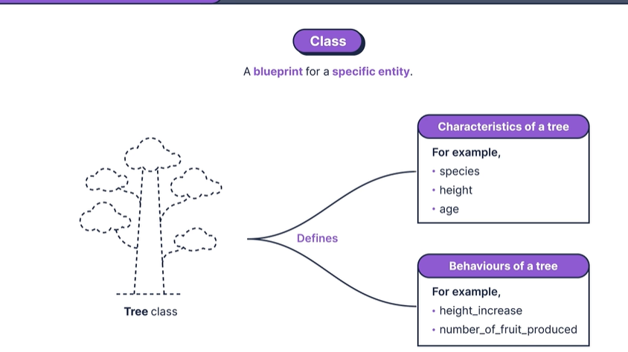
we can think of a class as a blueprint for a specific entity. In our case we can consider a tree class. this class is like a template that defines what a tree is made of and what it can do. it specifies essential details like the type of tree, its height and age. the class also includes information about what behaviors that she can have such as growing taller or producing fruit.
So if a forest is a program, a class can be likened to a tree within that ecosystem. now using a tree class as a blueprint we can create instances of trees in our program, each created tree is called an object.
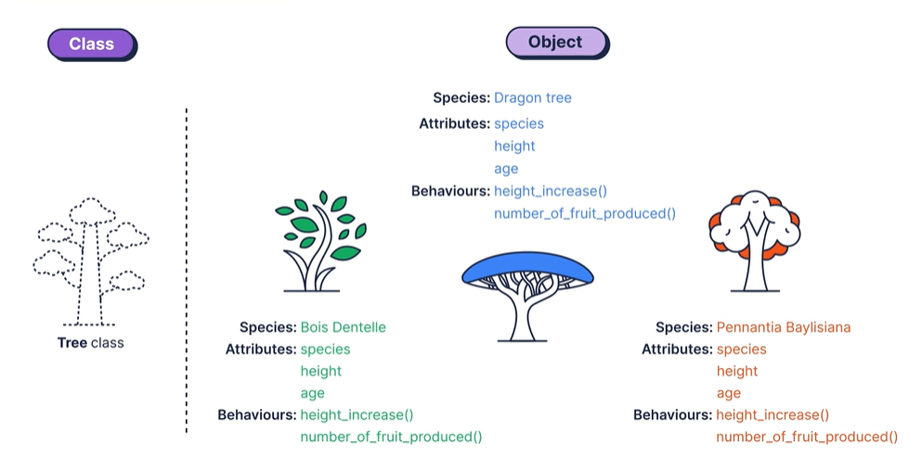
Using this blueprint to create tree objects means that each instance inherits the attributes listed in the original tree class which include its species height and age. These tree objects also inherit the behaviors of the original tree class, namely the ability to grow taller and to produce fruit. in our class these behaviors are defined by the height increase and number of fruit produced functions.
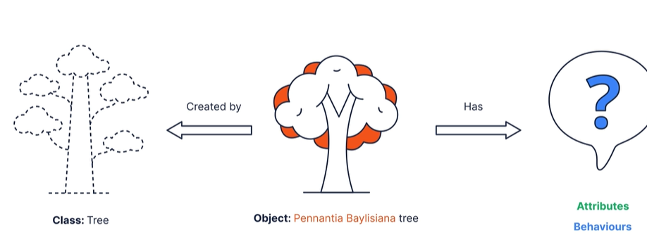
we know that objects are instances of classes and that these objects have attributes and behaviors but what exactly are attributes and behaviors?.
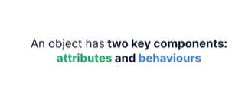
imagine we’ve decided to plant a tree, this is equivalent to knowing that we need to use the tree class, after a few days of reading about the different trees we finally decided on a specific type of tree, an apple tree in the world of OPP, an object is like this apple tree with specific attributes and behaviors distinguishing it from other tree types.
Attributes
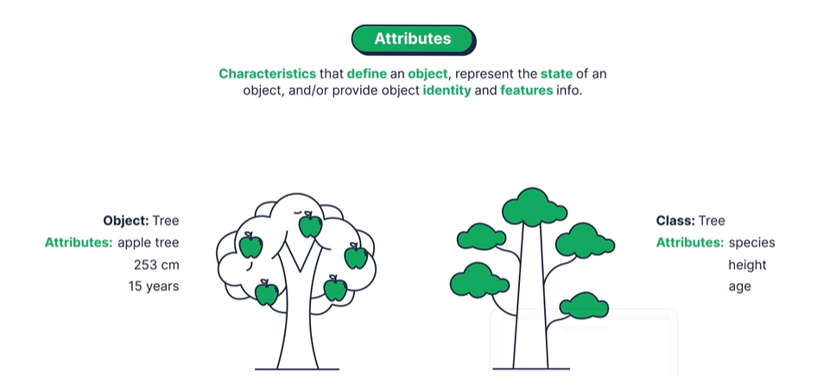
Attributes are comparable to the essential elements that shape an object’s identity. in our example with a tree class, the attributes are the defining characteristics of a tree. our tree class has attributes like species, heights and age. our appletree object or instance of this class has specific values for each of those attributes. these attributes give identity to the tree object, they tell us what kind of tree it is and how tall or old it is.

Behaviors
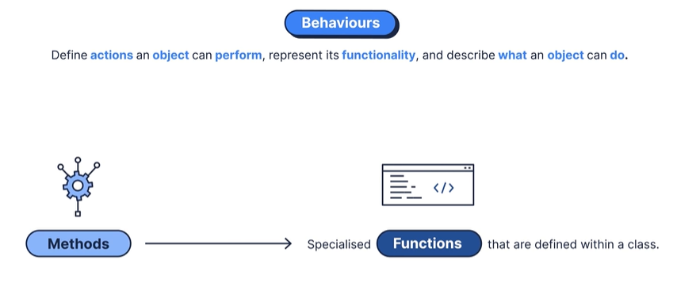
Behaviors on the other hand are the actions we can perform with an object. In OPP they are typically implemented through functions. since these functions are defined within a class, they take on a specific designation and are referred to as methods.
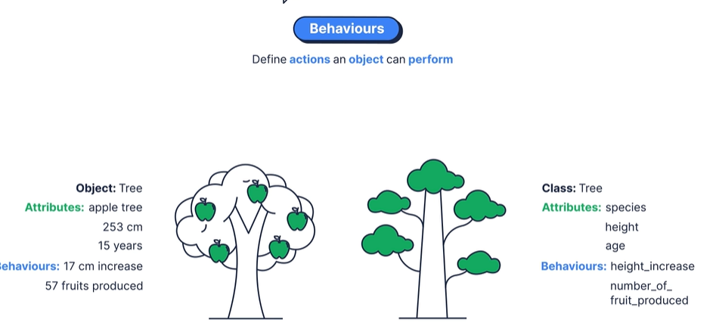
our tree class contains two methods, height increase, and number of fruits produced, describing possible behaviors of trees created by the class. For our Appletree these methods behave in a way specific to the apple tree.

In python, methods and functions have similar purposes but differ in important ways.
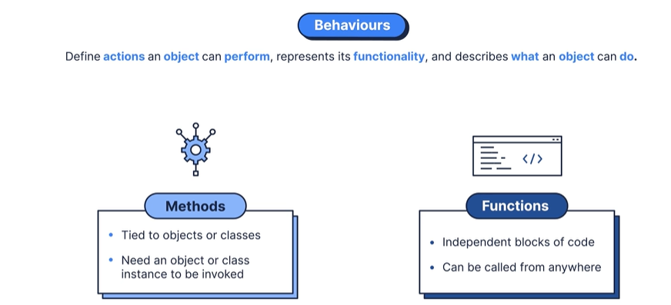
Functions are independent blocks of code that can be called from anywhere while methods are tied to objects or classes and need an object or class instance to be invoked.
python also provides a group of built-in methods that are referred to as dunder methods or magic methods. these methods are like helpers digging a hole to plant a tree, setting up the watering system and creating fertilizer mixes. think of them as special techniques passed down through generations of gardeners to make each tree in the forest thrive. the reason they are called dunder is that they start and end with double underscores giving them a unique appearance. the most used dunder method is called the __init__ method.
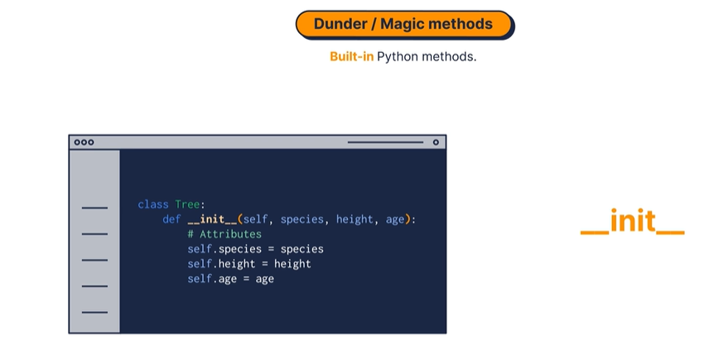

This method is like a preparation of the soil before planting a tree a crucial step for ensuring a solid foundation. in programming terms __init__ is called when we create a new object from a class, it initializes the object’s attributes setting the stage for the object to perform its actions.
in this video we introduce the concept of object-oriented programming which involves classes as blueprints objects as instances created from those blueprints attributes that define objects and behaviors that are the actions those objects can perform we also introduced methods and how they differ from functions

Test your knowledge:
True or false? Methods in Python can be called from anywhere, while functions are tied to objects or classes and need an object or class instance to be invoked.
A: False
B: True
What is the primary purpose of the Dunder method __init__ in OOP?
A: To represent the end of a class definition.
B: To specify the number of objects allowed in a class.
C: To execute functions independently of objects.
D: To initialise the object's attributes, setting the stage for the object to perform its actions.

Which component of an object in OOP defines its unique characteristics, such as species, height, and age?
A: Behaviours
B: Attributes
C: Dunder methods
D: Functions

What is a class in object-oriented programming (OOP)?
A: A built-in method starting and ending with double underscores.
B: A specific instance created from a blueprint.
C: A set of actions tied to objects.
D: A blueprint for a specific entity.

