Big-O Notation &
Algorithm Complexity
Search Algorithms · Recursion · Space Complexity
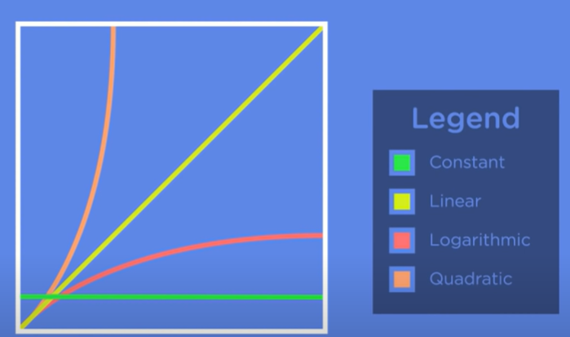
Big-O complexity curves: Constant · Logarithmic · Linear · Quadratic

1. Big-O Notation & Time Complexity
Big-O notation is the standard way of describing how the runtime (or memory usage) of an algorithm scales as the input size N grows. It always reflects the worst-case scenario and abstracts away hardware and constant factors so that we can compare algorithms on equal footing.
There are four runtime classes you will encounter most frequently:
- O(1) — Constant time: The algorithm takes the same amount of time regardless of how large N is. Reading a value at a specific index, or calling len() in Python, are constant-time operations.
- O(log N) — Logarithmic time: Runtime grows very slowly as N increases, because the algorithm discards a large fraction of the remaining work on each step. Binary search is the canonical example.
- O(N) — Linear time: Runtime grows proportionally with N. Linear search, which must inspect every element in the worst case, is O(N).
- O(N²) — Quadratic time: Runtime grows with the square of N. Typical of naive nested-loop algorithms.


Figure 1 — Growth curves for the four common complexity classes
💡 The goal when studying algorithms is not to memorise the maths, but to internalise where an algorithm sits on this efficiency scale and be able to reason about it from looking at the code.

2. Search Algorithms

2.1 Linear Search
Linear search is the simplest search strategy: iterate through every element in the list in order until the target is found or the list is exhausted. Because every element may need to be examined in the worst case, linear search runs in O(N) time. No extra storage is needed beyond the input list, so its space complexity is O(1).
Linear search works on both sorted and unsorted lists, which is its main advantage over binary search.

2.2 Iterative Binary Search

The algorithm
Binary search works by repeatedly halving the portion of the list under consideration. It requires the list to be sorted. We start by creating two pointer variables — first and last — that mark the boundaries of the current search window:
- first = 0 (points to the first element; list positions are zero-indexed)
- last = len(list) - 1 (points to the last element)
A while loop runs as long as first ≤ last. On each iteration:
- Calculate the midpoint: midpoint = (first + last) // 2
- The // operator is Python’s floor-division operator — it rounds the result down to the nearest whole number, giving a valid index position. For example, (0 + 7) // 2 = 3 (not 3.5).
- If list[midpoint] == target: return midpoint. The algorithm is done — this is the best-case scenario.
- Else if list[midpoint] < target: set first = midpoint + 1. The target cannot be in the left half, so we discard it.
- Else (list[midpoint] > target): set last = midpoint − 1. The target cannot be in the right half, so we discard it.
If the loop ends without finding the target, return None — the target is not in the list.

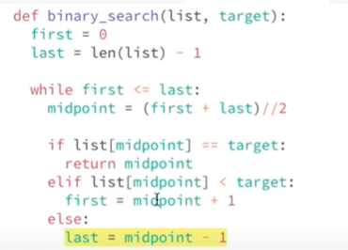
Figure 2 — Iterative binary search implementation in Python

Worked example: worst-case trace
Consider a list of 9 integers [0, 1, 2, 3, 4, 5, 6, 7, 8] and a target of 8 (worst case — the last element).
- first = 0, last = 8. midpoint = 4. list[4] = 4. 4 < 8, so first = 5.
- first = 5, last = 8. midpoint = 6. list[6] = 6. 6 < 8, so first = 7.
- first = 7, last = 8. midpoint = 7. list[7] = 7. 7 < 8, so first = 8.
- first = 8, last = 8. midpoint = 8. list[8] = 8. Match! Return 8.
The algorithm found the target in 4 steps on a list of 9 elements, rather than the 9 steps linear search would take.

Runtime analysis
Every individual operation inside the loop — value assignment, the midpoint calculation, the list read, the comparison — is a constant-time O(1) operation. It may seem puzzling that a function made up entirely of O(1) steps does not run in O(1) overall.
The while loop is what introduces the logarithmic growth. By redefining first and last on each pass, the algorithm halves the working portion of the list on every iteration. This continues until first > last, which happens after at most log₂(N) iterations. That halving pattern is precisely what produces a logarithmic runtime.
- Time complexity: O(log N)
- Space complexity: O(1) — only first, last, and midpoint are ever created, regardless of how large the list is. We never create a new list; we only redefine the two pointer variables.
💡 Binary search requires the input list to be sorted. If the list is unsorted the algorithm may return None even when the target is present, because the logic of discarding halves relies entirely on the sorted order.

2.3 Recursive Binary Search

The algorithm
The same binary search logic can be written as a recursive function — one that calls itself. This version returns True (found) or False (not found) rather than the index of the target. The overall structure is similar, but instead of moving pointer variables it passes a sub-list to each new call.
The function starts by handling the empty-list case: if len(list) == 0, return False. An empty list means the target was never found after all the halving.
If the list is not empty, we calculate the midpoint using floor division on the length of the list:
midpoint = len(list) // 2
There is no need for first and last variables here because we always work with the full extent of whatever list is passed in.
We then evaluate the same three cases as before:
- list[midpoint] == target: return True.
- list[midpoint] < target: call recursive_binary_search(list[midpoint + 1:], target) and return the result. The slice list[midpoint + 1:] creates a new sub-list that starts just after the midpoint and runs to the end.
- list[midpoint] > target: call recursive_binary_search(list[:midpoint], target) and return the result. The slice list[:midpoint] creates a new sub-list from the start up to (but not including) the midpoint.
The return statement before each recursive call is crucial — it threads the result back up through every function that called it, all the way to the original caller.

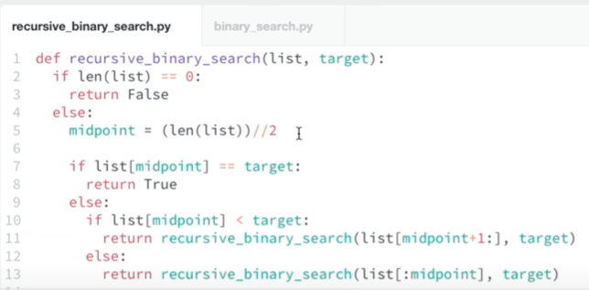
Figure 3 — Recursive binary search implementation in Python

Base cases
Every recursive function needs one or more base cases — conditions that stop the self-calls. Without them the function recurses forever (until the language's recursion-depth limit is hit). Recursive binary search has two:
- Empty list: len(list) == 0 → return False. If the target existed, it would have been found by now.
- Midpoint match: list[midpoint] == target → return True.
These two cases together cover every possible execution path — either we find the value, or we exhaust the list without finding it.

Worked example: tracing the call stack
Using the same 9-element list [0..8] with target 8:
- Call 1: list = [0..8], midpoint = 4, list[4] = 4 < 8 → call with list[5:] = [5,6,7,8]
- Call 2: list = [5,6,7,8], midpoint = 2, list[2] = 7 < 8 → call with list[3:] = [8]
- Call 3: list = [8], midpoint = 0, list[0] = 8 == target → return True
- True is returned back through Call 2, then Call 1, until the original caller receives True.
This ‘returning upward through callers’ behaviour is what distinguishes recursive functions from iterative ones. Like a book that redirects you to another page for part of the answer: you keep following references until you get a concrete value, then you work back up to your original question.

Runtime analysis
The time complexity is the same as the iterative version — O(log N) — because the list is still halved on every call.
The space complexity is different. Each recursive call creates a new sub-list via slicing. For a list of N elements:
- Call 1 allocates N/2 elements
- Call 2 allocates N/4 elements
- Call 3 allocates N/8 elements, and so on…
This pattern continues for log₂(N) calls, so the total additional memory is proportional to log N.

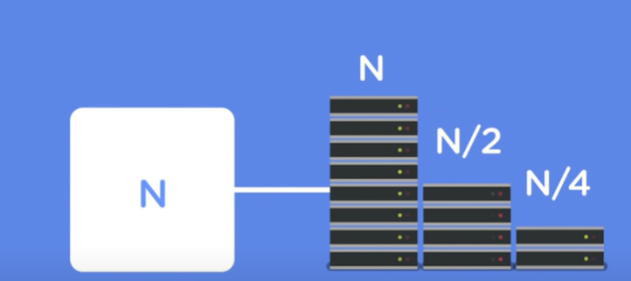
Figure 4 — Memory allocation pattern for recursive binary search: N → N/2 → N/4…

- Time complexity: O(log N)
- Space complexity: O(log N) — one new sub-list is created per recursive call.

3. Recursion
A recursive function is one that calls itself. This is a concept many programmers find initially confusing because everyday analogies are rare. One useful analogy: imagine a book of multiplication answers where the answer to your problem says “add 10 to the answer for problem 52”. You look up problem 52, which says “add 12 to the answer for problem 85”. Problem 85 finally gives you the concrete value 10. You then work back: 10 + 12 = 22 for problem 52, then 22 + 10 = 32 for your original problem. The book instructed you to keep consulting itself until you had a concrete answer — that is recursion.

3.1 Key terminology
- Base case: The stopping condition(s) that prevent infinite recursion. Always defined at the start of a recursive function.
- Recursive case: The part of the function that calls itself with a smaller or simpler version of the problem.
- Recursive depth: The number of times the function calls itself before reaching a base case. For binary search on N elements, the recursive depth is at most log₂(N).

3.2 Iterative vs. recursive solutions
When you see algorithms described in computer science textbooks — particularly older ones — you will often find recursive implementations. This is because many classic textbooks were written in or for functional programming languages, where modifying variables passed into a function is discouraged.
- Iterative solution: Uses a loop structure (while or for). State is tracked through variables that are modified in place — for example, redefining first and last in iterative binary search.
- Recursive solution: Uses a function that calls itself with progressively smaller inputs. State is managed by the call stack and sliced sub-lists, not by mutating variables.
Functional languages (Haskell, Erlang, and to a degree Swift) prefer recursive solutions. Python is an imperative language and is the opposite: it imposes a maximum recursion depth (by default 1000) after which the interpreter will raise a RecursionError. Python actively prefers iterative solutions.

3.3 Tail call optimisation
Tail call optimisation (TCO), also called tail call elimination, is a compiler/interpreter trick that removes the memory overhead of tracking recursive calls when the recursive call is the very last thing the function does (a ‘tail call’).
In our recursive binary search the recursive call is the last line of each branch, making it tail-recursive. Languages like Swift implement TCO, so even deeply recursive functions consume only constant space. Python does not implement TCO, so each call still adds a frame to the call stack, resulting in O(log N) space.
💡 If you move into other languages — Swift, Scala, Haskell, etc. — the recursive implementation of binary search may be equally space-efficient as the iterative one, or even preferred, thanks to TCO. In Python, always prefer the iterative version.

4. Space Complexity
Space complexity is a measure of how much additional (working) storage an algorithm requires as N grows. Like time complexity, it is expressed in Big-O notation and describes the worst case.
In the early days of computing, memory was scarce and expensive, so space complexity was a primary concern. Modern devices are memory-rich, and for everyday code this rarely matters. However, when working with very large data sets or designing algorithms for constrained environments, understanding space complexity becomes important.
💡 Space complexity measures the extra memory the algorithm creates while running — not the memory used to hold the input itself. The input is assumed to already exist.

4.1 Iterative binary search — O(1) space
The iterative implementation of binary search creates only three scalar variables: first, last, and midpoint. These variables exist for the lifetime of the function and occupy a fixed, constant amount of memory regardless of the size of the list N.
Crucially, the algorithm never creates a new list. When it eliminates half the search space, it simply redefines the first or last pointer to point to a different position in the original list. The list itself is not duplicated, and no sub-lists are allocated.
This means that for any value of N — a list of 10 elements or 10 million elements — the additional memory required by the algorithm is the same fixed amount. This is constant space: O(1).

4.2 Recursive binary search — O(log N) space
The recursive implementation tells a different story. Each time the function calls itself, it does not use pointer variables to track which portion of the list to examine. Instead, it uses Python’s slice notation to create a brand new sub-list and pass that to the next call.
For a list of size N, in the worst case the function calls itself log₂(N) times, creating sub-lists of size N/2, N/4, N/8, …, 1. The total additional memory allocated is proportional to log N, giving a space complexity of O(log N).
Both the iterative and recursive versions of binary search have the same time complexity — O(log N). Given that the iterative version also has better space complexity — O(1) vs O(log N) — the iterative implementation is the clear choice in Python.


Figure 5 — The recursive version allocates decreasing sub-lists on each call: N, N/2, N/4…

5. Summary

Figure 6 — Binary search runs in O(log N) time. The iterative version runs in O(1) space.

5.1 Algorithm comparison
- Linear search: O(N) time, O(1) space. No sorting required.
- Iterative binary search: O(log N) time, O(1) space. Sorted list required. Preferred in Python.
- Recursive binary search: O(log N) time, O(log N) space in Python. Sorted list required. May be preferred in languages with TCO.

5.2 Core concepts
- Algorithmic thinking: Breaking a problem into clearly defined inputs, outputs, and repeatable steps. It develops gradually through exposure to many examples.
- Big-O notation: Expresses the worst-case growth rate of time or space as N → ∞. The maths is secondary to developing an intuition for reading code and identifying the growth pattern.
- Common runtimes in order of efficiency: O(1) < O(log N) < O(N) < O(N²)
- Recursion: A function that calls itself. Requires clearly defined base cases. Natural in functional languages; use with caution in Python due to the recursion depth limit and lack of TCO.
- Space complexity: Iterative binary search is O(1); recursive binary search is O(log N) in Python. When time complexity is equal, prefer the lower-space solution.
- Tail call optimisation: A language feature that eliminates recursive space overhead when the recursive call is the last operation. Not available in Python.

