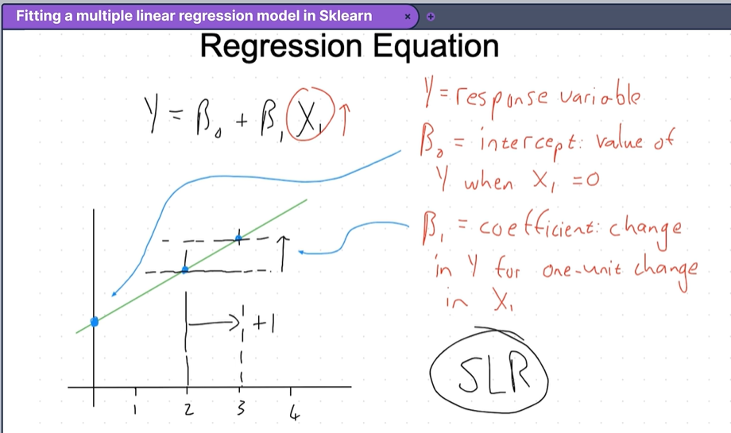
Regression model in multiple dimensions
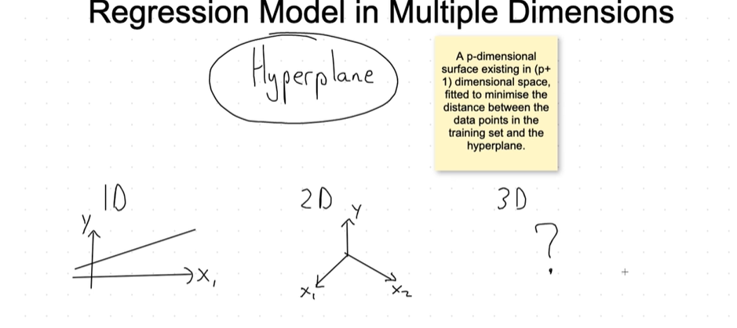
Humans can’t be able to visualise 3D Dimensions, so we need mathematical constricts that will enable us to visualise in 3D.
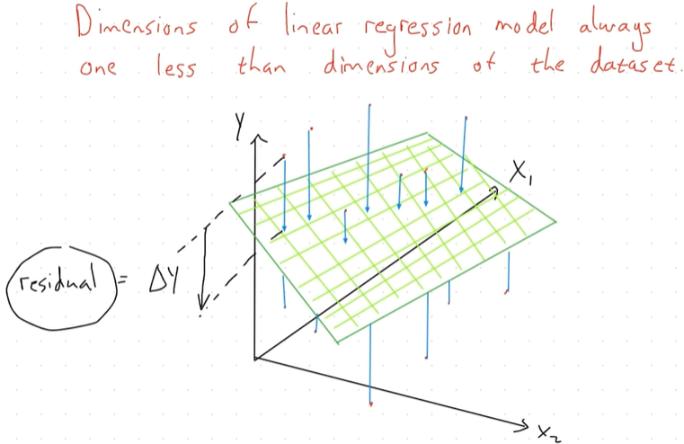

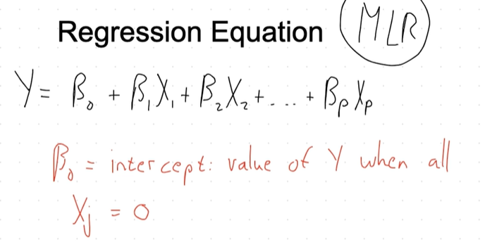

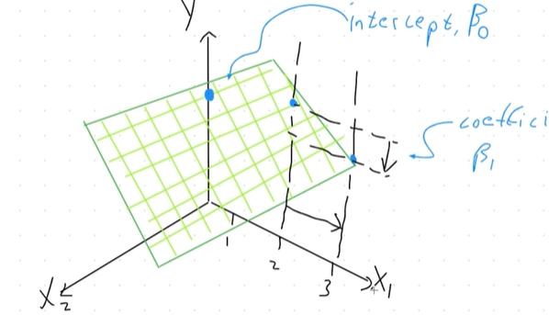
We have two predictor variables, X1 and X2. The place where our plane crosses the y – axis is the intercept of the place. i.e Value of Y when X = 0.
Making a move of 1 unit of the X1 axis, when X1 = 2 and X1 = 3. What is the change in Y, in this case its negative and the coefficient will be negative, hence a negative slope. In this case, it’s going to be
-1. We didn’t include X2 in the calculation.

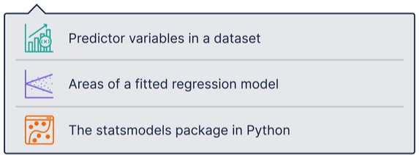
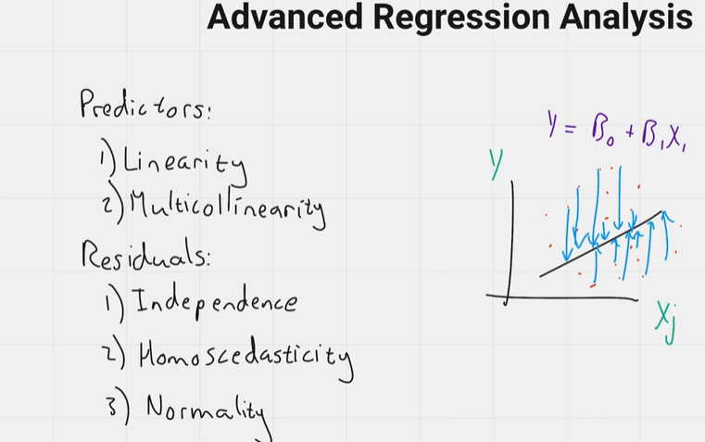
checking whether or not, a multiple linear regression if fit for the model

Advanced Regression Analysis

Introduction
In this tutorial, we are going to break down an advanced regression analysis in the context of multiple linear regression. We will look at the concepts of linearity and multicollinearity regarding the predictor variables in a dataset. Additionally, we will examine the errors of a fitted regression model, known as the residuals, focusing on independence, homoscedasticity, and normality. Finally, we will take a quick look at the output from the stats models package in Python to understand the various parts of this robust statistical methods package.

Linearity of Predictor Variables
When we refer to linearity, we mean the relationship between each predictive variable and the response variable. By definition, linearity means that the change in Y due to a one-unit change in X is constant for all X. If these relationships are not linear, the data in our dataset is nonlinear, and predictions on unseen data will likely not be satisfactory.
Checking for linearity.
Check # 1
To check for linearity among our data, we can produce scatter plots for each predictive variable against the response variable. A linear relationship would appear as a diagonal line sloping from the bottom left to the top right or from the top left to the bottom right. We might produce a grid of scatter plots to quickly observe whether linearity is present among all the predictive variables and the response variable.
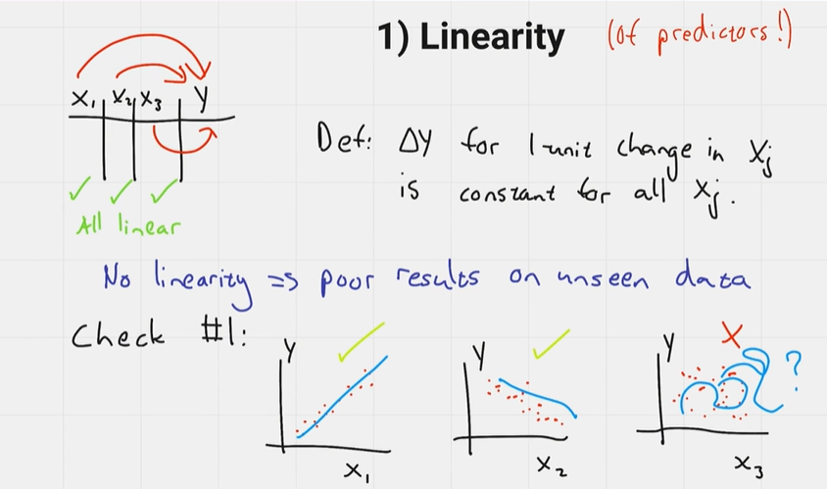

Check # 2
Another common way to check for linearity is to plot the residuals versus the fitted values. In this case, we plot the fitted values on the X-axis and the residuals along the Y-axis. We are looking for a symmetrical distribution that appears to be uniformly random about a horizontal line. We also want to ensure constant variance among the data points, meaning they should not form a funnel shape as we move towards larger fitted values.

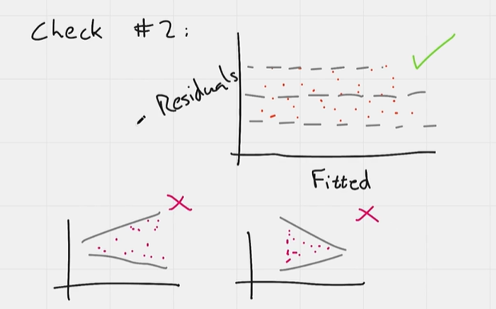
Fixing non-linearity. Log transformation
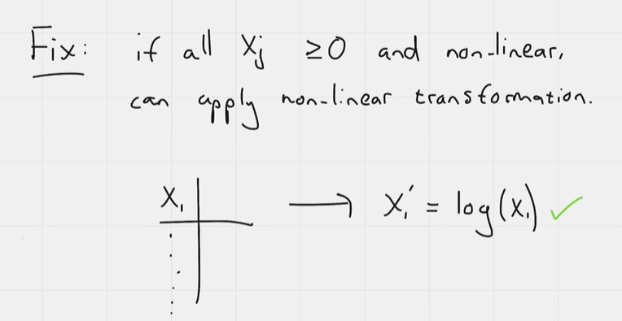

Multicollinearity
Multicollinearity is another phenomenon observed between the predictive variables in the data. It is defined as the correlation between two or more predictive variables. In the presence of multicollinearity, it becomes difficult to determine the true relationship that a predictive variable has with the response variable. For example, it can be challenging to ascertain which variable is contributing to the output observed from our model.
Additionally, the standard errors tend to increase, which in turn widens the confidence intervals for our coefficient estimates. This means we get less precise estimates of the slope parameters in our model.

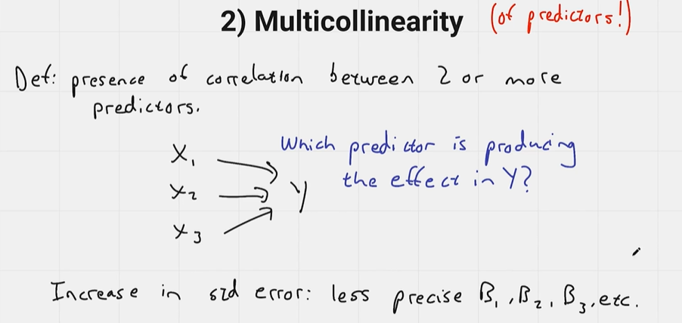

Checking for multicollinearity
One way to check for multicollinearity is to calculate the Variance Inflation Factor (VIF) for each variable. Values of the VIF fall into three categories:
- Between 0 and 5 are perfectly fine.
- Values between 5 and 10 may require attention, potentially leaving only one of the correlated predictor variables.
- Values greater than 10 are considered very large and should almost certainly be removed.
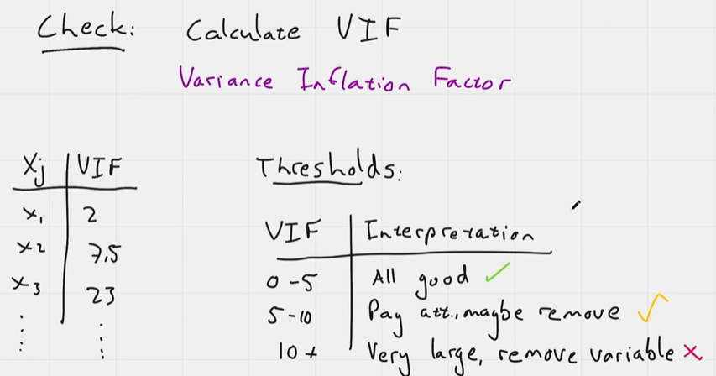
Other ways to look for multicollinearity.
- Pairwise scatter plots
- Correlation heat map (Correlation matrix)

Looking at the errors of the fitted regression model

Independence of Residuals and Autocorrelation
Now that we are aware of the phenomena to look out for among the predictive variables, it’s time to examine the residuals or errors of the fitted regression model. Autocorrelation refers to the correlation between the residuals of the fitted regression model. We are looking for independence, meaning we do not want any correlation among these residuals. Some correlation is particularly problematic in time series models, as it can lead to underestimating the estimated standard error.

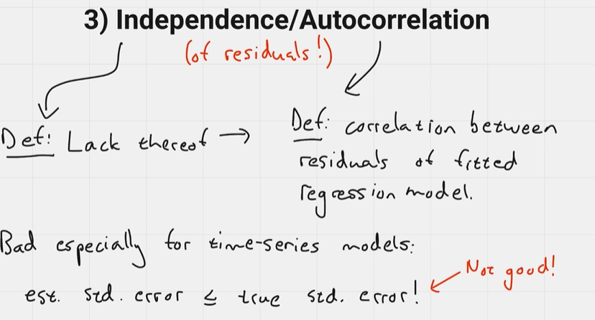
Checking for autocorrelation
To check for autocorrelation, we can plot the residuals versus each predictor variable and observe the shapes that occur. We want the data points to be distributed uniformly and randomly about the 0 X-axis. We should also ensure that the data points do not form specific clusters anywhere on these plots.
Another check we can perform is to calculate the Durbin-Watson statistic (DW statistic). The Durbin-Watson statistic lies between 0 and 4, where values between 0 and 2 indicate positive autocorrelation, values between 2 and 4 indicate negative autocorrelation, and a value of approximately 2 suggests little to no autocorrelation.

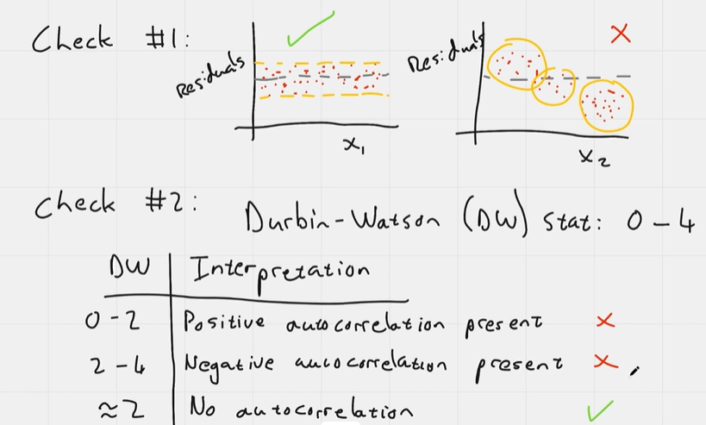

4. Homoscedasticity
Homoscedasticity refers to the constant variance among residuals for all fitted values. Non-constant variance among the residuals is known as heteroscedasticity, which complicates gauging the true standard deviation of the forecast errors. When using our model for prediction, we may lack confidence in the errors.

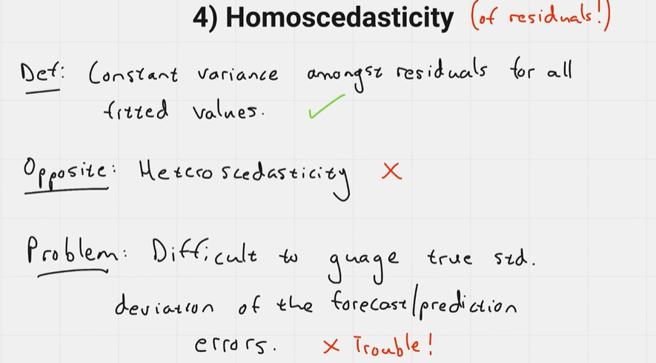

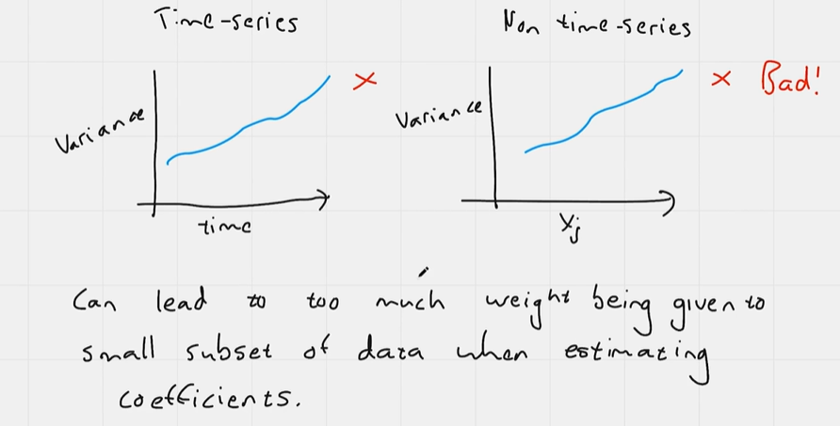

Checking for homoscedasticity
To check for homoscedasticity, we can produce a scatter plot of the response variable values versus the residual values. We are looking for a uniformly random distribution of data points around a horizontal line. The presence of a funnel shape in the data, indicating decreasing density as we move towards the right of the plot, suggests an increase in variance for larger response values.

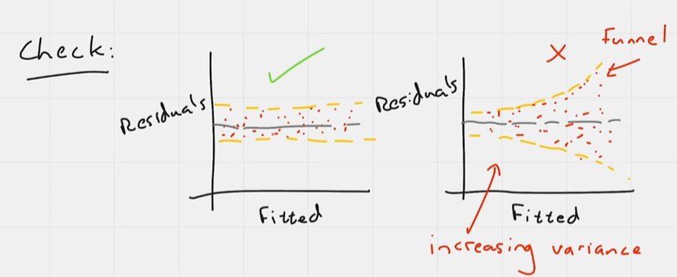
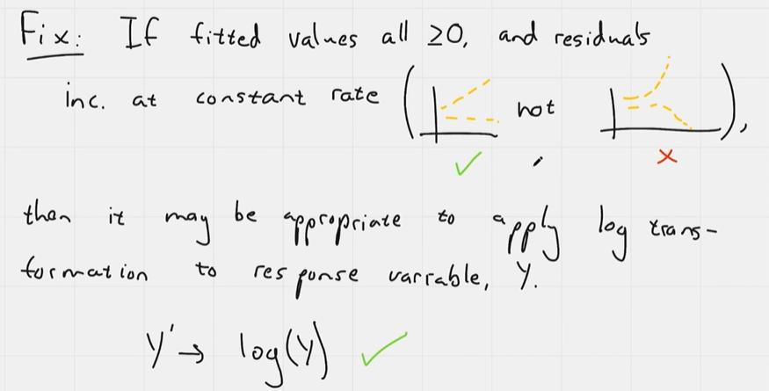

Normality of Residuals
Normality among the residuals is another important assumption in regression analysis. It means that the errors are generated from a normal distribution, albeit with an unknown mean and standard deviation. A lack of normality among the residuals makes it difficult to calculate the confidence intervals for forecasts using the regression model, as they can be too wide or too narrow.

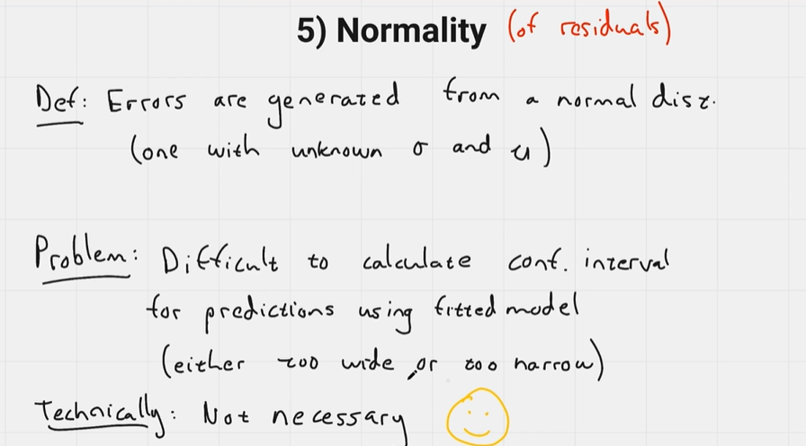

To check for normality among the residuals, we can use several methods:
- Histogram: Plot a histogram of the residuals and check if it approximately follows the shape of the normal distribution curve.
- Quantile-Quantile (QQ) Plot: Create a QQ plot that compares the quantiles from a theoretical normal distribution against the quantiles from our sample distribution. We look for data points that closely follow a 45-degree line, indicating normality.
- Shapiro-Wilk Test: Conduct the Shapiro-Wilk test, which tests the null hypothesis that the data comes from a normal distribution. If the p-value is greater than 0.05, it indicates that the data does indeed come from a normal distribution.
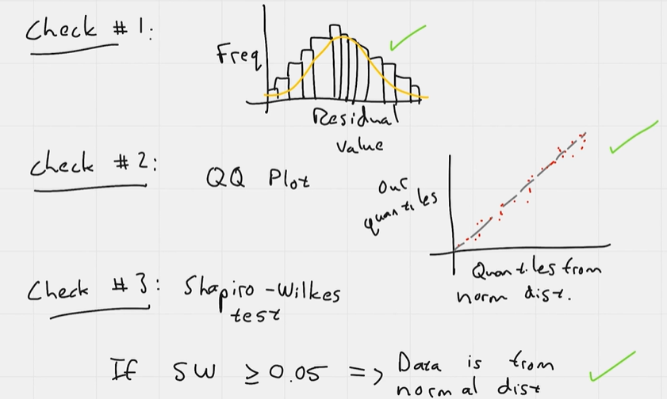

Output of the stats package
The output of the stats models package in Python provides a comprehensive summary of the regression analysis results. Here’s a breakdown of the key components typically found in the output:

Key Components of the Stats Models Output
- Model Information:
  - Model Type: Indicates the type of regression model used (e.g., OLS - Ordinary Least Squares).
  - Dependent Variable: The response variable (Y) that is being predicted.
- R-squared Value:
  - This statistic measures the proportion of variance in the dependent variable that can be explained by the independent variables. It ranges from 0 to 1, where a higher value indicates a better fit.
- Coefficients Table:
  - Coefficients (coef): Estimated values for each predictor variable (β values). These represent the change in the dependent variable for a one-unit change in the predictor variable, holding all other variables constant.
  - P-values: Indicate the statistical significance of each coefficient. A low p-value (typically < 0.05) suggests that the predictor variable is significantly associated with the response variable.
  - Confidence Intervals: Typically shown as two columns (e.g., 0.025 and 0.975), indicating the lower and upper bounds of the 95% confidence interval for each coefficient.
- Statistical Tests:
  - F-statistic: Tests the overall significance of the model. It assesses whether at least one predictor variable has a non-zero coefficient.
  - Prob (F-statistic): The p-value associated with the F-statistic. A low value indicates that the model is statistically significant.
- Residual Statistics:
  - Durbin-Watson statistic: Tests for autocorrelation in the residuals. Values close to 2 suggest no autocorrelation, while values below 2 indicate positive autocorrelation and values above 2 indicate negative autocorrelation.
- Warnings:
  - Any warnings related to the model fit, such as potential multicollinearity issues, will be printed at the bottom of the output.
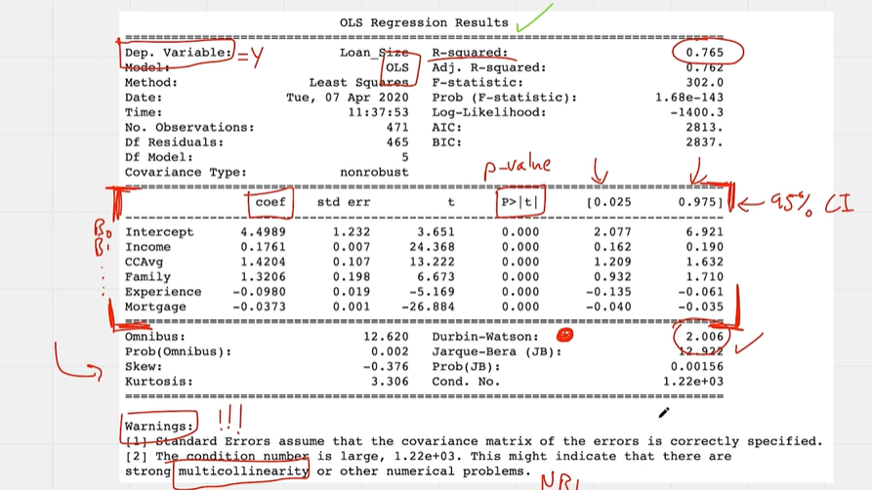
The output from the stats models package provides essential information for interpreting the results of a regression analysis. By examining the coefficients, p-values, R-squared value, and residual statistics, you can assess the model's fit and the significance of the predictor variables.

Conclusion
In conclusion, understanding these concepts is crucial for determining whether a linear regression model is appropriate for your dataset. By checking for linearity, multicollinearity, autocorrelation, and homoscedasticity, you can ensure that your regression analysis is robust and reliable. After reviewing this video and the accompanying notebook, you should feel more comfortable carrying out regression modeling using the stats models package in Python.

What are the key assumptions of multiple linear regression discussed in the video?
The key assumptions of multiple linear regression discussed in the video include:
- Linearity: The relationship between each predictor variable and the response variable should be linear. This means that a one-unit change in a predictor variable should result in a constant change in the response variable across all values of the predictor.
- Independence: The residuals (errors) of the model should be independent of each other. This is particularly important in time series models, where correlation among residuals can lead to underestimation of the standard error.
- Homoscedasticity: The residuals should have constant variance across all levels of the independent variables. If the variance of the residuals changes (heteroscedasticity), it can affect the reliability of the coefficient estimates and the confidence intervals.
- Normality of Residuals: The residuals should be normally distributed. This assumption is important for calculating confidence intervals and conducting hypothesis tests. While normality is not strictly necessary for estimating coefficients, it is important for inference.
- No Multicollinearity: The predictor variables should not be highly correlated with each other. Multicollinearity can make it difficult to determine the individual effect of each predictor on the response variable and can inflate the standard errors of the coefficients.
These assumptions are crucial for ensuring that the results of the multiple linear regression analysis are valid and reliable. If any of these assumptions are violated, it may be necessary to take corrective actions, such as transforming variables or using different modelling techniques.

How can I visually assess the linearity between predictor variables and the response variable?
You can visually assess the linearity between predictor variables and the response variable using the following methods:
- Scatter Plots:
  - Create scatter plots for each predictor variable against the response variable. In these plots, the predictor variable is on the x-axis and the response variable is on the y-axis.
  - Look for a linear pattern in the data points. A linear relationship would appear as a diagonal line (either sloping upwards or downwards) rather than a random scatter of points.
- Residuals vs. Fitted Values Plot:
  - After fitting a regression model, plot the residuals (errors) against the fitted values (predicted values).
  - In this plot, the fitted values are on the x-axis and the residuals are on the y-axis.
  - You should look for a random distribution of points around the horizontal line at zero. If you see a clear pattern (like a curve), it suggests that the relationship may not be linear.
- Pair Plots:
  - If you have multiple predictor variables, you can create a pair plot (or scatterplot matrix) that shows scatter plots for each pair of variables.
  - This allows you to visually inspect the relationships between all predictor variables and the response variable simultaneously.
- Linearity Check with Transformation:
  - If the scatter plots indicate non-linearity, you might consider applying transformations (like log or polynomial transformations) to the predictor variables and then re-evaluating the scatter plots.
These visual assessments help in determining whether the assumptions of linearity are met before proceeding with the regression analysis , .

What role do residuals play in evaluating the performance of a regression model?
Residuals play a crucial role in evaluating the performance of a regression model for several reasons:
- Assessment of Model Fit:
  - Residuals are the differences between the observed values and the predicted values from the regression model. Analyzing these residuals helps assess how well the model fits the data. Ideally, residuals should be randomly distributed around zero, indicating that the model captures the underlying relationship well.
- Checking Assumptions:
  - The analysis of residuals is essential for checking the assumptions of linear regression, including:
    - Linearity: A plot of residuals versus fitted values should show no discernible pattern. If a pattern exists, it suggests that the relationship may not be linear.
    - Homoscedasticity: Residuals should have constant variance across all levels of the independent variables. A funnel shape in the residual plot indicates heteroscedasticity, which can affect the reliability of the model.
    - Independence: Residuals should be independent of each other. In time series data, autocorrelation in residuals can indicate that the model is not capturing all relevant information.
- Normality of Residuals:
  - For valid hypothesis testing and confidence interval estimation, residuals should ideally be normally distributed. This can be assessed using histograms or quantile-quantile (Q-Q) plots. Non-normality can affect the validity of statistical inferences made from the model.
- Identifying Outliers and Influential Points:
  - Analyzing residuals can help identify outliers or influential data points that may disproportionately affect the model's estimates. Large residuals may indicate observations that do not fit the model well and could be investigated further.
- Model Improvement:
  - By examining residuals, you can identify areas where the model may be improved, such as by adding interaction terms, polynomial terms, or transforming variables to better capture the relationship between predictors and the response variable.
In summary, residuals are a key diagnostic tool in regression analysis, providing insights into the model's performance, the validity of its assumptions, and opportunities for improvement , , .

