MCQS
- A data scientist applies Lasso regularization (L1) to a multiple linear regression model in an attempt to improve model performance. After tuning the regularization strength, they observe that several coefficients of predictor variables have been reduced to zero. What does this outcome indicate about the affected predictor variables?
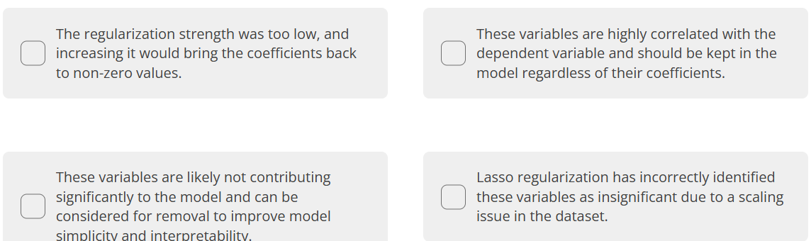
- What does RSS stand for?
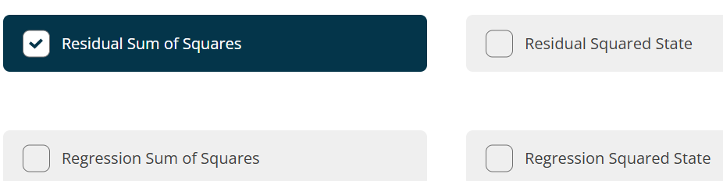
- Compare the three models below:
Model 1: train MSE = 0.423, test MSE = 0.978 Model 2: train MSE = 0.572, test MSE = 0.644 Model 3: train MSE = 0.218, test MSE = 1.103
Based on this information, which of these models generalises the best to unseen data?
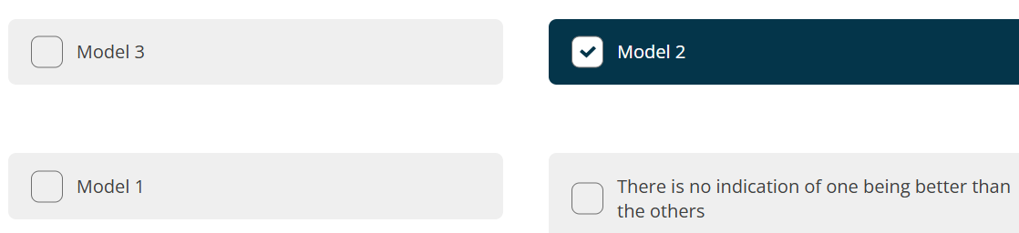

- Compare the three models below:
Model 1: train MSE = 0.323, test MSE = 0.812 Model 2: train MSE = 0.682, test MSE = 0.694 Model 3: train MSE = 0.257, test MSE = 1.112
Based on this information, which of these models generalises the worst to unseen data?
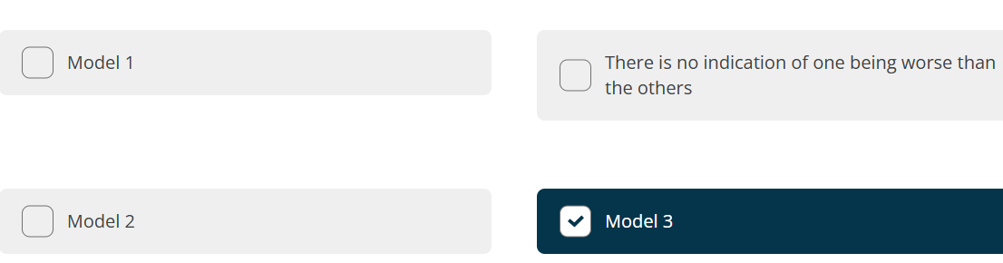
- When adding more variables to a linear model, what is true about the R-squared value?
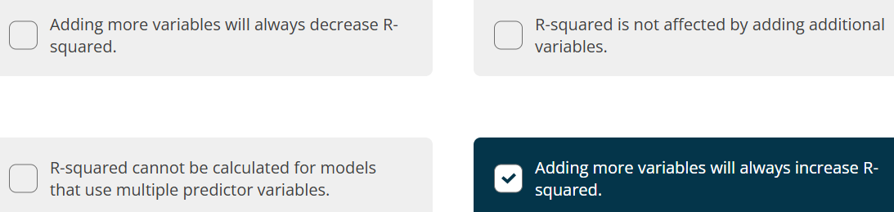
7.
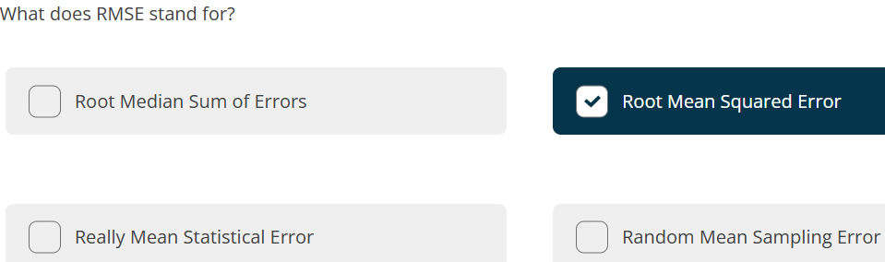

8.
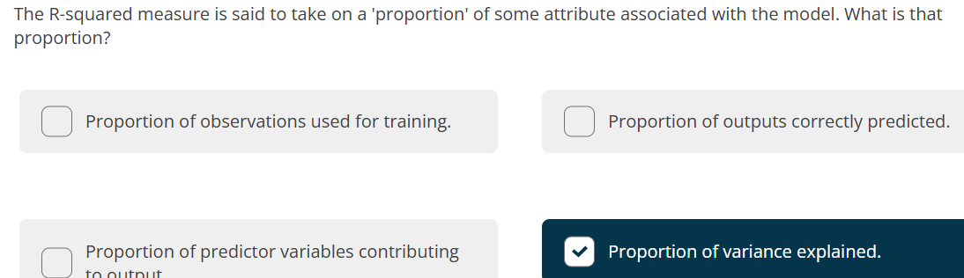
9.

10

