Summary

Natural Language Processing: How Machines Learn Language
Welcome! In this document, we will explore the fascinating world of Natural Language Processing (NLP) and how machines learn to understand language.
We'll start by cleaning and preparing text data, including removing noise, tokenization, stemming, and lemmatization. Then, we'll move on to feature extraction methods like N-grams and the Bag of Words model. By the end, you'll have a solid understanding of how to handle and process text data for machine learning applications. Let's embark on this enlightening journey together!
Here are three example questions you can ask about this topic:
- What are the key techniques used in text cleaning for Natural Language Processing?
- Can you explain the difference between stemming and lemmatization?
- How does the Bag of Words model work in feature extraction?

Introduction to Text Cleaning
The first section will focus on text cleaning and how we filter out unstructured text data. We will look at the removal of noise and punctuation, followed by tokenization.

Tokenization
Tokenization is the process of splitting a phrase, sentence, or paragraph into smaller units, known as tokens. These tokens are typically individual words, but they can also include punctuation marks or other elements.

Stemming and Lemmatization
Next, we will discuss stemming and lemmatization methods for your corpus of text. Stemming is the process of mapping each word in the document to its root form, while lemmatization involves performing a morphological analysis to reduce each word to its lemma.

Stop Words
We will also cover stop words, which are words that do not add significant value to the data. These include common words like "and," "is," and "on." Removing stop words helps to streamline the analysis.

Feature Extraction
The next section will focus on feature extraction, specifically how we create features from the words in our text data. We will first look at the N-grams method, which involves splitting text into groups of words, and then move on to the simpler Bag of Words model.

N-grams Method
The N-grams method takes a single argument, N, and scans through each document in the corpus, splitting the text into groups of words that contain the specified number of words. For example, given the sentence "Papa John loves data science" and a value of N = 2, the resulting N-grams would be: "Papa John," "John loves," "loves data," and "data science."

Bag of Words Model
The Bag of Words model creates a list or group of all the individual words that appear in the corpus. It is a special case of the N-grams method where the value of N is set to 1. This method results in binary and categorical features that can be used in various NLP problems.

Conclusion
In conclusion, we have covered essential techniques for handling, processing, and propagating text data for machine learning problems involving text and language data. These methods are crucial for preparing unstructured text data for analysis and model training.
Thank you for joining us on this journey into Natural Language Processing!

In-depth study

Natural Language Processing: How Machines Learn Language
In this document, we will explore something quite different from the numerical and categorical features we have been accustomed to. We will learn about an area called Natural Language Processing (NLP).

Text Cleaning
The first section will focus on text cleaning and how we filter out unstructured text data by looking at the removal of noise and punctuation. We will also discuss tokenization, stemming, and lemmatization methods for your corpus of text. Additionally, we will cover stop words.
Text data is considered unstructured and typically requires considerable preprocessing. Depending on the data source, we may need to remove elements such as at handles from social media, web addresses, spelling errors, email addresses, and other associated characters and symbols. We also need to remove punctuation like colons, semicolons, commas. etc
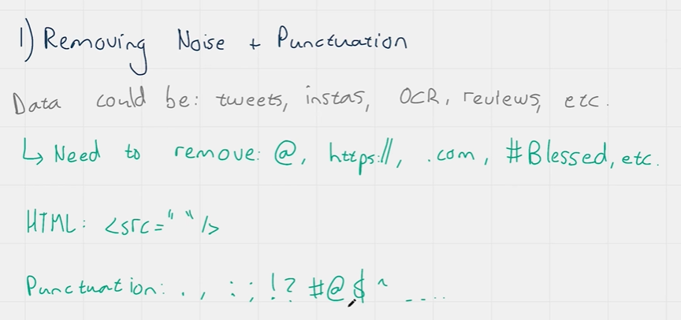

Noise can also be introduced through the process of scraping information, which may unintentionally include HTML artifacts, tags, and even JavaScript code that won't be useful for our analysis.
One of the more effective ways to remove all these unwanted items is to use what is known as a regular expression commonly known as a regex. A regex is a sequence of characters that we can use to define a search pattern or search condition and when paired with useful find and replace methods in Python, regex can be a very effective and very efficient way of matching and removing the unwanted symbols and terms that we have in messy and noisy text data.
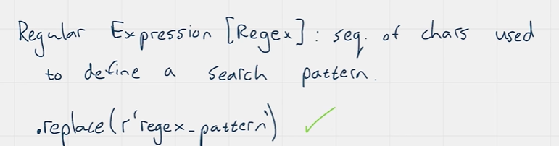
A common regex search pattern to remove decimal numbers might look like this:
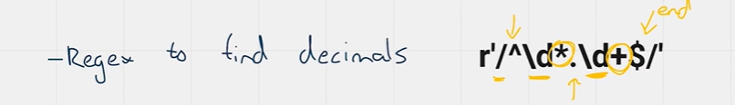

The slash starts the pattern, and the hat means what follows must be at the beginning of the pattern, we then use a back slash and a d which are considered together to mean digit, and the * that follows the back slash d means that that number must end the section of the string. In other words, the section before the dot in the middle of the string. After the dot we have another back slash d for a digit followed by a plus which means that one or more digits must be matched and the dollar symbol means that what precedes that dollar symbol must be the end of the string.
Here's another common regex search pattern to remove common e-mail addresses:
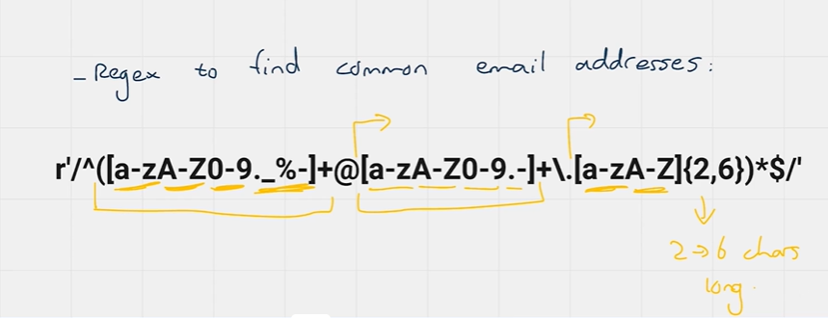
The section before the @ symbol can contain any number of letters in both lower and uppercase digits from zero to 9 as well dot, slashes, underscores and percentage symbols and then after @, the pattern is quite similar but with just dots and dashes allowed for the domain names and then after the dot, then comes the top-level domain which can contain only letters between 2 and 6 characters in length.
Capitalization can also be considered a type of noise in our data and therefore another step in the noise removal process may be to convert all uppercase letters to lowercase.

Tokenization
Tokenization is the process of splitting a phrase, sentence, or paragraph into smaller units, known as tokens. Each of these units is called a token. Most tokens will be individual words, but they can also include punctuation marks or other elements. The process of tokenization is effectively a comprehensive use of regular expressions (regex) to find, and match known words and phrases in the document and split them accordingly.
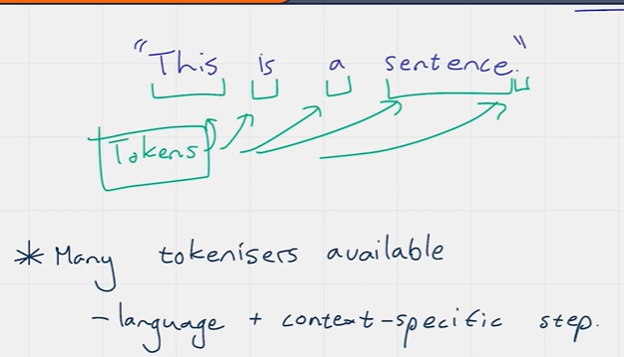
Tokenization is very language and context-specific, so we have many different types of tokenizers from which we can choose the most suitable for our task.
For instance, we might have a tweet tokenizer, a French language tokenizer, or an English language tokenizer, each of which would tokenize the document into appropriate tokens based on the context.

Stemming and Lemmatization

Stemming
The simplest way to describe stemming is as the process of mapping each word in the document to its root word or root form. The root form of a word is the common base from which all variations derived but there is a chance that it may not be a word of itself.
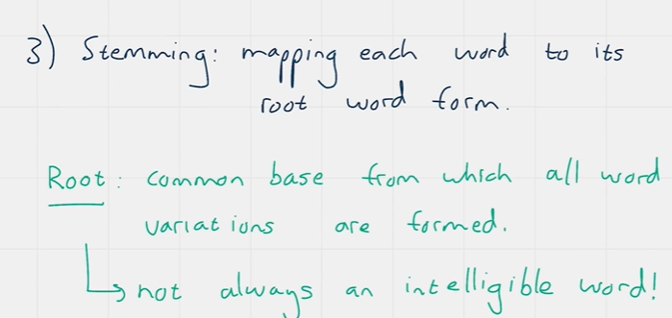
For example, we might map the words "difference," "differentiates," "different," and "differ" all to the root form "differ."
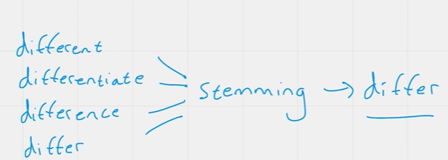
Stemming is highly dependent on the context of the documents, and the process of mapping words to their root forms can lead to significant losses in precision.
For example, the word "operate" (verb) is very different from "operative" (noun), which in turn is different from "operation" (noun). They would all likely be stemmed to the word "oper," which reduces meaning in at least two of those cases.
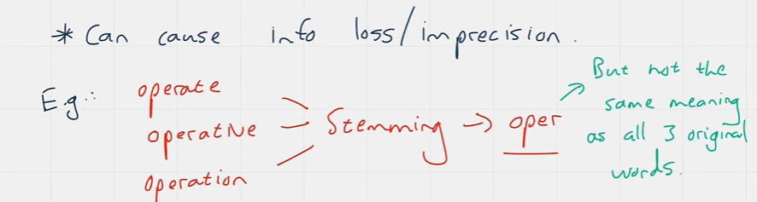
There are multiple stemming libraries and algorithms available, and the best approach in an NLP task is to test a few different stemming algorithms to see which one results in the most appropriate forms for your documents.
Lemmatization
Technically speaking, lemmatization is the process of performing a morphological analysis on each word in the document with the intention of reducing each word to its lemma. An intuitive way to think about lemmatization is as a dictionary lookup. For example, the words "good," "better," and "best" are all inflectional variations of the word "good," which is the lemma of those three.
The lemmatization process sometimes aggressively modifies each word, removing all prefixes and suffixes to get to its root meaning. This is where lemmatization differs from stemming, as stemming does not always return a word that is considered part of the language in question, while lemmatization always does.
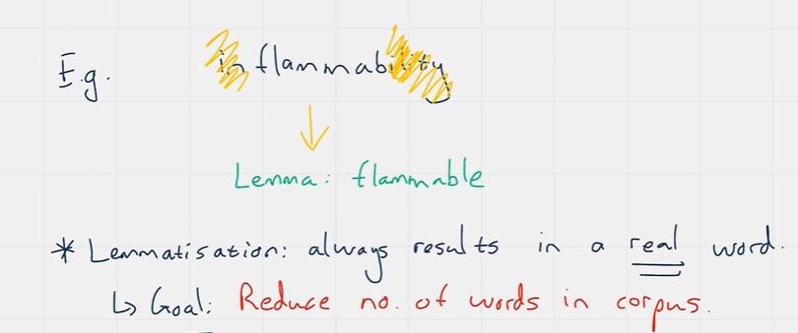
The role of lemmatization in NLP is essentially to reduce or simplify the number of different words that we have in the corpus.

Stop Words
Stop words are those words in our corpus that do not add any value by their presence in the data. There are quite a lot of stop words, and typically we can think of them as words that can be changed to a different version without losing any information about the data point or document. Another way to think of them is as words that everyone uses to put together sentences in a sensible way. Examples include "is," "on," "off," "because" and "about." We remove them because they are considered superfluous.

Feature Extraction
NLP problems need features too, just like the continuous and categorical features we have become familiar with during regression. There are two primary ways to extract and set up individual features from our corpus of text data.
The N-grams method takes a single argument, N, and scans through each document in the corpus, splitting the text into groups of words that contain the specified number of words. For example, given the sentence "Papa John loves data science" and a value of N = 2, you would end up with the following N-grams: "Papa John," "John loves," "loves data," and "data science."
Once we have the N-grams, the next step is to turn each of those N-grams into an individual column in the dataset, making it a feature. We then place a 0 or 1 in that column for each document, depending on whether the N-gram actually appears.
Typically, when we create N-gram features, we use an N-gram range. For example, if we specify an N-gram of 1 to 3, we will get a list of features that contain all of the one-word, two-word, and three-word sequential combinations of words from our corpus. The N-grams are not simply all combinations of N words in the document; rather, they are only those combinations of N words in the order that they appear.
The Bag of Words method is exactly what it sounds like; it creates a list or group of all the individual words that appear in the corpus. The Bag of Words method is actually just a special case of the N-grams method where the value of N is set to 1. This method results in binary and categorical features that we can then use in our NLP problems.

Conclusion
In summary, we have covered essential techniques for handling, processing, and propagating text data for machine learning problems involving text and language data. These methods are crucial for preparing unstructured text data for analysis and model training.
Thank you for joining us on this journey into Natural Language Processing!

