LAB Logbook

Lab 1
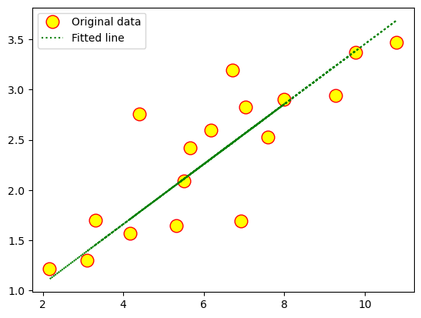
Lab 2
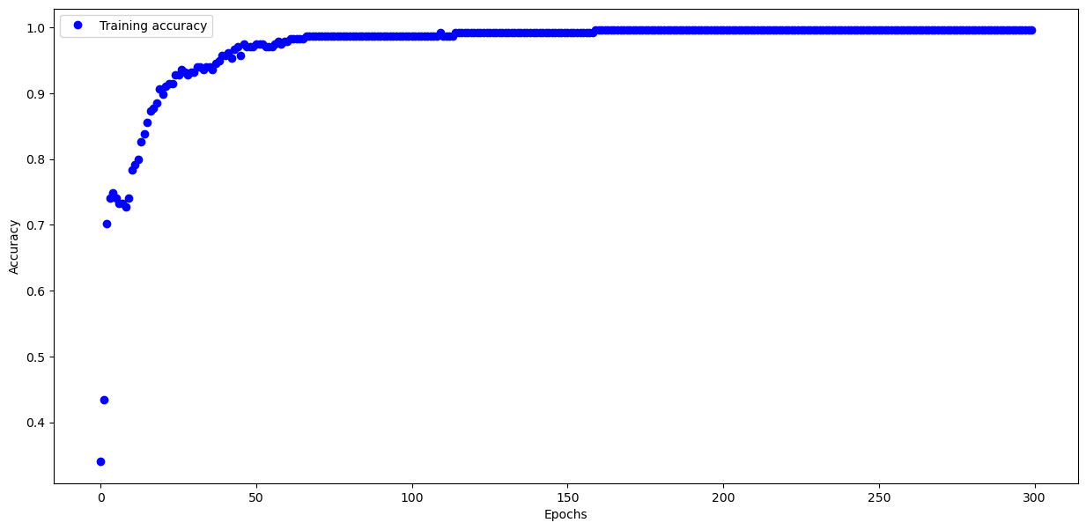

Test Accuracy: 0.940
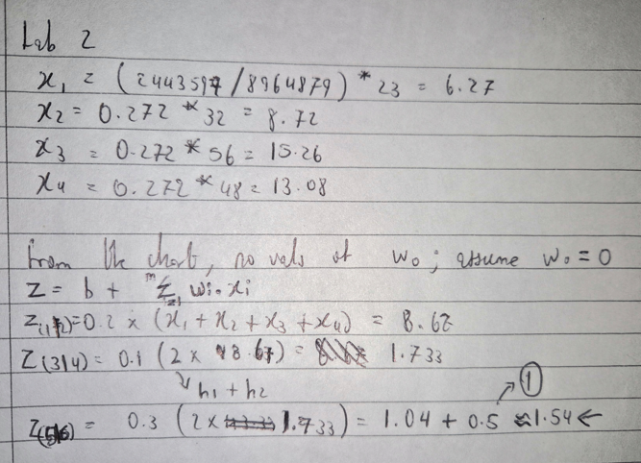
Z = 1.54 (approx.)

Lab 3
Model Accuracy: 0.8862000107765198
Model: "sequential"
┏━━━━━━━━━━━━━━━━━━━━━━━━━━━━━━━━━┳━━━━━━━━━━━━━━━━━━━━━━━━┳━━━━━━━━━━━━━━━┓
┃ Layer (type) ┃ Output Shape ┃ Param # ┃
┡━━━━━━━━━━━━━━━━━━━━━━━━━━━━━━━━━╇━━━━━━━━━━━━━━━━━━━━━━━━╇━━━━━━━━━━━━━━━┩
│ flatten (Flatten) │ (None, 784) │ 0 │
├─────────────────────────────────┼────────────────────────┼───────────────┤
│ dense (Dense) │ (None, 120) │ 94,200 │
├─────────────────────────────────┼────────────────────────┼───────────────┤
│ dense_1 (Dense) │ (None, 10) │ 1,210 │
└─────────────────────────────────┴────────────────────────┴───────────────┘
Total params: 286,232 (1.09 MB)
Trainable params: 95,410 (372.70 KB)
Non-trainable params: 0 (0.00 B)
Optimizer params: 190,822 (745.40 KB)

Lab 4

Lab 5

Lab 6

Lab 7

Lab 8

Lab 9

Lab 10

Lab 11

Lab 12

Github:

