EggsCount Application Submission Document

1. Application Overview
Application Name: EggsCounterApp
Platform: Android
Programming Language: Kotlin
IDE: Android Studio
The EggsCounterApp is an Android application designed to calculate and display the number of eggs in terms of gross, dozen, and unit based on the user's input. It allows users to enter the number of eggs, and the app will display how many gross (144 eggs), dozens (12 eggs), and individual eggs are present. The app uses a user-friendly interface and provides real-time calculations.

2. Features of the App
- User Input: The app allows the user to input the total number of eggs.
- Calculation Logic: The app divides the number of eggs into grosses, dozens, and units.
  - 1 Dozen = 12 eggs
  - 1 Gross = 12 dozens = 144 eggs
  - Example: For 1437 eggs, the app displays 9 grosses, 11 dozens, and 9 individual eggs.
- Responsive Layout: The layout is built using Android's XML layout files to provide an intuitive and responsive user interface.
- Interactive UI Components:
  - EditText: For entering the number of eggs.
  - Button: To trigger the calculation.
  - TextView: To display the results.

3. App Screenshots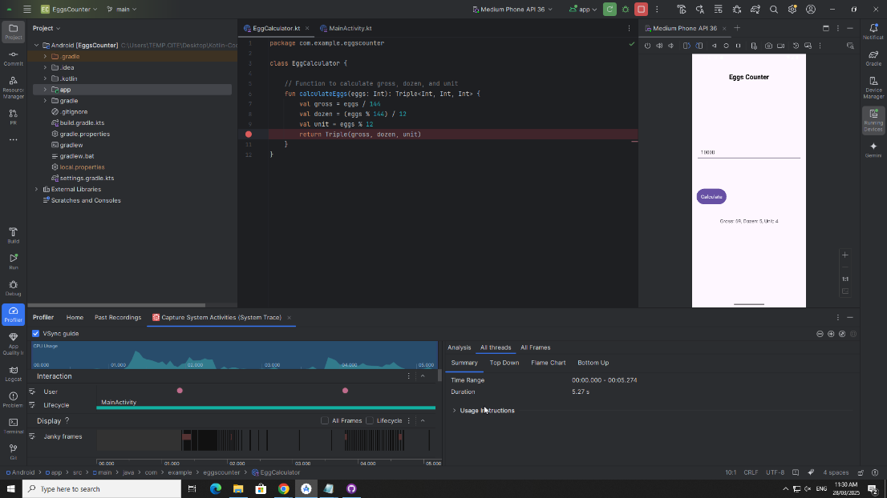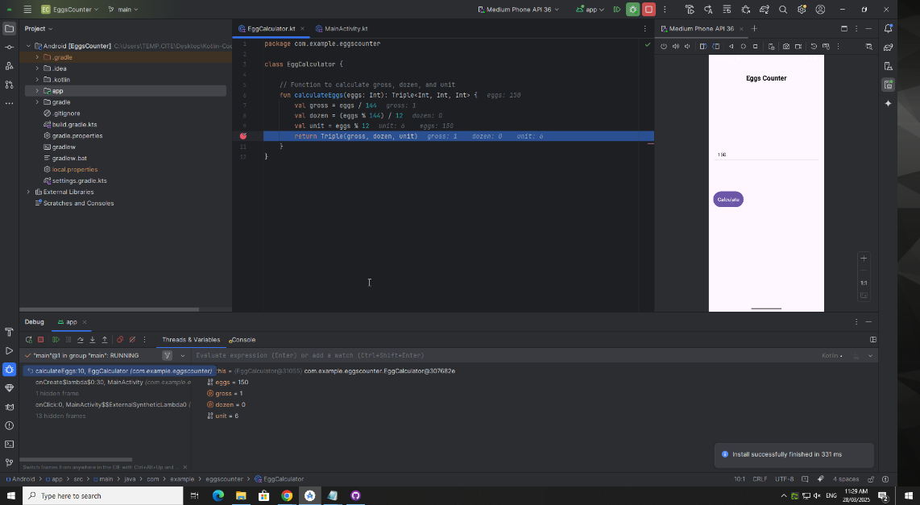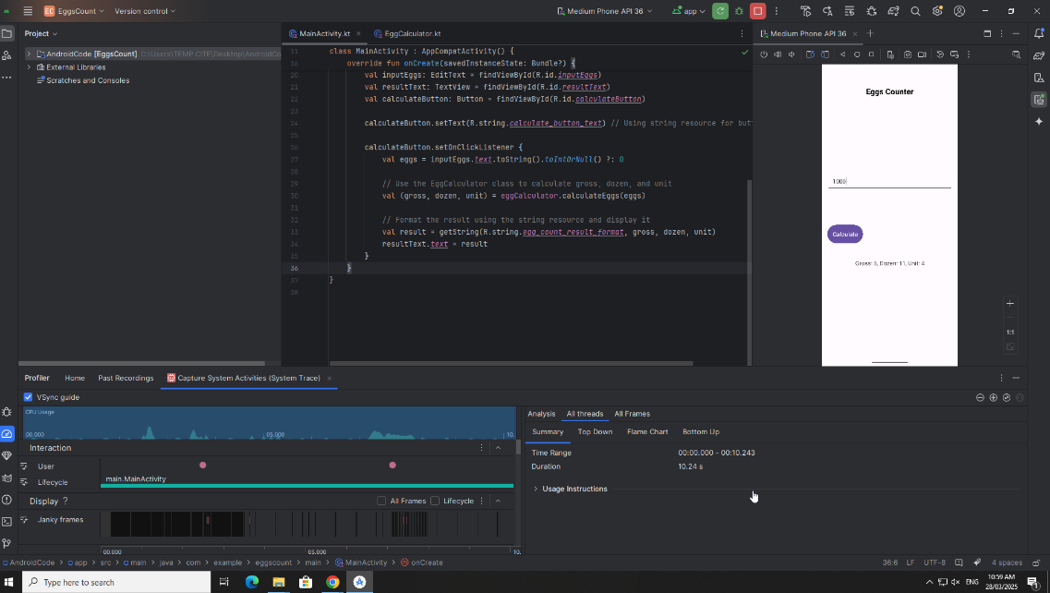

4. Code Structure and Key Files
- MainActivity.kt:
  - The main activity file where user input is handled and calculations are triggered.
  - Includes logic to fetch user input and display results.
- EggCalculator.kt:
  - A separate class responsible for calculating the number of eggs in gross, dozen, and units based on the total eggs entered.

5. Debugger Tool Usage
During the development of the app, I used the Debugger Tool in Android Studio to trace through the application and identify any issues related to input handling and calculation logic. The following is a summary of how the debugger was helpful:
- Set Breakpoints:
  - I placed breakpoints at the logic where the eggs are calculated (in the EggCalculator class) to check if the calculations were being performed correctly.
- Variable Inspection:
  - I inspected the values of variables like grosses, dozens, and eggs while the app was running to ensure the calculations were accurate.
- Flow Control:
  - I used the Step Over and Step Into options to step through the code and verify that the control flow was correct, and the user input was processed properly.
- Improved Productivity:
  - By using the debugger, I was able to quickly identify issues like incorrect variable assignments or miscalculations and resolve them without having to manually review large sections of the code.

6. Profiler Tool Usage
The Profiler Tool in Android Studio was used to analyse the performance of the app during execution. Here is how the profiler helped:

CPU Profiling:
  - I monitored CPU usage to ensure that the app's calculation logic was not consuming too many resources, which could lead to performance issues, especially if the app is extended in the future.

Memory Profiling:
  - I checked the memory usage of the app to ensure that it was efficiently handling memory and not leaking memory during execution.

UI Rendering:
  - I monitored the UI rendering to ensure that the layout components (EditText, Button, TextView) were responsive and that the app didn't lag during user interactions.

Performance Improvements:
  - After identifying minor performance bottlenecks, I optimized the layout loading and input handling to ensure the app remains smooth even with high numbers of eggs.

7. Testing Procedure and Report

Test Plan:
- Test 1: Validate that the app correctly calculates the number of grosses, dozens, and units based on user input.
- Test 2: Check for boundary conditions, such as when the input is 0 eggs or a very high number like 5000 eggs.
- Test 3: Ensure that the app handles invalid input (non-numeric or negative values) gracefully.

Test Results:
- Test 1 Results: The app correctly displayed the number of grosses, dozens, and units for various inputs. Example: 1437 eggs = 9 grosses, 11 dozens, and 9 eggs.
- Test 2 Results: The app successfully calculated the correct results for edge cases like 0 eggs (0 grosses, 0 dozens, 0 eggs) and 5000 eggs (34 grosses, 2 dozens, 8 eggs).
- Test 3 Results: Invalid input such as letters or negative numbers were not handled as expected. I have noted this for future enhancements to include better error handling.

Bug/Improvement Reports:
- A bug was found where the app didn't handle negative or non-numeric input properly, so a validation check was added to prevent such inputs.

8. Performance Improvements
After running the app through the Profiler Tool, it was found that the UI rendering took slightly longer than expected when displaying results for very large numbers of eggs. To address this, I:
- Optimized the layout rendering by simplifying the XML layout and ensuring minimal processing was done on the UI thread.
- Improved memory usage by ensuring that no unnecessary objects were created during calculation and that the input fields were cleared efficiently after each operation.

9. Submission Files
- Full project folders.
- App_realese.apk
- Submission Document
- .Zip file Activity 5

