CarStorage Application - Submission Document

Project Overview

Description:
CarStorage is a vehicle management system designed to track and manage a collection of cars efficiently. Users can add, remove, and update car records, search for specific vehicles, and maintain a structured database of stored cars. The system ensures unique identifiers for each car and provides features for viewing and modifying details.

Key Components:
- Car: Represents individual vehicles with attributes like make, model, year, registration number, and storage location.
- StorageUnit: Represents different storage units where cars are kept.
- Main Application: Manages the overall operation of adding, searching, updating, and deleting cars from the system.

Functional Requirements

1. Unique Car IDs
Each car has a unique identifier generated automatically upon creation to avoid duplicate records.

2. Car Management
- Users can add new cars to the system.
- Users can remove cars from the system.
- Users can update car details (e.g., owner, storage unit, or status).
- Users can search for cars using various attributes.

3. Storage Management
- Cars are assigned to specific storage units.
- Storage units have limited capacity and cannot exceed their maximum allowed cars.

4. Search and Filter Options
- Users can search for cars by make, model, year, or registration number.
- Filtering options allow viewing cars in specific storage units or by specific attributes.

5. Data Persistence
- Car and storage unit information is stored in a database or file system to ensure data is saved between sessions.

6. Error Handling
- The system prevents duplicate car entries.
- Attempts to exceed storage capacity trigger an error message.
- Users cannot remove cars that do not exist in the system.

Non-Functional Requirements

1. Object-Oriented Design
The system follows an object-oriented approach, ensuring modularity and maintainability. Classes interact through well-defined methods and encapsulate their respective functionalities.

2. Implementation
- Language: Kotlin
- IDE: IntelliJ IDEA
- Execution: Runs via JAR file and batch script

3. Performance
- Optimized for fast search and retrieval of car data.
- Scalable to support multiple storage units and thousands of cars.

Object Interaction

Class: Car

Properties:
- make: String
- model: String
- year: Int
- registrationNumber: String (Unique)
- storageUnit: StorageUnit?

Methods:
- assignStorage(unit: StorageUnit)
- updateDetails(newDetails: Car)
- removeFromStorage()

Class: StorageUnit

Properties:
- name: String
- capacity: Int
- currentCars: List

Methods:
- addCar(car: Car)
- removeCar(car: Car)
- isFull(): Boolean

Class: CarStorageSystem

Methods:
- addCar(car: Car)
- removeCar(registrationNumber: String)
- updateCarDetails(registrationNumber: String, newDetails: Car)
- searchCarByAttribute(attribute: String, value: Any): List
- viewAllCars(): List

Screenshots

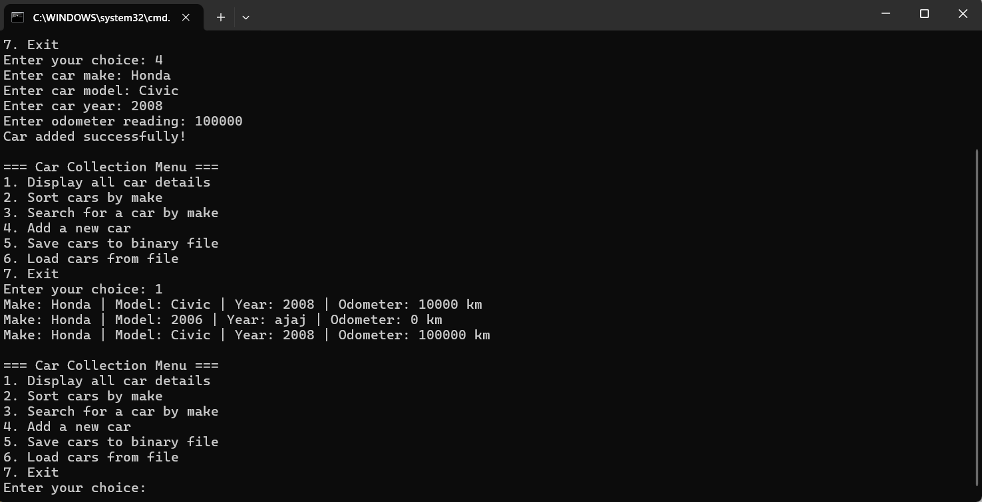

Implementation
- Language: Kotlin
- IDE: IntelliJ IDEA
- Execution: Runs via JAR file and batch script.

How to Run
- JAR File: java -jar CarStorage.jar
- Batch Script: Double-click run.bat

Files Submitted
- src/ Car.kt
- src/ StorageUnit.kt
- src/ CarStorageSystem.kt
- src/ Main.kt
- CarStorage.jar (Executable)
- run.bat (Batch Script)
- SubmissionDocument.docx (This document)
- CarStorage.zip (Final Submission)

