**2**

**Programming with Java Statements**

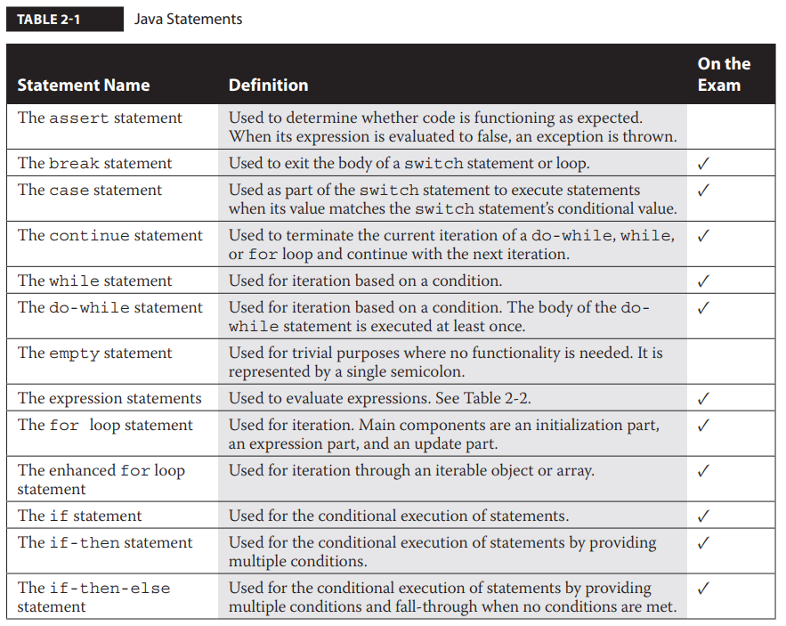

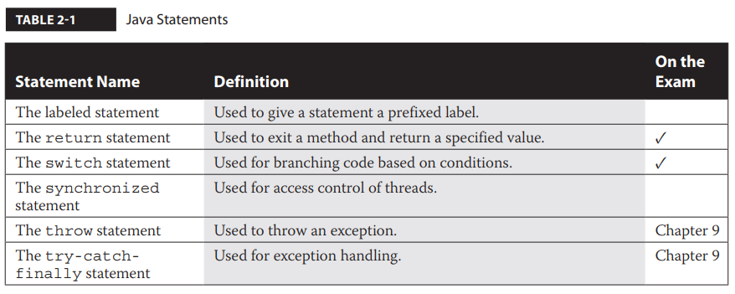

Expression statements are used for the evaluation of expressions. The assignment expression statements allow assignments to be performed on variables.

Conditional statements, also known as decision statements, assist in directing the flow of control when a decision needs to be made. Conditional statements include the if, if-then, if-then-else, and switch statements.

Iteration statements provide support in looping through blocks of code. Iteration statements include the for loop, the enhanced for loop, the while statement, and the do-while statement.

Transfer of control statements provide a means of stopping or interrupting the normal flow of control. Transfer of control statements include the continue, break, and return statements. Transfer of control statements are always seen within other types of statements.

**Understand Assignment Statements**

An assignment statement sets a value within a variable. All assignment statements are considered to be expression statements. Expressions in Java are anything that has a value or is reduced to a value. All expressions can be used as statements; the only requirement is that they end with a semicolon.

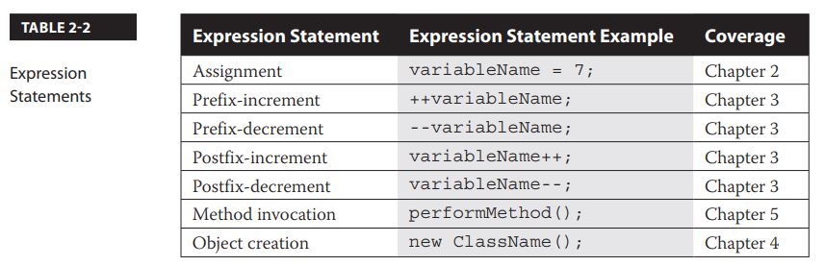

**The Assignment Expression Statement**

Assignment statements, are designed to assign values to variables. All assignment statements must be terminated with a semicolon.

*variable* = *value*;

On the left is the variable that will be associated with the memory and type necessary to store the value. On the right is a literal value. If an expression is on the right, such as (1+2), it must be evaluated down to its literal value before it can be assigned. Lastly, an equal sign resides between the variable and value of an assignment statement.