Delayed effects of [responses to?] climate lead to demographic divergence in a fragmented Amazonian landscape

Eric R. Scott1,✉, Maria Uriarte2, and Emilio M. Bruna1,3,4

03 March, 2021

Text of abstract

1 Department of Wildlife Ecology and Conservation, University of Florida, Gainesville, Florida 32611-0430  
2 Department of Ecology, Evolution and Environmental Biology, Columbia University 1200 Amsterdam Avenue, New York, New York 10027 USA  
3 Center for Latin American Studies, University of Florida, Gainesville, Florida 32611-5530  
4 Biological Dynamics of Forest Fragments Project, INPA-PDBFF, CP 478, Manaus, Amazonas 69011-970 Brazil

✉ Correspondence: [Eric R. Scott <[scottericr@gmail.com](mailto:scottericr@gmail.com)>](mailto:scottericr@gmail.com)

Keywords: forest fragmentation; vital rates; *Heliconia acuminata*; drought; ENSO; edge effects

Highlights: These are the highlights

# Introduction

Deforestation driven by the expansion of agriculture and other human activities is a primary driver of biodiversity loss worldwide (Haddad et al. 2015). Deforestation also results in landscapes where the remaining forest can be highly fragmented, with remnants of different sizes embedded in a matrix of often highly-contrasting habitat. Although the local extinction of species from individual fragments is common (Haddad et al. 2015), the demographic mechanisms underlying these extinctions are poorly understood (Bruna et al. 2009). However, it is often assumed that that the dramatically altered environmental conditions often observed in fragments can depress rates of reproduction or survivorship (Laurance et al. 1998, Bruna 1999, Zartman et al. 2015), leading to local or regional population declines (Bruna et al. 2009). This is thought to be particularly true in species-rich tropical forests (Didham and Lawton 1999, Laurance et al. 2001), which continue to be cleared and fragmented at unprecedented rates. For example, over 24 million ha of the Brazilian Amazon have been cleared in the last two decades *(CITATION_4)*, resulting in extensive fragmentation and creation of over 70,000 km of new forest edges annually (Broadbent et al. 2008). Despite this, evidence linking fragmentation-related changes in environmental conditions with population-level demographic responses remains scarce.

Populations in fragmented tropical landscapes are also at risk from climate change (Brodie et al. 2012, Scheffers et al. 2017). These effects may be especially pronounced in Amazonia, parts of which have been experiencing a drying trend since the mid-1970s and where climate models for the 21st century predict substantial decreases in dry season precipitation (Malhi et al. 2008) and increases in both drought frequency and severity (Zeng et al. 2008, Mora et al. 2013, Cai et al. 2014). All of these have the potential to exacerbate the microclimatic changes observed in forest fragments that are hypothesized to make populations demographically vulnerable. Plants, unlike animals, are unable to move in response to increased in air temperature, decreased relative humidity, reduced soil moisture, or the increased penetration of solar radiation in the forest understory resulting from fragmentation (Didham and Lawton 1999, Ewers and Banks-Leite 2013). Alternatively, populations persisting in fragments may be more demographically resilient to drought than those in primary forest if the individuals susceptible to desiccation died quickly after fragment isolation (Betts et al. 2019).

Whether plant populations in tropical forest fragments are particularly susceptible to drought remains unclear for three primary reasons. First, most studies of plants in fragments have focused on a single history-stage or process ***(CITATIONS)***, making it challenging to draw broader demographic conclusions. Similarly, there is a growing literature on how tropical plants respond to droughts, but few studies have compared the responses of plants in continuous forest with those in forest fragments.(Laurance et al. 2001). Finally, the multi-year data needed to test population-level hypotheses about climate change and fragmentation are scant, especially for tropical systems (Crone et al. 2011, Salguero-Gomez et al. 2015). These data are critical not only because they allow for capturing variation in climatic conditions and the resulting demographic responses (Morris and Doak 2002, Teller et al. 2016). They are also essential because while some demographic effects of fragmentation or drought can be detected immediately, others may take years to manifest (Gagnon et al. 2011). Indeed, lagged responses of demographic vital rates to climate may in fact be the rule rather than the exception (Evers et al. 2021).

We used a decade of demographic and climatic data to assess the effects of climate on populations of a tropical understory herb (*Heliconia acuminata*, Heliconiaceae) in an experimentally fragmented landscape in the Central Amazon. Herbaceous plants represent up to 25% of plant diversity in tropical forests (Gentry and Dodson 1987), are critical food and habitat for myriad species (Snow 1981), and are economically and culturally vital (Ticktin 2003, Nakazono et al. 2004). Nevertheless, the impacts of global change phenomena on their demography remain conspicuously understudied ***(CITATION Bruna, Gaoue)***. We addressed the following questions:

1. Does drought increase or decrease the growth, survival, and fertility of plant populations in continuous forest?
2. What lag times are most important in considering the effects of drought on vital rates? [Maybe: are there temporal delays effects in demographic responses to drought, and if so what lag times are most critical?]
3. Are the effects of drought on the vital rates of populations in fragments similar in direction and magnitude to those in continuous forest?

# Methods

## Study site

The Biological Dynamics of Forest Fragments Project (BDFFP) is located ~70 km north of Manaus, Brazil (2º30’ S, 60ºW). In addition to large areas of continuous forest, the BDFFP has forest fragment reserves isolated from 1980–1984 by felling the trees surrounding the area chosen for isolation and, in most cases, burning the downed trees once they dried (Figure S_ ). In subsequent decades the vegetation regenerating around fragments has been periodically cleared to ensure fragment isolation (Bierregaard et al. 2001).

The BDFFP reserves are located in nonflooded (i.e., *terra firme*) tropical lowland forest with a 30–37m tall canopy (Rankin-de-Mérona et al. 1992) and an understory dominated by stemless palms (Scariot 1999). The soils in the reserves are nutrient-poor xanthic ferrosols; their water retention capacity is poor despite having a high clay content. Mean annual temperature in the region is 26º C (range=19–39º C), and annual rainfall at the BDFFP reserves ranges from 1900-2300 mm. There is a pronounced dry season from June to October **(Appendix?)**.

## Focal species

*Heliconia acuminata* (LC Rich.) (Heliconiaceae) is a perennial monocot distributed throughout Central Amazonia (Kress 1990) and is the most abundant understory herb at the BDFFP (Ribeiro et al. 2010). While many *Heliconia* species grow in large patches along forest edges or in treefall gaps, others—such as *H. acuminata*—are found at lower densities in the darker and cooler forest understory. These species produce fewer infloresences and are pollinated by traplining rather than territorial hummingbirds (Berry and Kress 1991). While some *Heliconia* species are at least partially self-compatible (Kress 1983), pollen transfer experiments indicate self-fertilization in *Heliconia acuminata* is extremely rare *[darrigo unpubl. data]*.

In our sites *H. acuminata* is pollinated by *Phaeothornis superciliosus* and *P. bourcieri* (Bruna et al. 2004). Plants begin flowering at the start of the rainy season; reproductive plants have = **1.1** flowering shoots (range = 1-7), each of which has an inflorescence with 20–25 flowers (Bruna and Kress 2002). Fruits mature April-May, have 1–3 seeds per fruit (=2), and are eaten by a thrush and several species of manakin (Uriarte et al. 2011). Dispersed seeds germinate ~6 months after dispersal at the onset of the subsequent rainy season, with rates of germination and seedling establishment higher in continuous forest than forest fragments (Bruna 1999, Bruna and Kress 2002).

## Demographic data collection

In 1997–1998 we established a series of 5000 plots (m) in the BDFFP reserves in which we marked and measured all *Heliconia acuminata*. The plots are located in continuous forest (n=6), 10-ha fragments (n=3), and 1-ha fragments (n=4), with distance between plots ranging from 500 m–41 km. Plots in 1-ha fragments were on one randomly selected half of the fragment, plots in 10-ha fragments were in the fragment center, and plots in continuous forest were placed in locations 500-4000 m from the borders of secondary and mature forest (**Supplemental__** ). This study uses data from 1-ha fragments and Continuous Forest sites.

Each plot is subdivided into 50 quadrats (m) to simplify the annual surveys, during which we recorded the number of vegetative shoots each plant had, the height of each plant to the tallest leaf, and the identity of any flowering plants. We also surveyed plots regularly during the rainy season to identify any that flowered after the survey. Height and shoot number are correlated with leaf area, the probability of flowering, and rates of survivorship (Bruna 2002, Bruna and Kress 2002). Plants that were not found for three consecutive surveys were considered dead. There is a seven-fold range in *H. acuminata* density in the forest plots, with density in several of the plots comparable to that in low-density fragments (Bruna and Kress 2002).

## Weather data

Data on precipitation and potential evapotranspiration in our sites were obtained from a published gridded dataset (0.25º x 0.25º resolution) built using data from 3,625 ground-based weather stations across Brazil (Xavier et al. 2016). We used these data to calculate the standardized precipitation evapotranspiration index (SPEI) (Vicente-Serrano et al. 2010). SPEI is a proxy for meteorological drought that integrates precipitation and evapotranspiration anomalies over a specified time scale. Positive SPEI values for a given month indicate conditions wetter than the historical average for that month, while negative values of SPEI indicate droughts with intensity categorized as mild (0 to -1), moderate (-1 to -1.5), severe (-1.5 to -2), or extreme (< -2) (McKee et al. 1993). SPEI can be calculated to represent different temporal scales of drought; we used 3-month SPEI because—given its shallow roots and rhizome—*H. acuminata* relies primarily on soil moisture rather than deeper water sources that can persist for longer timescales. SPEI calculations were done using the SPEI package in R version 4.0.2 (2020-06-22) (Beguería 2017a, R Core Team 2020). The timing of drought events based on these SPEI calculations is consistent with that resulting from SPEI calculated with other data sources (e.g., nearby weather stations, the global SPEI database (Beguería 2017b), TRMM (“TRMM (TMPA/3B43) rainfall estimate L3 1 month 0.25 degree x 0.25 degree V7” 2011)), though the magnitude of drought can sometimes differ (**Supplemental __**).

## Statistical Modeling of Vital Rates

We assessed the effects of drought history on plant vital rates using distributed lag non-linear models (DLNMs) (Gasparrini et al. 2017). DLNMs model potentially delayed effects of predictor variables (e.g. SPEI) by fitting a bi-dimensional predictor-lag-response association spline, referred to as a crossbasis function. This models a non-linear relationship between predictor and response (e.g. between SPEI and vital rates) and allows the shape of that relationship to vary smoothly over lag time. Crossbasis functions were created using the *dlnm* package with possible lags from 0–36 months (Gasparrini 2011, R Core Team 2020). We chose 36 months as a maximum lag because prior *H. acuminata* individuals transplanted to forest fragments typically recovered from transplant shock within 36 months (Bruna et al. 2002). The crossbasis function was fit to the data in the context of a generalized additive model (GAM) using the *mgcv* package with restricted maximum likelihood (Wood 2017). The general form of the vital rate models was as follows:

Where is a smooth function of plant size (natural log of height shoot number), fit using a penalized cubic regression spline, is the crossbasis function in which is the SPEI value during the census month of an observation (February) and is the SPEI months prior (see Gasparrini et al. 2017 for details). The crossbasis function, can also be written:

Where the crossbasis function, , is composed of two marginal basis functions: the standard predictor-response function , and the additional lag-response function . These marginal functions are combined as a tensor product smooth such that the shape of one marginal function varies smoothly along the other dimension (see Wood (n.d.) and Gasparrini et al. (2017) for more detail). Penalized cubic regression splines were used for both marginal bases of the crossbasis function, with 35 knots for the lag dimension and 3 knots for the drought response dimension to restrict the fitted response to drought to bimodal at most complex. A random effect of plot ID on the intercept is represented by . For plant growth the response was plant size (natural log of height shoot number) in year t+1 modeled with a scaled t family error distribution. A scaled t family was chosen because residuals were leptokurtic with a Gaussian error structure. The data on number of infloresences was converted to binary (1 for ≥1 inflorescence, 0 for no inflorescences). When survival and flowering were the response variables we used a binomial family error distribution with a logit link function.

In the process of fitting the models, the penalty on the crossbasis smooth (and other smoothed terms) is optimized such that more linear shapes are favored unless the data supports non-linearity (Wood 2017). We applied an additional penalty to shrink linear portions toward zero with the select=TRUE option to the gam() function, and inferred statistical significance of model terms with p-values from the summary.gam() function as recommended in Marra and Wood (2011).

Because the dlnm package does not currently allow modeling of factor by smooth interactions, we fit separate models for plants in fragments and in continuous forest to allow the shape of the crossbasis function to differ between habitats.

# Results

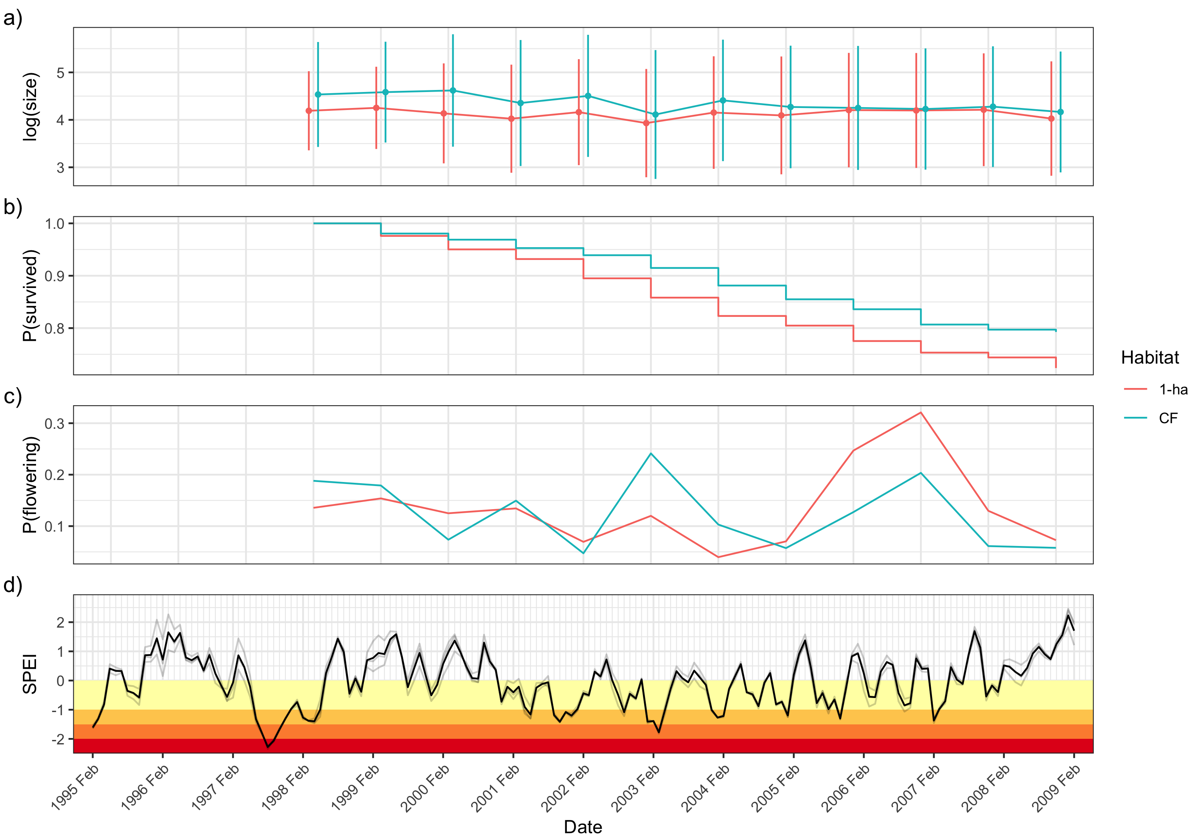

Figure 1: Timeseries of demographic parameters and drought ocurrence. Mean plant size ± standard deviation (a) shows that plants were smaller in fragments (red) than continuous forest (blue). (b) shows the survival curve for the 1998 cohort of plants in both fragments and continuous forest. c) shows the proportion of plants with 4 or more shoots flowering each census. In d), monthly 3-month SPEI is plotted. Light grey lines represent values from different grid cells encompassing BDFFP and the dark line is the site mean. Yellow, orange, dark orange, and red stripes show mild, moderate, severe, and extreme drought, respectively.

The meteorological drought occurrences indicated by SPEI mostly agree with drought events in the Amazon reported in the literature. For example, the drought associated with the 1997 El Niño Southern Oscillation (ENSO) event was one of the most severe on record for the Amazon (Williamson et al. 2000); correspondingly, 1997 has the lowest SPEI values in our timeseries (Figure 1d).  
The 2005 dry season (June–October) was also reported as an exceptionally dry year, although this drought mostly affected the south western Amazon (Zeng et al. 2008, Marengo et al. 2008). Our SPEI data show the 2005 dry season to be a moderate drought.

Mean plant size dropped dramatically in 2003 in both habitat types, corresponding with the most severe drought in the timeseries (Figure 1d). Two noticeable peaks in the proportion of flowering mature plants occur in the most severe drought years (2003 and 2007) (Figure 1c).

## Survival

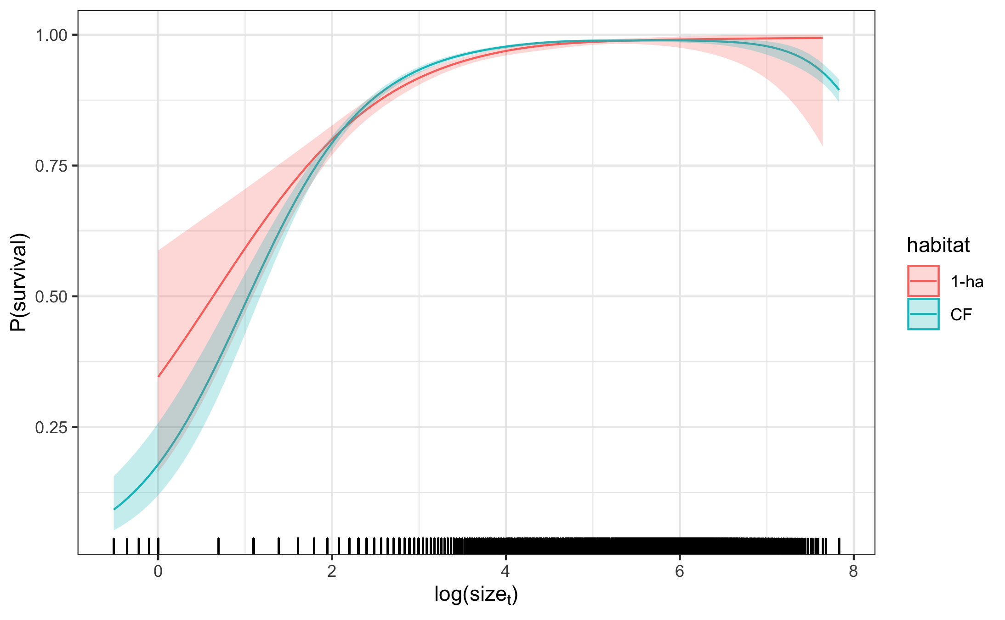

Figure 2: Smooth effect of plant size in the previous census on survival modeled by a cubic regression spline. 95% confidence intervals are shown and include uncertainty in the model intercept and uncertainty due to smoothness selection. The smooths for 1-ha fragments and continuous forest are fit in separate models. The model intercepts were added to the fitted values of the smooth and values are back-transformed to the response scale

Overall survival rate across the entire dataset was the same (0.95) in both CF and 1-ha. The proportion of surviving plants across both habitat types was lowest in 2004 (0.92) which coincided with a moderate drought in Jan 2004 / Feb 2005 and a severe drought in Jan–Mar of 2004 (Figure 1b,d). The lowest survival for 1-ha fragment plots (0.93) was in the 2006 census corresponding to unusually wet weather (SPEI >0.5), but with a moderate drought the preceding October.

Log transformed plant size had a significant effect on survival in both continuous forest and 1-ha fragments (both p < 0.001). Survival probability of large plants approached 1 in both habitat types (Figure 2). Survival of the smallest plants was higher in 1-ha fragments, but the 95% confidence intervals for 1-ha fragments and continuous forest overlapped for all sizes.

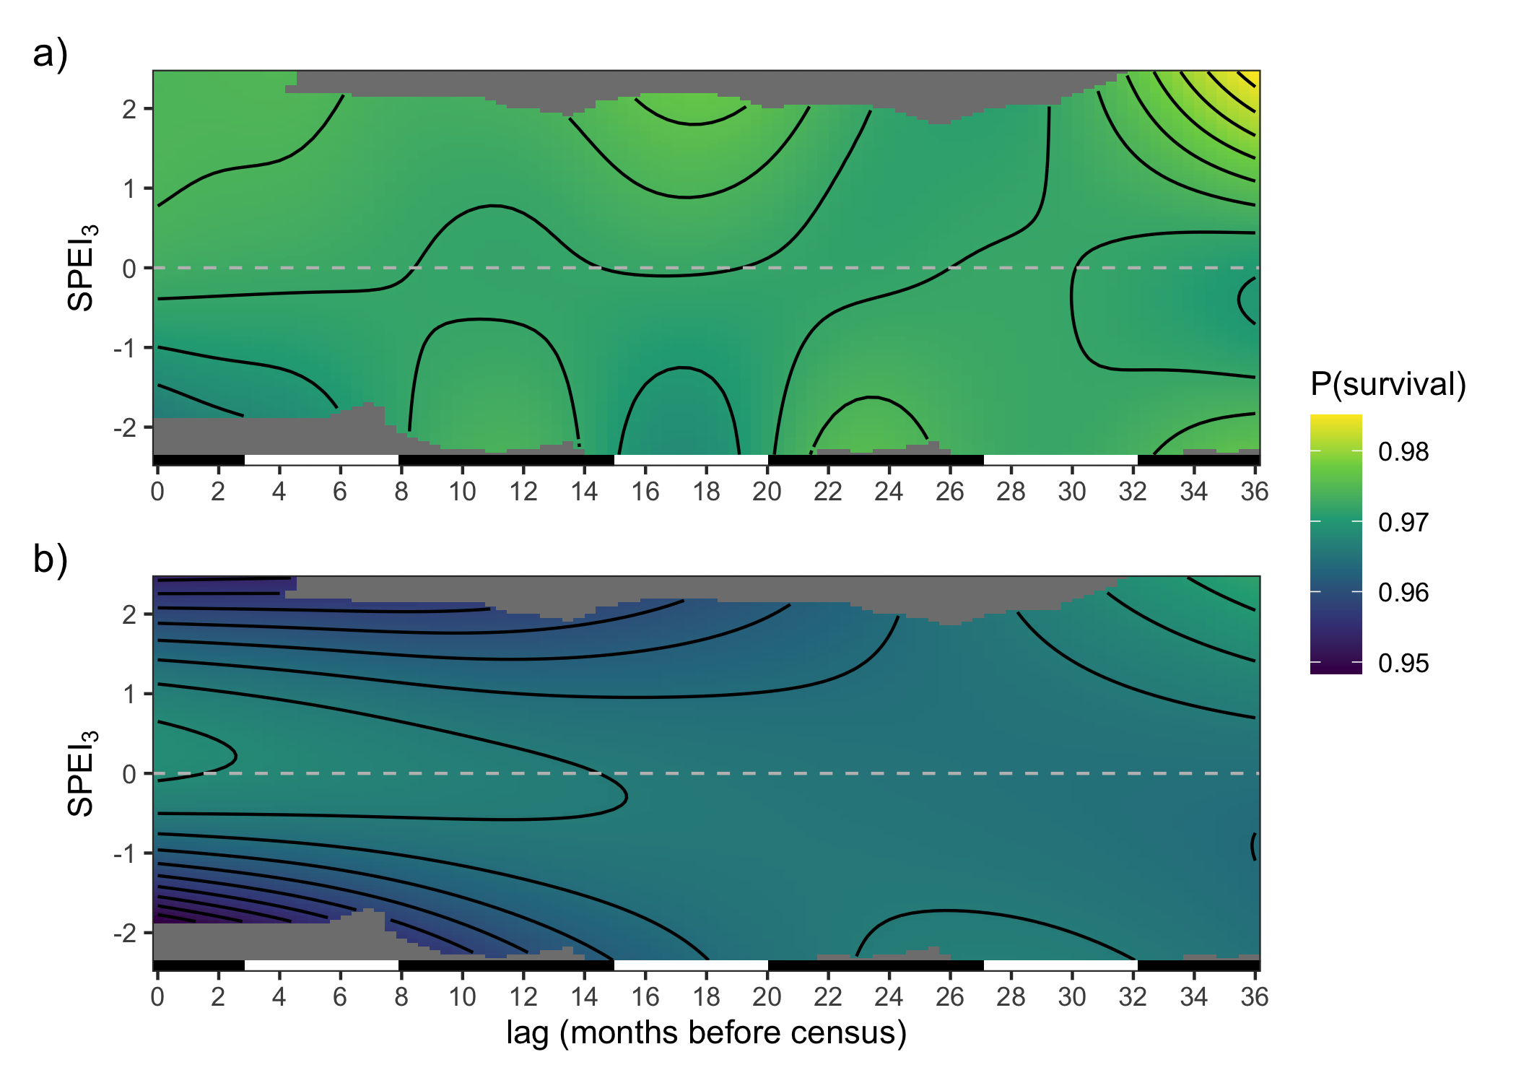

Figure 3: Smooth effect of lagged SPEI on survival in a) continuous forest and b) 1-ha fragments. Surface is modeled as a crossbasis function with cubic regression splines for each marginal basis. Model intercepts were added to fitted values of the crossbasis function and back-transformed to the response scale. Contour lines correspond to a change of 0.002. The bar on the bottom of each panel indicates wet seasons (black, November–May) and dry seasons (white, June–October).

Drought history had a significant effect on survival in both habitats (P < 0.001), but the shape of the crossbasis surface differed. For 1-ha fragments, recent SPEI values had the strongest effect on survival with the highest survival near SPEI of 0 and decreasing survival in both drier and wetter conditions (Figure 3a). In continuous forest, recent SPEI had a weaker effect with only SPEI values less than -1 producing slightly reduced survival probabilities (Figure 3b). However, SPEI at a lag time of 15–20 months, corresponding to June–October of the previous year (i.e. not the most recent dry season, but the one before that), also effected survival probabilities. Lower SPEI (drought) 15–20 months prior to census was associated with reduced survival and higher SPEI at these lag times was associated with higher survival. Plants in both continuous forest and 1-ha fragments showed an increase in survival probability with very high (wet) SPEI values at a lag time of 36 months. However, it should be noted that only the first year of census data (1999) had an SPEI value greater than 2 within 36 months in the past.

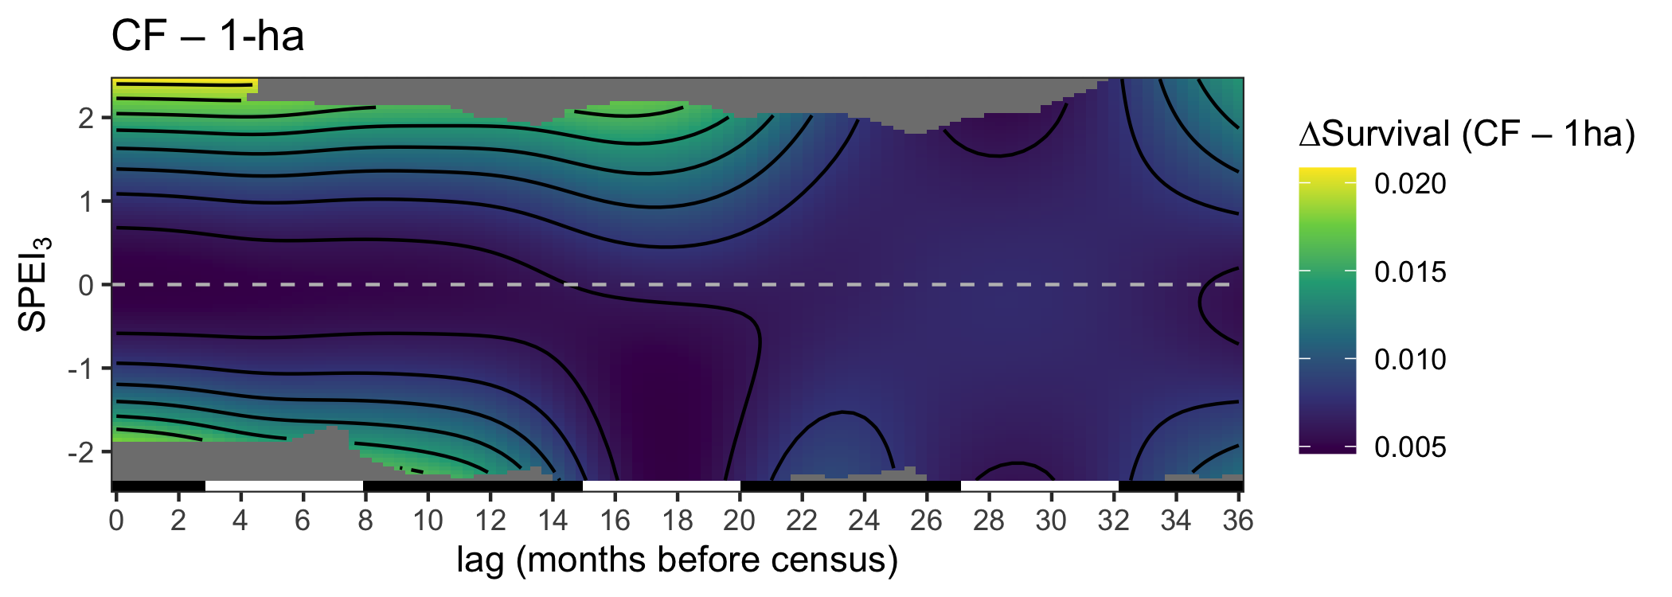

Figure 4: The difference between predicted effects of SPEI history on survival in continuous forest and 1-ha fragments.

Subtracting the estimated contribution of SPEI history to survival in fragments from that in continuous forest shows that in average conditions (SPEI = 0), there is little difference in survival probability between continuous forest and fragments (Figure 4). However, under extreme conditions, survival probability is higher in continuous forest by up to 0.02.

The random effect of plot was significant for continuous forest ( p < 0.001), but not for 1-ha fragments (p = 0.257).

## Growth

Plants were on average larger in continuous forest compared to 1-ha fragments. In continuous forest, plants had an average of 2.9 ± 1.8 shoots (mean ± standard deviation) and were on average 40.6 ± 26.5 cm tall with an average size (shoots height) of 150 ± 175. In 1-ha fragments, plants had 2.5 ± 1.5 shoots on average and a mean height of 36.2 ± 24.1 cm and a mean size of 112 ± 141. The size difference between plants in continuous forest and 1-ha fragments was more dramatic early on in the timeseries with mean sizes becoming more similar over time (Figure 1a).

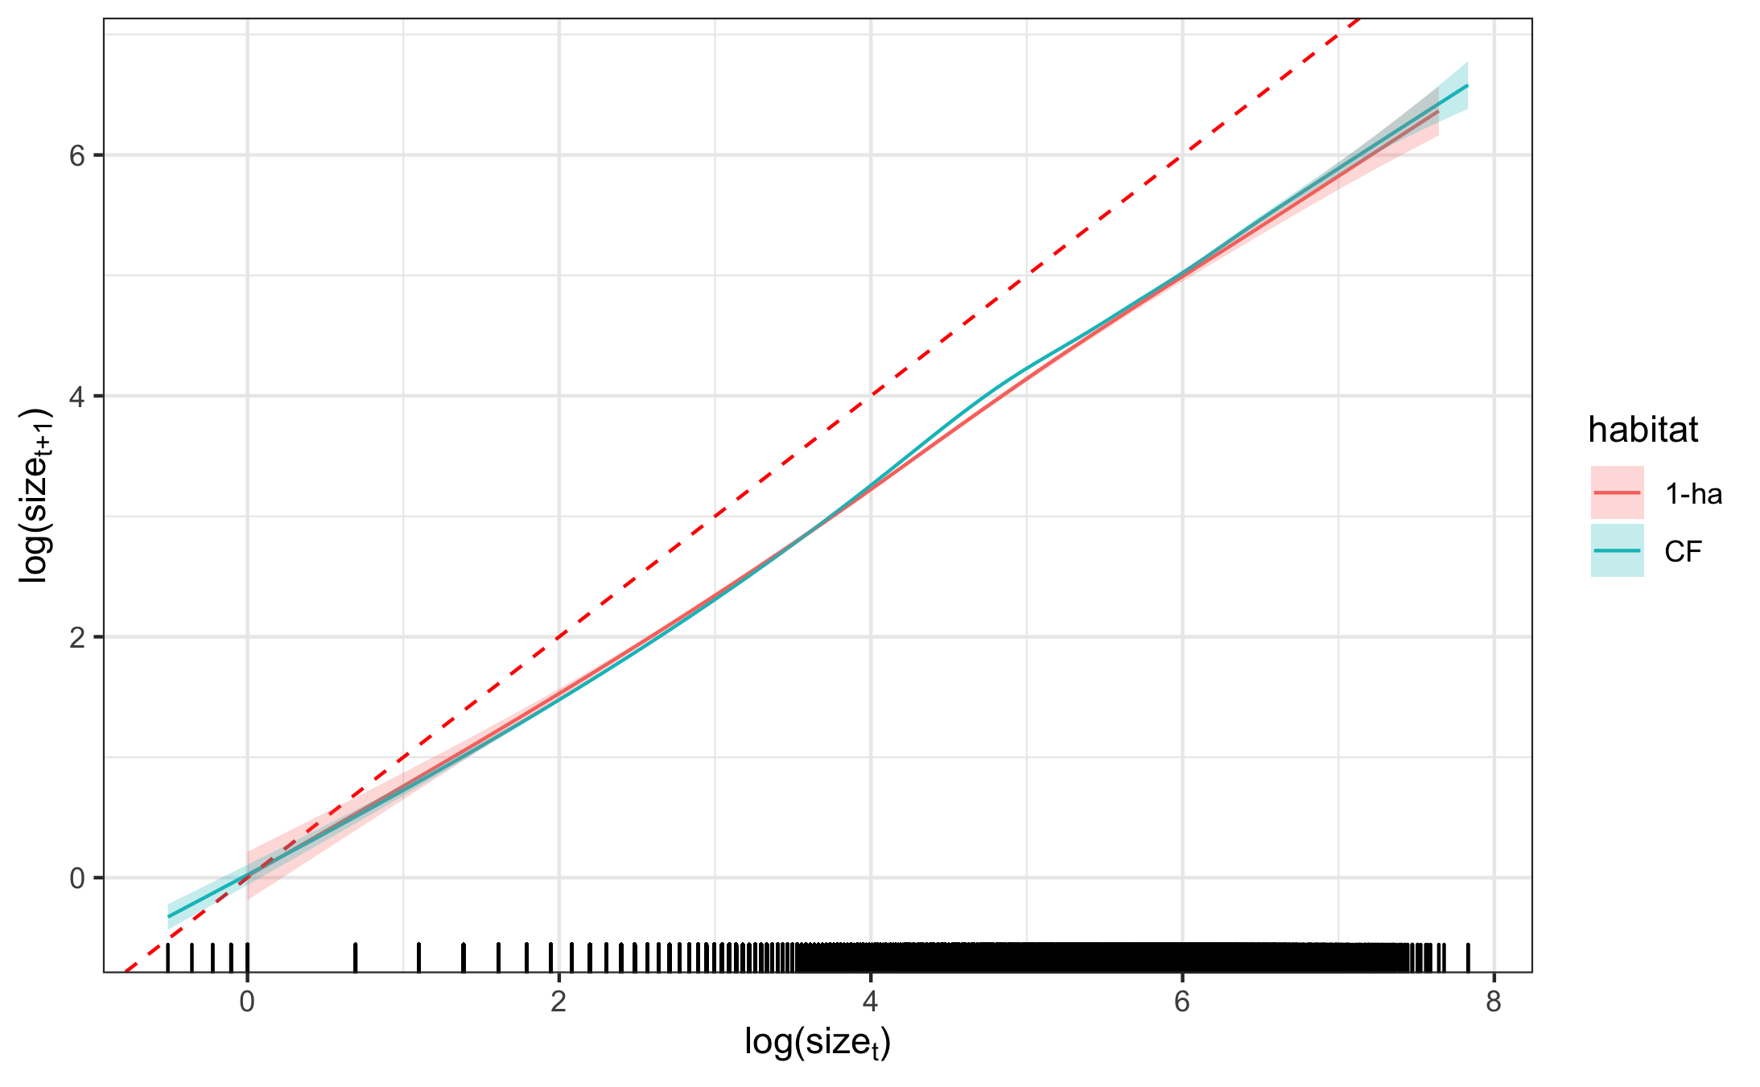

Figure 5: Smooth effect of plant size in year t on plant size in year t+1 modeled by a cubic regression spline. 95% confidence intervals are shown and include uncertainty in the model intercept as well as uncertainty due to smoothness selection. The dashed red line represents a 1:1 line for reference. The smooths for 1-ha fragments and continuous forest are fit in separate models. Model intercepts were added to the fitted values of the smooths.

Size in year t was a significant predictor of size in year t+1 (p < 0.001). The 95% confidence intervals for the effect of size in year t in fragments and continuous forest overlapped for most sizes, but was slightly higher in continuous forest for mid-sized plants (Figure 5).

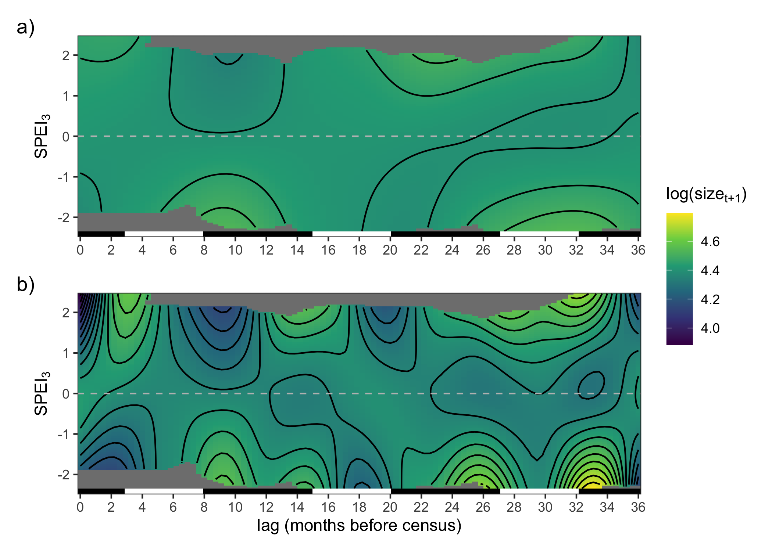

Figure 6: Smooth effect of lagged SPEI on plant growth for a) continuous forest and b) 1-ha fragments. Surface is modeled as a crossbasis function with cubic regression splines for each marginal basis. Model intercepts were added to fitted values of the crossbasis function. Contour lines correspond to a change of 0.05. The bar on the bottom of each panel indicates wet seasons (black, November–May) and dry seasons (white, June–October).

Drought history also had a significant effect on plant size in both habitats (p < 0.001). The fitted crossbasis functions for fragments and continuous forest showed somewhat similar patterns, although the surface for 1-ha fragments was much more complex (edf = 17.9 for 1-ha fragments; edf = 5.9 for continuous forest; see also Figure 6). Drought at lags 8–11 (March - June, the end of the wet season) increase growth in both habitats, but more strongly in 1-ha fragments.

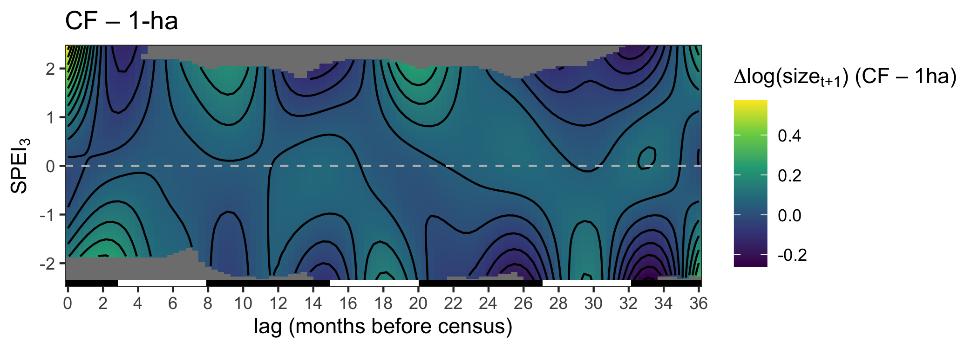

Figure 7: The difference between predicted effects of SPEI history on plant size in continuous forest and 1-ha fragments.

The difference between the effects of SPEI history in continuous forest and 1-ha fragments shows that growth is equal or slightly higher in continuous forest for average conditions (SPEI = 0) over all lag periods (Figure 7. However, growth in continuous forests is higher by up to log(size) = 0.57 when the current wet season is unusually wet (SPEI>2). This is due to reduced growth in fragments under wet conditions.

The random effect of plot is significant in both habitat models (p < 0.001).

## Flowering

The mean proportion of flowering plants across all census years was generally higher in continuous forest (0.050 ± 0.021) compared to 1-ha fragments (0.036 ± 0.027). In fact, the proportion of flowering plants was higher in continuous forest in all survey years except 2006 and 2008 (Figure 1c). The most striking difference between habitat types in flowering proportion coincided with a severe drought in 2003 when the percentage of flowering plants with four or more shoots was 24.1% in continuous forest and 12% in 1-ha fragments (Figure 1c). The back-transformed model intercepts, representing the flowering probability of averaged sized plants in each habitat given average SPEI, showed a similar pattern with 0.008 for continuous forest and 0.004 for 1-ha fragments.

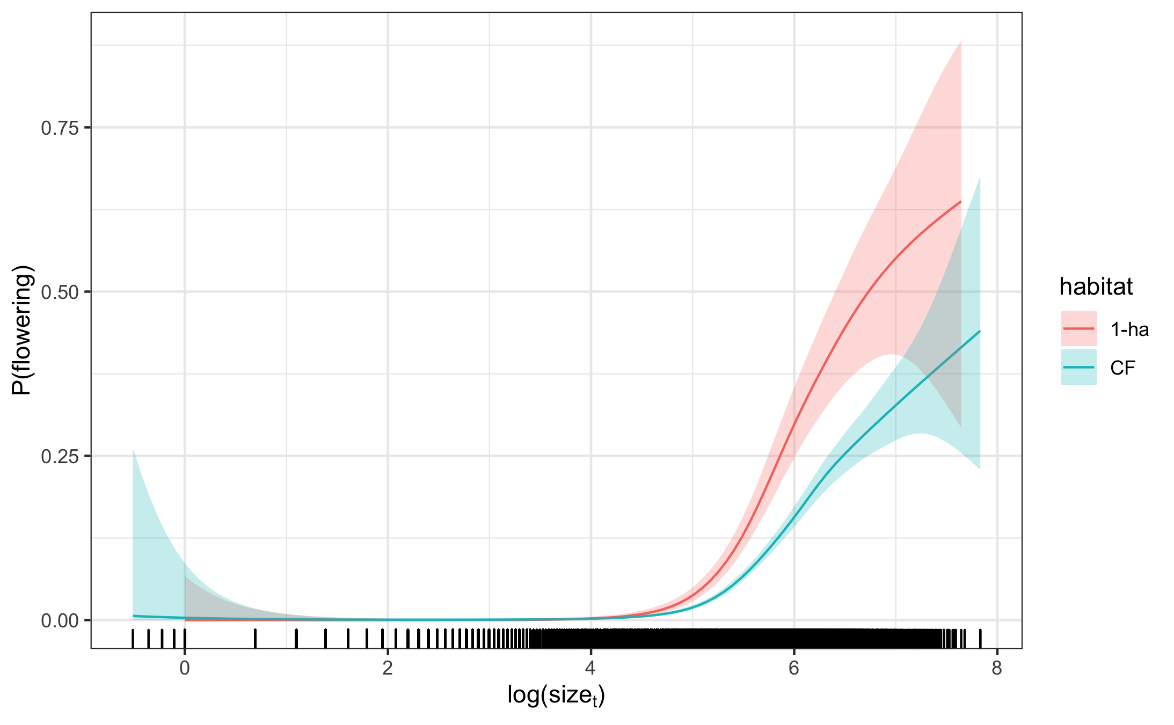

Figure 8: Smooth effect of plant size in the previous census on flowering probability modeled by a cubic regression spline. 95% confidence intervals are shown and include uncertainty in the model intercept as well as uncertainty due to smoothness selection. The smooths for 1-ha fragments and continuous forest are fit in separate models. The model intercepts were added to the fitted values of the smooth and values are back-transformed to the response scale

Plant size had a significant effect on flowering probability in both habitats (p < 0.001). Flowering probability increased rapidly with log-transformed plant size greater than 5 in both habitats (Figure 8). Flowering probability of large plants (log(size) > 5) was greater in 1-ha fragments compared to continuous forest. However, because mean plant size is larger in continuous forest, overall flowering probability was greater.

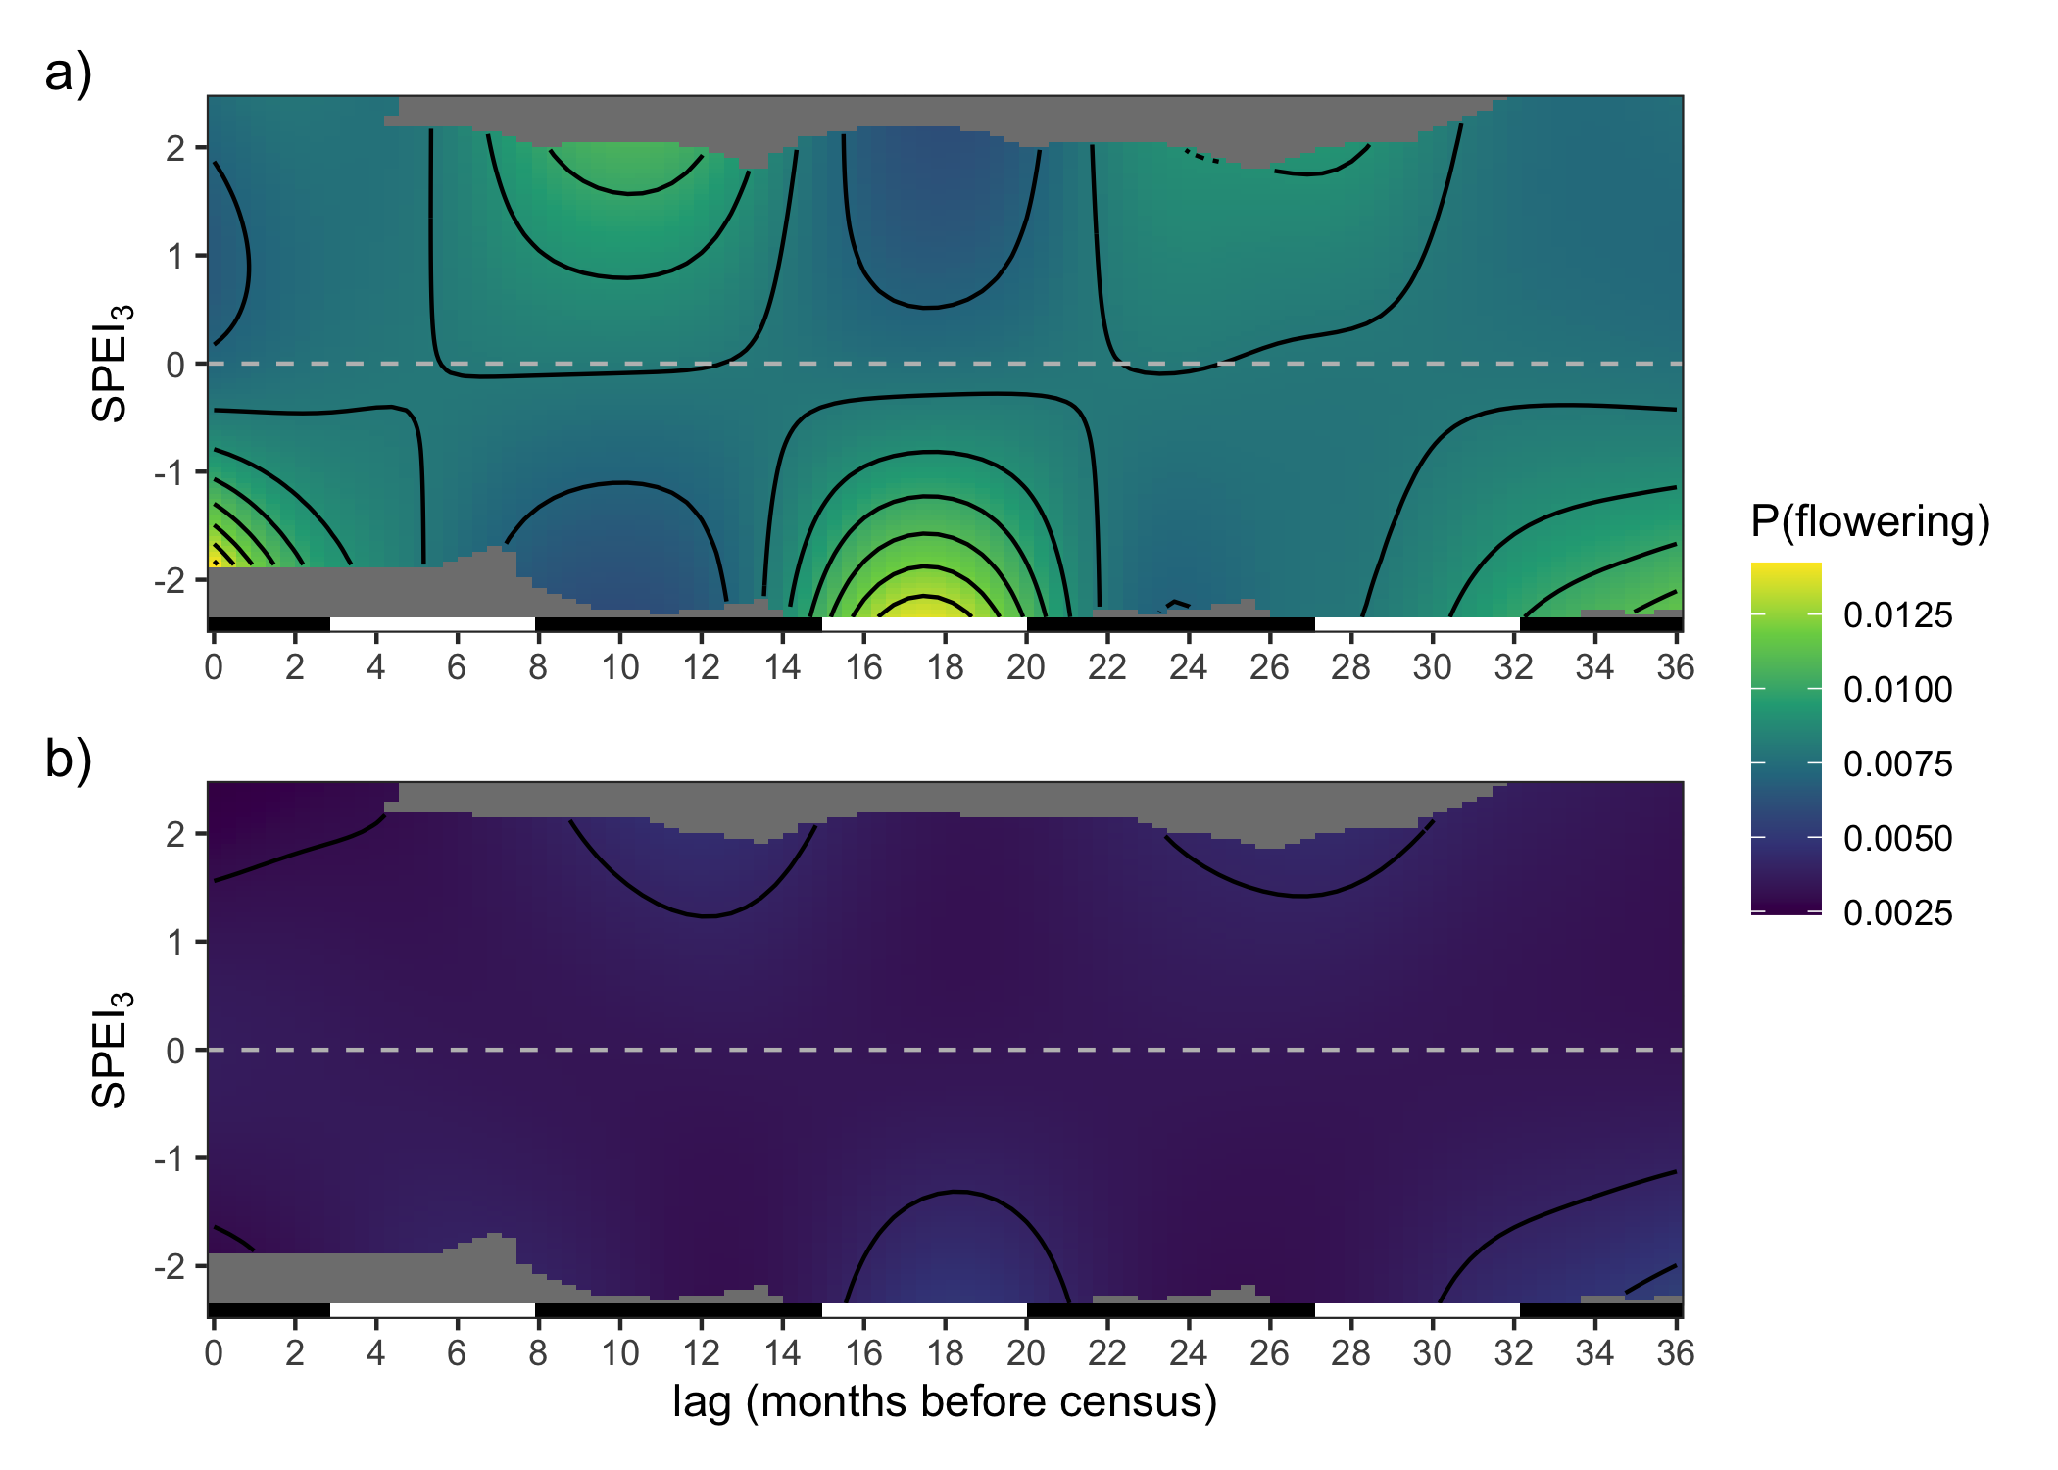

Figure 9: Smooth effect of lagged SPEI on flowering probability. Surface is modeled as a crossbasis function with cubic regression splines for each marginal basis. Model intercepts were added to fitted values of the crossbasis function and back-transformed to the response scale. Contour lines correspond to a change of 0.001. The bar on the bottom of each panel indicates wet seasons (black, November–May) and dry seasons (white, June–October).

Drought history had a significant effect on flowering probability in both habitat types (p < 0.001). Flowering probability was overall higher at all values of SPEI in continuous forest compared to 1-ha fragments (Figure 9). The effects of SPEI on flowering probability were also stronger and more complex in continuous forest compared to fragments (1-ha edf = 8.5, continuous forest edf = 10.5). In continuous forest, flowering probability was increased by recent drought (at lag = 0 with SPEI < -1) and drought at lags 15–20 (Jun-Nov, the dry season in the previous year). Drought at lags 7–13 reduced flowering probability. The shape of the crossbasis function was similar in 1-ha fragments, but significantly muted (Figure 9a). That is, the variation in fitted values along the SPEI dimension was much lower at all values of the lag dimension in fragments.

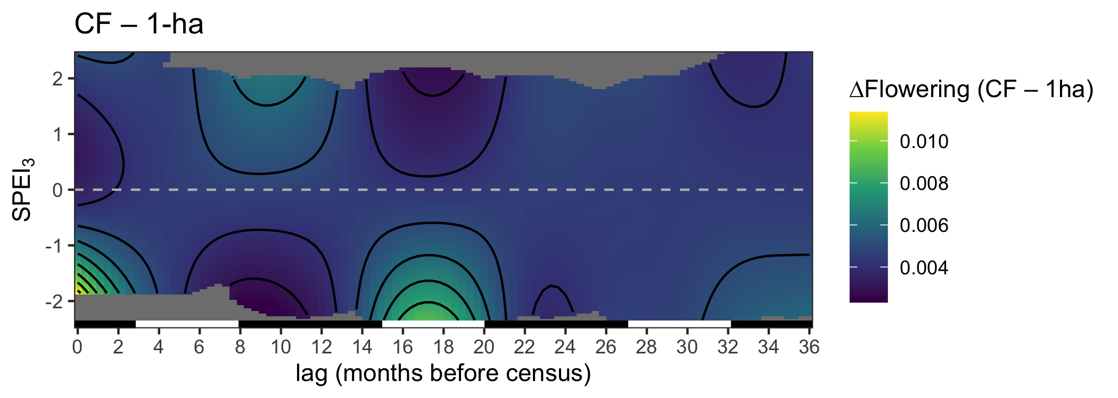

Figure 10: The difference between predicted effects of SPEI history on flowering probability in continuous forest and 1-ha fragments.

Plotting the difference between the crossbasis smooths for continuous forest and 1-ha fragments revealed that flowering probability is higher in continuous forest compared to 1-ha fragments and is increased by recent drought and drought during the dry season 15–20 months prior to the census (Figure 10). The least difference between habitat types occurs when there is strong drought at about 8–12 months lag or very wet conditions at 15–20 months lag.

The random effect of plot also had a significant effect in both habitats (p < 0.001).

# Discussion

Understanding how landscape structure and environmental conditions act to influence population dynamics is fundamental to many of the emerging conceptual frameworks for studying and conserving fragmented landscapes [7,8].

MAJOR TAKE-HOME MESSAGES

1. Survival and growth rates are similar in CF and fragments, but more strongly effected by SPEI in fragments.
2. Flowering probability is higher in CF (overall and for averaged sized plants), but large plants have higher flowering probability in fragments than in CF.
3. Two dry seasons ago (lag of 15–20 months) is important for all three vital rates, but most clearly for flowering where drought in this period increases flowering probability (cite Nihad et al. (2018) )

Future directions/Caveats:

* There could be size-specific effects: Fragmentation affects plant size (in *Heliconia* (Bruna and Oli 2005) and trees (Schwartz et al. 2019)). Smaller/larger plants might be more susceptible to drought. So differential effects of drought in fragments and continuous forest could be due to an interaction between drought and plant size.
* Synergistic effects of fragmentation and climate (need the stats to catch up with us) “Organisms simultaneously experience multiple forms of disturbance. While work investigating the demographic effects of individual factors is common, studies investigating how multiple factors interact to influence population dynamics remains poorly understood. They could act in concert to exacerbate or dampen population dynamics.”

Caveats:

One limitation of the DLNM approach is that it does not currently allow for modeling of interactions with a crossbasis function. This limitation meant that we were unable to model a potential size by environment (i.e. drought history) interaction, which may occur with many plant species (Tredennick et al. 2018). To check for a size by environment interaction, we followed the methods of Tredennick et al. (2018) and fit a pair of generalized linear mixed effects models (GLMMs) for each vital rate using the *lme4* package (Bates et al. 2015). Rather than explicitly modeling the effects of drought history, we modeled environmental stochasticity with random effects of year. For each vital rate, we essentially replaced the crossbasis function in Eq 1. with a random effect of year on either the intercept or both the intercept and relationship with plant size. We assessed the significance of the year-by-size interaction by testing the likelihood ratio of models with and without the interaction against an expected likelihood ratio distribution under the null hypothesis of no interaction (Tredennick et al. 2018).

# Conclusion

# Acknowledgments

We thank —-, —-, —-, and — anonymous reviewers for helpful discussions and comments on the manuscript. We also thank the technicians and students who helped conduct the *Heliconia* censuses and the BDFFP and INPA for logistical support. Financial support was provided by the U.S. National Science Foundation (awards DEB-0614339, DEB-0614149, INT 98-06351, and DEB-1948607). This is publication No. —- in the BDFFP Technical Series.

If TRMM data is used, they suggest: “The TMPA data were provided by the  
NASA/Goddard Space Flight Center’s Mesoscale Atmospheric Processes Laboratory and  
PPS, which develop and compute the TMPA as a contribution to TRMM.”

# References

Bates, D., M. Mächler, B. Bolker, and S. Walker. 2015. Fitting linear mixed-effects models using lme4. Journal of Statistical Software 67:1–48.

Beguería, S. 2017a. Sbegueria/SPEIbase: Version 2.5.1. Zenodo.

Beguería, S. 2017b, July. Sbegueria/SPEIbase: Version 2.5.1. Zenodo.

Berry, F., and W. J. Kress. 1991. Heliconia: An identification guide. Smithsonian Institution Press, Washington D.C., USA.

Betts, M. G., C. Wolf, M. Pfeifer, C. Banks-Leite, V. Arroyo-Rodríguez, D. B. Ribeiro, J. Barlow, F. Eigenbrod, D. Faria, R. J. Fletcher, A. S. Hadley, J. E. Hawes, R. D. Holt, B. Klingbeil, U. Kormann, L. Lens, T. Levi, G. F. Medina-Rangel, S. L. Melles, D. Mezger, J. C. Morante-Filho, C. D. L. Orme, C. A. Peres, B. T. Phalan, A. Pidgeon, H. Possingham, W. J. Ripple, E. M. Slade, E. Somarriba, J. A. Tobias, J. M. Tylianakis, J. N. Urbina-Cardona, J. J. Valente, J. I. Watling, K. Wells, O. R. Wearn, E. Wood, R. Young, and R. M. Ewers. 2019. Extinction filters mediate the global effects of habitat fragmentation on animals. Science 366:1236–1239.

Bierregaard, R. O., C. Gascon, T. E. Lovejoy, and R. Mesquita, editors. 2001. Lessons from Amazonia: The ecology and conservation of a fragmented forest. Yale University Press, New Haven.

Bierregaard, R. O., C. Gascon, T. E. Lovejoy, and R. Mesquita, editors. 2001. Lessons from Amazonia: The ecology and conservation of a fragmented forest. Yale University Press, New Haven.

Broadbent, E. N., G. P. Asner, M. Keller, D. E. Knapp, P. J. C. Oliveira, and J. N. Silva. 2008. Forest fragmentation and edge effects from deforestation and selective logging in the Brazilian Amazon. Biological Conservation 141:1745–1757.

Brodie, J., E. Post, and W. F. Laurance. 2012. Climate change and tropical biodiversity: A new focus. Trends in Ecology & Evolution 27:145–150.

Bruna, E. M. 1999. Seed germination in rainforest fragments. Nature 402:139.

Bruna, E. M. 1999. Seed germination in rainforest fragments. Nature 402:139.

Bruna, E. M. 2002. Effects of forest fragmentation on Heliconia acuminata seedling recruitment in central Amazonia. Oecologia 132:235–243.

Bruna, E. M., I. J. Fiske, and M. D. Trager. 2009. Habitat fragmentation and plant populations: is what we know demographically irrelevant? Journal of Vegetation Science 20:569–576.

Bruna, E. M., and W. J. Kress. 2002. Habitat Fragmentation and the Demographic Structure of an Amazonian Understory Herb (Heliconia acuminata). Conservation Biology 16:1256–1266.

Bruna, E. M., W. J. Kress, F. Marques, and O. F. da Silva. 2004. Heliconia acuminata reproductive success is independent of local floral density. Acta Amazonica 34:467–471.

Bruna, E. M., O. Nardy, S. Y. Strauss, and S. Harrison. 2002. Experimental assessment of Heliconia acuminata growth in a fragmented Amazonian landscape. Journal of Ecology:11.

Bruna, E. M., and M. K. Oli. 2005. Demographic effects of habitat fragmentation on a tropical herb: life-table response experiments. Ecology 86:1816–1824.

Cai, W., S. Borlace, M. Lengaigne, P. van Rensch, M. Collins, G. Vecchi, A. Timmermann, A. Santoso, M. J. McPhaden, L. Wu, M. H. England, G. Wang, E. Guilyardi, and F.-F. Jin. 2014. Increasing frequency of extreme El Niño events due to greenhouse warming. Nature Climate Change 4:111–116.

Crone, E. E., E. S. Menges, M. M. Ellis, T. Bell, P. Bierzychudek, J. Ehrlen, T. N. Kaye, T. M. Knight, P. Lesica, W. F. Morris, G. Oostermeijer, P. F. Quintana-Ascencio, A. Stanley, T. Ticktin, T. Valverde, and J. L. Williams. 2011. How do plant ecologists use matrix population models? Ecology Letters 14:1–8.

Didham, R. K., and J. H. Lawton. 1999. Edge Structure Determines the Magnitude of Changes in Microclimate and Vegetation Structure in Tropical Forest Fragments. Biotropica 31:17–30.

Didham, R. K., and J. H. Lawton. 1999. Edge Structure Determines the Magnitude of Changes in Microclimate and Vegetation Structure in Tropical Forest Fragments. Biotropica 31:17–30.

Didham, R. K., and J. H. Lawton. 1999. Edge Structure Determines the Magnitude of Changes in Microclimate and Vegetation Structure in Tropical Forest Fragments. Biotropica 31:17–30.

Evers, S. M., T. M. Knight, D. W. Inouye, T. E. X. Miller, R. Salguero-Gómez, A. M. Iler, and A. Compagnoni. 2021. Lagged and dormant season climate better predict plant vital rates than climate during the growing season. Global Change Biology n/a.

Ewers, R. M., and C. Banks-Leite. 2013. Fragmentation Impairs the Microclimate Buffering Effect of Tropical Forests. PLoS ONE 8:e58093.

Gagnon, P. R., E. M. Bruna, P. Rubim, M. R. Darrigo, R. C. Littell, M. Uriarte, and W. J. Kress. 2011. Growth of an understory herb is chronically reduced in Amazonian forest fragments. Biological Conservation 144:830–835.

Gasparrini, A. 2011. Distributed Lag Linear and Non-Linear Models in *R* : The Package **dlnm**. Journal of Statistical Software 43.

Gasparrini, A., F. Scheipl, B. Armstrong, and M. G. Kenward. 2017. A penalized framework for distributed lag non-linear models: Penalized DLNMs. Biometrics 73:938–948.

Gentry, A. H., and C. Dodson. 1987. Contribution of nontrees to species richness of a tropical rain forest. Biotropica 19:149–156.

Gentry, A. H., and C. Dodson. 1987. Contribution of nontrees to species richness of a tropical rain forest. Biotropica 19:149–156.

Haddad, N. M., L. A. Brudvig, J. Clobert, K. F. Davies, A. Gonzalez, R. D. Holt, T. E. Lovejoy, J. O. Sexton, M. P. Austin, C. D. Collins, W. M. Cook, E. I. Damschen, R. M. Ewers, B. L. Foster, C. N. Jenkins, A. J. King, W. F. Laurance, D. J. Levey, C. R. Margules, B. A. Melbourne, A. O. Nicholls, J. L. Orrock, D.-X. Song, and J. R. Townshend. 2015. Habitat fragmentation and its lasting impact on Earth’s ecosystems. Science Advances 1:e1500052.

Kress, J. 1990. The diversity and distribution of Heliconia (Heliconiaceae) in Brazil. Acta Botanica Brasileira 4:159–167.

Kress, W. J. 1983. Self-incompatibility systems in Central American Heliconia. Evolution 37:735–744.

Laurance, W. F., L. V. Ferreira, J. M. Rankin de Merona, and S. G. Laurance. 1998. Rain forest fragmentation and the dynamics of Amazonian tree communities. Ecology 79:2032–2040.

Laurance, W. F., G. B. Williamson, P. Delamônica, A. Oliveira, T. E. Lovejoy, C. Gascon, and L. Pohl. 2001. Effects of a Strong Drought on Amazonian Forest Fragments and Edges. Journal of Tropical Ecology 17:771–785.

Laurance, W. F., G. B. Williamson, P. Delamônica, A. Oliveira, T. E. Lovejoy, C. Gascon, and L. Pohl. 2001. Effects of a Strong Drought on Amazonian Forest Fragments and Edges. Journal of Tropical Ecology 17:771–785.

Laurance, W. F., G. B. Williamson, P. Delamônica, A. Oliveira, T. E. Lovejoy, C. Gascon, and L. Pohl. 2001. Effects of a Strong Drought on Amazonian Forest Fragments and Edges. Journal of Tropical Ecology 17:771–785.

Malhi, Y., J. T. Roberts, R. A. Betts, T. J. Killeen, W. Li, and C. A. Nobre. 2008. Climate Change, Deforestation, and the Fate of the Amazon. Science 319:169–172.

Marengo, J. A., C. A. Nobre, J. Tomasella, M. D. Oyama, G. Sampaio de Oliveira, R. de Oliveira, H. Camargo, L. M. Alves, and I. F. Brown. 2008. The Drought of Amazonia in 2005. Journal of Climate 21:495–516.

Marra, G., and S. N. Wood. 2011. Practical variable selection for generalized additive models. Computational Statistics & Data Analysis 55:2372–2387.

McKee, T. B., N. J. Doesken, and J. Kleist. 1993. The Relationship of Drought Frequency and Duration to Time Scales.

Mora, C., A. G. Frazier, R. J. Longman, R. S. Dacks, M. M. Walton, E. J. Tong, J. J. Sanchez, L. R. Kaiser, Y. O. Stender, J. M. Anderson, C. M. Ambrosino, I. Fernandez-Silva, L. M. Giuseffi, and T. W. Giambelluca. 2013. The projected timing of climate departure from recent variability. Nature 502:183–187.

Morris, W. F., and D. F. Doak. 2002. Quantitative conservation biology: Theory and practice of population viability analysis. Sinauer, Sunderland, MA.

Nakazono, E. M., E. M. Bruna, and R. C. G. Mesquita. 2004. Experiemental harvesting of the non-timber forest product Ischnosiphon polyphyllus in central Amazonia. Forest Ecology and Management 190:219–225.

Nihad, K., V. Krishnakumar, and V. L. Sheela. 2018. Relationship between Stress and Flowering in Heliconia (Heliconia Stricta). International Journal of Agriculture Sciences(IJAS) 10:5137.

R Core Team. 2020. R: A language and environment for statistical computing. Vienna, Austria.

Rankin-de-Mérona, J. M., G. T. Prance, R. W. Hutchings, M. F. da Silva, W. A. Rodrigues, and M. E. Uehling. 1992. Preliminary results of a large-scale tree inventory of upland rain forest in the central Amazon. Acta Amazonica 22:493–534.

Ribeiro, M. B. N., E. M. Bruna, and W. Mantovani. 2010. Influence of post-clearing treatment on the recovery of herbaceous plant communities in amazonian secondary forests. Restoration Ecology 18:50–58.

Salguero-Gomez, R., O. R. Jones, C. R. Archer, Y. M. Buckley, J. Che-Castaldo, H. Caswell, D. Hodgson, A. Scheuerlein, D. A. Conde, E. Brinks, H. de Buhr, C. Farack, F. Gottschalk, A. Hartmann, A. Henning, G. Hoppe, G. Roemer, J. Runge, T. Ruoff, J. Wille, S. Zeh, R. Davison, D. Vieregg, A. Baudisch, R. Altwegg, F. Colchero, M. Dong, H. de Kroon, J. D. Lebreton, C. J. E. Metcalf, M. M. Neel, I. M. Parker, T. Takada, T. Valverde, L. A. Velez-Espino, G. M. Wardle, M. Franco, and J. W. Vaupel. 2015. The COMPADRE Plant Matrix Database: An open online repository for plant demography. Journal of Ecology 103:202–218.

Scariot, A. 1999. Forest fragmentation effects on palm diversity in central Amazonia. Journal of Ecology 87:66–76.

Scheffers, B. R., D. P. Edwards, S. L. Macdonald, R. A. Senior, L. R. Andriamahohatra, N. Roslan, A. M. Rogers, T. Haugaasen, P. Wright, and S. E. Williams. 2017. Extreme thermal heterogeneity in structurally complex tropical rain forests. Biotropica 49:35–44.

Schwartz, N. B., A. M. Budsock, and M. Uriarte. 2019. Fragmentation, forest structure, and topography modulate impacts of drought in a tropical forest landscape. Ecology 100:e02677.

Snow, D. W. 1981. Tropical frugivorous birds and their food plants - a world survey. Biotropica 13:1–14.

Teller, B. J., P. B. Adler, C. B. Edwards, G. Hooker, and S. P. Ellner. 2016. Linking demography with drivers: climate and competition. Methods in Ecology and Evolution 7:171–183.

Ticktin, T. 2003. Relationships between El Niño Southern Oscillation and Demographic Patterns in a Substitute Food for Collared Peccaries in Panama. Biotropica 35:189–197.

Tredennick, A. T., Brittany J. Teller, P. B. Adler, G. Hooker, and S. P. Ellner. 2018. Size-by-environment interactions: a neglected dimension of species’ responses to environmental variation. Ecology Letters 21:1757–1770.

TRMM (TMPA/3B43) rainfall estimate L3 1 month 0.25 degree x 0.25 degree V7. 2011. Goddard Earth Sciences Data; Information Services Center (GES DISC), Greenbelt, MD.

Uriarte, M., M. Anciães, M. T. B. da Silva, P. Rubim, E. Johnson, and E. M. Bruna. 2011. Disentangling the drivers of reduced long-distance seed dispersal by birds in an experimentally fragmented landscape. Ecology 92:924–937.

Vicente-Serrano, S. M., S. Beguería, and J. I. López-Moreno. 2010. A Multiscalar Drought Index Sensitive to Global Warming: The Standardized Precipitation Evapotranspiration Index. Journal of Climate 23:1696–1718.

Williamson, G. B., W. F. Laurance, A. A. Oliveira, P. Delamônica, C. Gascon, T. E. Lovejoy, and L. Pohl. 2000. Amazonian Tree Mortality during the 1997 El Niño Drought. Conservation Biology 14:1538–1542.

Wood, S. N. 2017. Generalized additive models: An introduction with r. Second edition. CRC Press/Taylor & Francis Group, Boca Raton.

Wood, S. N. (n.d.). Chapter 5: Smoothers. Pages 195–247 Generalized additive models: An introduction with R.

Xavier, A. C., C. W. King, and B. R. Scanlon. 2016. Daily gridded meteorological variables in Brazil (19802013). International Journal of Climatology 36:2644–2659.

Zartman, C. E., J. A. Amaral, J. N. Figueiredo, and C. D. Dambros. 2015. Drought impacts survivorship and reproductive strategies of an epiphyllous leafy liverwort in central Amazonia. Biotropica 47:172–178.

Zartman, C. E., J. A. Amaral, J. N. Figueiredo, and C. D. Dambros. 2015. Drought impacts survivorship and reproductive strategies of an epiphyllous leafy liverwort in central Amazonia. Biotropica 47:172–178.

Zeng, N., J.-H. Yoon, J. A. Marengo, A. Subramaniam, C. A. Nobre, A. Mariotti, and J. D. Neelin. 2008. Causes and impacts of the 2005 Amazon drought. Environmental Research Letters 3:014002.

### Colophon

This report was generated on 2021-03-03 09:46:04 using the following computational environment and dependencies:

#> ─ Session info ───────────────────────────────────────────────────────────────  
#> setting value   
#> version R version 4.0.2 (2020-06-22)  
#> os macOS Catalina 10.15.7   
#> system x86_64, darwin17.0   
#> ui X11   
#> language (EN)   
#> collate en_US.UTF-8   
#> ctype en_US.UTF-8   
#> tz America/New_York   
#> date 2021-03-03   
#>   
#> ─ Packages ───────────────────────────────────────────────────────────────────  
#> ! package * version date lib source   
#> P assertthat 0.2.1 2019-03-21 [?] CRAN (R 4.0.0)  
#> P bookdown 0.21 2020-10-13 [?] CRAN (R 4.0.2)  
#> callr 3.5.1 2020-10-13 [1] CRAN (R 4.0.2)  
#> P cli 2.2.0 2020-11-20 [?] CRAN (R 4.0.2)  
#> crayon 1.4.1 2021-02-08 [1] CRAN (R 4.0.2)  
#> P desc 1.2.0 2018-05-01 [?] CRAN (R 4.0.0)  
#> P devtools 2.3.2 2020-09-18 [?] CRAN (R 4.0.2)  
#> digest 0.6.27 2020-10-24 [1] CRAN (R 4.0.2)  
#> P ellipsis 0.3.1 2020-05-15 [?] CRAN (R 4.0.0)  
#> P evaluate 0.14 2019-05-28 [?] CRAN (R 4.0.0)  
#> P fansi 0.4.1 2020-01-08 [?] CRAN (R 4.0.0)  
#> P fs 1.5.0 2020-07-31 [?] CRAN (R 4.0.2)  
#> P glue 1.4.2 2020-08-27 [?] CRAN (R 4.0.2)  
#> P here * 1.0.1 2020-12-13 [?] CRAN (R 4.0.2)  
#> P highr 0.8 2019-03-20 [?] CRAN (R 4.0.0)  
#> P htmltools 0.5.0 2020-06-16 [?] CRAN (R 4.0.0)  
#> P knitr * 1.30 2020-09-22 [?] CRAN (R 4.0.2)  
#> P lifecycle 0.2.0 2020-03-06 [?] CRAN (R 4.0.0)  
#> P magrittr 2.0.1 2020-11-17 [?] CRAN (R 4.0.2)  
#> P memoise 1.1.0 2017-04-21 [?] CRAN (R 4.0.0)  
#> P pkgbuild 1.2.0 2020-12-15 [?] CRAN (R 4.0.2)  
#> P pkgload 1.1.0 2020-05-29 [?] CRAN (R 4.0.0)  
#> P png 0.1-7 2013-12-03 [?] CRAN (R 4.0.0)  
#> P prettyunits 1.1.1 2020-01-24 [?] CRAN (R 4.0.0)  
#> P processx 3.4.5 2020-11-30 [?] CRAN (R 4.0.2)  
#> P ps 1.5.0 2020-12-05 [?] CRAN (R 4.0.2)  
#> P purrr 0.3.4 2020-04-17 [?] CRAN (R 4.0.0)  
#> R6 2.5.0 2020-10-28 [1] CRAN (R 4.0.2)  
#> P remotes 2.2.0 2020-07-21 [?] CRAN (R 4.0.2)  
#> P rlang 0.4.10 2020-12-30 [?] CRAN (R 4.0.2)  
#> P rmarkdown 2.6 2020-12-14 [?] CRAN (R 4.0.2)  
#> P rprojroot 2.0.2 2020-11-15 [?] CRAN (R 4.0.2)  
#> P sessioninfo 1.1.1 2018-11-05 [?] CRAN (R 4.0.2)  
#> P stringi 1.5.3 2020-09-09 [?] CRAN (R 4.0.2)  
#> P stringr 1.4.0 2019-02-10 [?] CRAN (R 4.0.0)  
#> P testthat 3.0.1 2020-12-17 [?] CRAN (R 4.0.2)  
#> P usethis 2.0.0 2020-12-10 [?] CRAN (R 4.0.2)  
#> withr 2.3.0 2020-09-22 [1] CRAN (R 4.0.2)  
#> P xfun 0.20 2021-01-06 [?] CRAN (R 4.0.2)  
#> P yaml 2.2.1 2020-02-01 [?] CRAN (R 4.0.0)  
#>   
#> [1] /Users/scottericr/Documents/HeliconiaDemography/renv/library/R-4.0/x86_64-apple-darwin17.0  
#> [2] /private/var/folders/b_/2vfnxxls5vs401tmhhb3wqdh0000gp/T/RtmpPV70xv/renv-system-library  
#> [3] /Library/Frameworks/R.framework/Versions/4.0/Resources/library  
#>   
#> P ── Loaded and on-disk path mismatch.

The current Git commit details are:

#> Local: master /Users/scottericr/Documents/HeliconiaDemography  
#> Remote: master @ origin (https://github.com/BrunaLab/HeliconiaDemography.git)  
#> Head: [cff07e3] 2021-03-01: inserted citations and other minor edits