[1]

Emilio M. Bruna1, 2, 3

1 Department of Wildlife Ecology and Conservation, University of Florida, PO Box 110430, Gainesville, FL 32611-0430, USA

2 Center for Latin American Studies, University of Florida, PO Box 115530, Gainesville, FL 32611-5530, USA

3 Corresponding Author; email: [embruna@ufl.edu](mailto:embruna@ufl.edu)

Received:______; Revised:______; Accepted:______.

Abstract

The ecosystems of The Tropics comprise the majority of the planet’s biodiversity, approximately 40% of its terrestrial surface area, and half the human population. Depsite this, Tropical Biology has historically been conceptualized as a specialized subdiscipline of the Biological Sciences. I assessed the validity of this assumption, and conclude that it depends on the framework and evidence used to evaluate it. I suggest that the way forward as a discipline is not for Tropical Biologists to drop the geographic adjective that unites them, but to recenter The Tropics as the foundation of ecology and evolutionary biology.

Los ecosistemas tropicales contienen la mayor parte de la biodiversidad del planeta, aproximadamente el 40% de su superficie terrestre y la mitad de la población humana. Aún así, la biología tropical ha sido históricamente conceptualizada como una subdisciplina especializada de las ciencias biológicas. Evalué este supuesto y concluí que su validez depende del marco analítico y de la evidencia utilizada para evaluarlo. Sugiero que el camino a seguir para la disciplina no es que los biólogos tropicales abandonen el adjetivo geográfico que los une, sino más bien volver a centrar los trópicos como base fundamental de la ecología y la biología evolutiva.

*Keywords:* bibliometrics, collaboration, colonialism, Global South, scholarly societies, scientometrics, temperate, text-mining

[2]

## 1. INTRODUCTION

*“This is an interesting and useful study, but I feel the manuscript is better suited to a specialized journal focusing on tropical ecosystems.”*

Subject Editor *(name and journal redacted)*

This decision regarding my submission to one of our field’s well-known journals is likely familiar to many members of the Association for Tropical Biology & Conservation (ATBC). All three reviews were positive, with none of the referees identifying significant shortcomings or requesting major changes. So why had the manuscript been rejected? My only clue was in the Editor’s conclusion, from which I gathered that they felt studies done *in* the tropics were of limited relevance to researchers working *outside* the tropics. After all, that’s for whom a specialized journal is published – a smaller community of subject-matter experts – while the journal to which we submitted our study sought to publish “broad conceptual advances”. In short, the Subject Editor was drawing a distinction between Biology and *Tropical* Biology, with the latter a specialized subdiscipline of the former.

This provincial view of research done in the tropics is not new. In 1963, P. W. Richards felt it necessary to use his Presidential Address to the British Ecological Society to explain “what the Tropics can contribute to ecology”, advocate for financial investment in tropical research and field stations, and encourage students to visit and dedicate study “the most [biologically] exciting part of the world” (Richards 1963). His justification for this topic was self-deprecating but pointed — he was concerned that a talk summarizing recent advances in tropical ecology, including his studies of forest structure and diversity in Borneo and Guyana, “would probably bore the large part of my audience who have never been to the tropics and never intend to do so” (Richards 1963). That he felt this advocacy was still necessary despite decades of effort (Richards 1946, 1964) must have been extremely frustrating.

Sixty years on many of us find ourselves similarly frustrated. Tropical field stations continue to be underfunded (Chapman *et al.* 1945, Corner 1946, Eppley *et al.* 2024). Financial support for research in the tropics is relatively low and declining (Chapman *et al.* 1945, Sohmer 1980, Stegmann *et al.* 2024). And while tropical ecosystems comprise the majority of the planet’s biodiversity (Gaston 2000), approximately 40% of its terrestrial surface area, and are home to half the human population (Hoornweg & Pope 2017), their study is still considered by many to be a scientific subdsicipline. My objective here is not to review the biological validity (Robinson 1978, Moles & Ollerton 2016) or scientific implications (Zuk 2016) of this generalization, nor to summarize the history, status, and direction of tropical research (*e.g.,* Buechner & Fosberg 1967, Janzen 1972, Janzen 1986, Chazdon & Whitmore 2001, Bawa *et al.* 2004). Instead, I will attempt to assess the fundamental assumption behind the Editor’s summary that motivated this essay: Is there really such a thing as *Tropical* Biology?[3]

## 1. Why the answer is *‘No’.*

*“…in the case of biology, a major part of the accumulated biological knowledge is concerned with a rather minor part of the world’s fauna and flora, because of the chance development of biology in the temperate zones.”*

S. D. Ripley (1967)

One means of assessing if *Tropical* Biology is a distinct academic discipline is by considering the communities into which scientists self-organize. Scholarly societies are one such community; their establishment requires both an intellectual pursuit with which individuals identify and a critical mass of like-minded individuals in search of community. Some of these communities coalesce around broad conceptual domains (e.g., *Evolutionary* Biology, *Conservation* Biology, *Integrative* Biology; Figure 1A). Still others bring together individuals from different conceptual domains that share an interest in a particular system (e.g., *Avian* Biology, *Island* Biology; Figure 1B). Finally, some scholarly societies comprise individuals using a common methodological framework to study disparate systems or address questions from distinct conceptual domains (e.g., *Molecular* Biology, *Mathematical* Biology, *Experimental* Biology; Figure 1C).

*Tropical* Biology fails to align with any of these constructs. Its practitioners investigate fundamental questions across conceptual domains with a broad range of methodological approaches and study systems. This intellectual diversity was cogently summarized by the historian Megan Raby: “The work that tropical biologists do is nearly as diverse as the ecosystems they study” (Raby 2017, p.5). Moreover, the “geographic pigeonhole” (*sensu* Raby 2017) that presumably unites this community of scientists — the adjective ‘tropical’ — is itself challenging to operationalize. Formally, *The Tropics* are the band of the Earth’s surface receiving at least one day of direct overhead sunlight per year; this region is delineated by the Tropics of Capricorn and Cancer (23°26’10.4” S and N, respectively). However, the ranges of many ‘tropical’ species and ecosystems extend far beyond these boundaries[4], which is in part why Feeley and Stroud (2018) identified no less than eight distinct criteria by which authors to define ‘tropical’ systems. How then is it that *Tropical* Biology - whose practitioners conduct research in habitats ranging from rain forests to savannas - can came to be seen as a specialized subdicipline despite the lack the sharp boundaries around which scientific groups typically coalesce?

This contemporary perception of ‘The Tropics’ as distant and special is the result of centuries of historical and cultural reinforcement (Arnold 1996, Driver & Yeoh 2000, Stepan 2001, Miller & Reill 2011). The first Europeans to visit the tropics returned with vivid, captivating, and frequently pejorative descriptions of the places and people they encountered (Putz & Holbrook 1988). Their stories and images established and inculcated a number of persistent and often contradictory tropes about tropical regions and people that were then repeated and reinterpreted by subsequent visitors (Smith 1950, Stepan 2001). The historian David Arnold (1996) has argued that these narratives of “Tropicality” (*sensu* Gourou 1947) allowed Europeans to justify colonial expansion by defining the region as environmentally and culturally distinct while simultaneously superimposing on its remarkable diversity a generic and simplified identity: *The Tropics*.

The narratives of naturalists such as von Humboldt, Darwin, and Wallace were both informed by and reinforced these conceptions of the tropics as ‘distant’ and ‘other’ (Raby 2017). Their writing and ideas then inspired many of the scientists central to the coalescing sciences of ecology and evolutionary biology, who were themselves immersed in a cultural milieu that viewed *The Tropics* as ‘distant’ and ‘exotic’. However, as Raby (2017) elegantly demonstrates, the scientific frameworks these disciplinary pioneers put forward, including the unique status of *Tropical* Biology, were not simply distillations of prevailing cultural and environmental tropes. Instead they emerged from the complex interplay of European colonialism, the expansion of US hegemony in Latin America and the Caribbean at the turn of the twentieth century, and the construction of tropical field stations for use by North American scientists that accompanied this expansion. The role of this scientific colonialism at such a pivotal moment of scientific consolidation cannot be overstated. As Richards (1963) explains, “the science of ecology developed first in central Europe, Scandinavia and Britain and very slightly later in the United States. The ideas and concepts with which it started were therefore inevitably based on the conditions in a temperate climate” (see also Webb 1960, Buechner & Fosberg 1967, Ripley 1967). The same would be true of subsequent studies testing and refining these fundamental concepts, further reinforcing the “temperate bias” (*sensu* Zuk 2016) in the leading journals of the day. While engagement with the burgeoning community of field biologists in tropical countries could have expanded the prevailing theories to make them more general, these scientists were rarely to work at the new US-run field stations (Raby 2017). Their exclusion from the scientific discourse and literature, coupled with the temperate-centered focus of the early theory, suggests that the distinction between Biology and *Tropical* Biology is a historical legacy and largely artificial.

## 2. Why the answer is *‘Maybe’.*

*“…to this day ecology is biased by concepts and ideas appropriate mainly to the study of vegetation in temperate climate and areas where a very large proportion of the land has long been modified by agriculture and other more or less intensive forms of land usage.”*

P. W. Richards (1963)

Even if *The Tropics* are a historical construct, *Tropical* Biology could still be conceptually distinct field of study if the scientific community has identified or converged on a suite of topics that are either unique to or best studied in tropical systems. To assess this possibility, I used a text-mining approach to compare the research foci of N = 11,702 studies conducted in the tropics with those of N = 29,440 studies conducted in other parts of the world. Specifically, I extracted and summarized the information from two structural components used by authors to describe the subject of their articles: the title and keywords. These provide distinct but complementary information, and so they are often analyzed both independently and in unison. For simplicity I present here results based on pooling each article’s title and keywords, which were qualitatively similar to those for analyzing titles and keywords independently. The results for all analyses can be found in the *Supporting Information*, where one can also find a complete description of the methods used to gather and process the data.

Briefly, I download the bibliographic record from SCOPUS or the Web of Science ‘Core Collection’ for every article published from 1990-2022 in one of N = 10 journals (*Journal of Evolutionary Biology, Ecology, Journal of Applied Ecology, Evolution, Biotropica, Journal of Ecology, Tropical Conservation Science, American Naturalist, Tropical Ecology, Journal of Tropical Ecology, Revista de Biologia Tropical*). I then used the refsplitr package (Fournier *et al.* 2020) and code written in the R programming language (R Core Team 2023) to process the records, extract, process, and combine the terms extracted from each article’s title and keywords, and assign the article to its respective geographic category. Collectively this resulted in N = 145,893 terms, of which I identified and ranked the 50 terms most frequently used in articles from each geographic category. Two major patterns emerge from this analysis. The first is that 28% of the most frequently used terms from ‘tropical’ articles reflected geographic locations (e.g., *Costa Rica*, *Amazon*, *Panama*, *tropical*). In contrast, all of the top-50 terms from non-tropical articles were conceptual (e.g., *phenotypic plasticity*, *food web*, *sexual selection*; Table 1). The second is that after removing the system- and location-specific terms, there is ample conceptual overlap between tropical and non-tropical studies (Table 2) and that the topics studied are broadly consistent with disciplinary trends (Carmel *et al.* 2013, McCallen *et al.* 2019, Anderson *et al.* 2021). That said, the most common research topics within each article category often differ dramatically in their relative rankings (Figure 5), and there are notable areas of topical divergence (Table 2). One interpretation of these results is that Tropical Biology is in fact a subdiscipline focused on problems and topics of particular relevance in tropical locations. While there are subjects for which this is undoubtedly true, the observed differences could also indicate that some topics are extensively studied in over-represented research sites (Stocks *et al.* 2008) or the historical relegation of certain subjects to the tropics (Zuk 2016). While preliminary, these results are consistent with those of Castro Torres and Alburez-Gutierrez (2022), who analyzed of over half a million articles from the social sciences. They found a far greater prevalence of geographic markers in the titles of articles by authors in the Global South, which they argue both indicates and perpetuates “an unwarranted claim on universality” by scholars from North America and Europe. This parallel evidence from a different field is compelling, and biases in the types of research conducted in the tropics – regardless of the underlying mechanism – could shape the development of theory and determine what data are used to test it (Raby 2017). Without more (and more sophisticated) tests of alternative hypotheses for the patterns presented here, it seems premature to conclude that Tropical Biology is a conceptually distinct field.

## 3. Why the answer is *‘Yes’.*

*“No education is complete without a trip to the Tropics.”*

J. E. Webb (1960)

Finally, I believe an argument can be made for treating *Tropical* Biology as a unique discipline, but not one based on the reasons typically put forward by others. What sets the field apart is not the biology *per se* (*sensu* Robinson 1978). Rather, what Tropical Biologists have in common is the broader context in which their scholarship is embedded and carried out. Research anywhere is challenging, but for tropical biologists the precarious infrastructure, economic volatility, limited resources, and political instability can make the challenges feel insurmountable. These struggles can be compounded by having to communicate one’s results in a foreign language (Amano *et al.* 2016) to the potentially biased reviewers and readers (Smith *et al.* 2023) of journals that are increasingly charging publications fees equivalent to several months salary (Smith *et al.* 2021). When added to the physical and emotional toll of disease, crime, working in isolation, the destruction of their field sites, and the potential for professional retribution or physical violence (Clancy *et al.* 2014, Ellwanger *et al.* 2020, Palinkas & Wong 2020), research in the tropics can be uniquely stressful, dangerous — even deadly. Lamentably, this is also true for the heroic conservationists, indigenous leaders, and journalists with whom we work (Cavalcanti *et al.* 2023).

## 4. The Future of (Tropical) Biology

*“There are few things more presumptuous than a US scientist holding forth on the future of tropical ecology”*

D. H. Janzen (1972)

In 1945 the President of the Ecological Society of America (ESA), Orlando Park, encouraged its members to establish a “full scale program in tropical ecology”, including “a new journal…dealing with tropical biology in its broadest aspects” (Park 1945). How would the field be different if the ESA had done so? What if the scientific community had paid heed to Richards (1946) and properly centered the tropics when drawing biological generalizations? Or if UNESCO’s International Hylean Amazon Institute, the ambitious international consortium proposed in 1946 by Brazilian biochemist and diplomat Paulo Carneiro (Dresser 1948, Maio & Sá 2000), had come to fruition? Perhaps universities in Europe and North America would offer elective courses in *Temperate* Biology. The instructors of these courses might present their research at the annual meeting of the *Association for Temperate Biology & Conservation* (Figure 2) and publish papers in specialized journals, with article titles that — in contrast to the broader conceptual advances from the tropics — emphasize the specific temperate systems or locations the work was done (Figure 3).

I prefer instead to consider what the ambiguity of my conclusions implies for how we should move forward. I suggest that the future lies in neither dropping the geographic adjective that motivates so many of us, nor keeping it and accepting status as as specialization. Instead, I call on ATBC members to continue taking pride in and elevating what makes biology in the tropics distinct and important — the places and context in which we work — while working to recenter tropical ecosystems as the biological foundation and conceptual focus of Ecology and Evolutionary Biology. Below are six actions with which I propose anyone can help us *reclaim and reshape the Tropical Narrative*.

***Cite with purpose.*** Citation is a powerful and political act; it conveys legitimacy on the scholarship in the article being cited as well as its author, helps elevate the profile of the author and study system, and those reading your work will cite these articles when writing their own. For many scientists it also plays an important role in their professional advancement. Be mindful of this impact and the opportunity it presents when choosing whom to cite. Cite scientists whose work or approach you feel is undervalued or overlooked. Cite scientists from countries or institutions that have been ignored by the broader scientific community. Cite scientists whose approach to research you feel others should emulate. Cite studies conducted in the tropics.

***Teach with Purpose.*** All tropical biologists are teachers, whether it be in a classroom or in a meeting with policy makers, and teaching also provides an opportunity to elevate the scholarship of others. Be mindful of whose papers are assigned as readings, the studies and systems used to illustrate concepts, and the scientists highlighted in presentations. Use your syllabus as a tool to recast the narrative about the tropics and the scientific community that studies them. Train students in the skills needed when working in tropical systems — collaboration, facilitation, conflict resolution, and communication to diverse audiences (Kainer *et al.* 2006). Teach collaboratively and cross-nationally (Russell *et al.* 2022).

***Collaborate with Purpose.*** International collaboration can be challenging, but personally and professionally rewarding (Smith *et al.* 2014). Be mindful of global scientific inequities, laws, and ‘parachute science’ (Gómez-Pompa 2004, Asase *et al.* 2022, Ramírez-Castañeda *et al.* 2022). Partner with communities to identify research priorities and return the results of research to them (Duchelle *et al.* 2009, Kainer *et al.* 2009). Push for organizations and universities to strengthen collaborations with — and especially within — the Global South (Kainer *et al.* 2006, Ocampo-Ariza *et al.* 2023). Treat the parataxonomists, field technicians, and station staff that make our work possible with the respect they deserve (Basset *et al.* 2004); that includes recognizing their contributions with coauthorship the way one would other essential contributors (e.g., Bruna *et al.* 2004). Review submissions for and submit articles to national journals. Make an effort to learn the local language.

***Engage the Public.*** Public fascination with the tropics and their charismatic species (Albert *et al.* 2018) provides unparalleled opportunities for outreach and education (Moreira & Robles 2017). Take advantage of global sporting events (Melo *et al.* 2014), teams with tropical species as mascots (Sartore-Baldwin & McCullough 2019), movies set in the tropics (Yong *et al.* 2011), tropical images in fashion (Kutesko 2014), or other connections between people’s interests and tropical biodiversity. Leverage this universal appeal into support for tropical research and conservation, but beware of philanthropic paternalism and the risk of perpetuating stereotypes.

***Get in the Game.*** Help make the process of publishing more fair by serving as a review or subject editor for *Biotropica* (Powers *et al.* 2024). Contribute to capacity building efforts by reviewing student seed grants proposals or serving as a judge for student presentations at the ATBC’s Annual Meeting. Join a committee or chapter and organize a webinar, workshop, hackathon, or reading group. What should the ATBC be doing differently? Communicate your ideas to the leadership or stand for election and push for change as a Councilor or Chapter Officer.

***Support and celebrate one another.*** Finally, remember that the work done by tropical biologists addresses the “neglected problems that afflict most of the world’s people” (Annan 2003). Conducting research — regardless of the subject — advances the socioeconomic condition of the country in which it’s conducted. It is difficult, frustrating, and not without risk. Take a moment to thank, congratulate, and support each other (Rudzki *et al.* 2022, Nordseth *et al.* 2023) for your contributions and the effort and resilience that they required. There is no more important a time to be a *Tropical* Biologist.

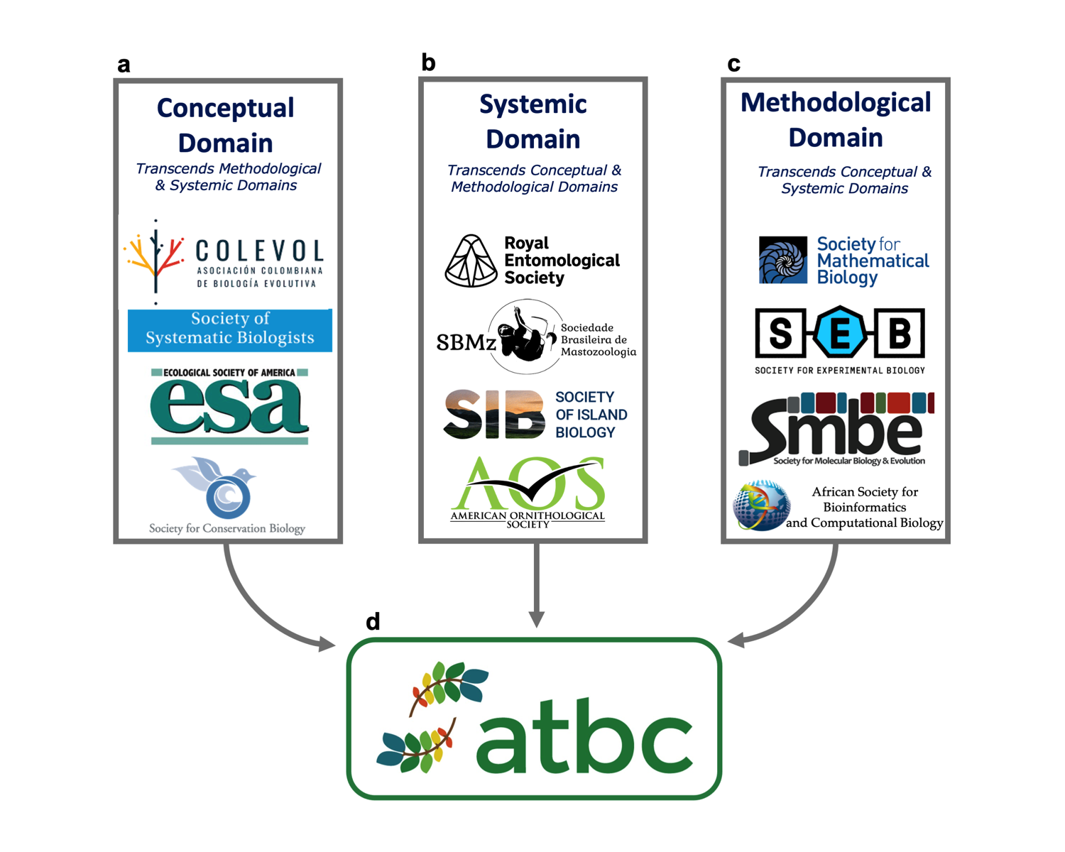

Figure 1: Alternative ways in which researchers self-organize in scholarly societies: (a) Conceptual Domain, (b) Systemic Domain, or (c) Methodological Domain. The Association for Tropical Biology & Conservation (i.e., ATBC) is unique in that transcends the three domains: its members use a broad diversity of species, ecosystems, and methods to address questions grounded in – or even transcending – multiple distinct conceptual domains.

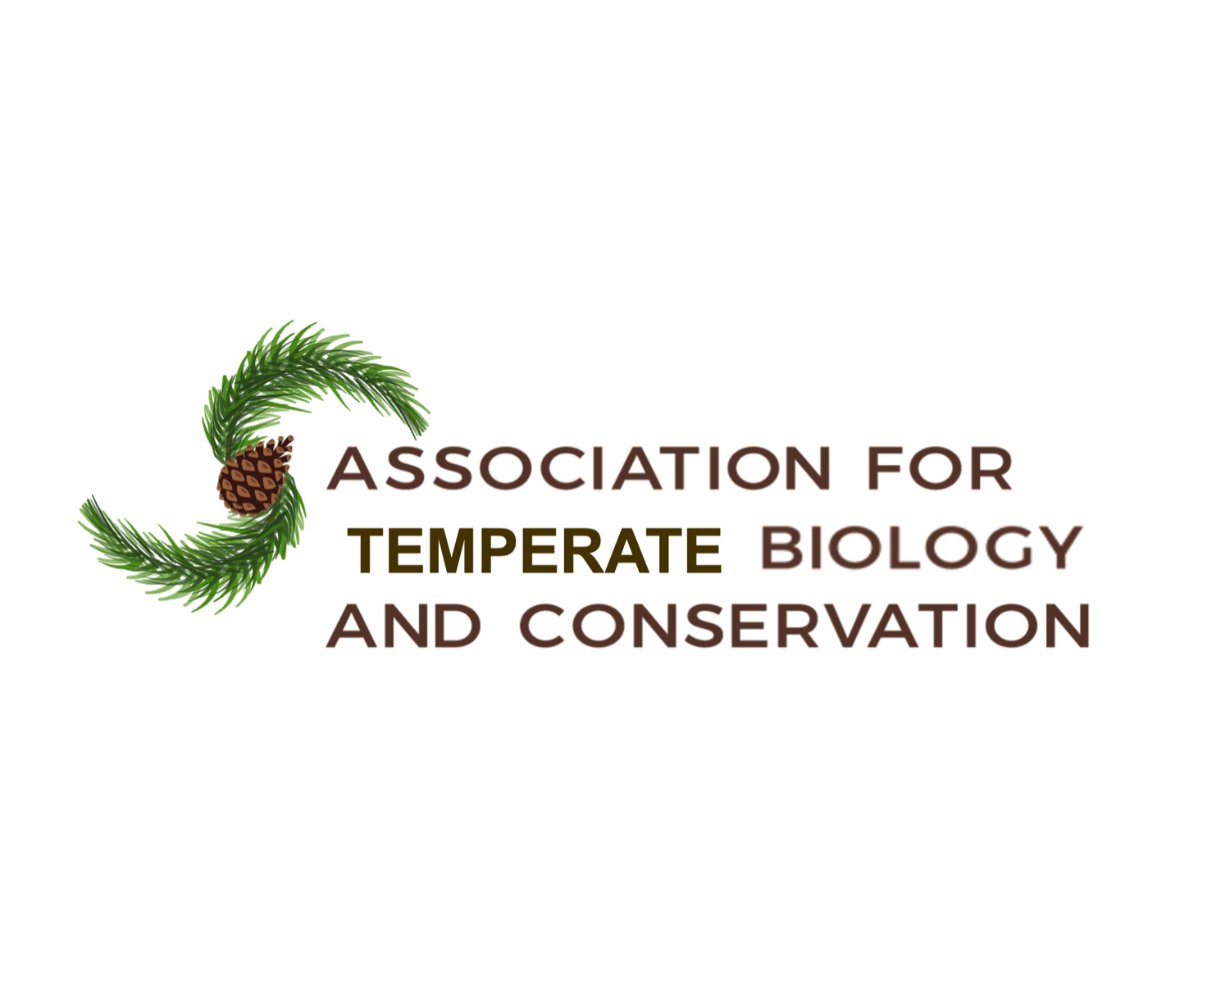

Figure 2: The logo for a proposed new scholarly society for researchers specializing on temperate ecosystems and species.

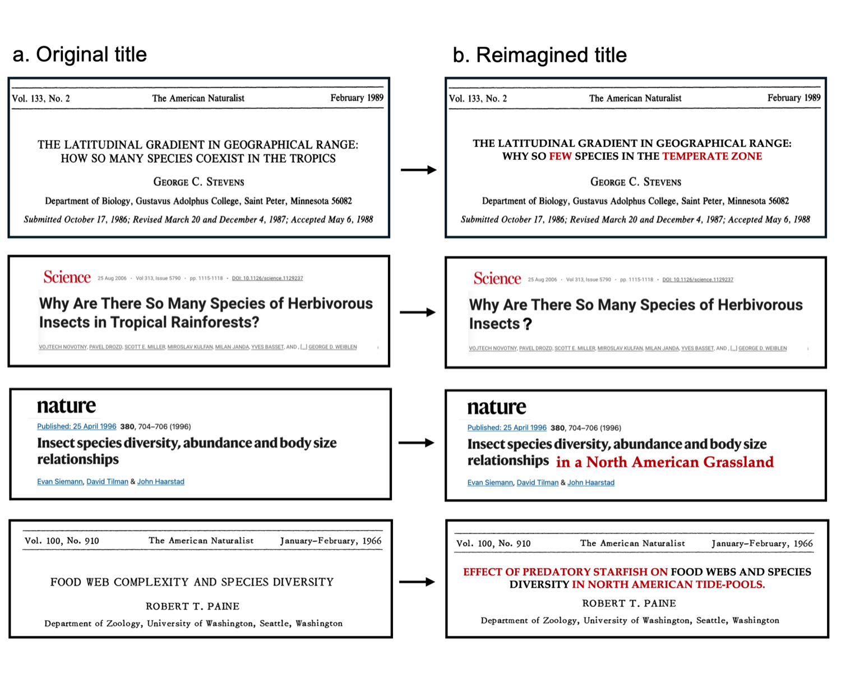

## ACKNOWLDGEMENTS

I am grateful to the organizers of the 2022 Meeting of the ATBC for encouraging the Presidential Plenary on which this essay is based, to J. Powers for her outstanding editorial work, and to P. Delamônica for her unending support and insights. I am also grateful to M. Raby and N. Stepan, whose outstanding books shaped many of the ideas expressed here. This essay is dedicated to the memory of Emilio Bruna Jr.

## DATA AVAILABILITY STATEMENT

The data used in this publication are available at Dryad <*DOI added upon acceptance*>. The code used to import, organize, and analyze these data, along with the code for preparing the figures, tables,and manuscript, are available at Zenodo <*DOI added upon acceptance*>.  
The data used in this paper are part of a larger dataset collected for a longitudinal study of research in the tropics. That data set, and the code used to harvest, clean, and organize it, are available at Github <https://github.com/BrunaLab/tropical_bibliometrics>. Questions regarding the data or code, or suggestions for improvement should be posted as Issues on that repository or referred to E. M. Bruna. That respository also includes a NEWS.md file summarizing any post-publication updates.

## DISCLOSURE STATEMENT

The author confirms that there have been no involvements that might raise the question of bias in the work reported or in the conclusions, implications, or opinions stated.

## AUTHOR CONTRIBUTION STATEMENT

E.M.B conceived the study and is responsible for the methodology, data collection, data curation, formal analysis, validation, visualization, software, and writing.

# REFERENCES

Albert, C., G. M. Luque, and F. Courchamp. 2018. The twenty most charismatic species. PLOS ONE 13: e0199149. [10.1371/journal.pone.0199149](https://doi.org/10.1371/journal.pone.0199149).

Amano, T., J. P. González-Varo, and W. J. Sutherland. 2016. Languages are still a major barrier to global science. PLoS Biology 14: e2000933. [10.1371/journal.pbio.2000933](https://doi.org/10.1371/journal.pbio.2000933).

Anderson, S. C., P. R. Elsen, B. B. Hughes, R. K. Tonietto, M. C. Bletz, D. A. Gill, M. A. Holgerson, S. E. Kuebbing, C. McDonough MacKenzie, M. H. Meek, and D. Veríssimo. 2021. Trends in ecology and conservation over eight decades. Frontiers in Ecology and the Environment 19: 274–282. [10.1002/fee.2320](https://doi.org/10.1002/fee.2320).

Annan, K. 2003. A challenge to the world’s scientists. Science 299: 1485–1485. [10.1126/science.299.5612.1485](https://doi.org/10.1126/science.299.5612.1485).

Arnold, D. 1996. The problem of nature: Environment, culture and European expansion. Blackwell.

Asase, A., T. I. Mzumara-Gawa, J. O. Owino, A. T. Peterson, and E. Saupe. 2022. Replacing “parachute science” with “global science” in ecology and conservation biology. Conservation Science and Practice 4: e517. [10.1111/csp2.517](https://doi.org/10.1111/csp2.517).

Bairlein, F., D. R. Norris, R. Nagel, M. Bulte, C. C. Voigt, J. W. Fox, D. J. T. Hussell, and H. Schmaljohann. 2012. Cross-hemisphere migration of a 25 g songbird. Biology Letters 8: 505–507. [10.1098/rsbl.2011.1223](https://doi.org/10.1098/rsbl.2011.1223).

Basset, Y., V. Novotny, S. E. Miller, G. D. Weiblen, O. Missa, and A. J. A. Stewart. 2004. Conservation and biological monitoring of tropical forests: The role of parataxonomists. Journal of Applied Ecology 41: 163–174.

Bawa, K. S., W. J. Kress, N. M. Nadkarni, and S. Lele. 2004. Beyond paradise: Meeting the challenges in tropical biology in the 21st century. Biotropica 36: 437–446. [10.1111/j.1744-7429.2004.tb00341.x](https://doi.org/10.1111/j.1744-7429.2004.tb00341.x).

Benoit, K., D. Muhr, and K. Watanabe. 2021. [Stopwords: Multilingual stopword lists. Https://CRAN.R-project.org/package=stopwords](https://CRAN.R-project.org/package=stopwords).

Bruna, E. M., W. J. Kress, F. Marques, and O. F. da Silva. 2004. *Heliconia acuminata* reproductive success is independent of local floral density. Acta Amazonica 34: 467–471. [10.1590/S0044-59672004000300012](https://doi.org/10.1590/S0044-59672004000300012).

Buechner, H. K., and F. R. Fosberg. 1967. A contribution toward a world program in tropical biology. BioScience 17: 532–538. [10.2307/1294010](https://doi.org/10.2307/1294010).

Carmel, Y., R. Kent, A. Bar-Massada, L. Blank, J. Liberzon, O. Nezer, G. Sapir, and R. Federman. 2013. Trends in ecological research during the last three decades: A systematic review. PLoS ONE 8: e59813. [10.1371/journal.pone.0059813](https://doi.org/10.1371/journal.pone.0059813).

Castro Torres, A. F., and D. Alburez-Gutierrez. 2022. North and South: Naming practices and the hidden dimension of global disparities in knowledge production. Proceedings of the National Academy of Sciences 119: e2119373119. [10.1073/pnas.2119373119](https://doi.org/10.1073/pnas.2119373119).

Cavalcanti, R. P., G. F. Benzaquen, S. da S. R. Gomes, and V. P. Almeida. 2023. Political violence and mobilisation in Brazil’s Amazonian region during Bolsonaro’s government (2019–2022). Justice, Power and Resistance 6: 152–170. [10.1332/SONH8866](https://doi.org/10.1332/SONH8866).

Chapman, V. J., C. O. Flemmich, A. L. Griffith, J. L. Harley, R. Hobbins, C. H. Holmes, C. De Rosayro, and J. Wyatt-Smith. 1945. Need for development of tropical ecological studies. Nature 156: 627–628. [10.1038/156627a0](https://doi.org/10.1038/156627a0).

Chazdon, R. L., and T. C. Whitmore eds. 2001. [Foundations of Tropical Forest Biology: Classic Papers with Commentaries](https://press.uchicago.edu/ucp/books/book/chicago/F/bo3637848.html). University of Chicago Press, Chicago, IL.

Clancy, K. B. H., R. G. Nelson, J. N. Rutherford, and K. Hinde. 2014. Survey of academic field experiences (SAFE): Trainees report harassment and assault. PLoS ONE 9: e102172. [10.1371/journal.pone.0102172](https://doi.org/10.1371/journal.pone.0102172).

Corner, E. J. H. 1946. Need for the development of tropical ecological stations. Nature 157: 377–377. [10.1038/157377b0](https://doi.org/10.1038/157377b0).

Dresser, P. van. 1948. The Future of the Amazon. Scientific American 178: 11–15.

Driver, F., and B. S. A. Yeoh. 2000. Constructing the tropics: introduction. Singapore Journal of Tropical Geography 21: 1–5. [10.1111/1467-9493.00059](https://doi.org/10.1111/1467-9493.00059).

Duchelle, A. E., K. Biedenweg, C. Lucas, A. Virapongse, J. Radachowsky, D. J. Wojcik, M. Londres, W.-L. Bartels, D. Alvira, and K. A. Kainer. 2009. Graduate students and knowledge exchange with local stakeholders: Possibilities and preparation. Biotropica 41: 578–585. [10.1111/j.1744-7429.2009.00563.x](https://doi.org/10.1111/j.1744-7429.2009.00563.x).

Ellwanger, J. H., B. Kulmann-Leal, V. L. Kaminski, J. M. Valverde-Villegas, A. B. G. D. Veiga, F. R. Spilki, P. M. Fearnside, L. Caesar, L. L. Giatti, G. L. Wallau, S. E. M. Almeida, M. R. Borba, V. P. D. Hora, and J. A. B. Chies. 2020. Beyond diversity loss and climate change: Impacts of Amazon deforestation on infectious diseases and public health. Anais da Academia Brasileira de Ciências 92: e20191375. [10.1590/0001-3765202020191375](https://doi.org/10.1590/0001-3765202020191375).

Eppley, T. M. et al. 2024. Tropical field stations yield high conservation return on investment. Conservation Letters e13007. [10.1111/conl.13007](https://doi.org/10.1111/conl.13007).

Feeley, K. J., and J. T. Stroud. 2018. Where on Earth are the “tropics”? Frontiers of Biogeography 10. [10.21425/F5FBG38649](https://doi.org/10.21425/F5FBG38649).

Fournier, A. M. V., M. E. Boone, F. R. Stevens, and E. M. Bruna. 2020. Refsplitr: Author name disambiguation, author georeferencing, and mapping of coauthorship networks with Web of Science data. Journal of Open Source Software 5: 2028. [10.21105/joss.02028](https://doi.org/10.21105/joss.02028).

Gaston, K. J. 2000. Global patterns in biodiversity. Nature 405: 220–227. [10.1038/35012228](https://doi.org/10.1038/35012228).

Gómez-Pompa, A. 2004. The role of biodiversity scientists in a troubled world. BioScience 54: 217–225. [10.1641/0006-3568(2004)054[0217:TROBSI]2.0.CO;2](https://doi.org/10.1641/0006-3568(2004)054%5b0217:TROBSI%5d2.0.CO;2).

Gourou, P. 1947. Les pays tropicaux, principes d’une géographie humaine et économique. [1. éd.]. Presses Universitaires de France, Paris.

Hoornweg, D., and K. Pope. 2017. Population predictions for the world’s largest cities in the 21st century. Environment and Urbanization 29: 195–216. [10.1177/0956247816663557](https://doi.org/10.1177/0956247816663557).

Janzen, D. 1972. Whither Tropical Ecology. *In* J. A. Behnke (Ed.) Challenging Biological Problems: Directions Toward Their Solution. pp. 281–296, Oxford University Press, New York.

Janzen, D. H. 1986. The future of tropical ecology. Annual Review of Ecology and Systematics 17: 305–324.

Kainer, K. A., M. L. DiGiano, A. E. Duchelle, L. H. O. Wadt, E. M. Bruna, and J. L. Dain. 2009. Partnering for greater success: Local stakeholders and research in tropical biology and conservation. Biotropica 41: 555–562. [10.1111/j.1744-7429.2009.00560.x](https://doi.org/10.1111/j.1744-7429.2009.00560.x).

Kainer, K. A., M. Schmink, H. Covert, J. R. Stepp, E. M. Bruna, J. L. Dain, S. Espinosa, and S. Humphries. 2006. A graduate education framework for tropical conservation and development. Conservation Biology 20: 3–13. [10.1111/j.1523-1739.2006.00356.x](https://doi.org/10.1111/j.1523-1739.2006.00356.x).

Kutesko, E. 2014. [Adidas shows the changing face of Brazil with tropical collection](http://theconversation.com/adidas-shows-the-changing-face-of-brazil-with-tropical-collection-26546). The Conversation (available at http://theconversation.com/adidas-shows-the-changing-face-of-brazil-with-tropical-collection-26546).

Maio, M. C., and M. R. Sá. 2000. Ciência na periferia: A Unesco, a proposta de criação do Instituto Internacional da Hiléia Amazônica e as origens do Inpa. História, Ciências, Saúde-Manguinhos 6: 975–1017. [10.1590/S0104-59702000000500011](https://doi.org/10.1590/S0104-59702000000500011).

McCallen, E., J. Knott, G. Nunez-Mir, B. Taylor, I. Jo, and S. Fei. 2019. Trends in ecology: Shifts in ecological research themes over the past four decades. Frontiers in Ecology and the Environment 17: 109–116. [10.1002/fee.1993](https://doi.org/10.1002/fee.1993).

Melo, F. P., J. A. Siqueira, B. A. Santos, O. Álvares-da-Silva, G. Ceballos, and E. Bernard. 2014. Football and biodiversity conservation: FIFA and Brazil can still hit a green goal. Biotropica 46: 257–259. [10.1111/btp.12114](https://doi.org/10.1111/btp.12114).

Miller, D. P., and P. H. Reill eds. 2011. Visions of empire: Voyages, botany, and representations of nature. Cambridge University Press.

Moles, A. T., and J. Ollerton. 2016. Is the notion that species interactions are stronger and more specialized in the tropics a zombie idea? Biotropica 48: 141–145. [10.1111/btp.12281](https://doi.org/10.1111/btp.12281).

Moreira, J. C., and R. A. Robles. 2017. Tamar Project: Conservation and education in ecotourism activities related to turtles in Fernando de Noronha Archipelago, Brazil. *In* I. Borges de Lima and R. J. Green (Eds.) Wildlife Tourism, Environmental Learning and Ethical Encounters: Ecological and Conservation Aspects. Geoheritage, Geoparks and Geotourism. pp. 169–181, Springer International Publishing, Cham. [10.1007/978-3-319-55574-4_10](https://doi.org/10.1007/978-3-319-55574-4_10).

Nordseth, A. E., J. R. Gerson, L. K. Aguilar, A. E. Dunham, A. Gentles, Z. Neale, and E. Rebol. 2023. The Fieldwork Wellness Framework: A new approach to field research in ecology. Frontiers in Ecology and the Environment 21: 297–303. [10.1002/fee.2649](https://doi.org/10.1002/fee.2649).

Ocampo-Ariza, C. et al. 2023. Global South leadership towards inclusive tropical ecology and conservation. Perspectives in Ecology and Conservation 21: 17–24. [10.1016/j.pecon.2023.01.002](https://doi.org/10.1016/j.pecon.2023.01.002).

Palinkas, L. A., and M. Wong. 2020. Global climate change and mental health. Current Opinion in Psychology 32: 12–16. [10.1016/j.copsyc.2019.06.023](https://doi.org/10.1016/j.copsyc.2019.06.023).

Park, O. 1945. Observations concerning the future of ecology. Ecology 26: 1–9. [10.2307/1931910](https://doi.org/10.2307/1931910).

Powers, J. S., J. Ratnam, and E. Slade. 2024. *Biotropica* ’s first open call for editorial service. Biotropica 56: e13339. [10.1111/btp.13339](https://doi.org/10.1111/btp.13339).

Putz, F. E., and N. M. Holbrook. 1988. Tropical rain-forest images. *In* J. S. Denslow and C. Padoch (Eds.) People of the Tropical Rain Forest. pp. 37–52, University of California Press, Berkeley.

R Core Team. 2023. [R: A language and environment for statistical computing](https://www.R-project.org/). R Foundation for Statistical Computing, Vienna, Austria https://www.R-project.org/.

Raby, M. 2017. American tropics: The Caribbean roots of biodiversity science. UNC Press Books.

Ramírez-Castañeda, V. et al. 2022. A set of principles and practical suggestions for equitable fieldwork in biology. Proceedings of the National Academy of Sciences 119: e2122667119. [10.1073/pnas.2122667119](https://doi.org/10.1073/pnas.2122667119).

Richards, P. W. 1946. Need for the development of tropical ecological stations. Nature 157: 377–377. [10.1038/157377a0](https://doi.org/10.1038/157377a0).

Richards, P. W. 1963. What the tropics can contribute to ecology. Journal of Ecology 51: 231–241. [10.2307/2257682](https://doi.org/10.2307/2257682).

Richards, P. W. 1964. Towards a programme for tropical biology. Bulletin of the Association for Tropical Biology 8–15.

Ripley, S. D. 1967. Perspectives in tropical biology. BioScience 17: 538–540. [10.2307/1294011](https://doi.org/10.2307/1294011).

Robinson, M. H. 1978. Is tropical biology real. Tropical Ecology 19: 30–52.

Rudzki, E. N., S. E. Kuebbing, D. R. Clark, B. Gharaibeh, M. J. Janecka, R. Kramp, K. D. Kohl, T. Mastalski, M. E. B. Ohmer, M. M. Turcotte, and C. L. Richards‐Zawacki. 2022. A guide for developing a field research safety manual that explicitly considers risks for marginalized identities in the sciences. Methods in Ecology and Evolution 13: 2318–2330. [10.1111/2041-210X.13970](https://doi.org/10.1111/2041-210X.13970).

Russell, A. E., T. M. Aide, E. Braker, C. N. Ganong, R. D. Hardin, K. D. Holl, S. C. Hotchkiss, J. A. Klemens, E. K. Kuprewicz, D. McClearn, G. Middendorf, R. Ostertag, J. S. Powers, S. E. Russo, J. L. Stynoski, U. Valdez, and C. G. Willis. 2022. Integrating tropical research into biology education is urgently needed. PLoS Biology 20: e3001674. [10.1371/journal.pbio.3001674](https://doi.org/10.1371/journal.pbio.3001674).

Sartore-Baldwin, M., and B. McCullough. 2019. Examining sport fans and the endangered species who represent their affiliated team mascots. Society & Animals 29: 268–286. [10.1163/15685306-12341605](https://doi.org/10.1163/15685306-12341605).

Silge, J., and D. Robinson. 2016. Tidytext: Text mining and analysis using tidy data principles in R. Journal of Open Source Software 1(3). [10.21105/joss.00037](https://doi.org/10.21105/joss.00037).

Smith, A. C., L. Merz, J. B. Borden, C. K. Gulick, A. R. Kshirsagar, and E. M. Bruna. 2021. Assessing the effect of article processing charges on the geographic diversity of authors using Elsevier’s “Mirror Journal” system. Quantitative Science Studies 2: 1123–1143. [10.1162/qss_a_00157](https://doi.org/10.1162/qss_a_00157).

Smith, B. 1950. European vision and the South Pacific. Journal of the Warburg and Courtauld Institutes 13: 65–100. [10.2307/750143](https://doi.org/10.2307/750143).

Smith, M. J., C. Weinberger, E. M. Bruna, and S. Allesina. 2014. The scientific impact of nations: Journal placement and citation performance. PLoS ONE 9. [10.1371/journal.pone.0109195](https://doi.org/10.1371/journal.pone.0109195).

Smith, O. M., K. L. Davis, R. B. Pizza, R. Waterman, K. C. Dobson, B. Foster, J. C. Jarvey, L. N. Jones, W. Leuenberger, N. Nourn, E. E. Conway, C. M. Fiser, Z. A. Hansen, A. Hristova, C. Mack, A. N. Saunders, O. J. Utley, M. L. Young, and C. L. Davis. 2023. Peer review perpetuates barriers for historically excluded groups. Nature Ecology & Evolution 7: 512–523. [10.1038/s41559-023-01999-w](https://doi.org/10.1038/s41559-023-01999-w).

Sohmer, S. H. 1980. NSF support of basic research in tropical biology. BioScience 30: 412–415. [10.2307/1308006](https://doi.org/10.2307/1308006).

Stegmann, L. F., F. M. França, R. L. Carvalho, J. Barlow, E. Berenguer, L. Castello, L. Juen, F. B. Baccaro, I. C. G. Vieira, C. A. Nunes, R. Oliveira, E. M. Venticinque, J. Schietti, and J. Ferreira. 2024. Brazilian public funding for biodiversity research in the Amazon. Perspectives in Ecology and Conservation 22: 1–7. [10.1016/j.pecon.2024.01.003](https://doi.org/10.1016/j.pecon.2024.01.003).

Stepan, N. 2001. Picturing tropical nature. Cornell University Press, Ithaca.

Stocks, G., L. Seales, F. Paniagua, E. Maehr, and E. M. Bruna. 2008. The geographical and institutional distribution of ecological research in the tropics. Biotropica 40: 397–404. [10.1111/j.1744-7429.2007.00393.x](https://doi.org/10.1111/j.1744-7429.2007.00393.x).

Webb, J. E. 1960. Biology in the Tropics. Nature 188: 617–619. [10.1038/188617a0](https://doi.org/10.1038/188617a0).

Yong, D. L., S. D. Fam, and S. Lum. 2011. Reel conservation: Can big screen animations save tropical biodiversity? Tropical Conservation Science 4: 244–253. [10.1177/194008291100400302](https://doi.org/10.1177/194008291100400302).

Zuk, M. 2016. Temperate assumptions: How where we work influences how we think. The American Naturalist 188: S1–S7. [10.1086/687546](https://doi.org/10.1086/687546).

1. Inspired by the provocative title of M. H. Robinson’s 1978 essay in the journal *Tropical Ecology*.
2. Inspired by the provocative title of M. H. Robinson’s 1978 essay in the journal *Tropical Ecology*.
3. Biology *sensu lato*, i.e., the study of living organisms, including their morphology and physiology, behavior, ecology, evolution, and conservation.
4. Perhaps the most extreme examples are migratory birds such as the northern wheatear (*Oenanthe oenanthe*), which fly over 14,000 km from sub-Saharan Africa to their breeding grounds in the Arctic (Bairlein *et al.* 2012)