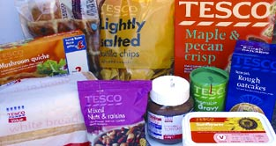

This week in class you have been studying the effect of Palm Oil on the world’s tropical rainforest. It is now your turn to work out how you are affecting the rainforest and its inhabitants. How do you use palm oil?
PRODUCTS THAT COMMONLY CONTAIN PALM OIL AND ITS DERIVATIVES

Food
Biscuits, bread, cakes, cereals, cereal bars, chips, chocolate, crisps, fish fingers, ice cream, margarine

Non food
Candles, cleansers, conditioners, deodorants, eye make-up, fabric softeners, foundations, hair dyes, hair removers, lipsticks, moisturisers, shampoos, shower gels, soaps, pharmaceuticals, washing powders.

NAMES UNDER WHICH PALM OIL AND ITS DERIVATIVES APPEAR
Cetyl alcohol
Dicetyldimonium chloride
Elaeis guineesis
E471
Isopropyl palmitate, octy palimate,
Potassium palimate, retinyl palimate,
Vit A Palmiate
Palmitic acid
Palm kernel oil
Palm kernelamide DEA and MEA
Palm Oil
Palm olein vegetable oil
Steareth-2, Steareth-20
Sodium Palm kernelate
Vegetable oil
WHAT PRODUCTS DO YOU HAVE IN YOUR SHOPPING THAT CONTAINS PALM OIL?
