***DOOR LOCK SYSTEM BASED ON QR CODE***

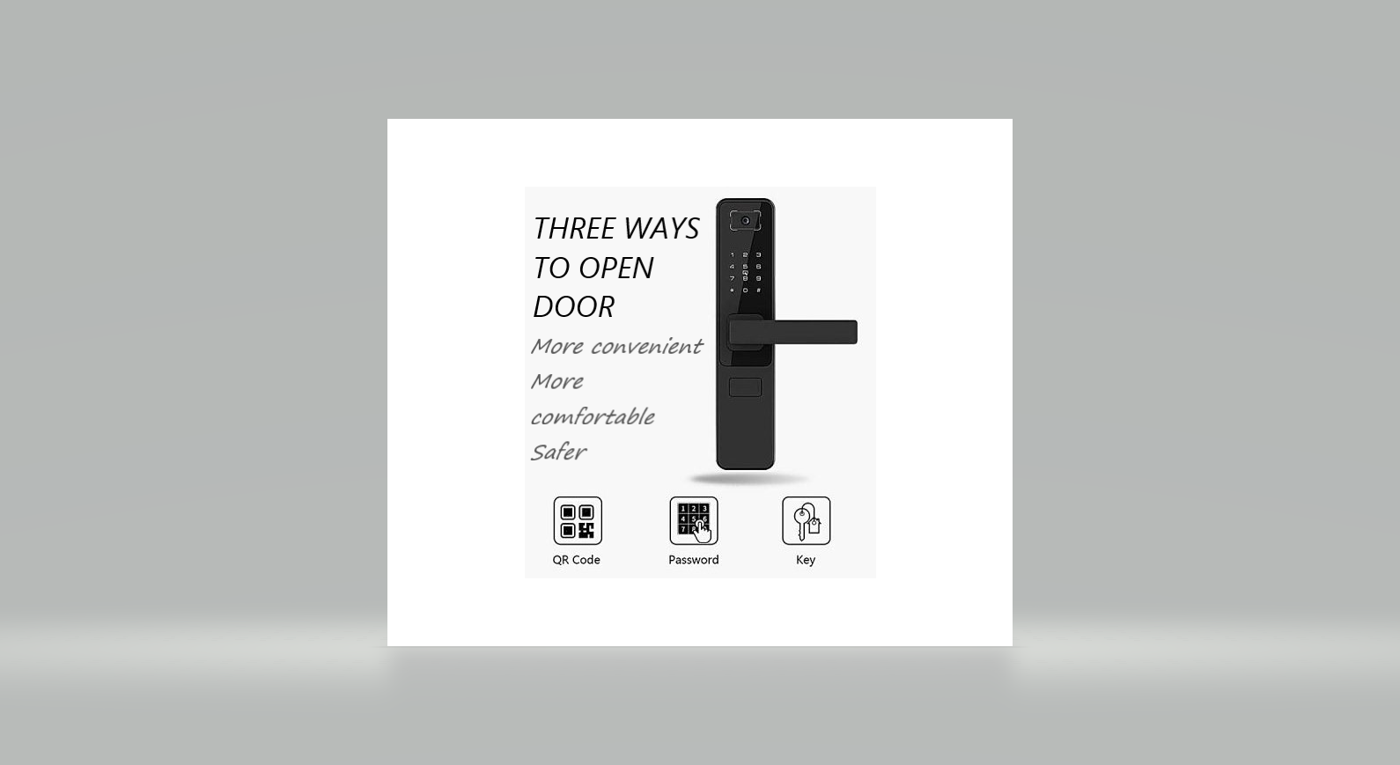

**Done by:**

U.Brunda <https://github.com/Brunda01>

Ch. Chaitanya <https://github.com/Chaitu-24>

CH.V.M. Sai Praneeth <https://github.com/sai1381>

**Abstract:**

Door locks are a common occurrence in our everyday lives. Yet, we still rely on traditional doorknobs that use physical keys that brings with it many problems such as key duplication from photos and lock-picking. There are also costs associated with making keys. This project aims to create a digital door lock system as a better alternative that accepts QR codes.

**Problem statement:**

we know that security is the main priority for us and our door knobs are less secure compared to modern technology. To improve our security, we have to move towards modern technology. **QR CODE DOOR LOCK SYSTEM** is more secure compared to traditional door lock.

**Project Description:**

In this project an advanced security system is presented using QR Identification code, which is specially designed to be used in door locks. The QR system presented here is a new methodology implemented to provide security services to hotel rooms along with better hospitality to guests (or) for homes.

Just we go back to old door lock they can be cracked easily by using some tools. Door locks are a common occurrence in our everyday lives. Yet, we still rely on traditional doorknobs that use physical keys that brings with it many problems such as key duplication from photos and lock-picking. There are also costs

associated with making keys. This project aims to create a digital door lock system as a better alternative that accepts QR codes. when we are using a barcode to open a door lock it will be safer. When user comes to home, he simply holds this QR code against the door computer which authenticates whether the right QR code has been presented by the guest/user and unlocks the door or keeps the door locked accordingly.

**Business Case:**

Door locks are a common occurrence in our everyday lives. Yet, we still rely on traditional door knobs that use physical keys that bring with it many problems such as key duplication from photos and lock-picking. There are also costs associated with making keys. This project aims to create a digital door lock system as a better alternative that accepts QR codes.

QR codes are easily produced and are low cost compared to making a new physical key. Any compromised QR code can be easily deleted or disabled. From day-to-day life we are improving our technology, but still using traditional door knobs does not give security. As we are modern technology, we have to improve our security, so QR CODE DOOR LOCK SYSTEM will replace the traditional door knobs with more security.

**EXECUTIVE SUMMARY**

This business case outlines how the QR CODE DOOR LOCK Project will address current business concerns, the benefits of the project, and recommendations and justification of the project. The business case also discusses detailed project goals, performance measures, assumptions, constraints, and alternative options.

**STRATEGIC BUSINESS CONTEXT**

**.1 BUSINESS NEED**

Everyone needs to be secured in this modern technology, and many of using still the traditional door locks, to improve the security we moving towards QR code door lock system, in this way we can easily change and produce new QR to unlock door lock and not easily copied so by using this lock system we are secure.

**.2 BUSINESS OUTCOME**

By doing this project we can get more security and easily produce and remove the keys (QR code) you don’t want and get recordings like I want time we are using in a day.

**DETAILED BUSINESS PROBLEM**

**.1 PROBEM/ OPPORTUNITY STATEMENT**

All we know that security is the main priority for us and our door knobs are less secure compared to modern technology, to improve our security we have to move towards the modern technology. QR CODE DOOR LOCK SYSTEM is more secure compared to traditional door lock.

**.2 HIGH LEVEL REQUIREMENTS**

1.OPEN CV4 to run the code belongs to computer vision

2.QR CODES

3.DATA BASE to save the key for door lock

4.CAMERA to scan the QR code.

# Epics [Major Functions]

|  |  |
| --- | --- |
| **EPIC** | **EPIC DESCRIPTION** |
| E1 | Creating a code to decode QR code |
| E2 | Storing QR codes |
| E3 | Linking the database with the code to decode the QR code |

ARCHITECTURE AND DESIGN OF THE SYSTEM

**Class Diagram:**

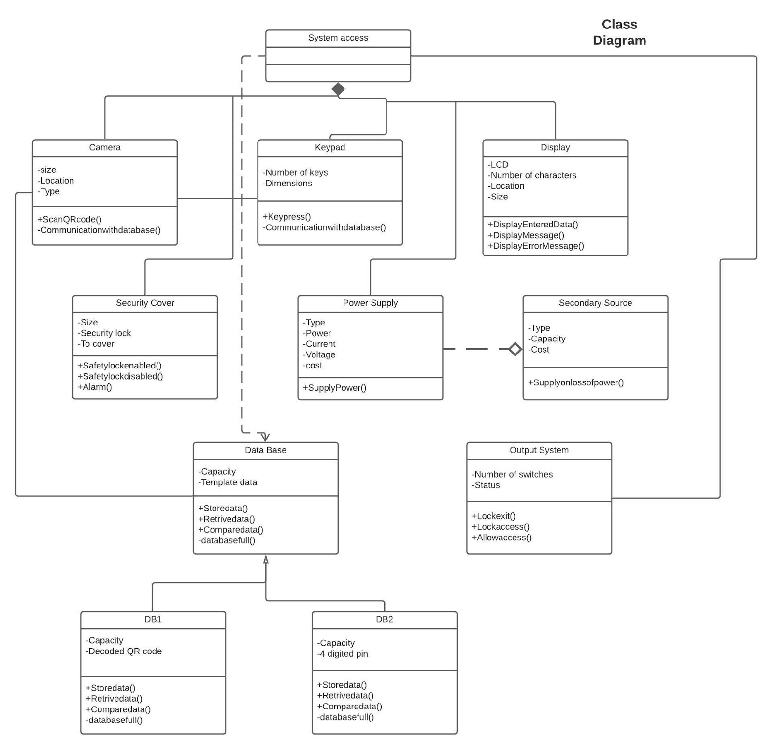

**Architecture Diagram:**

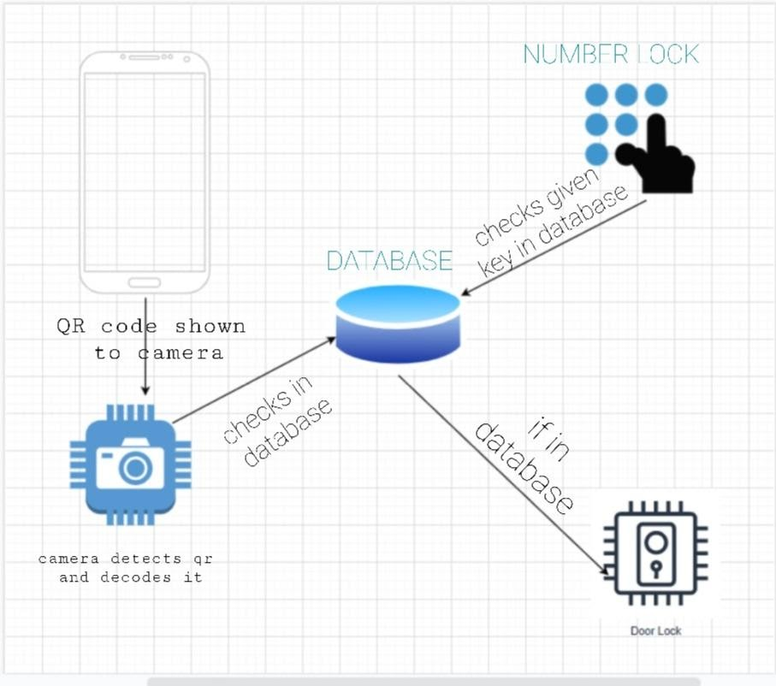

**ER Diagram:**

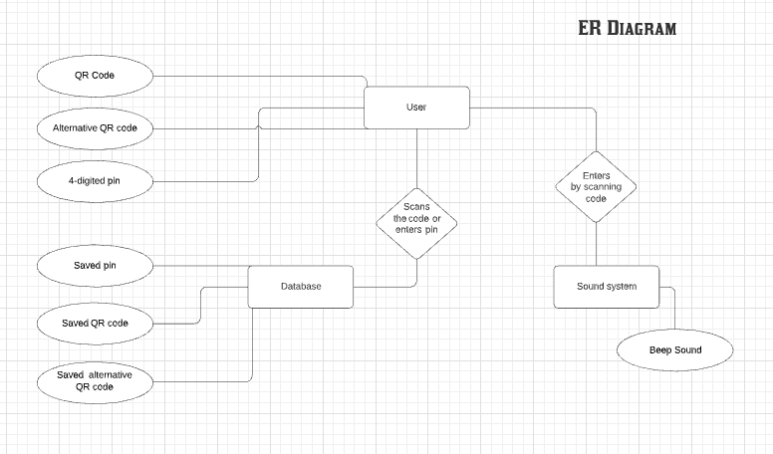

**DFD Diagram level 0:**

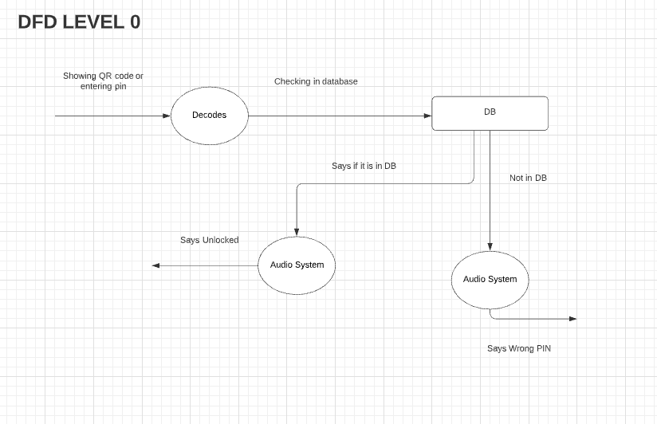

**DFD diagram level 1:**

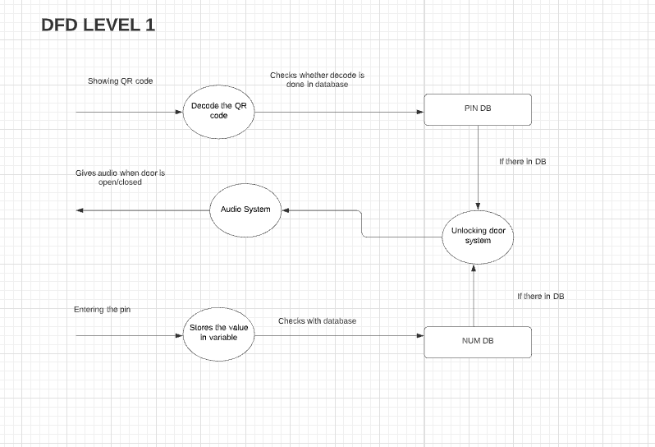

**Use case diagram:**

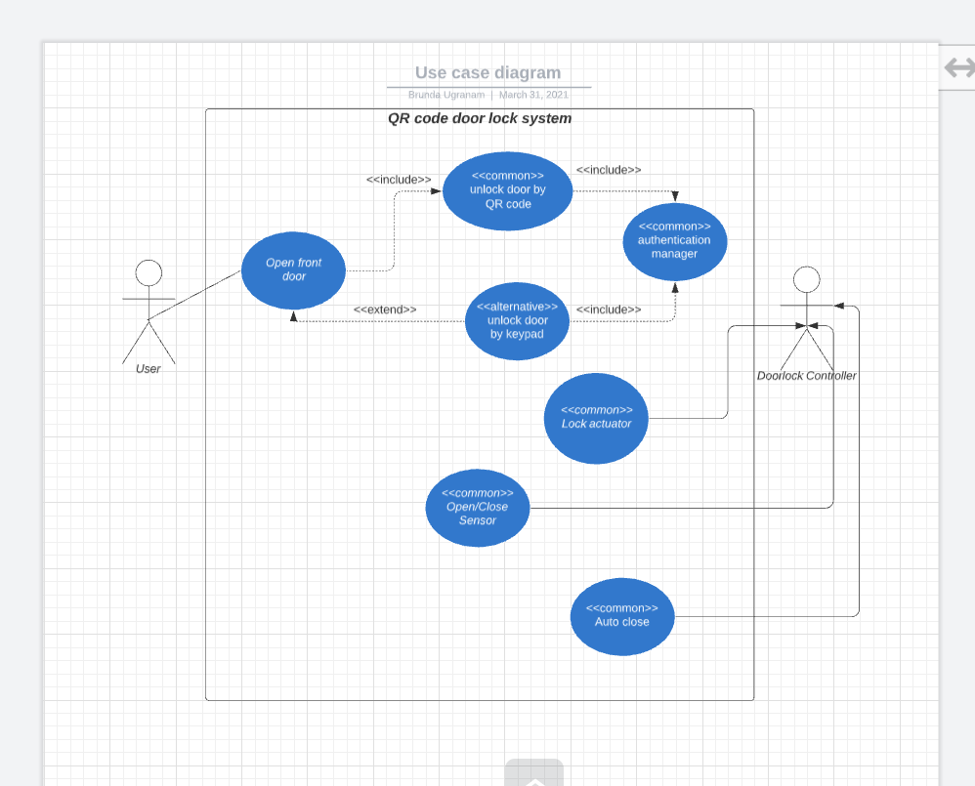

Sequence Diagram:

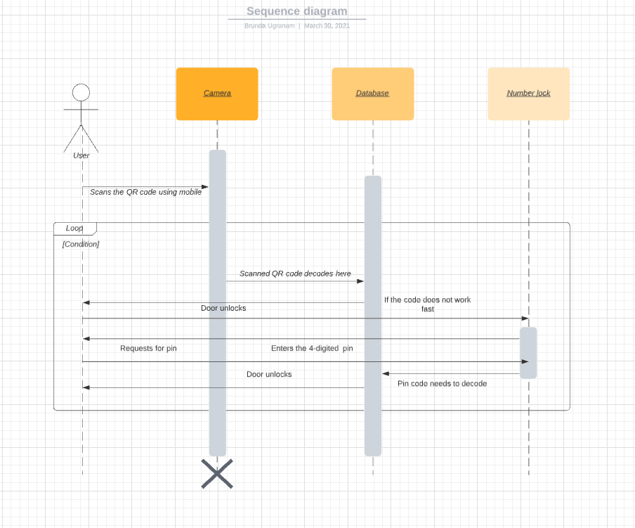

**Collaboration Diagram:**

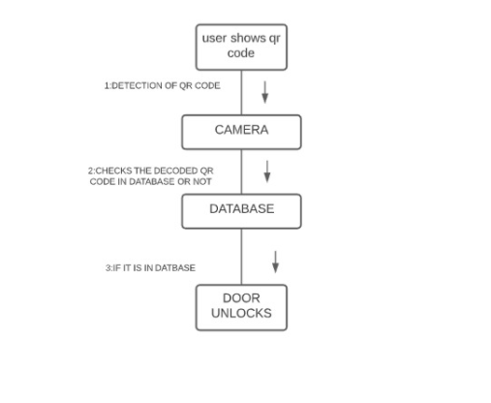

**State diagram:**

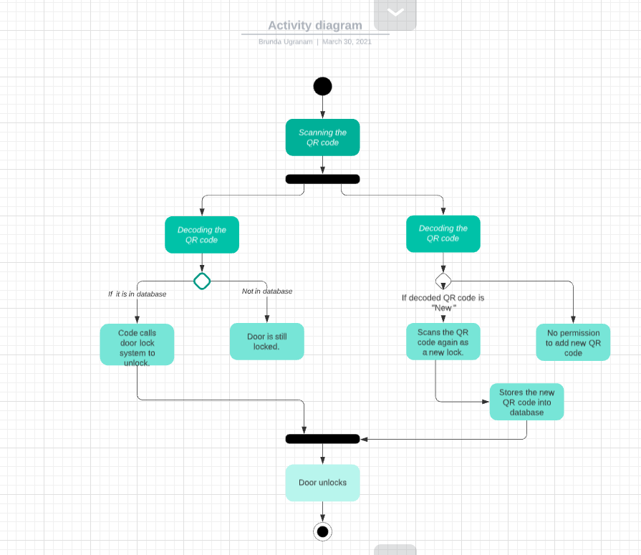

**Deployment diagram:**

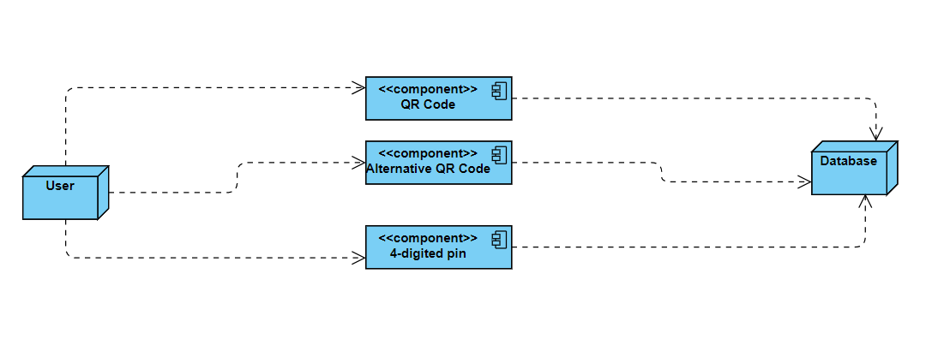

**Sample Frontend design:**

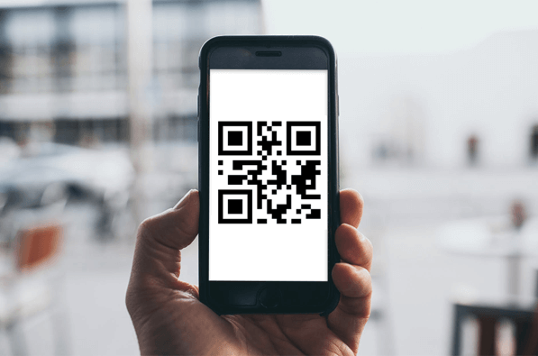

Module Description And Implementation:

*Module 1: -*

The module1 fully covers decoding of QR code shown by user.

Software Used: Python

Modules included: OPENCV2, NUMPY, PYZBAR

**Code of Module 1:**

#Including or importing all modules

import cv2

import numpy as np

import pyzbar.pyzbar as pyzbar

#here we used VideoCapture to start video capturing

cap = cv2.VideoCapture(0)

#setting frame size

cap.set(3,640)

cap.set(4,480)

#setting the font on screen frame

font = cv2.FONT_HERSHEY_PLAIN

#using string variable to store the decoded qr code

str=""

#running an infinite loop to read the qr code

while True:

success,frame = cap.read()

#here the qr decode using decode() function and stored all data in decodedobjects

decodedObjects = pyzbar.decode(frame)

#We are taking variable and using that variable we are printing decoded one

for obj in decodedObjects:

str=obj.data.decode('utf-8')

print("DECODED QR CODE IS",str)

cv2.putText(frame, str(obj.data), (50, 50), font, 2,(255, 0, 0), 3)

cv2.imshow("Frame", frame)

#wait key is used to stop running of the code

key = cv2.waitKey(0)

if key == 27:

Break

**OUTPUT:**

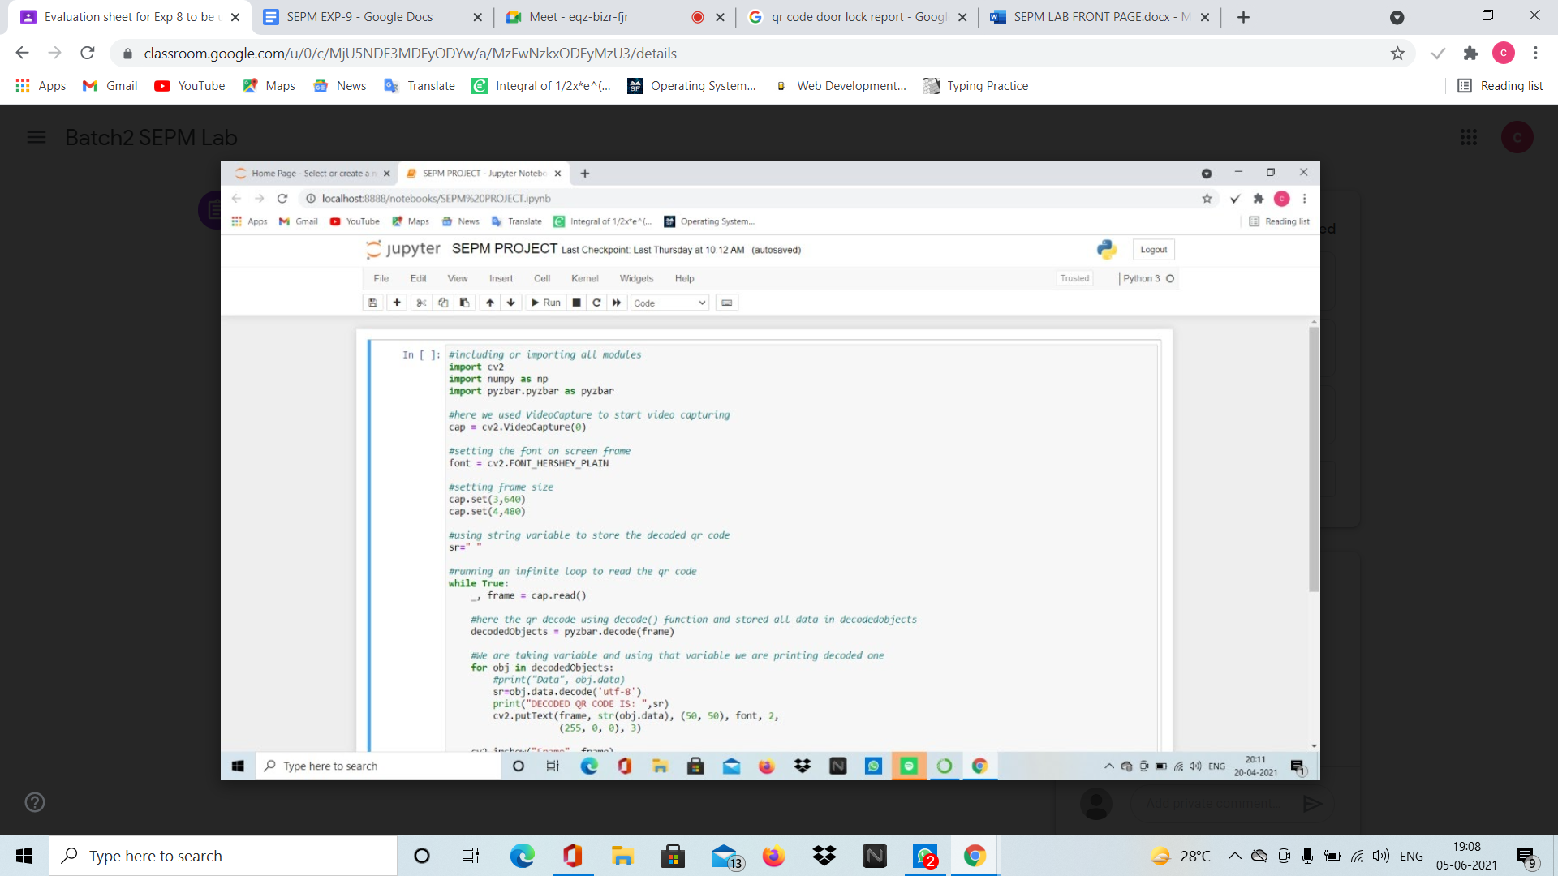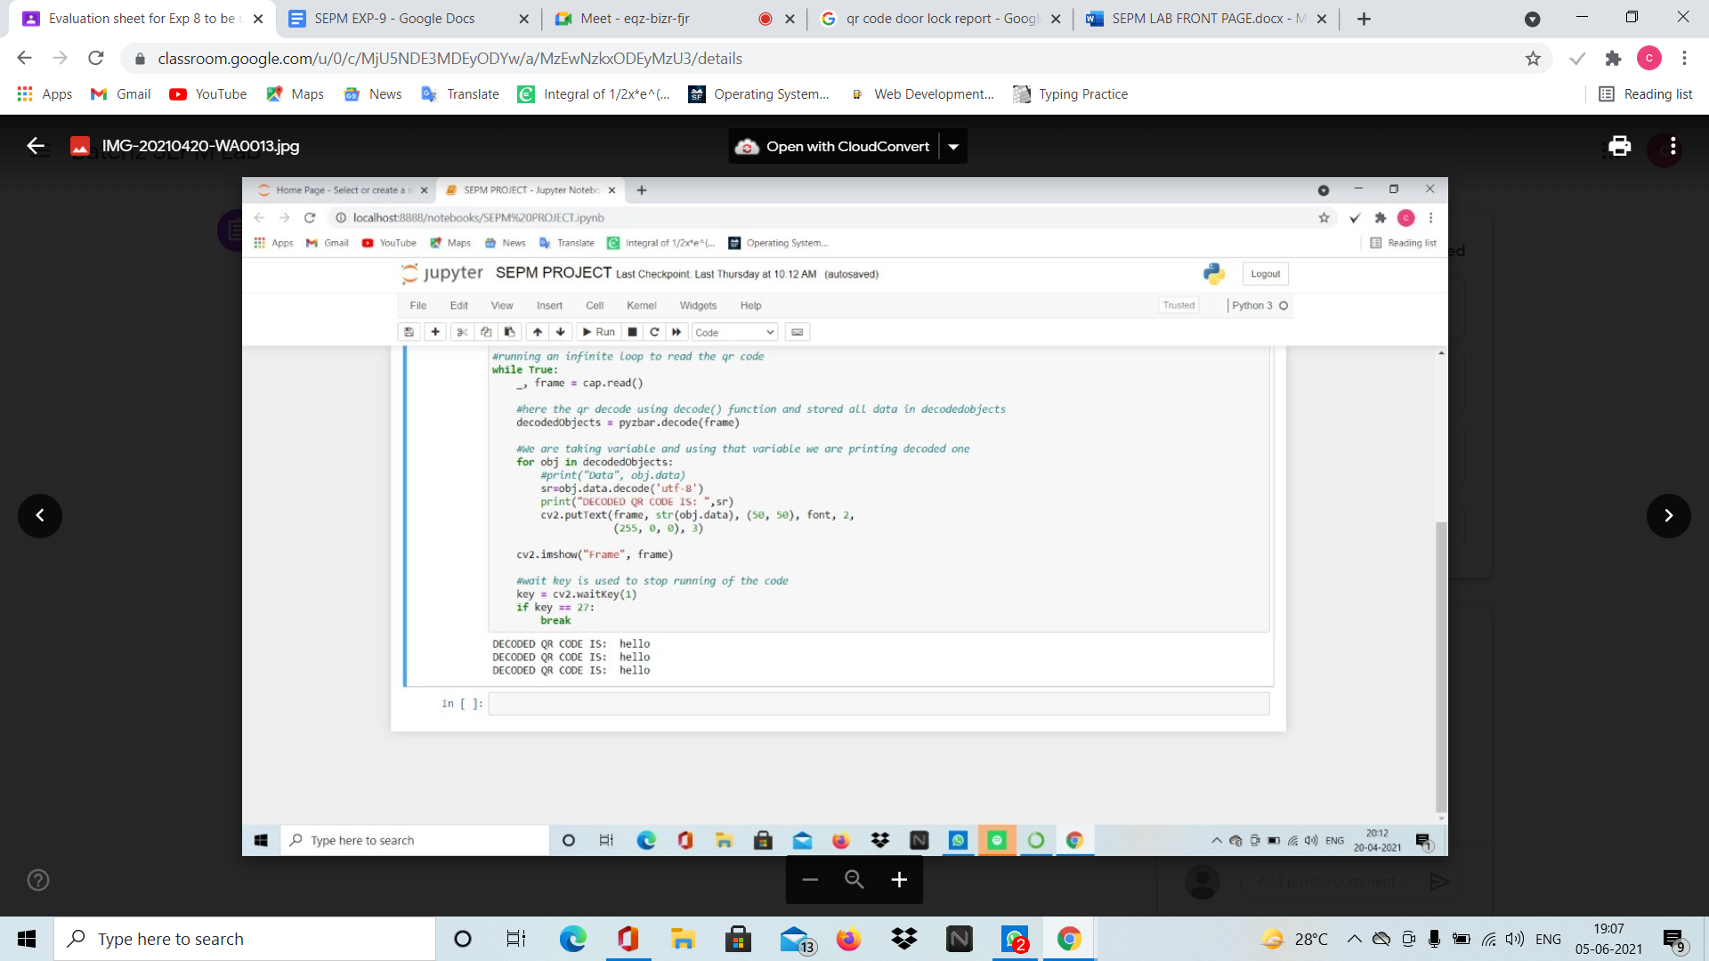

*Module 2: -*

*This module 2 is about unlocking the door using number lock alternate for QR lock. When user enters correct number lock door unlocks by searching entered lock in database.*

**CODE:**

import sqlite3

def func(num):

conn=sqlite3.connect('owner.db')

c=conn.cursor()

c.execute("""CREATE TABLE IF NOT EXISTS ju ( pass varchar(20))""")

c.execute("SELECT * FROM ju ")

if len(c.fetchall())==0:

c.execute("INSERT INTO ju VALUES('12345')")

c.execute("INSERT INTO ju VALUES('112233')")

c.execute("INSERT INTO ju VALUES('998877')")

c.execute("SELECT * FROM ju where pass=?",(num,))

le=len(c.fetchall())

conn.commit()

conn.close()

return le

while 1<2:

num=input("Enter number lock: ")

if func(num)>=1:

print("DOOR UNLOCKED :)")

break

else:

print("*****TRY AGAIN*****")

**OUTPUT:**

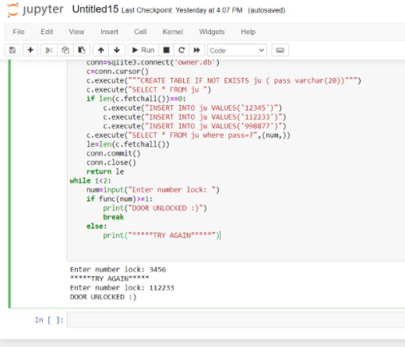

*Module 3: -*

This module 3 is about adding a new QR code as lock and unlocking the door. And in this module, there will be a separate QR code when we show that QR it will accept the new QR into database.

**CODE:**

#including or importing all modules

import cv2

import numpy as np

import pyzbar.pyzbar as pyzbar

import sqlite3

#THIS FUNCTION USED TO DECODE QR CODE

def func():

#here we used VideoCapture to start video capturing

cap = cv2.VideoCapture(0)

#setting the font on screen frame

font = cv2.FONT_HERSHEY_PLAIN

#setting frame size

cap.set(3,640)

cap.set(4,480)

#using string variable to store the decoded qr code

sr=""

decodedObjects=[]

#running an infinite loop to read the qr code

while len(decodedObjects)==0:

_, frame = cap.read()

#here the qr decode using decode() function and stored all data in decodedobjects

decodedObjects = pyzbar.decode(frame)

#We are taking variable and using that variable we are printing decoded one

for obj in decodedObjects:

#print("Data", obj.data)

sr=obj.data.decode('utf-8')

#print("DECODED QR CODE IS: ",sr)

cv2.putText(frame, str(obj.data), (50, 50), font, 2, (255, 0, 0), 3)

cv2.imshow("Frame", frame)

return sr

#THIS FUNCTION USED TO CONNECT WITH DATABASE AND SEARCHING IN DATABASE

def func2():

conn=sqlite3.connect('owner.db')

c=conn.cursor()

c.execute("""CREATE TABLE IF NOT EXISTS qcode ( pass varchar(40))""")

c.execute("SELECT * FROM qcode ")

if len(c.fetchall())==0:

c.execute("INSERT INTO qcode VALUES('qwerty123')")

c.execute("INSERT INTO qcode VALUES('poiu456')")

c.execute("INSERT INTO qcode VALUES('asdfgh789')")

c.execute("INSERT INTO qcode VALUES('hello')")

re=func()

if re=='++NEW++':

print("SHOW NEW QR CODE!!!!")

re=func()

c.execute("INSERT INTO qcode VALUES(?)",(re,))

print("ADDED NEW QR CODE :)")

c.execute("SELECT * FROM qcode where pass=?",(re,))

le=len(c.fetchall())

conn.commit()

conn.close()

return le

while 1<2:

if func2()>=1:

print("DOOR UNLOCKED :)")

break

else:

print("*****TRY AGAIN*****")

**OUTPUTS :**

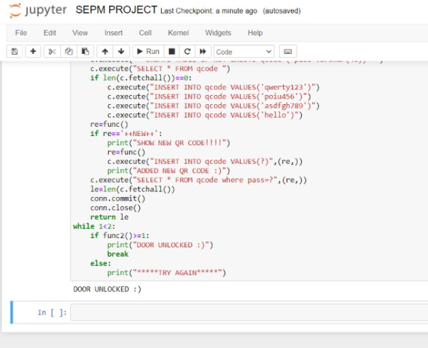

*The above code is the output for the decoded QR code. To add a new QR code the procedure is as follows.*



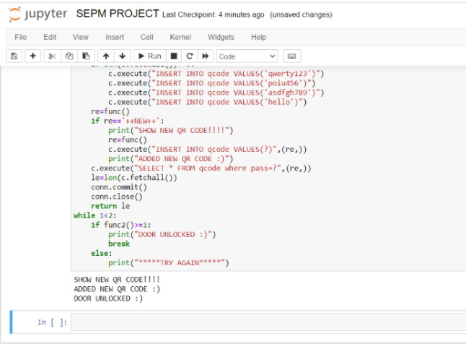

**Conclusion**

The main goal of this project was to achieve several objectives. The first objective was to investigate and analyse the requirements of a quick to use, QR code-based door lock. The Lock system is able to validate a QR code in less than 10 seconds which passes for a quick to use QR code door lock.