1. **Creating Test Plan called Bunnycart -Test Plan**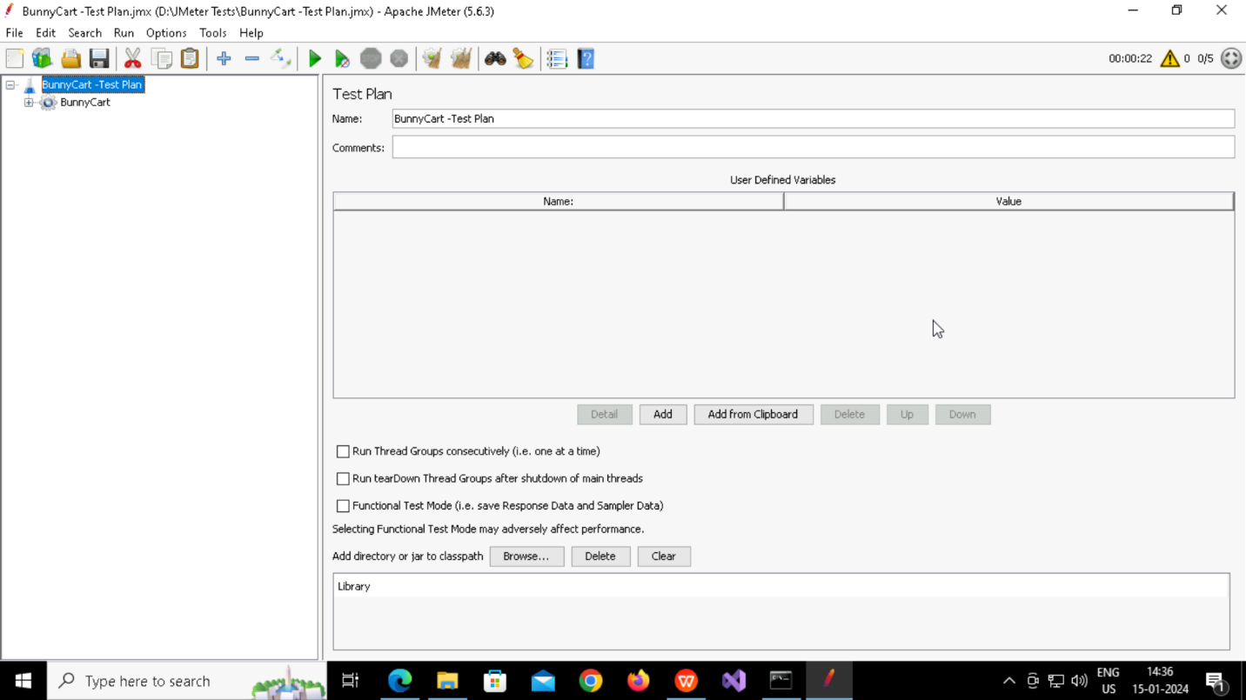
2. **Creating Thread Group called BunnyCart**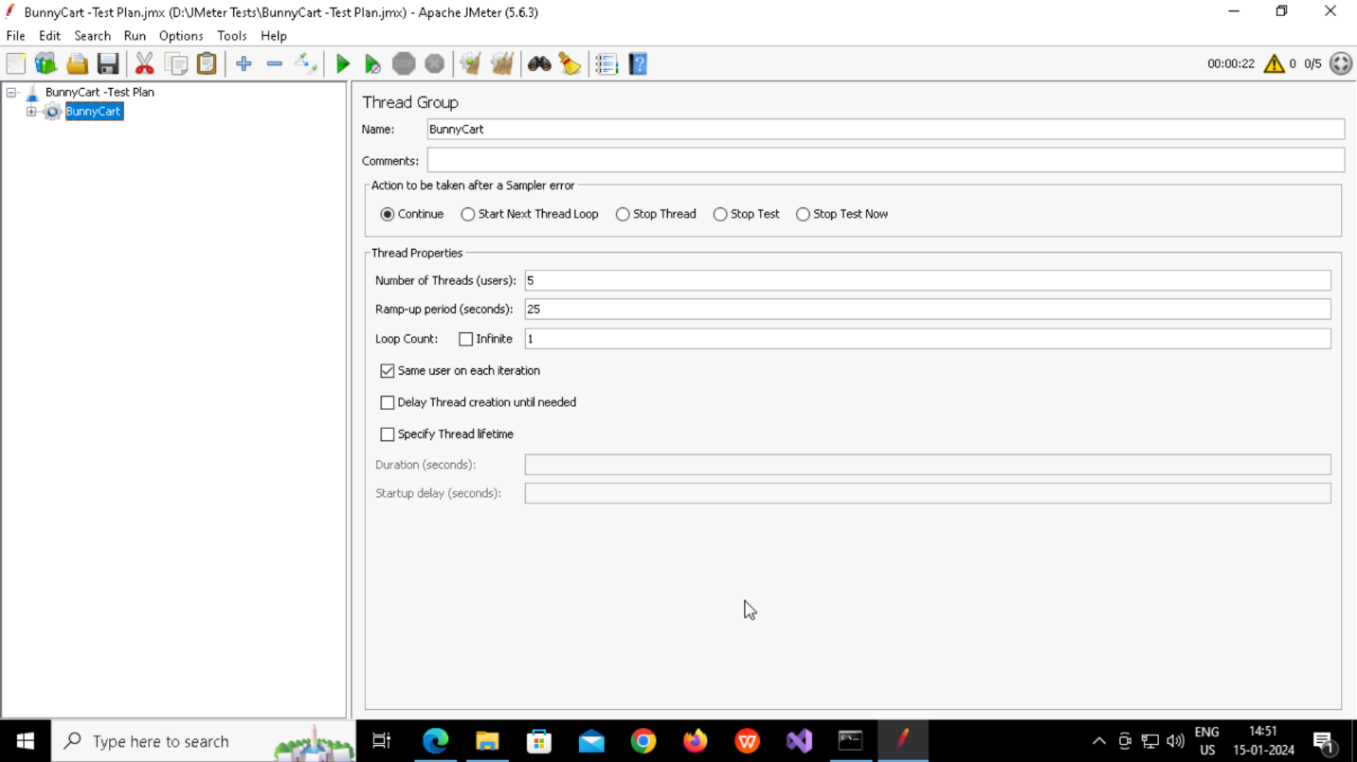
3. **Adding HTTP Sampler like BunnyCart HomePage HTTP Request, Aquatic Plant HTTP Request,Guppy Grass HTTP Request**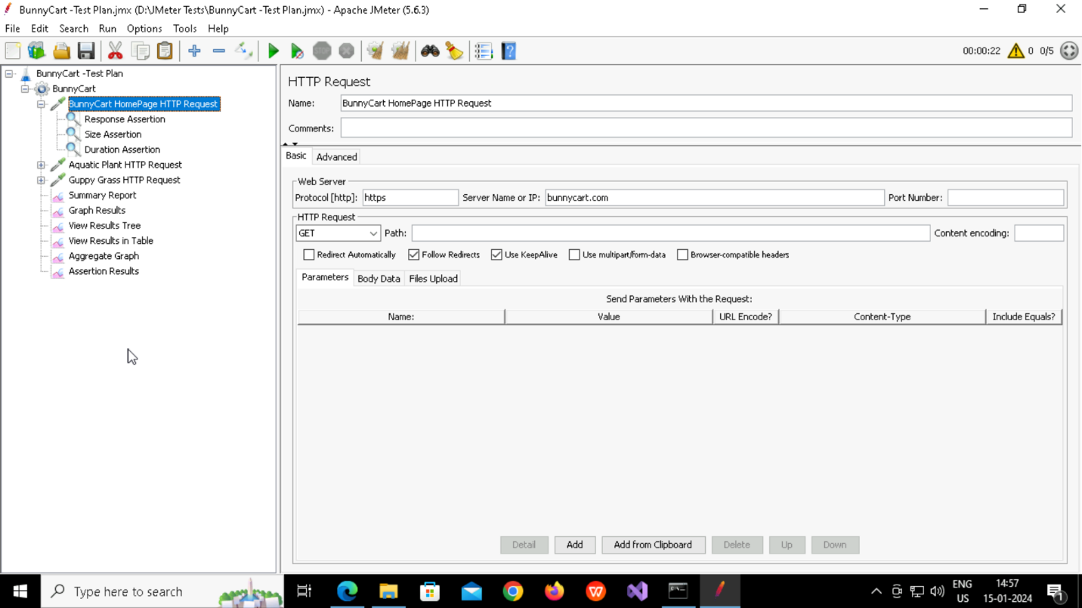
4. **Adding Response Assertions** 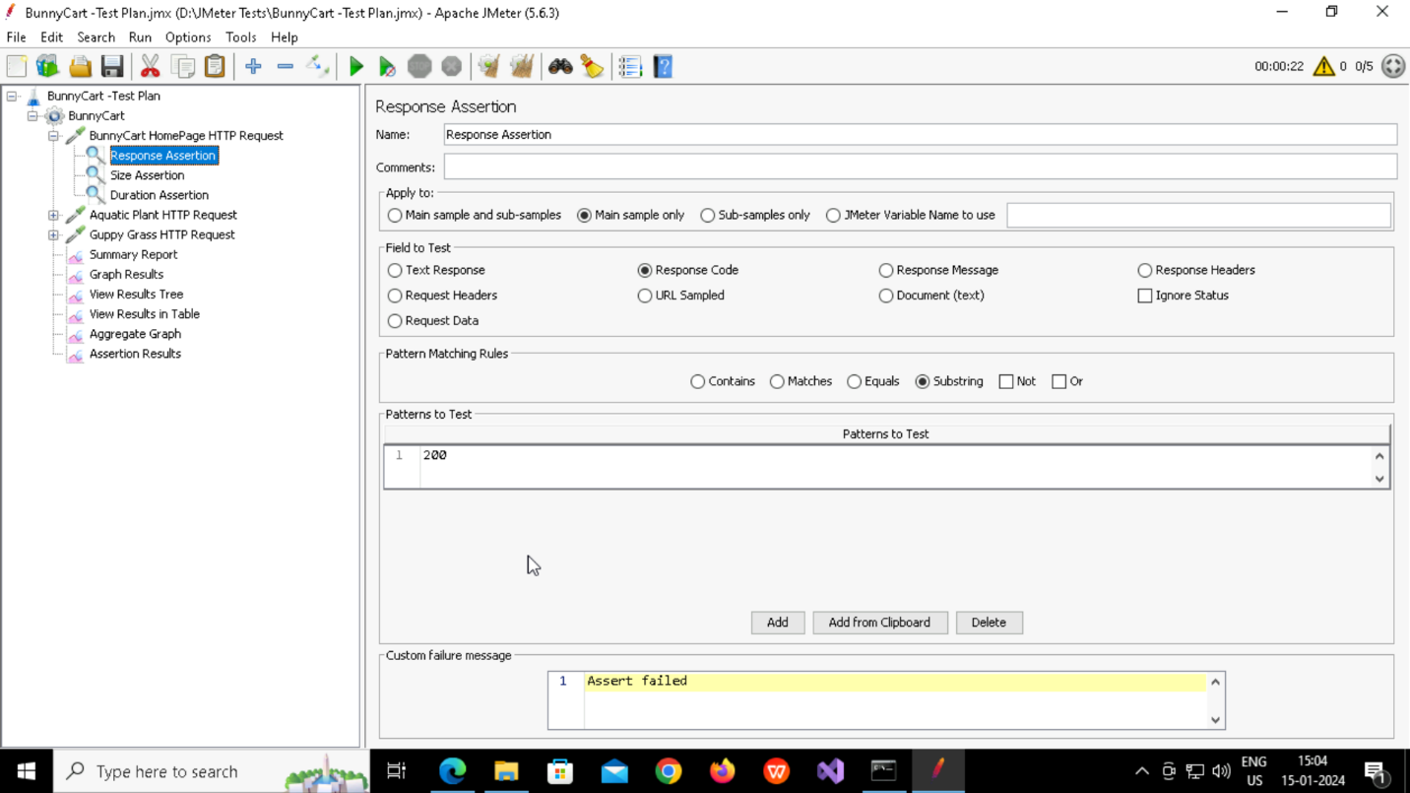
5. **Adding Size Assertion**

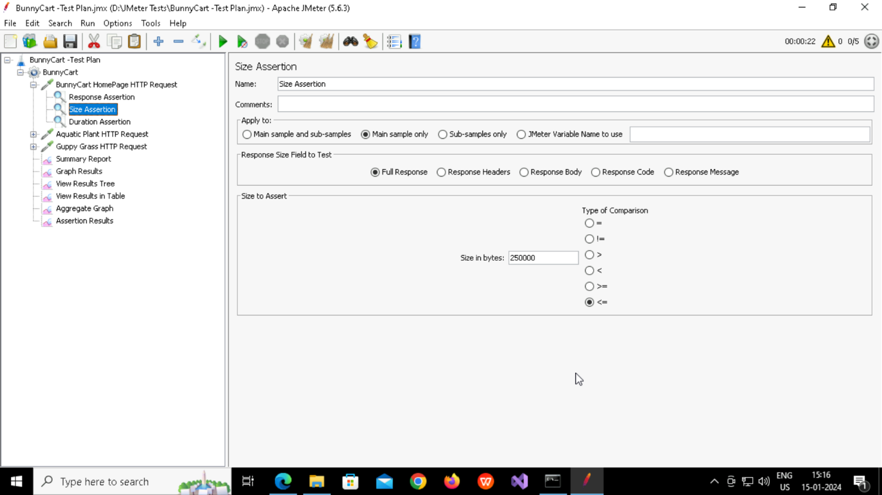

1. **Adding Duration Assertion**

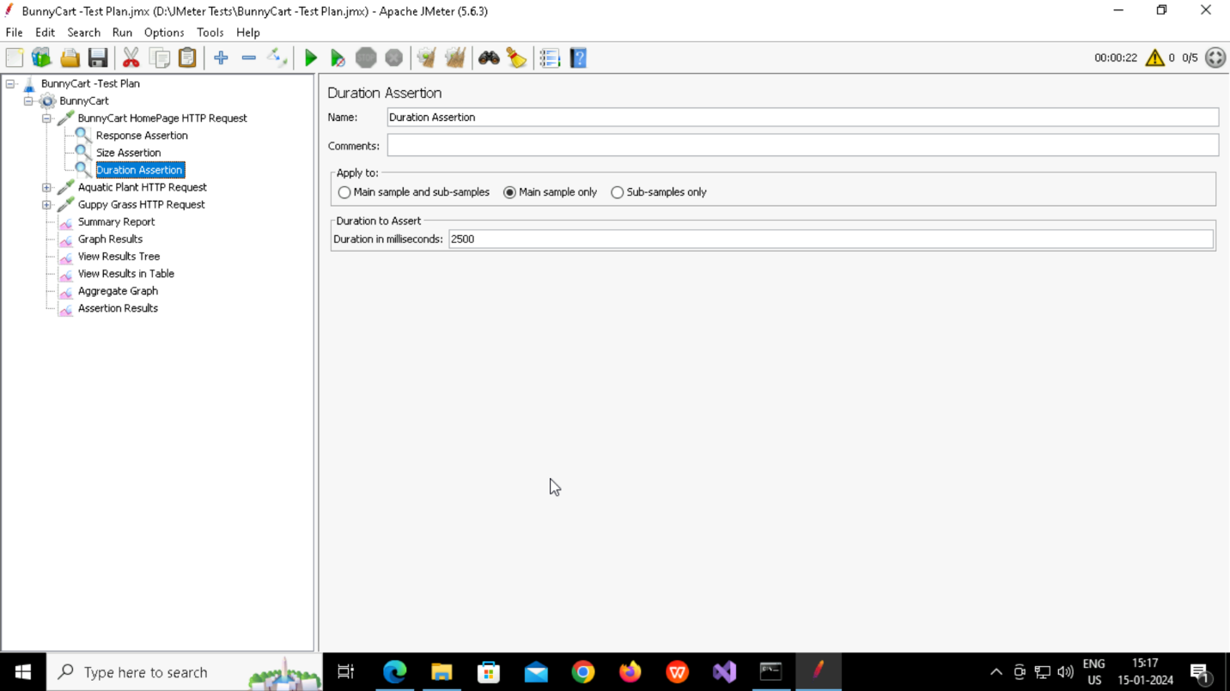

1. **Adding Listener called Summary Report**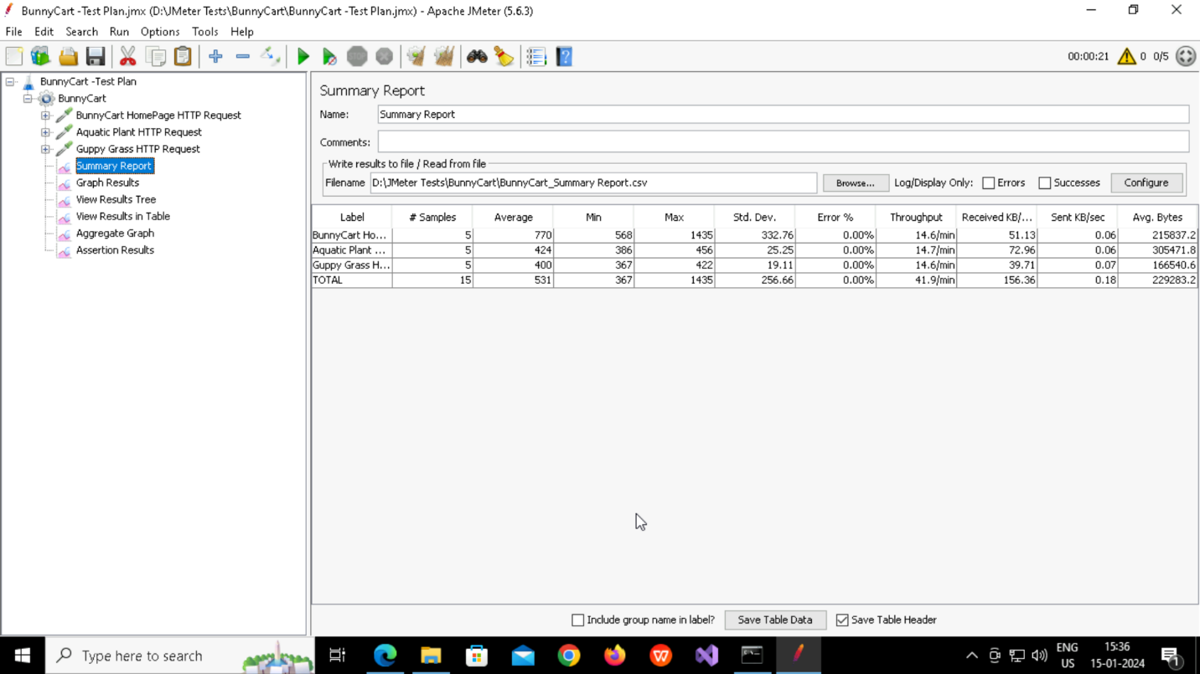
2. **Adding Listener called Graph ResultsA screenshot of a computer

   Description automatically generated**
3. **Adding Listener called View Results Tree**

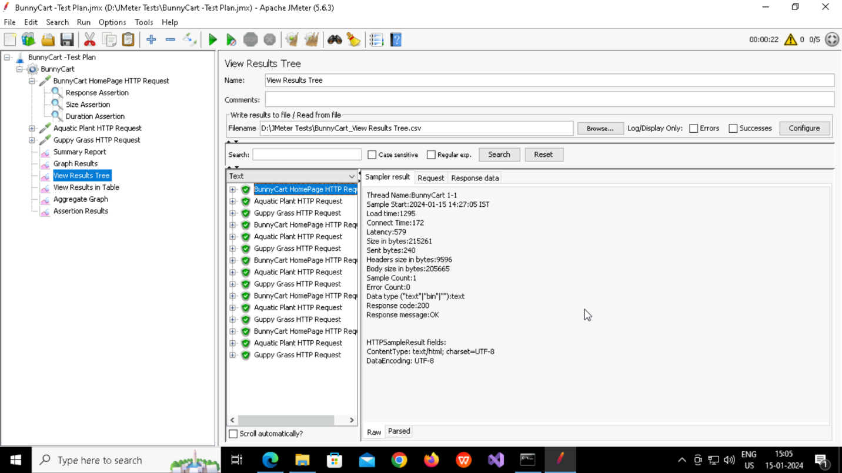

1. **Adding Listener called View Results in Table**

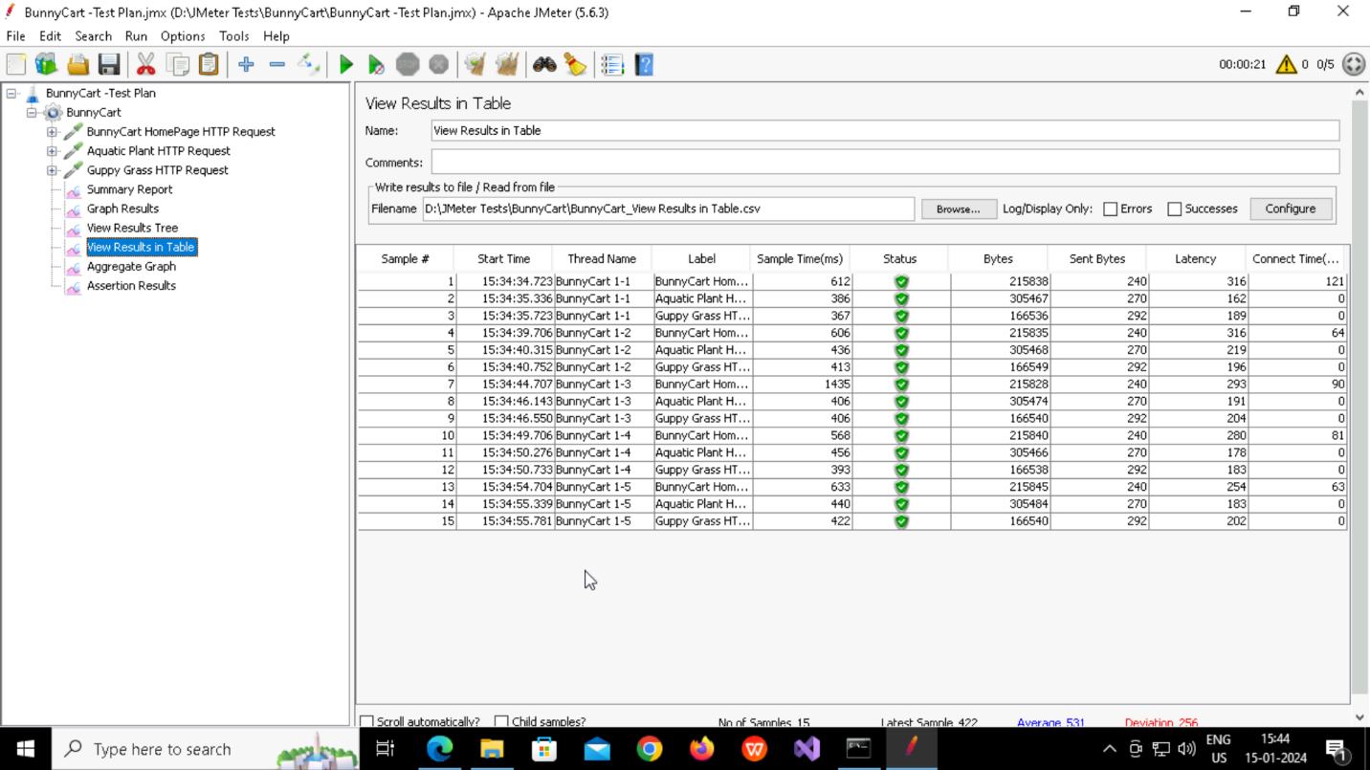

1. **Adding Listener called Aggregate Graph**

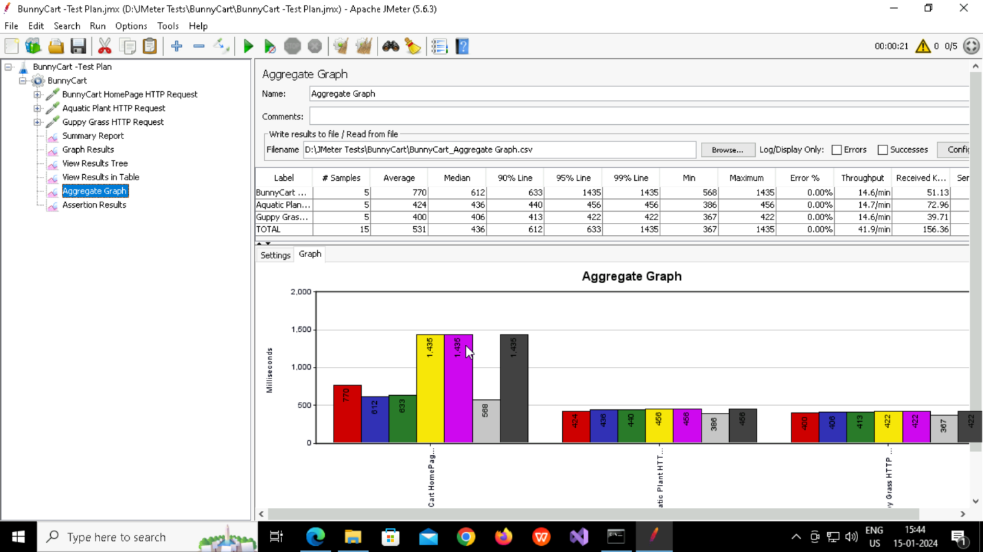

1. **Adding Listener called Assertion Results**

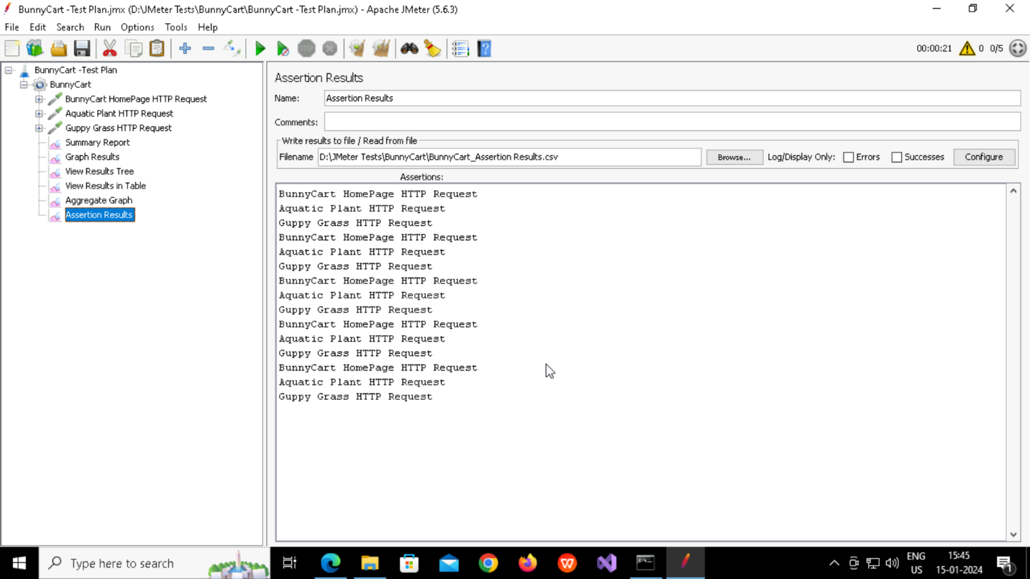

1. **Adding Listener called Response Time Graph**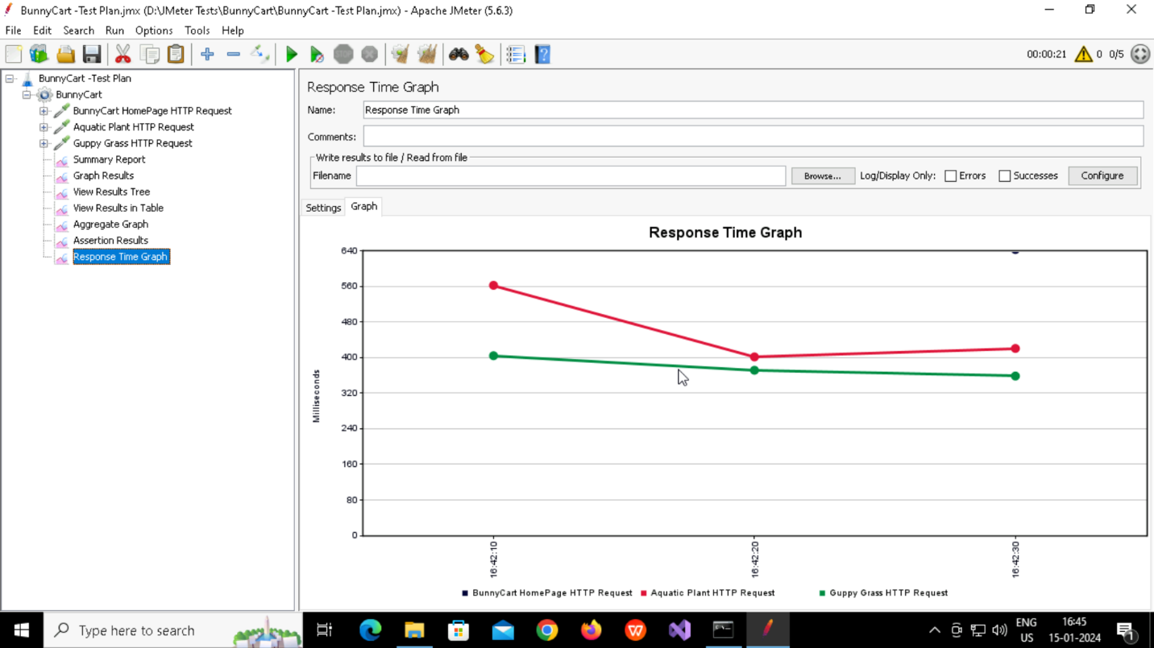

**Questions and Answers:**

1. What is the average response time for the homepage of the website?

* 770

1. Did all requests meet the assertion criteria? If not, what failed?

* Yes

1. How does the response time vary over time during the test run?

* It’s Decreasing