**DQL**

**1. Retrieve the details (Name, Salary and dept code) of the staff who are working in**

**department code 20, 30 and 40.**

SELECT Staff_Name, Staff_Sal, Dept_Code

FROM Staff_Masters

WHERE Dept_Code IN ('20', '30', '40');

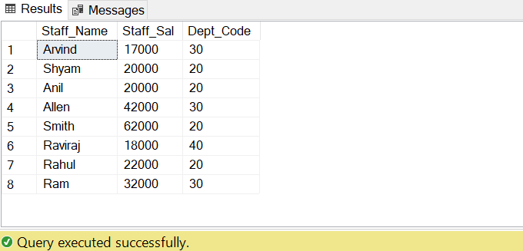

**2. Display the code and total marks for every student. Total Marks will be calculated as**

**subject1+subject2+subject3 .(Refer Student_marks table )**

SELECT masters.Student_Code,

SUM(marks.Subject1 + marks.Subject2 + marks.Subject3) AS Total_Marks

FROM Student_Masters masters

JOIN Student_Marks marks ON masters.Student_Code = marks.Student_Code

GROUP BY masters.Student_Code;

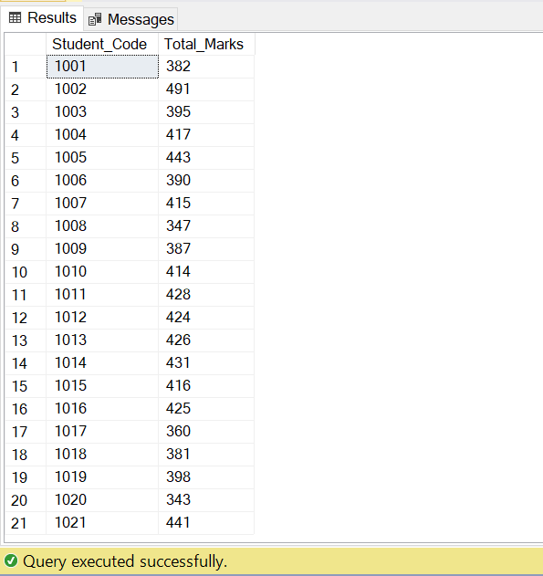

**3. List the Name and Designation code of the staff who have joined before Jan 2003 and whose salary range is between 12000 and 25000. Display the columns with user defined Column headers. Hint: Use As clause along with other operators**

SELECT Staff_Name AS Name, Design_Code AS Designation_Code

FROM Staff_Masters

WHERE Hiredate < '2003-01-01'

AND

Staff_Sal BETWEEN 12000 AND 25000;

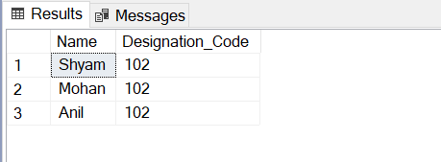

**4. List the code, name, and department number of the staff who have experience of 18**

**or more years and sort them based on their experience.**

SELECT Staff_Code AS Code, Staff_Name AS Name, Dept_Code AS Department_Number

FROM Staff_Masters

WHERE DATEDIFF(YEAR, Hiredate, GETDATE()) >= 18

ORDER BY DATEDIFF(YEAR, Hiredate, GETDATE());

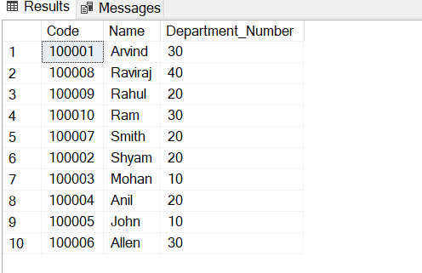

**5. List the name, designation code, and salary for 10 years of the staff who are working**

**in departments 10 and 30.**

SELECT Staff_Code AS Code, Staff_Name AS Name, Dept_Code AS Department_Number

FROM Staff_Masters

WHERE YEAR(GETDATE()) - YEAR(Hiredate) >= 18

ORDER BY Hiredate;

**6. Display name concatenated with dept code separated by comma and space. Name**

**the column as ‘Student Info’.**

SELECT CONCAT(Student_Name, ', ', Dept_Code) AS 'Student Info'

FROM Student_Masters;

**7. Display the staff details who do not have manager. Hint: Use is null**

SELECT *FROM Staff_Masters

WHERE Mgr_Code IS NULL;

**8. Write a query which will display name, department code and date of birth of all students who were born between January 1, 1981 and March 31, 1983. Sort it based on date of birth (ascending).Hint: Use between operator**

SELECT Student_Name AS Name,Dept_Code AS Department_Code,Student_Dob AS Date_of_Birth

FROM Student_Masters

WHERE Student_Dob BETWEEN '1981-01-01' AND '1983-03-31'

ORDER BY Student_Dob ASC;

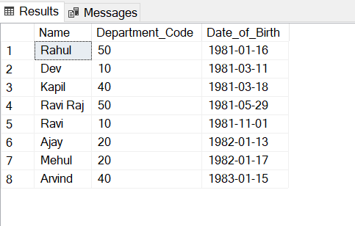

**9. Display the Book details that were published during the period of 2001 to 2004. Also display book details with Book name having the character ‘&’ anywhere.**

SELECT *FROM Book_Masters

WHERE (Book_pub_year BETWEEN 2001 AND 2004) OR (Book_name LIKE '%&%');

**10. Display the Book details where the records have the word “COMP” anywhere in the**

**Book name.**

SELECT *FROM Book_Masters

WHERE Book_name LIKE '%COMP%';

**11. List the details of the staff, whose names start with ‘A’ and end with ‘S’ or whose names contains N as the second or third character, and ending with either ‘N’ or ‘S’.**

SELECT *FROM Staff_Masters

WHERE (Staff_Name LIKE 'A%S' OR Staff_Name LIKE 'N_%'

OR Staff_Name LIKE '_N%' OR Staff_Name LIKE '%N' OR Staff_Name LIKE '%S');

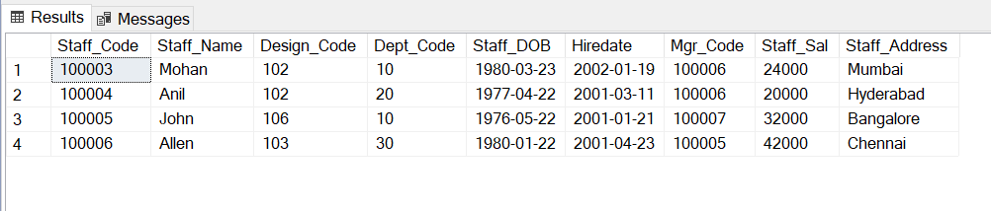

**12. List the names of the staff having ‘_’ character in their name.**

SELECT Staff_Name FROM Staff_Masters

WHERE Staff_Name LIKE '%\_%' ESCAPE '\';

=====================================================================

**JOINS**

**1. Write a query which displays Staff Name, Department Code, Department Name, and**

**Salary for all staff who earns more than 20000.**

SELECT sm.Staff_Name,sm.Dept_Code,dm.Dept_Name,sm.Staff_Sal

FROM Staff_Masters sm

JOIN Department_Masters dm ON sm.Dept_Code = dm.Dept_Code

WHERE sm.Staff_Sal > 20000;

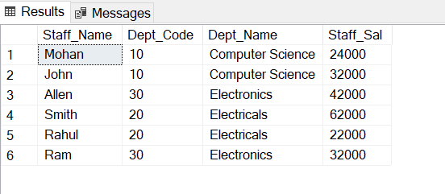

**2. Display Staff Code, Staff Name, Department Name, and his manager’s number and name. Label the columns Staff#, Staff, Mgr#, Manager.**

SELECT s1.Staff_Code AS 'Staff#', s1.Staff_Name AS 'Staff',

s1.Mgr_Code AS 'Mgr#', s2.Staff_Name AS 'Manager',

dm.Dept_Name AS 'Department Name'

FROM Staff_Masters s1

LEFT JOIN Staff_Masters s2 ON s1.Mgr_Code = s2.Staff_Code

JOIN Department_Masters dm ON s1.Dept_Code = dm.Dept_Code;

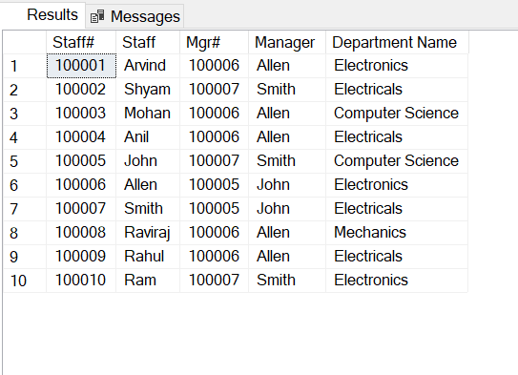

**3. Create a query that will display Student Code, Student Name, Department Name, Subject1, Subject2, and Subject3 for all students who are getting 60 and above in each subject from department 10 and 20.**

SELECT sm.Student_Code, sm.Student_Name, dm.Dept_Name AS 'Department Name',

marks.Subject1, marks.Subject2, marks.Subject3

FROM Student_Masters sm

JOIN Department_Masters dm ON sm.Dept_Code = dm.Dept_Code

JOIN Student_Marks marks ON sm.Student_Code = marks.Student_Code

WHERE (dm.Dept_Code = '10' OR dm.Dept_Code = '20')

AND marks.Subject1 >= 60

AND marks.Subject2 >= 60

AND marks.Subject3 >= 60;

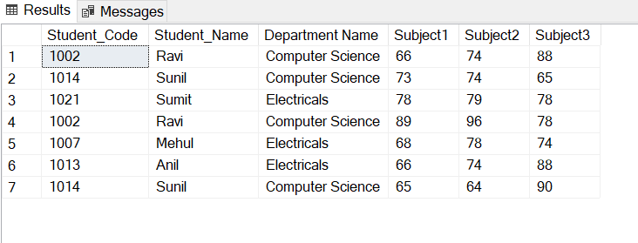

**4. Create a query that will display Student Code, Student Name, Book Code, and Book Name for all students whose expected book return date is today.**

SELECT sm.Student_Code,sm.Student_Name,bt.Book_code,bm.Book_name

FROM Student_Masters sm

JOIN Book_Transactions bt ON sm.Student_Code = bt.Student_Code

JOIN Book_Masters bm ON bt.Book_code = bm.Book_code

WHERE CONVERT(DATE, bt.Book_expected_return_date) = CONVERT(DATE, GETDATE());

**5. Create a query that will display Staff Code, Staff Name, Department Name, Designation name, Book Code, Book Name, and Issue Date. For only those staff who have taken any book in last 30 days.**

SELECT sm.Staff_Code, sm.Staff_Name, dm.Dept_Name AS 'Department Name',

des.Design_Name AS 'Designation Name', bt.Book_code,bm.Book_name,bt.Book_issue_Date

FROM Staff_Masters sm

JOIN Department_Masters dm ON sm.Dept_Code = dm.Dept_Code

JOIN Designation_Masters des ON sm.Design_Code = des.Design_Code

JOIN Book_Transactions bt ON sm.Staff_Code = bt.Staff_Code

JOIN Book_Masters bm ON bt.Book_code = bm.Book_code

WHERE DATEDIFF(DAY, bt.Book_issue_Date, GETDATE()) <= 30;

=====================================================================

**DDL**

**1. Create the Customer table with the following columns.**

**CustomerId Number(5)**

**Cust_Name varchar2(20)**

**Address1 Varchar2(30)**

**Address2  Varchar2(30)**

CREATE TABLE Customer (

CustomerId INT,

Cust_Name VARCHAR(20),

Address1 VARCHAR(30),

Address2 VARCHAR(30)

);

**2. Modify the Customer table Cust_Name column of datatype with Varchar2(30), rename the column to CustomerName and it should not accept Nulls.**

-- Add a new column with the desired datatype and constraints

ALTER TABLE Customer

ADD CustomerName VARCHAR(30) NOT NULL;

-- Drop the old column

ALTER TABLE Customer

DROP COLUMN Cust_Name;

**3.**

**a) Add the following Columns to the Customer table.**

**Gender  Varchar2(1)**

**Age  Number(3)**

**PhoneNo Number(10)**

ALTER TABLE Customer

ADD Gender VARCHAR(1),

Age INT,

PhoneNo BIGINT;

**b) Rename the Customer table to Cust_Table**

EXEC sp_rename 'Customer', 'Cust_Table';

==================================================================

**DML**

**Insert rows with the following data into the Customer table.**

**1000, Allen, #115 Chicago, #115 Chicago, M, 25, 7878776**

**1001, George, #116 France, #116 France, M, 25, 434524**

**1002, Becker, #114 New York, #114 New York, M, 45, 431525**

INSERT INTO Cust_Table (CustomerId, CustomerName, Address1, Address2, Gender, Age, PhoneNo)

VALUES

(1000, 'Allen', '#115 Chicago', '#115 Chicago', 'M', 25, 7878776),

(1001, 'George', '#116 France', '#116 France', 'M', 25, 434524),

(1002, 'Becker', '#114 New York', '#114 New York', 'M', 45, 431525);