MortgageFlow Guardian
Architecture & Workflow Document
AI-Powered Reliability and Incident Automation for Mortgage Document Workflows
Fictional proof of concept. Uses synthetic data only — no real mortgage, financial, or personal information. The system does not approve or deny mortgages and does not replace a loan-origination system. It demonstrates the reliability, security, and observability layer around an AI document workflow.

1. Executive Overview
MortgageFlow Guardian is an event-driven, serverless AWS platform that makes AI document processing reliable, secure, and observable at enterprise scale. A document enters the system, is sent to an AI extraction service, and its output is validated, standardized, and safely routed — with automatic retries for transient failures, human review for uncertain results, and durable preservation of anything that cannot be processed.
The core idea: the value is not the AI model itself, but the reliability and orchestration layer around it that makes AI output trustworthy for downstream systems to consume.

2. Problem Statement
When AI services extract data from documents, their raw output is inconsistent and occasionally wrong: fields are named differently across providers, values are formatted differently ("$3,250.00" vs 3250), confidence varies, some results are incomplete, and providers occasionally time out or fail. A downstream loan platform should not have to understand every provider quirk, nor should it act on low-confidence or incomplete data. The engineering challenge is to make AI document output standardized, validated, resilient to failure, auditable, and secure.

3. Solution Summary
A reusable orchestration and reliability layer sits between document uploads, AI services, and downstream systems. It:
- Validates that extracted data is complete and correctly typed.
- Stores valid results in a single standardized schema.
- Routes low-confidence or incomplete results to human review.
- Retries temporary failures automatically with exponential backoff.
- Sends permanent failures to a dead-letter queue — never dropped.
- Detects duplicate documents via a content hash.
- Records logs, metrics, retry counts, and processing status.
- Alerts a human reviewer when intervention is required.

4. Architecture Diagram
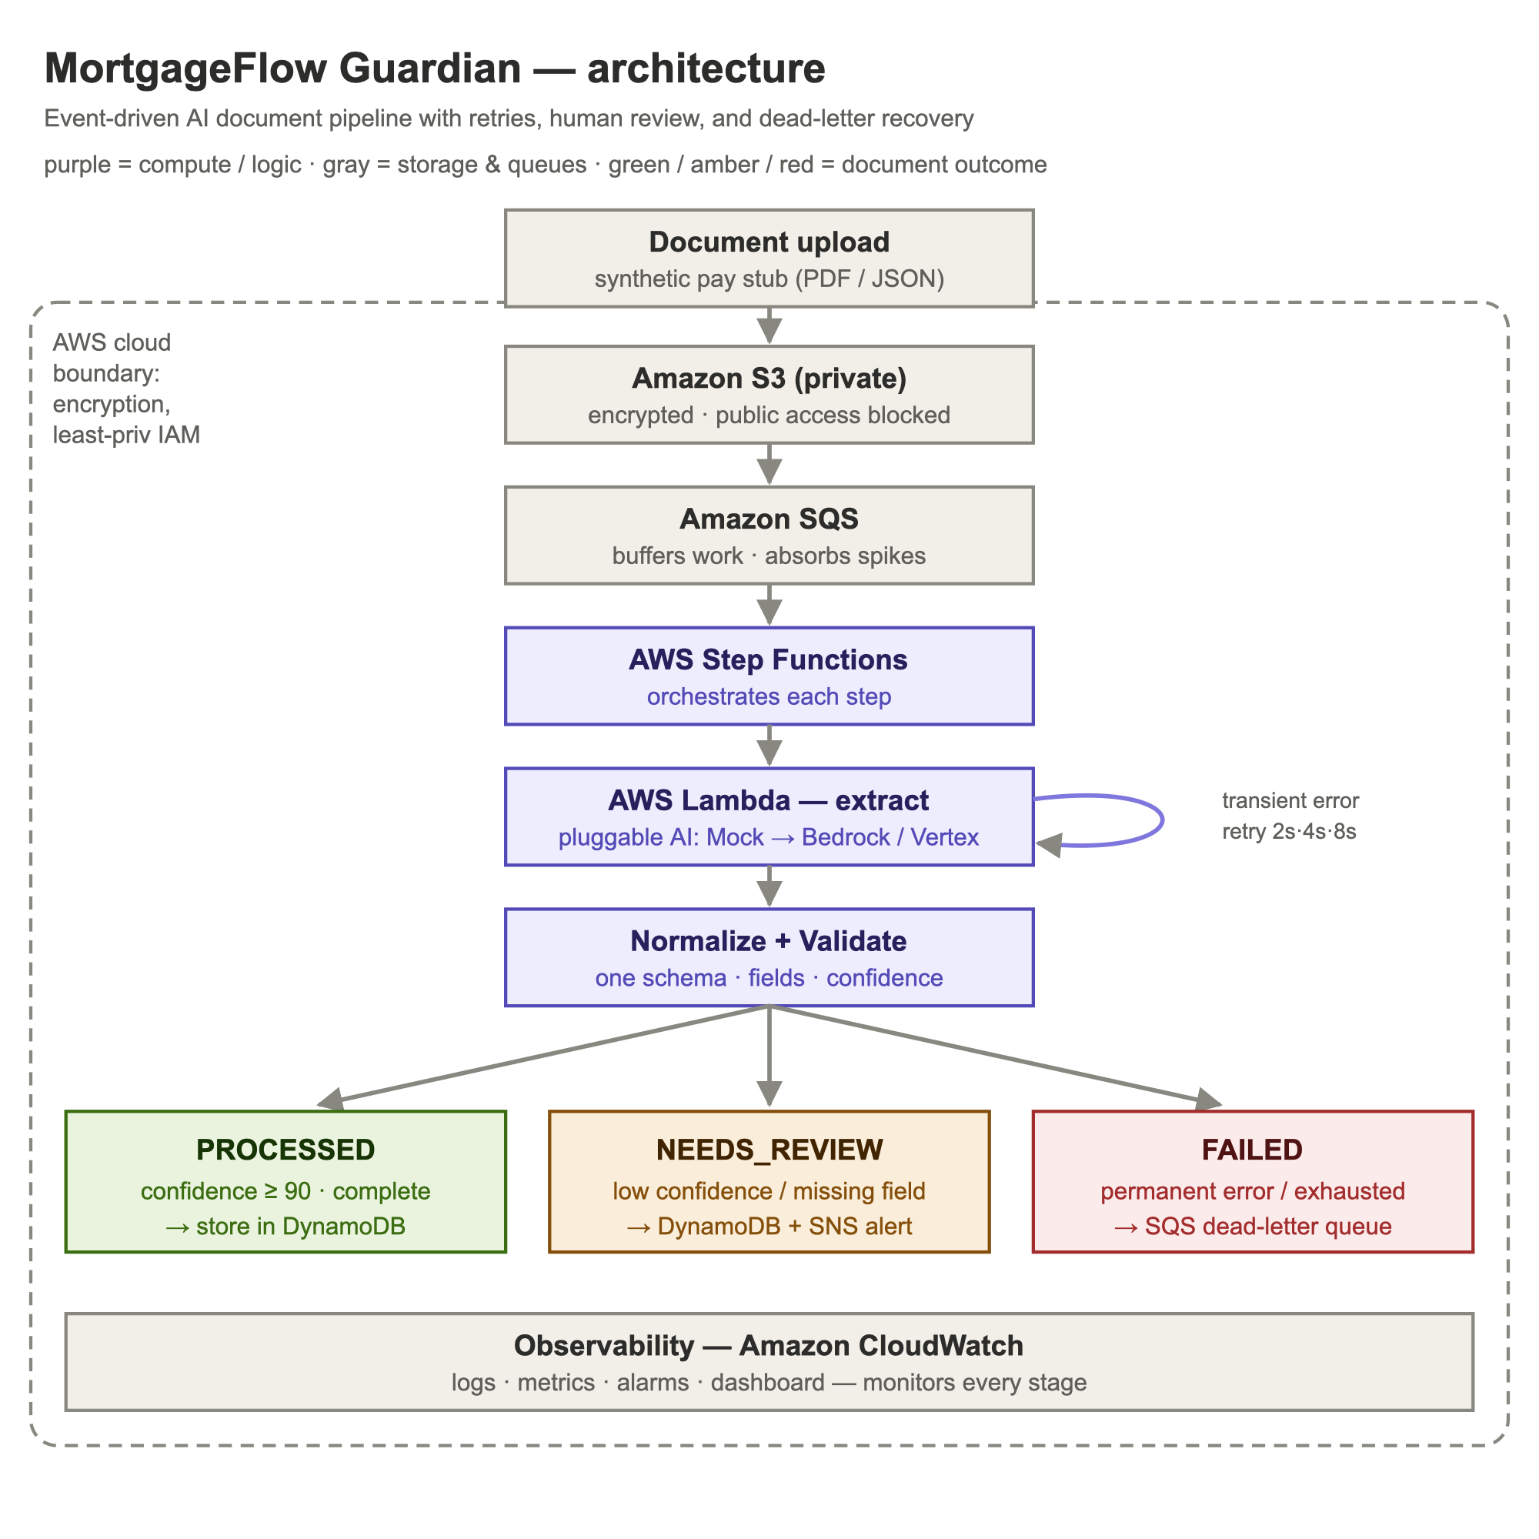
Figure 1 — End-to-end system architecture and trust boundary.

5. End-to-End Workflow
- A document is uploaded to a private, encrypted Amazon S3 bucket under the incoming/ prefix.
- S3 emits an ObjectCreated event to an Amazon SQS processing queue.
- The ingestion Lambda validates file type and size, then starts an AWS Step Functions execution.
- Step Functions invokes the processor Lambda, which calls the AI extractor, normalizes the output to one schema, validates fields and confidence, detects duplicates, and writes the result to Amazon DynamoDB.
- Step Functions routes on the outcome: PROCESSED, NEEDS_REVIEW (with an SNS alert), transient error (retry with backoff), or permanent failure (dead-letter queue).
- Amazon CloudWatch records logs, metrics, and alarms across every stage.

6. The Four Processing Paths

Success path
The document is complete and confidence is at or above the threshold. It is stored as PROCESSED in DynamoDB and the execution succeeds. No human is involved.

Retry path
A transient error (for example, a provider timeout) causes the processor to raise a retryable error. Step Functions retries with exponential backoff (2s, 4s, 8s). If a later attempt succeeds, the document continues; the attempt count is recorded.

Human-review path
The data is incomplete or confidence is below the threshold. The record is stored with status NEEDS_REVIEW and specific reasons, and an SNS alert is published to a human reviewer. Uncertain data is never auto-accepted.

Permanent-failure path
Corrupt files, unsupported formats, or repeatedly failing providers are caught and sent to the SQS dead-letter queue for inspection or replay — never silently lost — and a CloudWatch alarm fires.

7. AWS Components
Service | Role and rationale
Amazon S3 | Durable, encrypted storage and the pipeline's event source. Public access blocked; HTTPS-only.
Amazon SQS | Buffers processing work; decouples ingestion from processing; absorbs spikes; enables retry.
SQS dead-letter queue | Preserves messages that exceed retries so failures are inspectable and replayable.
AWS Step Functions | Orchestrates the workflow with declarative retry/catch; each step is visible and independently retryable.
AWS Lambda | Runs the ingestion and processing code; serverless, event-driven, scales to zero.
Amazon DynamoDB | Stores standardized records; key lookups with no joins; single-digit-ms reads; no idle cost.
Amazon SNS | Publishes human-review alerts without coupling the workflow to a delivery mechanism.
Amazon CloudWatch | Logs, custom metrics, alarms, and a dashboard for proactive incident response.
AWS IAM | Least-privilege roles so each component can perform only its own job.

8. Reliability and Failure Handling
Failures are classified into explicit categories, and each maps to a single action: transient errors are retried with exponential backoff; permanent errors are dead-lettered; uncertain or incomplete results are routed to human review; and duplicates are skipped.
- Idempotency — a SHA-256 hash of the file bytes detects duplicates, so at-least-once delivery from S3/SQS stays correct even under a re-upload with a new name.
- Retry in the orchestration layer — Step Functions performs retries declaratively, so every attempt is visible in the execution history rather than buried in code.
- Never dropped — permanently-failed messages are preserved in the dead-letter queue for inspection or replay.
Processing statuses: UPLOADED, QUEUED, PROCESSING, RETRYING, PROCESSED, NEEDS_REVIEW, FAILED.

9. AI Extraction Layer
The pipeline depends on a DocumentExtractor interface, never on a specific vendor. Two implementations exist: a mock extractor (deterministic, free, used for testing every path and in the deployed pipeline) and a real Claude LLM extractor that calls the Anthropic API to read a document. Swapping one for the other is a single line with no pipeline changes — the design avoids vendor lock-in and leaves room for Amazon Bedrock, Textract, or Vertex AI behind the same interface.

10. Data Model
A DynamoDB table keyed by documentId, with two global secondary indexes: documentHash (for duplicate detection) and processingStatus (to list documents awaiting review). Access patterns are simple key lookups with no joins, which is why a key-value store is the right fit over a relational database for this workload.

11. Security Design
- Private S3 bucket with public access fully blocked.
- Encryption at rest (S3 SSE, DynamoDB, SQS) and in transit (HTTPS-only bucket policy).
- Least-privilege IAM roles per function — no AdministratorAccess on any role.
- Sanitized logs — sensitive fields masked before anything is written to CloudWatch.
- No credentials in source code; Secrets Manager placeholder for future external credentials.
- File type and size validation; synthetic data only.

12. Infrastructure as Code
The entire cloud system is defined as code and provisioned reproducibly. It is validated with both Terraform and OpenTofu (the open-source, Linux Foundation-governed fork), and has been deployed to AWS.

13. CI/CD Pipeline
A GitHub Actions workflow runs on every push and pull request: dependency installation, linting (ruff), syntax checks, unit tests (pytest), a security scan (bandit), and Terraform formatting and validation. Tests and Terraform validation are blocking; the security scan is informational. The pipeline deliberately does not auto-deploy to AWS — provisioning stateful, billable infrastructure is a deliberate, human-approved step.

14. Observability
CloudWatch collects structured logs from every stage, custom metric filters (documents processed, duplicates detected), alarms (Lambda errors, dead-letter-queue depth, workflow failures), and a dashboard summarizing the system's health.

15. Containerization
The core pipeline is serverless and containerless by design — the right choice for an event-driven, scale-to-zero workload. The Streamlit dashboard, a standalone web application, is containerized with Docker (including a healthcheck for orchestrators such as ECS or Kubernetes), making it portable across a laptop, ECS, or Kubernetes.

16. Key Architectural Decisions and Trade-offs
Decision | Why | Trade-off
SQS before processing | Buffering, spike protection, durability | Added latency for reliability
Step Functions vs. one Lambda | Visibility and declarative retry/catch | More infrastructure to maintain
DynamoDB vs. relational | Simple key lookups, no joins | No ad-hoc relational queries
Retry in orchestration layer | Retries visible in execution history | —
Provider interface | No vendor lock-in; swappable AI | Slight indirection
Serverless over containers | Event-driven, scales to zero, no cluster | Cold starts; less low-level control

17. Deployment Status
The system is deployed and running in AWS (region us-east-1) with 31 resources provisioned via Infrastructure as Code. Test documents uploaded to S3 flow through the live pipeline and produce standardized records in DynamoDB, with Step Functions executions completing successfully. The system also runs fully locally (with a mock or real Claude provider), as a public Streamlit application, and inside a Docker container.

18. Current Limitations and Future Work
- The deployed pipeline uses the mock extractor; the real Claude LLM runs locally and in the dashboard. Wiring Claude into the cloud Lambda is a small change (API key via Secrets Manager).
- Confidence thresholds are demonstration values, not real business rules.
- Human review is modeled via alerts and status; a reviewer UI is future work.
- Future enhancements: real provider adapters (Bedrock, Textract, Vertex), a results API and reviewer dashboard, KMS customer-managed keys, and data-retention lifecycle policies.

