# The importance of face alignment in face recognition?

One of the most problems that we have when building a face recognition system is getting a good AUC for our model.

Therefore, one way to significantly improve the AUC is to align the faces that are in our dataset.

Align the faces will help the AI to train better and because of that the accuracy and AUC of our model will improve.

Here’s an example:

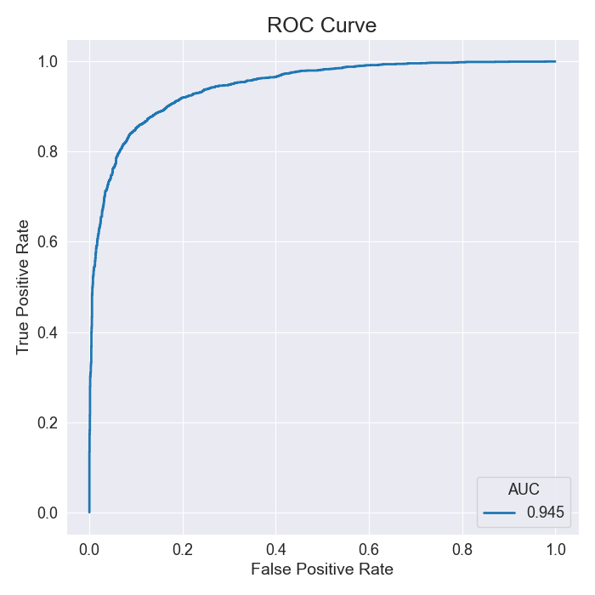I use a model that is available on <https://github.com/Brunex0/Projeto-FaceRecognition>. If we test that model with a dataset that isn’t align, we obtain this ROC curve for LFW dataset:

The difference is significant when we decide to align the dataset. For example, in the LFW dataset with the faces aligned we can obtain this ROC curve:

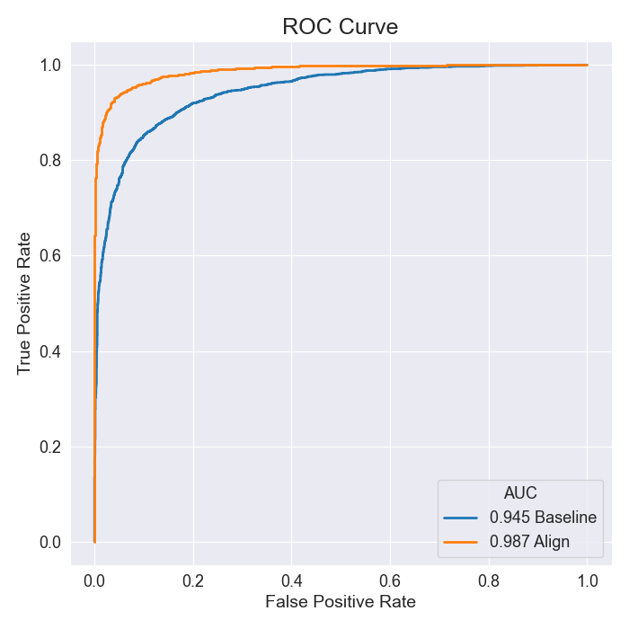

(por a outra curva aqui também)

Compared to the first ROC we could see that there is a significant increase in AUC.

So, to get these results we will proceed to the alignment of the faces. To do this we used the script align_dataset_mtcnn.py (from <https://github.com/davidsandberg/facenet> ). Unfortunately, this script has some outdated libraries, so it is necessary to make some changes that are explained in <https://github.com/Brunex0/Projeto-FaceRecognition>.

To make the alignment faster you should split the process into 4 subprocesses by running the script as follows:

for N in {1..4}; do python3 ../facenet/src/align/align_dataset_mtcnn.py pathToDataset pathToSaveAlignDataset --image_size 224 --margin 32 --random_order --gpu_memory_fraction 0.24 & done

You will finally have your database aligned, and therefore the AUC value will increase significantly.

References

* <https://github.com/Brunex0/Projeto-FaceRecognition>
* <https://github.com/davidsandberg/facenet>
* <http://vis-www.cs.umass.edu/lfw/>