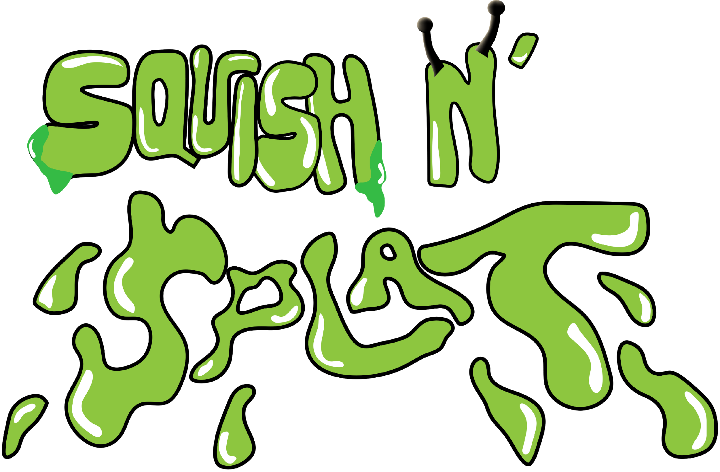

Version: 0.1 Last Updated: 11/4/15

TABLE OF CONTENTS

*GENRE*

*SYSTEM REQUIREMENTS*

*GAME MECHANICS*

*GAME STORY*

*GAME CONTROLS & USER INTERFACE*

*MONETIZATION*

*REPLAYABILITY*

*SEQUEL*

*INSPIRATIONS & EXAMPLES*

*ASSET LIST*

# GENRE

* Casual
* Arcade
* Strategy

# SYSTEM REQUIREMENTS

PC / Mac or smartphone. Mouse or touchscreen capability.

Android 2.3.1+

IOS 6.0+

# GAME MECHANICS

* 2D
* Top down view
* Play-style: First person (no character or movement)
* Player actions: Tapping, dragging, and gestures
* Feedback: Tapping enemies and spawn points will destroy the targets based on their health
* Tools: Power-ups, area-of-effect explosions, screen-wide explosions

Gameplay:

* There will be five waves of insects that will come and try to eat your food. The objective is to survive the five waves and keep the insects away from the food.
  + First wave of insects will start out fairly easy with ants that die with one click
  + Second wave of insects will introduce a second bug that takes three clicks to kill.
  + Third wave of insects will introduce a third bug that flies and takes two clicks to kill.
  + Fourth wave of insects will have all three bugs.
  + Fifth wave of insects will have a boss encounter.
* The player will click or tap the insects to kill them. Each insect will have different health. Each click or tap will take away one health.
  + Ants: 1 health (normal speed)
  + Beetle: 3 health (slow speed)
  + Flying bug: 2 health (fast speed)
  + Beetle boss: 25 health (super slow speed)
* Power ups may be implemented in the future.
  + Magnifying glass to burn them
  + Candy to distract insects away from your picnic

# GAME STORY

A family picnic has run amok with an infestation of various creatures and insects. The player must defend the picnic with their squishing powers and various abilities in order to save the picnic from the ongoing infestation.

# GAME CONTROLS & USER INTERFACE

Controls:

* The main control of the game is clicking or tapping.

We’ll have a main menu with three different buttons: “Play”, “Settings”, “About”.

* Settings will allow players to adjust the sound effect and music level.
* About will contain the credits.

During gameplay:

* There will be a pause button in the corner. The menu will pop up when paused.
* If implemented, power up buttons will be available on screen

# MONETIZATION

The game will be free to play. However in the future, players may be able to purchase power-up items with cash to help get rid of insects.

Ideas for future implementations may include: Cosmetic rewards such as bug skins, tapping effects (confetti, rainbows, snowballs, etc.), and goal skins.

# REPLAYABILITY

There will be various degrees of difficulty in the game. The game is casual, but will be challenging enough that it may take several tries to move on to the next level.

Difficult levels will challenge the player and encourage them to attempt several times until completion.

# SEQUEL

There are no sequels planned for the moment. Various or more challenging waves may be implemented in the future to increase game variability.

# INSPIRATIONS & EXAMPLES

**Whack-a-Mole**: This was our initial inspiration. The core mechanics of hitting an enemy to get rid of them was what inspired Squish N’ Splat. This was intriguing because it was a somewhat mindless game, but got continually more difficult when the moles got faster.

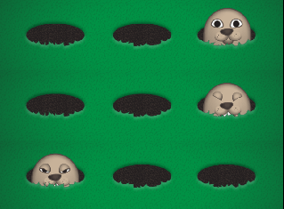

**Clicker Heroes**: Much like Whack-a-Mole, it is an endless clicker game that allows one to “beat” the opponent by hitting or clicking the enemy, using monsters for the enemy.

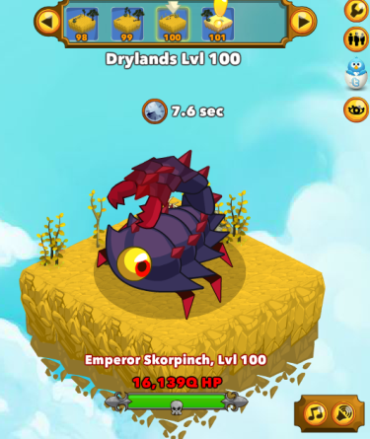

**Plants vs. Zombies**: This game was an inspiration because of the waves of zombies that come for the goal, the house.

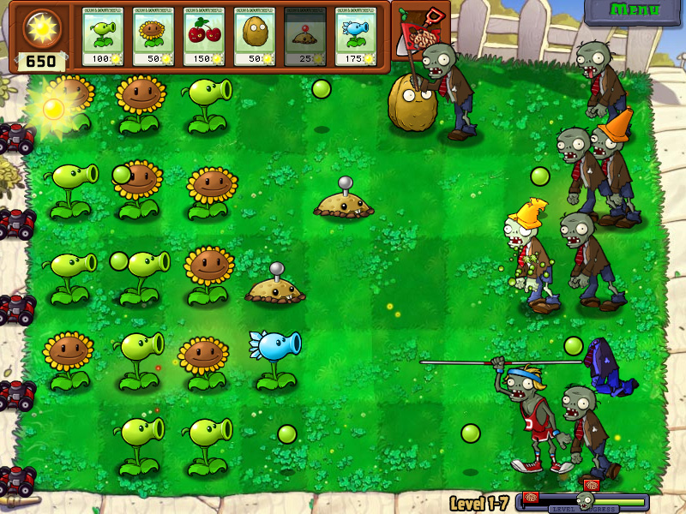

# ASSET LIST

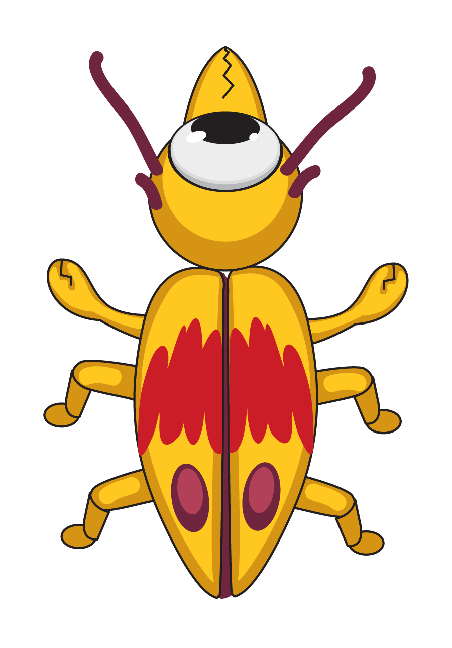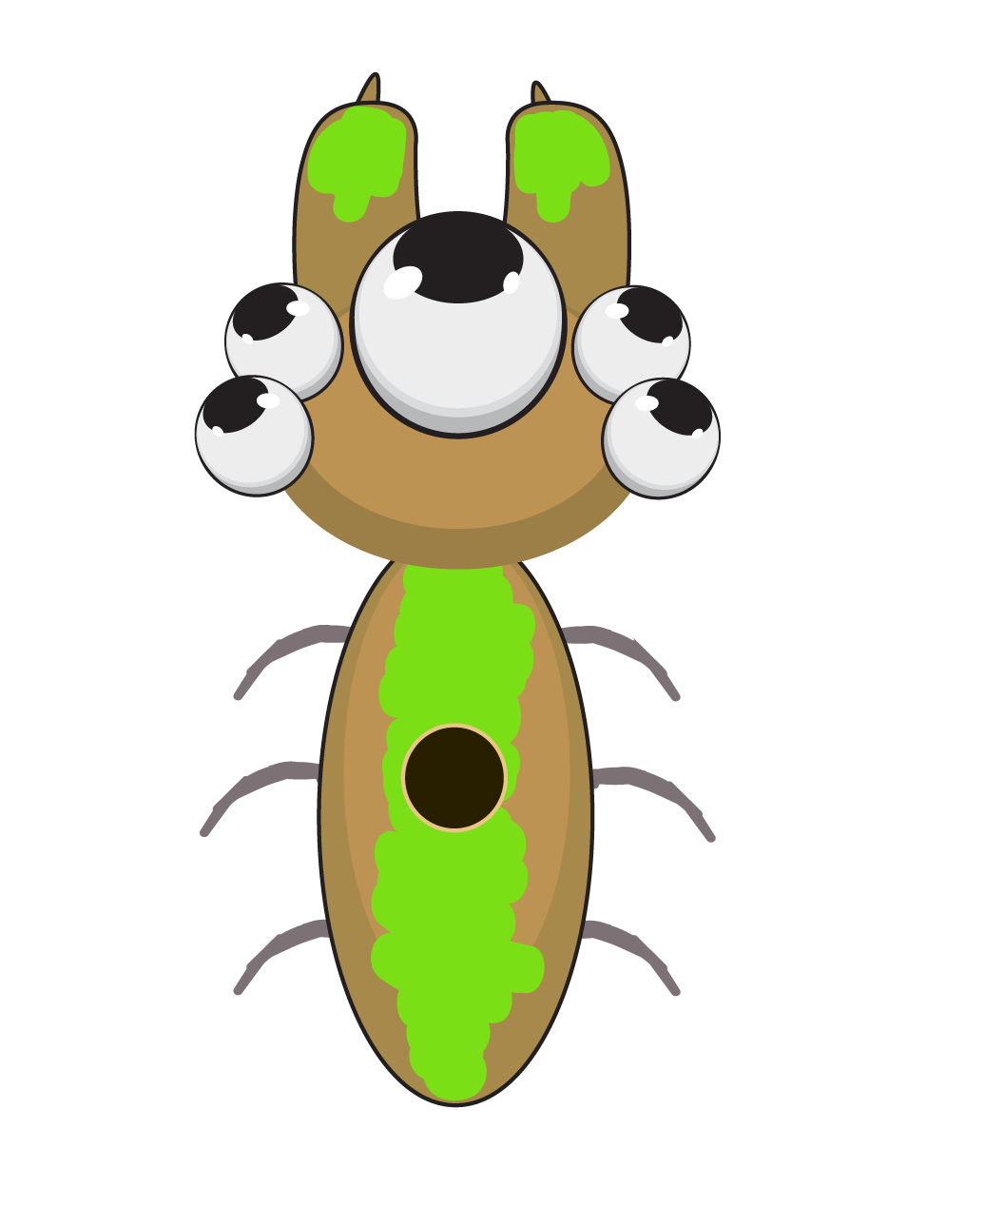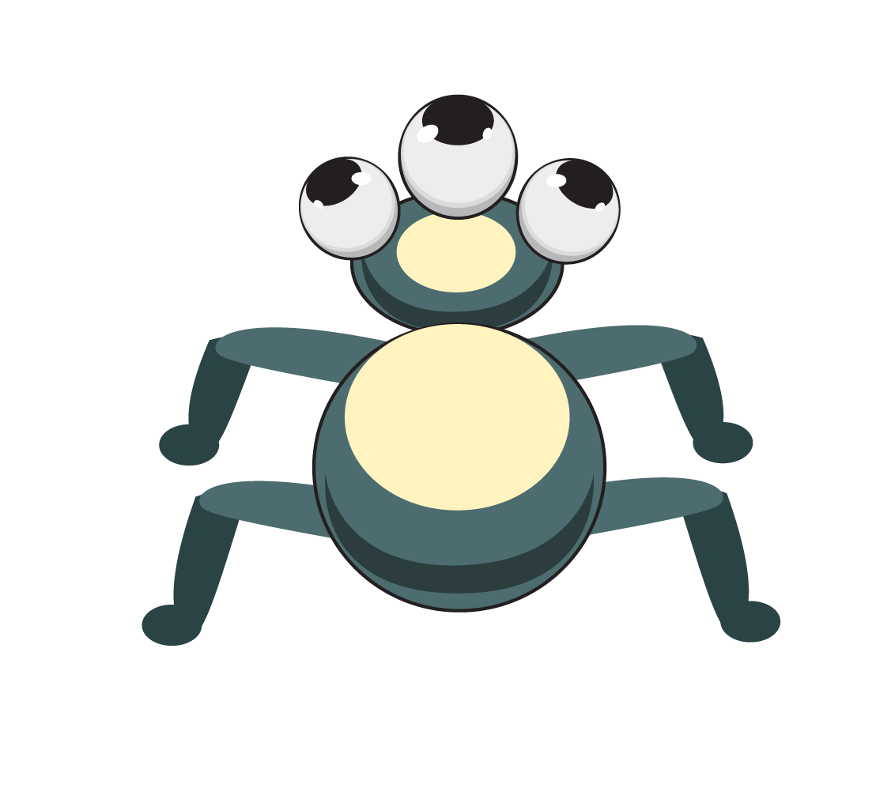

Live bugs that the player must squish, these bugs will have different instances to display the life state of the bugs.

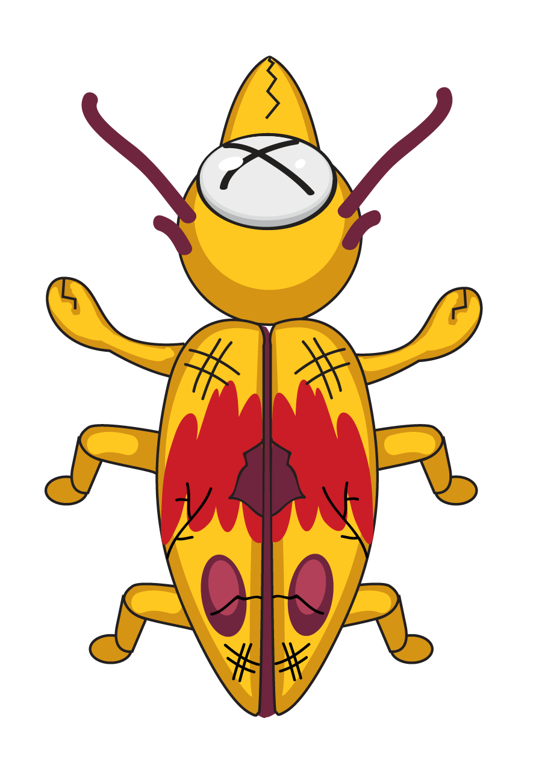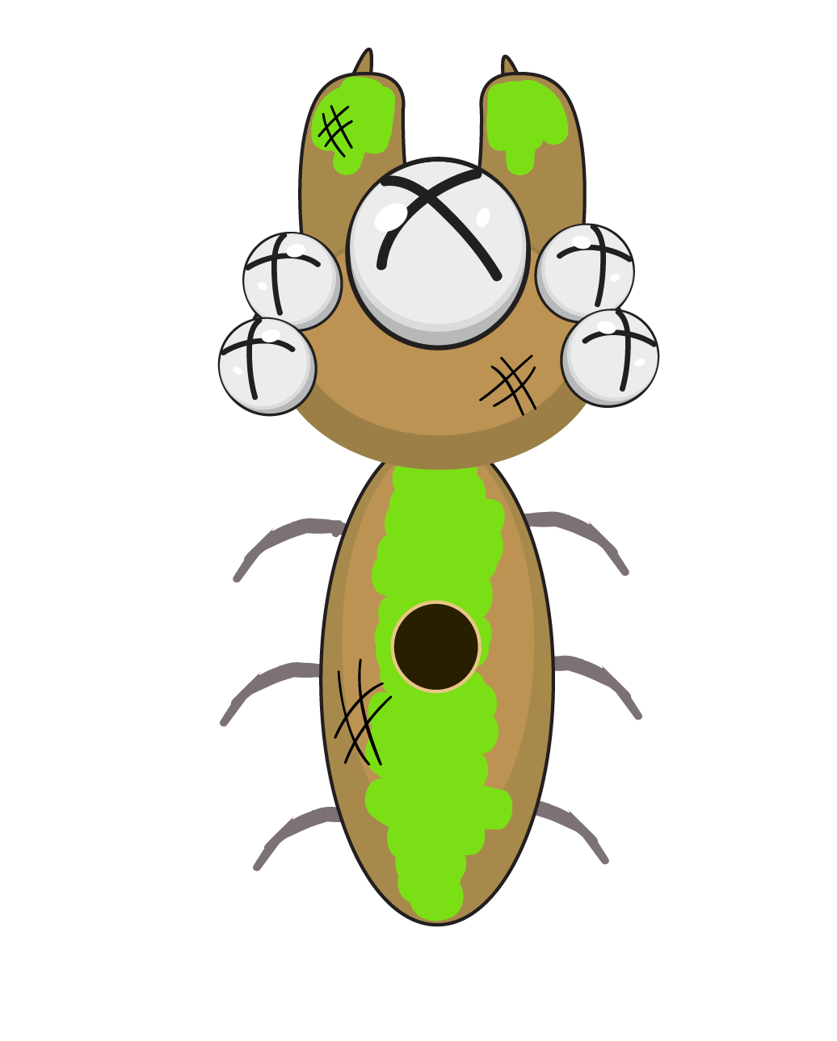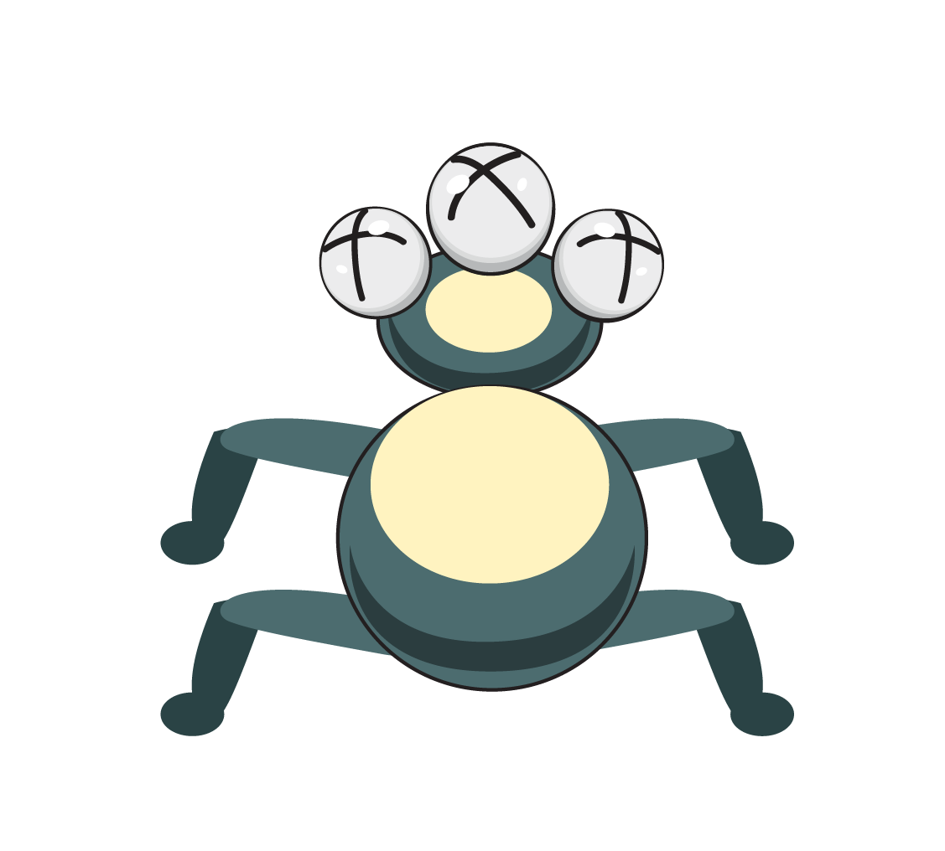

Dead bugs after they have been squished!



Picnic basket (this is our goal that we must protect)

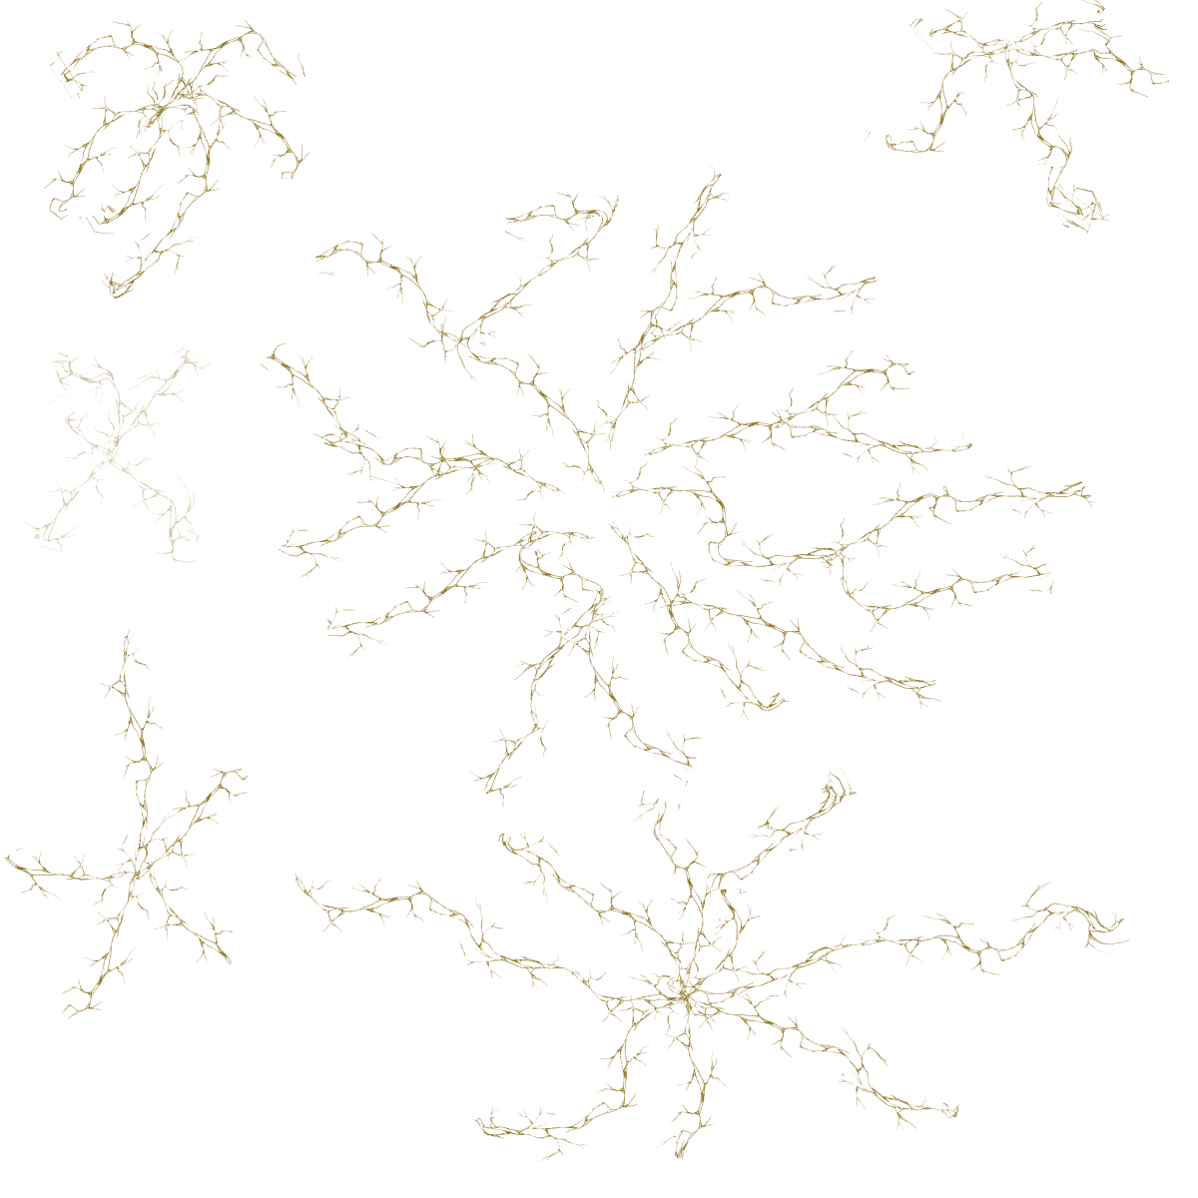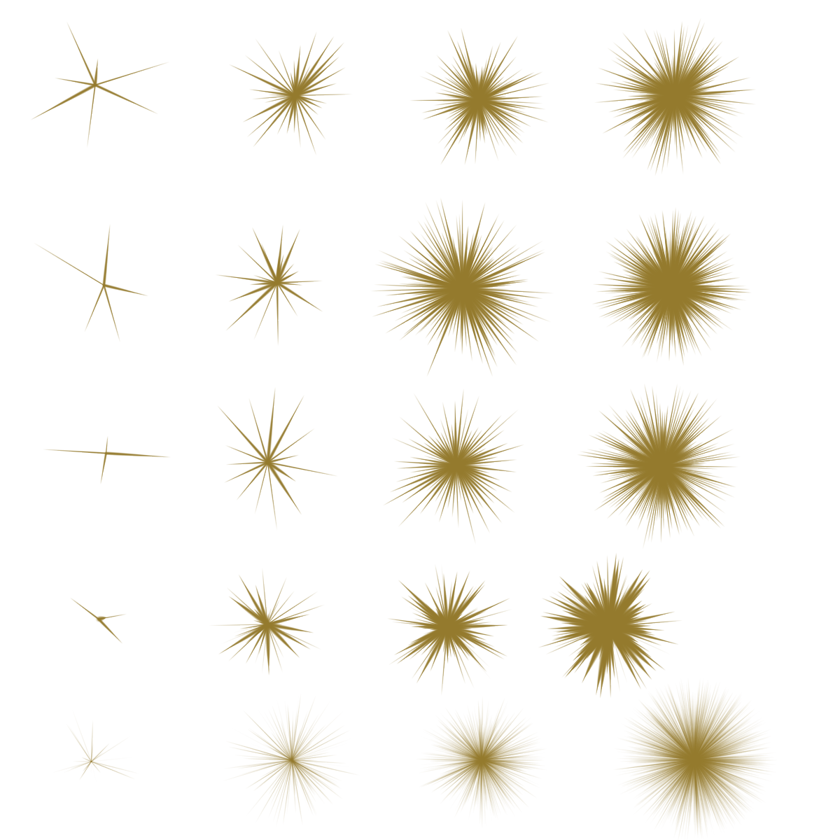

Some of the effects during gameplay

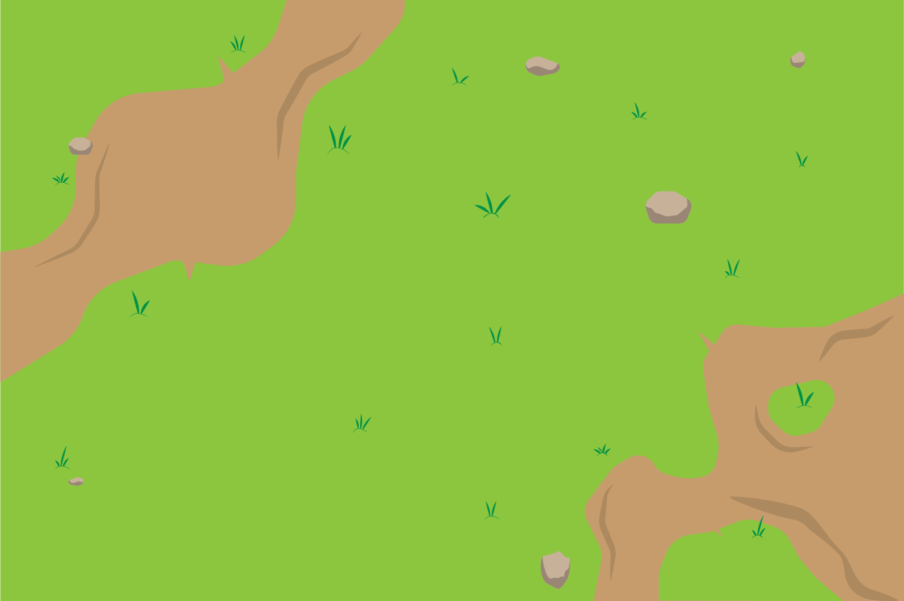

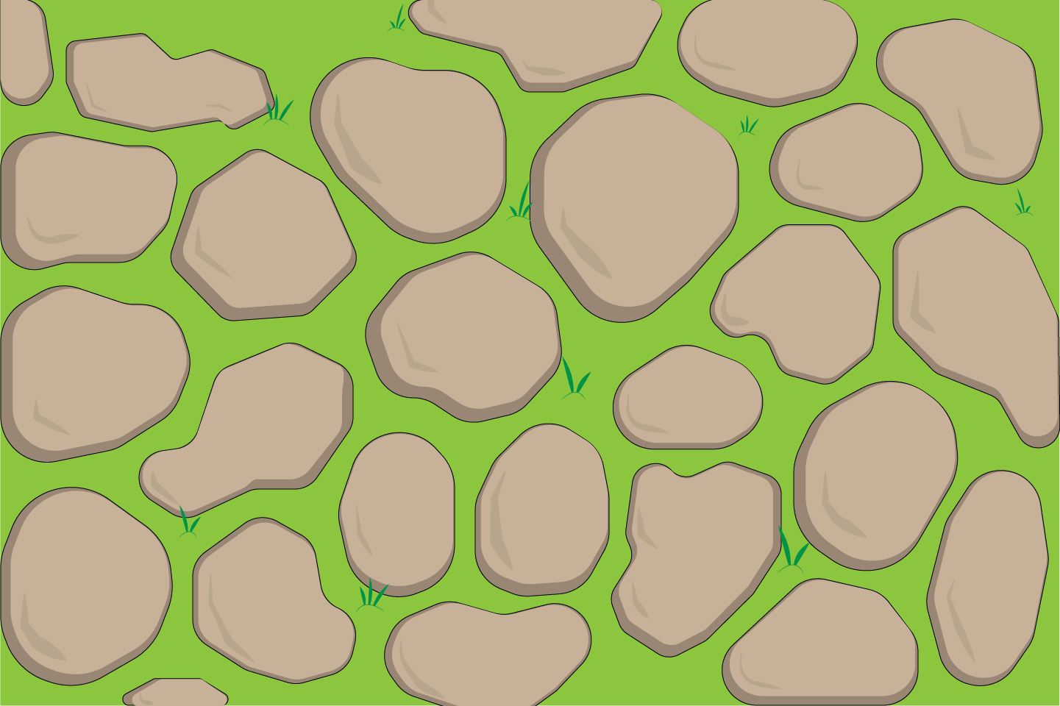

Backgrounds