Bruno Leandro da Silva

Professor Dr. Elizabeth Pannell

IMED-1341.WW1: Interface Design

23 October 2017

MissionNow: Overview Documentation

The website is based on a Non-profit organization called MissionNow, and its main purpose is to connect the audience to the mission field by providing information on current projects, missionary staff, and Missionary courses. Additionally, the website it is not only informative, the audience can participate by engaging on one of the missionary schools and /or donating to support the Non-profit’s project and full-time missionaries.

MissionNow, short-term goals are to present information form the missionary field reaching as many viewers as possible, to make our projects known and increase our areas of geographic reach to a global scale helping different communities with their needs, finally, to demonstrate that we are competent with the fund's thrust and increase our staff member. The long-term goals are to localize Communities Center focus on their needs, providing an online learning tool where viewers can enroll to an Online Missionary Schools and develop their own Missionary project, so they can apply it to their own communities or anywhere they are around the Globe. If you do not want to participate in an ongoing project you can identify the need and create your own.

The MissionNow website will contain a Horizontal descriptive drop-down menu, with the logo located on the far-left hand side, which will serve as a home button. Including in the functionalities the social media icon, on the right-top of the Menu. Complementing the functionalities, on the Donate page, an extra layer of security will be implemented with an option to the user provides credit card information to support one of the projects.

The success of the Website is due to our target audience which is vast, it can range from Family to solo mission trip seekers, from short-term to full-time missionaries or anyone, who are willing to help, by volunteering or donating, however, for volunteers we target youth groups. If you cannot be a volunteer, you can still participate by sending a volunteer. The Web site will be responsive across all platforms and devices, users can utilize a regular computer, phone or tablet and an internet connection. The main, competitors are the Compassion International, Samaritan’s purse, and the Salvation Army.

Accessibilities issues. All videos will have legends, Zoom the page and enlarge text will be applied, finally, any generic link text will be adjusting to a more descriptive text.

The main page (Home) will display a slideshow, with an attractive information regarding the projects, where the user can click and be redirected to that page. The slideshow will be followed by three main buttons, which highlight our projects. Complementing the main page, an article and three pictures with its description.

The About page contains two subpages, Our History, and Our Vision which will provide a background information to users, where we came from, what drives our success, and where we pretend to be.

The Training page contains three subtabs, one for each course, where users that are interested can find more information regarding each course.

The Project page, also contain three tabs, one for each course, where users can find more information on the course, with a link to redirect the users to the donate page.

Finally, the Contact page and Donate page. The Contact information will provide the Mission Now contact information and an option to the user send an email. The Donate page will gather credit card information to support our projects. The estimate of the cost would be around 2000 to 2500 dollars.

The website organization is hierarchical, where we have the home page, and the main menu followed by its subpages.

1. Home
2. About
   1. Our History
   2. Our Vision
3. Training
   1. Disciple Training School
   2. School of Evangelism
   3. Children at Risk School
4. Projects
   1. Hope House
   2. Soccer Ministry
   3. Street Team
5. Contact
6. Donation

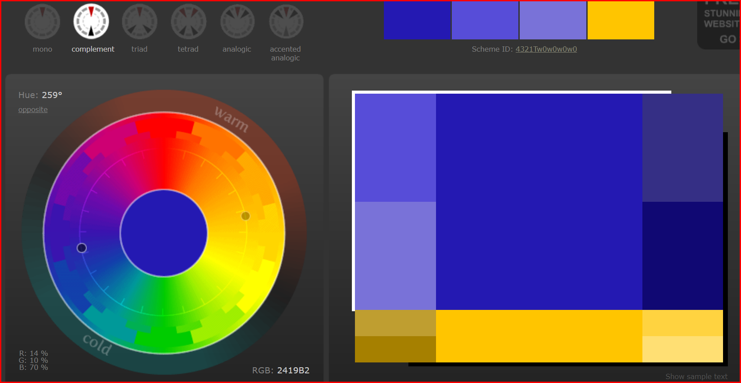 The color scheme is Complementary, blue and gold.

**Navigation Flow Chart:**

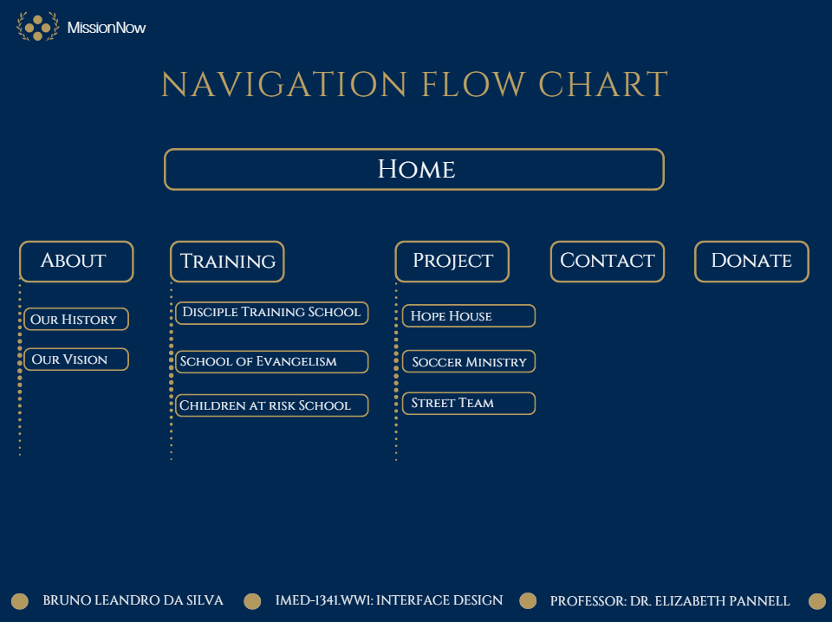

**Home Page Wire-frame:**

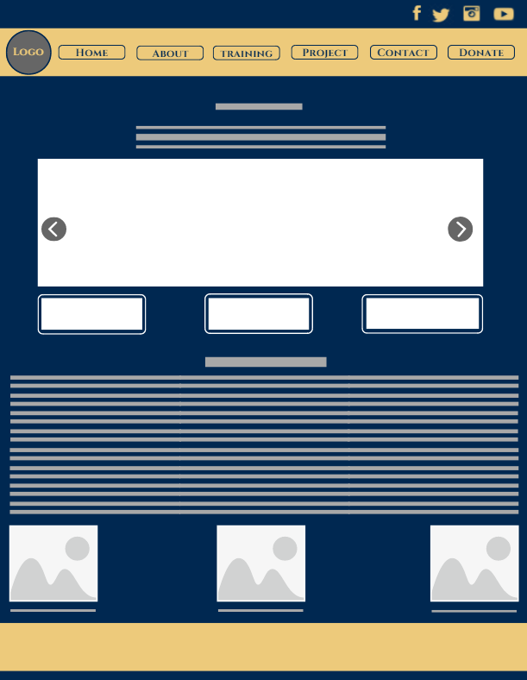

The maintenance of the website will be done periodically, in order to adjust any design feature or to preserve the integrity of the site and its user as an example Updating the plug-ins, seeking for browser updates and ensure the security of the site by using authentication features. Finally, I will use online tools to test the website such as W3C validation tool to test the code and Sort Site which will analyze the entire website and provide features such as emails updates and testing schedules.