CONFIDENTIAL — PREPARED FOR PROSPECTIVE INVESTORS

Product Demo Script
Global Office · 20-minute investor demo · Founder-led

FRAMING (2 MINUTES)
"What I'm about to show you is not a suite of features. It is a single operating substrate that a business runs on. As we move through it, notice one thing: every screen reads from and writes to the same graph. There is no import, no export, no integration. That is the entire product bet."

Act I — Coherence (5 minutes)

Screen 1: Executive Control Center
Open with the organizational Health Score. Explain that it is derived from real activity — attendance, task completion velocity, communication density, workflow SLA adherence — not from a self-reported dashboard.
Talk track. "Every executive dashboard you have ever seen is a report on inputs. This is a reading of the organism."

Screen 2: Activity Feed
Show the system-wide activity feed. Filter by department, by user, by module. Point out that every event is a node in the same graph feeding the Health Score.
Talk track. "This is the substrate. Everything else you will see writes into this."

Act II — Execution (5 minutes)

Screen 3: Project & Task Kanban
Open a project, drag a task through the kanban, show the AI workload balancing suggesting a rebalance based on capacity.
Talk track. "Notice the AI is not doing the work. It is watching the work and suggesting the next best action. Suggestive, not autonomous — because trust is the constraint at this stage of adoption."

Screen 4: Workflow Automation
Build a workflow live: IF new customer added THEN assign onboarding tasks, notify account owner, create knowledge folder, schedule kickoff meeting.
Talk track. "Every SME I have worked with wants Zapier and doesn't know it. This is Zapier native to the graph, no glue code required."

Act III — Intelligence (5 minutes)

Screen 5: AI Insights Widget
Surface an anomaly: unusual sign-in pattern, task velocity drop in one department, delayed decision escalation. Show the audit trail and remediation prompt.
Talk track. "This is the payoff. AI on top of the graph produces this. AI on top of a fragmented stack produces nothing."

Screen 6: Partner Connect
Show inter-organization messaging with another Global Office tenant. Point out that context (contracts, project state, shared documents) travels with the message.
Talk track. "Email is a message. This is a message with organizational context attached. That is why enterprises will move."

Close (3 minutes)
Return to the Executive Control Center. Point out that the Health Score has changed in the last twenty minutes because of the actions taken during the demo.
Final line. "You just watched a business run on Global Office for twenty minutes. Every organization on earth will one day run on one of these. Our thesis is that we build it."

Q&A Preparation
- If they ask about security → surface the RLS policy view and tenant isolation model.
- If they ask about cost → show the AI credit metering and tier structure.
- If they ask about scale → show the multi-tenant admin panel.
- If they ask about defensibility → return to the graph and the switching-cost narrative.
- If they ask about competitors → do not open a competitor's product; describe the architectural asymmetry from memory.

Confidential — Founder-only script. Not for distribution.
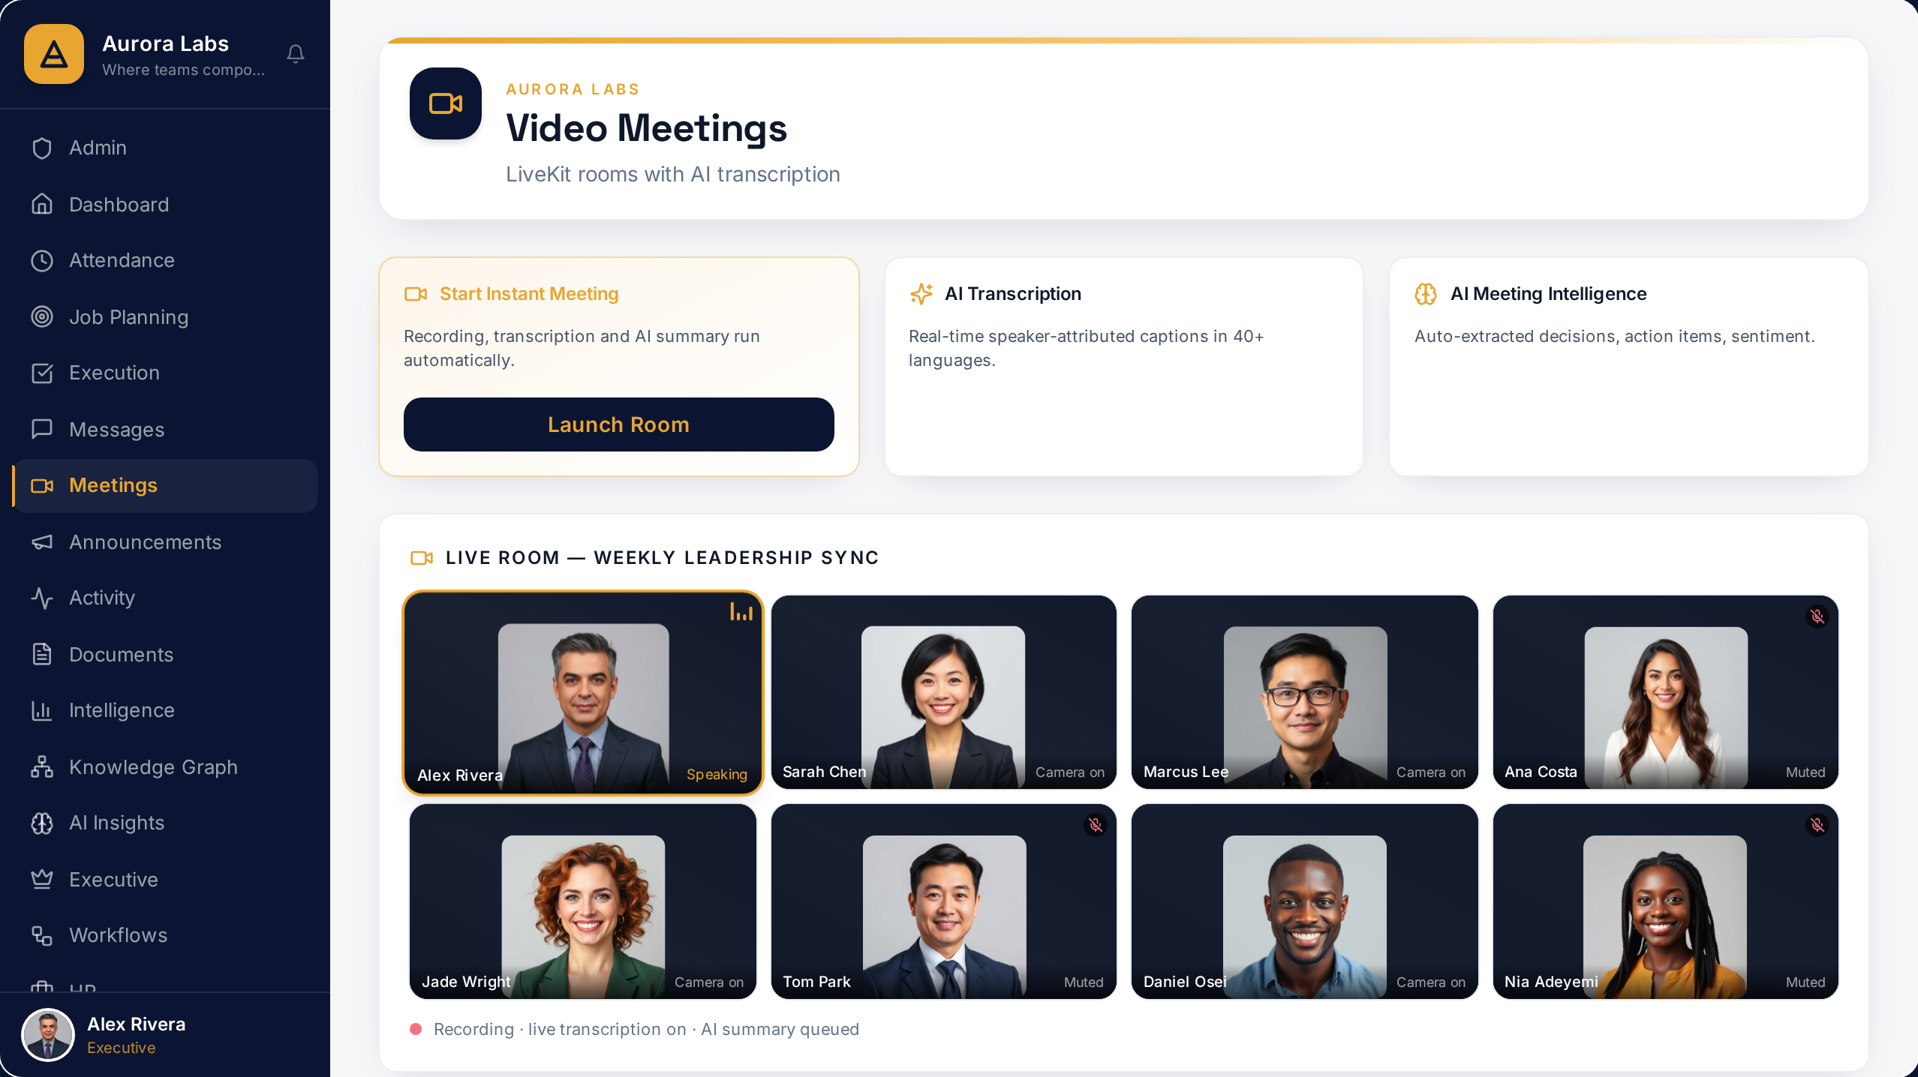
Global Office — Meetings Intelligence (live product)

