GLOBAL OFFICE
The AI Business Operating System · Investor One-Pager · Confidential

One intelligent surface for how modern organizations actually work.
THE COMPANY
Global Office (a product of Soteria AI Technologies Inc. (a Delaware C-Corporation)) is building the AI Business Operating System — a single, AI-native surface unifying attendance, execution, communication, knowledge, HR, finance, meetings, and executive intelligence.
WHY NOW
- Generative AI has crossed the utility threshold — ~$2.6–4.4T annual productivity value at stake (McKinsey, 2023).
- SaaS unbundling has run its course; the rebundling window — historically the moment new category leaders emerge — is open.
- Global SME digitization: ~400M SMEs worldwide, ~90% of employment (World Bank), rapidly ready for consolidated software.
MARKET
Global application software: $340B (2025) → $460B (2028) [IDC]. AI-native application layer: $18B → $92B (50%+ CAGR). Serviceable market for Global Office: ~$48.8B blended global SAM. 5-year SOM target: ~$170M ARR (0.35% capture).
PRODUCT & MOAT
- Ten integrated modules on one unified data graph — every entity is a first-class node.
- Intelligence layer that observes and suggests across the whole organization, not per-app.
- Suggestive-only AI — auditable, reversible; addresses enterprise AI-governance risk.
- Mobile-first, global-first: multi-currency, multi-language, local payroll/tax, low-bandwidth optimized.
BUSINESS MODEL
Per-seat SaaS subscription: Standard $12/user/mo, Business $22/user/mo, Enterprise custom. AI usage metered above included credits. Gross margin target 78–82% at scale. Blended Year-3 ARPU: $220/org/mo.
TRACTION & STAGE
Pre-seed, pre-launch. Ten production-ready modules built. Design-partner cohort forming across US, UK, and Nigeria. Founder-market fit: Wisdom Jonathans, prior AI systems and organizational leadership experience.
FINANCIAL FRAMEWORK (BASE CASE)
Yr 1: 120 orgs, ~$0.32M ARR. Yr 2: 900 orgs, ~$2.4M ARR. Yr 3: 3,600 orgs, ~$13.0M ARR. Break-even late Yr 3. Bear / Base / Bull sensitivity modeled.
THE ASK
Raising $1.5M pre-seed for 18–24 months of runway. Use of funds: 50% product & engineering, 25% go-to-market and design-partner acquisition, 15% compliance (SOC 2), 10% operating reserve. Milestones: 1,000 paying orgs, $2M+ ARR, SOC 2 Type I, Series-A ready.
TEAM
Wisdom Jonathans — Founder & CEO, Soteria AI Technologies. AI systems strategist and technology founder focused on intelligent platforms for large-scale operational challenges. Founding engineering and design team in place.
CONTACT
investors@globaloffice.ai · Full data room and materials available on request.

Confidential — prepared for prospective investors. Forward-looking statements reflect strategic assumptions and are not guarantees of future performance.
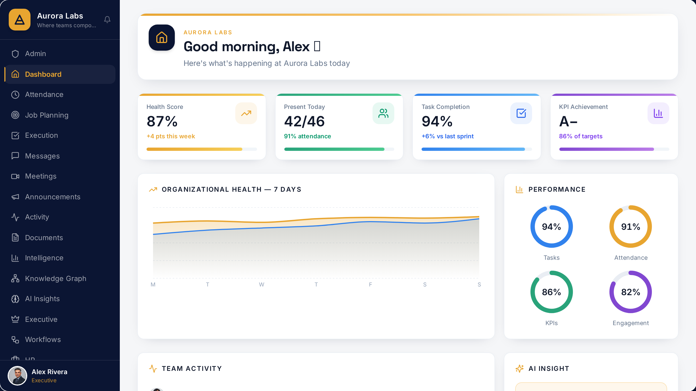
Global Office — Organization Health Dashboard (live product)

