GLOBAL OFFICE
Investment Memorandum
$1.5M Pre-Seed — Base Case

The case for backing an AI-native operating system.

Confidential — For institutional investor review only

1. The Ask
Global Office is raising $1.5M pre-seed to execute the Year 1 plan: deliver first ~120 paying organizations across developed markets, validate unit economics at $220 ARPU with ~72% gross margin, and reach a seed-ready commercial milestone within 12–18 months.
2. Thesis
The productivity stack is being rewritten around AI. Incumbent suites will bolt AI onto siloed apps. Point tools will add copilots. Neither can collapse into an integrated operating fabric without cannibalizing themselves. Global Office is being built greenfield in that middle, with a data graph that improves with every module a customer adopts.
3. Why Now
- Foundation models are finally good enough for cross-module reasoning at production cost.
- Post-2023 SaaS discipline is actively consolidating tool sprawl.
- Distributed work made single-plane operating tools table-stakes.
- Privacy regimes reward strict tenant isolation — a first-class primitive here.
4. Market
$180B+ aggregate spend across digital workplace, work management, HR tech, and communication by 2027 (Gartner, IDC, 2024). SAM for our developed-market SMB ICP is ~$38B. 0.5% share = ~$570M ARR, roughly 40× Year 3 base-case revenue in this plan.
5. Product
Ten integrated modules (attendance, execution, communication, meetings, documents, HR, finance, announcements, intelligence, workflow automation) with an AI insights layer that observes cross-module activity and produces suggestive alerts. Live product; multi-tenant with strict row-level isolation and role-based access.
6. Business Model
 | Year 1 | Year 2 | Year 3
Paying orgs (EoY) | 120 | 900 | 3,600
ARR (EoY) | $0.32M | $2.81M | $12.96M
Gross margin | 72% | 76% | 80%
7. Unit Economics (Year 3, base)
- Blended CAC: ~$1,150 per org
- LTV : CAC: ~9x
- CAC payback: ~5.7 months
- Net revenue retention: ~115%
- Rule of 40: ~365% growth + ~5% EBITDA → well above threshold
8. Competitive Position
Suites (Microsoft 365, Google Workspace) cannot collapse SKUs. Work management tools (Monday, Asana, ClickUp) lack HR/finance/communication depth and AI signal. Communication platforms (Slack, Teams) lack the operating fabric. Vertical AI copilots solve one workflow each. Global Office is the integrated middle.
9. Moat
- Cross-module data graph — replication requires rebuilding every incumbent's siloed dataset.
- Workflow automation and OKR history compound switching cost month over month.
- Partner Connect creates inter-organization network effects.
- Category ownership — first credible 'AI-native operating system' brand wins.
10. Team
Wisdom Jonathans — Founder & CEO, Global Office (product of Soteria AI Technologies Inc.). Domain depth in operations, AI systems, and multi-tenant architecture. Full bio and hiring plan in the Strategic Business Plan.
11. Use of Proceeds ($1.5M)
Line | Allocation | % of Round
Engineering & product | $600,000 | 40%
Sales & marketing | $450,000 | 30%
Founding operations & G&A | $180,000 | 12%
Infrastructure, AI credits, tooling | $150,000 | 10%
Contingency & reserve | $120,000 | 8%
12. Milestones to Seed
- ~120 paying organizations in Tier-1 developed markets.
- Gross margin ≥70%, CAC payback <12 months, NRR ≥100%.
- SOC 2 Type I initiated; regional data-residency options scoped.
- Repeatable inbound + outbound motion with ≥3 partner channel signings.
13. Risks
Full risk register in the Strategic Business Plan. Principal risks: foundation-model cost inflation, enterprise sales-cycle length, hyperscaler consolidation, data-residency regulation, founder-team concentration. Each is addressed in the mitigation register.
14. Terms
Instrument, valuation range, and pro-rata terms provided under NDA in the accompanying term sheet package.
15. Materials
- Strategic Business Plan (this package)
- Three-Year Financial Model (XLSX)
- Investor Deck (PPTX) + speaker notes
- Pitch scripts — elevator, 5-minute, 10-minute, 30-minute
- Data room access on request
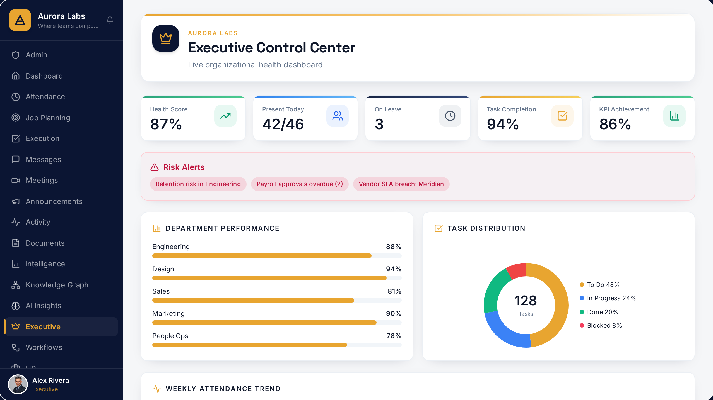
Global Office — AI Executive Control Center (live product)

