FATEC Zona Leste

**Engenharia de Software II**

Bruno Pallin de Azevedo

William Villela de Carvalho

São Paulo

2019

**Caso de Uso**

**Diagrama de Objetos**

**VCP**

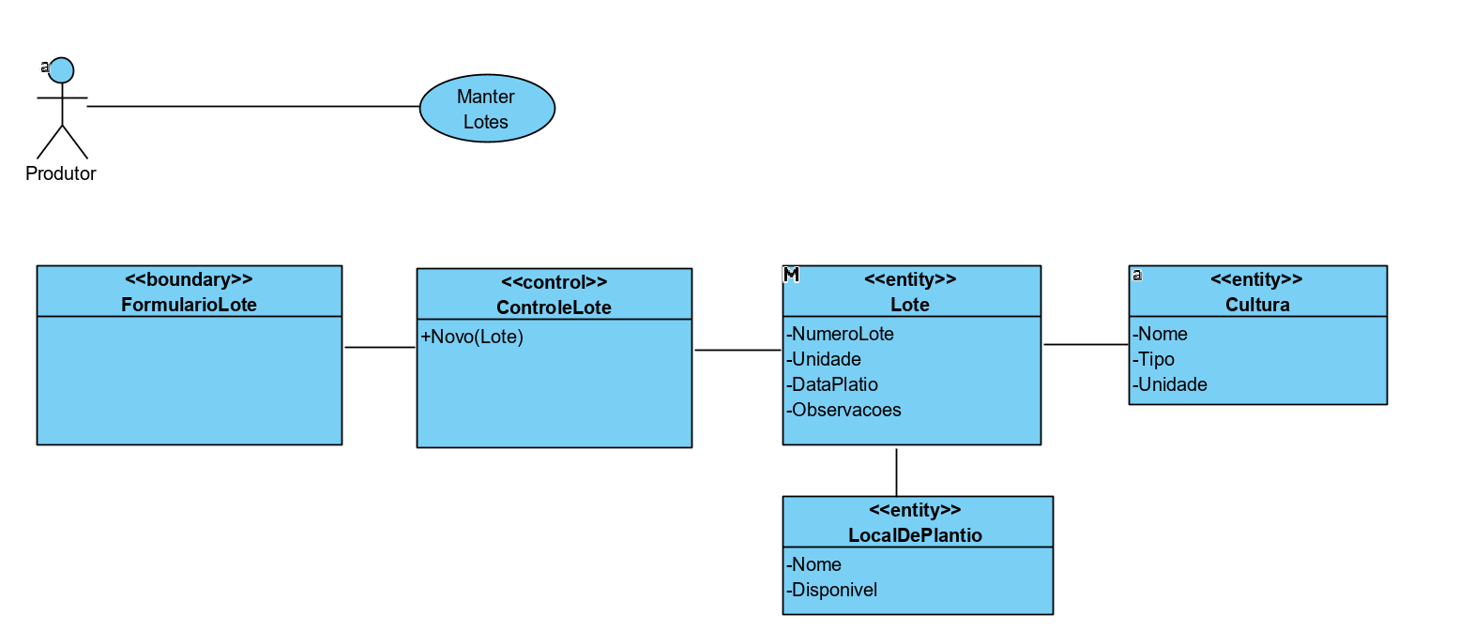

2

**Diagrama de Sequência**

CadastraAplicacaoDeInsumo – Aplicar(Insumo)

CadastraColheita – Colher(Colheita)

ManterClientes – Buscar()

ManterClientes – Editar(Cliente)

ManterClientes – Excluir(Cliente)

ManterClientes – Incluir(Cliente)

ManterCulturas – Buscar()

ManterCulturas – Editar(Cultura)

ManterCulturas – Excluir(Cultura)

ManterCulturas – Incluir(Culturas)

ManterEmbalagens – Embalar(Embalagem)

ManterEmbalagens – GerarEtiqueta(Embalagem)

ManterInsumos – Buscar()

ManterInsumos – Editar(Insumo)

ManterInsumos – Excluir(Insumo)

ManterInsumos - Incluir(Insumo)

ManterLocaisDePlantio – Buscar()

ManterLocaisDePlantio – Disponibilizar(LocalDePlantio)

ManterLocaisDePlantio – Excluir(LocalDePlantio)

ManterLocaisDePlantio – Incluir(LocalDePlantio)

ManterLotes – Buscar()

ManterLotes – Editar(Lote)

ManterLotes – Incluir(Lote)

ManterPropriedade – Editar(Propriedade)

ManterProprietario – Editar(Proprietario)

ManterVendas – Cancelar(Venda)

ManterVendas – Incluir(Venda)

