

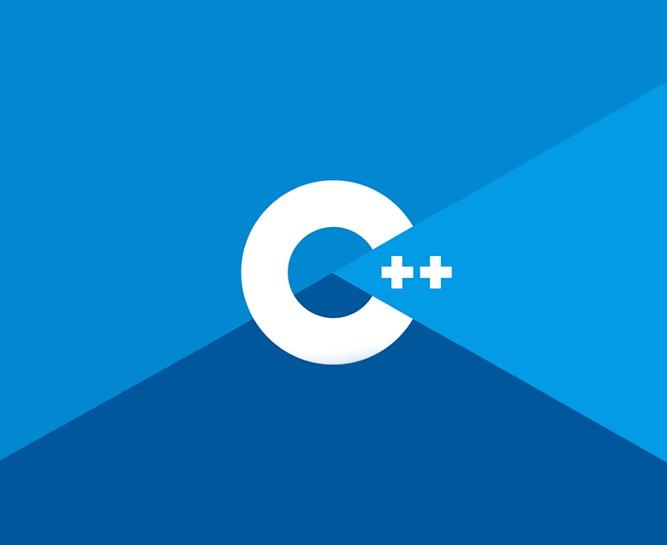

**Game Engine Creation**

COSE40638

Student Name: Bruno Reeve

Student Number: r019574m

**Portfolio**

Contents

Chapter 1: Introduction

Chapter 2: Data Types

Chapter 3: Variables

Chapter 4: Operators

Chapter 5: Conditionals

Chapter 6: Loops

Chapter 7: Functions

Chapter 8: Arrays and vectors

Chapter 9: Strings

Chapter 10: Debugging

Chapter 11: Pointers

Chapter 12: References

Chapter 13: File Handling

Chapter 14: Object Orientated Programming – Structs

Chapter 15 OOP - Classes

Chapter 1: Introduction

To begin we will be going through the steps required to build a simple application in C++ using Visual Studio. This will be the traditional ‘Hello World’ program written by all new coders. This will go through the steps required to create a new program and how to add source files. If you followed along with the code-along then this section will just need a screenshot of your output.

NOTE: There is one function in the HelloWorld program. It is called main(). All programs must have a main function as this is where execution of the program begins. There can only be 1 main function in any given program.

Firstly, create a folder in your OneDrive and call it GitHub. Inside this create another folder called GEC. It is recommended you add folders for each week to make finding work easier, but this can be done later as needed.

**Program 1: Hello World**

1. To begin, start Visual Studio and you will be met with this window…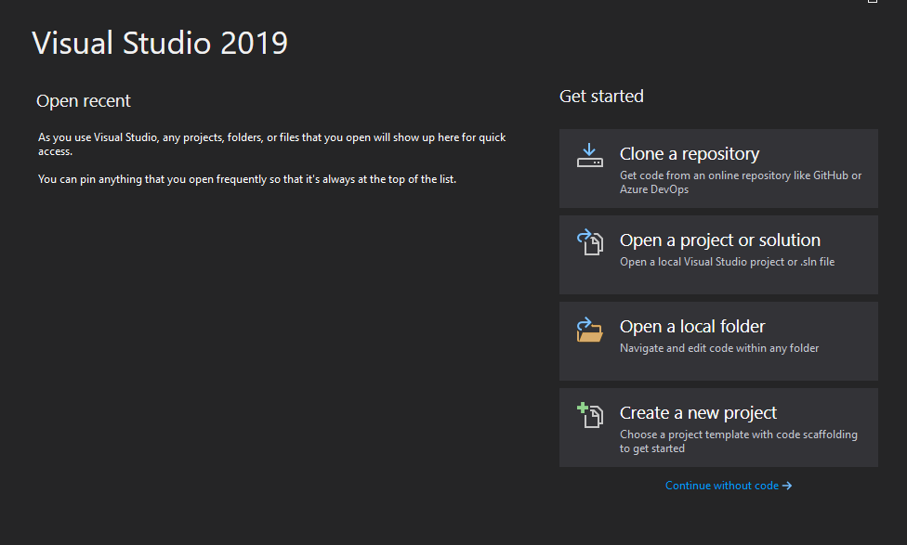

1. Click Create a new project and select the C++ Empty Project and click **Next**.
2. Name your Project HelloWorld and save to the location of your GEC folder within OneDrive that you created earlier, then click **Create**.
3. You should have the following window open. Right click the folder **Source Files** -> **Add** -> **New Item**. The default can be left as it is, it should have C++ File selected with the name **Source.cpp**. Click **Add** 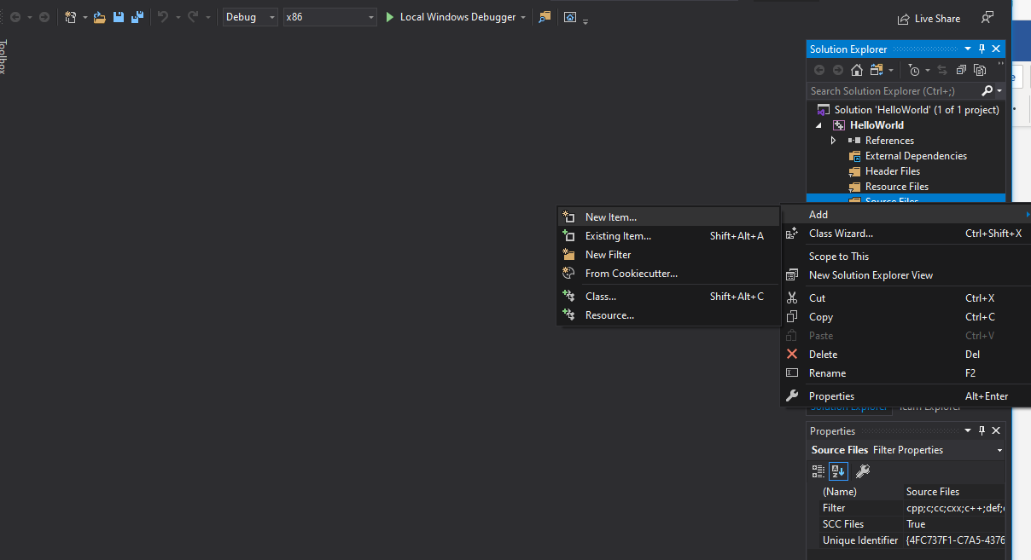
4. Now for some code! Replicate the following code: 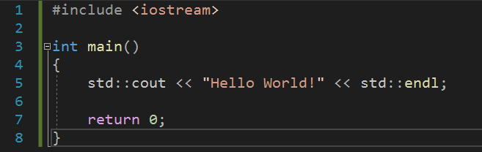
5. The first line of code adds the input/ output streams library that contains the cout object that allows us to print to screen. As mentioned above, every program needs a main function as a point of entry. As you can see this function is of type **int**, this means that the function expects a return type of type int, as seen on line 7 where we return 0. This return is reached only if the function is completed. On line 5 we start with **std::** this allows us to use the objects with the std namespace of the standard library, the use of **std::** can be omitted if **using namespace std;** is added below our include, but for now lets use best practice and include them. After cout we have two left chevrons << when outputting these will face left, putting what is on the right of them to the screen. If we were taking information in from a user, they would face right. We will cover this later. We then end with **endl;** which is the same if we were to add \n for a new line and of course the semicolon which is needed to end a line of code. Keep an eye out for these as they are a common result for program errors from new coders.
6. Now run your program using the green play button for Local Windows Debugger or F5. If you have followed along correctly you will be met with a console window containing “Hello World!”.
7. Screenshot this and add it below.

**Program 1 Screenshot:**

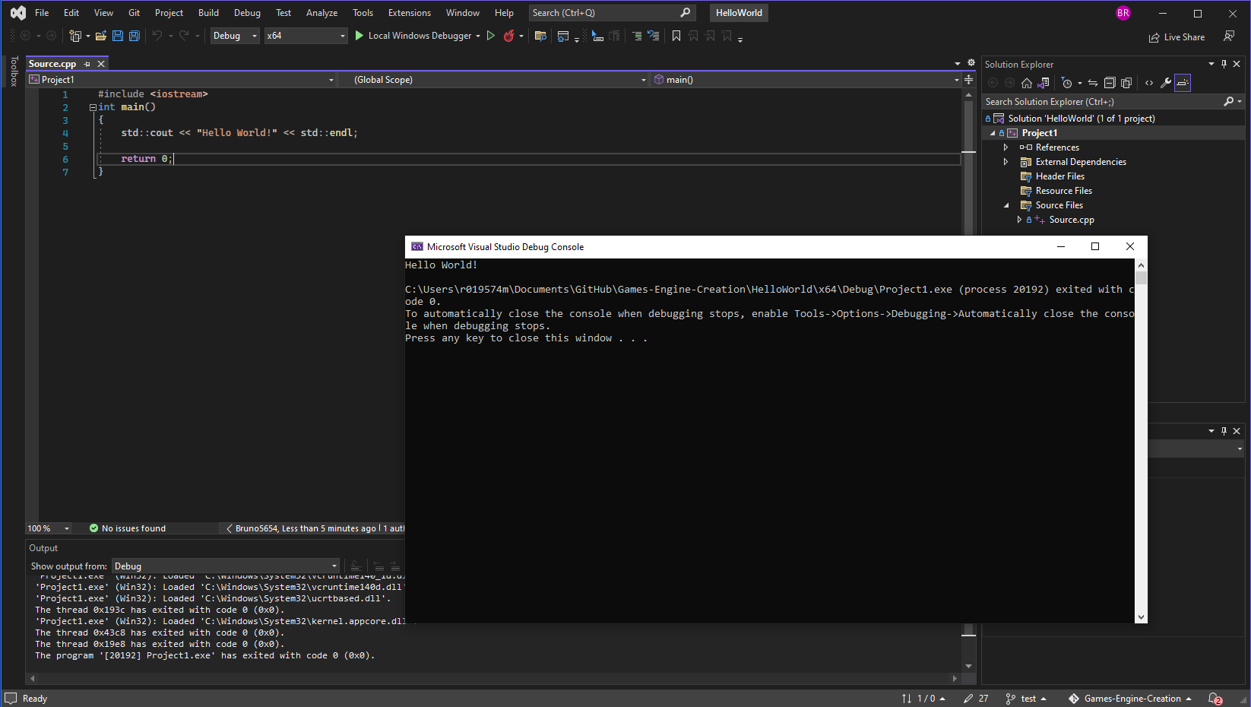

Chapter 2: Data Types

Before we can create variable to store our data, we need to learn what a data type is and how they work. There are a variety of built-in data types that we can use immediately, but it is also possible to create your own.

This table details the data types that are found in C++ and you will be using throughout your studies.

|  |  |
| --- | --- |
| **Type** | **Keyword** |
| Boolean | bool |
| Character | char |
| Integer | int |
| Floating point | float |
| Double floating point | double |
| Valueless | void |
| Wide character | wchar_t |

Table 2.1: Data types

The keyword is how this type is written in C++. If you make a mistake typing this in, for example miss a letter or use an uppercase character where it should be lowercase you will be alerted to a syntax error.

Not: Syntax is the term used for how the compiler expects to receive the code. If something does not match, you will receive a syntax error.

**Data Type Modifiers**

Each type reserves a certain amount of memory from the computer. In some situations, you may find that you require the memory to be increased / decreased or you would like the value stored in a variable to be in a different range. To enable this there are data type modifiers.

|  |  |
| --- | --- |
| **Modifier** | **Description** |
| signed | Use values in the negative and positive range. |
| unsigned | Use only the positive range. |
| short | Decrease the range, thus reducing the memory used. |
| long | Increase the range, which increases the memory used. |

Table 2.2: Data type modifiers

The following table details the data type, the amount of memory used and the range of values that can be stored in a variable of this type.

|  |  |  |
| --- | --- | --- |
| **Type** | **Typical Bit Width** | **Typical Range** |
| char | 1 byte | -127 to 127 or 0 to 255 |
| unsigned char | 1 byte | 0 to 255 |
| signed char | 1 byte | -127 to 127 |
| int | 4 bytes | -2,147,483,647 to 2,147,483,647 |
| unsigned int | 4 bytes | 0 to 4,294,967,295 |
| signed int | 4 bytes | -2,147,483,647 to 2,147,483,647 |
| short int | 2 bytes | -32,768 to 32,768 |
| unsigned short int | range | 0 to 65535 |
| signed short int | range | -32,768 to 32,768 |
| long int | 4 bytes | -2,147,483,647 to 2,147,483,647 |
| unsigned long int | 4 bytes | 0 to 4,294,967,295 |
| signed long int | 4 bytes | -2,147,483,647 to 2,147,483,647 |
| float | 4 bytes | +/- 3.4e +/- 38 (7 digits) |
| double | 8 bytes | +/- 1.7e +/- 308 (15 digits) |
| long double | 8 bytes | +/- 1.7e +/- 308 (15 digits) |
| wchar_t | 2 or 4 bytes | 1 wide character |

Table 2.3: Data type memory and range

Note: We can use a built in function called **sizeof( type )** which takes one of the types listed above and returns the number of bytes in memory used.

**Program 2: Data Type Size**

1. To begin, start Visual Studio.
2. Create a new project but this time select **Console Application**, this will populate the basics for us such as the main function etc. Name this project “Program2_dataTypeSize” and ensure you are saving to the right location.
3. You can clear the getting started comments should you wish and delete the Hello World code line. Then proceed to replicate the following:Text

   Description automatically generated

**Program 2 Screenshot:**

**Declaring User Data Types**

As mentioned above as well as the in-built types, C++ allows you to create your own data types by using the keyword **typedef**. The reason for doing is purely for the coder benefit and ease of reading. To the compiler your data type is no different form the original. The format for creating your own data type is as follows:

Note: this does not have to be int, this is just what is used for this example. Any data type from table 2.3 can be used.

Now instead of using the keyword **int** we could use our own defined type **date** like so:

The above code is exactly the same as using int currentDate;

If, however you required a data type to represent several values we can create an Enumeration. This allows you to create a new type and assign the constant value it represents. It follows this format:Graphical user interface, text

It will become clearer if we use an example. So, sticking with the date idea, in this example we would rather use the terms JANUARY, FEBRUARY, MARCH, etc to represent the month. We could create our own typedef month as shown above, but then in code we will always be using integer values. This is not very readable, so instead we will use an enumeration:

Note: Notice the syntax used when creating an enumerated type. After each type, a comma is used except for the last value and the semicolon is used after the curly brace.

As you can see **JANUARY** has been given the value of **1**, and all the following names will be incremented by 1. For example, **FEBRUARY** will hold the value **2**, **MARCH** the value **3**, and so on.

You can set the value of any name, but it is important to remember that the following names will be incremented by 1.

It is also possible to set none of the names to an initial value. In this case the first name will be assigned the value **0**, and the following names incremented in the usual way.

To use this enumerated data type, we create a variable of this type in the exact same way as we do any other.



Chapter 3: Variable Types

A variable is storage in memory that we can access using a name of our choosing. All variables must be of a data type described in the previous chapter. That is because the data type informs the compiler how much memory is to be reserved and what values can be stored. Refer to Table 2.1 for the data types that can be used along with the keywords that must entered for C++ to recognise the type.

When defining a variable, the user chooses what to name it, but there are restrictions. The name can be composed of letters, digits and underscores, but the first character must always be a letter or underscore. It is good practice to make the first letter of each new word uppercase. For example, **thisIsMyExampleVariableName**. This can also be seen in the previous chapter where we named our variables **currentDate** and **currentMonth**.

Also, the name chosen should be something informative. Variables of this sort: **a**, **b**, or **myVariable** do not help in any way, if you are dealing with user’s names call it **userName** or if dealing with ages call it **age**. Also, there may only ever be one variable of this name. duplicating names will produce syntax errors.

One final thing to note is that C++ is case sensitive, so when using your variables throughout your code ensure that they match. You will receive a syntax error if they do not.

The most straight forward way to declare a variable is with the following format:

To assign a value to our variable **myNum** we use the assignment operator =. (Operators are covered in more depth in the next chapter.)

So, at this point wherever you use the variable myNum it will produce the value **5**. You could however choose to assign the value of **5** at the same time as declaring the variable. This reduces the number of lines of code and makes the code easier to read. Bare in mind that you will not always know the starting value, so cannot do this.

So far so good. We have one last addition to make to this defining a variable section before we will get on to a mini program, and this is the use of definition lists. We can define multiple variables on the same line provided they are of the same data type. For example:



Variables can be changed as often as required. There is no special code required for this, you simply reset the variable to hold a different value.

If you require a variable that will never change, then you can use the **const** modifier. This will make the value constant and can never be changed. You may think this unlikely to occur, but it is a feature that you will find useful more often than you may think. It is common to see a lowercase k before the variable name to signify that it is a constant variable throughout the code.

Note: Don’t forget if using float, it is good practice to add the f at the end of your value.

**Program 3: Defining Variables**

1. To start, open Visual Studio.
2. Create a new C++ console application as before and name it Program3_definingVariables.
3. Next, replicate the following code (ensure when assigning a value to a char type you use single quotation marks).

**Program 3 Screenshot:**

**Program 4: Defining User-Defined Variables**

This program is for you to complete. Please pay attention to the instructions.

Create a program named Program4_userDefinedVars, this will contain both a **typedef** and an **enum** type. If you still have Visual Studio open, you can use the shortcut ctrl + shift + n

1. Create a typedef of data type **int** named **health**.
2. Create an enumerated data type named **Weapons**, this list should contain the following weapons in this order.
   1. SWORD
   2. DAGGER
   3. MACE
   4. TWIN_SWORDS
   5. SAMURAI
   6. WIZARD_STAFF
   7. FIRE_POTION
   8. ICE_BLADE
   9. SMALL_KNIFE
3. Next create a variable of data type **health** with the value of 13000, and a variable of data type **Weapons** with the value of SAMURAI.

Output the following to screen:  
My current health is: …

And the ID of my weapon of choice is: …

HINT: You will need to pass the variables to the cout statement just as you did with program 3. Output should read:

My current health is: 13000

And the ID of my weapon of choice is: 5

**Program 4 Source code:**



For testing purposes please follow these steps to adding code to this portfolio.

1. Copy the code from within Visual Studio
2. In word click **Insert** and then in the Text field click object
3. In the dropdown popup select OpenDocument Text and click OK
4. Paste your code in the new blank document that opens and close when done. ENSURE CURSOR IS IN THE RIGHT PLACE IN THIS DOCUMENT FOR WHERE YOU WANT YOUR CODE

**Program 4 Screenshot:**

As before this should be a screenshot of your output.

Chapter 4: Operators

Operators are special characters that represent mathematical or logical manipulations. C++ has a range of different operators, and we will be covering the following in this chapter: Mathematical Operators, Assignment Operators, Relational Operators, and Logical Operators.

**Mathematical Operators**

Looking at table 4.1 you will no doubt recognise the first four operators. These represent the usual mathematical operators we use in everyday life. As such we will not be explaining those, instead we will be focusing on the unfamiliar symbols.

|  |  |
| --- | --- |
| **Operator** | **Description** |
| + | Adds two operands |
| - | Subtracts second operand from first |
| * | Multiplies both operands |
| / | Divides numerator by denominator |
| % | Remainder left after integer division |
| ++ | Increases integer by one |
| -- | Decreases integer by one |

Table 4.1: Mathematical Operators

**Modulus**

The following code snippet creates two integer variables which each store a number. The final line of code creates an integer variable named remainder which holds the remaining digits from a & b divided by a calculation.

The variable remainder will be equal to 1 as 3 goes into 10 3 times with the remainder of 1.

**Increment Operator**

The increment operator adds 1 to the current value stored in the variable. This is simple enough and will be shown below. Confusion can arise when the increment operator is placed before the variable.

The following code snippet assumes the existence of an integer variable named num, which stores the value 1. After the following line of code, num will now be equal to 2.

As stated above, the increment operator can be placed before the variable like so: ++num. This has the effect of changing the value stored in the variable in the same manner as before. But the effect takes place immediately. Assuming num started with a value of 1, in the above line of code, num will equal 2 as soon as it is reached, not on the following line.

Note: The placement of the Increment Operator may seem trivial or confusing now, but once we get to using loops in chapter 6 the placement will be crucial.

**Decrement Operator**

The decrement operator subtracts 1 from the current value stored in the variable. It works very much like the increment operator.

Again, the following code snippet assumes the existence of an integer variable named num, which stores the value 1. After the following line of code, num will now be equal to 0.

Just as with the increment operator, decrement can be placed before the variable. This has the effect of changing the value stored in the variable in the same manner as before. Assuming num started with a value of 1, in the above line of code, num will equal 0 as soon as it is reached, not on the following line.

**Program 5: Increment / Decrement Operators**

1. If you haven’t already open VS and start a new project called Project5_IncrementDecrment
2. Replicate the following code.

Note: It is a good idea to comment your code. This means to add comments, which are only there for the programmer’s benefit. The compiler ignores them. This may seem trivial, but it really helps other programmers who may use your code, or even yourself if you have not looked at a program in a while. To comment you can either use a double slash // or surround the text with a /* */ block. Both are demonstrated in the following code.

**Program 5 Screenshot:**

**Program 6: Area of a Rectangle**

This program is for you to complete. Please pay attention to the instructions.

1. Create a program named Program6_area, which creates variables of integer data types for **width** and **height**. Initialise **width** to the value of 15 and the **height** variable to the value of 25.
2. Next create an integer variable called **area** and set this to equal the width times by the height.
3. The output should be in the following format:

**Program 6 Source code:**

As before, please ensure to copy your code via the insert object format.



**Program 6 Screenshot:**

**Program 7: Converting from Fahrenheit to Celsius**

This program is for you to complete. Please pay attention to the instructions.

1. Create a program called Program7_converting, in which you are required to write code that will convert Fahrenheit into Celsius
2. Create two floating-point variables named **fahrenheit** and **celsius**, set the value of Fahrenheit to equal 95.0f.
3. To calculate the Celsius, it must equal this formula: (Fahrenheit - 32) * 0.5556
4. Output the results in the following format:



**Program 7 Source code:**

As before, please ensure to copy your code via the insert object format.



**Program 7 Screenshot:**

**Program 8: Area of a Circle**

This program is for you to complete. Please pay attention to the instructions.

1. Create a program called Program8_pi, in this program we will calculate the area of a circle.
2. Create a constant floating-point variable named **pi**, this will hold the value 3.14159.
3. Next create two float variables, one called **area** and one called **radius.** Set the value of **radius** to equal **25.0f**. And set the value of **area** to equal this formula: **pi** * **radius** * **radius.**
4. Output the result in the following format:



**Program 8 Source code:**



**Program 8 Screenshot:**

**Assignment Operators**

Now that we understand the mathematical operators, we can move on to assignment operators. These operators simply reduce the amount of code required to do a simple operation. Look at Table 4.2. Examples of each operator will follow below.

|  |  |
| --- | --- |
| **Operator** | **Description** |
| = | Assigns value from the right-side operand to the left side operand. |
| += | Adds right operand to the left operand and assigns the result to the left operand. |
| -= | Subtracts right operand to the left operand and assigns the result to the left operand. |
| *= | Multiplies the right and left operands together and assigns the result to the left operand. |
| /= | Divides the left operand by the right operand and assigns the result to the left operand. |
| %= | Takes the modulus of two operands and assigns the result to the left operand. |

Table 4.2: Assignment Operators

**Equals Operator**

As has been shown previously the equals operator is used to assign a value to a variable. A variable must always be on the left-hand side of these operations. The following snippet assigns the value of 5 to the variable num.



You can also assign a variable to equal the value stored in a completely different variable provided they are of the same data type, like so:

**Calculate and assign**

**Rational Operators**

Relational Operators are used to return a result of true or false. These will be used all the time in conjunction with conditionals [chapter 5 next week]. Look at Table 4.3 and the corresponding examples below for an explanation of each operator.

|  |  |
| --- | --- |
| **Operator** | **Description** |
| == | Checks if the values of the two operands are equal, if so, the condition becomes true. |
| != | Checks if the values of the two operands are not equal, if they are not equal then the condition becomes true. |
| > | Checks if the left operand is greater than the right operand, if so, the condition becomes true. |
| < | Checks if the left operand is less than the right operand, if so, the condition becomes true. |
| >= | Checks if the left operand is greater than or equal to the right operand, if so, the condition becomes true. |
| <= | Checks if the left operand is less than or equal to the right operand, if so, the condition becomes true. |

Table 4.3: Relational Operators

**Examples of Rational Operators**

If the variables being compared store the same value the result returned will be true, otherwise it will return false. Take notice of how a single = sign is for assignment and the double == is for comparison.

**Logical Operators**

Logical Operators are used to return a result of true or false. Just like Relational Operators, these will be used all the time in conjunction with conditionals next week. Look at Table 4.4 and the corresponding examples below for an explanation of each operator.

|  |  |
| --- | --- |
| **Operator** | **Description** |
| && | AND Operator  If both operands are non-zero [true], then the condition becomes true. |
| || | OR Operator  If any of the two operands is non-zero [true], then condition becomes true. |
| ! | NOT Operator  Used to reverse the logical state of an operand. If a condition is true, the NOT Operator will make it false. |

Table 4.4: Logical Operators

**Examples of Logical Operators**

Logical AND checks if both variables being checked are true the result will be true, otherwise false will be returned. Whereas the logical OR checks if either of the variables being checked are true. If one of them is true then the result returned will be true, otherwise false will be returned.

The Logical NOT operator will reverse the result from the other two logical operators. This may seem a redundant operation, but using the ! (NOT) operator will come in useful. The following two examples are the exact same as the examples used for Logical AND except that we have included the ! (NOT) operator. Notice how the results have been reversed.

Chapter 5: Conditionals

At some point in every program you will need to run different portions of code. For example, in a text adventure game the player will decide which direction to take at a fork in the road. We need some way of telling the program to execute a different portion of code depending on this choice. Unsurprisingly C++ has functionality built in for this type of decision-making.

The following table shows the possible statements, which can be used. These will be used with the operators you looked at in the previous chapter. Following on from Table 5.1: Conditional Statements there will be an example depicting each approach in code.

|  |  |
| --- | --- |
| **Statement** | **Description** |
| if statement | An if statement consists of a Boolean expression followed by one or more statements. |
| if…else statement | An if statement can be followed by an optional else statement, which executes when the Boolean expression is false. |
| nested if statements | You can use one if or else statement inside another if or else statement. |
| switch statement | A switch statement allows a variable to be tested for equality against a list of values. |

Table 5.1: Conditional Statements

**Example of an if statement**

An if statement is the simplest form of condition check. It literally works, as you would expect – If the condition is true, do the following portion of code. If the condition equates to false, then the following portion of code is skipped. The portion of code to be executed is defined by the curly braces.Text

We can further reduce the code in the above example by removing the curly braces. This will only work if the code to be executed is a single line of code, this done in a similar manor to that of Python. If there is more than one line of code, only the first will be executed. The following lines will be executed after the if statement has exited. This may cause issues later as a syntax error will not be given. This is a logical error and the compiler cannot help you. Text

**Task 1: Run through the code ensure you understand what is happening and why. Post an output screenshot below.**

If num1 = 12; num2 = 5; and num3 = 7; what do they equal after the above sums are performed on them? **Num1 = 14 num2 = 15 num3= 28**

**Example of if – else statement**

We can extend an if statement to include a portion of code to be executed in the event of the condition being false. In English we are saying, if the condition is true do the first portion of code, otherwise do the second portion of code. This extra portion of code will only ever be executed if the condition is false.

**Example of if – else if – else**

Building on from the if…else statement, we can add another condition to the second portion of code. Here we are saying, if the first condition is true then do the first portion of code, otherwise check if the second condition is true, and if so do the second portion of code, and if neither are true, do the third portion of code.

Note: If a condition equates to true, the corresponding code portion will be executed. All others will be ignored.

**Task 2:**

Sticking with num1 = 12; num2 = 5; and num3 = 7; Set a to equal false, b to equal true and add the following scenarios:

If a true – num1 += 10; num2 += 15;

If b true – num1++; num3 += 20;

If both false – num1--; num2--; num3--;

Screenshot the output below.

**Nested if statements**

Any legal code can go inside the if statement portion of code to be executed; therefore, it is possible to have any of the above variants of an if statement inside an if statement code block.

**Switch statements**

When you have a lot of options multiple if statements can become messy. Take the text-based adventure example again. The player could enter numerous responses to the on-screen prompt and you as programmer would need to code an if statement for each one. Alternatively, you can use a switch statement. A switch statement allows a variable to be tested against a list of constant values.

As you can see from the above code snippet, the variable to be tested against goes into the brackets beside the switch keyword, then within the curly braces are a list of values to compare against. We are saying, in the case of playerInput matching with ‘0’ do this portion of code. It is crucial to include the break keyword, otherwise code execution will automatically drop through to the next section without checking the condition.

The last part of a switch statement to note is the **default** case. This states that if none of the values match then do this portion of code. It acts in the same way as an else portion of an if…else statement.

There may be occasions where you wish a portion of code to execute if several conditions are met, in the same manner as an if statement which uses the Logical OR operator. In this case follow the below format.Text

It is also possible to nest switch statements and is a common occurrence in programming. This is done the same way as seen above with the nested if statements.

**Task 3:**

Building on what was covered in the slides and here, create a switch statement of chars.

Create a char variable called play_again

Ask user if they want to play again, y or n?

Store the char in play_again and enter the switch statement. If case ‘y’ cout “you chose to play again”. If ‘n’, cout “goodbye” and if neither cout “that’s not y or n”

Test all conditions and paste output below.

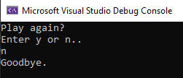

**Program 9: Share of Savings**

1. If you haven’t already open VS and start a new project called Project9_ShareOfSavings

2. Replicate the following code:

Run this program in Visual studio and see if you can understand why we get a wrong answer printed out instead of the correct answer of 1000. Then try and fix the error! Note there are multiple ways of fixing this and the quickest solution requires only 2 keystrokes!

Add the fixed code below along with a screenshot of the output.



**Program 9 Source code:**

As before, please ensure to copy your code via the insert object format.

**Program 9 Screenshot:**

**Program 10: Share of Haribo**

Pretend that, for some reason, you are now entitled to my stash of Haribo. There are 40 packets available and to make things fair, they are to be shared out equally, as in you all must have the same number of packets.

On the day when I decide to hand out the Haribo, only 14 students turned up.

**Write a program that**

1. Calculates how many of the 40 packets of Haribo do each of the students get?

2. Calculates how many I get, which will be the remainder left after sharing the 40 packets as equally as possible

Your final answers should be **2** packets for each student, leaving **12** packets left for me. What we want to see is you coding the solution and getting the computer to do the right calculations that come up with these 2 answers. We are not bothered about the answers themselves, like how many mathematics questions are more concerned with “method marks” than the final answer.

**Program 10 Source code:**

As before, please ensure to copy your code via the insert object format.



**Program 10 Screenshot:**

**Program 11: Doom Difficulty Menu**

Write a program that displays a short menu such as:

* Please choose your difficulty:
  1. I’m too young to die!
  2. Hey, not to rough!
  3. Hurt me plenty.
  4. Ultra-Violence.
  5. Nightmare…

The program should use a **switch statement** to display a short message appropriate to the option chosen (such as "Just FYI, they will shoot back" or something fun for each, get creative).

For an example of reading input from the player, see the switch statements example above and the use of **cin**.

**Program 11 Source code:**



As before, please ensure to copy your code via the insert object format.

**Program 11 Screenshot:**

**Program 12: If This Then That**

This program is going to be a little more complex than the previous programs. For this task you will need to create a program that does the following:

* Stores two ints, rain = 1; and snow = 2.
* You will need to create two more variable to hold a user’s answers and then ask the following:
  + Please tell me if it is raining with ‘1’ or snowing with ‘2’. And store the answer.
  + Then ask what the temperature is in Celsius.
* Next create an if – else if – else statement
  + If the users answer is equal to 1, jump into a nested **if else** statement with the condition of if temp > 15, wear a light raincoat, otherwise wear a thick coat.
  + If the user selected 2, jump into a **nested** if – else if – else statement with the conditions of, if temp > 5 tell them to wear something warm. Or if temp > 0 tell them to wrap up well, otherwise tell them to stay home.
  + The final outer else should just inform them to have a nice day as it is neither raining nor snowing.
* Test all your conditions to make sure your program works correctly.

**Program 12 Source code:**



As before, please ensure to copy your code via the insert object format.

**Program 12 Screenshot:**

**Program 13: Discount**

For this task you will be creating a program with an if – else if – else statement that has multiple conditions. It must have the following:

* A char to hold/store the user’s status and an int for the user’s game choice.
* You will then need to ask:
  + Please tell me your status with ‘s’ for student, ‘t’ for teacher or ‘o’ for other.
  + Then ask which game they would like, 1 or 2?
* Next create an if – else if – else statement
  + If the user’s status is equal to **s** or **t** and the game value is equal to **1**. Output a message that they can get 20% discount.
  + If the user’s status is **s** or **t** and the game value is equal to **2**. Output a message saying they can get a 10% discount.
  + Otherwise inform them they are not entitled to a discount.
* Test all your conditions to make sure your program works correctly.

Hint: If you are struggling refer to the slides in the PowerPoint for help. Read the instructions carefully, writing pseudocode may help.

**Program 13 Source code:**



As before, please ensure to copy your code via the insert object format.

**Program 13 Screenshot:**

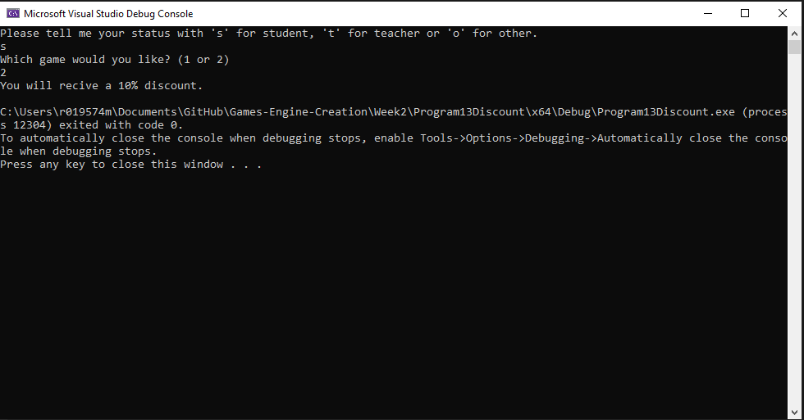

Chapter 6: Loops

Repetition is a key element of any program, whether that is just to repeat a function several times or encompass the entire program in, such as a game loop. This chapter is going to look at the 3 loops found within C++ and how they are used.

Before we get to some example code, look at Table 6.1: Loop Types. As you can see there are different types of loops. You will use different loops in different scenarios, but it is possible to use any of the listed loops with a little extra coding.

The main difference between a for loop and the others is that with a for loop you state how many iterations you wish to carry out, the others require a condition to be met to exit. The difference between a while loop and a do while loop is that a do while loop will always run at least once, whereas a while loop must meet a condition to run at all.

|  |  |
| --- | --- |
| **Loop Type** | **Description** |
| for loop | Execute a sequence of statements a set number of times. |
| while loop | Repeat a sequence of statements while a given condition is true. The condition is tested before executing the body of the loop. |
| do… while loop | Like the while loop, but the body of the loop is always executed once as the condition is not checked until the end of the loop. |

Table 6.1: Loop Types

**For Loop**

As described above, a for loop is used when you know the number of iterations required. If I want to do something 10 times, a for loop is what I need. If I want to loop until the player dies, a for loop is no use to you.

**For Loop Format**

Recapping on what was shown in the PowerPoint, a for loop typically needs three parameters; the initialiser, a condition that can become false and ending the loop, and an incrementation of the initialised variable. Now these do not have to be as shown above, and each can be set to anything that is needed of the loop and program. You should be familiar to the syntax used from previous weeks.

Note: the position of the ++ operator would normally have an impact on the value, like so:

However, having ++i or i++ in a for loop is down to preference and you will see many arguments online for which is correct, or which has better performance.

Also mentioned in the PowerPoint, for loops can work in reverse like so:

Note: As with if statements, the curly brackets can be omitted if your loop only requires one line.

**While Loops**

A while loop differs from the for loop in that we do not know how many loops we are going to do of the enclosed code. A while loop will only exit when a condition has been met and follows this format:

The condition can be in any of the formats covered in Chapter 5: Conditionals. The important point to remember is that you need to have some way of changing this condition from within the loop.

An example of a game loop that goes until the player dies could look something like this:

A while loop can also be constructed like a for loop, again, like with many things in programming there is more than one way to do something and it often comes down to preference and performance:

**Do While Loop**

A do while loop differs from the while loop in that the condition is checked at the end of the loop. This means that it will execute the code at least once. It would be entirely possible for a while loops condition to be false and the body of the loop get skipped over and never executes and has this format:

Recreating the player alive example from above, the following shows how a do while loop could be used. Remember though that this code will run at least once. What would happen if the player were in fact already dead when this loop was reached? You need to think ahead at what your program is doing or will do, consider every outcome.

**Nested Loops**

As loops are valid code statements it is entirely possible to have loops within loops. These are termed nested loops. You may think this unlikely, but imagine you are writing a game that has a game loop, it is more than likely that you will have other loops within this game loop.

Example:

**Control Statements**

At times you may wish to exit a loop before a condition is met. For example, if you had a for loop that iterated 10 times, but on the 3rd iteration you need to exit the entire loop you could use the break control statement. Similarly, let us say you need to skip the remainder of the code in a loop and move on to the next iteration, there is a control statement for that too - continue. Look at Table 6.2: for an overview.

|  |  |
| --- | --- |
| **Control Statement** | **Description** |
| break | Terminates the loop or switch statement and moves execution to the statement immediately following the loop or switch. |
| continue | Causes the loop to skip the remainder of its body and immediately retest the loop condition before reiterating through the loop body. |

Table 6.2: Control Statements

**Break Statement**

So, we have decided that on a condition met within the loop we need to stop executing the loop. Simply put the break keyword at the required place. Remember the switch statement in Chapter 5: Conditionals? Break is used to get out of that statement at the required time too.

This example takes the for loop example from above and allows us to break out of the loop when i reaches the value of 3. There is no logical reason for this, it is purely to demonstrate how break works:

**Continue Statement**

For the continue example we will be writing the example posed earlier. We will construct a for loop that iterates 10 times, but if i is 3 we will skip that iteration:

**Program 14: 10 Numbers**

Write a program

* That asks to user to enter 2 numbers.
  + Using those 2 numbers, calculate the sum (total) of the numbers and calculate the mean (average) value of those numbers.
  + Finally, print out the sum and mean values to the console.
* Ask the user to enter another number.
  + Calculate the sum and mean with the current total and output in the same way as in step 1. (This must add to the first numbers.)
* Continue to ask the user indefinitely until the user enters a value of zero.

**Things to consider:**

* The user being able to enter 0 during the first two numbers and not have the program exit. What type of loop would best suit this?
* Which numbers might not result in whole numbers?
* Make sure to increment the number of inputs for calculating the mean

**Program 14 Source Code:**



**Program 14 Screenshot:**

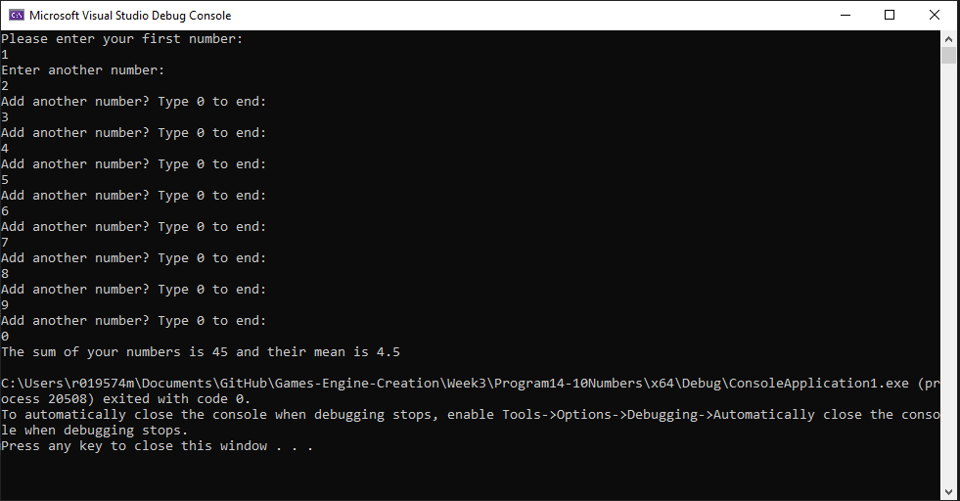

**Program 15: Starry Output**

Write a C++ program

* Which asks the user for a number n between 1 and 10. The program should then print out n lines. Each should consist of several stars of the same number as the current line number. For example:

Please enter a number: 5

*

* *

* * *

* * * *

* * * * *

* The user should then be asked if they wish to have another go [Y or N].
* An input of ‘Y’ will
  + Loop the player back to number 1 above,
* An input of ‘N’ will
  + Output a line of text saying “Goodbye.”
  + Pause for a brief second so the user can read the text
  + Then quit.

Hint: You will need to use nested loops, and this is easily done wrong and can output the opposite way round. Other things to consider dealing with user input if they have caps lock on or not.

**Program 15 Source Code:**



**Program 15 Screenshot:** (Please have your screenshot of output show multiple attempts from a user)

**Program 16: Early Exit**

Write a C++ program, which creates an integer called playerLife. Set it to a starting value of 100 and outputs this to the console screen.

The program should ask the user how much health to decrease the player life by with the following output:



It should ask this question 10 times unless the health value goes below 0.

In the event of the playerLife variable going below zero before the question is asked 10 times, the following should be output:



Otherwise all questions should succeed to be asked and the following should be output:



**Program 16 Source Code:**



**Program 16 Screenshot:**

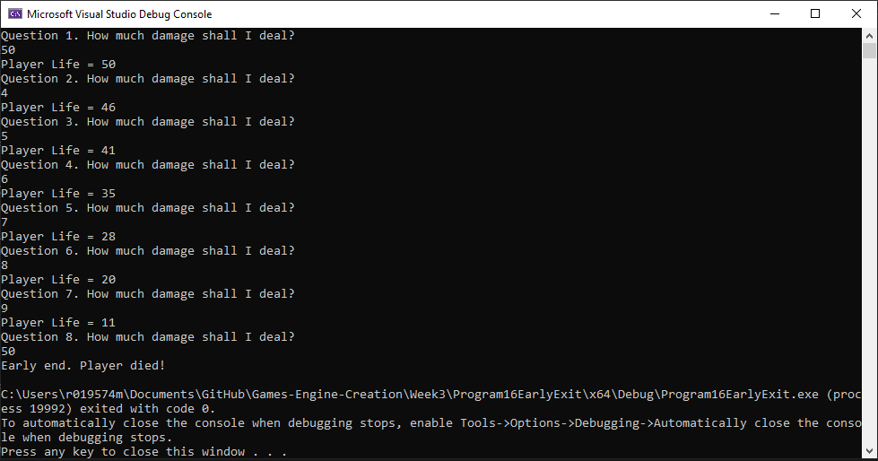

Chapter 7: Functions

Functions are a programming approach to reduce your codebase and stop the need to replicate the same code in multiple places. If approaching C++ from another language, you may be familiar with the term methods, which are very similar to functions, however; C++ standard does not use methods per se but slightly different variations of functions. The C++ equivalent being of a method being a *member function*. The only real difference is a function, or a *free function* is called by name anywhere in the code, and *a member function/method* is associated with an object. Each function is usually a block of code that does a single task. We have already seen one function that has been in every program we have written so far – the main() function.

Functions can take any number of parameters and can return any valid type. This includes void types which signifies that nothing is returned. When declaring functions various approaches can be taken.

• The first is to put the function ahead of the main() function in code. This will ensure the compiler knows of its existence before the main() function attempts to use it.

• The second, and preferred, is to use a prototype, which is placed ahead of the main() function and then add the function body below the main() function. The prototype gives the compiler all the information it requires to allow the main() function to use the function within its own body of code.

• The final approach is to use header files and source files. In the header the prototypes are declared, and in the source file the body of each function is added. You need to include the header file at the top of the source file that uses the functions contained within. We will be using this approach when we get to Chapter on Object Oriented Programming.

**Format of a function:**

Note: Parameter is just another name for variables that are passed to the function.

The format of the prototype matches the function detailed above, but it ends with a semi-colon rather than the curly braces and code body. This is because it is only used to inform the compiler what the function name is, what the return type is and what the parameters are.

The format of a prototype is as follows:



It is important to note that any variables passed into a function as a parameter will be copied for use within the function. These are placed on the stack, and when the function returns the copies will be deleted. This is important to know because it means any variable passed into a function can is not changed within the function. We can solve this issue using pointers & references, but this will not be covered later weeks with Pointers and References.

**Example functions**

In all examples the programmer is expected to add the correct namespace at the top of the file or use the correct syntax.

**I love Coding Function**

Firstly, we must add the function prototype. This goes above the int main() function:



Next, we will add our function body. This will go under the main function after the last closing bracket.

Note: As we progress, we will be using header files and classes to construct our code and typically the main function and cpp file will be but a few lines of code.

Finally, we add code to the main function that uses our new function:

Build and run your program to make sure everything has been done correctly.

**Passing Parameters**

This example will create a function that takes two integers, adds them together and outputs them to the screen. It does not require a return type, so it will be void. We will create some local integers to be passed in, we will pass through some constant integers and finally pass through a mixture of both. Note that the parameter name does not need to be the same as the integer name passed in.

First, add the function prototype at the top:



Next, add the function under the main like so:

Notice there is no return keyword. This is due to it being a void function and will automatically return at the end of the code.

And finally, we add our code calling the function to the main. We will do a couple of examples:

Build and run your program and make sure there are no errors. If there is anything you don’t understand about how the function is working now is the time to speak to a lecturer.

**Return Values**

This example will create a function that takes two integers, adds them together and returns the result. The result is then output to the console.

Add the prototype:



Next, add the function body:

And finally, add our code that calls the function in the main:

**Program 17: Local Variables & Copies**

This program will demonstrate how variables do not get affected outside of functions regardless of what you do to the local copies a function makes.

1. Open Visual Studio
2. Create a new project called Program17_LocalVariablesAndCopies
3. Create a function prototype called addTwo which takes one parameter of type int called num.
4. Add the function body below the main like so:  
   Text

   Description automatically generated
5. Now for the code within main:
   1. Create an int variable called myNum with the value of 6.
   2. Output to screen the value of myNum before the calling of the function  
      
   3. Call the function, passing myNum:  
      
   4. Now repeat step b but [after] the function call.
6. Build and run the program. If all is correct your outputs should be 6, 8, 6. The value myNum has not been changed but rather a copy of its value is used within the function scope.

**Program 17 Source code:**



**Program 17 Screenshot:**

**Program 18: Smallest Number**

Write a program which asks the user to input two integers, three times. These values should then be passed into a function to determine which is the smallest. The function does **not** need to **return** the smallest value but should print it to the console. Then once that loop is complete, the program should ask three more times for a number to be multiplied by 10 and then divided by 3. The multiplication should take place in a function and **returned,** when returned, store the result in a float this is then passed to another function that divides the parameter by three. This dividing function does not need to return but merely print to console.

This is the function prototype you must use for SmallestNumber is below:



The multiplication function should return an int and expect an int as a parameter. The dividing function should **not** return anything but should expect a float as a parameter. These are you to workout.

Things to consider:

* Creating variables to hold user input
* Not sure how to test which is bigger? Look back at week 1 Conditionals
* Have your program ask for the three sets of numbers before exiting. Look back at week 3 Loops.
* How will you deal with numbers of the same value?

Note: This is a function exercise and the result MUST be determined within the function body and then returned from the function. Use the values below.

Run your program using the following values. The screenshot must show the use of these elements for the first loop:

1, 2

2, 1

5, 5

And use the digits 2, 6, and 4 in the second loop. The output should look like this:

**Program 18 Source Code:**



**Program 18 Screenshot:**

**Program 19: Odds and Evens**

Write a program, which asks the user to input 10 integers. These values should be then passed individually to a function, which will determine whether the value is odd or even. This function should return a boolean value.

In the event of the value being odd, it should be added to an odd count, and in the event of it being even it should be added to the even count.

Your program should then call a function which will output how many odd numbers there were and the total, and in a similar manner for the even numbers. Use the following prototype for the output function:



Note: This is a function exercise and MUST demonstrate the use of functions as detailed above

**Things to consider:**

It might be useful to write some pseudo code in a notepad doc to plan out what the program needs,

* What local variables are needed?
* How will you ask for the 10 numbers?
* When will you call the Boolean is odd or even function?
* When will you call the outputResults function and what variables do you need to pass to it?
* The output should tell the user how many odd numbers were entered followed by the grand total of the odd numbers sum and the same with the even numbers.

**Program 19 Source code:**



**Program 19 Screenshot:**

**Program 20: Simple Text Battle**

Below you have been provided with some simple pseudo code for you to work from. The aim is to recreate the program in working code using everything you have covered in lectures and tutorials so far. To keep things simple while you get to grips with functions you may use the listed global variables. This program is a good one to revisit when you have learnt pointers/references and edit it in such a way as to remove the global variables and access the vars from within main and edit them.

namespace

*Global variables*

two integers for player and enemy health set to 1000(p) and 2000(e)

boolean variable for playing set to true

*Function prototypes*

attack choice that returns nothing. Parameters required: one integer for choice

play state function that returns a boolean

*Main Function*

local variable to hold the players choice

A loop to run as long as playing is true

tell user they have met a troll and have 3 options of attack

1. use sword, 2. use magic, 3. use axe

tell user choices have different effects

store users choice

call attack choice function passing user choice

call play state function

return 0;

*attack choice function*

set constant ints for the passed user choice, sword damage = 300, magic_damage = 650, axe_damage = 450,

troll_sword = 350, troll_magic = 50, troll_axe = 100;

switch statement(condition user choice)

case 1:

set enemy health to take sword damage

set player health to take troll sword damage

tell user they have hit the troll

tell user they have been hit

if player or enemy health is less than 0 set to 0 (prevents negative health)

tell user current player and enemy health

case 2:

set enemy health to take magic damage

set player health to take troll magic damage

tell user they have hit the troll

tell user they have been hit

if player or enemy health is less than 0 set to 0 (prevents negative health)

tell user current player and enemy health

case 3:

set enemy health to take axe damage

set player health to take troll axe damage

tell user they have hit the troll

tell user they have been hit

if player or enemy health is less than 0 set to 0 (prevents negative health)

tell user current player and enemy health

Any questions don’t hesitate to ask. Can you think of any improvements that could be made? Maybe check for wrong input etc? Ensure to full test your program and show this in your screenshots.

*play state function*

create a char for play again option

if enemy health is less than or equal 0

tell user they have killed the troll and won

ask to play again y/n

store choice

if they want to play again

reset enemy and player health

return playing true

else

return playing false

if player health less than or equal 0

tell user they have been killed

ask to play again y/n

store choice

if they want to play again

reset enemy and player health

return playing true

else

return playing false

return false;

**Program 20 Source Code:**



**Program 20 Screenshots:**

Chapter 8: Arrays and Vectors

An array is a data structure that holds a fixed number of elements of the same data type. We can create an array named myNumbers, which holds n integers. All elements of the array can be accessed using the variable name myNumbers. This approach saves the programmer creating multiple individual variables for the same data. The array data structure also works well with loops.

The way this works behind the scenes is with the use of memory addresses. Arrays are nothing more than pointers and can be accessed in the same way. Do not worry about pointers for the moment, they will be covered in a later chapter. It is just something to bear in mind.

**One-Dimensional Arrays**

**Declaring Arrays**

The most straightforward way to declare a variable is the following format:



This creates an array with enough memory to hold size elements. The square brackets are important here.



**Initialising Arrays**

To set the value of an element in the array you follow the same process as any other variable. The only difference being that you need to inform the compiler which element you want to access. This is done using the square brackets again.

Note: When accessing elements of an array the positions run from 0 to size -1. So, in the above example when accessing array elements, they run from 0 to 9. 0 will give you the first element, 1 will give you the second and so on.

Also, if you use an element position that is outside of the range, you will get an out of bounds runtime error.

If you know the values of the elements, then you can set this up at the declaration stage.



It is also possible to omit the size of the array if you are giving the element values at declaration. In this case an array of the required size will be created.



**Example array**

If you missed the lecture session, then please replicate the following program. This program will create an array and populate the elements. It will then output the array element and the value stored in a structured way using the setw() function. This function allows you to set how many characters to skip before moving onto the next output. It stands for set width and takes an integer as its only parameter.

**Multi-Dimensional Arrays**

We can extend the concept of arrays to hold more elements. The most common is a two-dimensional array. You can imagine this as a table. It is entirely possible to create arrays with more dimensions, but this happens infrequently.

**Declaring 2D Arrays**

In much the same way as a single dimensional array is created, two dimensional arrays follow the same format, only now we add an additional size component.



This creates an array with enough memory to hold (*rows* x *columns)* elements. To visualise this in a table take a look at Table 7.1: Array as Table.

Table 7.1: Array as Table

An example of an array called myNumbers that holds 9 integers in a 5x3 table would look like this:



**Initialising 2D Arrays**

To set the value of an element in the array you follow the same process as any other variable. The only difference being that you need to inform the compiler which element you want to access. This is done using the square brackets again. 

Note: Remember when accessing elements of an array the positions run from 0 to size-1. So, in the above example when accessing row 4 it is the 5th row. I.e. 0, 1, 2, 3, 4 is the 5th element when counting from zero.

If you know the values of the elements, then you can set this up at the declaration stage.

It is also possible to omit the nested curly braces and declare a two-dimensional array in a single line. This is less intuitive, and I would recommend declaring arrays in the previous format.



**Example of 2D Array**

As with the single array above, if you missed the lecture please replicate the following program.

This program will define and initialise a 2D array and then output the results of the values held at each row and column.

**Example of Vectors:**

If you missed the lecture, please replicate the following program to get some familiarity with the use of vectors. We will be using them more next week.

**Program 21: Smallest Element**

Write a program, which asks the user to input 10 integers. These values should be stored in an **array** for use later. Once all numbers have been entered, the program should find and output the smallest value and its position in the array.

Note: This is an array exercise and the numbers MUST be stored in an array.

**Things to consider:**

* How will you ask the user for input?
* How will you store the smallest element and its position?
* How will you loop through the array and compare numbers?
* How will you handle array range not being inclusive? I.E to match the user expected position being 1-10 instead of 0-9.
* Nested for loops are one option, you can also use one loop with a conditional inside. Research how to solve the problem if stuck.

**Program 21 Source Code:**



**Program 21 Screenshot:**

**Program 22: Ordered Output.**

Write a simple C++ program that:

• Declares a one-dimensional array to hold 5 ints.

• Asks the user for 5 integers to fill the array.

• Outputs the array in descending order.

• Outputs the array ascending order.

• Outputs the largest element in the array and its position in the array.

**Things to consider:**

* Use a function to handle finding the biggest integer in the list.
* Research the C++ library <algorithm>. Sorting the ints into ascending and descending can be done several ways. A good programmer will always find and use the simplest method. Specifically read up on the **sort** method in the algorithm library.

**Program 22 Source Code:**



**Program 22 Screenshot:**

**Program 23: Inventory**

For this program you will be given a several starting variables and a complete array containing strings. Your job as the programmer is to inform the user, they have picked up a wizard’s staff and ask them if they would like to swap it for the dagger in their inventory.

The program should have two outcomes:

1. The player chooses to keep the staff.
   1. Update the contents of their inventory accessing the correct element. (Look at indexing)
   2. Output the contents of their inventory to screen. (Loops are best here)
2. The player chooses to leave the staff behind.
   1. Inform the player they have left the item behind
   2. Output the contents of their inventory

**Variables and Array initialisation**

This is one way this could be done, there are numerous ways, choose the method that suits you best, but this an alternative method for initialising as an example.

**Program 23 Source Code:**



**Program 23 Screenshots (must show both outputs):**

**Program 24: Matching Pairs (challenging task)**

The player selects 2 cards (one at a time) if they match the player gets a point and the card remain face up. The game continues until all cards have been turned.

Tips

1. Look at the below pseudo code to help guide you as to how to construct this program

2. Use the system(“cls”) function.

3. Use the square brackets as the cards and have a number for selection.

4. Use letters as your card faces.

**Example board:** [1] [2] [3] [4] [5]

[6] [7] [8] [9] [10]

**Example card faces:** [A][B][C][D][E]

**Pseudo Code:**

Create a char array for your 10 board cards A-E twice over mixed up.

create a bool array for cards found and set this to equal false

^Hint: You'll need curly braces

create a variable to hold the attempt count

create two prototype functions for drawing the game board. One

takes no variables the other requires the two guesses to be passed

drawBoard

system("cls"); //this will clear the board of any turns

Tell player attempt count

Create a for loop

if cards found[i]

cout "[" << boardCards[i] << "]"

else

cout "[" << i + 1 << "]"

if i equal 4 split board

***Main***

create variables for score and a bool for playing

while the bool variable is true

draw the game board

Two ints to hold guess 1 and guess 2

ask for a selection and store it

Call the draw board that requires parameters, pass the guess

ask for second selection

do as above passing second guess

//Check results

Construct a way to check if the guesses match in an if statement

^Hint: boardCards[selectionA -1]

if match score++

cards found [selectionA -1] = true

cards found [B -1] = true

else

no match...

if score is equal to 5, player has won and end game

else attempts to be increased

drawBoard with parameters

system("cls"); //this will clear the board of any turns

Tell player attempt count

Create a for loop

if cards found[i] or i+1 == guess 1 or i+1 == guess 2

cout "[" << boardCards[i] << "]"

else

cout "[" << i + 1 << "]"

if i equal 4 split board

**Program 24 Source Code:**



**Program 24 Screenshots:**

Chapter 9: Strings

Last week, while creating your inventory array you were given code containing the key word “string”. This week we will be going into more depth about what a string is and how to use them, along with the use of char arrays. Before string was introduced as part of standard C++, the C-style char arrays were the common method used to create sentences.

If you have not yet completed your array work from last week, I suggest you do so before continuing, so you can get to grips with what we are making a little easier.

**Char Array**

The char array approach to strings comes from the C programming language. The way it works is that we create an array of char data type, which is terminated with a null character ‘\0’

To declare a string using this approach we have two options. The first is to categorically state what each character in the array is and add the terminating null character ourselves:

Note: The size of the array is 1 bigger than the size of the string. This is to cater for the null character.

You can of course miss out the size as in array declarations, but can then use the double quotes as shown here:



**Example Char Array**

If you missed the lecture this week, go ahead and replicate the code below to familiarise yourself with how to create char arrays.

Within the string header (also known as cstring header), there are a variety of functions, which can be used on null terminated strings. We will cover a few as detailed in Table 9.1: String Functions and in the examples below, but please look at: [http://www.cplusplus.com/reference/cstring/](http://www.cplusplus.com/reference/cstring/%20) for further details.

|  |  |
| --- | --- |
| **Function** | **Description** |
| Strcpy_s(s1, s2) | Copies string s2 into string s1. |
| Strcat_s(s1, s2) | Concatenates s2 on to the end of s1. |
| strlen(s1) | Returns the length of s1. |
| strcmp(s1, s2) | Returns 0 is s1 and s2 match.  Returns less than 0 if s1 < s2.  Returns greater than 0 if s1 > s2. |

Table 9.1: String Functions

Note: In all the below examples it is assumed that the program has included the <string> header like so:



Note: As Visual Studio is updated often by Microsoft, functions can become depreciated. If you get a warning of a depreciated function, you will need to investigate how to use the replacement.

**Example of Copying Character Strings**

To copy the contents from one char array to another you can use the strcpy() function. The first char array parameter passed in will be the one copied to; the second char array passed in is the one to be duplicated.

In this example we copied the entire string. It is possible to copy a portion of the string using the strncpy_s() function.

**Concatenating Character Strings**

To copy the contents from one char array and attach it to the end of another you can use the strcat() function. The first char array parameter passed in will be the one copied to, the second char array passed in is the one to be duplicated.

**Character String Length**

To determine the length of a string there is a function for that too. Use the strlen() function as shown below:



**Comparing Strings**

To determine whether two char arrays match simply pass the two strings through as parameters to the strcmp() function. This will only return a result of 0 if they are the same. Any other result means they do not match.

**Program 25: Initials**

Write a program to prompt the user to enter in a single line their first name initial, followed by a space, their middle name initial followed by a space and the entirety of their surname. Store this in a char array.

The program should then output the first initial on one line, then the middle initial on a separate line and the surname on a line of its own.

Note: This program is to demonstrate the use of char arrays. Ensure that you complete this program using a char array and that the data input by the user is stored in a single char array. You can separate out the various parts of the name into separate arrays afterwards, but the initial read from the console should put the entirety of the input into a single char array.

**Tips**

* You will need to loop through your characters to find the first occurrence of a space. This should give you the information you require to be able to access the middle name initial.
* You will need to use **cin.getline** instead of **cin**, if cin is used then only characters leading up to the first space will be stored. To use it with a char array you call the function, and as parameters pass the array name, then size. Like so**: get.line(name, 50);** You can read up on this function here:

<http://cplusplus.com/reference/istream/istream/getline/>

**Program 25 Source Code:**



**Program 25 Screenshot:**

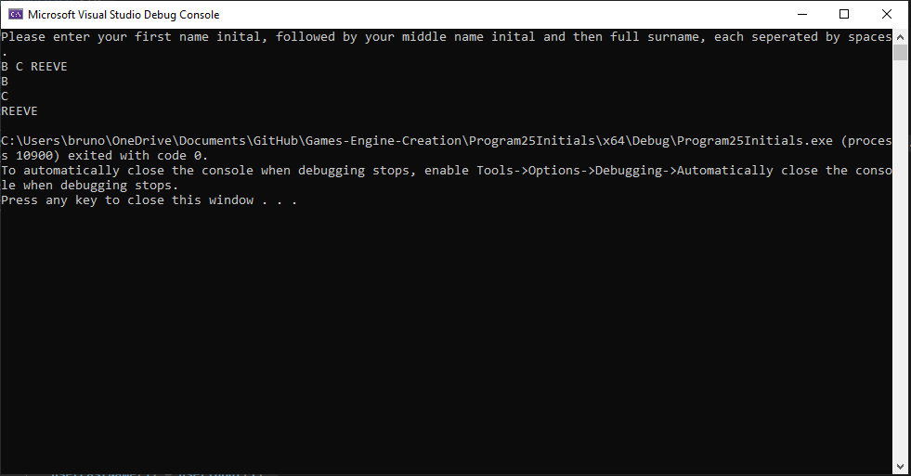

**The String Approach**

The string approach is an alternative way of dealing with a string of characters. Using string you are in fact using an underlying class, which is found in the string header. You must include this header at the top of any source file that uses string. String introduces a host of new functions, some of which are described below, others that you will need to research on your own.

So, to create a variable of string type it is as simple as:

Note: You MUST now use double quotes. Single quotes will create a syntax error.

When using a string type with the console, unlike the char array where you pass the array name and size to the getline function, you instead pass (cin, stringName) like so:



As before by just using cin alone, only characters that come before the first whitespace will be stored.

**Example of Input/Output with Strings**

Create a program and add the following code, run it twice to see what happens with cin and getline.

Note: If you were to create a program where you use cin to take in one word followed by getline to take in numerous words; you would be faced with getline skipping input. This is due to the new line or **endl** not being flushed and counting as an input. There is a number of ways to fix this, with one being to use cin.ignore before getline. You can express what it is to be ignored by the console as a function parameter. The most common being: 

**Example of String Concatenation**

There are a couple of approaches to combining string objects. The first to be shown is the append() function, the second is using operators that have been overloaded such as + and +=.

The above example will result in string1 containing the text “Superman”. The use of operators is shown next, which has the same result.



Alternatively, you could create a new string to hold the result:



**Note:** Overloading Operators refers to changing the functionality of an operator depending on the type being used. For example, int += int results in an int, string += string results in a string.

**Example of String Comparison**

There are also a couple of possible approaches to determining if two string types match. The first is the compare() method, the second is an overloaded == operator. Both examples below will give the same result.

**Example of Swapping Strings**

**<string>** has a function called **swap()** and this allows you to swap the contents of one string for the contents of another.

**Example of Substrings**

Another useful function is the substr(), which allows you to retrieve a particular portion from a string. The first integer parameter is the index in the string to start at, and the second integer parameter is how many characters from the first index.

**Example of Substring – Finding**

At times you will need to locate a particular phrase or character. **<string>** provides functionality for this. There are a few variants of the **find()** function and an example of each is shown below.

To find the location of the first occurrence of a phrase:



To find the location of the first occurrence of a phrase starting at the end of the string, use the rfind() method.



To locate the first / last occurrence of a character from a string you supply use the following examples.

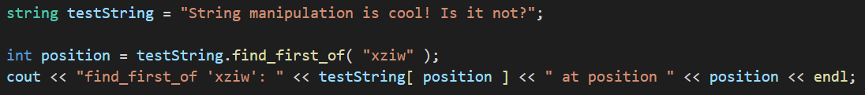

The above example will find a ‘i’ at position 3.

**Example of Substring – Replacing**

If you want to replace a character in a string with a different character then it’s as simple as using the replace() function. You will no doubt need to use the find() function first to locate the position of the character you want to replace. The first integer parameter is the position to start overwriting, the second parameter is how many characters to replace and the third is the string to replace with.

**Example of Substring – Inserting**

Replacing characters in a string is all well and good but what if you need to add some characters? That’s where the insert() function comes in useful.

The above example will result in testString containing “123xx456”.

Note: Before we move onto the string programs for you to implement it is important to note that there are many overloaded versions of the functions covered in this chapter, and a lot of others that have not been covered. It is up to you to do your own research to discover what they are and how they work.

**Program 26: Replacing Characters**

Write a program to prompt the user to enter in a sentence, which is then stored in a variable of type string. Output the string they have entered to the console screen, then replace every occurrence of ‘e’ with an ‘X’.

The program should then output the altered sentence.

**Tips**

* You will need to keep an index of position
* You will need to use a loop to access the characters in the string using the find and replace
* Alternatively, do research on the functions available in the <algorithm> file.

**Program 26 Source Code:**

**Program 26 Screenshot:**

**Program 27: String Manipulation**

Write a program to prompt the user to enter their name, which is then stored in a variable of string data type. Insert their name in between the ‘XX’ in the following string:



Output this string to the console. The program should then remove the two X’s and then output the string to the screen again. (You should have two outputs at this point:

“Do you know who loves C++ XnameX does!” and “Do you know who loves C++ name does!”)

The program should then ask the user to input another name (this one **MUST** longer than the first). The program should then locate the first name in the test string and replace it with the new name.

Output the altered string with the second name in place of the first to the console and screenshot the entire process.

**Tips**

* Store the first and second name in a strings of their own.
* Don’t forget to test for a longer name on the second entry

**Program 27 Source Code:**

**Program 27 Screenshot:**

**Program 28: Strings and Vectors**

Below is the output of a program you have to try and replicate.

The program must:

* Start with an empty vector of string
* Store the user’s choice in the aforementioned vector
* Decide if you are using cin, getline, or both
* Use a loop to ask for items until inventory is full. Set inventory max to 3.
* Give the user the contents of their inventory and replace their choice with the magic ring
* After being robbed you must delete the contents of the inventory and output the contents of the inventory one last time.
* If you are up to the challenge, proof check every entry to ensure no wrong entries. This is not a necessity.

**Program 28 Source Code:**

**Program 28 Screenshot:**

**Program 29: Rock, Paper, Scissors**

Write a game of Rock, Paper, Scissors; where the user is prompted to enter their choice as a string (e.g. Paper or paper) and the computer's choice is generated randomly. The first to score 3 wins, is the overall winner.

At the conclusion of the game your program should output the result (who won) and the scores of both players.

Those not familiar with the game can learn a little about it here (<https://en.wikipedia.org/wiki/Rock-paper-scissors)>

When you have completed your program, take a screen shot of the last three plays and the concluding output (see below for an example).

**Tip**

* Research the use of Rand or Random Device within the <random> file. (Rand will suffice)

**Program 29 Source Code:**

**Program 29 Screenshot:**