End-to-End Data Engineering Solution for HR Analytics
A Databricks-based historical HR data pipeline with interactive web-based analytics dashboard
CSIS 4495 – 050
Jay Clark Bermudez – 300380540
Bruno do Nascimento Beserra – 300392300
Matheus Filipe Figueiredo – 300389657

November 27, 2025

Table of Contents
1 Introduction 5
2 Proposed Research Project 6
2.1 Project Goal and Objectives 6
2.2 Background and Related Work 6
2.3 Methodology 6
2.3.1 System Architecture & Design 6
2.3.2 Data Engineering Pipeline 7
2.3.3 Analytics & Visualization Layer 7
2.4 Technical Requirements 8
3 Project Planning and Timeline 9
3.1 Phase Overview and Milestones 9
3.1.1 Requirement Analysis and Planning 9
3.1.2 System Design and Modeling 9
3.1.3 3.1.3 Implementation and Development 9
3.1.4 Testing and Validation 10
3.1.5 Deployment, Visualization, and Documentation 10
3.2 Weekly Work Plan and Schedule 10
3.3 Member Roles and Responsibilities 11
4 Dataset Creation 12
4.1 Overview of Dataset Creation 12
4.2 Details of Implementation 12
5 Data Engineering Pipeline 14
5.1 Overview of the Data Engineering Pipeline 14
5.2 Databricks 14
5.3 Medallion Architecture 14
5.3.1 Bronze Layer 14
5.3.2 Silver Layer 14
5.3.3 Gold Layer 14
5.4 Slowly Changing Dimensions (Type 2) 15
5.5 Kimball Architecture 15
6 Web Application 16
6.1 Overview of Web Application 16
6.2 Shift from Django to Dash Framework 16
6.3 Initial Web Application using Dash and Plotly 16
6.4 Future Updates (Change this, Notebook to Python script should be added here) 17
7 Other Visualization options (PowerBI and Other Ouputs?) 18
7.1 Power BI 18
7.1.1 Overview 18
7.1.2 Implementation 18
7.2 Tableau 19
7.3 others ????? like CSV and shit 19
8 Lessons Learned and Future Work 20
9 Concluding Remarks 21
10 Acknowledgement 22
11 References 23
12 Appendices 24
Appendix A: Installation Guide 25
A.1 Data Engineering Pipeline 25
A.2 Web Application 25
A.3 Others 25
Appendix B: User Guide 26
B.1 Data Engineering Pipeline 26
B.2 Web Application 26
Appendix C: Dataset and API Used (???) 27
C.1. Dataset 27
C.2 API 27
Appendix D: Hardware, Software, Cloud, Architecture, etc., 28
D.1 Databricks 28
D.2 Python Notebook – jupyter, collab 28
D.3 Python Script – venv 28
D.4 Shoud I also add the Diagrams here? 28
D.5 PowerBI 28
D.6 Tableau 28
Appendix E: Code Explanation (Check Mobile Dev Subtitles) 29
E.1 Data Engineering Pipeline 29
E.2 Web Application 29

Legend for updates:
- Sample Need to be recheck, have some inconsistencies, mistakes, or outdated info after updates
- Sample Need proper literature work or not enough
- Sample Check comment
- Sample

Introduction
This project looks at a challenge with Dayforce, a SaaS platform used to manage HR data like employee information and payroll. The problem is that Dayforce does not keep historical records. When an employee leaves, their data is deleted, and when updates are made, older records are replaced. This makes it hard to do historical analysis, track workforce trends, or study issues like employee turnover (Dayforce, 2024). This is not just a Dayforce issue, but a common limitation with HR SaaS platforms (Solutions, 2025).
Platform3 Solutions (Solutions, 2025) notes that not keeping payroll and HR records can lead to compliance issues, problems during audits, and even legal trouble. They stress that companies need a clear plan for keeping and archiving data so it stays available when needed and costs stay under control.
Research shows that without strong historical archives, companies struggle with workforce planning and decision-making (Madden, 2025). Using data engineering techniques like Slowly Changing Dimensions Type 2 and platforms like Databricks and Delta Lake can fix this problem by allowing data to be captured, stored, and analyzed over time (WJARR, 2025).
To solve this problem, the project will build a data pipeline that automatically collects, processes, and saves historical HR data. The pipeline will run in Databricks, using Python and PySpark for transformations and Delta Lake for reliable storage. On top of this, a web app will be built with Django and React to show the results of the analysis. ADD short details about this. But move whole paragraph in METHODOLOGY

The finished system will help organizations keep and study HR history in a more efficient way. It will make storage use better, allow faster queries, support long-term workforce analysis, and improve decision-making by giving insights that are not possible with the current setup.

Proposed Research Project

Project Goal and Objectives
The goal of this project is to design and implement an end-to-end data engineering solution that preserves and enables analysis of historical HR data. The project addresses a key limitation in current HR data management, where employee records are deleted after termination or overwritten when changes occur, making historical analysis impossible.
To solve this, the team will develop a data pipeline that ingests daily data from Dayforce and applies data engineering techniques such as Slowly Changing Dimensions (Type 2) to track changes over time, the medallion architecture to structure data into quality layers, and Kimball data modelling to reduce redundancy and simplify queries.
The solution will be built in Databricks using Python, PySpark, and Delta Lake, and will be paired with a Power BI dashboard that highlights key workforce metrics. Together, these components will demonstrate how historical HR records can be effectively preserved, organized, and analyzed to support long-term workforce insights. MOVE TO METHODOLOGY

Background and Related Work

Methodology
This study will develop an end-to-end data engineering solution to preserve and manage historical HR data. In the corporate world, businesses typically obtain their HR data from platforms such as Dayforce or other human resource management systems. When reports are needed, this data is often exported as a CSV file and analyzed using visualization tools. Add short version in the INTRO. Since our team does not have direct access to such corporate data, we will use a Kaggle dataset containing information on 2 million employees (Kaggle, 2025), from which we will extract a subset as our sample dataset for this project. This data will be updated monthly, allowing us to track trends over a period of seven years. The pipeline will follow the medallion architecture (Databricks, 2020), with Bronze, Silver, and Gold layers ensuring both quality and traceability.

System Architecture & Design
Figure 2.1 System Architecture
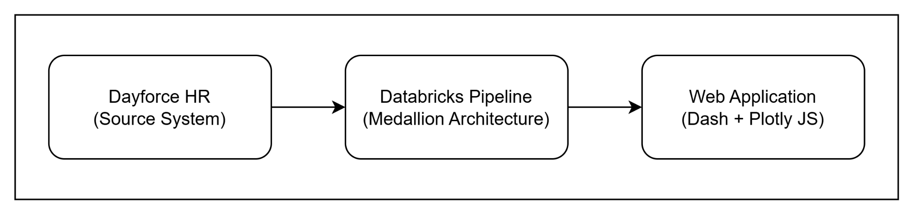
Figure 2.1 shows the overall system architecture. There are three (3) major stages. The raw data from Dayforce will be processed through a Databricks pipeline. Finally, one of the outputs of the system is a CSV file, which will then go through the web application for visualization.

Data Engineering Pipeline
Figure 2.2 Data Engineering Pipeline
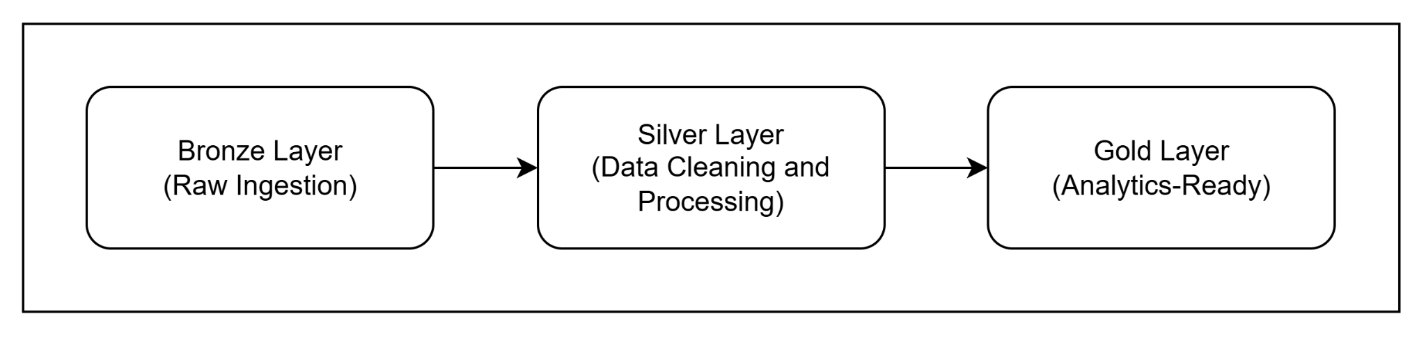

Figure 2.2 shows the data pipeline utilizing Databricks. The process begins with the ingestion of raw employee data from Dayforce (Dayforce, 2020) into the Bronze layer, capturing daily snapshots of the system. Data is then stored in a parquet format. The Silver layer will apply Slowly Changing Dimensions Type 2 (Asanka, 2021) to track historical changes, such as promotions, transfers, or terminations. Data cleaning will address missing values, duplicates, and inconsistent formats, while verifying key identifiers such as employee IDs. Each record will include timestamps and active/inactive flags to maintain historical accuracy.
The Gold layer will structure data for analysis using Kimball modelling (Nguyen, Pham, and Chin, 2020), creating fact and dimension tables to reduce redundancy and simplify queries. Implementation will be carried out in Databricks notebooks with Delta Lake features such as incremental ingestion, schema enforcement, and merge operations to ensure consistency.
Additionally, the output from Gold layer can be readily used for any analytics reports that can be utilized by Tableau, PowerBI, other business needs, and the custom web application developed by the team. This web application will serve as the primary interface for end users to access and explore the visuals.

Analytics & Visualization Layer
Figure 2.3 Web Application Architecture
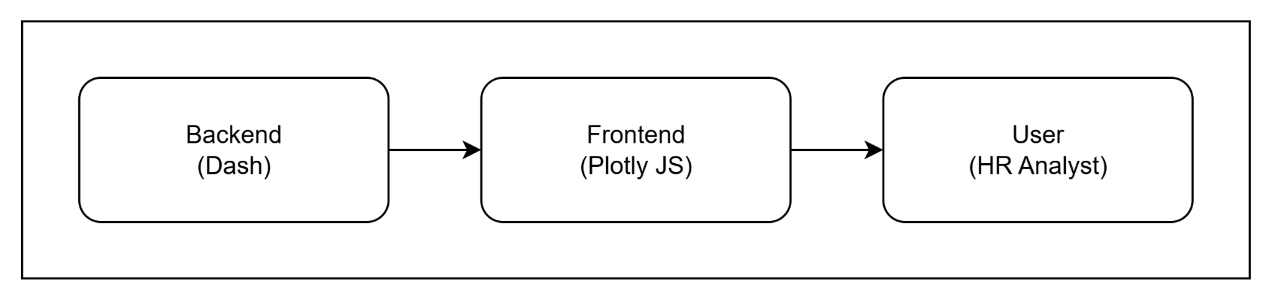
Figure 2.3 presents the architecture of the updated web application that works alongside the output from the data engineering pipeline. The initial design used Django for the backend and ReactJS for the frontend. However, the team decided to transition to Dash, which integrates both backend and frontend functionalities within a single Python framework. This change simplifies development, reduces the need for multiple technologies, and allows smoother interaction with the datasets produced by the Gold layer of the pipeline.
The new application will be developed using Dash and Plotly, which together support interactive, data-driven visualization. Dash manages data handling and user interaction, while Plotly generates dynamic charts and graphs directly from the processed CSV files of the Gold layer. This setup makes it possible to display real-time analytics without relying on separate web technologies.
The dashboards will present key HR metrics such as employee turnover, salary trends by department, experience versus performance, and departmental headcount distribution. Users will be able to filter results, compare values, and explore data through interactive charts, helping managers and analysts identify workforce patterns and make evidence-based decisions.
Development will follow best practices such as version control in Git (Microsoft, 2022) and thorough documentation. This methodology ensures the solution is robust, maintainable, and scalable, providing a framework that supports both current and future HR data analysis needs.

Technical Requirements
Data Platform: Databricks
Data Pipeline and Processing: Delta Lake, Python PySpark
Data Storage: Delta Lake Bronze, Silver, Gold layers
Data Modelling: Kimball dimensional modelling, Slowly Changing Dimensions (Type 2)
Backend: Dash, Python (3.something)
Frontend: Plotly JS
Version Control: Git

Project Planning and Timeline

Phase Overview and Milestones
Figure 3.1 Gantt Chart
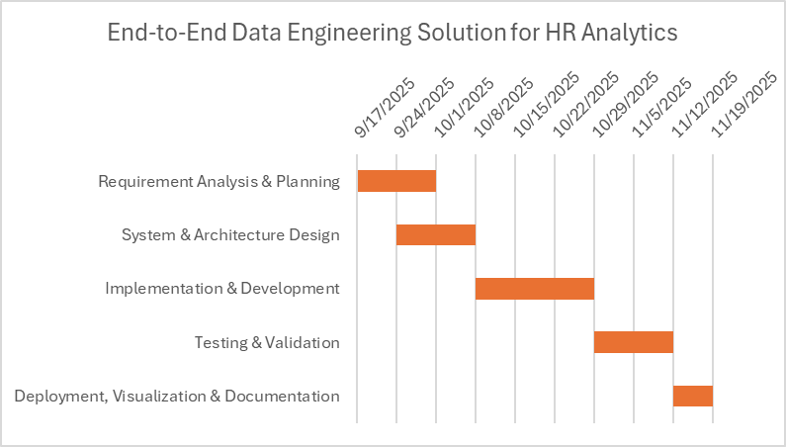

Figure 3.1 shows the Gantt chart, which outlines the five phases of the project: Requirement Analysis, System Design, Implementation, Testing, and Deployment, along with their timelines and dependencies. It shows how the earlier phases provide the foundation for development and testing, which ensures readiness for final deployment.

Requirement Analysis and Planning
The team will assess Dayforce’s data limitations, focusing on record loss after updates or employee exits. From these observations, requirements such as daily ingestion, historical record preservation, and trend analysis will be defined. The scope will outline Databricks, PySpark, Delta Lake, and Django as core tools, with acceptance criteria based on accurate ingestion, retention, and longitudinal querying.

System Design and Modeling
The system will be designed using the medallion architecture with Bronze, Silver, and Gold layers. SCD Type 2 logic will be specified to capture employee history, and Kimball-style modelling will define fact and dimension tables for analysis. Deliverables include schema definitions and a system design document. Additionally, the web application design will be planned, with Dash handling backend processes and Plotly JS enabling interactive dashboards for visualization.

3.1.3 Implementation and Development
A Databricks pipeline will be built to ingest simulated Dayforce data into the Bronze layer, transform and apply SCD Type 2 in the Silver layer, and organize fact/dimension tables in the Gold layer. Delta Lake features such as incremental ingestion, schema enforcement, and merge operations will ensure reliability. The web application will be developed with the backend processing data and the frontend displaying HR metrics such as headcount trends and payroll history.

Testing and Validation
Testing will cover both the pipeline and the web application. Unit tests will confirm that ingestion and transformation processes work correctly, while integration tests will ensure data flows smoothly across all layers. User acceptance testing (UAT) will check that historical records are preserved accurately and that analysis tasks return correct results. The web application will also be tested for responsiveness and accuracy of visualizations.

Deployment, Visualization, and Documentation
The pipeline will be deployed in Databricks and connected to a custom web application for dashboards displaying metrics such as workforce trends, employee retention and turnover, and other key metrics. Final deliverables include technical documentation, versioned code in Git, a project report, and a presentation of the solution.

Weekly Work Plan and Schedule
Phase | Duration | Due Date | Key Deliverables
Requirement Analysis & Planning | 2 weeks | Oct 1 | - Approved project proposal  - Draft use case diagram  - Initial dataset collection and exploration
System Design & Modeling | 2 weeks | Oct 8 | - System architecture design  - Data engineering pipeline design  - Web application architecture design  - UI/UX design  - Draft test cases  - Set up of GitHub repository  - Set up Databricks workspace
Implementation & Development | 3 weeks | Oct 29 | - Databricks ingestion and transformation pipeline  - Lakehouse configuration for Bronze, Silver, Gold layers  - Backend development  - Frontend development  - Unit testing of the pipeline and components
Testing & Validation | 2 weeks | Nov 12 | - Test execution  - Regression testing for pipeline and web app  - Bug tracking and resolution  - Test summary report
Deployment, Visualization & Documentation | 1 week | Nov 19 | - Final pipeline deployment  - Web application deployment  - Project documentation  - Final project presentation and demo

Member Roles and Responsibilities
Jay Clark Bermudez - Project Manager & Back-end Developer
- Coordinate team meetings, progress, and ensure deadlines are met
- Serve as the main point of communication between the team, instructor, and other stakeholders
- Design and implement the backend, frontend APIs for the web application

Bruno do Nascimento Beserra - Data Engineer
- Extract, clean, and transform raw HR data for pipeline integration
- Implement the medallion architecture
- Collaborate with the web developer to align data processing with the system requirements

Matheus Filipe Figueiredo - Front-end Developer & QA/Documentation
- Build the PowerBI and other dashboard used for the midterm and final presentations
- Develop and execute test cases to validate functionality and performance
- Track and document issues, prepare a user guide, and finalize project documentation

Dataset Creation

Overview of Dataset Creation
To showcase the result of the team’s data pipeline, they need an effective way to present it. Since the team did not have access to a dataset containing historical data over time, the team decided to design a realistic simulation environment that captures key workforce dynamics throughout multiple years. This approach allows the team to demonstrate the data pipeline solution built with state-of-the-art techniques.
Initially, the team considered performing an analysis using past data. However, after starting developing the code, the team realized that this approach would add unnecessary complexity to the project, as it would require making hiring dates pass through a complex historical logic. To simplify the process while maintaining realism, the teams instead created a simulation that represents the evolution of a mid-sized company with 5,000 employees over seven years.
Throughout these seven years, employees may experience promotions, change teams, or leave the company. In parallel, the organization continuously hires new employees, using information from the main dataset to maintain a dynamic workforce.
To build this simulation, we defined a set of key metrics to guide the algorithm responsible for generating time-based snapshots. The final output is a structured folder hierarchy following the pattern “data/year/month/file.csv”, effectively mimicking an automated process that fetches daily data from a source.

Details of Implementation
To build this part of the project, we defined a series of steps to complete the process. First, we imported the necessary libraries and the dataset. From there, we began by examining its basic information through an Exploratory Data Analysis (EDA), checking aspects such as data types, null value counts, shape, and statistical summaries. Once we gained a clear understanding of the dataset, we proceeded to the data cleaning stage, where we dropped unnecessary columns, corrected unrealistic values in the annual_salary column, and fixed the data types across the dataset.
After cleaning the data, we created the first snapshot by generating a random sample of 5,000 rows. We used a fixed random seed to ensure reproducibility and added a new column, Job Level, based on each employee’s years of experience. Before finalizing this version of the dataset, we verified that the distribution of employees by job level followed a realistic organizational structure, with fewer employees in higher-level positions, similar to a real-world company.
To generate the historical snapshots, we defined several key metrics representing possible events over time within the company. These included salaries raise percentages, monthly hiring rates, and promotion milestones to capture scenarios where an employee changes departments, leaves the company, earns a promotion, or receives a performance-based bonus. Using these parameters, we generated 84 monthly snapshots of the dataset, simulating seven consecutive years of company history, from October 2025 to September 2032.

Data Engineering Pipeline

Overview of the Data Engineering Pipeline
The data engineering pipeline was implemented using state-of-the-art techniques. To build it, we used Databricks, a widely recognized and commonly used data platform in the industry. We took this project as an opportunity to learn how to use the platform effectively. However, the free version of Databricks presented some limitations, such as not allowing multiple users to collaborate within the same workspace. To address this constraint, each team member worked in a separate workspace, and we synchronized our progress by updating the files through GitHub.
To ensure our data pipeline was robust, we applied several modern techniques, including the Medallion Architecture and Kimball Architecture, with plans to implement Slowly Changing Dimension Type 2 (SCD Type 2) for the final presentation. Based on our research, these methodologies provide data professionals with a clearer and more stable workspace, where data is organized in layers and enriched with metadata to track changes over time. This structured approach allows updates to occur only when necessary, minimizing data duplication and maintaining a clean, consistent environment.

Databricks

Medallion Architecture
Based on the Medallion Architecture, we divided our pipeline into three main folders, which will be described in more detail in the following sections.

Bronze Layer
The bronze layer is where the pipeline starts; its main goal is to fetch the data from the source and read it to import into the bronze layer. Depending on the dynamic of our source, it has a different form to access the data. For our case, we are mimicking it coming from some folder that updates every day, so we run through the CSV files, read them, and append them to our created table.

Silver Layer
In the silver layer, we make our pipeline in a way that we first check our silver data to check what the last data available in it is, and then it only reads the data that it still doesn’t have from bronze. Then, we do a data cleaning in it, renaming columns, checking null values or inconsistencies in the data and implementing the SCD type 2 (in the future). In our pipeline, we already implemented the metadata columns for the dataset.

Gold Layer
Here, we want the data to look exactly like what’s used in our reports and analytics tools. The data has already been cleaned and standardized in the Silver layer; the only step left is to create dimension and fact tables. This makes the data intuitive for business users to understand and query, while also making it easier to add new data marts in the future using the same structured and organized information. The Kimball architecture also helps the data load faster and improves analytics performance. Over time, it’s increasingly adopted because it reduces reliance on IT for every new report or dashboard.

Slowly Changing Dimensions (Type 2)

Kimball Architecture

Web Application

Overview of Web Application
The web application serves as the visualization layer of the HR data pipeline, allowing users to interactively explore workforce insights such as employee turnover, salary distribution, and performance trends. It functions as a prototype dashboard that supports data-driven decision-making through dynamic filtering and visual analytics.
Initially, the team planned to use Power BI for the visualization component. However, considering the project’s scope and the objective of demonstrating end-to-end development, the team chose to build a custom web application instead. This approach provided greater flexibility, deeper integration with the data pipeline, and enhanced control over functionality and design.

Shift from Django to Dash Framework
During the project proposal, the team initially planned to implement the web application using the Django framework for backend development and ReactJS with D3.js for frontend visualization. However, after evaluating the project’s requirements and overall scope, the team concluded that using Django would be excessive for the intended functionality. As a result, the team decided to shift to Dash, a Python-based framework designed for building interactive web applications and dashboards.
Additionally, Dash is highly compatible with PlotlyJS, which our professor strongly recommended and which the team chose to use instead of D3.js for creating data visualizations. Dash also integrates smoothly with Jupyter and other Python notebooks, enabling seamless incorporation into the team’s existing data analysis workflow.
This transition aligned with the project’s main objective of emphasizing data visualization and analysis rather than full-stack web development, making Dash a more efficient, flexible, and suitable framework for the project’s goals.

Initial Web Application using Dash and Plotly
To evaluate the functionality and layout of the web application, the team is currently using a sample HR dataset instead of connecting directly to Databricks. This dataset includes key employee attributes such as department, job title, salary, experience, and performance rating, closely resembling the structure of the processed data from the data pipeline.
The application was fully developed within Jupyter Notebook using several core Dash and Plotly components:
- Plotly Express - to create interactive visualizations such as bar charts, line graphs, and scatter plots.
- Dash Core Components and Dash HTML Components - to design the application layout and interactivity.
- Callbacks - to enable real-time updates and dynamic filtering based on user input.

The initial version of the dashboard included the following visualizations:
- Employee Turnover Rate by Department
- Salary Trend by Department
- Experience vs. Performance Relationship

These visuals were designed to test and validate the dashboard’s structure, interactivity, and usability before integrating it with live data from Databricks. More dashboards will be added on the later updates.

Future Updates (Change this, Notebook to Python script should be added here)
Future iterations of the web application will connect directly to Databricks, enabling real-time visualization of HR metrics stored in the Gold layer of the Medallion Architecture. This integration will replace static CSV files with dynamic data sources, ensuring that the dashboard always reflects the most recent workforce analytics.
However, integrating Dash with Databricks introduces several technical challenges:
- Environment Limitations - Databricks notebooks have restricted support for running interactive web servers such as Dash.
- Port Accessibility - the platform does not natively allow the open HTTP ports required for hosting Dash applications externally.
- Authentication and Security - establishing secure connections to Databricks SQL Warehouses or REST APIs requires proper handling of authentication tokens and cluster permissions.

To address these challenges, future development may involve deploying Dash externally (i.e. on a local device) and connecting it to Databricks through the Databricks SQL Connector. This setup would create a scalable architecture in which Databricks handles data processing while the Dash application functions as an independent visualization service.

Other Visualization options (PowerBI and Other Ouputs?)

Power BI

Overview
For the midterm, we implemented an interactive HR analytics dashboard using Power BI. This feature was designed to visualize and analyze employee data sourced from our gold layer, which was modelled using Kimball’s dimensional architecture. The main objective was to provide a clear and intuitive interface for exploring key workforce metrics and trends.
The dashboard includes multiple layers of analysis, starting with a general overview of the organization’s employee distribution, average salary, and experience. It then progresses into more detailed trend-based visualizations, such as performance ratings over time, hiring patterns by year, and salary progression based on experience. These insights are made accessible through interactive filters and slicers that allow users to drill down by department, job level, and work mode.
This implementation marks a shift from static reporting toward dynamic, user-driven exploration. It reflects our focus on usability and business relevance, ensuring that HR stakeholders can quickly access and interpret the data they need to support strategic decisions.

Implementation
The implementation process began with importing and cleaning the HR dataset directly into Power BI. This step involved organizing key fields such as job level, department, salary, experience, and hire year to ensure consistency and accuracy across all visuals.
But we decided to change after we got the Gold Layer working, so we created a new POWER BI with basically the same visualizations but now with more accurate stuff.
That said, the data was sourced from the gold layer, which had been structured using Kimball’s dimensional modelling approach, allowing for efficient relationships between fact and dimension tables.
Once the data model was established, a series of visuals was created to represent different aspects of the workforce. These included bar charts to show employee distribution by job level and department, line charts to track salary trends over time, pie charts to illustrate employment status breakdowns, and column charts to analyze performance ratings and hire year patterns. Each visual was designed to highlight specific HR metrics while maintaining a clean and readable layout.
Some filters and slicers were added to enable users to explore the data dynamically. These controls allowed for quick, making it easier to uncover targeted insights.
We also decided to use a custom blue color scheme throughout the dashboard to enhance visual consistency and improve readability.
The result is a professional and user-friendly dashboard that supports HR teams in analyzing workforce trends, identifying patterns, and making informed decisions with minimal effort.

Tableau

others ????? like CSV and stuff

Lessons Learned and Future Work
Provide the reflections and important lessons you have learned from your research project, how it is related with your coursework (if any), your future career aspirations and future work that you may carry forward from your applied research work.

Concluding Remarks
Mention:
- Planning done in SE
- Machine Learning
- Special topics
- Business Statistics 1 & 2
- Multimedia Web
- Applied Knowledge Management?
- UI/UX Design
- Data Visualization
- Database 1 & 2
- System Analysis and Design
- OTHERS:
  - Data engineering
  - Reseaching and learning new technologies not in curriculum
    - Databricks
    - Plotly Dash
- Check Program Outline to add more

Acknowledgement
We would like to extend our heartfelt appreciation to Dr. Bambang Sarif for his unwavering support, encouragement, and thoughtful guidance throughout our project journey. His feedback and mentorship greatly helped us refine our ideas, strengthen our proposals, and stay motivated from the initial concept, midterm updates, and final modifications and updates (?)

References
Asanka, D. (2021). Implementing Slowly Changing Dimensions (SCDs) in Data Warehouses. SQLShack. https://www.sqlshack.com/implementing-slowly-changing-dimensions-scds-in-data-warehouses/
Databricks. (2020). Medallion Architecture. Databricks. https://www.databricks.com/glossary/medallion-architecture
Dayforce. (2020). Dayforce Main Website. https://www.dayforce.com/
Dayforce. (2024). Personal Data Retention Policies. https://help.dayforce.com/r/ImplementationGuide/Dayforce-Implementation-Guide/Personal-Data-Retention-Policies
D3 by Observable. (2020). What Is D3? Observable. https://d3js.org/what-is-d3
Django Software Foundation. (2018). Django: The Web Framework for Perfectionists With Deadlines. https://www.djangoproject.com/
HRBrain. (2024). HR SaaS Platform Analytics and Reporting. https://hrbrain.ai/blog/hr-saas-platform-analytics-and-reporting/
Kaggle. (2025). HR Dataset (Multinational Company). Kaggle. https://www.kaggle.com/datasets/rohitgrewal/hr-data-mnc
Madden, S. (2025). Combating Turnover Using People Analytics. ScottMadden. https://www.scottmadden.com/insight/combating-turnover-using-people-analytics/
Microsoft. (2022). What Is Git? Microsoft Learn. https://learn.microsoft.com/en-us/devops/develop/git/what-is-git
Nguyen, H., Pham, H., & Chin, C. (2020). The Analytics Setup Guidebook. Holistics. https://www.holistics.io/books/setup-analytics/
Platform3 Solutions. (2025). Payroll Data Retention Management: How to Do It Right. https://platform3solutions.com/blog/solution-for-keeping-payroll-records-data-retention-compliance/
W3Schools. (2017). React Introduction. W3Schools. https://www.w3schools.com/react/react_intro.asp
World Journal of Advanced Research and Reviews (WJARR). (2025). Developing Scalable HR Analytics Platforms for SMEs With SCD2. https://journalwjarr.com/sites/default/files/fulltext_pdf/WJARR-2025-2920.pdf

Appendices
Please make some additional notes if you think it will help people understand your work. This include information the installation guide, the user guide and anything about the system/software you are using (that the company allow you to share, if you work with a company), datasheet (explanation of) of hardware/components you used (if any), etc.
Appendix A – sample
Appendix B – sample
Appendix C – sample
Appendix D – sample
Appendix E – sample
Appendix F – sample

Appendix A: Installation Guide

A.1 Data Engineering Pipeline
Add GitHub Repo
Import Data
Run Notebooks
Bronze
- Silver
- auto
- gold

A.2 Web Application
Have python installed – Check version (should be 3++)
Clone git repo
Add venv
Activate venv
Install requirements.txt
Run python app.py

A.3 Others
Should I add PowerBI and Tableau here?

Appendix B: User Guide

B.1 Data Engineering Pipeline
Show job here

B.2 Web Application
Screenshot of the web app per graph. Also show trendlines and sample analyses

Appendix C: Dataset and API Used (???)

C.1. Dataset
Check data creation part

C.2 API

databricks-sql-connector>=3.0
python-dotenv>=1.0
statsmodels>=0.14

Appendix D: Hardware, Software, Cloud, Architecture, etc.,

D.1 Databricks

D.2 Python Notebook – jupyter, collab

D.3 Python Script – venv

D.4 Should I also add the Diagrams here? or just wireframes?

D.5 PowerBI

D.6 Tableau

Appendix E: Code Explanation (Check Mobile Dev Subtitles)

E.1 Data Engineering Pipeline
Add all notebooks
Screenshots for each starting code

E.2 Web Application
Screenshots for each section

