Scripts for AT2

Priscilla Soenario

07/10/2019

knitr::opts_knit$set(root.dir = 'C:/Users/pfspl/Documents/R/STDS/STDS-2019')

## Library’s + Data sets imported

library(plyr)  
library(rgdal)

## Loading required package: sp

## rgdal: version: 1.4-4, (SVN revision 833)  
## Geospatial Data Abstraction Library extensions to R successfully loaded  
## Loaded GDAL runtime: GDAL 2.2.3, released 2017/11/20  
## Path to GDAL shared files: C:/Users/pfspl/Documents/R/win-library/3.6/rgdal/gdal  
## GDAL binary built with GEOS: TRUE   
## Loaded PROJ.4 runtime: Rel. 4.9.3, 15 August 2016, [PJ_VERSION: 493]  
## Path to PROJ.4 shared files: C:/Users/pfspl/Documents/R/win-library/3.6/rgdal/proj  
## Linking to sp version: 1.3-1

library(raster)  
library(readxl)  
library(tidyverse)

## -- Attaching packages ------------------------------------------------------------------------------------ tidyverse 1.2.1 --

## v ggplot2 3.2.1 v purrr 0.3.2  
## v tibble 2.1.3 v dplyr 0.8.3  
## v tidyr 0.8.3 v stringr 1.4.0  
## v readr 1.3.1 v forcats 0.4.0

## -- Conflicts --------------------------------------------------------------------------------------- tidyverse_conflicts() --  
## x dplyr::arrange() masks plyr::arrange()  
## x purrr::compact() masks plyr::compact()  
## x dplyr::count() masks plyr::count()  
## x tidyr::extract() masks raster::extract()  
## x dplyr::failwith() masks plyr::failwith()  
## x dplyr::filter() masks stats::filter()  
## x dplyr::id() masks plyr::id()  
## x dplyr::lag() masks stats::lag()  
## x dplyr::mutate() masks plyr::mutate()  
## x dplyr::rename() masks plyr::rename()  
## x dplyr::select() masks raster::select()  
## x dplyr::summarise() masks plyr::summarise()  
## x dplyr::summarize() masks plyr::summarize()

library(tmap)  
library(viridis)

## Loading required package: viridisLite

#Accident data downloaded from VicRoads  
accident <- read.csv("Datasets/Road Crashes/ACCIDENT.csv")  
accident_node <- read.csv("Datasets/Road Crashes/NODE.CSV")  
accident_chainage <- read.csv("Datasets/Road Crashes/ACCIDENT_CHAINAGE.csv")  
accident_event <- read.csv("Datasets/Road Crashes/ACCIDENT_EVENT.csv")  
accident_location <- read.csv("Datasets/Road Crashes/ACCIDENT_LOCATION.csv")  
atmospheric_cond <- read.csv("Datasets/Road Crashes/ATMOSPHERIC_COND.csv")  
node_id_complex_int_id <- read.csv("Datasets/Road Crashes/NODE_ID_COMPLEX_INT_ID.csv")  
person <- read.csv("Datasets/Road Crashes/PERSON.csv")  
road_surface_cond <- read.csv("Datasets/Road Crashes/ROAD_SURFACE_COND.csv")  
subdca <- read.csv("Datasets/Road Crashes/SUBDCA.csv")  
vehicle <- read.csv("Datasets/Road Crashes/VEHICLE.csv")  
  
#Rainfall and accident data combined - manipulated by Bruno  
rainfall_data <- read.csv("Datasets/Climate/Accidents2.csv")  
  
#Rainfall data by year - extracted initially by Bruno  
rain2018 <- read.csv("Datasets/Climate/daily_rain.dfVictoria2018.csv")  
rain2017 <- read.csv("Datasets/Climate/daily_rain.dfVictoria2017.csv")  
rain2016 <- read.csv("Datasets/Climate/daily_rain.dfVictoria2016.csv")  
rain2015 <- read.csv("Datasets/Climate/daily_rain.dfVictoria2015.csv")  
rain2014 <- read.csv("Datasets/Climate/daily_rain.dfVictoria2014.csv")  
rain2013 <- read.csv("Datasets/Climate/daily_rain.dfVictoria2013.csv")  
  
#Population dataset  
population <- read_xls("Datasets/Population/victoria_population_by_LGA_2011-18.xls" , skip = 8)

## Warning in read_fun(path = enc2native(normalizePath(path)), sheet_i =  
## sheet, : Expecting numeric in A3837 / R3837C1: got 'Note: Boundaries as at  
## LGA 2018'

## Warning in read_fun(path = enc2native(normalizePath(path)), sheet_i =  
## sheet, : Expecting numeric in A3839 / R3839C1: got '-'

## Warning in read_fun(path = enc2native(normalizePath(path)), sheet_i =  
## sheet, : Expecting numeric in A3841 / R3841C1: got 'Â© Commonwealth of  
## Australia 2019'

## New names:  
## * `%` -> `%...4`  
## * `%` -> `%...5`  
## * `%` -> `%...6`  
## * `%` -> `%...7`  
## * `%` -> `%...8`  
## * ... and 98 more problems

#Maps  
vic_state_map <- readOGR(dsn = ("Datasets/Shapefiles/VIC_STATE_POLYGON/VIC_STATE_POLYGON_shp.shp"))

## OGR data source with driver: ESRI Shapefile   
## Source: "C:\Users\pfspl\Documents\R\STDS\STDS-2019\Datasets\Shapefiles\VIC_STATE_POLYGON\VIC_STATE_POLYGON_shp.shp", layer: "VIC_STATE_POLYGON_shp"  
## with 346 features  
## It has 8 fields

vic_lga_map <- readOGR(dsn = ("Datasets/Shapefiles/VIC_LGA_POLYGON_shp/VIC_LOCALITY_POLYGON_shp.shp"))

## OGR data source with driver: ESRI Shapefile   
## Source: "C:\Users\pfspl\Documents\R\STDS\STDS-2019\Datasets\Shapefiles\VIC_LGA_POLYGON_shp\VIC_LOCALITY_POLYGON_shp.shp", layer: "VIC_LOCALITY_POLYGON_shp"  
## with 92 features  
## It has 10 fields

TR_ROAD <- readOGR(dsn = ("Datasets/Shapefiles/SDM644761/ll_gda2020/shape/whole_of_dataset/vic/VMTRANS/TR_ROAD.shp"))

## Mapping Victoria

Due to the size of the Roads shapefile, a smaller shapefile of the highways and freeways of Victoria was extracted.

#only highwas and freeways in shapefile  
TR_HIGHWAY_FREEWAY <- TR_ROAD[TR_ROAD@data$ROAD_TYPE == "HIGHWAY" | TR_ROAD@data$ROAD_TYPE == "FREEWAY" ,]  
  
#extract the highways and freeways shapefile  
writeOGR(obj = TR_HIGHWAY_FREEWAY, dsn = "Datasets/Shapefiles", layer = "VIC_HIGHWAYS_FREEWAYS", driver = "ESRI Shapefile")

#Highways and freeways shapefile  
vic_highway <- readOGR(dsn = "Datasets/Shapefiles/VIC_HIGHWAYS_FREEWAYS.shp")

## OGR data source with driver: ESRI Shapefile   
## Source: "C:\Users\pfspl\Documents\R\STDS\STDS-2019\Datasets\Shapefiles\VIC_HIGHWAYS_FREEWAYS.shp", layer: "VIC_HIGHWAYS_FREEWAYS"  
## with 26566 features  
## It has 49 fields

#Only highways and freeways within the Victoria borders  
vic_highways_freeways <- raster::intersect(vic_highway,vic_state_map)  
  
#change polygon for reading into ggplot  
vic_state_df <- fortify(vic_state_map)

## Regions defined for each Polygons

vic_lga_map_df <- fortify(vic_lga_map)

## Regions defined for each Polygons

#Create ggplot map of Victoria  
ggplot()+  
 geom_polygon(data = vic_lga_map_df, aes(x=long, y=lat, group=group),colour = "light coral", fill = NA)+  
 geom_polygon(data = vic_state_df, aes(x=long,y=lat, group=group), colour = "black", fill = NA)+  
 geom_path(data = vic_highways_freeways, aes(x=long,y=lat, group = group), colour = "slate gray")+  
 theme_classic()+  
 coord_equal()+  
 labs(x = NULL,  
 y = NULL)+  
 ggtitle("State of Victoria", subtitle = "LGA's and Major roads")+  
 theme(plot.title = element_text(hjust = 0.5),  
 plot.subtitle = element_text(hjust = 0.5))

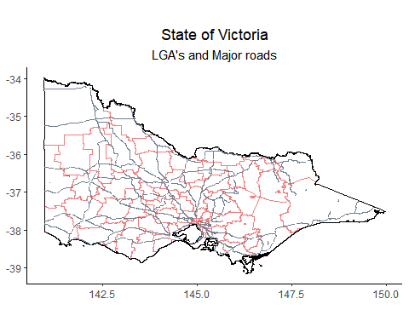

### Map Accidents

crash_locations <- left_join(accident, accident_node, by="ACCIDENT_NO" )

## Warning: Column `ACCIDENT_NO` joining factors with different levels,  
## coercing to character vector

crash_locations_1 <- crash_locations %>%  
 filter(SEVERITY == 1)  
  
ggplot()+  
 geom_polygon(data = vic_state_df, aes(x=long,y=lat, group=group), colour = "black", fill = "white")+  
 geom_point(data = crash_locations_1, aes(x = Long, y = Lat), colour = "deep pink",size = 0.5)+  
 theme_bw()+  
 ggtitle("Fatalities Across Victoria - 2006-19")

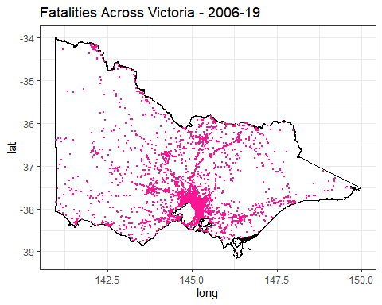

### Check Rainfall for each day to ensure average rainfall correct

rain2013$YEAR<-2013  
rain2014$YEAR<-2014  
rain2015$YEAR<-2015  
rain2016$YEAR<-2016  
rain2017$YEAR<-2017  
rain2018$YEAR<-2018  
  
rain2013_18 <- rbind(rain2013,rain2014,rain2015, rain2016, rain2017, rain2018)  
  
rain_count <- ddply(rain2013_18, .(YEAR, LONG, LAT), summarise, count = length(RAINFALL))  
  
head(rain_count)

## YEAR LONG LAT count  
## 1 2013 141 -38.05 365  
## 2 2013 141 -38.00 365  
## 3 2013 141 -37.95 365  
## 4 2013 141 -37.90 365  
## 5 2013 141 -37.85 365  
## 6 2013 141 -37.80 365

tail(rain_count)

## YEAR LONG LAT count  
## 54964 2018 149.70 -37.50 365  
## 54965 2018 149.70 -37.45 365  
## 54966 2018 149.70 -37.40 365  
## 54967 2018 149.75 -37.55 365  
## 54968 2018 149.75 -37.50 365  
## 54969 2018 149.75 -37.45 365

### Map Annual Average Rainfall and accidents

#Average annual rainfall for each latitude and longitude  
rain_avg_2018 <- rain2018 %>%  
 group_by(LONG,LAT) %>%  
 dplyr::summarize(Mean = mean(RAINFALL))  
  
crash_locations <- left_join(accident, accident_node, by="ACCIDENT_NO" )

## Warning: Column `ACCIDENT_NO` joining factors with different levels,  
## coercing to character vector

crash_locations <- separate(crash_locations,"ACCIDENTDATE",c("DAY", "MONTH", "YEAR"), remove = FALSE)  
  
#2018 accidents  
accident_2018 <- crash_locations %>%   
 filter(YEAR == "2018")  
  
ggplot() +   
 geom_raster(data = rain_avg_2018, aes(x=rain_avg_2018$LONG, y = rain_avg_2018$LAT, fill=Mean)) +   
 scale_fill_viridis(direction = -1, name = "Avg. Rainfall (mm)") +  
 geom_polygon(data = vic_state_df, aes(x=long,y=lat, group=group), colour = "black", fill = NA)+  
 geom_point(data = accident_2018, aes(x = Long, y = Lat), colour = "red", alpha = 0.5, size = 0.5)+  
 geom_path(data = vic_highways_freeways, aes(x=long,y=lat, group = group), colour = "slate gray")+  
 theme_classic()+  
 coord_equal()+  
 ggtitle("Road Accidents and Average Rainfall - 2018")+  
 labs(x = NULL,  
 y = NULL)+  
 theme(plot.title = element_text(hjust = 0.5))

## Warning: Removed 8 rows containing missing values (geom_point).

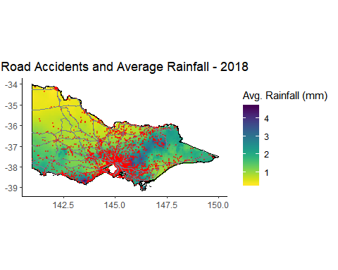

## Accidents by LGA

accidents_by_LGA <- ddply(accident_node, .(Lga.Name.All), summarise, accident_count = length(ACCIDENT_NO))  
  
accident_by_LGA_1 <- accidents_by_LGA %>%  
 separate(Lga.Name.All,c("VIC_LGA__3","LGA_2"),sep = ",")

## Warning: Expected 2 pieces. Additional pieces discarded in 14 rows [42, 87,  
## 88, 108, 110, 131, 135, 164, 171, 195, 202, 217, 219, 224].

## Warning: Expected 2 pieces. Missing pieces filled with `NA` in 85 rows [1,  
## 3, 4, 5, 6, 7, 8, 9, 10, 11, 12, 13, 14, 15, 16, 17, 18, 19, 20, 23, ...].

glimpse(accident_by_LGA_1)

## Observations: 230  
## Variables: 3  
## $ VIC_LGA__3 <chr> "(FALLS CREEK)", "(FALLS CREEK)", "(FRENCH ISLA...  
## $ LGA_2 <chr> NA, "ALPINE", NA, NA, NA, NA, NA, NA, NA, NA, N...  
## $ accident_count <int> 25, 1, 2, 21, 12, 26, 53, 2, 698, 379, 3206, 26...

#rename LGA's to summarise  
accident_by_LGA_1[1:2,"VIC_LGA__3"]<- "FALLS CREEK ALPINE RESORT (UNINC)"  
accident_by_LGA_1[3,"VIC_LGA__3"]<- "FRENCH-ELIZABETH-SANDSTONE ISLANDS (UNINC)"  
accident_by_LGA_1[4,"VIC_LGA__3"]<- "LAKE MOUNTAIN ALPINE RESORT (UNINC)"  
accident_by_LGA_1[5,"VIC_LGA__3"]<- "MOUNT BAW BAW ALPINE RESORT (UNINC)"  
accident_by_LGA_1[6,"VIC_LGA__3"]<- "MOUNT BULLER ALPINE RESORT (UNINC)"  
accident_by_LGA_1[7,"VIC_LGA__3"]<- "MOUNT HOTHAM ALPINE RESORT (UNINC)"  
accident_by_LGA_1[8,"VIC_LGA__3"]<- "MOUNT STIRLING ALPINE RESORT (UNINC)"  
accident_by_LGA_2 <- ddply(accident_by_LGA_1, .(VIC_LGA__3), summarise, accident_by_LGA = sum(accident_count))  
glimpse(accident_by_LGA_2)

## Observations: 86  
## Variables: 2  
## $ VIC_LGA__3 <chr> "ALPINE", "ARARAT", "BALLARAT", "BANYULE", "BA...  
## $ accident_by_LGA <int> 698, 379, 3206, 2649, 990, 2139, 2207, 522, 34...

#join to shapefile  
vic_lga_map_1 <- vic_lga_map   
vic_lga_map_1@data <-left_join(vic_lga_map_1@data,accident_by_LGA_2,by = "VIC_LGA__3")

## Warning: Column `VIC_LGA__3` joining factor and character vector, coercing  
## into character vector

head(vic_lga_map_1)

## LG_PLY_PID DT_CREATE DT_RETIRE LGA_PID VIC_LGA_sh VIC_LGA__1  
## 1 452 2017/09/08 <NA> VIC245 2017/09/08 <NA>  
## 2 465 2017/09/08 <NA> VIC246 2017/09/08 <NA>  
## 3 475 2017/09/08 <NA> VIC231 2017/09/08 <NA>  
## 4 480 2017/09/08 <NA> VIC226 2017/09/08 <NA>  
## 5 481 2017/09/08 <NA> VIC227 2017/09/08 <NA>  
## 6 484 2017/09/08 <NA> VIC230 2017/09/08 <NA>  
## VIC_LGA__2  
## 1 FALLS CREEK ALPINE RESORT (UNINCORPORATED)  
## 2 MOUNT BULLER ALPINE RESORT (UNINCORPORATED)  
## 3 CORANGAMITE SHIRE  
## 4 KINGSTON CITY  
## 5 FRANKSTON CITY  
## 6 GOLDEN PLAINS SHIRE  
## VIC_LGA__3 VIC_LGA__4 VIC_LGA__5 accident_by_LGA  
## 1 FALLS CREEK ALPINE RESORT (UNINC) <NA> 2 26  
## 2 MOUNT BULLER ALPINE RESORT (UNINC) <NA> 2 26  
## 3 CORANGAMITE <NA> 2 648  
## 4 KINGSTON <NA> 2 4658  
## 5 FRANKSTON <NA> 2 3653  
## 6 GOLDEN PLAINS <NA> 2 783

vic_lga_map_1@data[["accident_by_LGA"]][is.na(vic_lga_map_1@data[["accident_by_LGA"]])]<- 0  
  
#quick map  
qtm(vic_lga_map_1, fill = "accident_by_LGA")

## Linking to GEOS 3.6.1, GDAL 2.2.3, PROJ 4.9.3

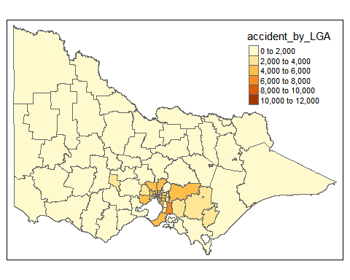

### Fatalities and Severe Injuries by LGA

death_by_LGA <- left_join(accident,accident_node,by = "ACCIDENT_NO")

## Warning: Column `ACCIDENT_NO` joining factors with different levels,  
## coercing to character vector

#Summarise  
death_by_LGA1 <- ddply(death_by_LGA, .(Lga.Name.All), summarise, death_count = sum(NO_PERSONS_KILLED), injury_2 = sum(NO_PERSONS_INJ_2))  
glimpse(death_by_LGA1)

## Observations: 231  
## Variables: 3  
## $ Lga.Name.All <fct> "(FALLS CREEK)", "(FALLS CREEK),ALPINE", "(FRENCH...  
## $ death_count <int> 1, 0, 1, 0, 1, 1, 3, 0, 23, 17, 54, 27, 30, 73, 2...  
## $ injury_2 <int> 14, 0, 2, 13, 4, 7, 27, 0, 350, 212, 1055, 882, 5...

death_by_LGA2 <- death_by_LGA1 %>%  
 separate(Lga.Name.All,c("VIC_LGA__3","LGA_2"),sep = ",")

## Warning: Expected 2 pieces. Additional pieces discarded in 14 rows [42, 87,  
## 88, 108, 110, 131, 135, 164, 171, 195, 202, 217, 219, 224].

## Warning: Expected 2 pieces. Missing pieces filled with `NA` in 85 rows [1,  
## 3, 4, 5, 6, 7, 8, 9, 10, 11, 12, 13, 14, 15, 16, 17, 18, 19, 20, 23, ...].

#rename LGA's to summarise  
death_by_LGA2[1:2,"VIC_LGA__3"]<- "FALLS CREEK ALPINE RESORT (UNINC)"  
death_by_LGA2[3,"VIC_LGA__3"]<- "FRENCH-ELIZABETH-SANDSTONE ISLANDS (UNINC)"  
death_by_LGA2[4,"VIC_LGA__3"]<- "LAKE MOUNTAIN ALPINE RESORT (UNINC)"  
death_by_LGA2[5,"VIC_LGA__3"]<- "MOUNT BAW BAW ALPINE RESORT (UNINC)"  
death_by_LGA2[6,"VIC_LGA__3"]<- "MOUNT BULLER ALPINE RESORT (UNINC)"  
death_by_LGA2[7,"VIC_LGA__3"]<- "MOUNT HOTHAM ALPINE RESORT (UNINC)"  
death_by_LGA2[8,"VIC_LGA__3"]<- "MOUNT STIRLING ALPINE RESORT (UNINC)"  
  
death_by_LGA_3 <- ddply(death_by_LGA2, .(VIC_LGA__3), summarise, death_LGA = sum(death_count), inj_2 = sum(injury_2))  
glimpse(death_by_LGA_3)

## Observations: 87  
## Variables: 3  
## $ VIC_LGA__3 <chr> "ALPINE", "ARARAT", "BALLARAT", "BANYULE", "BASS CO...  
## $ death_LGA <int> 23, 17, 54, 27, 30, 73, 29, 35, 87, 49, 84, 30, 56,...  
## $ inj_2 <int> 350, 212, 1055, 882, 506, 906, 919, 276, 1311, 1562...

vic_lga_map2 <- vic_lga_map  
VIC_LGA_df <- as.data.frame(vic_lga_map)  
  
#Test join with dataframes  
VIC_LGA_df2 <- left_join(VIC_LGA_df,death_by_LGA_3,by= "VIC_LGA__3")

## Warning: Column `VIC_LGA__3` joining factor and character vector, coercing  
## into character vector

VIC_LGA_df2[c("death_LGA","inj_2")][is.na(VIC_LGA_df2[c("death_LGA","inj_2")])]<- 0  
glimpse(VIC_LGA_df2)

## Observations: 92  
## Variables: 12  
## $ LG_PLY_PID <fct> 452, 465, 475, 480, 481, 484, 491, 492, 493, 502, 5...  
## $ DT_CREATE <fct> 2017/09/08, 2017/09/08, 2017/09/08, 2017/09/08, 201...  
## $ DT_RETIRE <fct> NA, NA, NA, NA, NA, NA, NA, NA, NA, NA, NA, NA, NA,...  
## $ LGA_PID <fct> VIC245, VIC246, VIC231, VIC226, VIC227, VIC230, VIC...  
## $ VIC_LGA_sh <fct> 2017/09/08, 2017/09/08, 2017/09/08, 2017/09/08, 201...  
## $ VIC_LGA__1 <fct> NA, NA, NA, NA, NA, NA, NA, NA, NA, NA, NA, NA, NA,...  
## $ VIC_LGA__2 <fct> FALLS CREEK ALPINE RESORT (UNINCORPORATED), MOUNT B...  
## $ VIC_LGA__3 <chr> "FALLS CREEK ALPINE RESORT (UNINC)", "MOUNT BULLER ...  
## $ VIC_LGA__4 <fct> NA, NA, NA, NA, NA, NA, NA, NA, NA, NA, NA, NA, NA,...  
## $ VIC_LGA__5 <fct> 2, 2, 2, 2, 2, 2, 2, 2, 2, 2, 2, 2, 2, 2, 2, 2, 2, ...  
## $ death_LGA <dbl> 1, 1, 44, 65, 55, 40, 71, 32, 19, 38, 31, 16, 35, 3...  
## $ inj_2 <dbl> 14, 7, 388, 1861, 1634, 481, 538, 323, 300, 1415, 9...

#Join to shapefile  
vic_lga_map2@data <-left_join(vic_lga_map2@data,death_by_LGA_3,by = "VIC_LGA__3")

## Warning: Column `VIC_LGA__3` joining factor and character vector, coercing  
## into character vector

vic_lga_map2@data[["death_LGA"]][is.na(vic_lga_map@data[["death_LGA"]])]<- 0  
vic_lga_map2@data[["inj_2"]][is.na(vic_lga_map@data[["inj_2"]])]<- 0  
  
#quick map  
qtm(vic_lga_map2, fill = "death_LGA")

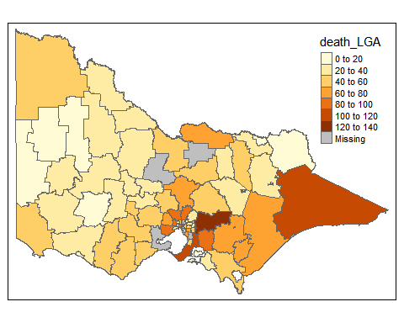

qtm(vic_lga_map2, fill = "inj_2")

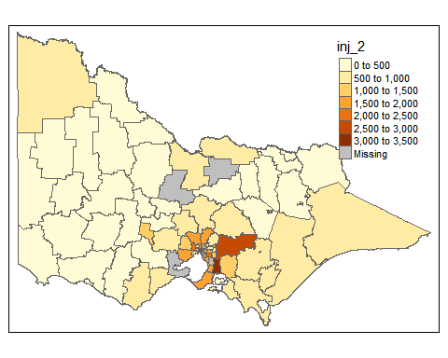

### Accidents by year

#Separate day, month and year  
accident_sep <- separate(accident,"ACCIDENTDATE",c("DAY", "MONTH", "YEAR"), remove = FALSE)  
  
#merge to get LGA and accident  
person_by_LGA <- left_join(person,accident_node,by = "ACCIDENT_NO")

## Warning: Column `ACCIDENT_NO` joining factors with different levels,  
## coercing to character vector

person_by_LGA <- left_join(person_by_LGA,accident_sep,by = "ACCIDENT_NO")

## Warning: Column `ACCIDENT_NO` joining character vector and factor, coercing  
## into character vector

#summarise accidents by LGA  
summary_by_LGA <- ddply(person_by_LGA, .(Lga.Name.All,YEAR, SEX, Road.User.Type.Desc,Inj.Level.Desc), summarise, count = length(ACCIDENT_NO))  
glimpse(summary_by_LGA)

## Observations: 38,236  
## Variables: 6  
## $ Lga.Name.All <fct> (FALLS CREEK), (FALLS CREEK), (FALLS CREEK...  
## $ YEAR <chr> "2006", "2008", "2008", "2008", "2008", "2...  
## $ SEX <fct> M, F, F, F, M, M, M, M, F, M, M, M, M, M, ...  
## $ Road.User.Type.Desc <fct> Motorcyclists, Passengers, Passengers, Ped...  
## $ Inj.Level.Desc <fct> Other injury, Not injured, Other injury, O...  
## $ count <int> 1, 1, 2, 2, 1, 1, 4, 1, 1, 1, 1, 1, 1, 1, ...

summary_by_LGA2 <- summary_by_LGA %>%  
 separate(Lga.Name.All,c("VIC_LGA__3","LGA_2"),sep = ",")

## Warning: Expected 2 pieces. Additional pieces discarded in 230 rows [9676,  
## 9677, 9678, 9679, 9680, 9681, 9682, 9683, 9684, 9685, 9686, 9687, 9688,  
## 9689, 9690, 9691, 9692, 9693, 9694, 17422, ...].

## Warning: Expected 2 pieces. Missing pieces filled with `NA` in 30565  
## rows [1, 2, 3, 4, 5, 6, 7, 8, 9, 10, 11, 12, 13, 14, 15, 16, 17, 18, 19,  
## 20, ...].

#rename LGA's to summarise  
summary_by_LGA2[1:49,"VIC_LGA__3"]<- "FALLS CREEK ALPINE RESORT (UNINC)"  
summary_by_LGA2[50:55,"VIC_LGA__3"]<- "FRENCH-ELIZABETH-SANDSTONE ISLANDS (UNINC)"  
summary_by_LGA2[56:79,"VIC_LGA__3"]<- "LAKE MOUNTAIN ALPINE RESORT (UNINC)"  
summary_by_LGA2[80:100,"VIC_LGA__3"]<- "MOUNT BAW BAW ALPINE RESORT (UNINC)"  
summary_by_LGA2[101:141,"VIC_LGA__3"]<- "MOUNT BULLER ALPINE RESORT (UNINC)"  
summary_by_LGA2[142:213,"VIC_LGA__3"]<- "MOUNT HOTHAM ALPINE RESORT (UNINC)"  
summary_by_LGA2[214:217,"VIC_LGA__3"]<- "MOUNT STIRLING ALPINE RESORT (UNINC)"  
  
summary_by_LGA2 <- summary_by_LGA2 %>% select(-"LGA_2")  
  
summary_by_LGA3 <- ddply(summary_by_LGA2, .(VIC_LGA__3,YEAR,Inj.Level.Desc), summarise, count_LGA = sum(count))  
glimpse(summary_by_LGA3)

## Observations: 4,443  
## Variables: 4  
## $ VIC_LGA__3 <chr> "ALPINE", "ALPINE", "ALPINE", "ALPINE", "ALPINE...  
## $ YEAR <chr> "2006", "2006", "2006", "2007", "2007", "2007",...  
## $ Inj.Level.Desc <fct> Not injured, Other injury, Serious injury, Fata...  
## $ count_LGA <int> 23, 35, 35, 1, 18, 43, 30, 2, 12, 33, 18, 5, 14...

#2018 subset  
fatal_2018 <- summary_by_LGA3 %>%  
 filter(YEAR==2018)  
  
fatal_2018_map <- vic_lga_map  
  
fatal_2018 <- fatal_2018 %>%  
 spread(key = "Inj.Level.Desc", value = "count_LGA")  
fatal_2018_map@data <- left_join(fatal_2018_map@data,fatal_2018,by = "VIC_LGA__3")

## Warning: Column `VIC_LGA__3` joining factor and character vector, coercing  
## into character vector

#map by fatalities and year  
tmap_mode ("plot")

## tmap mode set to plotting

tm_shape(fatal_2018_map)+  
 tm_polygons(c("Fatality","Serious injury","Other injury"))+  
 tm_layout(main.title = "2018 Accidents - Injury Severity")+  
 tm_legend(legend.position = c("right","top"))

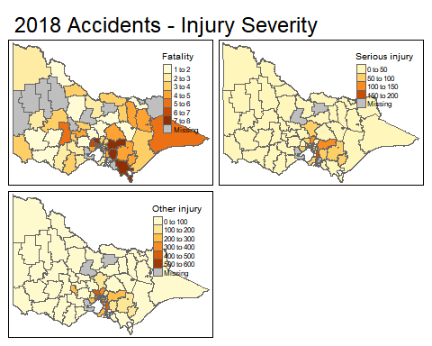

## Driver Fatility by sex and age

person_1 <- person %>%  
 filter(!(Age.Group %in% "unknown")) %>%  
 filter(INJ_LEVEL == 1|INJ_LEVEL == 2) %>%   
 filter(Road.User.Type.Desc == "Drivers") %>%   
 filter(Age.Group != "5-12") %>%   
 filter(SEX != "U")  
  
ggplot(person_1) +  
 aes(x = Age.Group, fill = SEX) +  
 geom_bar() +  
 theme_classic()+  
 ggtitle("Driver Fatalities by Age Group and Gender")+  
 theme(plot.title = element_text(hjust = 0.5))+  
 facet_wrap(~SEX)

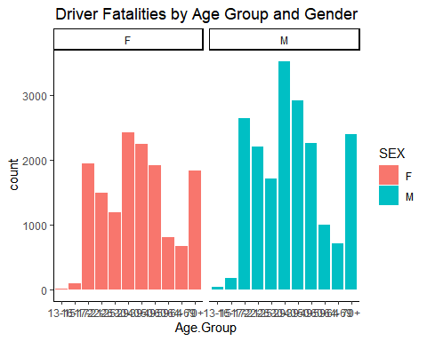

## Light Condition Heat tiles

accident_1 <- accident  
  
#Rename light conditions  
accident_1$LIGHT_CONDITION [accident_1$LIGHT_CONDITION == "1"] <- "Day"   
accident_1$LIGHT_CONDITION [accident_1$LIGHT_CONDITION == "2"] <- "Dusk/Dawn"   
accident_1$LIGHT_CONDITION [accident_1$LIGHT_CONDITION == "3"] <- "Night"   
accident_1$LIGHT_CONDITION [accident_1$LIGHT_CONDITION == "4"] <- "Night"   
accident_1$LIGHT_CONDITION [accident_1$LIGHT_CONDITION == "5"] <- "Night"   
accident_1$LIGHT_CONDITION [accident_1$LIGHT_CONDITION == "6"] <- "Night"   
  
accident_1$SEVERITY<- as.factor(accident_1$SEVERITY)  
  
#Light severity for the person's injured  
accident_2 <- left_join(person,accident_1, by = "ACCIDENT_NO")  
  
#Summarise the injuries in each light condition  
accident_3 <- ddply(accident_2, .(LIGHT_CONDITION,Road.User.Type.Desc, INJ_LEVEL), summarise, No_People = length(ACCIDENT_NO))  
  
#Summarise injury levels for each road user  
accident_4 <- ddply(accident_2, .(Road.User.Type.Desc, INJ_LEVEL), summarise, No_Population = length(ACCIDENT_NO))  
  
#Join the   
accident_5<- left_join(accident_3,accident_4, by = c("Road.User.Type.Desc","INJ_LEVEL"))  
  
#create proportions to create the tiles  
accident_5$portion <- accident_5$No_People/accident_5$No_Population*100  
  
#Remove non-injury accidents, unknown light conditions and unknown road users  
accident_6 <- accident_5 %>%  
 filter(!(LIGHT_CONDITION %in% "9")) %>%  
 filter(!(Road.User.Type.Desc %in%   
 "Unknown")) %>%  
 filter(INJ_LEVEL >= 1 & INJ_LEVEL <= 3.02)  
  
#Rename fatality levels  
accident_6$INJ_LEVEL [accident_6$INJ_LEVEL == "1"] <- "Fatality"  
accident_6$INJ_LEVEL [accident_6$INJ_LEVEL == "2"] <- "Serious Injury"  
accident_6$INJ_LEVEL [accident_6$INJ_LEVEL == "3"] <- "Minor Injury"  
  
#create heat tiles  
ggplot(accident_6) +  
 aes(x = LIGHT_CONDITION, y = Road.User.Type.Desc, fill = portion) +  
 geom_tile(size = 1L) +  
 scale_fill_distiller(palette = "RdYlGn") +  
 labs(x = "Light Condition", y = "Road User", title = "Proportion of Road User Injury Severity in Different Light Conditions", fill = "Proportion of Road User by Severity") +  
 theme_classic() +  
 theme(legend.position = "bottom") +  
 facet_wrap(vars(INJ_LEVEL))+  
 theme(plot.title = element_text(hjust = 0.5))

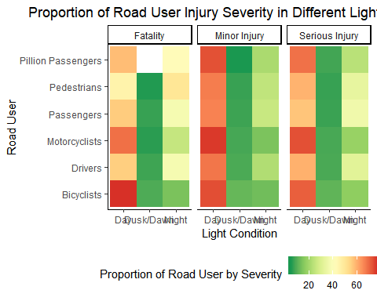

## Population Density

#Cleaning Population data  
#START BRUNO's CODE  
population <- population[,c(1,2,3,69,78)]  
colnames(population)[colnames(population)=="no....69"] <- "TOTAL_POPULATION"  
colnames(population)[colnames(population)=="LABEL"] <- "LGA"  
colnames(accident)[colnames(accident)=="LGA_NAME"] <- "LGA"  
for (i in 1:length(colnames(population))) {  
 colnames(population)[i] = toupper(colnames(population)[i])  
}  
  
  
population[population=="Greater Dandenong (C)"] <- "DANDENONG"  
population[population=="Casey (C)"] <- "CASEY"  
population[population=="Mornington Peninsula (S)"] <- "MORNINGTON PENINSULA"  
population[population=="Greater Dandenong (C)"] <- "DANDENONG"  
population[population=="Baw Baw (S)"] <- "BAW BAW"  
population[population=="Frankston (C)"] <- "FRANKSTON"  
population[population=="Wyndham (C)"] <- "WYNDHAM"  
population[population=="East Gippsland (S)"] <- "EAST GIPPSLAND"  
population[population=="Latrobe (C) (Vic.)"] <- "LATROBE"  
population[population=="Bass Coast (S)"] <- "BASS COAST"  
population[population=="Greater Geelong (C)"] <- "GEELONG"  
population[population=="Stonnington (C)"] <- "STONNINGTON"  
population[population=="Gannawarra (S)"] <- "GANNAWARRA"  
population[population=="Cardinia (S)"] <- "CARDINIA"  
population[population=="Glen Eira (C)"] <- "GLEN EIRA"  
population[population=="South Gippsland (S)"] <- "SOUTH GIPPSLAND"  
population[population=="Manningham (C)"] <- "MANNINGHAM"  
population[population=="Moreland (C)"] <- "MORELAND"  
population[population=="Wellington (S)"] <- "WELLINGTON"  
population[population=="Buloke (S)"] <- "BULOKE"  
population[population=="Melton (C)"] <- "MELTON"  
population[population=="Hobsons Bay (C)"] <- "HOBSONS BAY"  
population[population=="Melbourne (C)"] <- "MELBOURNE"  
population[population=="Strathbogie (S)"] <- "STRATHBOGIE"  
population[population=="Maribyrnong (C)"] <- "MARIBYRNONG"  
population[population=="Macedon Ranges (S)"] <- "MACEDON RANGES"  
population[population=="Brimbank (C)"] <- "BRIMBANK"  
population[population=="Surf Coast (S)"] <- "SURF COAST"  
population[population=="Nillumbik (S)"] <- "NILLUMBIK"  
population[population=="Ballarat (C)"] <- "BALLARAT"  
population[population=="Yarra (C)"] <- "YARRA"  
population[population=="Port Phillip (C)"] <- "PORT PHILLIP"  
population[population=="Golden Plains (S)"] <- "GOLDEN PLAINS"  
population[population=="Moira (S)"] <- "MOIRA"  
population[population=="Mitchell (S)"] <- "MITCHELL"  
population[population=="Yarra Ranges (S)"] <- "YARRA RANGES"  
population[population=="Greater Hume Shire (A)"] <- "HUME"  
population[population=="Bayside (A)"] <- "BAYSIDE"  
population[population=="Central Goldfields (S)"] <- "CENTRAL GOLDFIELDS"  
population[population=="Greater Shepparton (C)"] <- "SHEPPARTON"  
population[population=="Monash (C)"] <- "MONASH"  
population[population=="Kingston (C) (Vic.)"] <- "KINGSTON"  
population[population=="Moonee Valley (C)"] <- "MOONEE VALLEY"  
population[population=="Greater Bendigo (C)"] <- "BENDIGO"  
population[population=="Murrindindi (S)"] <- "MURRINDINDI"  
population[population=="Horsham (RC)"] <- "HORSHAM"  
population[population=="Southern Grampians (S)"] <- "SOUTHERN GRAMPIANS"  
population[population=="Banyule (C)"] <- "BANYULE"  
population[population=="Knox (C)"] <- "KNOX"  
population[population=="Moorabool (S)"] <- "MOORABOOL"  
population[population=="Whitehorse (C)"] <- "WHITEHORSE"  
population[population=="Hindmarsh (S)"] <- "HINDMARSH"  
population[population=="Boroondara (C)"] <- "BOROONDARA"  
population[population=="Darebin (C)"] <- "DAREBIN"  
population[population=="Moyne (S)"] <- "MOYNE"  
population[population=="Ararat (RC)"] <- "ARARAT"  
population[population=="Whittlesea (C)"] <- "WHITTLESEA"  
population[population=="Maroondah (C)"] <- "MAROONDAH"  
population[population=="Hepburn (S)"] <- "HEPBURN"  
population[population=="Warrnambool (C)"] <- "WARRNAMBOOL"  
population[population=="Mount Alexander (S)"] <- "MOUNT ALEXANDER"  
population[population=="Swan Hill (RC)"] <- "SWAN HILL"  
population[population=="Indigo (S)"] <- "INDIGO"  
population[population=="Wangaratta (RC)"] <- "WANGARATTA"  
population[population=="Mansfield (S)"] <- "MANSFIELD"  
population[population=="Pyrenees (S)"] <- "PYRENEES"  
population[population=="Benalla (RC)"] <- "BENALLA"  
population[population=="Mildura (RC)"] <- "MILDURA"  
population[population=="Campaspe (S)"] <- "CAMPASPE"  
population[population=="Towong (S)"] <- "TOWONG"  
population[population=="Loddon (S)"] <- "LODDON"  
population[population=="West Wimmera (S)"] <- "WEST WIMMERA"  
population[population=="Corangamite (S)"] <- "CORANGAMITE"  
population[population=="Northern Grampians (S)"] <- "NORTHERN GRAMPIANS"  
population[population=="Alpine (S)"] <- "ALPINE"  
population[population=="Glenelg (S)"] <- "GLENELG"  
population[population=="Yarriambiack (S)"] <- "YARRIAMBIACK"  
population[population=="Wodonga (C)"] <- "WODONGA"  
population[population=="Queenscliffe (B)"] <- "QUEENSCLIFFE"  
population[population=="Colac-Otway (S)"] <- "COLAC OTWAY"  
#END BRUNO's CODE  
  
population_1 <- population %>%   
 dplyr::select(-TOTAL_POPULATION) %>%   
 filter(YEAR != "NA") %>%   
 filter(YEAR != "2011")  
  
population_1$`PERSONS/KM2`<- as.numeric(population_1$`PERSONS/KM2`)

## Warning: NAs introduced by coercion

population_1<- population_1 %>%   
 spread(key = "YEAR",value = "PERSONS/KM2")  
  
LGA_map_1 <- vic_lga_map  
LGA_map_1@data<- left_join(LGA_map_1@data, population_1, by = c("VIC_LGA__3"="LGA"))

## Warning: Column `VIC_LGA__3`/`LGA` joining factor and character vector,  
## coercing into character vector

LGA_map_1@data[["2013"]][is.na(LGA_map_1@data[["2013"]])]<- 0  
LGA_map_1@data[["2014"]][is.na(LGA_map_1@data[["2014"]])]<- 0  
LGA_map_1@data[["2015"]][is.na(LGA_map_1@data[["2015"]])]<- 0  
LGA_map_1@data[["2016"]][is.na(LGA_map_1@data[["2016"]])]<- 0  
LGA_map_1@data[["2017"]][is.na(LGA_map_1@data[["2017"]])]<- 0  
LGA_map_1@data[["2018"]][is.na(LGA_map_1@data[["2018"]])]<- 0  
  
tm_shape(LGA_map_1)+  
 tm_polygons("2018",  
 title = "Population Density")+  
 tm_layout(main.title = "LGA Population Density 2018")

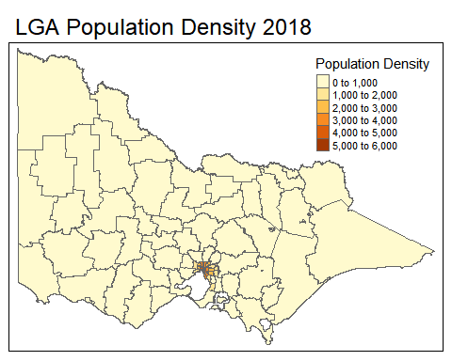

road_type <- left_join(accident,accident_location,by = "ACCIDENT_NO")  
road_type <- left_join(road_type,accident_node, by = "ACCIDENT_NO")

## Warning: Column `ACCIDENT_NO` joining factors with different levels,  
## coercing to character vector

glimpse(road_type)

## Observations: 184,409  
## Variables: 49  
## $ ACCIDENT_NO <chr> "T20060000010", "T20060000018", "T2006000...  
## $ ACCIDENTDATE <fct> 13/01/2006, 13/01/2006, 14/01/2006, 14/01...  
## $ ACCIDENTTIME <fct> 12.42.00, 19.10.00, 12.10.00, 11.49.00, 1...  
## $ ACCIDENT_TYPE <int> 1, 1, 7, 1, 1, 1, 4, 4, 1, 2, 4, 1, 2, 1,...  
## $ Accident.Type.Desc <fct> Collision with vehicle, Collision with ve...  
## $ DAY_OF_WEEK <int> 6, 6, 7, 7, 7, 7, 1, 1, 2, 2, 2, 2, 3, 3,...  
## $ Day.Week.Description <fct> Friday, Friday, Saturday, Saturday, Satur...  
## $ DCA_CODE <int> 113, 113, 190, 130, 121, 116, 171, 171, 1...  
## $ DCA.Description <fct> RIGHT NEAR (INTERSECTIONS ONLY) ...  
## $ DIRECTORY <fct> MEL, MEL, MEL, MEL, MEL, MEL, VCS, MEL, M...  
## $ EDITION <fct> 40, 40, 40, 40, 40, 40, 9, 40, 40, 40, 40...  
## $ PAGE <fct> 91A, 91, 169, 88, 169, 146, 704, 103, 90,...  
## $ GRID_REFERENCE_X <fct> G, H, C, J, G, G, A, B, E, D, E, F, D, D,...  
## $ GRID_REFERENCE_Y <int> 7, 8, 11, 8, 5, 2, 4, 5, 11, 3, 9, 5, 11,...  
## $ LIGHT_CONDITION <int> 1, 1, 1, 1, 1, 1, 1, 3, 1, 1, 1, 1, 3, 1,...  
## $ Light.Condition.Desc <fct> Day, Day, Day, Day, Day, Day, Day, Dark S...  
## $ NODE_ID.x <int> 43078, 29720, 203074, 55462, 202988, 2774...  
## $ NO_OF_VEHICLES <int> 3, 2, 1, 2, 2, 2, 1, 1, 3, 1, 1, 3, 1, 2,...  
## $ NO_PERSONS <int> 6, 4, 2, 2, 3, 2, 1, 1, 5, 2, 2, 4, 2, 2,...  
## $ NO_PERSONS_INJ_2 <int> 0, 0, 1, 1, 0, 1, 1, 1, 2, 0, 1, 1, 1, 1,...  
## $ NO_PERSONS_INJ_3 <int> 1, 1, 0, 0, 3, 0, 0, 0, 2, 1, 0, 2, 0, 0,...  
## $ NO_PERSONS_KILLED <int> 0, 0, 0, 0, 0, 0, 0, 0, 0, 0, 0, 0, 0, 0,...  
## $ NO_PERSONS_NOT_INJ <int> 5, 3, 1, 1, 0, 1, 0, 0, 1, 1, 1, 1, 1, 1,...  
## $ POLICE_ATTEND <int> 1, 1, 1, 1, 1, 1, 1, 1, 1, 1, 1, 1, 2, 1,...  
## $ ROAD_GEOMETRY <int> 1, 2, 5, 2, 5, 1, 5, 5, 2, 5, 5, 1, 5, 5,...  
## $ Road.Geometry.Desc <fct> Cross intersection, T intersection, Not a...  
## $ SEVERITY <int> 3, 3, 2, 2, 3, 2, 2, 2, 2, 3, 3, 2, 2, 3,...  
## $ SPEED_ZONE <int> 60, 70, 100, 80, 50, 100, 100, 70, 80, 60...  
## $ NODE_ID.y <int> 43078, 29720, 203074, 55462, 202988, 2774...  
## $ ROAD_ROUTE_1 <int> 2090, 5057, 9999, 2400, 9999, 9999, 5594,...  
## $ ROAD_NAME <fct> FOSTER, HALLAM, BROWNS, SPRINGVALE, ELIZA...  
## $ ROAD_TYPE <fct> STREET, ROAD, ROAD, ROAD, AVENUE, ROAD, H...  
## $ ROAD_NAME_INT <fct> MCCRAE, BELGRAVE-HALLAM, TRUEMANS, KEYSBO...  
## $ ROAD_TYPE_INT <fct> STREET, ROAD, ROAD, AVENUE, CRESCENT, ROA...  
## $ DISTANCE_LOCATION <int> 0, 70, 210, 0, 20, 49, 99, 82, 0, 26, 1, ...  
## $ DIRECTION_LOCATION <fct> SW, S, W, N, N, E, W, W, S, E, W, E, N, W...  
## $ NEAREST_KM_POST <int> NA, NA, NA, NA, NA, NA, NA, NA, NA, NA, N...  
## $ OFF_ROAD_LOCATION <fct> , , , , , , , , , , , , , , , , , , , , ,...  
## $ NODE_ID <int> 43078, 29720, 203074, 55462, 202988, 2774...  
## $ NODE_TYPE <fct> I, N, N, I, N, N, N, N, I, N, N, I, N, N,...  
## $ AMG_X <dbl> 2519155, 2524273, 2487322, 2512734, 24887...  
## $ AMG_Y <dbl> 2390265, 2389997, 2345020, 2390215, 23476...  
## $ LGA_NAME <fct> DANDENONG, CASEY, MORNINGTON PENINSULA, D...  
## $ Lga.Name.All <fct> "DANDENONG", "CASEY", "MORNINGTON PENINSU...  
## $ Region.Name <fct> METROPOLITAN SOUTH EAST REGION, METROPOLI...  
## $ Deg.Urban.Name <fct> MELB_URBAN, MELB_URBAN, RURAL_VICTORIA, M...  
## $ Lat <dbl> -37.98862, -37.99092, -38.39632, -37.9891...  
## $ Long <dbl> 145.2181, 145.2763, 144.8549, 145.1450, 1...  
## $ Postcode.No <int> 3175, 3804, 3939, 3173, 3940, 3931, 3820,...

#filter only for highways and freeways  
road_route1 <- road_type %>%  
 filter(ROAD_ROUTE_1 >2000) %>%   
 filter(ROAD_ROUTE_1<3000)  
  
road_route2 <- ddply(road_route1, .(Lga.Name.All), summarise, count = length(ACCIDENT_NO))  
glimpse(road_route2)

## Observations: 145  
## Variables: 2  
## $ Lga.Name.All <fct> "ALPINE", "ARARAT", "BALLARAT", "BANYULE", "BASS ...  
## $ count <int> 47, 139, 520, 772, 239, 228, 256, 186, 1265, 622,...

road_route3 <- road_route2 %>%  
 separate(Lga.Name.All,c("VIC_LGA__3","LGA_2"),sep = ",")

## Warning: Expected 2 pieces. Additional pieces discarded in 5 rows [29, 74,  
## 112, 131, 143].

## Warning: Expected 2 pieces. Missing pieces filled with `NA` in 78 rows [1,  
## 2, 3, 4, 5, 6, 7, 8, 9, 10, 11, 12, 14, 15, 17, 18, 19, 21, 23, 25, ...].

road_route4 <- road_route3 %>%  
 select(-LGA_2)  
glimpse(road_route4)

## Observations: 145  
## Variables: 2  
## $ VIC_LGA__3 <chr> "ALPINE", "ARARAT", "BALLARAT", "BANYULE", "BASS CO...  
## $ count <int> 47, 139, 520, 772, 239, 228, 256, 186, 1265, 622, 1...

road_route5 <- ddply(road_route4, .(VIC_LGA__3), summarise, count = sum(count))  
glimpse(road_route5)

## Observations: 79  
## Variables: 2  
## $ VIC_LGA__3 <chr> "ALPINE", "ARARAT", "BALLARAT", "BANYULE", "BASS CO...  
## $ count <int> 47, 139, 520, 772, 239, 228, 256, 186, 1265, 622, 1...

road_route_map <- vic_lga_map  
  
road_route_map@data <- left_join(road_route_map@data,road_route5,by = "VIC_LGA__3")

## Warning: Column `VIC_LGA__3` joining factor and character vector, coercing  
## into character vector

tmap_mode ("plot")

## tmap mode set to plotting

tm_shape(road_route_map)+  
 tm_polygons("count")+  
 tm_layout(main.title = "Accident Highways and Freeways")+  
 tm_legend(legend.position = c("right","top"))

