Assignment 3
STAT-540
Bruno Cavagnaro

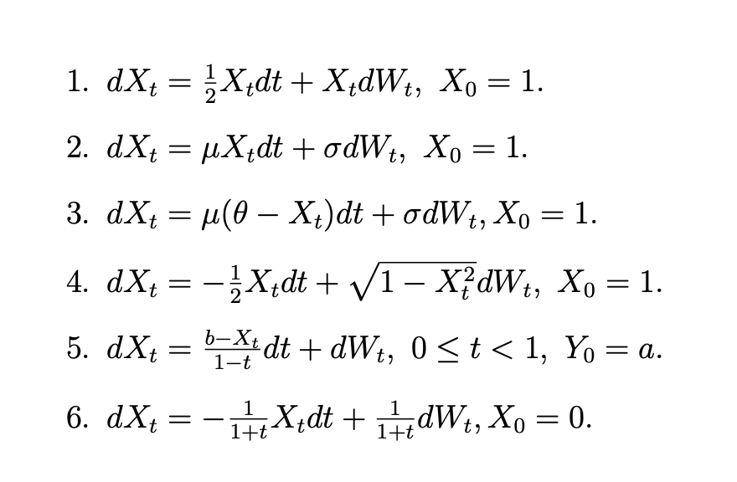

Solution:
- Problem: $dX_{t}=\frac{1}{2}X_{t}d_{t}+X_{t}{dW}_{t} , X_{0}=1$

Solution Method: Use Itô's formula with f(t,x) = ln(x). Let Yt = ln(Xt). By Itô's formula:

$$dY_{t}=\frac{1}{X_{t}}{dX}_{t}-\frac{1}{2{X_{t}}^{2} }{\left({dX}_{t}\right)}^{2}$$
Substituting dXt:

$$dY_{t}=\frac{1}{X_{t}}\left(\frac{1}{2}X_{t}d_{t}+X_{t}{dW}_{t}\right)-\frac{1}{2{X_{t}}^{2} }{\left(\frac{1}{2}X_{t}d_{t}+X_{t}{dW}_{t}\right)}^{2}= \frac{1}{X_{t}}\left(\frac{1}{2}X_{t}d_{t}+X_{t}{dW}_{t}\right)-\frac{1}{2{X_{t}}^{2} }\left(\frac{1}{4} {X_{t}}^{2} {\left(d_{t}\right)}^{2}+ {X_{t}}^{2}d_{t}W_{t}+{X_{t}}^{2}{\left(dW_{t}\right)}^{2} \right)=\frac{1}{X_{t}}\left(\frac{1}{2}X_{t}d_{t}+X_{t}{dW}_{t}\right)-\frac{1}{2{X_{t}}^{2} }\left(\frac{1}{4} {X_{t}}^{2} \left(0\right)+ {X_{t}}^{2}\left(0\right)+{X_{t}}^{2}d_{t}\right)=\frac{1}{X_{t}}\left(\frac{1}{2}X_{t}d_{t}+X_{t}{dW}_{t}\right)-\frac{1}{2{X_{t}}^{2} }\left({X_{t}}^{2}d_{t}\right)= \frac{1}{2}d_{t}+{dW}_{t}-\frac{1}{2 }d_{t}= {dW}_{t}$$

$$\int{dY_{t}}=\int{{dW}_{t}}$$

$$Y_{t}- Y_{0}=W_{t}$$

Since Y₀ = ln(X₀) = ln(1) = 0:

$${ln⁡(Y}_{t})=W_{t}$$

$$X_{t}=e^{W_{t}}$$

- Problem: $dX_{t}=μX_{t}d_{t}+σ{dW}_{t} , X_{0}=1$

Solution Method: This is a Linear SDE with additive noise. To solve it, we can use the integrating factor: e^(-μt):

Let Yt = e^(-μt)Xt. By Itô's formula:

$${dY}_{t}= {-μe}^{-μt}X_{t}d_{t}+e^{-μt}dX_{t}= {-μe}^{-μt}X_{t}d_{t}+e^{-μt}\left(μX_{t}d_{t}+σ{dW}_{t}\right)= {-μe}^{-μt}X_{t}d_{t}+{μe}^{-μt}X_{t}d_{t}+e^{-μt}σ{dW}_{t}=e^{-μt}σ{dW}_{t}$$

$$\int{dY_{t}}=\int{e^{-μt}σ{dW}_{t}}$$
$$Y_{t} - Y_{0}=σ\int_{0}^{t}{e^{-μs}{dW}_{s}}$$

Then we sustitute Y₀, since Y₀ = e⁰·X₀ = 1:

$$e^{-μt}X_{t} =1+σ\int_{0}^{t}{e^{-μs}{dW}_{s}}$$
$$X_{t} =e^{μt}+σe^{μt}\int_{0}^{t}{e^{-μs}{dW}_{s}}$$

- Problem: $dX_{t}=μ(θ-X_{t}) d_{t}+σ{dW}_{t} , X_{0}=1$

Solution Method: This is a the Ornstein-Uhlenbeck process (mean-reverting). To solve it, we can use the integrating factor: e^(μt):

Let Yt = e^(μt)Xt. By Itô's formula:

$${dY}_{t}= {μe}^{μt}X_{t}d_{t}+e^{μt}dX_{t}={μe}^{μt}X_{t}d_{t}+e^{μt}\left(μ\left(θ-X_{t}\right)d_{t}+σ{dW}_{t}\right)= {μe}^{μt}X_{t}d_{t}+e^{μt}μθd_{t}-μe^{μt}X_{t}d_{t}+σe^{μt}{dW}_{t}={μe}^{μt}θd_{t}+σe^{μt}{dW}_{t}$$

$$\int{dY_{t}}=\int{{μe}^{μt}θd_{t}+σe^{μt}{dW}_{t}}$$
$$Y_{t} - Y_{0}=μθ\int_{0}^{t}{e^{μs}}d_{s}+σ\int_{0}^{t}{e^{μs}}{dW}_{s}$$

Then we sustitute Y₀, since Y₀ = e⁰·X₀ = 1:

$$e^{μt}X_{t} - 1=μθ \frac{e^{μt}-1}{μ}+σ\int_{0}^{t}{e^{μs}}{dW}_{s}$$

$$e^{μt}X_{t}=1+θ{(e}^{μt}-1) +σ\int_{0}^{t}{e^{μs}}{dW}_{s}$$
$$X_{t}=e^{-μt}+θ(1-e^{-μt}) +σe^{μt}\int_{0}^{t}{e^{μs}}{dW}_{s}$$

- Problem: $dX_{t}=-\frac{1}{2}X_{t}d_{t}+ \sqrt{1-{X_{t}}^{2}}{dW}_{t} , X_{0}=1$

Solution Method: This equation keeps Xt bounded in [-1, 1]. To solve the problem, we can use the following transformation Xt = sin(Yt). Let Yt = arcsin(Xt), so Xt = sin(Yt).

By Itô's formula:

$${dX}_{t}=\cos{(Y_{t})}{dY}_{t}-\frac{1}{2}\sin{(Y_{t}){\left({dY}_{t}\right)}^{2}}$$

We can sustitute:
$$\cos{(Y_{t})}= \sqrt{1-{\sin{Y_{t}}}^{2}}= \sqrt{1-{X_{t}}^{2}}$$
$${\left({dY}_{t}\right)}^{2}= {(diffusion component)}^{2}d_{t}$$

From the original SDE:

$$dX_{t}=-\frac{1}{2}X_{t}d_{t}+ \sqrt{1-{X_{t}}^{2}}{dW}_{t}= \sqrt{1-{X_{t}}^{2}}{dY}_{t}-\frac{1}{2}\sin{(Y_{t}){\left({dY}_{t}\right)}^{2}}$$

Matching coefficients, if we try dYt = dWt:

$$\sqrt{1-{X_{t}}^{2}}{dW}_{t}= \sqrt{1-{X_{t}}^{2}}{dY}_{t}$$

$$-\frac{1}{2}\sin{(Y_{t})}d_{t}= -\frac{1}{2}X_{t}d_{t}$$

Therefore dYt must equal dWt:

Integrating:

$$\int{dY_{t}}=\int{{dW}_{t}}$$

$$Y_{t}-Y_{0}=W_{t}$$

Since X₀ = 1, we have Y₀ = arcsin(1) = π/2

$$X_{t}=\sin\left(\frac{π}{2}+W_{t}\right)=\cos{(W_{t})}$$

- Problem: $dX_{t}=\frac{b-X_{t}}{1-t}d_{t}+{dW}_{t} , 0≤t<1, X_{0}= α$

Solution Method: To solve the problem, we can use the following transformation use integrating factor 1/(1-t). By Ito’s formula:

$dY_{t}= \frac{dX_{t}}{1-t}$ + $\frac{X_{t}}{{\left(1-t\right)}^{2}} d_{t}$

$$\frac{dX_{t}}{1-t} = dY_{t}- \frac{X_{t}}{{\left(1-t\right)}^{2}}d_{t}$$

$$\frac{b-X_{t}}{{\left(1-t\right)}^{2}}d_{t} + \frac{1}{1-t}{dW}_{t} = dY_{t}- \frac{X_{t}}{{\left(1-t\right)}^{2}}d_{t}$$

$$dY_{t}= \frac{b}{{\left(1-t\right)}^{2}}d_{t} + \frac{1}{1-t}{dW}_{t}$$

Integrating:

$$\int{dY_{t}}=\int{\frac{b}{{\left(1-t\right)}^{2}}d_{t} + \frac{1}{1-t}{dW}_{t}}$$

$$Y_{t}- Y_{0}=b\int_{0}^{t}{\frac{ds}{{\left(1-s\right)}^{2}}} + \int_{0}^{t}{\frac{1}{1-s}{dW}_{s}}$$

$$\frac{X_{t}}{1-t}- α=b {\left[\frac{1}{1-s}\right]}_{0}^{t} + \int_{0}^{t}{\frac{1}{1-s}{dW}_{s}}$$

$$\frac{X_{t}}{1-t}=α+ b \left(\frac{1}{1-t}-1\right) + \int_{0}^{t}{\frac{1}{1-s}{dW}_{s}}$$

$$\frac{X_{t}}{1-t}=α+ b \left(\frac{t}{1-t}\right) + \int_{0}^{t}{\frac{1}{1-s}{dW}_{s}}$$

$$X_{t}=α(1-t)+ bt +(1-t)\int_{0}^{t}{\frac{1}{1-s}{dW}_{s}}$$

- Problem: $dX_{t}=-\frac{1}{1+t}X_{t}d_{t}+\frac{1}{1+t}{dW}_{t} , X_{0}=0$

Solution Method: To solve the problem, we can use the following transformation use integrating factor (1+t). By Ito’s formula:

$$dY_{t}= X_{t}d_{t}+\left(1+t\right){dX}_{t}= X_{t}d_{t}+\left(1+t\right) \left(-\frac{1}{1+t}X_{t}d_{t}+\frac{1}{1+t}{dW}_{t}\right)= X_{t}d_{t}+\left(-X_{t}d_{t}+{dW}_{t}\right)= {dW}_{t}$$

Integrating:

$$\int{dY_{t}}=\int{{dW}_{t}}$$

$$Y_{t}- Y_{0}=W_{t}$$

Since Y₀ = (1+0)X₀ = 0:

$$X_{t}(1+t) =W_{t}$$

$$X_{t}= \frac{W_{t}}{(1+t)}$$

