Assignment 4
STAT-540
Bruno Cavagnaro

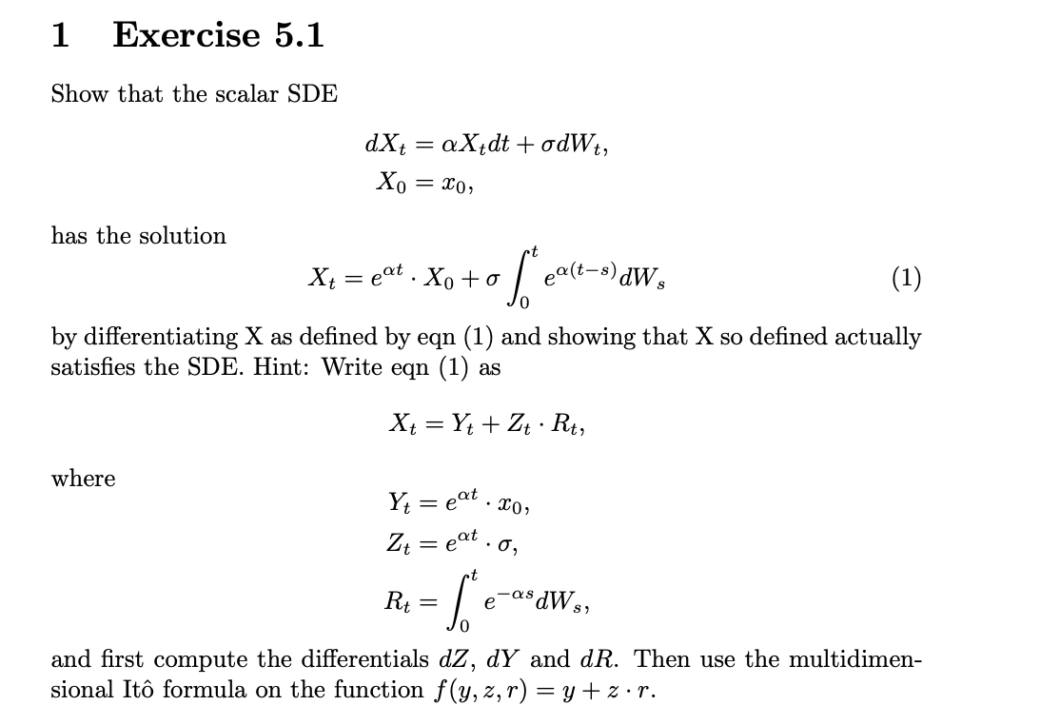

Solution:
To solve this first we need to derive the multidimensional Ito’s formula as stated in the problem:

$$df\left(y,z,r\right)= \frac{∂f}{∂y}dy+ \frac{∂f}{∂z}dz+ \frac{∂f}{∂r}dr+\frac{1}{2}\sum_{i,j}{\frac{∂^{2}f}{∂x_{i}∂x_{j}}dx_{i}dx_{j}}$$
Then we need to solve for the differentials:
$$dY_{t}= \frac{d}{dt}\left(e^{αt}x_{0}\right) =αe^{αt}x_{0}d_{t}= αY_{t}d_{t}$$

$$dZ_{t}= \frac{d}{dt}\left(e^{αt}σ\right) =αe^{αt}σd_{t}= αZ_{t}d_{t}$$

$$dR_{t}= \frac{d}{dt}\left(\int_{0}^{t}{e^{-αs}{dW}_{s}}\right) =e^{-αt}{dW}_{t}$$

Then the partial derivatives:
$$\frac{∂f}{∂y}=\frac{∂}{∂y}\left(y+zr\right)=1$$

$$\frac{∂f}{∂z}=\frac{∂}{∂z}\left(y+zr\right)=r$$

$$\frac{∂f}{∂r}=\frac{∂}{∂r}\left(y+zr\right)=z$$

$$\frac{∂^{2}f}{∂^{2}x_{i}}=0, as all first derivatives are constant respect to the variable$$

Then compute the quadratic variations:
$${\left({dY}_{t}\right)}^{2}=0 (it is deterministic)$$
$${\left({dZ}_{t}\right)}^{2}=0 (it is deterministic)$$
$${\left({dR}_{t}\right)}^{2}= e^{-2αt}dt$$
Lastly we replace the values:
$${dX}_{t}=df= {dY}_{t}+ R_{t}{dZ}_{t}+ Z_{t}{dR}_{t}+ \frac{1}{2}*0*e^{-2αt}dt= αY_{t}d_{t}+R_{t}αZ_{t}d_{t}+ Z_{t}e^{-αt}{dW}_{t}=αY_{t}d_{t}+R_{t}αZ_{t}d_{t}+ e^{αt}σ e^{-αt}{dW}_{t}=α\left(Y_{t}+R_{t}Z_{t}\right) d_{t}+ σ {dW}_{t}= αX_{t} d_{t}+ σ {dW}_{t}$$

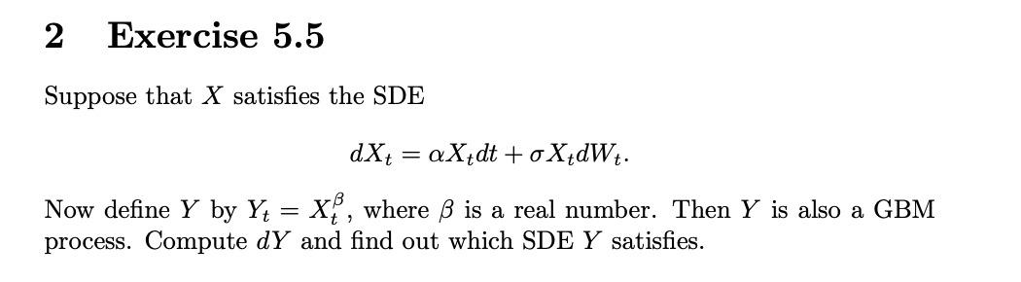

Solution:
To solve this first we use Itô's formula with $f(x)=x^{β}$:
$$f^{'}\left(x\right)= βx^{β-1}$$
$$f^{''}\left(x\right)= β(β-1)x^{β-2}$$

And using Itô's formula the value of dYt:
$${dY}_{t}= f^{'}\left(X_{t}\right){dX}_{t}+\frac{1}{2}f^{''}\left(x\right){\left({dX}_{t}\right)}^{2}$$
From the given SDE:
$${\left({dX}_{t}\right)}^{2}= {\left(σX_{t}{dW}_{t}\right)}^{2}= σ^{2}{X_{t}}^{2}d_{t}$$
Therefore:
$${dY}_{t}= β{X_{t}}^{β-1}{dX}_{t}+\frac{1}{2}β\left(β-1\right){X_{t}}^{β-2}σ^{2}{X_{t}}^{2}d_{t }= β{X_{t}}^{β-1}\left(αX_{t}d_{t}+ σX_{t}{dW}_{t}\right)+\frac{1}{2}β\left(β-1\right){X_{t}}^{β}σ^{2}d_{t }= αβ{X_{t}}^{β}d_{t}+σβ{X_{t}}^{β}{dW}_{t}+\frac{1}{2}β\left(β-1\right){X_{t}}^{β}σ^{2}d_{t }= \left[αβ+\frac{1}{2}β\left(β-1\right)σ^{2}\right]{X_{t}}^{β}d_{t}+βσ{X_{t}}^{β}{dW}_{t}$$
Since $Y_{t}=X_{t}^{β}$:
$${dY}_{t}= \left[αβ+\frac{1}{2}β\left(β-1\right)σ^{2}\right]Y_{t}d_{t}+βσY_{t}{dW}_{t}$$
And this is a GBM with:
- Drift coefficients: $\overline{α}= αβ+\frac{1}{2}β\left(β-1\right)σ^{2}$
- Diffusion coefficients: $\overline{σ}= βσ$

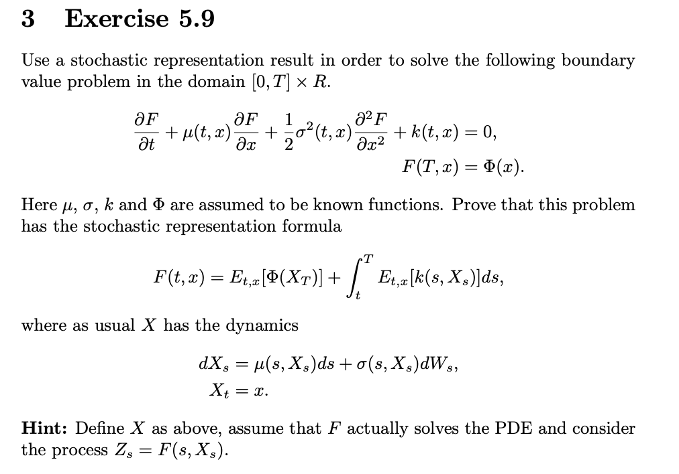

Solution:
To solve this first we follow the hint, assume F solves the PDE and define:
$$Z_{s}=F\left(s,X_{s}\right)+ \int_{t}^{s}{k\left(μ,X_{μ}\right)d_{μ}}$$
Then we apply Itô's formula to F(s, Xs):
$$dF\left(s, X_{s}\right)= \frac{∂F}{∂t}d_{s}+\frac{∂F}{∂x}{dX}_{s}+\frac{1}{2}\frac{∂^{2}F}{∂x^{2}}{\left({dX}_{s}\right)}^{2}= \frac{∂F}{∂t}d_{s}+\frac{∂F}{∂x}\left[μd_{s}+σ{dW}_{s}\right]+\frac{1}{2}\frac{∂^{2}F}{∂x^{2}}σ^{2}d_{s}=\left[\frac{∂F}{∂t}+μ\frac{∂F}{∂x}+\frac{1}{2}\frac{∂^{2}F}{∂x^{2}}σ^{2}d_{s}\right] d_{s}+\frac{∂F}{∂x}σ{dW}_{s}$$
Since F satisfies the SDE:
$$\left[\frac{∂F}{∂t}+μ\frac{∂F}{∂x}+\frac{1}{2}\frac{∂^{2}F}{∂x^{2}}σ^{2}d_{s}\right] d_{s}=-k\left(s,X_{s}\right)$$
Therefore:
$$dF\left(s, X_{s}\right)=-k\left(s,X_{s}\right)d_{s} +\frac{∂F}{∂x}σ{dW}_{s}$$
Then we compute the dZs:
$$dZ_{s}=dF\left(s, X_{s}\right)+k\left(s,X_{s}\right)d_{s}= \frac{∂F}{∂x}σ{dW}_{s}$$
This shows Zs is a martingale (no drift term)
Integrate from t to T:
$$Z_{T}-Z_{t}=\int_{t}^{T}{\frac{∂F}{∂x}\left(s,X_{s}\right)σ{dW}_{s}}$$
Taking conditional expectation $E_{t,x}[⋅]$:
$$E_{t,x}\left[Z_{T}\right]-Z_{t}=0$$
(The stochastic integral has zero expectation)
Therefore:
$$Z_{t}=E_{t,x}\left[Z_{T}\right]$$
$$F\left(t,x\right)+ \int_{t}^{t}{k\left(μ,X_{μ}\right)dμ}= E_{t,x}\left[F\left(T,X_{T}\right)+ \int_{t}^{T}{k\left(μ,X_{μ}\right)dμ}\right]$$

$$F\left(t,x\right)= E_{t,x}\left[F\left(T,X_{T}\right)\right]+ E_{t,x}\left[\int_{t}^{T}{k\left(μ,X_{μ}\right)dμ}\right]$$

Using $F(T,x)=Φ(x)$and Fubini's theorem:

$$F\left(t,x\right)= E_{t,x}\left[Φ\left(X_{T}\right)\right]+\int_{t}^{T}{E_{t,x}\left[k\left(s,X_{s}\right)\right]d_{s}}$$

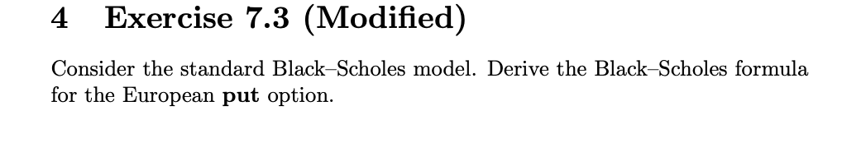

Solution:
Setup:
- Stock: $dS_{t}=μS_{t}dt+σS_{t}dW_{t}$, $S_{0}=s$
- Risk-free rate: $r$
- Put payoff: ${\left(K-S_{T}\right)}^{+}$

Find: Put price $P\left(t,s\right)= e^{-r(T-t)}{E_{t}}^{Q}\left[{\left(K-S_{T}\right)}^{+}\right]$
Under the risk-neutral measure Q, the stock follows:
$${dS}_{t}=rS_{t}d_{t}+ σS_{t}d\tilde{W_{t}}$$

The solution is:
$$S_{T}=S_{t}e^{\left(r-\frac{1}{2}σ^{2}\right)\left(T-t\right)+\sqrt{T-t}Z} , where Z\sim N(0,1)$$

Put–Call Parity:
$$P\left(t,s\right)+ S_{t}=C\left(t,s\right)+Ke^{-r(T-t)} , where C\left(t,s\right) is the call price$$

Black-Scholes Call formula:
$$C\left(t,s\right)= S_{T}Φ\left(d_{1}\right)-Ke^{-r\left(T-t\right)}Φ(d_{2})$$
$$d_{1}= \frac{ln\left({S_{t}}/K\right)+\left(r+1/2σ^{2}\right)\left(T-t\right)}{σ\sqrt{T-t}}$$

$$d_{2}= d_{1}- σ\sqrt{T-t}= \frac{ln\left({S_{t}}/K\right)+\left(r-1/2σ^{2}\right)\left(T-t\right)}{σ\sqrt{T-t}}$$

Using Put-Call Parity:
$$P\left(t,s\right)=C\left(t,s\right)+Ke^{-r(T-t)}-S_{t}= S_{T}Φ\left(d_{1}\right)-Ke^{-r\left(T-t\right)}Φ\left(d_{2}\right)+Ke^{-r\left(T-t\right)}-S_{t}=S_{t}\left[Φ\left(d_{1}\right)-1\right]+ Ke^{-r\left(T-t\right)}\left[1-Φ\left(d_{2}\right)\right]$$

Using $Φ(-x)=1-Φ(x)$:
$$P\left(t,s\right)=Ke^{-r\left(T-t\right)}Φ\left(-d_{2}\right)-S_{t}\left[-Φ\left(d_{1}\right)\right]$$

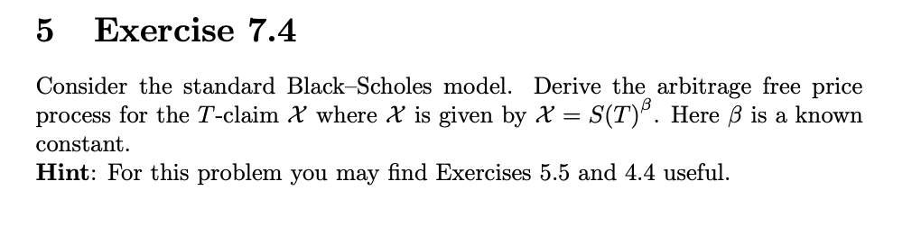

Solution:
To solve this first under the risk-neutral measure $Q$,:
$${dS}_{t}={rS}_{t}d_{t}+ σS_{t}{d\tilde{W}}_{t}$$
Using Itô’s formula, if $X_{t}= {S_{t}}^{β}$
$${dX}_{t}=\left[βr+\frac{1}{2}β(β-1)σ^{2}\right]X_{t}d_{t}+βσX_{t}{d\tilde{W}}_{t}$$
Then we solve for Xt, since it follows a Geometric Brownian Motion:
$$X_{T}= X_{t}e^{\left\{\left[βr+\frac{1}{2}β\left(β-1\right)σ^{2}-\frac{1}{2}β^{2}σ^{2}\right]\left(T-t\right)+βσ\sqrt{T-t}Z\right\}}, where Z\sim N(0,1)$$
Then:
$$X_{T}= {S_{t}}^{β}e^{\left\{\left[βr+-\frac{1}{2}βσ^{2}\right]\left(T-t\right)+βσ\sqrt{T-t}Z\right\}}, where Z\sim N(0,1)$$

Lastly we price at time t using the arbitrage-free price:
$$V\left(t,S_{t}\right)= e^{-r(T-t)}{E_{t}}^{Q}\left[{S_{T}}^{β}\right] = e^{-r(T-t)}{S_{t}}^{β}{E_{t}}^{Q}\left[e^{\left\{\left[βr+-\frac{1}{2}βσ^{2}\right]\left(T-t\right)+βσ\sqrt{T-t}Z\right\}}\right]$$
Using: $E\left[e^{aZ}\right]= e^{\frac{a^{2}}{2}}$
Then:
$$V\left(t,S_{t}\right)= {S_{t}}^{β}e^{\left\{-r\left(T-t\right)+βr\left(T-t\right)-\frac{1}{2}βσ^{2}(T-t)+\frac{1}{2}β^{2}σ^{2}(T-t)\right\}}={S_{t}}^{β}e^{\left\{r\left(β-1\right)(T-t)+\frac{1}{2}β(β-1)σ^{2}(T-t)\right\}}= {S_{t}}^{β}e^{\left\{\left[r\left(β-1\right)+\frac{1}{2}β(β-1)σ^{2}\right](T-t)\right\}}$$

