Laboratory 2:

Link to the jupyter notebook, with all the code:
https://github.com/BrunoCavag/Alicorp/blob/master/Lab2_custom_dataflow.ipynb

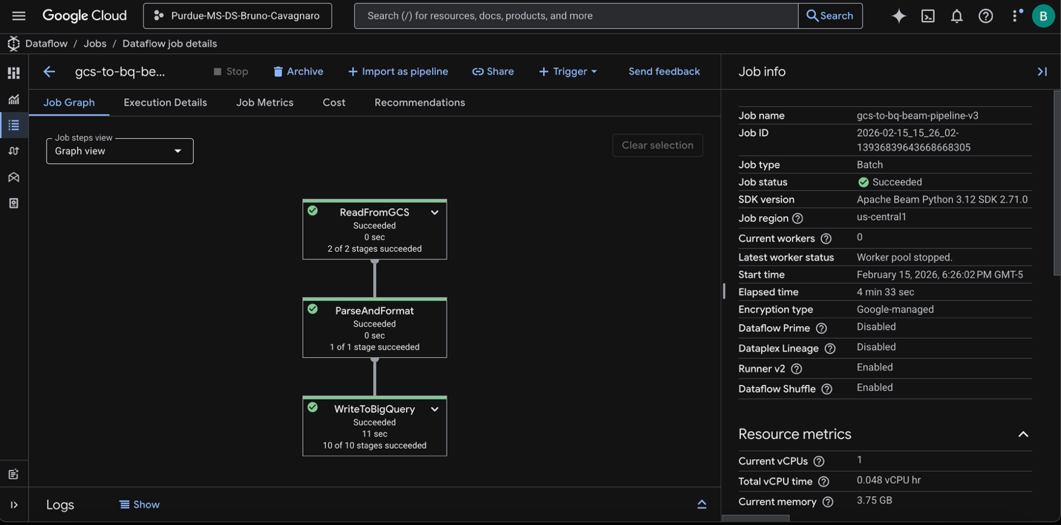

List of the different actions:
- Cell 1: Install Required Libraries and Resolve Dependencies
- Cell 2: Authenticate and Configure Project Variables (in this cell I have modified the different parameters of temporal buckets, bigquery dataset, etc; and the table schema, because is a different dataset).
- Cell 3: Write the Custom Apache Beam Pipeline Script (here a modified the parse script, so It matches the schema of this new dataset)
- Cell 4: Launch the Dataflow Job
- Cell 5: Verify the Final Result in BigQuery

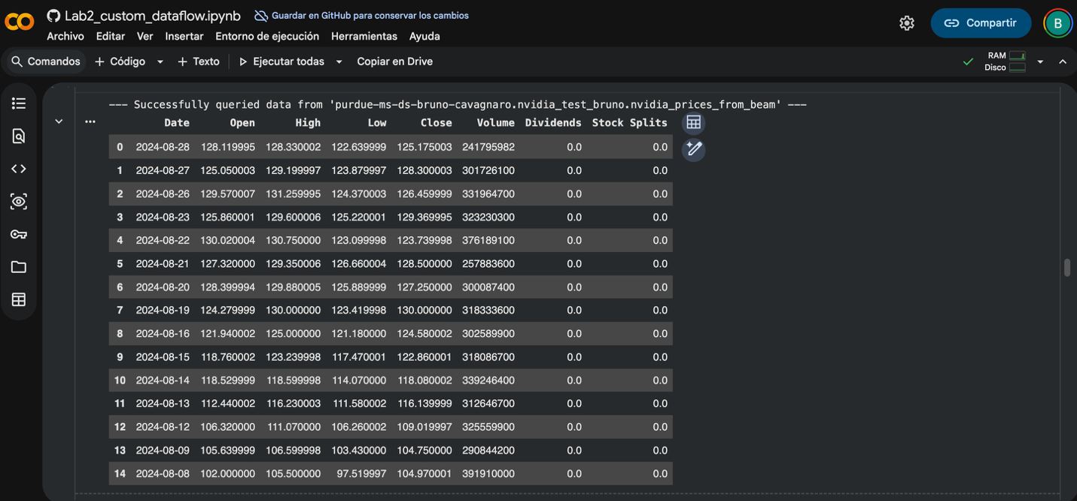

- Linear Regression (Predicting a Stock's High Price)
- Logistic Regression (Predicting a High Volume Day)
- K-Means Clustering (Grouping Similar Trading Days)

