Capstone Progress Report 1 – Capstone Planning & Setup
Due Date: 2/8/2026
Submission Format: Upload to Brightspace
Objective:
To ensure students have made meaningful progress on the foundational steps of their capstone project and are prepared to begin querying and analyzing data.
Submission Requirements (1–2 pages or equivalent in Jupyter Notebook):
1. Dataset Selection
- Identify the dataset you have selected from the options on Brightspace.
Global Energy Generation & Capacity (IMF)
- Justify your choice based on your interests or relevance to a specific domain.
This dataset was selected because it includes country data across different continents along with strong energy data. This allows us to explore interesting connections between developing and developed countries and their energy capacity. It also provides a large timespan and mostly clean data that makes a good starting point for the capstone project to see how energy generation has grown or failed in some places. The dataset allows for interesting analysis by leveraging location data with energy generation and capacity.
2. Research Question & Hypothesis (Draft)
- Provide a working draft of your research question.
Is the growth of renewable energy generation significantly different between developed economies and emerging markets from 2010 to 2023?
- Include a preliminary hypothesis that your project will investigate.
It is hypothesized that the growth of renewable energy is going to be significantly different and have higher growth in already developed countries/economies when compared to emerging markets. Developed countries are expected to show a clear trend of replacing fossil fuel with renewable energy while emerging markets are expected to add renewable energy on top of any fossil fuels, they have instead of replacing them, leading to a vast difference.
3. Problem Definition (Outline)
- Submit a rough outline or key bullet points for the Problem Definition section of your report.
- Developing countries often prioritize energy security and access over decarbonization
- Reports tend to only focus on global averages which hide regional differences. This means an increase in coal usage in a developing country might be overlooked because of a large increase of solar energy in a larger developed country
- More power might be needed in developing countries if the hypothesis is correct and developed countries have higher growth of renewable energy
- List at least one peer-reviewed source that you plan to use.
York, R., & Bell, S. E. (2019). Energy transitions or additions? Why a transition from fossil fuels requires more than the growth of renewable energy. Energy Research & Social Science, 51, 40–43. https://doi.org/10.1016/j.erss.2019.01.008
4. BigQuery Setup
- Confirm successful connection to Google Cloud Platform (include a brief statement or screenshot).
- Include one basic query you’ve run (e.g., previewing the dataset or filtering by date).
I was able to successfully connect the data to the Google Cloud Platform and ran a basic query to preview the dataset you can see screenshotted below.
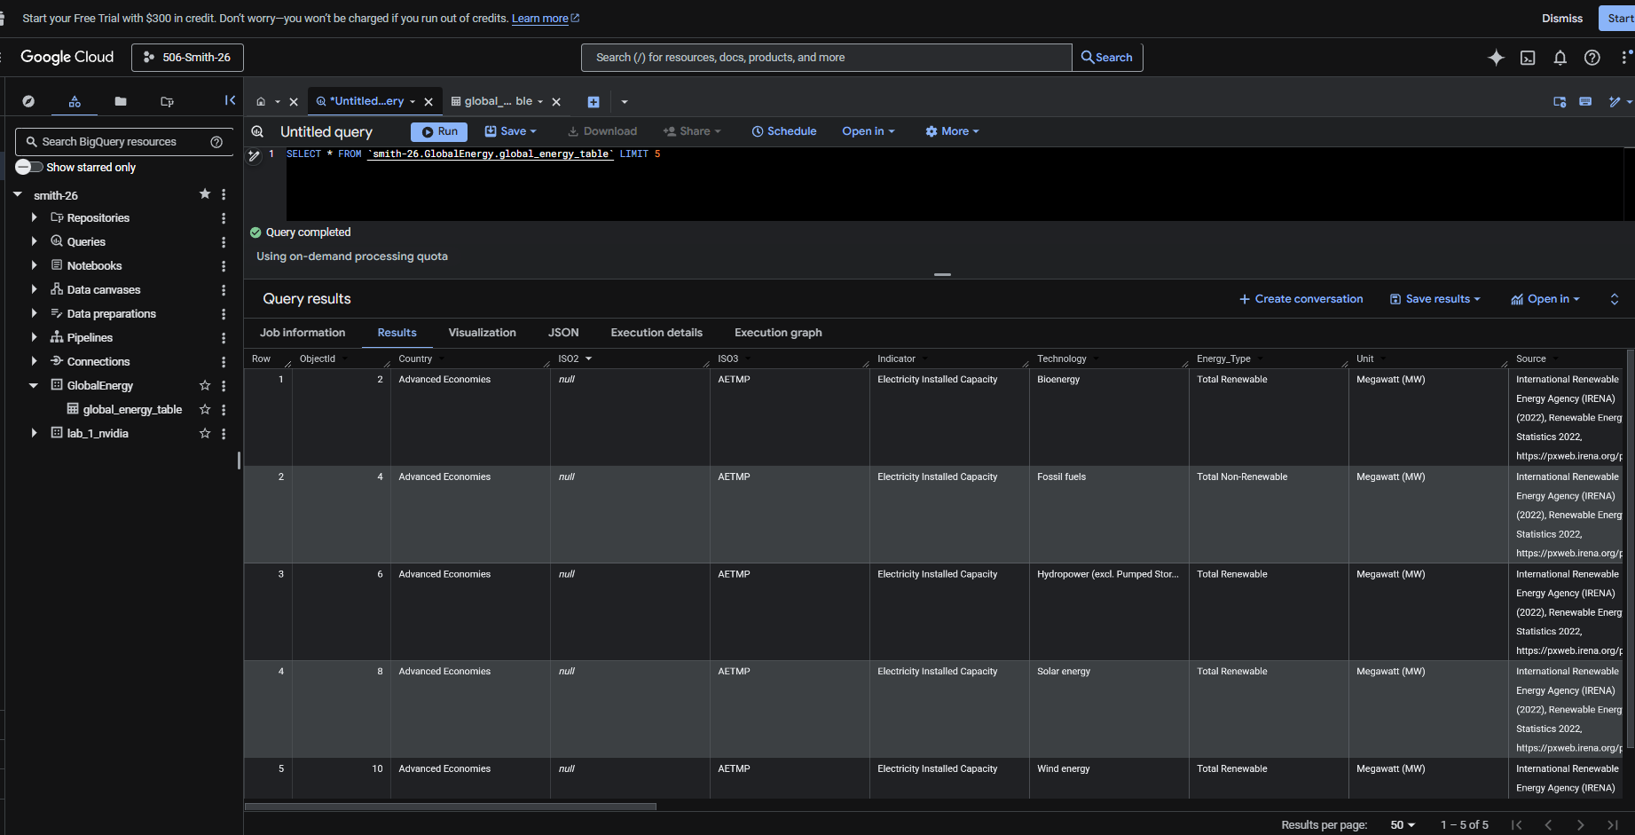

Also I perform a quick analysis of the data using BigQuery, to be able find and answer to the question:
“Is the growth of renewable energy generation significantly different between developed economies and emerging markets from 2010 to 2023?”

The query I build is the following:

WITH
UNPIVOT_TABLE AS (
select * from (
SELECT *,
CASE WHEN TRIM(Country) in('Australia','Austria','Belgium','Brazil','Canada','Chile','China, P.R.: Hong Kong','China, P.R.: Mainland','Finland',
'France','Germany','Iceland','India','Ireland','Israel','Italy','Japan','Korea, Rep. of','Luxembourg','Mexico','Netherlands, The',
'New Zealand','Norway','Qatar','Russian Federation','Saudi Arabia','Singapore','South Africa','Spain','Sweden','Switzerland',
'Taiwan Province of China','United Arab Emirates','United Kingdom','United States','Uruguay') THEN "DEVELOP"
ELSE "EMERGENT" END AS TYPE_COUNTRY
FROM `purdue-ms-ds-bruno-cavagnaro.lab1_eda.renewable_energy`
WHERE ISO2 IS NOT NULL)
UNPIVOT
(ENERGY FOR YEAR_S IN (F2000,F2001,F2002,F2003,F2004,F2005,F2006,F2007,F2008,F2009,F2010,F2011,F2012,F2013,F2014,F2015,F2016,F2017,F2018,F2019,F2020,F2021,F2022,F2023))
)

SELECT YEAR, TYPE_COUNTRY, Energy_Type, SUM(ENERGY_MW) AS TOTAL_ENERGY, AVG(ENERGY_MW) AS AVG_ENERGY
FROM (SELECT *,
CAST(SUBSTR(YEAR_S, 2) AS INT) AS YEAR,
CASE WHEN TRIM(UNIT) = "Megawatt (MW)" THEN ENERGY ELSE ENERGY*1000 END AS ENERGY_MW
FROM UNPIVOT_TABLE B)
GROUP BY YEAR, TYPE_COUNTRY, Energy_Type ORDER BY YEAR, TYPE_COUNTRY, Energy_Type

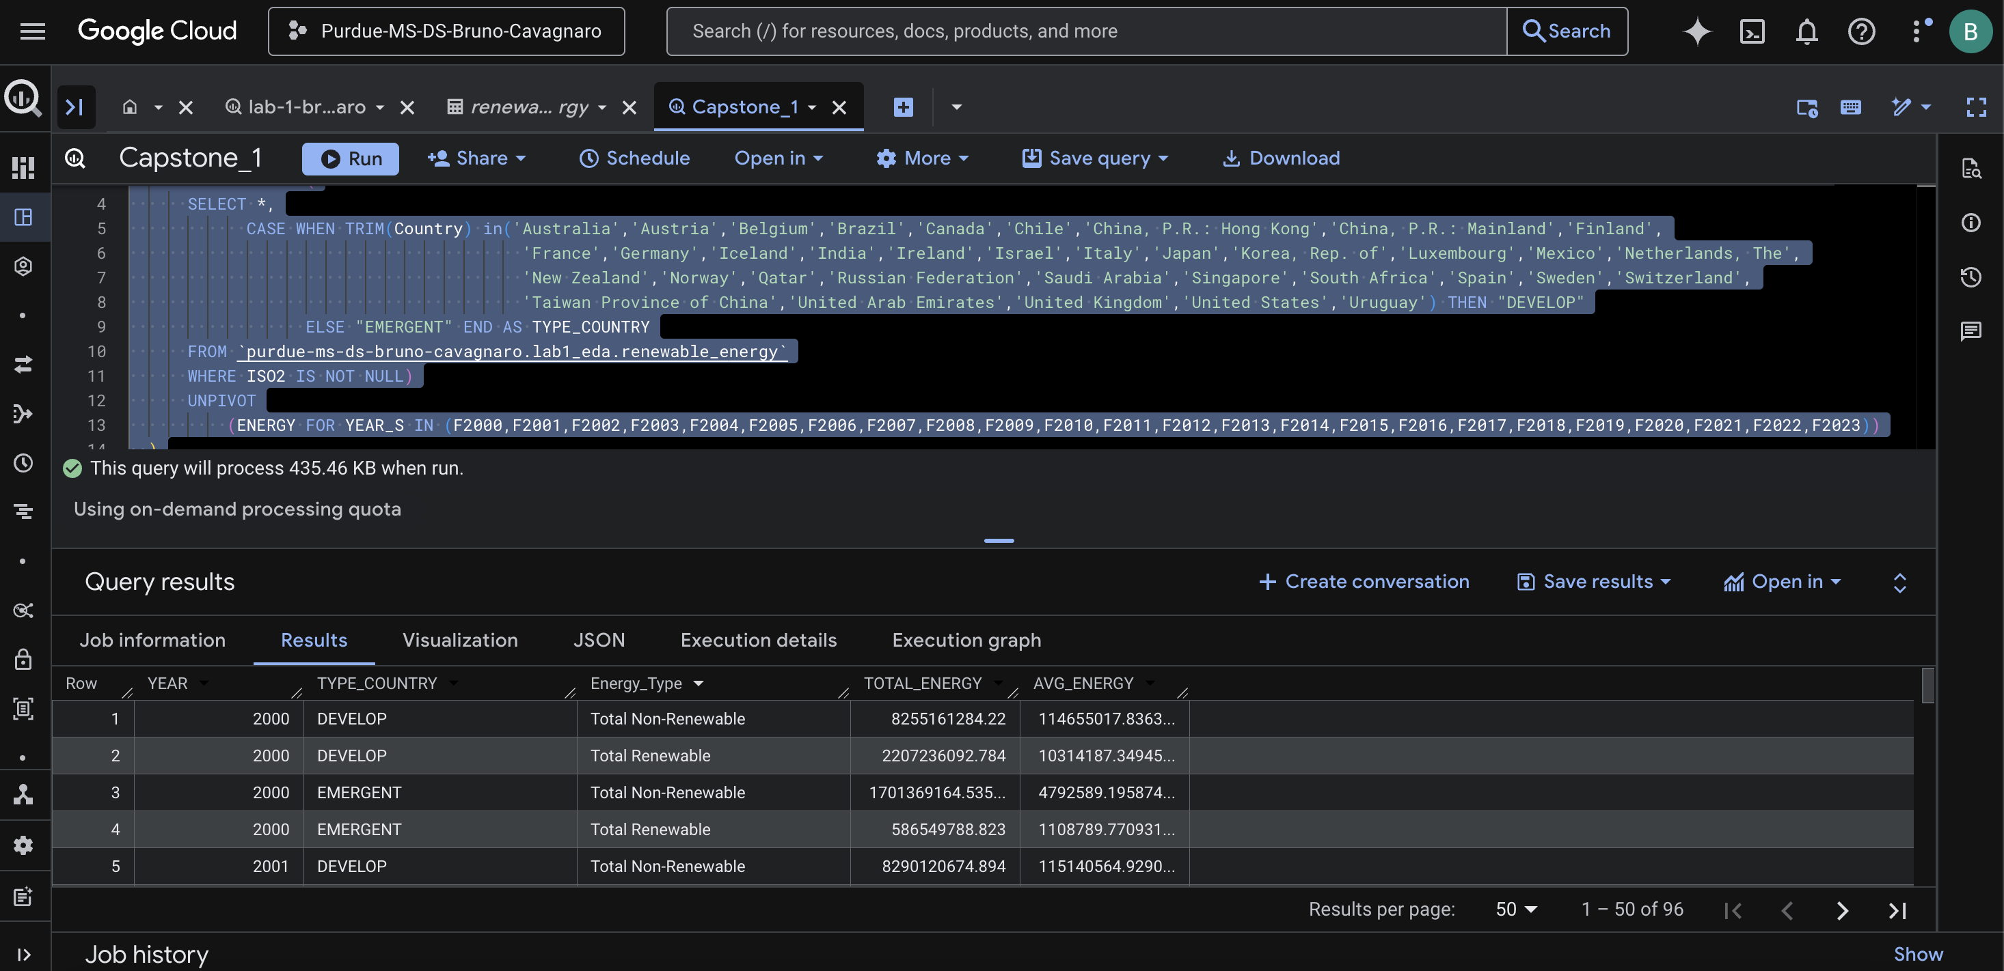

And the results where the following:

