Week 7: Reporting on Skills Development Progress
Due Date: 03/01/2026
Submission Format: Upload to Brightspace
Length: 1–2 pages
Goal
The purpose of this assignment is to report on the progress you made on the skill you aimed to develop in Week 0. If you recall, you were asked to focus on developing additional skills in one of the following core topic areas: “Introduction to Python and Jupyter Notebooks,” “BigQuery + SQL,” and “Data Analysis and Visualization in Python.”
1. Selected Area of Focus
Which skill area did you spend time developing throughout the course? (Check one)
- [ ] Introduction to Python and Jupyter Notebooks
- [ X ] BigQuery + SQL
- [ ] Data Analysis and Visualization in Python

2. What Resources You Used
Describe the resources you used to develop your skills in the area you selected. If they are course resources, you can refer to them by name. If you found other resources, you need to include links and descriptions here.

As I mention during the Week 0 of the course:
- My strongest areas include Python programming, pandas-based data analysis, SQL querying, research writing, and project planning. These skills provide a solid foundation for engaging with big data tools and completing the capstone project.
- I would like to improve my proficiency with Google BigQuery, cloud-based data workflows, and scalable data pipelines. Additionally, I aim to strengthen my data visualization skills to better communicate insights.

To develop these skills, I relied primarily on the course modules and Google Cloud labs, which provided structured hands-on experience with Google Cloud Storage, BigQuery, and Dataflow. I created Cloud Storage buckets, configured APIs, managed IAM permissions, and implemented ETL workflows within the Google Cloud environment.
In addition to course materials, I consulted external resources to reinforce my understanding of cloud data engineering concepts, including the book “Data Engineering with Google Cloud Platform” (https://www.amazon.com/Data-Engineering-Google-Cloud-Platform/dp/1800561326). This resource helped me better understand architecture design, pipeline orchestration, and best practices for scalable data systems.

3. What You Did
Discuss the milestones you set out to accomplish in Section 4 (``Timeline & Goals) of the Week 7: Planning & Intentions assignment which was distributed in Week 0. Did you meet your milestones? If not, what did you accomplish?
Example: "In Week 1, I followed the BigQuery basics lab on Google Cloud Skills Boost and wrote 3 custom queries using the COVID-19 dataset to calculate average cases per month."

I followed the structured seven-week plan I designed at the beginning of the course and successfully completed all planned milestones.
- In Weeks 1–3, I strengthened my conceptual understanding of Big Data principles and APIs while completing quizzes and discussions. This foundation helped me connect theoretical concepts with practical implementation.
- In Week 4, I reinforced my data visualization skills in Python to support exploratory data analysis and storytelling for the capstone project.
- In Week 5, I became comfortable navigating the Google Cloud environment. I created storage buckets, configured service permissions, enabled necessary APIs, and connected Cloud Storage with BigQuery for structured data ingestion.
- In Week 6, I implemented scalable data workflows using Google Cloud tools. I focused on schema validation, data transformation, and troubleshooting pipeline execution issues through log inspection. By the end of this phase, I had a functioning workflow that supported the objectives of my capstone project.
- In Week 7, I refined research questions, finalized this skills development report, and prepared for the capstone presentation.
All milestones were completed as planned, and more importantly, I gained practical confidence in designing and managing cloud-based data systems.

4. What I Learned
Summarize 2–3 key takeaways, concepts, or techniques you independently learned over the last seven weeks.
Example: "I learned how to use `GROUP BY` in BigQuery to analyze trends over time, and how to convert query results into a Pandas DataFrame."

One of the most impactful concepts I learned was the ability to train, evaluate, and deploy machine learning models directly within BigQuery using SQL. Using BigQuery ML, I successfully implemented a k-means clustering model entirely through SQL commands. Being able to train and evaluate a clustering model in minutes demonstrated the power of cloud-native machine learning tools and significantly lowered the barrier between data analysis and modeling.
Additionally, I developed a deeper understanding of cloud architecture principles, particularly the importance of data schema design, resource permissions (IAM), and pipeline logging. I learned that a well-designed pipeline is not only about transformation logic but also about governance, monitoring, and debugging through logs.
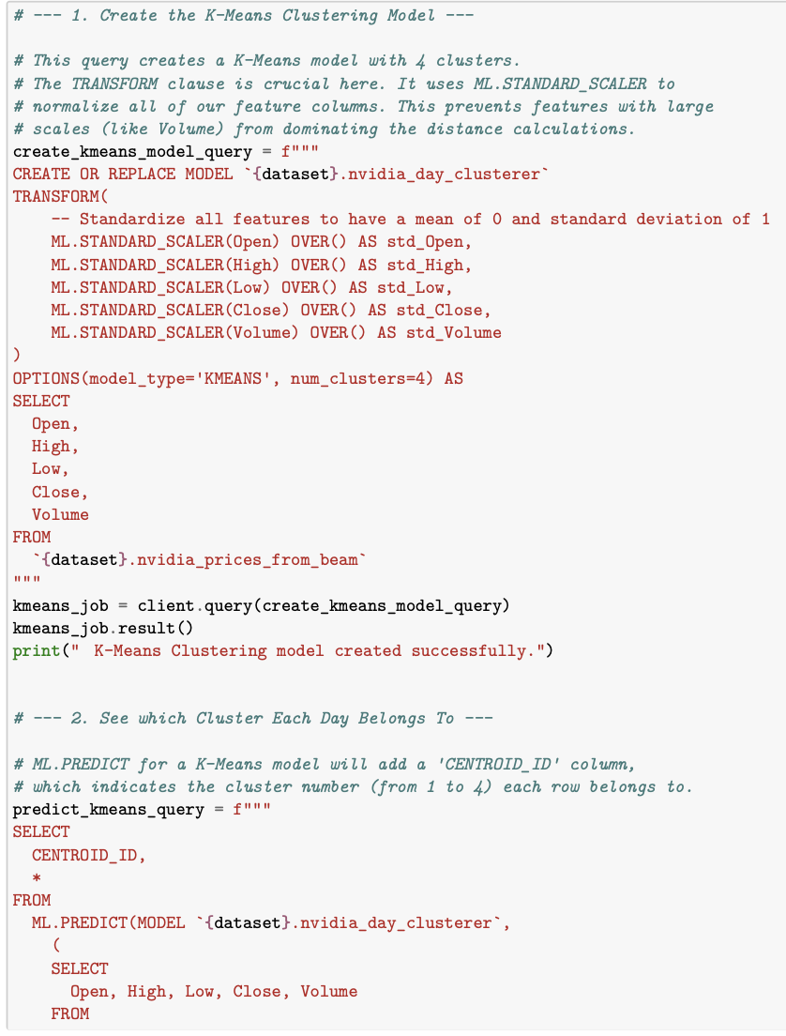

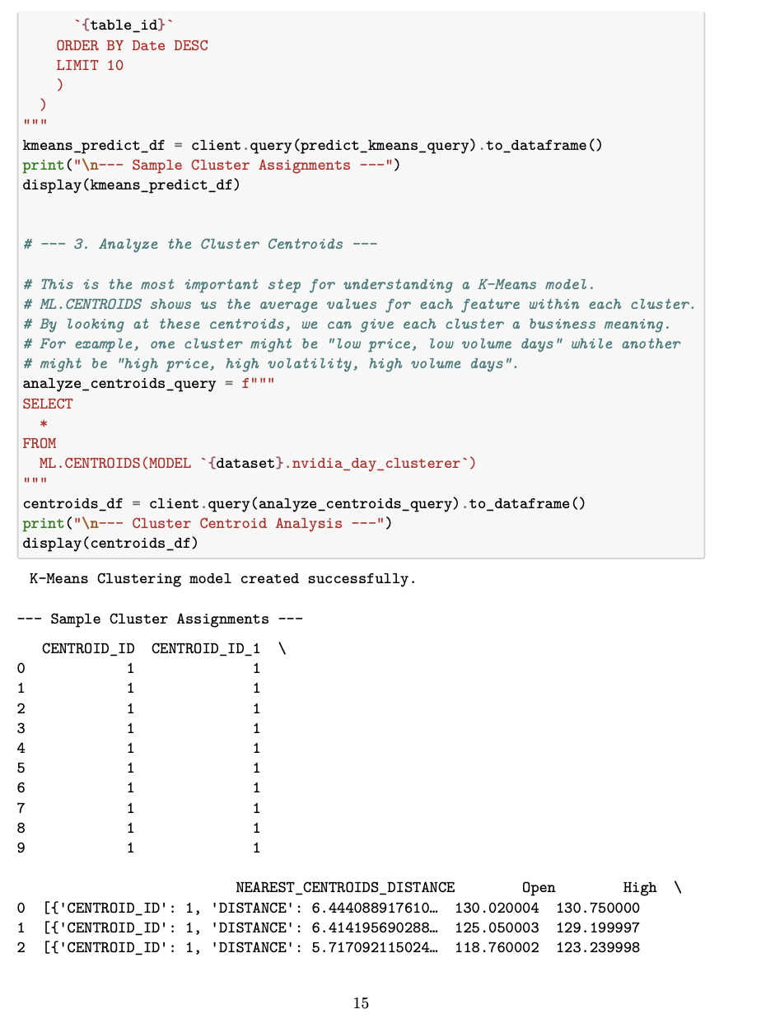

5. Questions or Roadblocks
List anything you found confusing, challenging, or are still trying to figure out. This helps instructors improve this assignment for future course offerings.
The most challenging aspect of this process was configuring data pipelines correctly. Ensuring proper data formatting, maintaining schema consistency, and correctly setting permissions across services required careful attention to detail. I also learned that reviewing pipeline logs is critical, as issues are often only detectable through detailed inspection rather than surface-level checks.

6. Final Grade
What letter grade would you assign to your efforts with respect to this assignment? Learning new skills is hard, especially when you are working independently. Looking back to the plan you laid out for yourself in Week 0, do you feel as though you tried your best to accomplish what you set out to do?

Reflecting on my initial goals, I believe I demonstrated consistent effort, technical implementation, and successful milestone completion. More importantly, I transitioned from understanding BigQuery conceptually to confidently implementing cloud-based data solutions independently. Based on the depth of learning, hands-on execution, and successful completion of my objectives, I believe an A+ accurately reflects my performance and commitment throughout the course.

