# *Assigment* 1 - Good and bad design

Tomás Silveira 60734

In this assignment were chosen two examples of designs, one from the daily life of a group of students and young adults, and another from the global network of multiple options that are currently being used in the web.

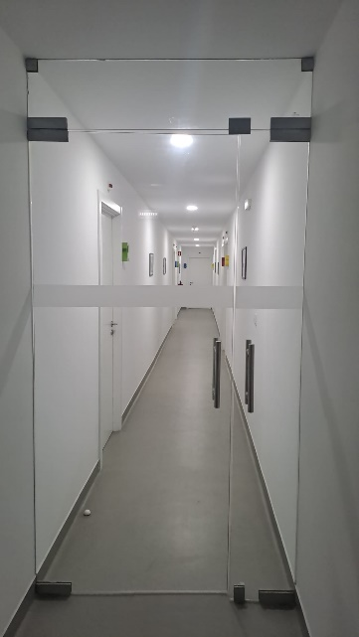Namely, on the image on the right, a glass door is separating a corridor in a residential space, this door is supposed to separate the male corridor from the main hall and the female corridor, giving them privacy and minimizing the noise made by either side.

As is made apparent in the image, it does not maintain a great degree of privacy to its users, no security because of the lack of locks and the noise passes trough like there is no object in between.

These deficiencies make it a bad design for this purpose, making a better fit for the general security and privacy of the users another more solid door that could be opaque and present a small window to minimize the privacy issues.

As for the good option in this research assignment, it was chosen the Trello web page, this web page is used by over 4.75 million users*, being a “[…] flexible work management tool where teams can ideate plans, collaborate on projects, organize workflows, and track progress in a visual, productive, and rewarding way.”*, this website makes use of intuitive tools such as customizable tags and identifiers of each list and item of the workflow phases, as shown in the picture below, besides that, every list and item is draggable to make the organization of contents more fluid. Every aspect of it is understood by hovering the cursor on the shown elements, indicating that they could be interact with.

Fig. 2 – Trello Website (Good Design)

Fig. 1 - Glass door (Bad Design)