

CCT College Dublin Continuous Assessment

Programme Title: | HDip in Science in Data Analytics for Business (FT)
Cohort Details: | HDip in Data Analytics - FT, Semester 1
Module Title(s): | Data Preparation  Machine Learning
Assignment Type: | Individual | Weighting(s): | 50%
Assignment Title: | Integrated CA2
Lecturer(s): | David McQuaid  Muhammad Iqbal
Issue Date: | 1st Oct 2024
Submission Deadline Date: | 17th Nov 2024
Late Submission Penalty: | Late submissions will be accepted up to 5 calendar days after the deadline. All late submissions are subject to a penalty of 10% of the mark awarded.  Submissions received more than 5 calendar days after the deadline above will not be accepted and a mark of 0% will be awarded.
Method of Submission: | This assignment is submitted via Moodle.
Instructions for Submission: | You must submit a zip file containing a Word with the report and a Jupyter  Notebook file with the code and the outcome
Feedback Method: | Results posted in Moodle gradebook
Feedback Date: | After the approval from the exams board
Student name | BRUNO ERNESTO ESQUIVEL VAZQUEZ
Student number | 2024499

Data Preparation.
Understanding the data we are working with is an essential part of the analysis and, most of the time, the most time-consuming task for a Data Scientist.
The dataset "biking_dataset" contains 900 observations and 8 features (4 numerical and 4 categorical). There are approximately 90 missing values, and there are no duplicates within the data. We decided to fill the missing values with the mode for the categorical variables and the mean for the numerical variables. We chose the mode and mean because the distribution of the variables is not significantly affected after this imputation. Additionally, the pattern of missing values appears to be random, as we can see in the following graph (the white lines represent the missing values).
Distribution of Missing Values
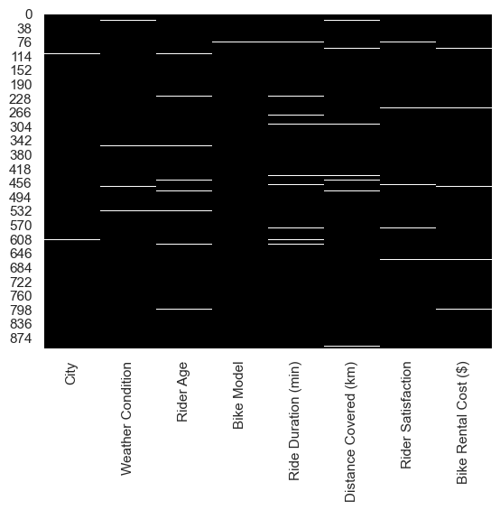
The dataset shows a moderate level of variability across all four numerical features. The average Rider Age is 39.26 years, with riders ranging from 18 to 60 years old, and 50% of the riders are between 29 and 50 years old. Ride durations have an average of 62.23 minutes, with a wide range from 5 to 120 minutes, and 50% of the rides last between 33 and 92 minutes. The distance covered during rides averages 20.13 kilometers, with values ranging from 0.51 km to 39.87 km, and 50% of rides cover between 11.04 and 29.03 kilometers. Rental costs for bikes average $26.58, with a range from $7.33 to $48.38, and 50% of the costs are between $19.28 and $33.94. Overall, the dataset reflects substantial variation in ride duration, distance, and rental cost, while rider age shows a more consistent distribution.
Distribution of Numerical Variables
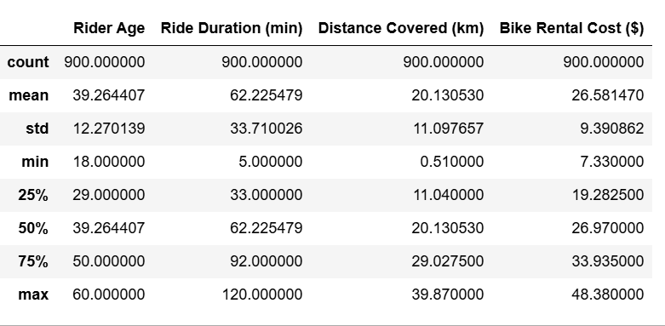

There are six unique cities, with London being the most frequent, appearing 186 times. In terms of weather condition, the dataset contains four unique types, and rainy is the most common, recorded 245 times. The bike model column has three unique types, with the mountain bike model being the most frequently used, appearing 298 times. Finally, the rider satisfaction variable has three unique categories, and High satisfaction is the most reported, occurring 319 times. This suggests that London is the most represented city, rainy weather is the most frequent, mountain bikes are the most popular choice, and riders generally report high satisfaction.
Distribution of Categorical Variables
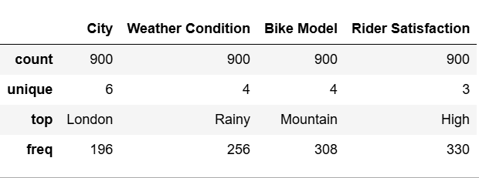
It is important to examine the frequencies of the categories in each categorical variable, as this could affect our analysis if the sample contains more data from a specific category.
The next graph shows the number of observations we have per city, as we can see there are more than 150 observations per city except for the city of Dublin, with only over 25 observations, this is something we need to keep in mind if we want to do a statistical analysis.
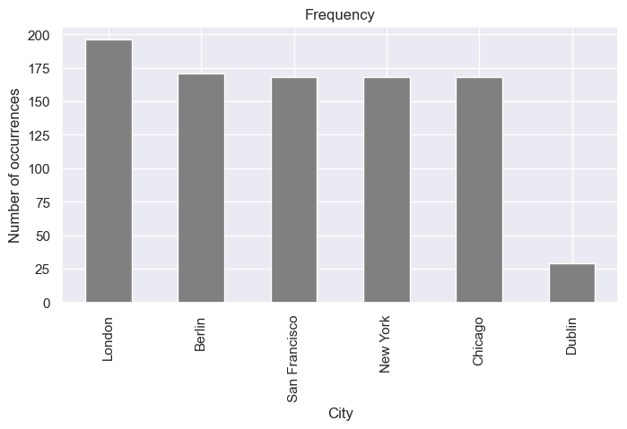
In terms of weather conditions rainy and sunny are the most popular within the dataset, we can observe that the number of observations per category is balanced, there is no category with just a few observations.
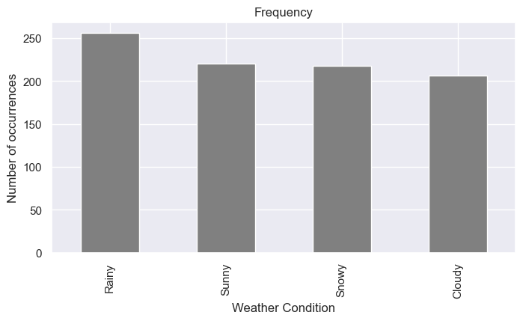
A similar situation applies to the bike model, with nearly 300 observations for each type of bike. Again, we can consider this a good sample of our population in terms of the bike model.
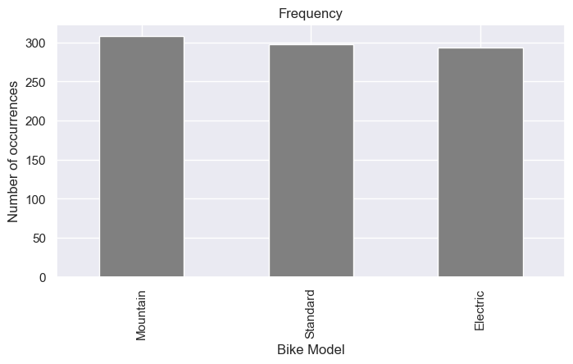
Rider satisfaction contains a good number of observations per category, which will help us conduct a better analysis, as we have a generally balanced dataset
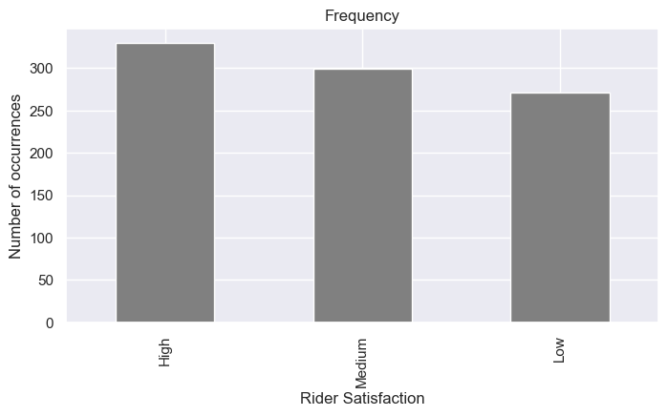
Behavior of numerical variables across categories.
A box plot provides a clear summary of the distribution of a numerical variable, showing the median, quartiles (25th and 75th percentiles), and potential outliers. This helps in understanding the central tendency and spread of the data across different categories. That’s why we are going to use this type of graphic to analyze the behavior of numerical variables across categories.

Numerical variables across cities
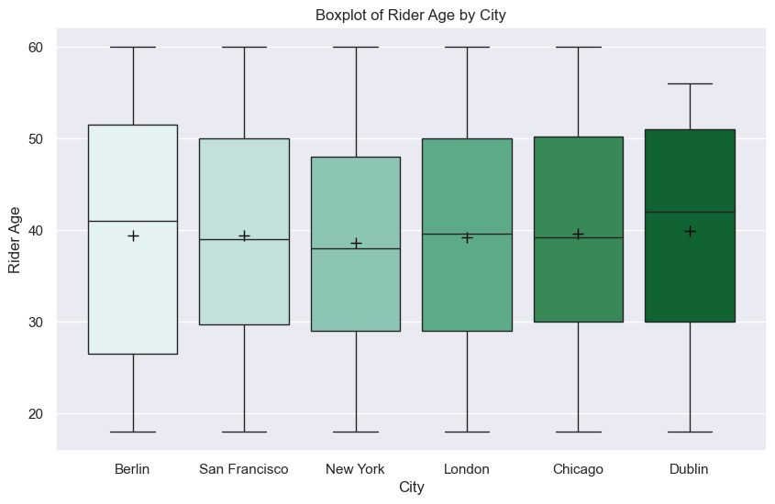
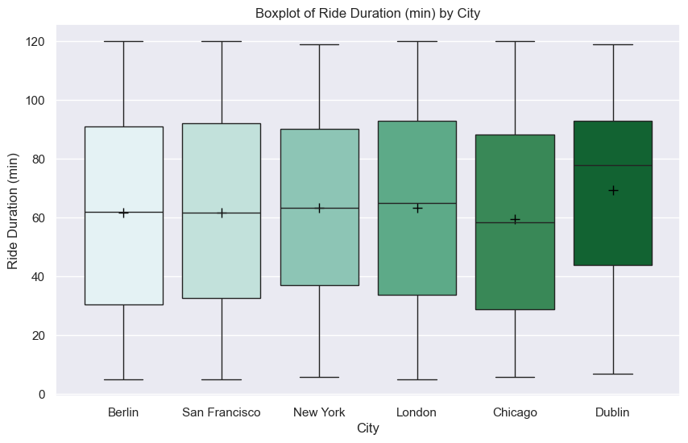
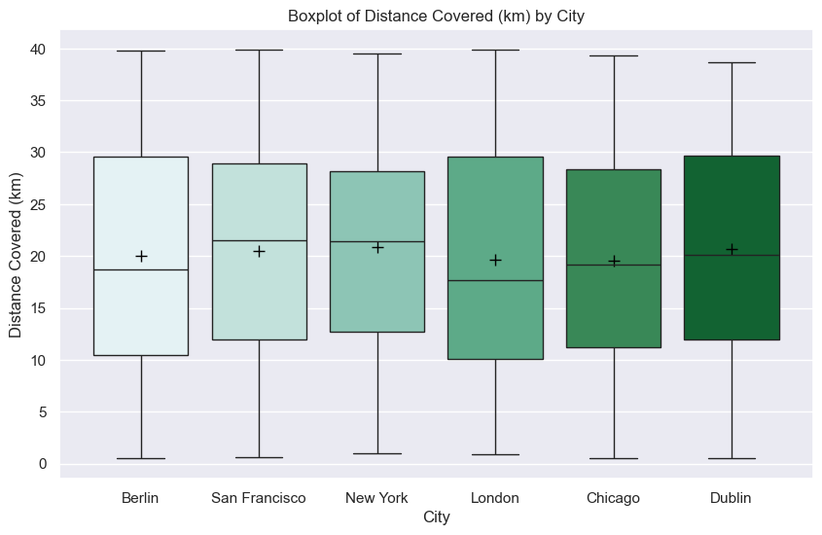

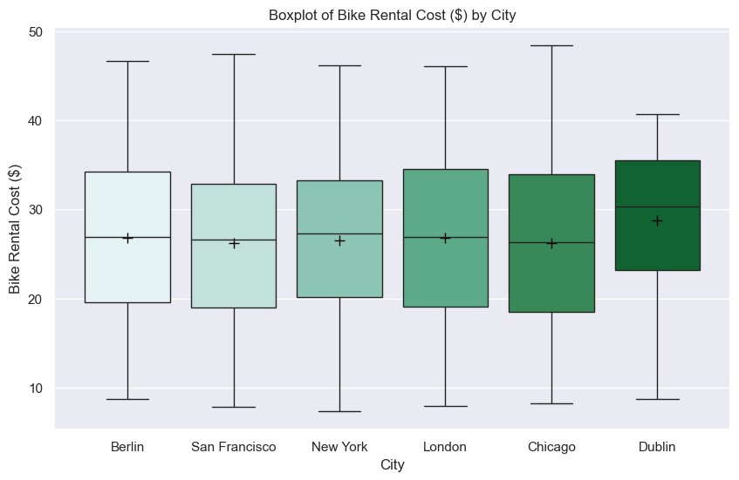
According to the data, the average age of the users across cities is 39 years. Berlin has the widest age range, with users both under 30 and over 50 using the bikes. Rides in Chicago tend to be shorter than the average, while rides in Dublin tend to last longer than the average. The bike rental cost is higher in Dublin, while the cost in the other cities is around $26.
Numerical variables across weather conditions
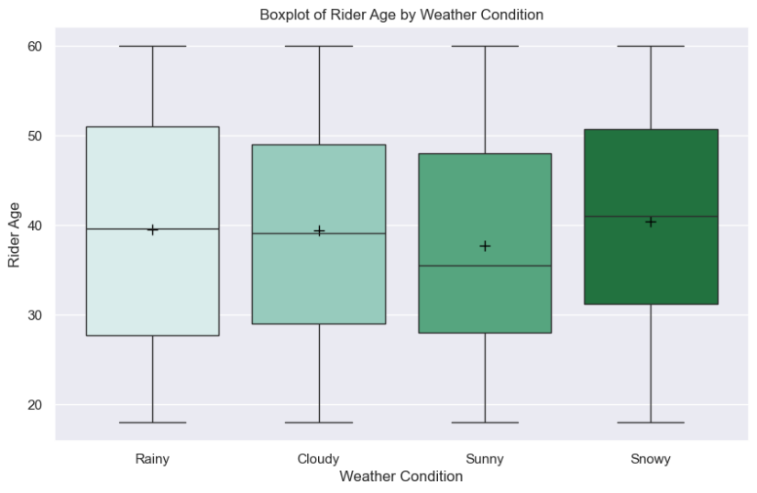
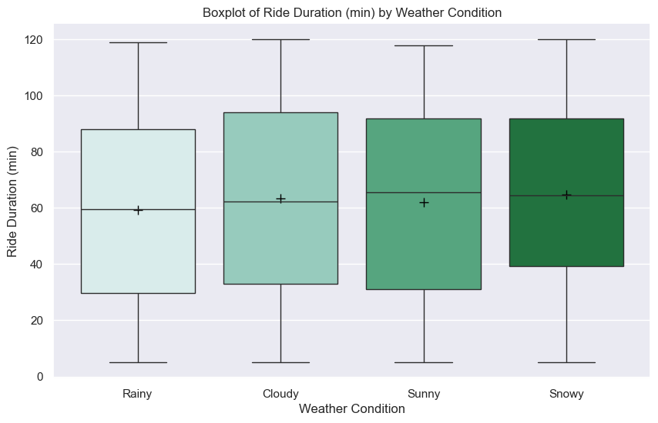
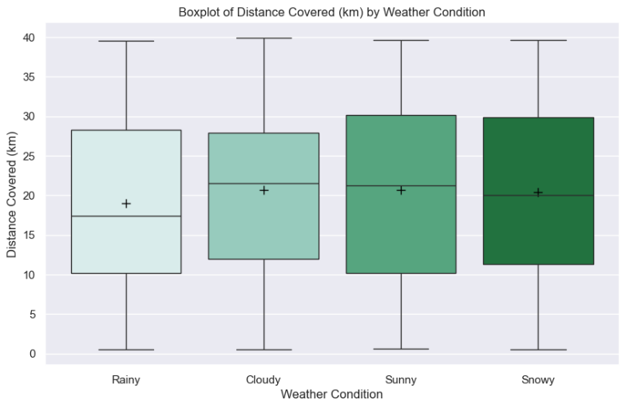
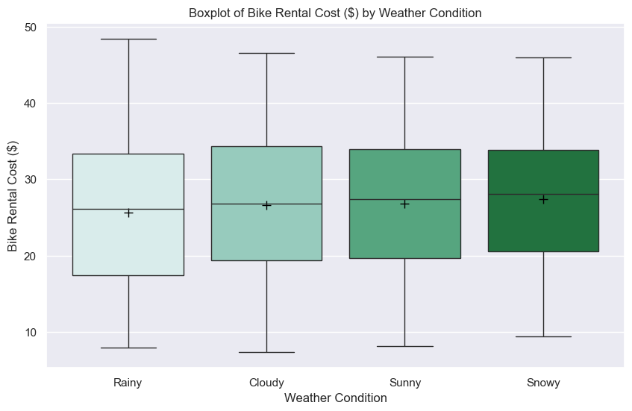
It seems that younger people prefer to use bikes on sunny days, while older people tend to use them when it’s raining or snowing. Rides tend to last slightly less when it’s raining, but surprisingly, the weather does not seem to affect the duration of the ride or the distance. It appears that the weather is not a variable that significantly influences the cost of the bike rental.
Numerical variables across bike models
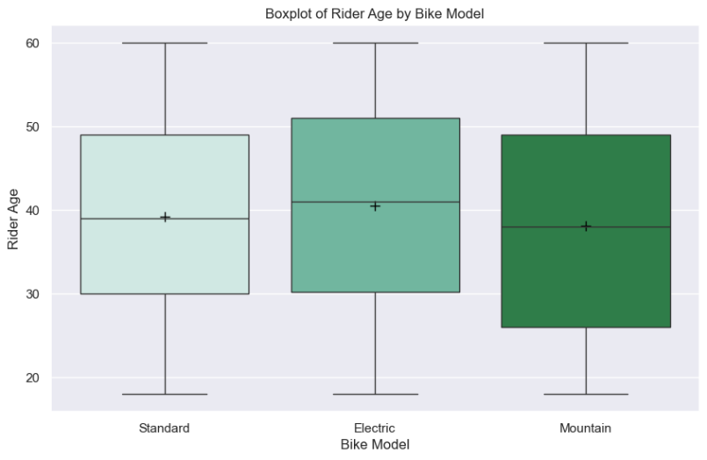
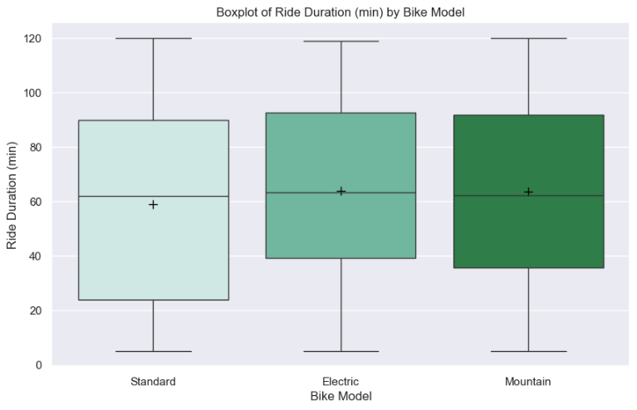
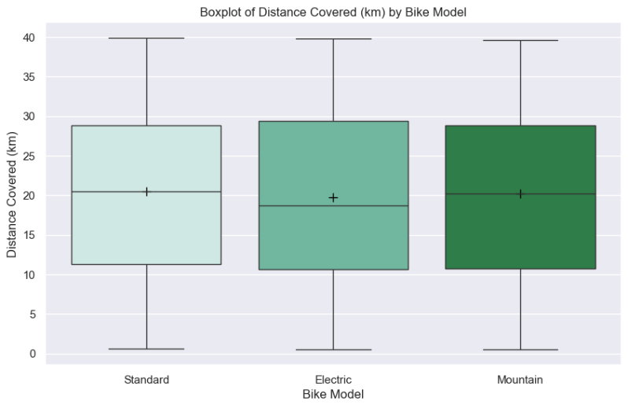
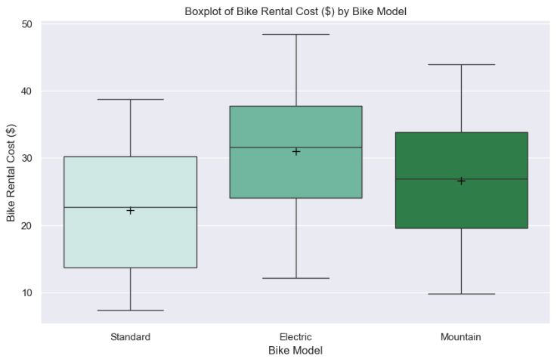

There is a slight preference for electric bikes among older people, while younger people tend to prefer mountain bikes. The data shows that there is no significant difference in the distance covered by different bike models, but the rental cost is higher for the electric model, whereas the standard model is the cheapest.
Numerical variables across rider satisfaction
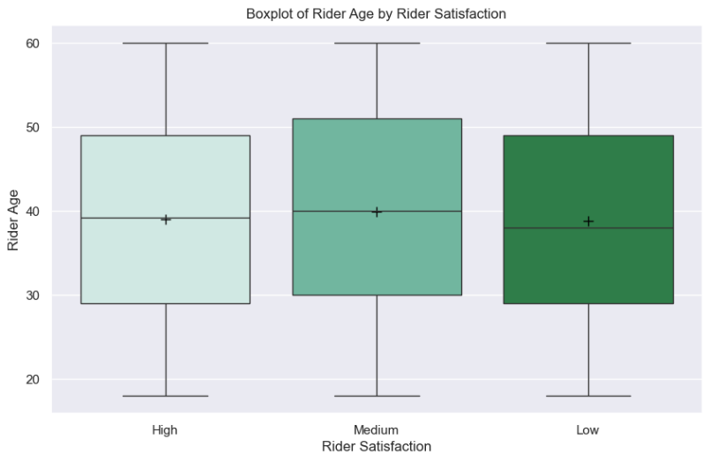
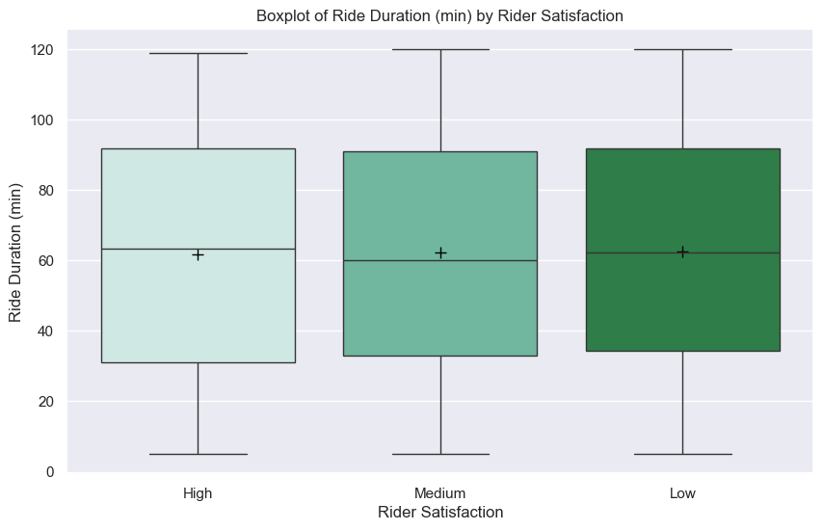

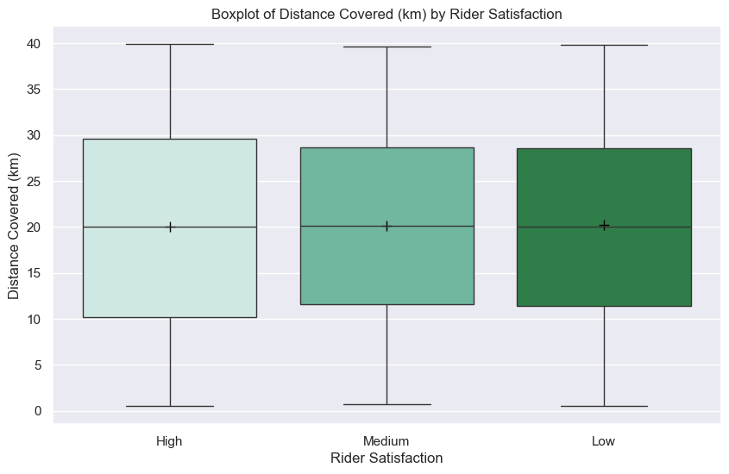
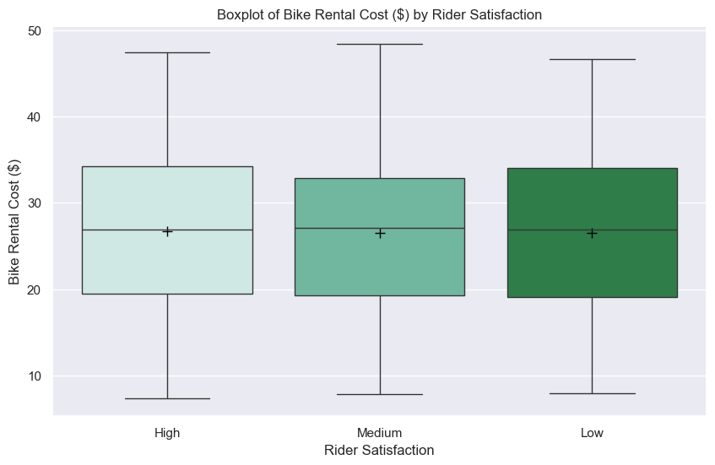
According to the data, it is difficult to determine a single factor that affects user satisfaction. Based on the boxplots for the categorical variables, there is no significant difference between the categories.

Correlation.
Doing a correlation heatmap of numerical variables we can see that there is a linear relationship between the rental cost and the duration of the ride.
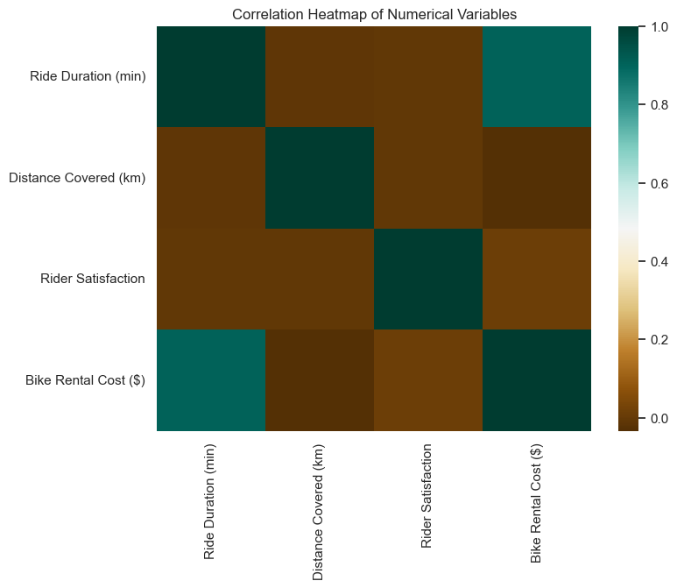

Rental cost vs Ride Duration
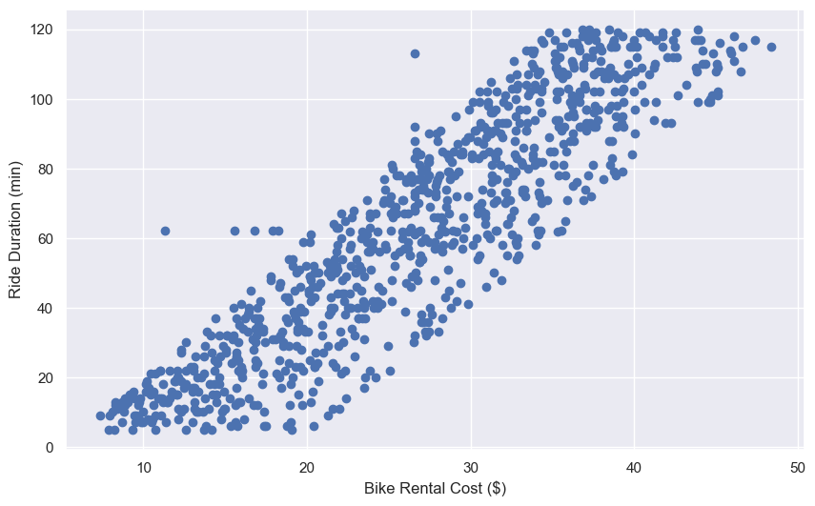
Principal Component Analysis (PCA) and Linear Discriminant Analysis (LDA) are both dimensionality reduction techniques. PCA is an unsupervised technique used to retain as much variability (information) as possible. It finds the directions (principal components) that maximize the variance in the data. In contrast, LDA is a supervised technique used to maximize the separability between different classes. LDA seeks to find the boundaries that contains the classes.
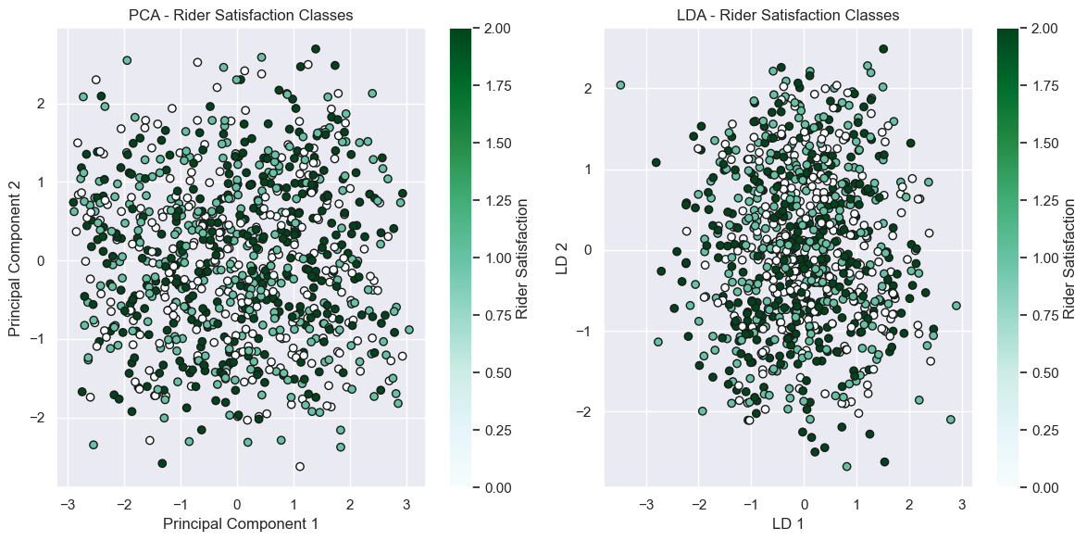
After performing PCA and LDA and comparing the separation of classes for rider satisfaction, we couldn't find clear classes within the data. The classes might be too similar in their distributions, making it hard for LDA to separate them effectively.
Machine Learning.
Unsupervised learning will be used to find patterns in the data. We will not use supervised machine learning because the objective is to identify patterns in customer behavior that can help improve operations, customer satisfaction, and pricing strategies. By understanding customer behavior, we can gain insights into the aspects of the operation that need to be changed or optimized.
If we were to implement a supervised learning algorithm for predicting rental cost, we found that two variables, ride duration and bike model, have a strong relationship with this variable. However, our primary goal is to extract insights into customer behavior, which is why we chose an unsupervised learning approach instead.
Our goal is to identify meaningful clusters within the data that can provide deeper insights into how different segments of users interact with various bike models under different weather conditions. Specifically, we aim to understand the patterns in how long users typically use each bike model, and how these patterns might vary depending on the weather. By discovering these clusters, we can uncover specific user behaviors and preferences, which can help optimize bike distribution, improve customer satisfaction, and inform operational strategies.
k-Means Clustering
K-means clustering is one of the simplest and most commonly used clustering algorithms. It tries to find cluster centres that are representative of certain regions of the
data.

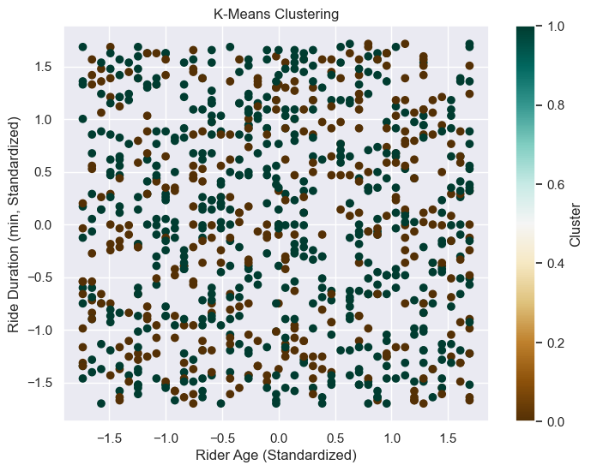
We applied K-means clustering using two numerical features in an attempt to identify any distinct classes within the data. However, it appears that the classes are overlapping, making it difficult to identify any clear patterns. This overlap suggests that the data may not have a natural or well-defined grouping structure in the selected features, or that the features used do not sufficiently differentiate between potential groups. In such cases, the clustering algorithm struggles to separate the data points into meaningful clusters, as K-means relies on the assumption that clusters are distinct and separable based on the selected features. The overlapping could be due to a variety of factors such as high similarity between data points, the need for more relevant features.
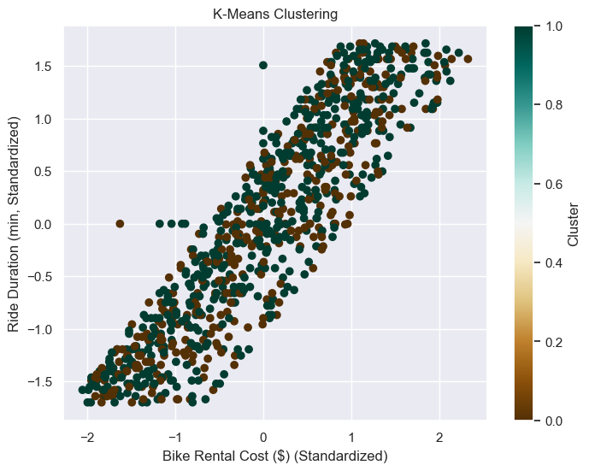

We changed the numerical variables that were used and we found a the same linear relationship between ride duration and bike rental cost, but the classes don’t seem to be clearly separated.

The Elbow Method is a popular technique used to determine the optimal number of clusters (K) for a K-means clustering algorithm. It involves plotting the within-cluster sum of squares (WSS), also called inertia, against the number of clusters. The goal is to identify the point at which the addition of more clusters doesn’t result in a significant reduction in the WSS. This point is often referred to as the "elbow" of the curve.

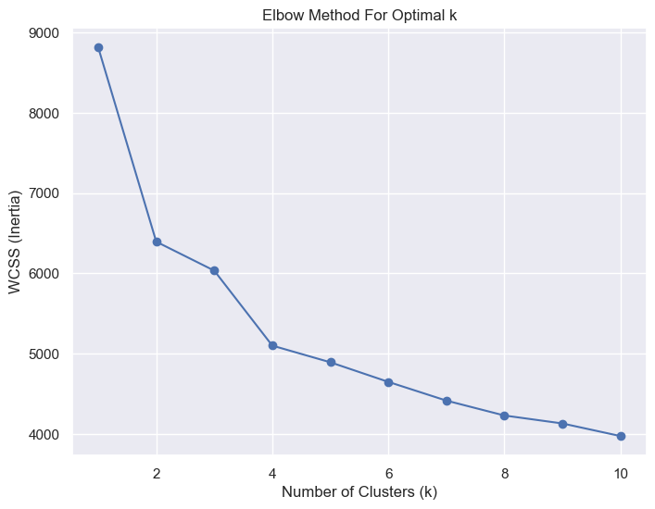
"Graphically, we can observe that the point where the curve bends sharply, around the number 4, is considered the 'elbow.' This point represents the optimal value for the number of clusters in the K-means clustering algorithm. Prior to this elbow, as we increase the number of clusters, the inertia (within-cluster sum of squares) decreases rapidly, indicating that the clusters are becoming more distinct and well-defined. However, beyond this point, the decrease in inertia becomes much slower, suggesting that adding more clusters does not significantly improve the model's ability to reduce the variance within each cluster. Therefore, the number of clusters at the elbow, in this case, 4, provides a good balance between model complexity and performance, making it the best choice for the number of clusters in this scenario.

K = 4
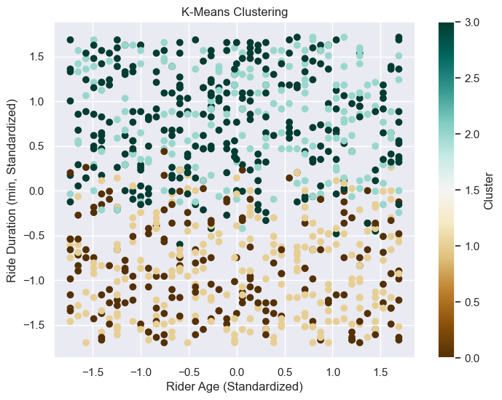
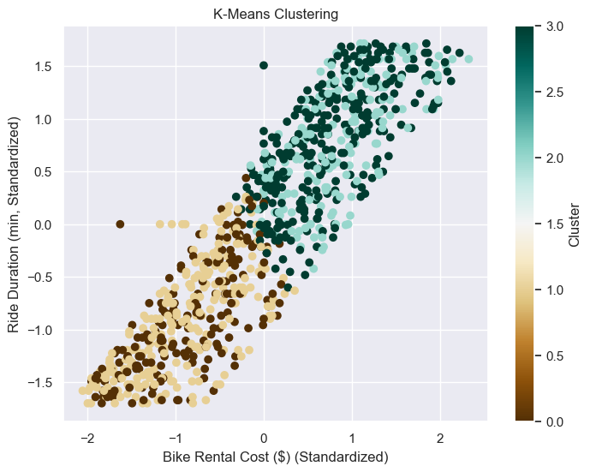

In the context of K-means clustering, the "classes" represent the distinct clusters or groups that the algorithm identifies in the dataset. These clusters are formed based on the similarities between data points, and each data point is assigned to a particular cluster.
The resulting classes (clusters) after using the best number of clusters could represent, young users who ride for shorter durations using standard bikes, older users who use electric bikes for longer rides or riders who prefer mountain bikes and have intermediate ride durations.
In the context of K-means clustering, inertia (also known as within-cluster sum of squares) measures the sum of squared distances between each data point and its assigned cluster's centroid. It is a measure of how well the data points fit into their respective clusters.
The average silhouette score is a metric used to evaluate the quality of clustering in unsupervised machine learning, particularly for algorithms like K-means. It provides a way to measure how similar an object is to its own cluster compared to other clusters, giving an indication of how well-separated and well-defined the clusters are.
