**Setting up MATLAB for mini-DREAM**

For the Module 6 and 7 activities, you’ll be using a cloud-based environment for the MATLAB programming language. If you wish to download and install MATLAB on your local computer, you’ll also have access to a trial license until 8/7/18 (though you might also have free access through your institution’s license). Note that **you should not use the local version for the mini-DREAM videoconferences**, as we won’t be able to share the necessary files with you in an easy way. However, for setup and install instructions, scroll down to page 3.

**MATLAB Online Setup**

Start by going to this link:

<https://www.mathworks.com/licensecenter/classroom/SageBio-MLOnline-18/>

You’ll need a MathWorks account to access the cloud environment:

1. Log in using the your MathWorks account information. If you don’t already have an account, click on the **Create Account** link to create one here. If you already have an account, it is not necessary to create a new one.

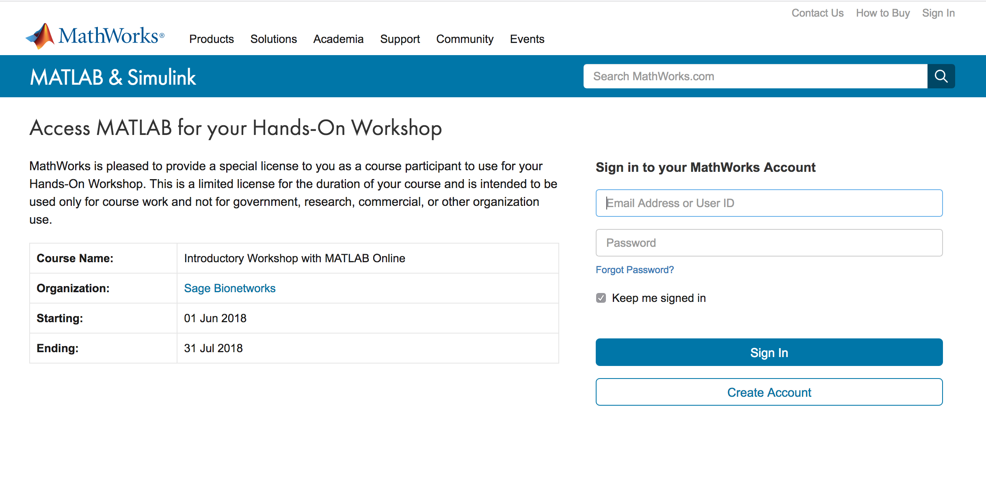

1. After completing the above steps, the “SageBio-MLOnline-2018June” license should be associated with your MathWorks account. To verify this, go to <https://www.mathworks.com/mwaccount/>. You should see the Sage Bio license listed under “My Software.”

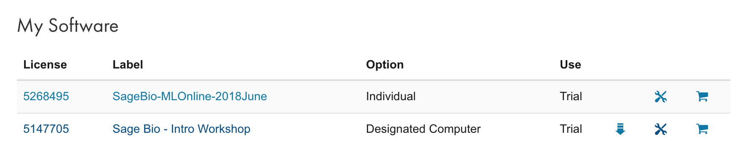

Once you have the associated license, you may run the online version of MATLAB by going to <https://matlab.mathworks.com/>, and logging in with your MathWorks account. That’s it, you’re ready to run MATLAB online! You can also use the same link as above and follow the link that says **Access MATLAB Online**:

<https://www.mathworks.com/licensecenter/classroom/SageBio-MLOnline-18/>

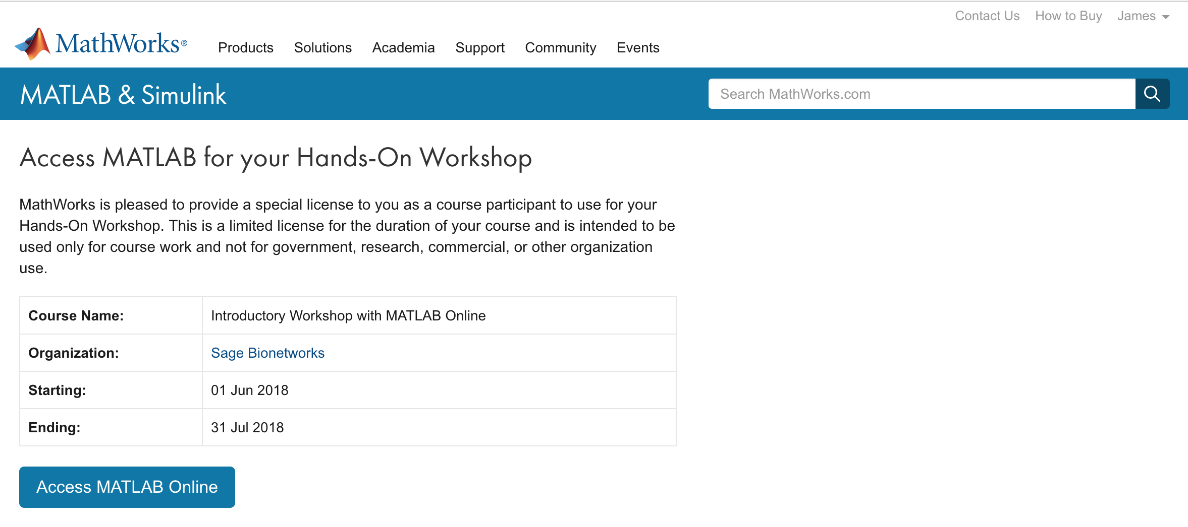

**MATLAB Local Setup**

Start by going to this link:

<https://www.mathworks.com/licensecenter/classroom/SageBio-2018/>

You’ll need a MathWorks account to download and access the software: Prior to clicking the download link provided by MathWorks, create a MathWorks account by going to <https://www.mathworks.com/mwaccount/register>. If you already have an account, it is not necessary to create a new one.

1. Log in using the your MathWorks account information. If you don’t already have an account, click on the **Create Account** link to create one here. You may need to click on the download link again after creating an account.

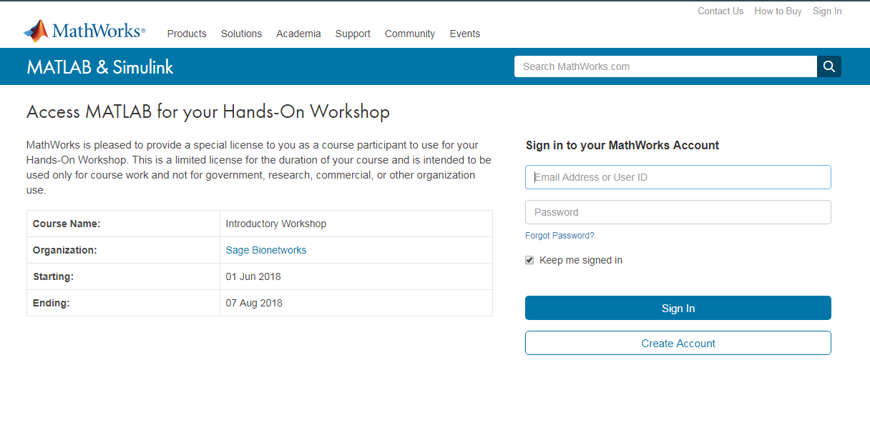

1. After completing the above steps, the “Sage Bio – Intro Workshop” license should be associated with your MathWorks account. To verify this, go to <https://www.mathworks.com/mwaccount/>. You should see the Sage Bio license listed under “My Software.”



1. Once logged in, you should see a link to download the software.

**Note, this link can be used to install the MATLAB application on your local computer, however, there is an online version of MATLAB that can be used without downloading. The online version runs MATLAB within your web browser application and avoids having to install it on your computer. This is the recommended option since it is simpler and code will run faster in the online version. It also takes fewer steps to set up.**

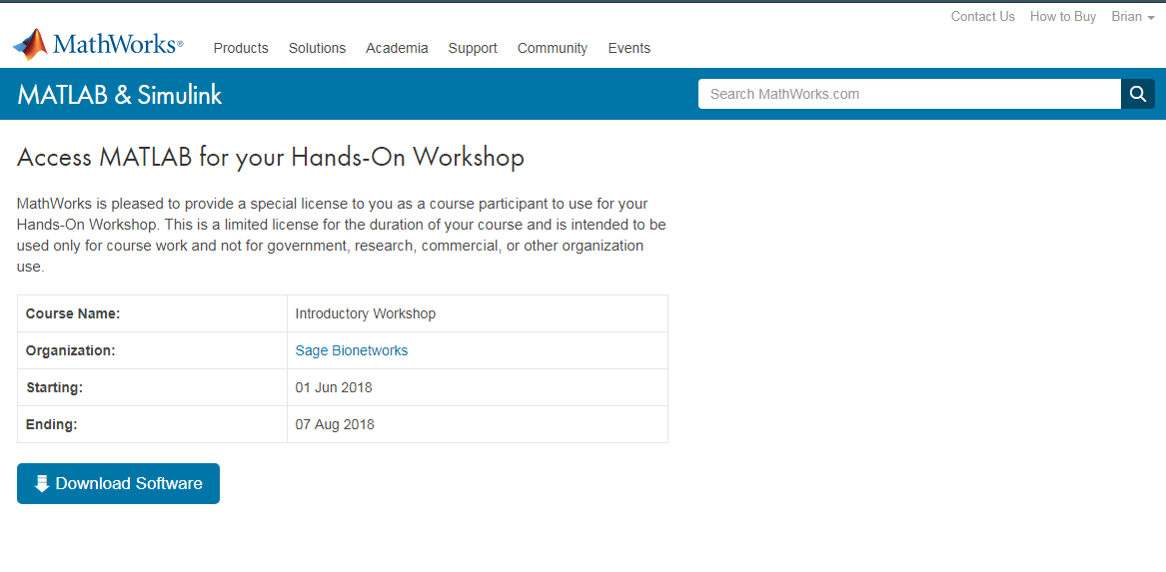

1. Choose the Operating System for your computer and click on it to initiate the download.

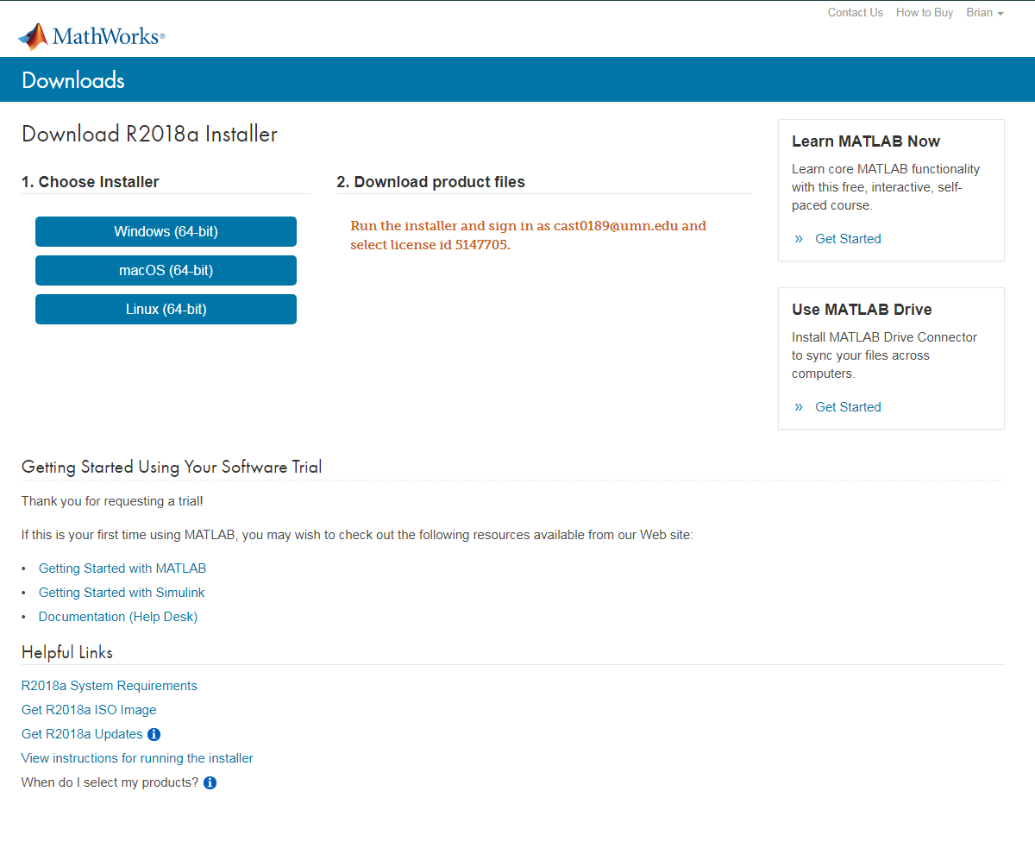

1. Run the installer once it finishes downloading. You may see a screen appear that unzips the downloaded files, this may take several minutes.
2. Once the installer initiates, choose **Log in with MathWorks Account or Install using the Internet** and click **Next**.

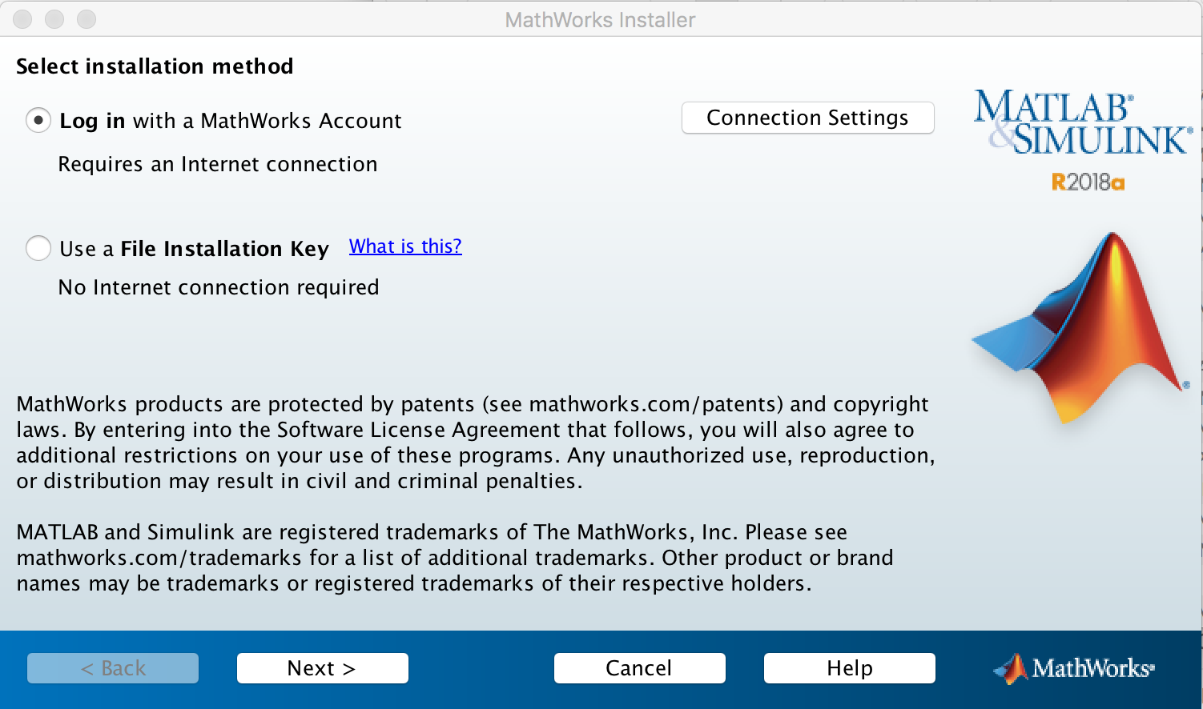

1. Accept the license agreement.
2. Fill in your MathWorks log in information and click **Next**.

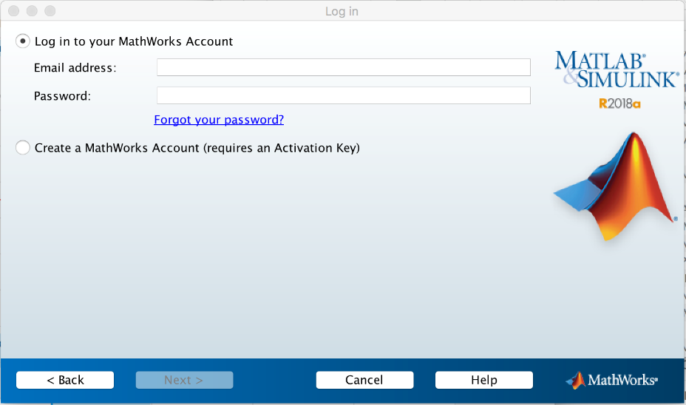

1. Select license number **5147705 Sage Bio – Intro Workshop**. If your institute has a MATLAB license you may see other licenses here, but be sure to select the Sage Bio license to ensure that all required toolboxes are installed.

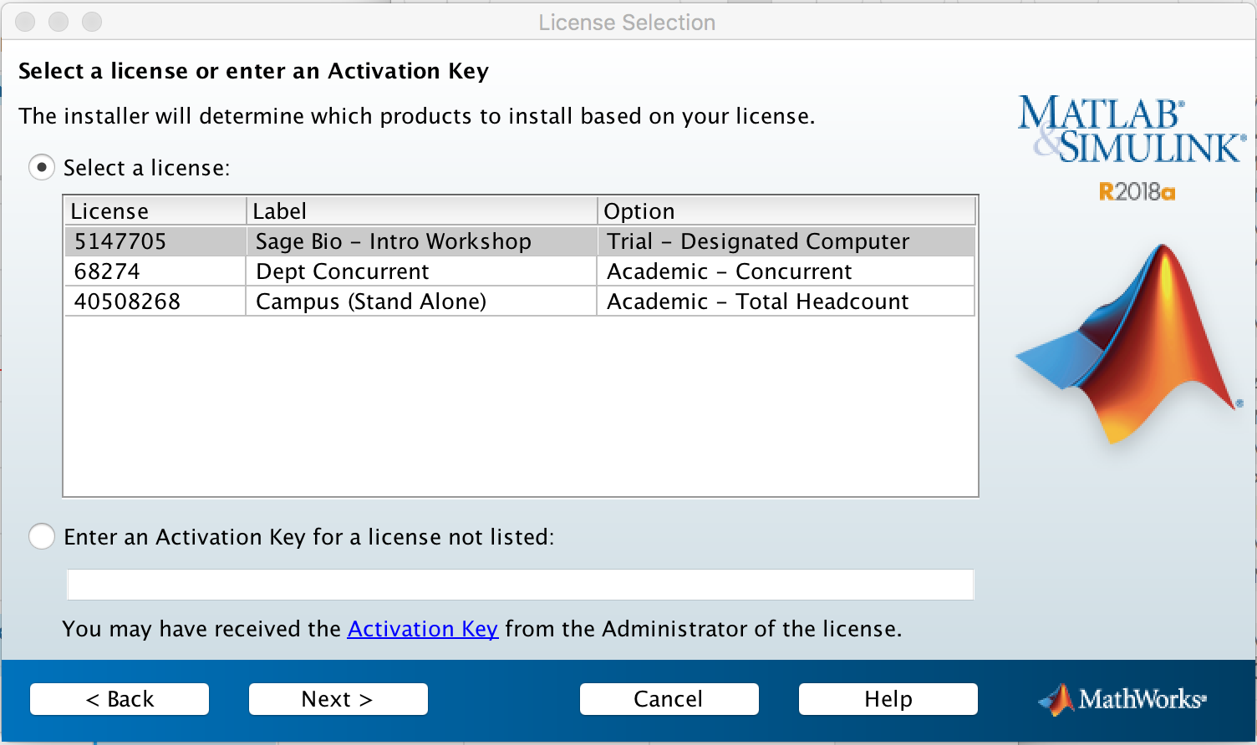

1. Click **Next**.
2. Choose where to install MATLAB and click **Next**.
3. Make sure that all the included toolboxes are selected and click **Next**.

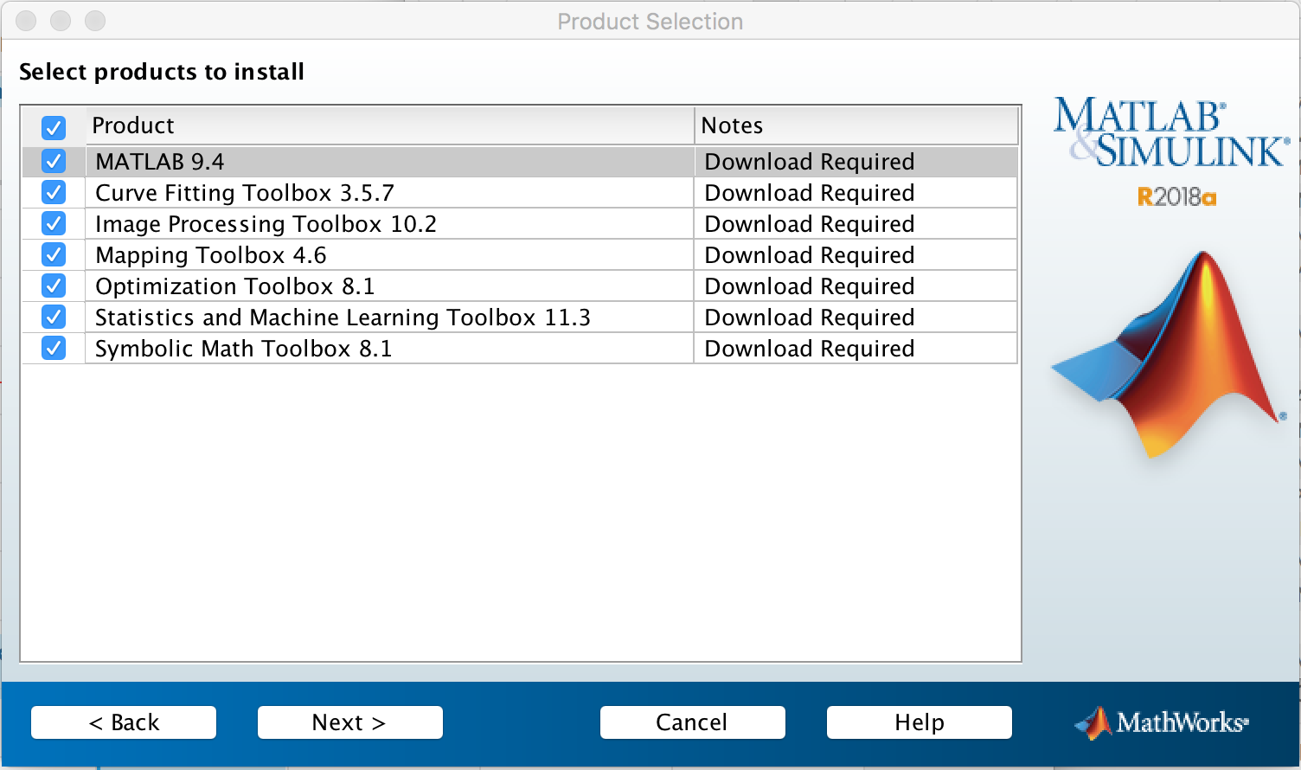

1. On the next screen you may select or deselect any installation options, then click **Next**.
2. Finally, click **Install**.
3. Note, downloading and installing the necessary components may take an hour or more depending on your internet connection and processor speed.
4. Once the installer is finished, select **Activate MATLAB**, click **Next**.

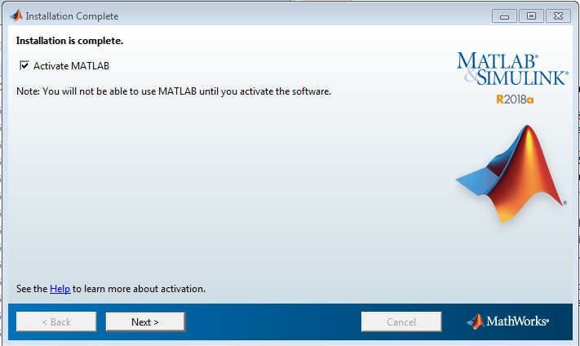

1. Click **Next** again to advance through the activation process.
2. Confirm that the Sage Bio license (5147705) is listed, then click **Confirm**.
3. You should receive a message that “Activation is Complete”, then click **Finish**.

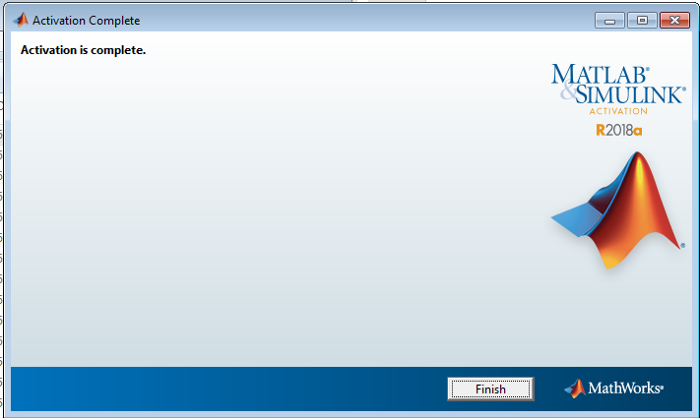

1. You are ready to use MATLAB on your local computer.

**Note, upon startup MATLAB verifies the activated license, therefore you will need an internet connection to run MATLAB on your computer.**