RelAgg_0300_score_Brain_GSE50161

ependymoma 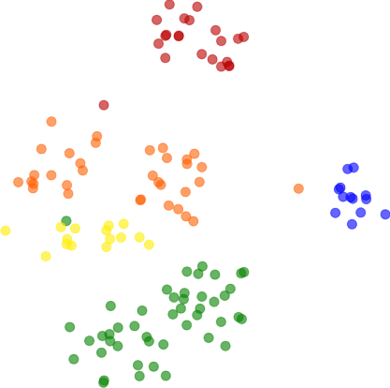

glioblastoma

medulloblastoma

normal

pilocytic_astrocytoma