CSC 285 Encrypting and Decrypting Files

//Encrypt.java

#include<stdio.h>

void main()

{

int c;

clrscr();

while ((c=getchar()) != EOF)

putchar(++c);

//printf("%d ",c);

}/\*main\*/

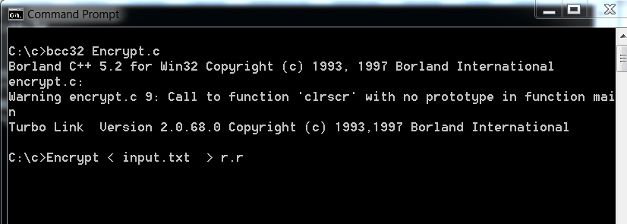

Type r.r

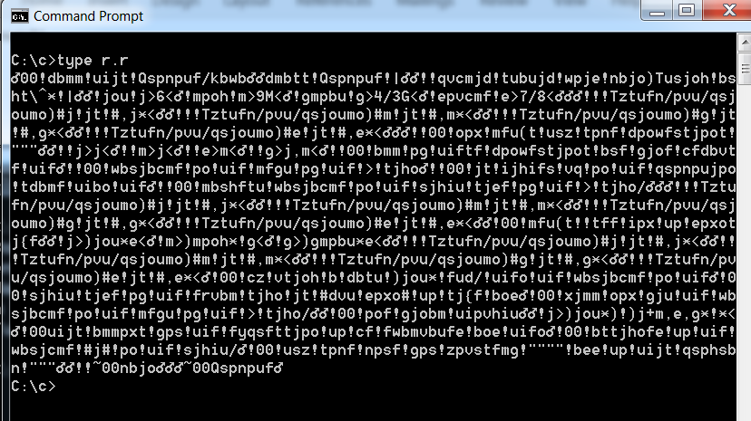

//Decrypt.c

#include<stdio.h>

void main()

{

int c;

clrscr();

while ((c=getchar()) != EOF)

putchar(--c);

//printf("%d ",c);

}/\*main\*/

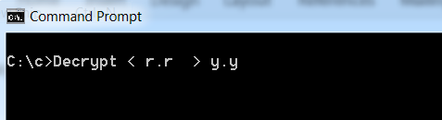

Type y.y

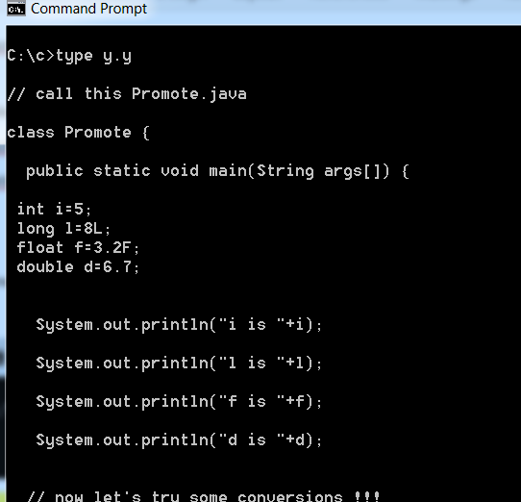

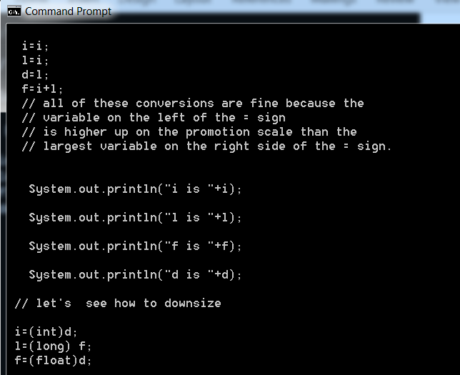

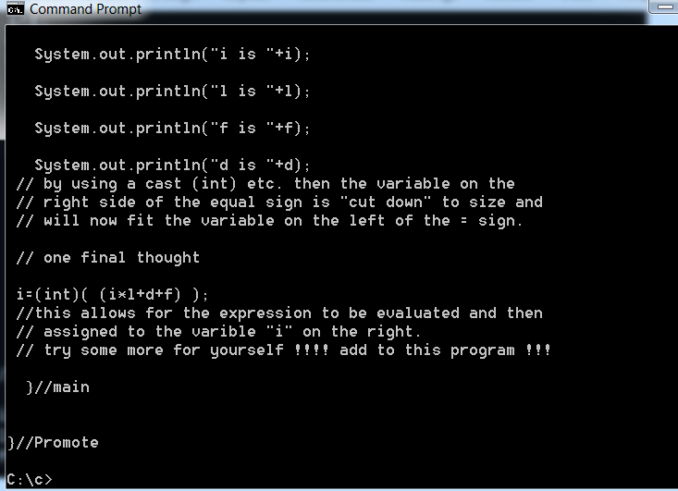

For significant extra credit write 2 java programs.

The first encrypts the input.txt file to another file.

The second then decrypts the encrypted from above into a decrypted file.

Good luck!!!!

Jack

339 222 4247 (cell)

C’est Finis