How to Include a MySQL File in your Project

Go to the following website and download Xampp <https://www.apachefriends.org/download.html>

You need only do this once.

Ok, now that you have Xampp downloaded

Click on the Xampp Icon to start Xampp



The icon looks like a dog bone! Lol!

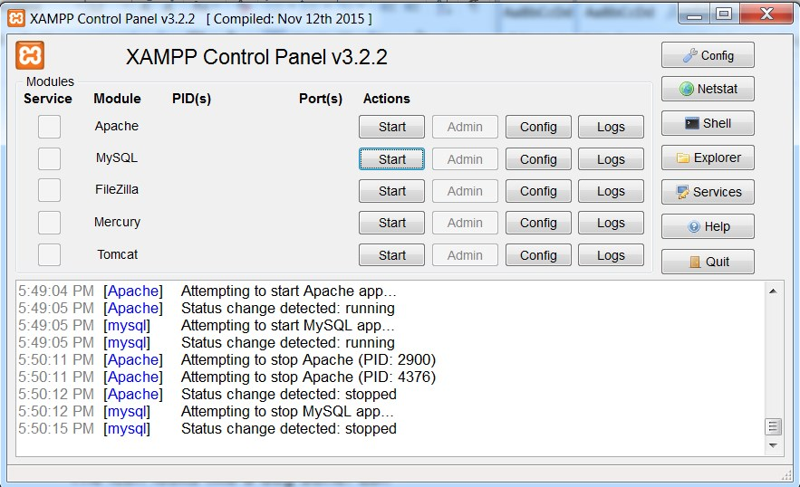

You are now going to click on the first 2 start buttons.

This starts the Apache Server and MySQL which, as you will see in a second, will allow you to work with MySQL files that will be opened on

Port 3306

Ok, let’s click the first to Start Buttons.

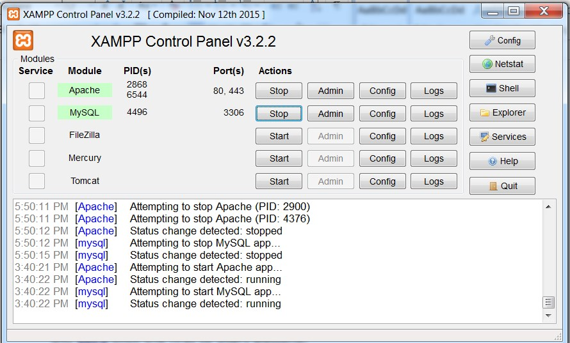

The Start buttons change to read “Stop” and the second button clearly shows

Port 3306 This is the port your program’s MySQL file will use!

Now open a browser and go to this link.

[http://**localhost**/**phpmyadmin**](http://localhost/phpmyadmin)

**What comes up is …….**

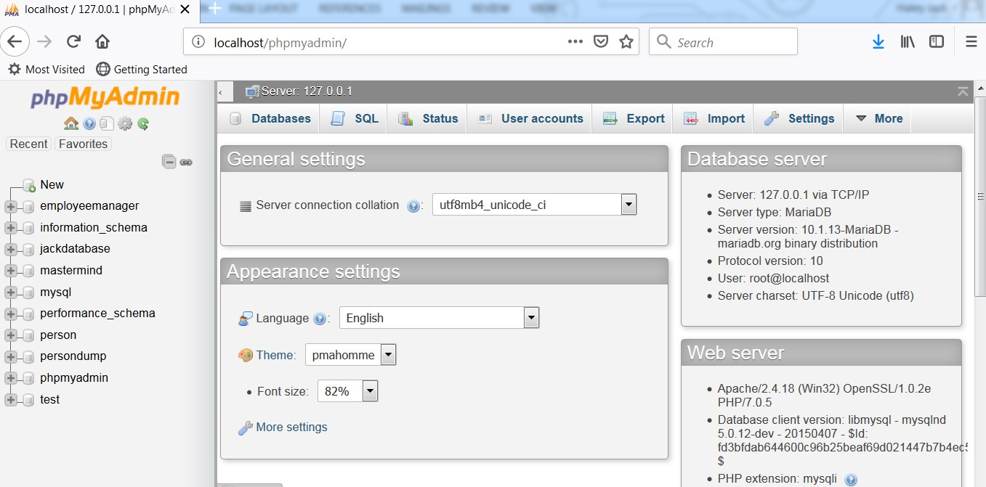

On your left hand side near the top click on the New Button

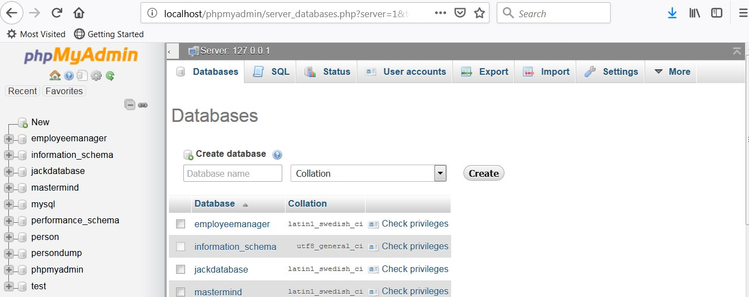

In the middle of the screen go to the “Create database” textbox and type employeemanager

Go to the right side of the same line and press the

“Create” button

Your list on the left should create a line that reads

employeemanager

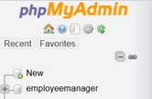

Ok, now click on the employeemanager button that you just created in the list. Look at the image just above to see the employeemanager button.

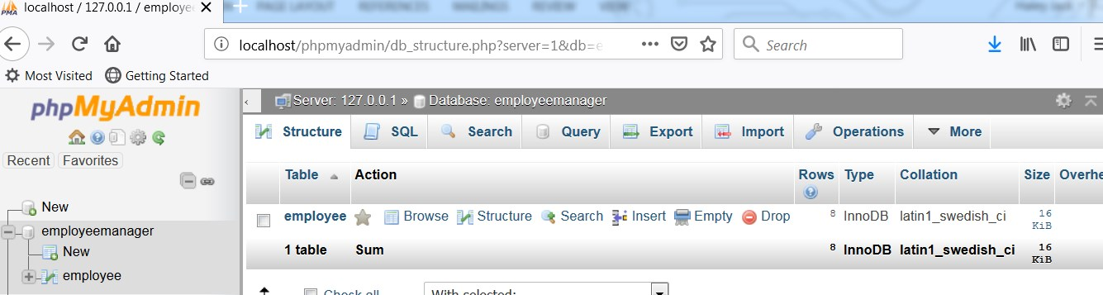

On the right hand side of the screen click on the Import Button

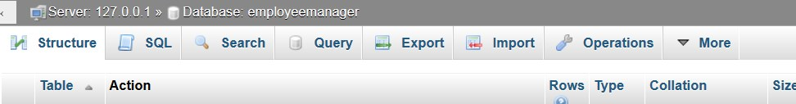

It’s at the top of the image above slightly to the right of Top-Center.

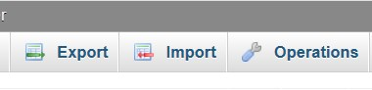

Now click on the Browse button and type in C:\employeemanager\employeemanager.sql

See the image directly below.

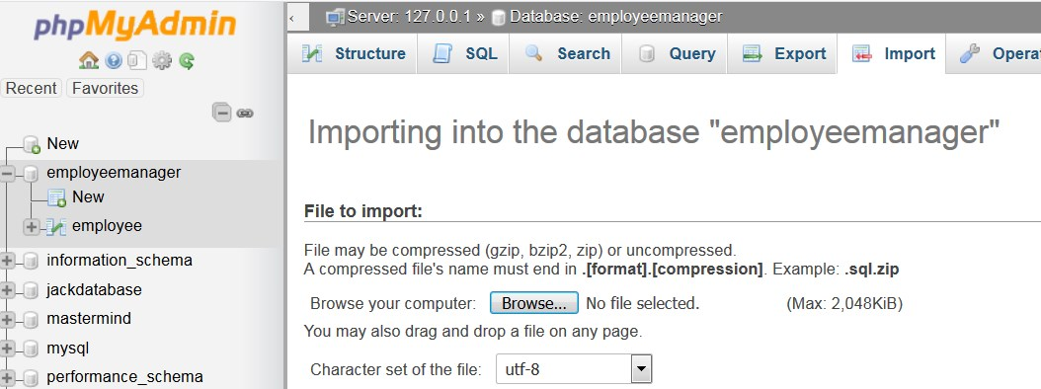

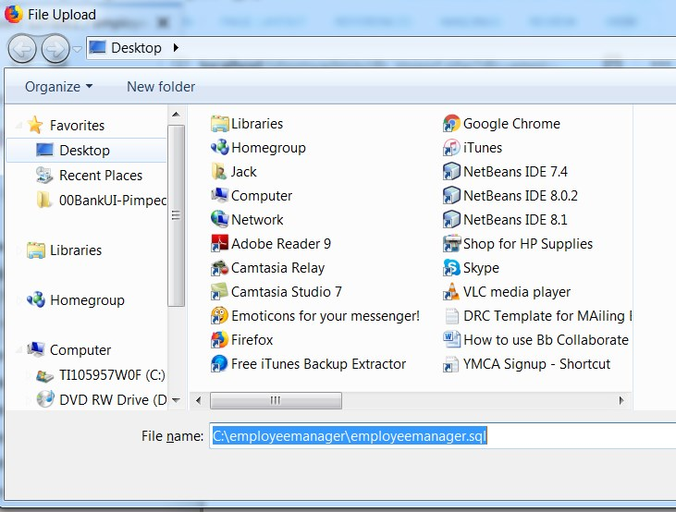

This will now show the employeemanager menu item that you created in the list where the actual data file resides.

Open NetBeans and create a new JavaFX project titled employeemanager

In the src subdirectory add the following files:

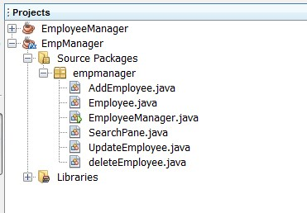

Right click on the Libraries Tab

And the third button reads

“Add Jar/Folder”

Click on it

Type

C:\employeemanager\ mysql-connector-java-5.1.34-bin

This jar file replaces the jdbc odbc bridge that we used with MS Access. This jar file is written entirely in Java.

Note that there are newer versions of this jar file and you may feel free to use them instead.

I will give you all the files that you need to create your project!!!!!

Now click on the employeemanager.java file in the src directory

See the image below.



To build the project press the F11 key

To run the project press the F6 key

Your screen will now look like this

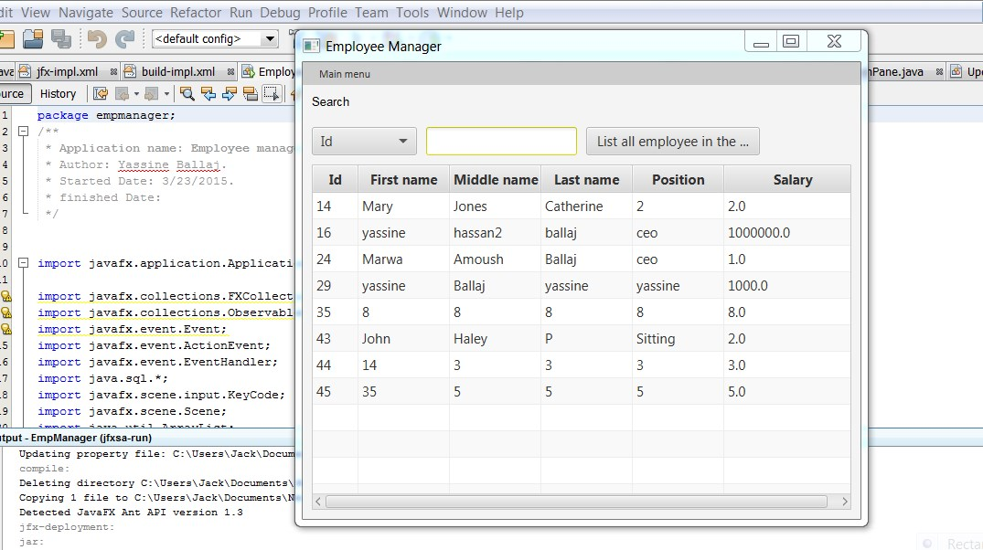

A final hint. You may wish to get the Netbeans going first and the project all set up before you open the Xampp and get the Apache Server started.

This is how I do it. But honestly it will work either way.

Again, I will include all the files that you need to run this program.

Good luck,

Jack

339 222 4247 (cell)