Session 6

CSC 285 FX Loan Calculator

EmployeeManager (MySQL)

Here is how to do the Package example from a different directory !

1.) make sure that you make the directory

c:\cdf (or which ever directory that you want to make)

type

cd \

md \cdf

2.)

C:\packages>javac -d c:\cdf Emprec.java

C:\packages>javac -classpath ".;c:\cdf" Emp_Ex.java

//PLEASE NOTE: do not make this package tree on both the root and c:\cdf directories

//or it will always go to the root when you make changes to the c:\cdf This is a common error !!!

C:\packages>java -classpath ".;c:\cdf" Emp_Ex

The gross salary for Mary Smith is 610.00

Calling the method the answer is 610.00

C:\packages>

YOU CAN CUT AND PASTE TOO!!!!!!

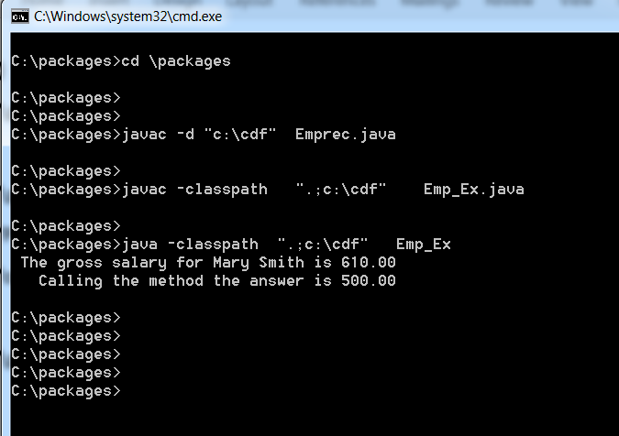

3.) Make sure that you use the quotes !!!!

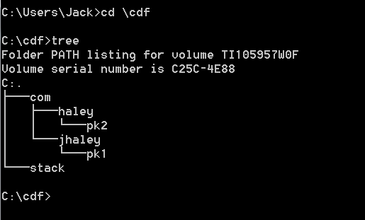

//Now watch what happens when you try to package Customer.java

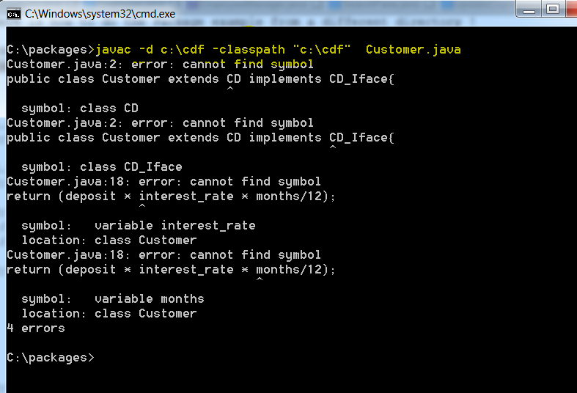

Why the 4 errors?

Simple. You need to package CD.java and CD_Iface.java before packaging Customer.java Customer needs to find the two class files waiting once it gets packaged.

SO…..

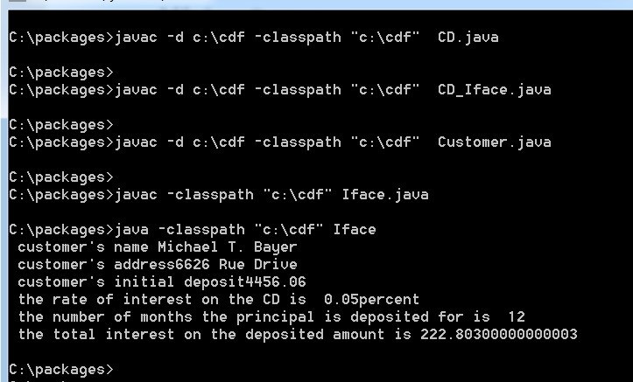

//CD.java

package com.haley.pk2;

public class CD {

public double interest_rate;

public int months;

}//class CD

//CD_Iface.java

//package com.haley.pk2;

public interface CD_Iface {

// there may never be any default implementation

// of any method found in an interface !!!

// this is an abstract method and

// must be defined by the implementing class

public double calc_interest();

// double calc_interest2();

//double cc() {return 100.0;}

}//class CD_Iface

//Customer.java

package com.haley.pk2;

public class Customer extends CD implements CD_Iface{

public String name;

public String address;

public double deposit;

// the implementing class must define the calc_interest method

// or must itself be declared as abstract !!!!

public double calc_interest()

{

// we will use the simple formula I = P * R * T;

//System.out.println(" the amount of interest earned is " + (deposit * interest_rate * months/12));

return (deposit * interest_rate * months/12);

}//calc_interest

}// class Customer

//Iface.java

import com.haley.pk2.Customer;

import com.haley.pk2.CD_Iface;

import com.haley.pk2.CD;

class Iface {

public static void main(String args[])

{

// let's create the object first

Customer person = new Customer();

CD_Iface X ;

double total_interest;

X = person;

// now we will load it with data

person.name = "Michael T. Bayer";

person.address = "6626 Rue Drive";

person.deposit = 4456.06;

// we can now load the following fields

person.interest_rate = .05;

person.months = 12;

// let us now display the data

System.out.println(" customer's name " + person.name);

System.out.println(" customer's address" + person.address);

System.out.println(" customer's initial deposit" + person.deposit);

// we can now display the following data

System.out.println(" the rate of interest on the CD is " + person.interest_rate + "percent");

System.out.println(" the number of months the principal is deposited for is " + person.months);

// we can now display the total interest earned

total_interest = X.calc_interest();

System.out.println(" the total interest on the deposited amount is " + total_interest);

}//main

}//class Iface

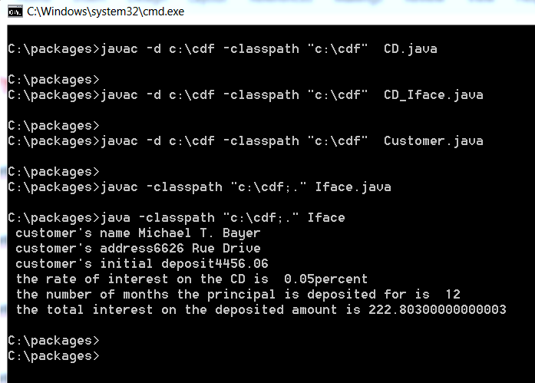

//NOW WATCH WHAT YOU CAN DO!!!!!!!!!

// Encore un fois!!!!!

javac -d c:\cdf -classpath "c:\cdf" CD.java

javac -d c:\cdf -classpath "c:\cdf" CD_Iface.java

javac -d c:\cdf -classpath "c:\cdf" Customer.java

javac -classpath "c:\cdf;." Iface.java

java -classpath "c:\cdf;." Iface



**Loan.java**

public class Loan {

private double annualInterestRate;

private int numberOfYears;

private double loanAmount;

private java.util.Date loanDate;

/** Default constructor */

public Loan() {

this(2.5, 1, 1000);

}

/** Construct a loan with specified annual interest rate,

number of years, and loan amount

*/

public Loan(double annualInterestRate, int numberOfYears,

double loanAmount) {

this.annualInterestRate = annualInterestRate;

this.numberOfYears = numberOfYears;

this.loanAmount = loanAmount;

loanDate = new java.util.Date();

}

/** Return annualInterestRate */

public double getAnnualInterestRate() {

return annualInterestRate;

}

/** Set a new annualInterestRate */

public void setAnnualInterestRate(double annualInterestRate) {

this.annualInterestRate = annualInterestRate;

}

/** Return numberOfYears */

public int getNumberOfYears() {

return numberOfYears;

}

/** Set a new numberOfYears */

public void setNumberOfYears(int numberOfYears) {

this.numberOfYears = numberOfYears;

}

/** Return loanAmount */

public double getLoanAmount() {

return loanAmount;

}

/** Set a newloanAmount */

public void setLoanAmount(double loanAmount) {

this.loanAmount = loanAmount;

}

/** Find monthly payment */

public double getMonthlyPayment() {

double monthlyInterestRate = annualInterestRate / 1200;

double monthlyPayment = loanAmount * monthlyInterestRate / (1 -

(1 / Math.pow(1 + monthlyInterestRate, numberOfYears * 12)));

return monthlyPayment;

}

/** Find total payment */

public double getTotalPayment() {

double totalPayment = getMonthlyPayment() * numberOfYears * 12;

return totalPayment;

}

/** Return loan date */

public java.util.Date getLoanDate() {

return loanDate;

}

}

**LoanCalculator.java**

import javafx.application.Application;

import javafx.geometry.Pos;

import javafx.geometry.HPos;

import javafx.scene.Scene;

import javafx.scene.control.Button;

import javafx.scene.control.Label;

import javafx.scene.control.TextField;

import javafx.scene.layout.GridPane;

import javafx.stage.Stage;

public class LoanCalculator extends Application {

private TextField tfAnnualInterestRate = new TextField();

private TextField tfNumberOfYears = new TextField();

private TextField tfLoanAmount = new TextField();

private TextField tfMonthlyPayment = new TextField();

private TextField tfTotalPayment = new TextField();

private Button btCalculate = new Button("Calculate");

@Override // Override the start method in the Application class

public void start(Stage primaryStage) {

// Create UI

GridPane gridPane = new GridPane();

gridPane.setHgap(5);

gridPane.setVgap(5);

gridPane.add(new Label("Annual Interest Rate:"), 0, 0);

gridPane.add(tfAnnualInterestRate, 1, 0);

gridPane.add(new Label("Number of Years:"), 0, 1);

gridPane.add(tfNumberOfYears, 1, 1);

gridPane.add(new Label("Loan Amount:"), 0, 2);

gridPane.add(tfLoanAmount, 1, 2);

gridPane.add(new Label("Monthly Payment:"), 0, 3);

gridPane.add(tfMonthlyPayment, 1, 3);

gridPane.add(new Label("Total Payment:"), 0, 4);

gridPane.add(tfTotalPayment, 1, 4);

gridPane.add(btCalculate, 1, 5);

// Set properties for UI

gridPane.setAlignment(Pos.CENTER);

tfAnnualInterestRate.setAlignment(Pos.BOTTOM_RIGHT);

tfNumberOfYears.setAlignment(Pos.BOTTOM_RIGHT);

tfLoanAmount.setAlignment(Pos.BOTTOM_RIGHT);

tfMonthlyPayment.setAlignment(Pos.BOTTOM_RIGHT);

tfTotalPayment.setAlignment(Pos.BOTTOM_RIGHT);

tfMonthlyPayment.setEditable(false);

tfTotalPayment.setEditable(false);

GridPane.setHalignment(btCalculate, HPos.RIGHT);

// Process events

btCalculate.setOnAction(e -> calculateLoanPayment());

// Create a scene and place it in the stage

Scene scene = new Scene(gridPane, 400, 250);

primaryStage.setTitle("LoanCalculator"); // Set title

primaryStage.setScene(scene); // Place the scene in the stage

primaryStage.show(); // Display the stage

}

private void calculateLoanPayment() {

// Get values from text fields

double interest =

Double.parseDouble(tfAnnualInterestRate.getText());

int year = Integer.parseInt(tfNumberOfYears.getText());

double loanAmount =

Double.parseDouble(tfLoanAmount.getText());

// Create a loan object. Loan defined in Listing 10.2

Loan loan = new Loan(interest, year, loanAmount);

// Display monthly payment and total payment

tfMonthlyPayment.setText(String.format("$%.2f",

loan.getMonthlyPayment()));

tfTotalPayment.setText(String.format("$%.2f",

loan.getTotalPayment()));

}

/**

* The main method is only needed for the IDE with limited

* JavaFX support. Not needed for running from the command line.

*/

public static void main(String[] args) {

launch(args);

}

}

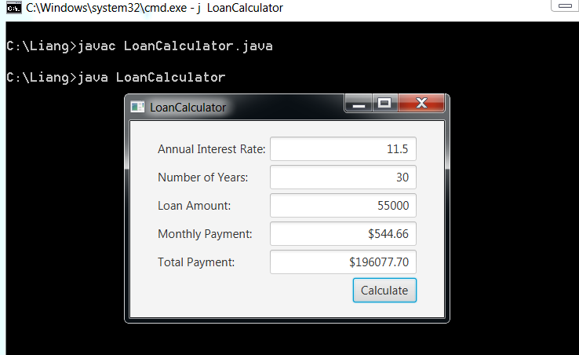

**NOW FOR JavaFX**

**//MenuDemo.java**

**import javafx.application.*;**

**import javafx.scene.*;**

**import javafx.stage.*;**

**import javafx.scene.layout.*;**

**import javafx.scene.control.*;**

**import javafx.event.*;**

**import javafx.geometry.*;**

**public class MenuDemo extends Application {**

**Label response;**

**public static void main(String[] args) {**

**// Start the JavaFX application by calling launch().**

**launch(args);**

**}**

**// Override the start() method.**

**public void start(Stage myStage) {**

**// Give the stage a title.**

**myStage.setTitle("Demonstrate Menus");**

**// Use a BorderPane for the root node.**

**BorderPane rootNode = new BorderPane();**

**// Create a scene.**

**Scene myScene = new Scene(rootNode, 300, 300);**

**// Set the scene on the stage.**

**myStage.setScene(myScene);**

**// Create a label that will report the selection.**

**response = new Label("Menu Demo");**

**// Create the menu bar.**

**MenuBar mb = new MenuBar();**

**// Create the File menu.**

**Menu fileMenu = new Menu("File");**

**MenuItem open = new MenuItem("Open");**

**MenuItem close = new MenuItem("Close");**

**MenuItem save = new MenuItem("Save");**

**MenuItem exit = new MenuItem("Exit");**

**fileMenu.getItems().addAll(open, close, save,**

**new SeparatorMenuItem(), exit);**

**// Add File menu to the menu bar.**

**mb.getMenus().add(fileMenu);**

**// Create the Options menu.**

**Menu optionsMenu = new Menu("Options");**

**// Create the Input Devices submenu.**

**Menu inDevicesMenu = new Menu("Input Devices");**

**MenuItem keyboard = new MenuItem("Keyboard");**

**MenuItem mouse = new MenuItem("Mouse");**

**MenuItem touchscreen = new MenuItem("Touchscreen");**

**inDevicesMenu.getItems().addAll(keyboard, mouse, touchscreen);**

**optionsMenu.getItems().add(inDevicesMenu);**

**// Create the Clock Style submenu.**

**Menu clockMenu = new Menu("Clock Style");**

**MenuItem analog = new MenuItem("Analog");**

**MenuItem digital = new MenuItem("Digital");**

**clockMenu.getItems().addAll(analog, digital);**

**optionsMenu.getItems().add(clockMenu);**

**// Add a separator.**

**optionsMenu.getItems().add(new SeparatorMenuItem());**

**// Create the Reset menu item.**

**MenuItem reset = new MenuItem("Reset");**

**optionsMenu.getItems().add(reset);**

**// Add Options menu to the menu bar.**

**mb.getMenus().add(optionsMenu);**

**// Create the Help menu.**

**Menu helpMenu = new Menu("Help");**

**MenuItem about = new MenuItem("About");**

**helpMenu.getItems().add(about);**

**// Add Help menu to the menu bar.**

**mb.getMenus().add(helpMenu);**

**// Create one event handler that will handle all menu action events.**

**EventHandler<ActionEvent> MEHandler =**

**new EventHandler<ActionEvent>() {**

**public void handle(ActionEvent ae) {**

**String name = ((MenuItem)ae.getTarget()).getText();**

**// If Exit is chosen, the program is terminated.**

**if(name.equals("Exit")) Platform.exit();**

**response.setText( name + " selected");**

**}**

**};**

**// Set action event handlers for the menu items.**

**open.setOnAction(MEHandler);**

**close.setOnAction(MEHandler);**

**save.setOnAction(MEHandler);**

**exit.setOnAction(MEHandler);**

**keyboard.setOnAction(MEHandler);**

**mouse.setOnAction(MEHandler);**

**touchscreen.setOnAction(MEHandler);**

**analog.setOnAction(MEHandler);**

**digital.setOnAction(MEHandler);**

**reset.setOnAction(MEHandler);**

**about.setOnAction(MEHandler);**

**// Add the menu bar to the top of the border pane and**

**// the response label to the center position.**

**rootNode.setTop(mb);**

**rootNode.setCenter(response);**

**// Show the stage and its scene.**

**myStage.show();**

**}**

**}**

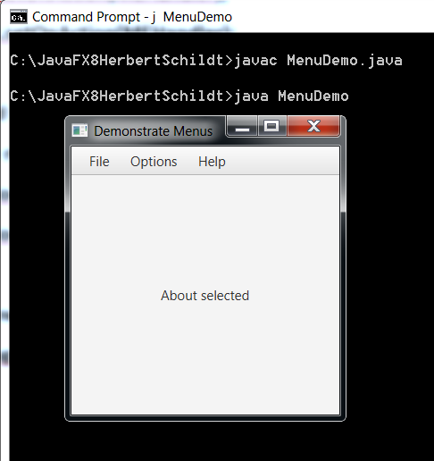

**// try clicking on all menu items and look at the center of the screen.**

**// you now prove that all menu items are readily accessible!!!!**

**// you now have a terrific template.**

// Employee.java

package empmanager;

/**

* Application name: Employee manager.

* Author: Yassine Ballaj.

* Started Date: 3/23/2015.

* finished Date:

*/

import javafx.application.Application;

import javafx.collections.FXCollections;

import javafx.collections.ObservableList;

import javafx.event.Event;

import javafx.event.ActionEvent;

import javafx.event.EventHandler;

import java.sql.*;

import javafx.scene.input.KeyCode;

import javafx.scene.Scene;

import java.util.ArrayList;

import javafx.geometry.Insets;

import javafx.scene.control.Button;

import javafx.scene.image.Image;

import javafx.scene.image.ImageView;

import javafx.scene.layout.HBox;

import javafx.scene.layout.VBox;

import javafx.scene.paint.Color;

import javafx.scene.text.Font;

import javafx.scene.text.Text;

import javafx.stage.Modality;

import javafx.stage.Stage;

/**

*

* @author ballaj

*/

public class EmployeeManager extends Application {

private SearchPane searchPane =new SearchPane();

private Connection conn;

private Statement stm;

private int [] startingPoint=new int []{0};

private ArrayList<Employee> employees =new ArrayList<Employee>();

@Override

public void start(Stage primaryStage) {

/**Connect to a database */

connectToDataBase();

listAllEmployee();

employees.addAll(searchPane.data);

/**List all Employee in the database */

searchPane.listAllButton.setOnAction(new EventHandler<ActionEvent>() {

public void handle(ActionEvent event) {

searchPane.data.clear();

searchPane.data.addAll(employees);

}

});

/**Add Employee */

searchPane.addEmployee.setOnAction(new EventHandler<ActionEvent>(){

public void handle (ActionEvent event)

{

new AddEmployee(primaryStage,stm, searchPane.data, startingPoint,employees);

}

});

/**Delete employee */

searchPane.deleteEmployee.setOnAction(e->{

new deleteEmployee(primaryStage,stm,searchPane.data,employees);

});

/**Update Employee */

searchPane.updateEmployee.setOnAction(e->{new UpdateEmployee(primaryStage, stm, searchPane.data, startingPoint,employees);});

/**Search */

searchPane.setOnKeyPressed(e->{

if(e.getCode()==KeyCode.ENTER)

{

search(primaryStage);

}

});

/**Exit the application*/

searchPane.exit.setOnAction(new EventHandler<ActionEvent>(){

public void handle(ActionEvent event)

{

System.exit(0);

}

});

/**Create a scene */

Scene scene =new Scene(searchPane,610,500);

primaryStage.setScene(scene);

primaryStage.setTitle("Employee Manager");

primaryStage.show();

}

/**

* @param args the command line arguments

*/

public static void main(String[] args) {

launch(args);

}

public void connectToDataBase()

{

try {

// Class.forName("com.mysql.jdbc.Driver");

conn=DriverManager.getConnection("jdbc:mysql://localhost:3306/EmployeeManager","root","");

stm=conn.createStatement();

}catch(Exception exception)

{

System.out.println(exception.getMessage());

}

}

public void listAllEmployee()

{

try{

String query ="select * from employee where id>'"+startingPoint[0]+"'";

ResultSet resultSet=stm.executeQuery(query);

while(resultSet.next())

{

searchPane.data.add(new Employee(

Integer.parseInt(resultSet.getString("id")),

resultSet.getString("firstname"),

resultSet.getString("lastname"),

resultSet.getString("middlename"),

resultSet.getString("position"),

resultSet.getDouble("salary")

));

startingPoint[0]=Integer.parseInt(resultSet.getString(1));

}

}catch(Exception exception)

{

System.out.println(exception.getMessage());

}

}

/**Search method */

public void search(Stage primaryStage)

{

int index=-1;

int exist=0;

ArrayList<Integer> indexes=new ArrayList<>();

if (searchPane.searchField.getText().equals(""))

{

searchPane.searchField.requestFocus();

}

else

{

if (searchPane.comboBoxSearch.getValue().equals("Id"))

{

for(int i=0; i<employees.size();i++)

{

if (employees.get(i).getId()==Integer.parseInt(searchPane.searchField.getText()))

{

exist=1;

index=i;

}

}

if (exist==1)

{

searchPane.data.clear();

searchPane.data.add(employees.get(index));

startingPoint[0]=0;

}

else

{

popErrorMessage(primaryStage,"Employee Does Not Exist !!!");

}

}

else if (searchPane.comboBoxSearch.getValue().equals("First name"))

{

for(int i=0; i<employees.size();i++)

{

if (employees.get(i).getFirstName().equals(searchPane.searchField.getText()))

{

exist=1;

indexes.add(i);

}

}

if (exist==1)

{

searchPane.data.clear();

for(int i=0; i<indexes.size();i++)

{

searchPane.data.add(employees.get(indexes.get(i)));

}

startingPoint[0]=0;

}

else

{

popErrorMessage(primaryStage,"Employee Does Not Exist!!!");

}

}

else if (searchPane.comboBoxSearch.getValue().equals("Middle name"))

{

for(int i=0; i<employees.size();i++)

{

if (employees.get(i).getMiddleName().equals(searchPane.searchField.getText()))

{

exist=1;

indexes.add(i);

}

}

if (exist==1)

{

searchPane.data.clear();

for(int i=0; i<indexes.size();i++)

{

searchPane.data.add(employees.get(indexes.get(i)));

}

startingPoint[0]=0;

}

else

{

popErrorMessage(primaryStage,"Employee Does Not Exist!!!");

}

}

else if (searchPane.comboBoxSearch.getValue().equals("Last name"))

{

for(int i=0; i<employees.size();i++)

{

if (employees.get(i).getLastName().equals(searchPane.searchField.getText()))

{

exist=1;

indexes.add(i);

}

}

if (exist==1)

{

searchPane.data.clear();

for(int i=0; i<indexes.size();i++)

{

searchPane.data.add(employees.get(indexes.get(i)));

}

startingPoint[0]=0;

}

else

{

popErrorMessage(primaryStage,"Employee Does Not Exist!!!");

}

}

else if (searchPane.comboBoxSearch.getValue().equals("Position"))

{

for(int i=0; i<employees.size();i++)

{

if (employees.get(i).getPosition().equals(searchPane.searchField.getText()))

{

exist=1;

indexes.add(i);

}

}

if (exist==1)

{

searchPane.data.clear();

for(int i=0; i<indexes.size();i++)

{

searchPane.data.add(employees.get(indexes.get(i)));

}

startingPoint[0]=0;

}

else

{

popErrorMessage(primaryStage,"Employee Does Not Exist!!!");

}

}

else if (searchPane.comboBoxSearch.getValue().equals("Salary"))

{

for(int i=0; i<employees.size();i++)

{

if (employees.get(i).getSalary()==Double.parseDouble(searchPane.searchField.getText()))

{

exist=1;

indexes.add(i);

}

}

if (exist==1)

{

searchPane.data.clear();

for(int i=0; i<indexes.size();i++)

{

searchPane.data.add(employees.get(indexes.get(i)));

}

startingPoint[0]=0;

}

else

{

popErrorMessage(primaryStage,"Employee Does Not Exist!!!");

}

}

}

}

/**Error Message */

public void popErrorMessage(Stage primaryStage,String text2)

{

/**Create a Stage */

final Stage dialog=new Stage ();

dialog.initModality(Modality.APPLICATION_MODAL);

dialog.initOwner(primaryStage);

/**Set text properties */

Text text=new Text();

text.setText(text2);

text.setFill(Color.RED);

text.setFont(Font.font("Times new roman",20));

/**Set image properties */

ImageView image =new ImageView(new Image("file:warning.png"));

/**Set the button properties */

Button dialogOk=new Button("OK");

dialogOk.setPrefWidth(100);

/**Set dialog HBox properties */

HBox dialogHbox=new HBox ();

dialogHbox.setSpacing(10);

dialogHbox.getChildren().addAll(image,text);

HBox.setMargin(image,new Insets(0,0,0,10));

/**Set VBox properties */

VBox dialogVBox =new VBox();

dialogVBox.setSpacing(10);

dialogVBox.getChildren().addAll(dialogHbox,dialogOk);

VBox.setMargin(dialogOk,new Insets(0,0,0,170));

/** exit the pop up window*/

dialogOk.setOnAction(e->{dialog.close();});

/**Create a scene */

Scene scene=new Scene (dialogVBox,450,100);

dialog.setScene(scene);

dialog.setTitle("Error Message");

dialog.show();

}

}

// AddEmployee.java

package empmanager;

import javafx.scene.layout.GridPane;

import javafx.scene.layout.VBox;

import javafx.scene.layout.HBox;

import javafx.scene.control.TextField;

import javafx.scene.control.Label;

import javafx.scene.control.Button;

import javafx.scene.input.KeyCode;

import javafx.geometry.Insets;

import javafx.scene.Scene;

import javafx.stage.Stage;

import java.util.ArrayList;

import java.util.Arrays;

import javafx.geometry.Pos;

import javafx.stage.Modality;

import javafx.collections.ObservableList;

import java.sql.*;

import javafx.event.ActionEvent;

import javafx.event.EventHandler;

import javafx.scene.image.Image;

import javafx.scene.image.ImageView;

import javafx.scene.paint.Color;

import javafx.scene.text.Font;

import javafx.scene.text.Text;

/**

*

* @author ballaj

*/

public class AddEmployee {

/**Create a private data to build the pane */

private TextField tfFirstName=new TextField();

private TextField tfMiddleName =new TextField();

private TextField tfLastName=new TextField();

private TextField tfPosition=new TextField();

private TextField tfSalary=new TextField();

private ArrayList<Label> labels= new ArrayList<Label>(Arrays.asList(

new Label("First name: "), new Label("Middle name: "), new Label("Last name: "),

new Label("Position: "), new Label("Salary: ")));

private Button add=new Button("Add");

private Button clear=new Button("Clear");

private Button cancel =new Button ("Cancel");

private GridPane gridPane =new GridPane();

private VBox vbox =new VBox();

private HBox hbox =new HBox();

private Label title =new Label("Add Employee: ");

/**Create a default constructor */

public AddEmployee(Stage primaryStage, Statement stm, ObservableList<Employee> data, int [] startingPoint,ArrayList<Employee> employees )

{

title.setStyle("-fx-font-family:calibri;"+"-fx-font-size:17;");

/**Set the text fields properties */

tfFirstName.setStyle("-fx-background:yellow;");

tfFirstName.setPrefWidth(200);

tfMiddleName.setStyle("-fx-background:yellow;");

tfLastName.setStyle("-fx-background:yellow;");

tfPosition.setStyle("-fx-background:yellow;");

tfSalary.setStyle("-fx-background:yellow;");

/**Set the label properties */

for (int i=0; i<labels.size();i++)

{

labels.get(i).setStyle("-fx-text-fill:black;"+"-fx-font-family:calibri;"+"-fx-font-size:15;");

}

/**Set the button properties*/

add.setPrefWidth(100);

clear.setPrefWidth(100);

cancel.setPrefWidth(100);

/**Set the grid pane properties */

gridPane.setHgap(10);

gridPane.setVgap(10);

gridPane.setAlignment(Pos.CENTER);

gridPane.add(labels.get(0),0,0);

gridPane.add(tfFirstName,1,0);

gridPane.add(labels.get(1),0,1);

gridPane.add(tfMiddleName,1,1);

gridPane.add(labels.get(2),0,2);

gridPane.add(tfLastName,1,2);

gridPane.add(labels.get(3),0,3);

gridPane.add(tfPosition,1,3);

gridPane.add(labels.get(4), 0, 4);

gridPane.add(tfSalary,1,4);

gridPane.add(hbox,0,5);

/**Set the HBox properties */

hbox.setAlignment(Pos.CENTER);

hbox.setSpacing(20);

hbox.getChildren().addAll(add,clear,cancel);

/**Set the VBox properties */

vbox.setSpacing(5);

vbox.setPadding(new Insets(10,15,0,0));

vbox.getChildren().addAll(title,gridPane,hbox);

/** Create a Scene */

Scene scene=new Scene(vbox,400,300);

final Stage mainStage=new Stage();

mainStage.initModality(Modality.APPLICATION_MODAL);

mainStage.initOwner(primaryStage);

mainStage.setScene(scene);

mainStage.setTitle("Add Employee");

mainStage.show();

/**Register and handle the event fired by the clear button */

clear.setOnAction(e->{clearTextFields();});

/**Register and handle the event fires by the exit button */

cancel.setOnAction(e->{mainStage.close();});

/**Register and handle */

add.setOnAction(e->{

try{

addNewEmployee(primaryStage,stm,data, startingPoint,employees);

}catch(Exception exception)

{

popErrorMessage(mainStage,exception.getMessage());

}

});

/**Enter Key */

vbox.setOnKeyPressed(e->{

if(e.getCode()==KeyCode.ENTER)

{

try{

addNewEmployee(primaryStage,stm,data, startingPoint,employees);

}catch(Exception exception)

{

popErrorMessage(mainStage,exception.getMessage());

}

}

});

}

/**Clear text fields */

public void clearTextFields ()

{

tfFirstName.clear();

tfMiddleName.clear();

tfLastName.clear();

tfPosition.clear();

tfSalary.clear();

}

/**Add new employee */

public void addNewEmployee(Stage stage,Statement stm, ObservableList<Employee> data, int [] startingPoint, ArrayList<Employee> employees) throws Exception

{

if (tfFirstName.getText().equals(""))

{

tfFirstName.requestFocus();

}

else if (tfMiddleName.getText().equals(""))

{

tfMiddleName.requestFocus();

}

else if (tfLastName.getText().equals(""))

{

tfLastName.requestFocus();

}

else if(tfPosition.getText().equals(""))

{

tfPosition.requestFocus();

}

else if (tfSalary.getText().equals(""))

{

tfSalary.requestFocus();

}

else {

String query ="insert into employee (firstname, middlename, lastname, position, salary) values "

+ "('"+tfFirstName.getText()+"','"+tfMiddleName.getText()+"','"+tfLastName.getText()+"','"+tfPosition.getText()+"','"+tfSalary.getText()+"')";

stm.executeUpdate(query);

clearTextFields();

infoDialog(stage,"Employee Was Added Successfully!!!");

query ="select * from employee where id>'"+startingPoint[0]+"'";

ResultSet resultSet=stm.executeQuery(query);

while(resultSet.next())

{

data.add(new Employee(

Integer.parseInt(resultSet.getString("id")),

resultSet.getString("firstname"),

resultSet.getString("lastname"),

resultSet.getString("middlename"),

resultSet.getString("position"),

resultSet.getDouble("salary")

));

employees.add(new Employee(

Integer.parseInt(resultSet.getString("id")),

resultSet.getString("firstname"),

resultSet.getString("lastname"),

resultSet.getString("middlename"),

resultSet.getString("position"),

resultSet.getDouble("salary")

));

startingPoint[0]=Integer.parseInt(resultSet.getString(1));

}

}

}

/**Create Information Dialog method */

public void infoDialog (Stage primaryStage, String text1)

{

/**Create a Stage */

final Stage dialog=new Stage ();

dialog.initModality(Modality.APPLICATION_MODAL);

dialog.initOwner(primaryStage);

/**Set text properties */

Text localText=new Text();

localText.setText(text1);

localText.setFill(Color.BLUE);

localText.setFont(Font.font("Times new roman",20));

/**Set image properties */

ImageView image =new ImageView(new Image("file:info.jpg"));

/**Set dialog HBox properties */

HBox dialogHbox=new HBox();

dialogHbox.setSpacing(10);

dialogHbox.getChildren().addAll(image,localText);

HBox.setMargin(image,new Insets(0,0,0,10));

/**Set VBox properties */

VBox dialogVBox=new VBox();

Button dialogOk=new Button("Ok");

dialogVBox.setSpacing(10);

dialogVBox.getChildren().addAll(dialogHbox,dialogOk);

VBox.setMargin(dialogOk,new Insets(0,0,0,170));

/**Set the button properties */

dialogOk.setPrefWidth(100);

/** exit the pop up window*/

dialogOk.setOnAction(new EventHandler <ActionEvent>(){

public void handle (ActionEvent event)

{

dialog.close();

}

});

/**Create a scene */

Scene scene=new Scene (dialogVBox,450,100);

dialog.setScene(scene);

dialog.setTitle("Info Message");

dialog.show();

}

/**Error Message */

public void popErrorMessage(Stage primaryStage,String text2)

{

/**Create a Stage */

final Stage dialog=new Stage ();

dialog.initModality(Modality.APPLICATION_MODAL);

dialog.initOwner(primaryStage);

/**Set text properties */

Text text=new Text();

text.setText(text2);

text.setFill(Color.RED);

text.setFont(Font.font("Times new roman",20));

/**Set image properties */

ImageView image =new ImageView(new Image("file:warning.png"));

/**Set the button properties */

Button dialogOk=new Button("OK");

dialogOk.setPrefWidth(100);

/**Set dialog HBox properties */

HBox dialogHbox=new HBox ();

dialogHbox.setSpacing(10);

dialogHbox.getChildren().addAll(image,text);

HBox.setMargin(image,new Insets(0,0,0,10));

/**Set VBox properties */

VBox dialogVBox =new VBox();

dialogVBox.setSpacing(10);

dialogVBox.getChildren().addAll(dialogHbox,dialogOk);

VBox.setMargin(dialogOk,new Insets(0,0,0,170));

/** exit the pop up window*/

dialogOk.setOnAction(e->{dialog.close();});

/**Create a scene */

Scene scene=new Scene (dialogVBox,450,100);

dialog.setScene(scene);

dialog.setTitle("Error Message");

dialog.show();

}

}

//UpdateEmployee.java

package empmanager;

import java.sql.Statement;

import java.util.ArrayList;

import java.util.Arrays;

import javafx.collections.ObservableList;

import javafx.event.ActionEvent;

import javafx.event.EventHandler;

import javafx.scene.layout.GridPane;

import javafx.scene.layout.HBox;

import javafx.scene.control.TextField;

import javafx.scene.control.Button;

import javafx.scene.control.Label;

import javafx.scene.text.Text;

import javafx.geometry.Pos;

import javafx.geometry.Insets;

import javafx.scene.Scene;

import javafx.scene.image.Image;

import javafx.scene.image.ImageView;

import javafx.scene.input.KeyCode;

import javafx.scene.layout.VBox;

import javafx.scene.paint.Color;

import javafx.scene.text.Font;

import javafx.stage.Modality;

import javafx.stage.Stage;

public class UpdateEmployee {

int elementPosition=-1;

/**Create text fields */

private TextField tfId=new TextField();

private TextField tfFirstName=new TextField ();

private TextField tfMiddleName =new TextField();

private TextField tfLastName =new TextField();

private TextField tfPosition =new TextField();

private TextField tfSalary =new TextField ();

/**Create Labels */

private ArrayList<Label> labels= new ArrayList<Label>(Arrays.asList( new Label("Id"),

new Label("First name: "), new Label("Middle name: "), new Label("Last name: "),

new Label("Position: "), new Label("Salary: ")));

private Button update=new Button("Update");

private Button clear=new Button("Clear");

private Button cancel =new Button ("Cancel");

private GridPane gridPane =new GridPane();

private VBox vbox =new VBox();

private HBox hbox =new HBox();

private Label title =new Label("Update employee: ");

/**Create a default constructor */

public UpdateEmployee (Stage primaryStage, Statement stm, ObservableList<Employee> data, int [] startingPoint, ArrayList<Employee> employees )

{

title.setStyle("-fx-font-family:calibri;"+"-fx-font-size:17;");

/**Set the text fields properties */

tfFirstName.setStyle("-fx-background:yellow;");

tfFirstName.setPrefWidth(200);

tfMiddleName.setStyle("-fx-background:yellow;");

tfLastName.setStyle("-fx-background:yellow;");

tfPosition.setStyle("-fx-background:yellow;");

tfSalary.setStyle("-fx-background:yellow;");

/**Set the label properties */

for (int i=0; i<labels.size();i++)

{

labels.get(i).setStyle("-fx-text-fill:black;"+"-fx-font-family:calibri;"+"-fx-font-size:15;");

}

/**Set the button properties*/

update.setPrefWidth(100);

clear.setPrefWidth(100);

cancel.setPrefWidth(100);

/**Set the grid pane properties */

gridPane.setHgap(10);

gridPane.setVgap(10);

gridPane.setAlignment(Pos.CENTER);

gridPane.add(labels.get(0),0,0);

gridPane.add(tfId, 1, 0);

gridPane.add(labels.get(1),0,1);

gridPane.add(tfFirstName,1,1);

gridPane.add(labels.get(2),0,2);

gridPane.add(tfMiddleName,1,2);

gridPane.add(labels.get(3),0,3);

gridPane.add(tfLastName,1,3);

gridPane.add(labels.get(4),0,4);

gridPane.add(tfPosition,1,4);

gridPane.add(labels.get(5), 0,5);

gridPane.add(tfSalary,1,5);

gridPane.add(hbox,0,6);

/**Set the HBox properties */

hbox.setAlignment(Pos.CENTER);

hbox.setSpacing(20);

hbox.getChildren().addAll(update,clear,cancel);

/**Set the VBox properties */

vbox.setSpacing(5);

vbox.setPadding(new Insets(10,15,0,0));

vbox.getChildren().addAll(title,gridPane,hbox);

/** Create a Scene */

Scene scene=new Scene(vbox,400,300);

final Stage mainStage=new Stage();

mainStage.initModality(Modality.APPLICATION_MODAL);

mainStage.initOwner(primaryStage);

mainStage.setScene(scene);

mainStage.setTitle("Add Employee");

mainStage.show();

/**Register and handle the event fired by the clear button */

clear.setOnAction(e->{clearTextFields();});

/**Register and handle the event fires by the exit button */

cancel.setOnAction(e->{mainStage.close();});

/**Register and handle */

update.setOnAction(e->{

try{

updateEmployee(mainStage,data,stm,employees);

}catch(Exception exception)

{

popErrorMessage(mainStage,exception.getMessage());

}

});

/**Enter Key

vbox.setOnKeyPressed(e->{

if(e.getCode()==KeyCode.ENTER)

{

try{

updateEmployee(mainStage,data,stm,employees);

}catch(Exception exception)

{

popErrorMessage(mainStage,exception.getMessage());

}

}

});*/

/** Employee information */

tfId.setOnKeyPressed(e->{

if(e.getCode()==KeyCode.ENTER)

{

try{

employeeInfo(data,mainStage);

}catch(Exception exception)

{

popErrorMessage(mainStage,exception.getMessage());

}

}

});

}

/**Clear text fields */

public void clearTextFields ()

{

tfId.clear ();

tfFirstName.clear();

tfMiddleName.clear();

tfLastName.clear();

tfPosition.clear();

tfSalary.clear();

}

/**Create Information Dialog method */

public void infoDialog (Stage primaryStage, String text1)

{

/**Create a Stage */

final Stage dialog=new Stage ();

dialog.initModality(Modality.APPLICATION_MODAL);

dialog.initOwner(primaryStage);

/**Set text properties */

Text localText=new Text();

localText.setText(text1);

localText.setFill(Color.BLUE);

localText.setFont(Font.font("Times new roman",20));

/**Set image properties */

ImageView image =new ImageView(new Image("file:info.jpg"));

/**Set dialog HBox properties */

HBox dialogHbox=new HBox();

dialogHbox.setSpacing(10);

dialogHbox.getChildren().addAll(image,localText);

HBox.setMargin(image,new Insets(0,0,0,10));

/**Set VBox properties */

VBox dialogVBox=new VBox();

Button dialogOk=new Button("Ok");

dialogVBox.setSpacing(10);

dialogVBox.getChildren().addAll(dialogHbox,dialogOk);

VBox.setMargin(dialogOk,new Insets(0,0,0,170));

/**Set the button properties */

dialogOk.setPrefWidth(100);

/** exit the pop up window*/

dialogOk.setOnAction(new EventHandler <ActionEvent>(){

public void handle (ActionEvent event)

{

dialog.close();

}

});

/**Create a scene */

Scene scene=new Scene (dialogVBox,450,100);

dialog.setScene(scene);

dialog.setTitle("Info Message");

dialog.show();

}

/**Error Message */

public void popErrorMessage(Stage primaryStage,String text2)

{

/**Create a Stage */

final Stage dialog=new Stage ();

dialog.initModality(Modality.APPLICATION_MODAL);

dialog.initOwner(primaryStage);

/**Set text properties */

Text text=new Text();

text.setText(text2);

text.setFill(Color.RED);

text.setFont(Font.font("Times new roman",20));

/**Set image properties */

ImageView image =new ImageView(new Image("file:warning.png"));

/**Set the button properties */

Button dialogOk=new Button("OK");

dialogOk.setPrefWidth(100);

/**Set dialog HBox properties */

HBox dialogHbox=new HBox ();

dialogHbox.setSpacing(10);

dialogHbox.getChildren().addAll(image,text);

HBox.setMargin(image,new Insets(0,0,0,10));

/**Set VBox properties */

VBox dialogVBox =new VBox();

dialogVBox.setSpacing(10);

dialogVBox.getChildren().addAll(dialogHbox,dialogOk);

VBox.setMargin(dialogOk,new Insets(0,0,0,170));

/** exit the pop up window*/

dialogOk.setOnAction(e->{dialog.close();});

/**Create a scene */

Scene scene=new Scene (dialogVBox,450,100);

dialog.setScene(scene);

dialog.setTitle("Error Message");

dialog.show();

}

/**Update method */

public void employeeInfo(ObservableList<Employee> data, Stage stage) throws Exception

{

int exist=0;

if(tfId.getText().equals(""))

{

tfId.requestFocus();

}

else

{

for(int i=0;i<data.size();i++)

{

if(data.get(i).getId()==Integer.parseInt(tfId.getText()))

{

exist=1;

elementPosition=i;

break;

}

}

if(exist==1)

{

tfFirstName.setText(data.get(elementPosition).getFirstName());

tfMiddleName.setText(data.get(elementPosition).getMiddleName());

tfLastName.setText(data.get(elementPosition).getLastName());

tfPosition.setText(data.get(elementPosition).getPosition());

tfSalary.setText(String.valueOf(data.get(elementPosition).getSalary()));

}

else

{

popErrorMessage(stage,"Employee does not exist.\nPlease Enter Another Id Number!!!");

}

}

}

/**Update Employee */

public void updateEmployee(Stage stage, ObservableList<Employee> data, Statement stm, ArrayList<Employee> employees) throws Exception

{

int id=Integer.parseInt(tfId.getText());

String firstName=tfFirstName.getText();

String middleName=tfMiddleName.getText();

String lastName=tfLastName.getText();

String position =tfPosition.getText();

double salary=Double.parseDouble(tfSalary.getText());

String query="update employee set firstname='"+firstName+"', middlename='"+middleName+"', lastname='"+lastName+"', position='"+position+"', salary='"+salary+"' where id='"+id+"'";

if(tfSalary.getText().equals(""))

{

tfId.requestFocus();

}

else

{

stm.executeUpdate(query);

data.set(elementPosition, new Employee(id,firstName, lastName, middleName, position, salary));

employees.set(elementPosition, new Employee(id,firstName, lastName, middleName, position, salary));

clearTextFields();

infoDialog(stage,"Employee was successfully updated.");

}

}

}

// DeleteEmployee.java

package empmanager;

import javafx.scene.paint.Color;

import javafx.scene.layout.GridPane;

import javafx.scene.layout.VBox;

import javafx.scene.layout.HBox;

import javafx.scene.control.TextField;

import javafx.scene.control.Label;

import javafx.scene.control.Button;

import javafx.geometry.Pos;

import javafx.collections.ObservableList;

import javafx.scene.Scene;

import javafx.geometry.Insets;

import javafx.geometry.HPos;

import javafx.stage.Modality;

import javafx.stage.Stage;

import java.sql.*;

import java.util.ArrayList;

import javafx.event.ActionEvent;

import javafx.event.EventHandler;

import javafx.scene.text.Text;

import javafx.scene.image.ImageView;

import javafx.scene.image.Image;

import javafx.scene.text.Font;

import javafx.scene.input.KeyEvent;

import javafx.scene.input.KeyCode;

import javax.swing.*;

/**

*

* @author ballaj

*/

public class deleteEmployee {

/**Create a private data */

private TextField tfId=new TextField();

private Label idLabel=new Label("Id");

private Label titleLabel=new Label("Delete employee: ");

private Button delete =new Button ("Delete");

private Button cancel =new Button("Cancel");

private VBox vbox=new VBox();

private HBox hbox=new HBox();

private GridPane gridPane =new GridPane();

public deleteEmployee(Stage primaryStage, Statement stm, ObservableList<Employee> data, ArrayList<Employee> employees)

{

tfId.setStyle("-fx-background:yellow;");

tfId.setPrefWidth(200);

idLabel.setStyle("-fx-text-fill: black;"+"-fx-font-family:calibri;"+"-fx-font-size:14;");

titleLabel.setStyle("-fx-text-fill: black;"+"-fx-font-family:calibri;"+"-fx-font-size:16;");

delete.setPrefWidth(100);

cancel.setPrefWidth(100);

hbox.setSpacing(10);

hbox.getChildren().addAll(delete, cancel);

gridPane.setAlignment(Pos.CENTER);

gridPane.setHgap(15);

gridPane.setVgap(20);

gridPane.setPadding (new Insets(10,20,0,0));

gridPane.add(idLabel,0,0);

gridPane.add(tfId,1,0);

gridPane.add(hbox,1,1);

GridPane.setHalignment(hbox,HPos.RIGHT);

vbox.setSpacing(25);

vbox.setPadding(new Insets(10,20,0,0));

vbox.getChildren().addAll(titleLabel,gridPane);

Scene scene =new Scene(vbox,300,150);

Stage mainStage=new Stage();

mainStage.initModality(Modality.APPLICATION_MODAL);

mainStage.initOwner(primaryStage);

mainStage.setScene(scene);

mainStage.setTitle("Employee Manager App (Delete employee)");

mainStage.show();

/**Register and handle the event fired by cancel method */

cancel.setOnAction(e->{mainStage.close();});

/**Register and handle the event fired by the cancel method */

delete.setOnAction(e->{

try{

deleteEmployee(mainStage,stm,data,employees);

}catch (Exception exception)

{

popErrorMessage(mainStage, exception.getMessage());

}

});

/**Register and handle the event fired by the Enter key */

/**Enter Key */

vbox.setOnKeyPressed(e->{

if(e.getCode()==KeyCode.ENTER)

{

try{

deleteEmployee(primaryStage, stm, data,employees);

}catch(Exception exception)

{

popErrorMessage(mainStage,exception.getMessage());

}

}

});

}

/**Delete employee */

public void deleteEmployee(Stage stage, Statement stm, ObservableList<Employee> data, ArrayList<Employee> employees)throws Exception

{

int exist=0;

String query ="delete from employee where id='"+Integer.parseInt(tfId.getText())+"'";

int result = JOptionPane.showOptionDialog(null, "Are you sure you want to delete this record","Delete Record",JOptionPane.YES_NO_OPTION, JOptionPane.QUESTION_MESSAGE, null, null, null);

if (result == JOptionPane.YES_OPTION){

for (int i=0;i<data.size();i++)

{

if (data.get(i).getId()==Integer.parseInt(tfId.getText()))

{

stm.execute(query);

data.remove(data.get(i));

employees.remove(employees.get(i));

exist=1;

break;

}

}

}//if (result == JOptionPane.YES_OPTION)

if (exist==1)

{

tfId.clear();

infoDialog(stage,"Employee Was Successfully Deleted!!!");

}

else

{

popErrorMessage(stage,"Employee Doesn't Exist!!! ");

}

}

/**Error Message */

public void popErrorMessage(Stage primaryStage,String text2)

{

/**Create a Stage */

final Stage dialog=new Stage ();

dialog.initModality(Modality.APPLICATION_MODAL);

dialog.initOwner(primaryStage);

/**Set text properties */

Text text=new Text();

text.setText(text2);

text.setFill(Color.RED);

text.setFont(Font.font("Times new roman",20));

/**Set image properties */

ImageView image =new ImageView(new Image("file:warning.png"));

/**Set the button properties */

Button dialogOk=new Button("OK");

dialogOk.setPrefWidth(100);

/**Set dialog HBox properties */

HBox dialogHbox=new HBox ();

dialogHbox.setSpacing(10);

dialogHbox.getChildren().addAll(image,text);

HBox.setMargin(image,new Insets(0,0,0,10));

/**Set VBox properties */

VBox dialogVBox =new VBox();

dialogVBox.setSpacing(10);

dialogVBox.getChildren().addAll(dialogHbox,dialogOk);

VBox.setMargin(dialogOk,new Insets(0,0,0,170));

/** exit the pop up window*/

dialogOk.setOnAction(e->{dialog.close();});

/**Create a scene */

Scene scene=new Scene (dialogVBox,450,100);

dialog.setScene(scene);

dialog.setTitle("Error Message");

dialog.show();

}

/**Create Information Dialog method */

public void infoDialog (Stage primaryStage, String text1)

{

/**Create a Stage zip Files*/

final Stage dialog=new Stage ();

dialog.initModality(Modality.APPLICATION_MODAL);

dialog.initOwner(primaryStage);

/**Set text properties */

Text localText=new Text();

localText.setText(text1);

localText.setFill(Color.BLUE);

localText.setFont(Font.font("Times new roman",20));

/**Set image properties */

ImageView image =new ImageView(new Image("file:info.jpg"));

/**Set dialog HBox properties */

HBox dialogHbox=new HBox();

dialogHbox.setSpacing(10);

dialogHbox.getChildren().addAll(image,localText);

HBox.setMargin(image,new Insets(0,0,0,10));

/**Set VBox properties */

VBox dialogVBox=new VBox();

Button dialogOk=new Button("Ok");

dialogVBox.setSpacing(10);

dialogVBox.getChildren().addAll(dialogHbox,dialogOk);

VBox.setMargin(dialogOk,new Insets(0,0,0,170));

/**Set the button properties */

dialogOk.setPrefWidth(100);

/** exit the pop up window*/

dialogOk.setOnAction(new EventHandler <ActionEvent>(){

public void handle (ActionEvent event)

{

dialog.close();

}

});

/**Create a scene */

Scene scene=new Scene (dialogVBox,450,100);

dialog.setScene(scene);

dialog.setTitle("Info Message");

dialog.show();

}

}//DELETE

//EmployeeManager.java

package empmanager;

/**

* Application name: Employee manager.

* Author: Yassine Ballaj.

* Started Date: 3/23/2015.

* finished Date:

*/

import javafx.application.Application;

import javafx.collections.FXCollections;

import javafx.collections.ObservableList;

import javafx.event.Event;

import javafx.event.ActionEvent;

import javafx.event.EventHandler;

import java.sql.*;

import javafx.scene.input.KeyCode;

import javafx.scene.Scene;

import java.util.ArrayList;

import javafx.geometry.Insets;

import javafx.scene.control.Button;

import javafx.scene.image.Image;

import javafx.scene.image.ImageView;

import javafx.scene.layout.HBox;

import javafx.scene.layout.VBox;

import javafx.scene.paint.Color;

import javafx.scene.text.Font;

import javafx.scene.text.Text;

import javafx.stage.Modality;

import javafx.stage.Stage;

/**

*

* @author ballaj

*/

public class EmployeeManager extends Application {

private SearchPane searchPane =new SearchPane();

private Connection conn;

private Statement stm;

private int [] startingPoint=new int []{0};

private ArrayList<Employee> employees =new ArrayList<Employee>();

@Override

public void start(Stage primaryStage) {

/**Connect to a database */

connectToDataBase();

listAllEmployee();

employees.addAll(searchPane.data);

/**List all Employee in the database */

searchPane.listAllButton.setOnAction(new EventHandler<ActionEvent>() {

public void handle(ActionEvent event) {

searchPane.data.clear();

searchPane.data.addAll(employees);

}

});

/**Add Employee */

searchPane.addEmployee.setOnAction(new EventHandler<ActionEvent>(){

public void handle (ActionEvent event)

{

new AddEmployee(primaryStage,stm, searchPane.data, startingPoint,employees);

}

});

/**Delete employee */

searchPane.deleteEmployee.setOnAction(e->{

new deleteEmployee(primaryStage,stm,searchPane.data,employees);

});

/**Update Employee */

searchPane.updateEmployee.setOnAction(e->{new UpdateEmployee(primaryStage, stm, searchPane.data, startingPoint,employees);});

/**Search */

searchPane.setOnKeyPressed(e->{

if(e.getCode()==KeyCode.ENTER)

{

search(primaryStage);

}

});

/**Exit the application*/

searchPane.exit.setOnAction(new EventHandler<ActionEvent>(){

public void handle(ActionEvent event)

{

System.exit(0);

}

});

/**Create a scene */

Scene scene =new Scene(searchPane,610,500);

primaryStage.setScene(scene);

primaryStage.setTitle("Employee Manager");

primaryStage.show();

}

/**

* @param args the command line arguments

*/

public static void main(String[] args) {

launch(args);

}

public void connectToDataBase()

{

try {

// Class.forName("com.mysql.jdbc.Driver");

conn=DriverManager.getConnection("jdbc:mysql://localhost:3306/EmployeeManager","root","");

stm=conn.createStatement();

}catch(Exception exception)

{

System.out.println(exception.getMessage());

}

}

public void listAllEmployee()

{

try{

String query ="select * from employee where id>'"+startingPoint[0]+"'";

ResultSet resultSet=stm.executeQuery(query);

while(resultSet.next())

{

searchPane.data.add(new Employee(

Integer.parseInt(resultSet.getString("id")),

resultSet.getString("firstname"),

resultSet.getString("lastname"),

resultSet.getString("middlename"),

resultSet.getString("position"),

resultSet.getDouble("salary")

));

startingPoint[0]=Integer.parseInt(resultSet.getString(1));

}

}catch(Exception exception)

{

System.out.println(exception.getMessage());

}

}

/**Search method */

public void search(Stage primaryStage)

{

int index=-1;

int exist=0;

ArrayList<Integer> indexes=new ArrayList<>();

if (searchPane.searchField.getText().equals(""))

{

searchPane.searchField.requestFocus();

}

else

{

if (searchPane.comboBoxSearch.getValue().equals("Id"))

{

for(int i=0; i<employees.size();i++)

{

if (employees.get(i).getId()==Integer.parseInt(searchPane.searchField.getText()))

{

exist=1;

index=i;

}

}

if (exist==1)

{

searchPane.data.clear();

searchPane.data.add(employees.get(index));

startingPoint[0]=0;

}

else

{

popErrorMessage(primaryStage,"Employee Does Not Exist !!!");

}

}

else if (searchPane.comboBoxSearch.getValue().equals("First name"))

{

for(int i=0; i<employees.size();i++)

{

if (employees.get(i).getFirstName().equals(searchPane.searchField.getText()))

{

exist=1;

indexes.add(i);

}

}

if (exist==1)

{

searchPane.data.clear();

for(int i=0; i<indexes.size();i++)

{

searchPane.data.add(employees.get(indexes.get(i)));

}

startingPoint[0]=0;

}

else

{

popErrorMessage(primaryStage,"Employee Does Not Exist!!!");

}

}

else if (searchPane.comboBoxSearch.getValue().equals("Middle name"))

{

for(int i=0; i<employees.size();i++)

{

if (employees.get(i).getMiddleName().equals(searchPane.searchField.getText()))

{

exist=1;

indexes.add(i);

}

}

if (exist==1)

{

searchPane.data.clear();

for(int i=0; i<indexes.size();i++)

{

searchPane.data.add(employees.get(indexes.get(i)));

}

startingPoint[0]=0;

}

else

{

popErrorMessage(primaryStage,"Employee Does Not Exist!!!");

}

}

else if (searchPane.comboBoxSearch.getValue().equals("Last name"))

{

for(int i=0; i<employees.size();i++)

{

if (employees.get(i).getLastName().equals(searchPane.searchField.getText()))

{

exist=1;

indexes.add(i);

}

}

if (exist==1)

{

searchPane.data.clear();

for(int i=0; i<indexes.size();i++)

{

searchPane.data.add(employees.get(indexes.get(i)));

}

startingPoint[0]=0;

}

else

{

popErrorMessage(primaryStage,"Employee Does Not Exist!!!");

}

}

else if (searchPane.comboBoxSearch.getValue().equals("Position"))

{

for(int i=0; i<employees.size();i++)

{

if (employees.get(i).getPosition().equals(searchPane.searchField.getText()))

{

exist=1;

indexes.add(i);

}

}

if (exist==1)

{

searchPane.data.clear();

for(int i=0; i<indexes.size();i++)

{

searchPane.data.add(employees.get(indexes.get(i)));

}

startingPoint[0]=0;

}

else

{

popErrorMessage(primaryStage,"Employee Does Not Exist!!!");

}

}

else if (searchPane.comboBoxSearch.getValue().equals("Salary"))

{

for(int i=0; i<employees.size();i++)

{

if (employees.get(i).getSalary()==Double.parseDouble(searchPane.searchField.getText()))

{

exist=1;

indexes.add(i);

}

}

if (exist==1)

{

searchPane.data.clear();

for(int i=0; i<indexes.size();i++)

{

searchPane.data.add(employees.get(indexes.get(i)));

}

startingPoint[0]=0;

}

else

{

popErrorMessage(primaryStage,"Employee Does Not Exist!!!");

}

}

}

}

/**Error Message */

public void popErrorMessage(Stage primaryStage,String text2)

{

/**Create a Stage */

final Stage dialog=new Stage ();

dialog.initModality(Modality.APPLICATION_MODAL);

dialog.initOwner(primaryStage);

/**Set text properties */

Text text=new Text();

text.setText(text2);

text.setFill(Color.RED);

text.setFont(Font.font("Times new roman",20));

/**Set image properties */

ImageView image =new ImageView(new Image("file:warning.png"));

/**Set the button properties */

Button dialogOk=new Button("OK");

dialogOk.setPrefWidth(100);

/**Set dialog HBox properties */

HBox dialogHbox=new HBox ();

dialogHbox.setSpacing(10);

dialogHbox.getChildren().addAll(image,text);

HBox.setMargin(image,new Insets(0,0,0,10));

/**Set VBox properties */

VBox dialogVBox =new VBox();

dialogVBox.setSpacing(10);

dialogVBox.getChildren().addAll(dialogHbox,dialogOk);

VBox.setMargin(dialogOk,new Insets(0,0,0,170));

/** exit the pop up window*/

dialogOk.setOnAction(e->{dialog.close();});

/**Create a scene */

Scene scene=new Scene (dialogVBox,450,100);

dialog.setScene(scene);

dialog.setTitle("Error Message");

dialog.show();

}

}

Start XAMPP first!!!!

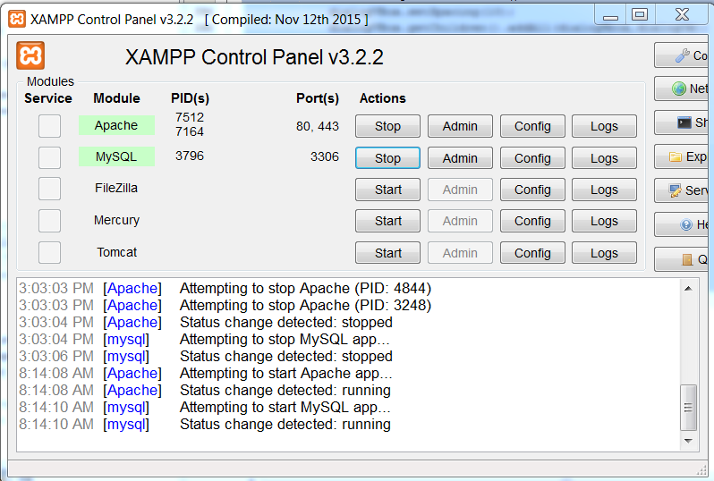

Now in NetBeans ….

F11 to build the project

Then

F6 to run the project

****The data in your employeemanager.sql may differ from below!!!!

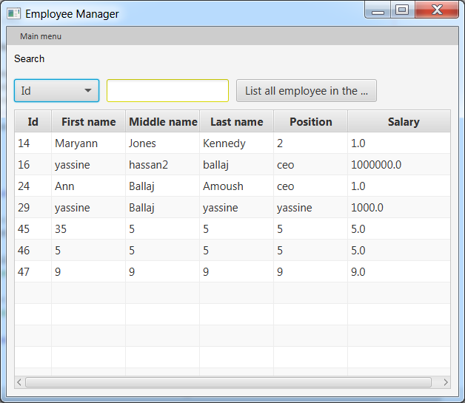

C’est Finis!!!!!!