**Instructions**

The application will take as input a distance in mega lights (MGLT).

The output should be a collection of all the star ships and the total amount of stops required to make the distance between the planets.

Sample output for 1000000:

Y-wing: 74

Millennium Falcon: 9

Rebel Transport: 11

1. Open the Visual Studio and open the project

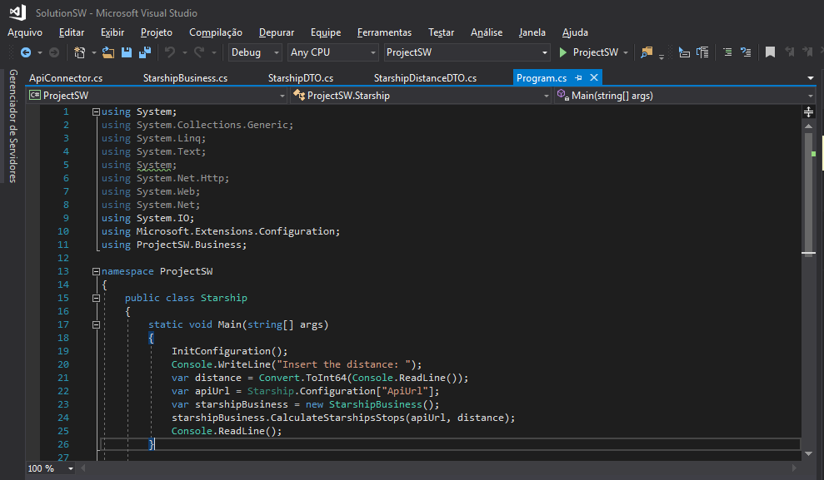

1. Insert value in console and press Enter.

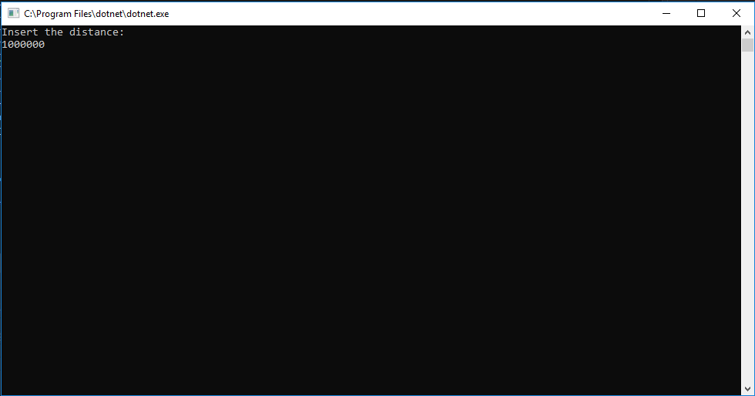

1. After input the distance, the console will show you the result.

