*Lappeenrannan teknillinen yliopisto*

*School of Business and Management*

Thien Nhan Nguyen, student number: x106928

LEARNING DIARY, SOFTWARE DEVELOPMENT SKILLS: FULL-STACK MODULE

**MODULE TASKLIST:**

***NODEJS:***

What I learned:

-Knowledge about the defination, benefits, best types of projects for NodeJS.

-Knowledge about NPM, Node Modules

-Download Nodejs for Windows

-Create package.json for a project

-Understand NodeJS core fundamentals such as path, url, fs, event, https

-Create a basic server

-Know how to deploy a server to Heroku

***MONGODB:***

What I learned:

-Know how to download MongoDB and understand MongoDB fundamentals.

-Understand how to work with MongoDB Compass graphical interface and MongoDB Atlas.

*Basic commands to display all database in mongo shell*

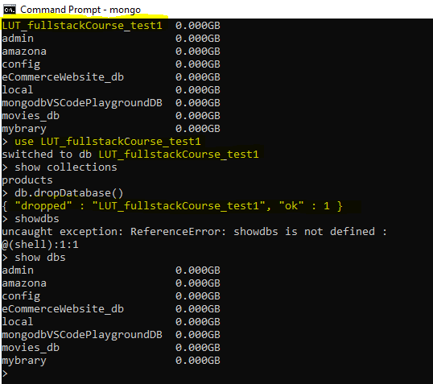

*Basic commands to add one row and multiple rows in collection*

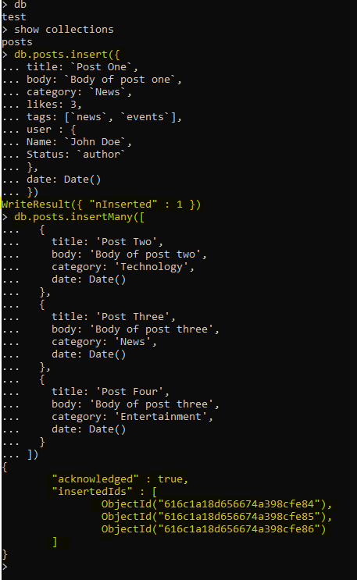

*Basic commands to get all rows and formatted all rows in collection*

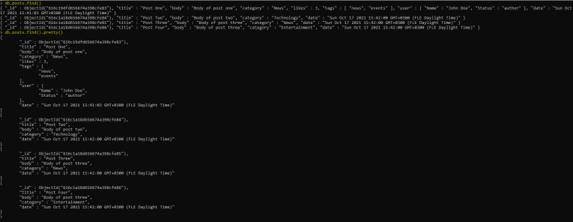

*Basic commands to sort all formatted rows in collection in ascendant/descendant order*

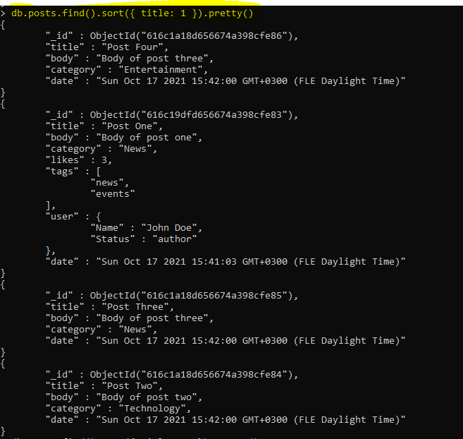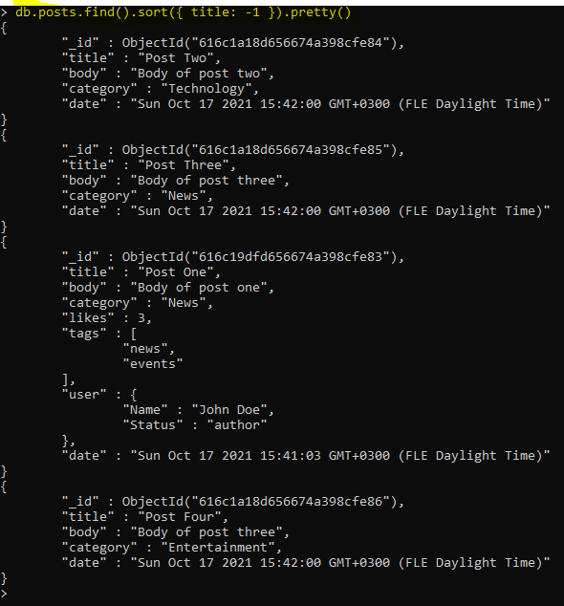

*Basic commands to count rows in collection*

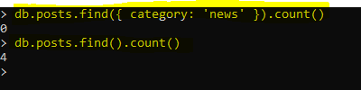

*Basic commands to find one row in collection*

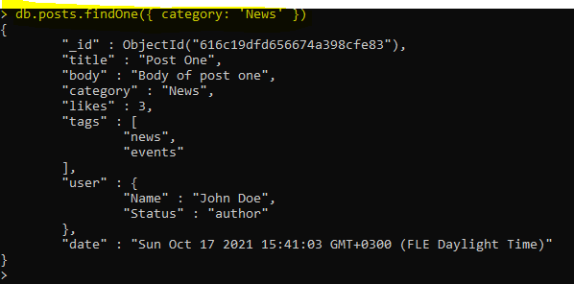

*Basic commands to update one row in collection*

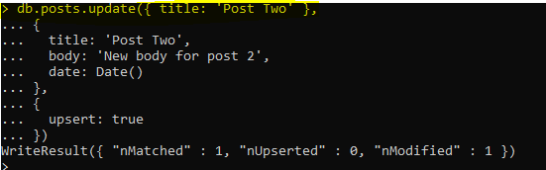

*Basic commands to delete one row in collection*

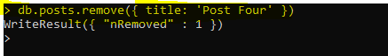

*Basic commands to add index in collection*

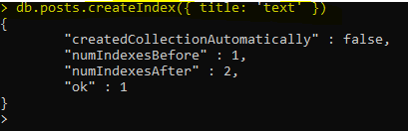

*Basic commands to search text in collection*



***EXPRESSJS:***

What I learned:

-Knowledge about the defination and the advantages of ExpressJS.

-Download and use Postman which is an HTTP client to make requests(GET, POST, PUT, DELETE) to server

-Know about middlewares and how to handle them

-Understand how to render static folder in ExpressJS

-Know how to get all, get one, create, update, delete member in ExpressJS

-Understand the method to render templates using express-handlebars

-In the future, I have to learn how to send JSON web tokens to authenticate

***ANGULAR:***

What I learned:

-Understand the Angular fundamentals as well as know the structure of an Angular project

-Know how to use CLI to create components and services

-I am working with React so when move to Angular framework, the logic is not different but the syntax is tricky for me to remember and understand

-Using two-way data binding with the ngModel directive

-Know some condition syntax in Angular: *ngFor, *ngIf…

-Know lifecycle hook: ngOnInit

-Know how to defined routes, a redirect route, and a parameterized route.

-Know how to share a service among multiple components

-Use HTTP and add post, put, delete, get method to a service

-Learn how to use observables

-Angular is more difficult for me because of its syntax and the flow of code. I need to spend more time on researching about this framework.