Smart Card Authentication
Our first delivery did not include authentication using the Portuguese citizen smart card due to technical issues. We have added it in now.

We’ve created a new class “SmartCardSession” for handling PKCS11 sessions. It can sign data using the private key and share it’s public key in the form of a modulus and public exponent. We sign data using the SHA-256 hashing algorithm instead of SHA-1 (which was used in the practical classes) for increased robustness.

We used the PyKCS11 python module as a PKCS11 wrapper. It does not include a PKCS11 library, however, so we used OpenSC’s to that end.

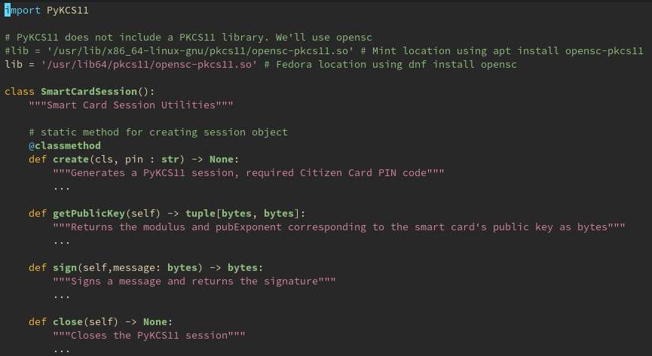
Signatures for SmartCardSession’s methods in the smartcard_reader.py

Furthermore, we expanded the “crypto.py” cryptographic utility class to include methods for recreating the RSA key object from the modulus and exponent as well as a method for verifying a digital signature from the smart card.
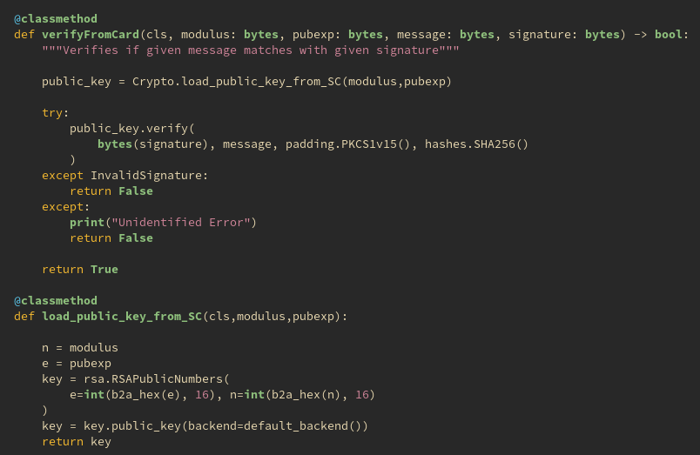
The only other difference is that “Player.py” and “Caller.py” need an additional PIN parameter from creating the smart card session.

AES Block Cipher Mode
When faced with the choice of what block cipher mode of operation we should use with AES for symmetric encryption, we originally chose Galois Counter Mode (GCM).

Our reasoning for GCM to be the better choice was that it offered more features than the other modes, such as automatic integrity checking, higher tampering resistance, capability for pre-processing and parallel processing.

This conclusion proved to be foolhardy, as GCM was completely overkill for the use case of deck encryption, as pointed out by Professor Zúquete. It also added unnecessary complexity in the form of the IVs required for cipher operations.

As it turns out, the simpler Electronic Code Book (ECB) is a much better fit to our problem. It doesn’t boast as many qualities as GCM, but it’s good enough for our use case and doesn’t have unnecessary overhead for features we won’t use. Since decks don’t have repeating numbers, pattern propagation is not an issue either.

We learned a valuable lesson about the importance of carefully considering the requirements and constraints of a system to determine what technological solution best satisfies those needs, as opposed to instinctively going for the theoretically “best” option. Although GCM was supposedly the better choice, it’s advantages over ECB were superfluous to the needs of the system while keeping the complexity associated with them.

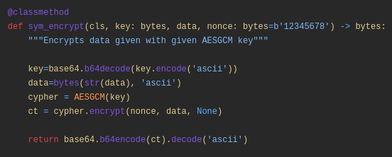
Previously, with GCM. Note that the same IV is used for every message, compromising robustness.
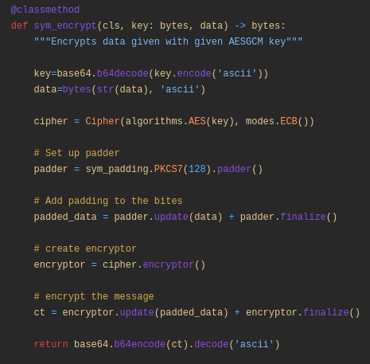
Currently, with ECB.

Cross Language Interoperability
Our system features a novel method for card generation, in which every player shuffles the playing deck as they sign it with their symmetric key.

Once the generation process has been completed and everyone knows the clear deck, users unshuffle the deck in the reverse order it was shuffled in to determine the card of every player. The first N numbers of the deck as shuffled by a given player is their playing card, where N is the card length.

More information about our method can be found at our previous report.

It was vital that whenever a user shuffles the deck, it is done deterministically as to allow the others users to unshuffle it. To achieve that, we used a method that deterministically shuffles and unshuffles a list given a seed. The seed is the player’s deck encryption key, as it is a secret up until the point everyone shares theirs at the end of the deck generation.

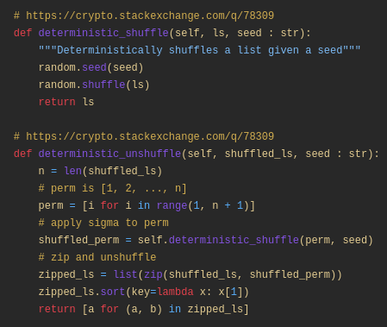
Original shuffling methods. Note the use of the random module.

One issue we had not considered raised by Professor Zúquete is that our methods rely on Python’s module for random number generation. This means that a bingo client written in a programming language other than Python could not play with our Python client as it would shuffle the deck differently, even though they both follow the same communication protocol.

To fix this, we refactored those functions to use a cross-language method for random number generation. The solution we came up with is to hash the seed using MD5 and treating each of the sixteen bytes of the digest as a pool of random integers to be used by the Fisher-Yates list shuffling algorithm. If we run out of numbers in the pool, we generate it again using a different nonce.
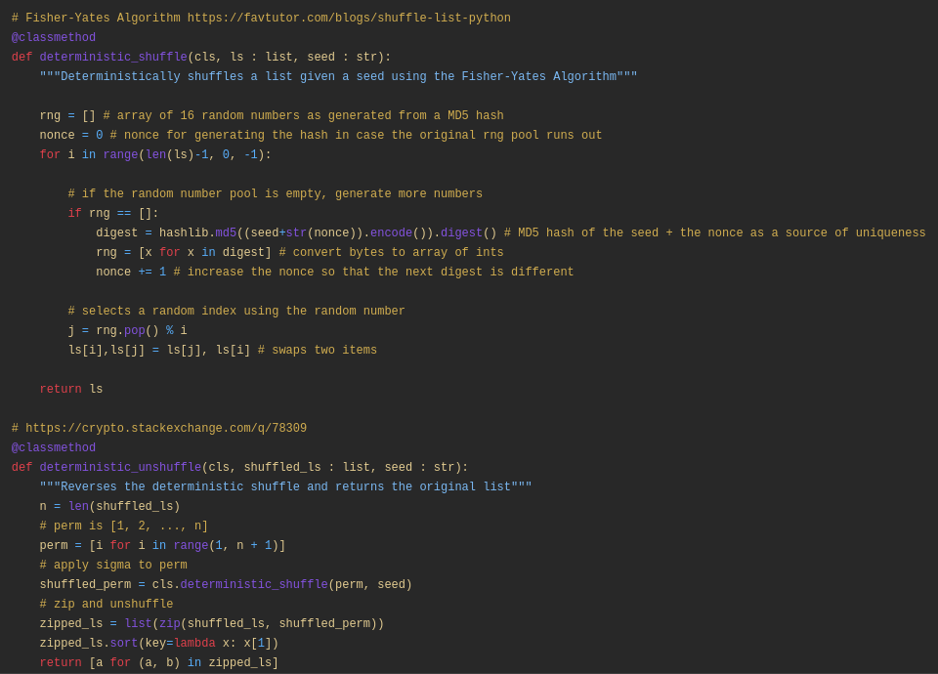
Shuffling using MD5. The unshuffling method remains unaltered.

